World’s Future
Universe, Human Immortality and Future Human Evaluation
by Alexander Bolonkin
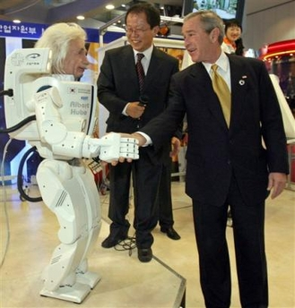
U.S. President George W. Bush shakes hands with 'Albert Hubo,' robot topped with a head modeled after Albert Einstein as leaders of the Asia Pacific Economic Cooperation (APEC) forum toured South Korea's hitech exhibition in Busan, South Korea, Friday, Nov. 18, 2005.

World’s Future

Universe, Human Immortality and Future Human Evaluation
by Alexander Bolonkin
Dr.Sci, professor NJIT, former Senior researcher of NASA and scientific laboratories of the USA Air Forces, <abolonkin@juno.com>, t/f 718-339-4563 USA

New York, 2010

Book Universe, Immortality 11 16 10

Abstract
Immortality is the most cherished dream and the biggest wish of any person. In book the author shows that the problem of immortality can be solved only by changing the biological human into an artificial form. After natural death the man and his consciousness, mind may be converted in a new electronic form. Such an immortal person made of chips and super-solid material (the E-man, E-being as was called in earlier author articles and book) will have incredible advantages in comparison to conventional biological people. An E-man will need no food, no dwelling, no air, no sleep, no rest, and no ecologically pure environment. His brain will work from radio-isotopic batteries (which will work for decades) and muscles that will work on small nuclear engines. Such a being will be able to travel into space and walk on the sea floor with no aqualungs. He will change his face and figure. He will have super-human strength and communicate easily over long distances to gain vast amounts of knowledge in seconds (by re-writing his brain). His mental abilities and capacities will increase millions of times. It will be possible for such a person to travel huge distances at the speed of light. The information of one person like this could be transported to other planets with a laser beam and then placed in a new body. The biological people gradually transfers in E-beings. The biological civilization little by little converts in higher electronic civilization. In further development of technology the electronic civilization may be converted in a wave electromagnetic civilization and so on.
This is the popular book about the Universe, the development of new technologies in 21st century and future of human race. Author shows that a human soul is only the information in a person head. He offers new unique method for re-writing the main brain information in chips without any damage of human brain.
This is the scientific prediction of the non-biological (electronic) civilization and immortality of human being. Such a prognosis is predicated upon a new law, discovered by the author, for the development of complex systems. According to this law, every self-copying system tends to be more complex than the previous system, provided that all external conditions remain the same. The consequences are disastrous: humanity will be replaced by a new civilization created by intellectual robots (which the author refers to as "E-humans" and "E-beings"), These creatures, whose intellectual and mechanical abilities will far exceed those of man, will require neither food nor oxygen to sustain their existence. They may have the emotion. Capable of developing science, technology and their own intellectual abilities thousands of times faster than humans can, they will, in essence, be eternal.
--------------------
Key words: Universe, immortality, future of humanity, computer, 21st Century, non-biological civilization,

Universe, Human Immortality and Future Human Evaluation
by Alexander Bolonkin
Abstract
Contents:
Preface
Part 1. Universe. Who are we? Where are we?
Ch.1. Macro World 5
1. Universe.
2. Stars.
3. Exotic stars and Black Holes
4. Sun
5. Solar Planets.
Summary
Ch.2. Micro World 20
1. Matter
2. Atoms, Molecules.
3. Nucleus, protons, neutrons, quarks, nuclear forces.
4. Degenerate matter.
5. Summary
Ch.3. Surprising properties of our World. 25
1. All Would in point, all time in moment. Universe in Black Hole.
Summary
2. Travel in Future.
Summary
3. Law of existence of Universe. Aim of Universe. Purpose of Humanity.
Ch.4. What is God? 30
1. General notes. God.
2. Existence of God.
Ch.5. What is human soul? 32
1. General notes.
2. Soul in religious.
3. Summary.
Ch.6. What is “I”? What are “We”? 35
1. Individual (person).
2. Intelligence.
3. Artificial intelligence and Artificial soul.
4. Artificial intelligence as a person.
5. Robots
Ch.7. People emotions, Happiness, Pleasure. 42
1. Emotions.
2. Happiness.
3. Pleasure.
Summary.
Part 2. Human immortality and future human evaluation. 47
Chapter 1. The Advent of the Non-Biological Civilization.
Chapter 2. The Beginning of Human Immortality.
Chapter 3. What are Science, Soul, Paradise, and Artificial Intelligence?
Chapter 4. Real Breakthrough to Immortality.
Chapter 5. The natural Purpose of Mankind is to become God
Chapter 6. Settle God into Computer-Internet Net
Chapter 7. Interview of professor A. Bolonkin “Immortality become a reality”
Chapter 8. Person. Three laws of Person.
Chapter 9. Summary
Appendixes
- An Open Statement to the President of the United States of America and to the Presidents and Prime Ministers of all countries about a scientific and technology jump in 21st Century.
- Current Artificial Intelligence
- Current Supercomputers.
- References

Part 1.
Universe. Who are we? Where are we?
Chapter 1. Macro World
1. Universe.
The universe is commonly defined as the totality of everything that exists, including all physical matter and energy, the planets, stars, galaxies, and the contents of intergalactic space. The term universe may be used in slightly different contextual senses, denoting such concepts as the cosmos, the world, or nature.
Observations of earlier stages in the development of the universe, which can be seen at great distances, suggest that the universe has been governed by the same physical laws. The Solar System is embedded in a galaxy composed of billions of stars, the Milky Way, and that other galaxies exist outside it, as far as astronomical instruments can reach. Careful studies of the distribution of these galaxies and their spectral lines have led the modern cosmology. Discovery of the red shift and cosmic microwave background radiation revealed that the universe is expanding and apparently had a beginning. This high-resolution image of the Hubble ultra deep field shows a diverse range of galaxies, each consisting of billions of stars.
According to the prevailing scientific model of the universe, known as the Big Bang, the universe expanded from an extremely hot, dense phase called the Planck epoch, in which all the matter and energy of the observable universe was concentrated. Since the Planck epoch, the universe has been expanding to its present form, possibly with a brief period (less than 10⁻³² seconds, 15 billions of years) of cosmic inflation. Several independent experimental measurements support this theoretical expansion and, more generally, the Big Bang theory. Recent observations indicate that this expansion is accelerating because of dark energy, and that most of the matter in the universe may be in a form which cannot be detected by present instruments, and so is not accounted for in the present models of the universe; this has been named dark matter. The imprecision of current observations has hindered predictions of the ultimate fate of the universe.
Current interpretations of astronomical observations indicate that the age of the universe is 13.75 ±0.17 billion years, and that the diameter of the observable universe is at least 93 billion light years, or 8.80 × 10²⁶ meters. According to general relativity, space can expand faster than the speed of light, although we can view only a small portion of the universe due to the limitation imposed by light speed. Since we cannot observe space beyond the limitations of light (or any electromagnetic radiation), it is uncertain whether the size of the universe is finite or infinite.
More customarily, the universe is defined as everything that exists, has existed, and will exist. According to this definition and our present understanding, the universe consists of three elements: space and time, collectively known as space-time or the vacuum; matter and various forms of energy and momentum occupying space-time; and the physical laws that govern the first two. A related definition of the term universe is everything that exists at a single moment of cosmological time, such as the present, as in the sentence "The universe is now bathed uniformly in microwave radiation".
The universe is very large and possibly infinite in volume. The region visible from Earth (the observable universe) is about 92 billion light years across, based on where the expansion of space has taken the most distant objects observed. For comparison, the diameter of a typical galaxy is only 30,000 light-years, and the typical distance between two neighboring galaxies is only 3 million light-years. As an example, our Milky Way Galaxy is roughly 100,000 light years in diameter, and our nearest sister galaxy, the Andromeda Galaxy, is located roughly 2.5 million light years away. There are probably more than 100 billion (10¹¹) galaxies in the observable universe. Typical galaxies range from dwarfs with as few as ten million (10⁷) stars up to giants with one trillion (10¹²) stars, all orbiting the galaxy's center of mass. Thus, a very rough estimate from these numbers would suggest there are around one sextillion (10²¹) stars in the observable universe; though a 2003 study by Australian National University astronomers resulted in a figure of 70 sextillion (7 × 10²²).
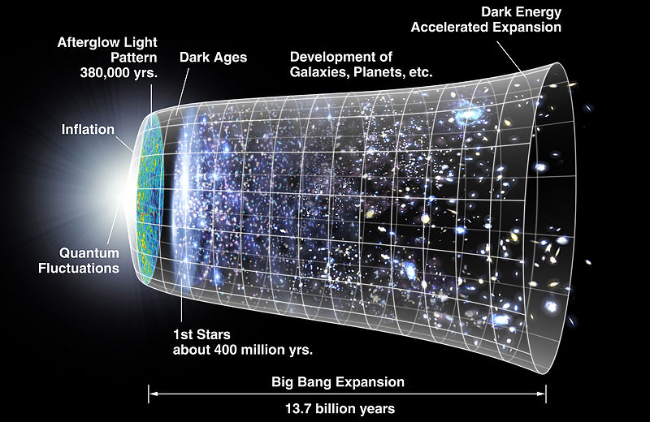
Creating and development of Universe
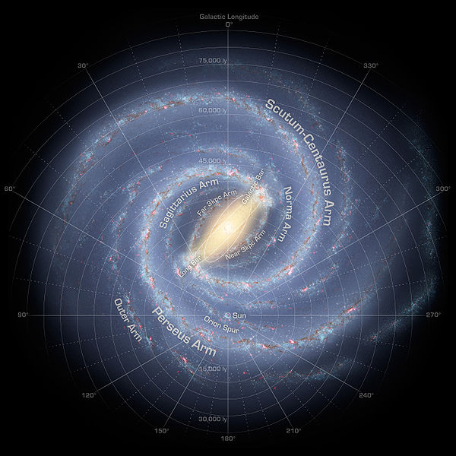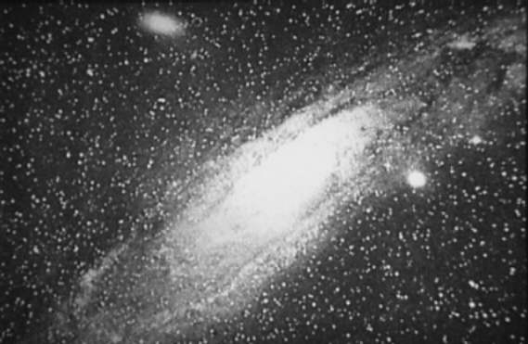
Left: Artist's conception of the spiral structure of the Milky Way with two major stellar arms and a bar.
Right: Photograph of the "Great Andromeda Nebula" from 1899, later identified as the Andromeda Galaxy.
The universe is believed to be mostly composed of dark energy and dark matter, both of which are poorly understood at present. Less than 5% of the universe is ordinary matter, a relatively small contribution.
The observable matter is spread uniformly (homogeneously) throughout the universe, when averaged over distances longer than 300 million light-years. However, on smaller length-scales, matter is observed to form "clumps", i.e., to cluster hierarchically; many atoms are condensed into stars, most stars into galaxies, most galaxies into clusters, superclusters and, finally, the largest-scale structures such as the Great Wall of galaxies. The observable matter of the universe is also spread isotropically, meaning that no direction of observation seems different from any other; each region of the sky has roughly the same content. The universe is also bathed in a highly isotropic microwave radiation that corresponds to a thermal equilibrium blackbody spectrum of roughly 2.725 kelvin. The hypothesis that the large-scale universe is homogeneous and isotropic is known as the cosmological principle, which is supported by astronomical observations.
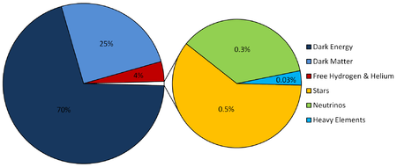
Composition of Universe
The present overall density of the universe is very low, roughly 9.9 × 10⁻³⁰ grams per cubic centimeter. This mass-energy appears to consist of 73% dark energy, 23% cold dark matter and 4% ordinary matter. Thus the density of atoms is on the order of a single hydrogen atom for every four cubic meters of volume. The properties of dark energy and dark matter are largely unknown. Dark matter gravitates as ordinary matter, and thus works to slow the expansion of the universe; by contrast, dark energy accelerates its expansion.
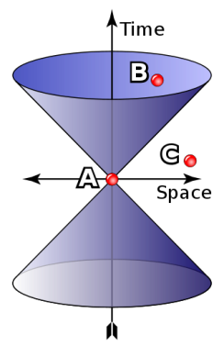
Visible and invisible part of Universe. B is visible. C is invisible. If star located in distance 100 million light years is burn now, we will see it only 100 million light years later.
The most precise estimate of the universe's age is about 13.73±0.12 billion years old, based on observations of the cosmic microwave background radiation. This expansion accounts for how Earth-bound scientists can observe the light from a galaxy 30 billion light years away, even if that light has traveled for only 13 billion years; the very space between them has expanded. This expansion is consistent with the observation that the light from distant galaxies has been redshifted; the photons emitted have been stretched to longer wavelengths and lower frequency during their journey. The rate of this spatial expansion is accelerating, based on studies of Type Ia supernovae and corroborated by other data.
As such the conditional probability of observing a universe that is fine-tuned to support intelligent life is 1. This observation is known as the anthropic principle and is particularly relevant if the creation of the universe was probabilistic or if multiple universes with a variety of properties exist.
Of the four fundamental interactions, gravitation is dominant at cosmological length scales; that is, the other three forces are believed to play a negligible role in determining structures at the level of planets, stars, galaxies and larger-scale structures. Given gravitation's predominance in shaping cosmological structures, accurate predictions of the universe's past and future require an accurate theory of gravitation. The best theory available is Albert Einstein's general theory of relativity.
That leads to a single form for the metric tensor, called the Friedmann-Lemaître-Robertson-Walker metric. This metric has only two undetermined parameters: an overall length scale R that can vary with time, and a curvature index k that can be only 0, 1 or −1, corresponding to flat Euclidean geometry, or spaces of positive or negative curvature. In cosmology, solving for the history of the universe is done by calculating R as a function of time, given k and the value of the cosmological constant Λ, which is a (small) parameter in Einstein's field equations. The equation describing how R varies with time is known as the Friedmann equation, after its inventor, Alexander Friedmann.
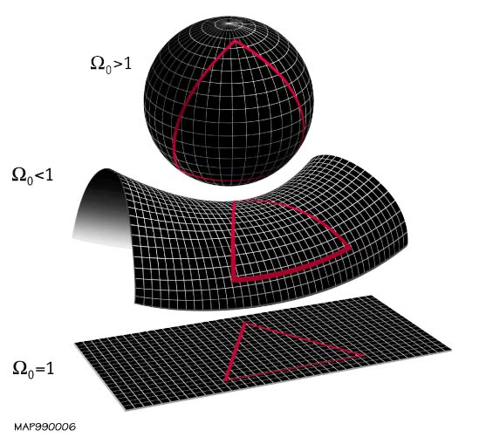
Curvature of two dimensional plate. Here is Ω_{o}= k , (52KB).
The solutions for R(t) depend on k and Λ, but some qualitative features of such solutions are general. First and most importantly, the length scale R of the universe can remain constant only if the universe is perfectly isotropic with positive curvature (k = 1) and has one precise value of density everywhere, as first noted by Albert Einstein. However, this equilibrium is unstable and since the universe is known to be inhomogeneous on smaller scales, R must change, according to general relativity. Einstein's field equations include a cosmological constant (Λ), that corresponds to an energy density of empty space.
Russian physicist Zel'dovich suggested that Λ is a measure of the zero-point energy associated with virtual particles of quantum field theory, a pervasive vacuum energy that exists everywhere, even in empty space. Evidence for such zero-point energy is observed in the Casimir effect.
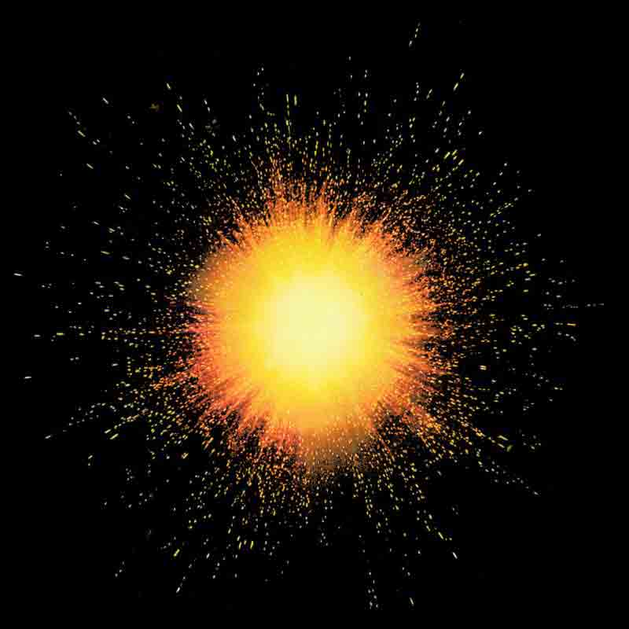 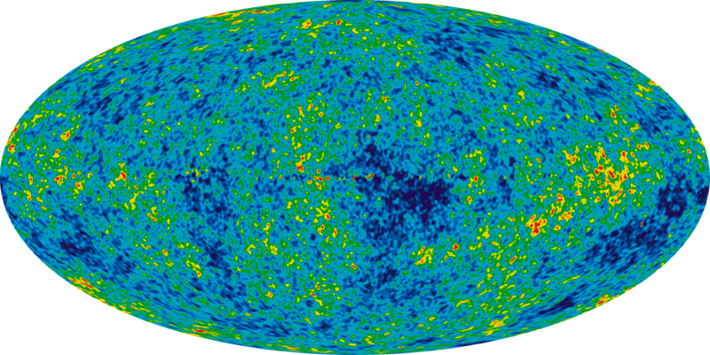
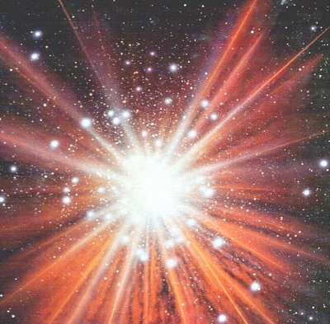
History and possible future of Universe: Big Bang, Current Universe, Big Crunch into dot
of singularity, New Big Bang.
The ultimate fate of the universe is still unknown, because it depends critically on the curvature index k and the cosmological constant Λ. If the universe is sufficiently dense, k equals +1, meaning that its average curvature throughout is positive and the universe will eventually recollapse in a Big Crunch, possibly starting a new universe in a Big Bounce. Conversely, if the universe is insufficiently dense, k equals 0 or −1 and the universe will expand forever, cooling off and eventually becoming inhospitable for all life, as the stars die and all matter coalesces into black holes (the Big Freeze and the heat death of the universe). As noted above, recent data suggests that the expansion speed of the universe is not decreasing as originally expected, but increasing; if this continues indefinitely, the universe will eventually rip itself to shreds (the Big Rip). Experimentally, the universe has an overall density that is very close to the critical value between recollapse and eternal expansion; more careful astronomical observations are needed to resolve the question.
2. Stars
Conventional Stars.
A star is a massive, luminous ball of plasma held together by gravity. At the end of its lifetime, a star can also contain a proportion of degenerate matter. The nearest star to Earth is the Sun, which is the source of most of the energy on Earth.
For at least a portion of its life, a star shines due to thermonuclear fusion of hydrogen in its core releasing energy that traverses the star's interior and then radiates into outer space. Almost all naturally occurring elements heavier than helium were created by stars, either via stellar nucleosynthesis during their lifetimes or by supernova nucleosynthesis when stars explode. Astronomers can determine the mass, age, chemical composition and many other properties of a star by observing its spectrum, luminosity and motion through space. The total mass of a star is the principal determinant in its evolution and eventual fate. Other characteristics of a star are determined by its evolutionary history, including diameter, rotation, movement and temperature. A plot of the temperature of many stars against their luminosities, known as a Hertzsprung-Russell diagram (H–R diagram), allows the age and evolutionary state of a star to be determined.
Binary and multi-star systems consist of two or more stars that are gravitationally bound, and generally move around each other in stable orbits. When two such stars have a relatively close orbit, their gravitational interaction can have a significant impact on their evolution. Stars can form part of a much larger gravitationally bound structure, such as a cluster or a galaxy.
As stars of at least 0.4 solar masses exhaust their supply of hydrogen at their core, their outer layers expand greatly and cool to form a red giant. For example, in about 5 billion years, when the Sun is a red giant, it will expand out to a maximum radius of roughly 1 AU (150,000,000 km), 250 times its present size. As a giant, the Sun will lose roughly 30% of its current mass.
An evolved, average-size star will now shed its outer layers as a planetary nebula. If what remains after the outer atmosphere has been shed is less than 1.4 solar masses, it shrinks to a relatively tiny object (about the size of Earth) that is not massive enough for further compression to take place, known as a white dwarf. The electron-degenerate matter inside a white dwarf is no longer a plasma, even though stars are generally referred to as being spheres of plasma. White dwarfs will eventually fade into black dwarfs over a very long stretch of time.
Most of the matter in the star is blown away by the supernova explosion (forming nebulae such as the Crab Nebula) and what remains will be a neutron star (which sometimes manifests itself as a pulsar or X-ray burster) or, in the case of the largest stars (large enough to leave a stellar remnant greater than roughly 4 solar masses), a black hole. In a neutron star the matter is in a state known as neutron-degenerate matter, with a more exotic form of degenerate matter, QCD matter, possibly present in the core. Within a black hole the matter is in a state that is not currently understood.
The nearest star to the Earth, apart from the Sun, is Proxima Centauri, which is 39.9 trillion (10¹²) kilometres, or 4.2 light-years away. Light from Proxima Centauri takes 4.2 years to reach Earth. Travelling at the orbital speed of the Space Shuttle (5 miles per second—almost 30,000 kilometres per hour), it would take about 150,000 years to get there.
Most stars are between 1 billion and 10 billion years old. Some stars may even be close to 13.7 billion years old—the observed age of the universe. The oldest star yet discovered, HE 1523-0901, is an estimated 13.2 billion years old.
The more massive the star, the shorter its lifespan, primarily because massive stars have greater pressure on their cores, causing them to burn hydrogen more rapidly. The most massive stars last an average of about one million years, while stars of minimum mass (red dwarfs) burn their fuel very slowly and last tens to hundreds of billions of years.
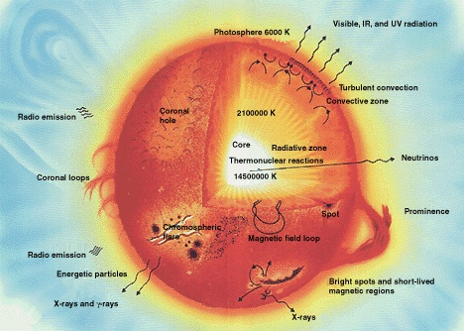
The most important for us star is the Sun.
Stars range in size from neutron stars, which vary anywhere from 20 to 40 km in diameter, to supergiants like Betelgeuse in the Orion constellation, which has a diameter approximately 650 times larger than the Sun—about 0.9 billion kilometres. However, Betelgeuse has a much lower density than the Sun.
3.Exotic stars
Neutron stars.
A neutron star is a large gravitationally-bound lump of electrically neutral nuclear matter, whose pressure rises from zero (at the surface) to an unknown value in the center.
A neutron star is a type of remnant that can result from the gravitational collapse of a massive star during a Type II, Type Ib or Type Ic supernova event. Such stars are composed almost entirely of neutrons, which are subatomic particles with zero electrical charge and roughly the same mass as protons. Neutron stars are very hot and are supported against further collapse because of the Pauli exclusion principle. This principle states that no two neutrons (or any other fermionic particle) can occupy the same place and quantum state simultaneously.
A typical neutron star has a mass between 1.35 and about 2.1 solar masses, with a corresponding radius of about 12 km if the Akmal-Pandharipande-Ravenhall (APR) Equation of state (EOS) is used. In contrast, the Sun's radius is about 60,000 times that. Neutron stars have overall densities predicted by the APR EOS of 3.7 × 10¹⁷ (2.6 × 10¹⁴ times Solar density) to 5.9 × 10¹⁷ kg/m³ (4.1 × 10¹⁴ times Solar density), which compares with the approximate density of an atomic nucleus of 3 × 10¹⁷ kg/m³. The neutron star's density varies from below 1 × 10⁹ kg/m³ in the crust increasing with depth to above 6 or 8 × 10¹⁷ kg/m³ deeper inside. This density is approximately equivalent to the mass of the entire human population compressed to the size of a sugar cube.
In general, compact stars of less than 1.44 solar masses, the Chandrasekhar limit, are white dwarfs; above 2 to 3 solar masses (the Tolman-Oppenheimer-Volkoff limit), a quark star might be created, however this is uncertain. Gravitational collapse will always occur on any star over 5 solar masses, inevitably producing a black hole.
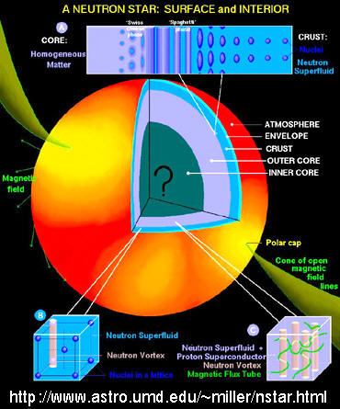
Probability structure of neutron star.
The gravitational field at the star's surface is about 2×10¹¹ times stronger than on Earth. The escape velocity is about 100,000 km/s, which is about one third the speed of light. Such a strong gravitational field acts as a gravitational lens and bends the radiation emitted by the star such that parts of the normally invisible spectrum near the surface become visible.
The gravitational binding energy of a two solar mass neutron star is equivalent to the total conversion of one solar mass to energy (From the law of mass-energy equivalence, E=mc²). That energy was released during the supernova explosion.
A neutron star is so dense that one teaspoon (5 millilitre) of its material would have a mass over 5×10¹² kg. The resulting force of gravity is so strong that if an object were to fall from just one meter high it would hit the surface of the neutron star at 2 thousand kilometers per second, or 4.3 million miles per hour.
The Equation of state (EOS) for a Neutron star is still not known as of 2008.
On the basis of current models, the matter at the surface of a neutron star is composed of ordinary atomic nuclei as well as electrons.
White dwarfs.
A white dwarf, also called a degenerate dwarf, is a small star composed mostly of electron-degenerate matter. They are very dense; a white dwarf's mass is comparable to that of the Sun and its volume is comparable to that of the Earth. Its faint luminosity comes from the emission of stored thermal energy. In January 2009, the Research Consortium on Nearby Stars project counted eight white dwarfs among the hundred nearest star systems of the sun. The unusual faintness of white dwarfs was first recognized in 1910 by Henry Norris Russell, Edward Charles Pickering, and Williamina Fleming; the name white dwarf was coined by Willem Luyten in 1922.
White dwarfs are thought to be the final evolutionary state of all stars whose mass is not high enough to become supernovae—over 97% of the stars in our galaxy. After the hydrogen-fusing lifetime of a main-sequence star of low or medium mass ends, it will expand to a red giant which fuses helium to carbon and oxygen in its core by the triple-alpha process. If a red giant has insufficient mass to generate the core temperatures required to fuse carbon, an inert mass of carbon and oxygen will build up at its center. After shedding its outer layers to form a planetary nebula, it will leave behind this core, which forms the remnant white dwarf. Usually, therefore, white dwarfs are composed of carbon and oxygen. It is also possible that core temperatures suffice to fuse carbon but not neon, in which case an oxygen-neon–magnesium white dwarf may be formed. Also, some helium white dwarfs appear to have been formed by mass loss in binary systems.
The material in a white dwarf no longer undergoes fusion reactions, so the star has no source of energy, nor is it supported by the heat generated by fusion against gravitational collapse. It is supported only by electron degeneracy pressure, causing it to be extremely dense. The physics of degeneracy yields a maximum mass for a nonrotating white dwarf, the Chandrasekhar limit—approximately 1.4 solar masses—beyond which it cannot be supported by degeneracy pressure. A carbon-oxygen white dwarf that approaches this mass limit, typically by mass transfer from a companion star, may explode as a Type Ia supernova via a process known as carbon detonation. (SN 1006 is thought to be a famous example.)
A white dwarf is very hot when it is formed but since it has no source of energy, it will gradually radiate away its energy and cool down. This means that its radiation, which initially has a high color temperature, will lessen and redden with time. Over a very long time, a white dwarf will cool to temperatures at which it will no longer be visible, and become a cold black dwarf. However, since no white dwarf can be older than the age of the Universe (approximately 13.7 billion years), even the oldest white dwarfs still radiate at temperatures of a few thousand kelvins, and no black dwarfs are thought to exist yet.
Quark star.
A quark star or strange star is a hypothetical type of exotic star composed of quark matter, or strange matter. These are ultra-dense phases of degenerate matter theorized to form inside particularly massive neutron stars.
It is theorized that when the neutron-degenerate matter which makes up a neutron star is put under sufficient pressure due to the star's gravity, the individual neutrons break down into their constituent quarks–up quarks and down quarks. Some of these quarks may then become strange quarks and form strange matter. The star then becomes known as a "quark star" or "strange star", similar to a single gigantic hadron (but bound by gravity rather than the strong force). Quark matter/strange matter is one candidate for the theoretical dark matter that is a feature of several cosmological theories.
Magnetar.
A magnetar is a type of neutron star with an extremely powerful magnetic field, the decay of which powers the emission of copious amounts of high-energy electromagnetic radiation, particularly X-rays and gamma rays. The theory regarding these objects was proposed by Robert Duncan and Christopher Thompson in 1992, but the first recorded burst of gamma rays thought to have been from a magnetar was detected on March 5, 1979. During the following decade, the magnetar hypothesis has become widely accepted as a likely explanation for soft gamma repeaters (SGRs) and anomalous X-ray pulsars (AXPs).
Magnetars are primarily characterized by their extremely powerful magnetic field, which can often reach the order of ten gigateslas. These magnetic fields are hundreds of thousands of times stronger than any man-made magnet, and quadrillions of times more powerful than the field surrounding Earth. As of 2010, they are the most magnetic objects ever detected in the universe.
A magnetic field of 10 gigateslas is enormous relative to magnetic fields typically encountered on Earth. Earth has a geomagnetic field of 30–60 microteslas, and a neodymium based rare earth magnet has a field of about 1 tesla, with a magnetic energy density of 4.0×10⁵ J/m³. A 10 gigatesla field, by contrast, has an energy density of 4.0×10²⁵ J/m³, with an E/c² mass density >10⁴ times that of lead. The magnetic field of a magnetar would be lethal even at a distance of 1000 km, tearing tissues due to the diamagnetism of water. At a distance halfway to the moon, a magnetar could strip information from all credit cards on Earth.
As described in the February 2003 Scientific American cover story, remarkable things happen within a magnetic field of magnetar strength. "X-ray photons readily split in two or merge together. The vacuum itself is polarized, becoming strongly birefringent, like a calcite crystal. Atoms are deformed into long cylinders thinner than the quantum-relativistic wavelength of an electron." In a field of about 10⁵ teslas atomic orbitals deform into rod shapes. At 10¹⁰ teslas, a hydrogen atom becomes a spindle 200 times narrower than its normal diameter.
Although most common magnetic phenomena are electromagnetic, a second source of magnetism occurs due to the spin magnetic moment of sub-atomic particles. Spin magnetic moment is responsible for the magnetic field of magnetars, and is also exploited in technologies such as NMR/MRI.
Black hole.
Black hole. In general relativity, a black hole is a region of space in which the gravitational field is so powerful that nothing, including light, can escape its pull. The black hole has a one-way surface, called the event horizon, into which objects can fall, but out of which nothing can come out. It is called "black" because it absorbs all the light that hits it, reflecting nothing, just like a perfect blackbody in thermodynamics.
Despite its invisible interior, a black hole can reveal its presence through interaction with other matter. A black hole can be inferred by tracking the movement of a group of stars that orbit a region in space which looks empty. Alternatively, one can see gas falling into a relatively small black hole, from a companion star. This gas spirals inward, heating up to very high temperature and emitting large amounts of radiation that can be detected from earthbound and earth-orbiting telescopes. Such observations have resulted in the general scientific consensus that, barring a breakdown in our understanding of nature, black holes do exist in our universe.
It is impossible to directly observe a black hole. However, it is possible to infer its presence by its gravitational action on the surrounding environment, particularly with microquasars and active galactic nuclei, where material falling into a nearby black hole is significantly heated and emits a large amount of X-ray radiation. This observation method allows astronomers to detect their existence. The only objects that agree with these observations and are consistent within the framework of general relativity are black holes.
A black hole has only three independent physical properties: mass, charge and angular momentum.
In astronomy black holes are classed as:
- Supermassive - contain hundreds of thousands to billions of solar masses and are thought to exist in the center of most galaxies, including the Milky Way.
- Intermediate - contain thousands of solar masses.
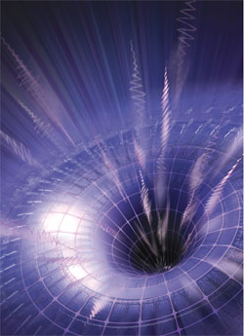
- Micro (also mini black holes) - have masses much less than that of a star. At these sizes, quantum mechanics is expected to take effect. There is no known mechanism for them to form via normal processes of stellar evolution, but certain inflationary scenarios predict their production during the early stages of the evolution of the universe.
According to some theories of quantum gravity they may also be produced in the highly energetic reaction produced by cosmic rays hitting the atmosphere or even in particle accelerators such as the Large Hadron Collider. The theory of Hawking radiation predicts that such black holes will evaporate in bright flashes of gamma radiation. NASA's Fermi Gamma-ray Space Telescope satellite (formerly GLAST) launched in 2008 is searching for such flashes. 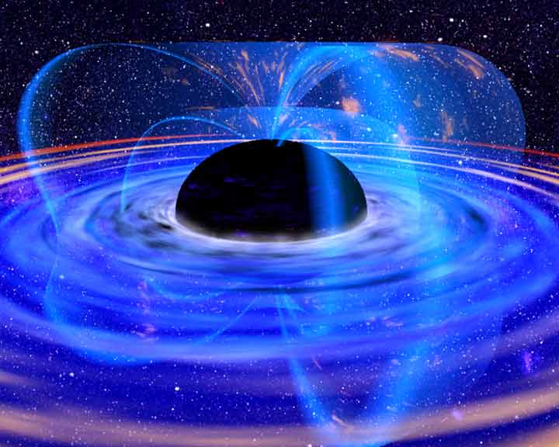
Left: Artist’s conception of a stellar mass black hole. Credit NASA.
Right: Artist’s rendering showing the space-time contours around a black hole. Credit NASA.
The defining feature of a black hole is the appearance of an event horizon; a boundary in spacetime beyond which events cannot affect an outside observer.
Since the event horizon is not a material surface but rather merely a mathematically defined demarcation boundary, nothing prevents matter or radiation from entering a black hole, only from exiting one.
For a non rotating (static) black hole, the Schwarzschild radius delimits a spherical event horizon. The Schwarzschild radius of an object is proportional to the mass. Rotating black holes have distorted, nonspherical event horizons. The description of black holes given by general relativity is known to be an approximation, and it is expected that quantum gravity effects become significant near the vicinity of the event horizon. This allows observations of matter in the vicinity of a black hole's event horizon to be used to indirectly study general relativity and proposed extensions to it.
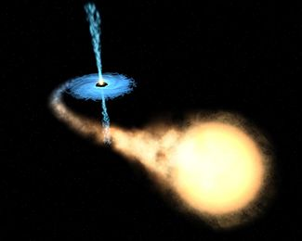 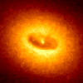
(Left). Artist's impression of a binary system consisting of a black hole and a main sequence star. The black hole is drawing matter from the main sequence star via an accretion disk around it, and some of this matter forms a gas jet.
(Right). Ring around a suspected black hole in galaxy NGC 4261. Date: Nov.1992. Courtesy of Space Telescope Science
Though black holes themselves may not radiate energy, electromagnetic radiation and matter particles may be radiated from just outside the event horizon via Hawking radiation.
At the center of a black hole lies the singularity, where matter is crushed to infinite density, the pull of gravity is infinitely strong, and spacetime has infinite curvature. This means that a black hole's mass becomes entirely compressed into a region with zero volume. This zero-volume, infinitely dense region at the center of a black hole is called a gravitational singularity.
The singularity of a non-rotating black hole has zero length, width, and height; a rotating black hole's is smeared out to form a ring shape lying in the plane of rotation. The ring still has no thickness and hence no volume.
The photon sphere is a spherical boundary of zero thickness such that photons moving along tangents to the sphere will be trapped in a circular orbit. For non-rotating black holes, the photon sphere has a radius 1.5 times the Schwarzschild radius. The orbits are dynamically unstable, hence any small perturbation (such as a particle of infalling matter) will grow over time, either setting it on an outward trajectory escaping the black hole or on an inward spiral eventually crossing the event horizon.
Rotating black holes are surrounded by a region of spacetime in which it is impossible to stand still, called the ergosphere. Objects and radiation (including light) can stay in orbit within the ergosphere without falling to the center.
Once a black hole has formed, it can continue to grow by absorbing additional matter. Any black hole will continually absorb interstellar dust from its direct surroundings and omnipresent cosmic background radiation.
Much larger contributions can be obtained when a black hole merges with other stars or compact objects.
4. Sun
The Sun is the star at the center of the Solar System. It has a diameter of about 1,392,000 km, about 109 times that of Earth, and its mass (about 2 × 10³⁰ kilograms, 330,000 times that of Earth) accounts for about 99.86% of the total mass of the Solar System. About three quarters of the Sun's mass consists of hydrogen, while the rest is mostly helium. Less than 2% consists of heavier elements, including oxygen, carbon, neon, iron, and others.
Sunlight is Earth's primary source of energy. The solar constant is the amount of power that the Sun deposits per unit area that is directly exposed to sunlight. The solar constant is equal to approximately 1,368 W/m² (watts per square meter) at a distance of one astronomical unit (AU) from the Sun (that is, on or near Earth). Sunlight on the surface of Earth is attenuated by the Earth's atmosphere so that less power arrives at the surface—closer to 1,000 W/m² in clear conditions when the Sun is near the zenith.
Solar energy can be harnessed by a variety of natural and synthetic processes—photosynthesis by plants captures the energy of sunlight and converts it to chemical form (oxygen and reduced carbon compounds), while direct heating or electrical conversion by solar cells are used by solar power equipment to generate electricity or to do other useful work, sometimes employing concentrating solar power (that it is measured in suns). The energy stored in petroleum and other fossil fuels was originally converted from sunlight by photosynthesis in the distant past.
Its surface temperature of approximately 5778 K (5505 °C). Of the 50 nearest stellar systems within 17 light-years from Earth (the closest being a red dwarf named Proxima Centauri at approximately 4.2 light years away). The sun's resultant velocity with respect to the CMB is about 370 km/s in the direction of Crater or Leo.
The mean distance of the Sun from the Earth is approximately 149.6 million kilometers (1 AU). At this average distance, light travels from the Sun to Earth in about 8 minutes and 19 seconds. The energy of this sunlight supports almost all life on Earth by photosynthesis, and drives Earth's climate and weather.
The core of the Sun is considered to extend from the center to about 0.2 to 0.25 of the solar radius. It has a density of up to 150 g/cm³ (about 150 times the density of water) and a temperature of close to 13.6 million kelvin (K).
Earth's fate is precarious. As a red giant, the Sun will have a maximum radius beyond the Earth's current orbit, 1 AU (1.5×10¹¹ m), 250 times the present radius of the Sun. However, by the time it is an asymptotic giant branch star, the Sun will have lost roughly 30% of its present mass due to a stellar wind, so the orbits of the planets will move outward. If it were only for this, Earth would probably be spared, but new research suggests that Earth will be swallowed by the Sun owing to tidal interactions. Even if Earth would escape incineration in the Sun, still all its water will be boiled away and most of its atmosphere would escape into space. Even during its current life in the main sequence, the Sun is gradually becoming more luminous (about 10% every 1 billion years), and its surface temperature is slowly rising. The Sun used to be fainter in the past, which is possibly the reason life on Earth has only existed for about 1 billion years on land. The increase in solar temperatures is such that in about another billion years the surface of the Earth will likely become too hot for liquid water to exist, ending all terrestrial life.
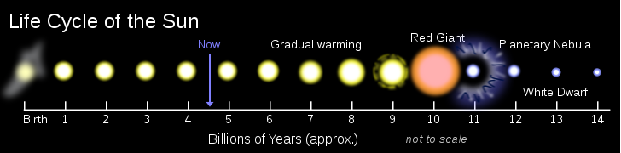
Following the red giant phase, intense thermal pulsations will cause the Sun to throw off its outer layers, forming a planetary nebula. The only object that will remain after the outer layers are ejected is the extremely hot stellar core, which will slowly cool and fade as a white dwarf over many billions of years. This stellar evolution scenario is typical of low- to medium-mass stars.
5. Solar planets
The inner Solar System is the traditional name for the region comprising the terrestrial planets and asteroids. The inner planets: Mercury, Venus, Earth, and Mars.
The four inner or terrestrial planets have dense, rocky compositions, few or no moons, and no ring systems. They are composed largely of refractory minerals, such as the silicates which form their crusts and mantles, and metals such as iron and nickel, which form their cores. Three of the four inner planets (Venus, Earth and Mars) have atmospheres substantial enough to generate weather; all have impact craters and tectonic surface features such as rift valleys and volcanoes. The term inner planet should not be confused with inferior planet, which designates those planets which are closer to the Sun than Earth is (i.e. Mercury and Venus).
Venus has no natural satellites. It is the hottest planet, with surface temperatures over 400 °C, most likely due to the amount of greenhouse gases in the atmosphere.
Mars (1.5 AU from the Sun) is smaller than Earth and Venus (0.107 Earth masses). It possesses an atmosphere of mostly carbon dioxide with a surface pressure of 6.1 millibars (roughly 0.6 percent that of the Earth's). Its surface, peppered with vast volcanoes such as Olympus Mons and rift valleys such as Valles Marineris, shows geological activity that may have persisted until as recently as 2 million years ago. Its red colour comes from iron oxide (rust) in its soil. Mars has two tiny natural satellites (Deimos and Phobos) thought to be captured asteroids.
The four outer planets, or gas giants (sometimes called Jovian planets), collectively make up 99 percent of the mass known to orbit the Sun. Jupiter and Saturn are each many tens of times the mass of the Earth and consist overwhelmingly of hydrogen and helium; Uranus and Neptune are far less massive (<20 Earth masses) and possess more ices in their makeup. For these reasons, some astronomers suggest they belong in their own category, “ice giants.” All four gas giants have rings, although only Saturn's ring system is easily observed from Earth. The term outer planet should not be confused with superior planet, which designates planets outside Earth's orbit and thus includes both the outer planets and Mars.

Jupiter. Jupiter (5.2 AU), at 318 Earth masses, is 2.5 times the mass of all the other planets put together. It is composed largely of hydrogen and helium. Jupiter's strong internal heat creates a number of semi-permanent features in its atmosphere, such as cloud bands and the Great Red Spot.
Jupiter has 63 known satellites. The four largest, Ganymede, Callisto, Io, and Europa, show similarities to the terrestrial planets, such as volcanism and internal heating. Ganymede, the largest satellite in the Solar System, is larger than Mercury.

Saturn.
Saturn (9.5 AU), distinguished by its extensive ring system, has several similarities to Jupiter, such as its atmospheric composition and magnetosphere. Although Saturn has 60% of Jupiter's volume, it is less than a third as massive, at 95 Earth masses, making it the least dense planet in the Solar System. The rings of Saturn are made up of small ice and rock particles.
Saturn has 62 confirmed satellites; two of which, Titan and Enceladus, show signs of geological activity, though they are largely made of ice. Titan, the second largest moon in the Solar System, is larger than Mercury and the only satellite in the Solar System with a substantial atmosphere.

Uranus.
Uranus (19.6 AU), at 14 Earth masses, is the lightest of the outer planets. Uniquely among the planets, it orbits the Sun on its side; its axial tilt is over ninety degrees to the ecliptic. It has a much colder core than the other gas giants, and radiates very little heat into space.
Uranus has 27 known satellites, the largest ones being Titania, Oberon, Umbriel, Ariel and Miranda.

Neptune.
Neptune (30 AU), though slightly smaller than Uranus, is more massive (equivalent to 17 Earths) and therefore more dense. It radiates more internal heat, but not as much as Jupiter or Saturn.
Neptune has 13 known satellites. The largest, Triton, is geologically active, with geysers of liquid nitrogen. Triton is the only large satellite with a retrograde orbit. Neptune is accompanied in its orbit by a number of minor planets, termed Neptune Trojans, that are in 1:1 resonance with it.

Neighbourhood
The immediate galactic neighbourhood of the Solar System is known as the Local Interstellar Cloud or Local Fluff, an area of denser cloud in an otherwise sparse region known as the Local Bubble, an hourglass-shaped cavity in the interstellar medium roughly 300 light years across. The bubble is suffused with high-temperature plasma that suggests it is the product of several recent supernovae.
There are relatively few stars within ten light years (95 trillion km) of the Sun. The closest is the triple star system Alpha Centauri, which is about 4.4 light years away. Alpha Centauri A and B are a closely tied pair of Sun-like stars, while the small red dwarf Alpha Centauri C (also known as Proxima Centauri) orbits the pair at a distance of 0.2 light years. The stars next closest to the Sun are the red dwarfs Barnard's Star (at 5.9 light years), Wolf 359 (7.8 light years) and Lalande 21185 (8.3 light years). The largest star within ten light years is Sirius, a bright main sequence star roughly twice the Sun's mass and orbited by a white dwarf called Sirius B. It lies 8.6 light years away. The remaining systems within ten light years are the binary red dwarf system Luyten 726-8 (8.7 light years) and the solitary red dwarf Ross 154 (9.7 light years). Our closest solitary sun-like star is Tau Ceti, which lies 11.9 light years away. It has roughly 80 percent the Sun's mass, but only 60 percent its luminosity. The closest known extrasolar planet to the Sun lies around the star Epsilon Eridani, a star slightly dimmer and redder than the Sun, which lies 10.5 light years away. Its one confirmed planet, Epsilon Eridani b, is roughly 1.5 times Jupiter's mass and orbits its star every 6.9 years.
Summary
1. The universe is commonly defined as the totality of everything that exists, Radius of Universe is about 8.8 ×10²⁶ m, the mass is 1.7×10⁵³ kg, energy is 1.5 ×10⁷⁰ Joules.
Universe contains millions (billions) of galactic. Every galactic has a millions (billions) of stars. Many stars is similar our Sun and have the planets with conditions closed to our Earths.
2. Universe exists about 13.7 billions years. That means the intelligent live can be in many (millions) planets of Universe. The population of Earth is about 6.9 billions in 2010 year. You can estimate what part of the Universe are you? What part of the Universe life is your life?
3. The intelligent civilizations (want it or no) take part in a competition to Supreme Mind. Who the first reaches a highest knowledge, that wins this competition and that will be the Lord of the Universe (see Part 2 of this book). It is possible this highest civilization will create the new Universities.
Chapter 2. Micro World.
1. Matter.
Matter is a general term for the substance of which all physical objects are made. Typically, matter includes atoms and other particles which have mass. A common way of defining matter is as anything that has mass and occupies volume. In practice however there is no single correct scientific meaning of "matter," as different fields use the term in different and sometimes incompatible ways.
A definition of "matter" more fine-scale than the atoms and molecules definition is: matter is made up of what atoms and molecules are made of, meaning anything made of protons, neutrons, and electrons.
Matter is commonly said to exist in four states (or phases): solid, liquid, gas and plasma. However, advances in experimental techniques have realized other phases, previously only theoretical constructs, such as Bose–Einstein condensates and fermionic condensates. A focus on an elementary-particle view of matter also leads to new phases of matter, such as the quark–gluon plasma.
In physics and chemistry, matter exhibits both wave-like and particle-like properties, the so-called wave–particle duality.
In the realm of cosmology, extensions of the term matter are invoked to include dark matter and dark energy, concepts introduced to explain some odd phenomena of the observable universe, such as the galactic rotation curve. These exotic forms of "matter" do not refer to matter as "building blocks", but rather to currently poorly understood forms of mass and energy.
2. Atoms, molecules.
Atoms are the smallest (size is about some 10⁻⁸ m) neutral particles into which matter can be divided by chemical reactions. An atom consists of a small, heavy nucleus surrounded by a relatively large, light cloud of electrons. Each type of atom corresponds to a specific chemical element. To date, 117 elements have been discovered (atomic numbers 1-116 and 118), and the first 111 have received official names. The well-known periodic table provides an overview. Atoms consist of protons and neutrons within the nucleus. Within these particles, there are smaller particles still which are then made up of even smaller particles still.
Molecules are the smallest particles into which a non-elemental substance can be divided while maintaining the physical properties of the substance. Each type of molecule corresponds to a specific chemical compound. Molecules are a composite of two or more atoms.
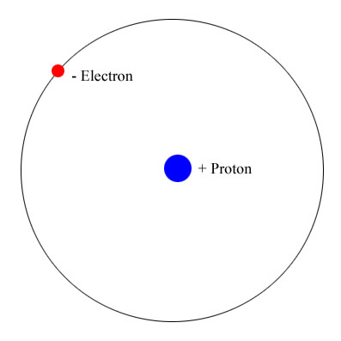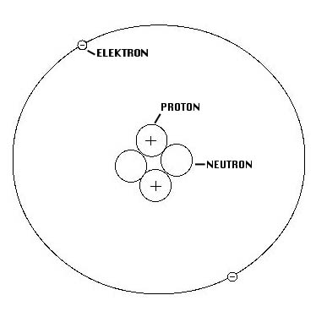
(Left) Hydrogen atom contains one proton and one electron.
(Right) Helium atom contains two protons, two neutrons and two electrons.
Atoms contain small (size is about some 10⁻¹⁵ m) nuclei and electrons orbit around these nuclei. The nuclei of most atoms consist of protons and neutrons, which are therefore collectively referred to as nucleons. The number of protons in a nucleus is the atomic number and defines the type of element the atom forms. The number of neutrons determines the isotope of an element. For example, the carbon-12 isotope has 6 protons and 6 neutrons, while the carbon-14 isotope has 6 protons and 8 neutrons.
While bound neutrons in stable nuclei are stable, free neutrons are unstable; they undergo beta decay with a lifetime of just under 15 minutes. Free neutrons are produced in nuclear fission and fusion. Dedicated neutron sources like research reactors and spallation sources produce free neutrons for the use in irradiation and in neutron scattering experiments.
Outside the nucleus, free neutrons are unstable and have a mean lifetime of 885.7±0.8 s, decaying by emission of a negative electron and antineutrino to become a proton.
This decay mode, known as beta decay, can also transform the character of neutrons within unstable nuclei.
Bound inside a nucleus, protons can also transform via inverse beta decay into neutrons. In this case, the transformation occurs by emission of a positron (antielectron) and a neutrino (instead of an antineutrino).
The transformation of a proton to a neutron inside of a nucleus is also possible through electron capture.
Four forces active between particles: strong interaction, weak interacting, charge force (Coulomb force) and gravitation force. The strong interaction is the most strong force in short nuclei distance, the gravitation is very small into atom.
Beta decay and electron capture are types of radioactive decay and are both governed by the weak interaction.
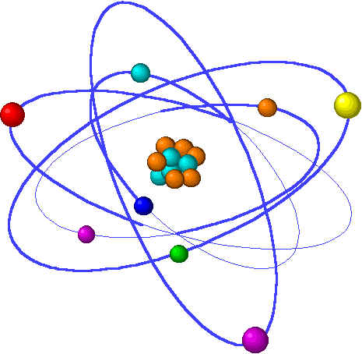
More complex atom which contains many protons, neutrons and electrons.
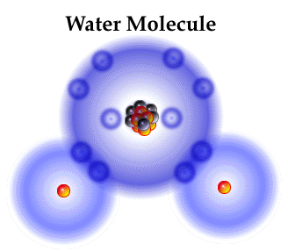
Molecule contains some atoms connected by its electrons.
3. Nucleus, protons, neutrons. Quark. Nuclear forces.
The nuclear force is only felt among hadrons. In particle physics, a hadron is a bound state of quarks (particles into nucleous). Hadrons are held together by the strong force, similarly to how atoms are held together by the electromagnetic force. There are two subsets of hadrons: baryons and mesons; the most well known baryons are protons and neutrons.
The elementary particles from which the universe is constructed. Six leptons and six quarks comprise most of the matter; for example, the protons and neutrons of atomic nuclei are composed of quarks, and the ubiquitous electron is a lepton. The universe appears to behave in a manner that regularly follows a set of physical laws and physical constants. According to the prevailing Standard Model of physics, all matter is composed of three generations of leptons and quarks, both of which are fermions. These elementary particles interact via at most three fundamental interactions: the electroweak interaction which includes electromagnetism and the weak nuclear force; the strong nuclear force described by quantum chromodynamics; and gravity, which is best described at present by general relativity.
There is no explanation for the particular values that physical constants appear to have throughout our universe, such as Planck's constant h or the gravitational constant G. Several conservation laws have been identified, such as the conservation of charge, momentum, angular momentum and energy; in many cases, these conservation laws can be related to symmetries or mathematical identities.
At much smaller separations between nucleons the force is very powerfully repulsive, which keeps the nucleons at a certain average separation. Beyond about 1.7 femtometer (fm) separation, the force drops to negligibly small values.
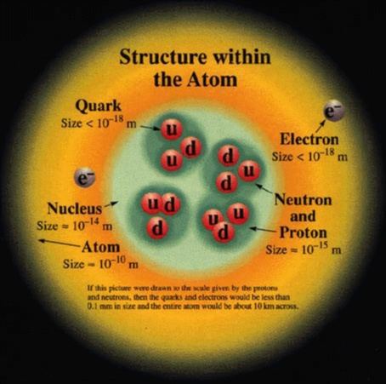
Atom and nucleus structure. Proton and neutron contain quarks.
At short distances, the nuclear force is stronger than the Coulomb force; it can overcome the Coulomb repulsion of protons inside the nucleus. However, the Coulomb force between protons has a much larger range and becomes the only significant force between protons when their separation exceeds about 2.5 fm.
The nuclear force is nearly independent of whether the nucleons are neutrons or protons. This property is called charge independence. It depends on whether the spins of the nucleons are parallel or antiparallel, and has a noncentral or tensor component. This part of the force does not conserve orbital angular momentum, which is a constant of motion under central forces.
The nuclear force (or nucleon-nucleon interaction or residual strong force) is the force between two or more nucleons. It is responsible for binding of protons and neutrons into atomic nuclei. To a large extent, this force can be understood in terms of the exchange of virtual light mesons, such as the pions. Sometimes the nuclear force is called the residual strong force, in contrast to the strong interactions which are now understood to arise from quantum chromodynamics (QCD). This phrasing arose during the 1970s when QCD was being established. Before that time, the strong nuclear force referred to the inter-nucleon potential. After the verification of the quark model, strong interaction has come to mean QCD.
A subatomic particle is an elementary or composite particle smaller than an atom. Particle physics and nuclear physics are concerned with the study of these particles, their interactions, and non-atomic matter.
Elementary particles are particles with no measurable internal structure; that is, they are not composed of other particles. They are the fundamental objects of quantum field theory. Many families and sub-families of elementary particles exist. Elementary particles are classified according to their spin. Fermions have half-integer spin while bosons have integer spin. All the particles of the Standard Model have been observed, with the exception of the Higgs boson
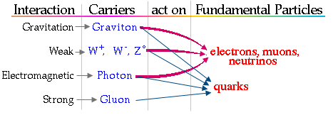
Interaction between fundamental particles.
Subatomic particles include the atomic constituents electrons, protons, and neutrons. Protons and neutrons are composite particles, consisting of quarks. A proton contains two up quarks and one down quark, while a neutron consists of one up quark and two down quarks; the quarks are held together in the nucleus by gluons. There are six different types of quark in all ('up', 'down', 'bottom', 'top', 'strange', and 'charm'), as well as other particles including photons and neutrinos which are produced copiously in the sun. Most of the particles that have been discovered are encountered in cosmic rays interacting with matter and are produced by scattering processes in particle accelerators. There are dozens of known subatomic particles.
4. Degenerate matter.
Degenerate matter is matter which has such very high density that the dominant contribution to its pressure rises from the Pauli exclusion principle. The pressure maintained by a body of degenerate matter is called the degeneracy pressure, and arises because the Pauli principle forbids the constituent particles to occupy identical quantum states. Any attempt to force them close enough together that they are not clearly separated by position must place them in different energy levels. Therefore, reducing the volume requires forcing many of the particles into higher-energy quantum states. This requires additional compression force, and is manifest as a resisting pressure.
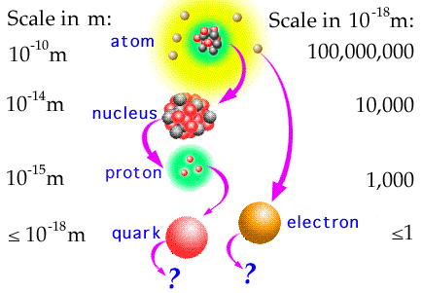
Size and scale of nucleus particles.
Degenerate matter still has normal thermal pressure, but at high densities the degeneracy pressure dominates. Thus, increasing the temperature of degenerate matter has a minor effect on total pressure until the temperature rises so high that thermal pressure again dominates total pressure.
Exotic examples of degenerate matter include neutronium, strange matter, metallic hydrogen and white dwarf matter. Degeneracy pressure contributes to the pressure of conventional solids, but these are not usually considered to be degenerate matter as a significant contribution to their pressure is provided by the interplay between the electrical repulsion of atomic nuclei and the screening of nuclei from each other by electrons allocated among the quantum states determined by the nuclear electrical potentials. In metals it is useful to treat the conduction electrons alone as a degenerate, free electron gas while the majority of the electrons are regarded as occupying bound quantum states. This contrasts with the case of the degenerate matter that forms the body of a white dwarf where all the electrons would be treated as occupying free particle momentum states.
Neutrons are the most "rigid" objects known - their Young modulus (or more accurately, bulk modulus) is 20 orders of magnitude larger than that of diamond.
For white dwarfs the degenerate particles are the electrons while for neutron stars the degenerate particles are neutrons. In degenerate gas, when the mass is increased, the pressure is increased, and the particles become spaced closer together, so the object becomes smaller. Degenerate gas can be compressed to very high densities, typical values being in the range of 10⁷ grams per cubic centimeter.
Preons are subatomic particles proposed to be the constituents of quarks, which become composite particles in preon-based models.
Summary:
Matter contains the molecules (10⁻⁹ m). Molecule contains the atoms (10⁻¹⁰ m). Atom has a nuclei (10⁻¹⁵ m) and electrons. A nucleus is composed bу protons and neutrons. Proton and neutron include quarks (10⁻¹⁸ m).
The forces which keep the protons and neutrons into nuclei are gigantic but short-acting. The forces which keep together quarks into sub-atomic particles are very large and increases via distance. Now we cannot separate the quarks into matter particles.
Chapter 3. Surprising properties of our Universe.
1. All World (Universe) in point, all time (Universe history) in moment.
Universe into Black Hole.
General notes. Light speed. In 1887 the experiment performed by scientists Albert Michelson and Edward Morley shows the light speed is the fast speed in the World and anything cannot have the speed more than 300,000 km/s. This fact creates the revolution in the physics. Based on this experiment Lorentz shows if the non-accelerating observer will measure the moving object the length and time in this body will be decreases and mass will be increases. In 1905 Einstein proposed that the speed of light in vacuum, measured by a non-accelerating observer, is independent of the motion of the source or observer. Using this and the principle of relativity as a basis he derived the special theory of relativity, in which the speed of light in vacuum c featured as a fundamental parameter, also appearing in contexts unrelated to light.
Light and all other electromagnetic radiation always travel at this speed in empty space (vacuum), regardless of the motion of the source or the inertial frame of the observer. Its value is exactly 299,792,458 metres per second (approximately 186,282 miles per second). In the theory of relativity, c connects space and time, and appears in the famous equation of mass–energy equivalence E = mc². The speed of light is the speed of all massless particles and associated fields in vacuum, and it is predicted by the current theory to be the speed of gravity and of gravitational waves and an upper bound on the speed at which energy, matter, and information can travel.
In most practical cases, light can be thought of as moving instantaneously, but for long distances and very sensitive measurements the finite speed of light can have noticeable effects. In communicating with distant space probes, it can take minutes to hours for the message to get from Earth to the satellite and back. The light we see from stars left them many (millions) years ago, allowing us to study the history of the universe by looking at distant objects. The finite speed of light also limits the theoretical maximum speed of computers, since information must be sent within the computer chips and from chip to chip. Finally, the speed of light can be used with time of flight measurements to measure large distances to high precision.
Albert Einstein postulated that the speed of light in vacuum was independent of the source or inertial frame of reference, and explored the consequences of that postulate deriving the theory of special relativity and showing that the parameter c had relevance outside of the context of light and electromagnetism. After centuries of increasingly precise measurements, in 1975 the speed of light was known to be 299,792,458 m/s with a relative measurement uncertainty of 4 parts per billion. In 1983, the metre was redefined in the International System of Units (SI) as the distance travelled by light in vacuum in ¹⁄_{299,792,458} of a second. As a result, the numerical value of c in metres per second is now fixed exactly by the definition of the metre.
Special relativity incorporates the principle that the speed of light is the same for all inertial observers regardless of the state of motion of the source.

This theory has a wide range of consequences which have been experimentally verified, including counter-intuitive ones such as length contraction, time dilation and relativity of simultaneity, contradicting the classical notion that the duration of the time interval between two events is equal for all observers. (On the other hand, it introduces the space-time interval, which is invariant.) Combined with other laws of physics, the two postulates of special relativity predict the equivalence of matter and energy, as expressed in the mass-energy equivalence formula E = mc², where c is the speed of light in a vacuum. The predictions of special relativity agree well with Newtonian mechanics in their common realm of applicability, specifically in experiments in which all velocities are small compared with the speed of light. Special relativity reveals that c is not just the velocity of a certain phenomenon—namely the propagation of electromagnetic radiation (light)—but rather a fundamental feature of the way space and time are unified as spacetime. One of the consequences of the theory is that it is impossible for any particle that has rest mass to be accelerated to the speed of light.
Lorentz transformation. In physics, the Lorentz transformation, named after the Dutch physicist Hendrik Lorentz, describes how, according to the theory of special relativity, two observers' varying measurements of space and time can be converted into each other's frames of reference. It reflects the surprising fact that observers moving at different velocities may measure different distances, elapsed times, and even different orderings of events.
The Lorentz transformation was originally the result of attempts by Lorentz and others to explain how the speed of light was observed to be independent of the reference frame, and to understand the symmetries of the laws of electromagnetism. Albert Einstein later re-derived the transformation from his postulates of special relativity. The Lorentz transformation supersedes the Galilean transformation of Newtonian physics, which assumes an absolute space and time. According to special relativity, this is a good approximation only at relative speeds much smaller than the speed of light.
The theory of special relativity shows: if we have the two systems (two observers) fixed and moving (′), the time, length and mass measured by observers of the first system (fixed) system in the second (moving) system will be different. The values in moving system (′) may be computed by equation (Lorentz transformation):
where l is length m; v is speed m/s, v < c; c ≈ 300,000 km/sec is speed m/s; ∆t is time sec; m is mass, kg.
As you see the distance in moving system decreases, the moving clock (in system (′)) runs slowly than in fixed system; the mass in moving system increases. The last fact is not surprised because the kinetic energy of the moving mass increases. But mass is promotional energy.
Lorentz thought that is only the mathematical transformation of system. Einstein believed that is reality. Many people and scientists did not believe in it, because it is out of our logic and Earth experience. However the later experiments showed Einstein was true.
Relative time and length of a moving object measured by motionless observer decreases up zero.
The mass of visible stars in Universe is about M = 1.7×10⁵³kg. That mass is only 0.5% from total mass (dark energy, dark matter, black hole, stars, free hydrogen, neutrino, etc.). The total mass of Universe is about 3.4×10⁵⁵ kg. The radius (event horizon) of Black Hole equals r = 1.5×10⁻²⁷ M = 1.5×10⁻²⁷×3.4×10⁵⁵ = 5.1×10²⁸ m. This radios is 100 ÷ 400 times more than a known radius of our Universe R = (1.2 ÷ 4.4) ×10²⁶ m. That means our Universe locates INSIDE the Universe Black Hole! From this follow: Our Universe is a closet system. The civilization of outer Universes can come to us, but we cannot pass go out; we cannot send an information to outer Universe.
Summary.
From these transformations follow the surprised results:
1) If the speed of astronaut aspires (seeks) to the light speed that the time (millions of years) aspires to a moment and the space (Universe) aspires to point.
In our Earth system the light from the far stars runs to us the millions of years. In the system of moving observer that may be some seconds and all stars will be neared.
Who had a small success in the school mathematics, must to remember the definition of an infinity value. That is value which is more any given numbers. But if you divide one (unit) by the infinite you get the zero or more exactly the magnitude is closed to zero or closed as possible.
2) Our Universe locates INSIDE the Universe Black Hole! The civilization of outer Universes can come to us, but we cannot pass go out.
2.Travel in Future
General notes. Time travel is the concept of moving between different points in time in a manner analogous to moving between different points in space, either sending objects (or in some cases just information) backwards in time to some moment before the present, or sending objects forward from the present to the future without the need to experience the intervening period (at least not at the normal rate).
Although time travel has been a common plot device in fiction since the 19th century, and one-way travel into the future is arguably possible given the phenomenon of time dilation based on velocity in the theory of special relativity (exemplified by the twin paradox), as well as gravitational time dilation in the theory of general relativity, it is currently unknown whether the laws of physics would allow backwards time travel.
Any technological device, whether fictional or hypothetical, that is used to achieve time travel is commonly known as a time machine.
Some interpretations of time travel also suggest that an attempt to travel backwards in time might take one to a parallel universe whose history would begin to diverge from the traveler's original history after the moment the traveler arrived in the past.
Some theories, most notably special and general relativity, suggest that suitable geometries of spacetime, or specific types of motion in space, might allow time travel into the past and future if these geometries or motions are possible. In technical papers, physicists generally avoid the commonplace language of "moving" or "traveling" through time ('movement' normally refers only to a change in spatial position as the time coordinate is varied), and instead discuss the possibility of closed timelike curves, which are worldlines that form closed loops in spacetime, allowing objects to return to their own past. There are known to be solutions to the equations of general relativity that describe spacetimes which contain closed timelike curves (such as Gödel spacetime), but the physical plausibility of these solutions is uncertain.
Relativity states that if one were to move away from the Earth at relativistic velocities and return, more time would have passed on Earth than for the traveler, so in this sense it is accepted that relativity allows "travel into the future" (according to relativity there is no single objective answer to how much time has 'really' passed between the departure and the return, but there is an objective answer to how much proper time has been experienced by both the Earth and the traveler, i.e. how much each has aged; twin paradox). On the other hand, many in the scientific community believe that backwards time travel is highly unlikely. Any theory which would allow time travel would require that problems of causality be resolved. The classic example of a problem involving causality is the "grandfather paradox": what if one were to go back in time and kill one's own grandfather before one's father was conceived? But some scientists believe that paradoxes can be avoided, either by appealing to the Novikov self-consistency principle or to the notion of branching parallel universes.
Stephen Hawking once suggested that the absence of tourists from the future constitutes an argument against the existence of time travel—a variant of the Fermi paradox. Of course this would not prove that time travel is physically impossible, since it might be that time travel is physically possible but that it is never in fact developed (or is cautiously never used); and even if it is developed, Hawking notes elsewhere that time travel might only be possible in a region of spacetime that is warped in the right way, and that if we cannot create such a region until the future, then time travelers would not be able to travel back before that date, so "This picture would explain why we haven't been over run by tourists from the future." Carl Sagan also once suggested the possibility that time travelers could be here, but are disguising their existence or are not recognized as time travelers.
There are various ways in which a person could "travel into the future" in a limited sense: the person could set things up so that in a small amount of his own subjective time, a large amount of subjective time has passed for other people on Earth. For example, an observer might take a trip away from the Earth and back at relativistic velocities, with the trip only lasting a few years according to the observer's own clocks, and return to find that thousands of years had passed on Earth. It should be noted, though, that according to relativity there is no objective answer to the question of how much time "really" passed during the trip; it would be equally valid to say that the trip had lasted only a few years or that the trip had lasted thousands of years, depending on your choice of reference frame.
This form of "travel into the future" is theoretically allowed (and has been demonstrated at very small time scales) using the following methods:
- Using velocity-based time dilation under the theory of special relativity, for instance:
  - Traveling at almost the speed of light to a distant star, then slowing down, turning around, and traveling at almost the speed of light back to Earth (the Twin paradox)
- Using gravitational time dilation under the theory of general relativity, for instance:
  - Residing inside of a hollow, high-mass object;
  - Residing just outside of the event horizon of a black hole, or sufficiently near an object whose mass or density causes the gravitational time dilation near it to be larger than the time dilation factor on Earth.
Additionally, it might be possible to see the distant future of the Earth using methods which do not involve relativity at all, although it is even more debatable whether these should be deemed a form of "time travel": Hibernation, Suspended animation .
  - Summary.
Follows from the above we can move in Future! But it will be REAL future. We cannot return in the present time. We will not useful the future generation. Our technology will be very old and bad for future people. Our information storages are developed well in present and future generation will know about our time more than we can save in our brain. Our unilateral relocation may be useful only for us. For example, the person is sick with an incurable disease, or he must die soon. In this case he wants to relocate in future because he hopes the future medicine cures him. Or he wants to know who will be his children, grandchildren, descendants, friends, or what it will be history of his country, Earth. Or how his ideas, theories, inventions will be developed and so on. There are persons who are freezing himself after dead. They hope the future medicine livens them and they continue their live.
But you must remember: that will be real future. You cannot to return in your previously life, you cannot change anything. You can only to regret about your wrong actions. Causality is the relationship between an event (the cause) and a second event (the effect), where the second event is a consequence of the first. There is law “Cause and Effect” in physics. The Effect cannot be early then Cause.
The reader can ask: how to relocate in future?
We must reach a very high speed for it, the speed closed to the light speed 300,000 km/s. The gigantic energy is needed for it. We need as minimum the generator which convert the matter to energy according the Einstein equation E = mc² and a photon rocket (see, for example, the author scientific work “Converting of Any Matter to Energy by-AB-Generator “
http://www.scribd.com/doc/24048466/ .
Production of this gigantic energy is impossible in the present time. The author offered the following way to reach temporary the speed closed to light speed. The space ship flights to the nearest Black Hole. The gravity of black hole accelerated the space ship to speed closed to 300,000 km/s. If trajectory designed correct, the space ship walks round the black hole in the hyperbolic trajectory and returns to start. The jump to future depends from the relativistic speed and from distance to the near black hole. The time of jump can be computed.
3. Law of existence the Universe. Aim of Universe. Purpose of Humanity
From this follows the possible Aim of Universe (Law of existence the Universe):
The Universe must create the Supreme Brain who will have enough knowledge for design the next Universe.
The Universe uses the intelligent civilizations for it. One makes the competition of them – who creates the first Supreme Mind. The other civilizations become the slaves of forward civilization as all Earth flora and fauna are used humanity for our needs.
From here follow the Purpose of Humanity: Mankind must be the first to create the Supreme Mind. Better if one Universe can pass the knowledge to Supreme Mind of next Universe. But as we know now the eventually recollapse in a Big Crunch, possibly starting a new universe in a Big Bounce (or next Big Bang) destroy the any information and Supreme Mind.

Chapter 4. What is God?
1. General notes. God.
God is the English name given to a singular being in theistic and deistic religions (and other belief systems) who is either the sole deity in monotheism, or a single deity in polytheism.
God is most often conceived of as the supernatural creator and overseer of the universe. Theologians have ascribed a variety of attributes to the many different conceptions of God. The most common among these include omniscience (infinite knowledge), omnipotence (unlimited power), omnipresence (present everywhere), omnibenevolence (perfect goodness), divine simplicity, and eternal and necessary existence.
God has also been conceived as being incorporeal (immaterial), a personal being, the source of all moral obligation, and the "greatest conceivable existent". These attributes were all supported to varying degrees by the early Jewish, Christian and Muslim theologian philosophers, including Maimonides, Augustine of Hippo, and Al-Ghazali, respectively. Many notable medieval philosophers and modern philosophers developed arguments for the existence of God. Many notable philosophers and intellectuals have, in contrast, developed arguments against the existence of God.
Conceptions of God vary widely. Theologians and philosophers have studied countless conceptions of God since the dawn of civilization. The Abrahamic conceptions of God include the monotheistic definition of God in Judaism, the trinitarian view of Christians, and the Islamic concept of God. The dharmic religions differ in their view of the divine: views of God in Hinduism vary by region, sect, and caste, ranging from monotheistic to polytheistic to atheistic; the view of God in Buddhism is almost non-theist. In modern times, some more abstract concepts have been developed, such as process theology and open theism. Conceptions of God held by individual believers vary so widely that there is no clear consensus on the nature of God. The contemporaneous French philosopher Michel Henry has however proposed a phenomenological approach and definition of God as phenomenological essence of Life.
2. Existence of God.
Many arguments which attempt to prove or disprove the existence of God have been proposed by philosophers, theologians, and other thinkers for many centuries. In philosophical terminology, such arguments concern schools of thought on the epistemology of the ontology of God.
There are many philosophical issues concerning the existence of God. Some definitions of God are sometimes nonspecific, while other definitions can be self-contradictory. Arguments for the existence of God typically include metaphysical, empirical, inductive, and subjective types, while others revolve around perceived holes in evolutionary theory and order and complexity in the world. Arguments against the existence of God typically include empirical, deductive, and inductive types. Conclusions reached include: "God does not exist" (strong atheism); "God almost certainly does not exist" (de facto atheism); "no one knows whether God exists" (agnosticism); "God exists, but this cannot be proven or disproven" (weak theism); and "God exists and this can be proven" (strong theism). There are numerous variations on these positions.
Some theologians, such as the scientist and theologian A.E. McGrath, argue that the existence of God cannot be adjudicated on for or against by using scientific method. Agnostic Stephen Jay Gould argues that science and religion are not in conflict and do not overlap. (Non-overlapping magisteria)
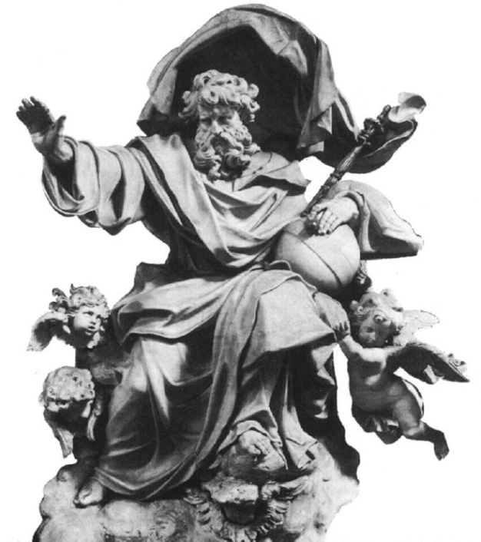 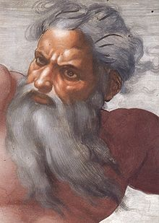
God. (Right) Detail of Sistine Chapel fresco Creation of the Sun and Moon by Michelangelo (c. 1512), a well known example of the depiction of God the Father in Western art.

As of 2000, approximately 53% of the world's population identifies with one of the three primary Abrahamic religions (33% Christian, 20% Islam, <1% Judaism), 6% with Buddhism, 13% with Hinduism, 6% with traditional Chinese religion, 7% with various other religions, and less than 15% as non-religious. Most of these religious beliefs involve a god or gods. (Other Abrahamic religions include Baha'i, Samaritanism, the Rastafari movement, Yazidism, and the Unification Church.).
Author is scientist. If God exists, any real scientists will study him. They will find the persuasive proofs of God existing, answers of questions: Who is he? Where is he located? What is he age? What is he power? And so on.
But no strong scientific arguments about existing of God. If God is powerful, what is his power?
For example, the man is God over ants. He can destroy anthill and kill all ants in given area. Or he can create the excellent conditions for living and flourish of ants. The author thinks, if God existed, one is Supreme Mind of previous Universe, who created our Universe and gives us possibility to create our own Supreme Mind (God) and continue existing of High Intellect. The live of Universe as life of any system is limited.
Chapter 5. What is Human Soul?
When the author debates about the electronic immortality, the religious people have trouble about soul. Let us to consider this problem.
1. General note. Soul.
A soul, in certain spiritual, philosophical, and psychological traditions, is the incorporeal essence of a person or living thing. Many philosophical and spiritual systems teach that humans are souls; some attribute souls to all living things and even to inanimate objects (such as rivers); this belief is commonly called animism. The soul is often believed to exit the body and live on after a person’s death, and some religions posit that God creates souls. The soul has often been deemed integral or essential to consciousness and personality, and soul sometimes functions as a synonym for spirit, mind or self, although the soul is said to function in a distinct enough way from both the spirit and the psyche that the terms should not be treated interchangeably.
2. Soul in religions.
Christian. The majority of Christians understand the soul as an ontological reality distinct from, yet integrally connected with, the body. Its characteristics are described in moral, spiritual, and philosophical terms. When people die their souls will be judged by God and determined to spend an eternity in heaven or in hell. Though all branches of Christianity –Catholics, Eastern Orthodox and Oriental Orthodox, Evangelical or mainline Protestants – teach that Jesus Christ plays a decisive role in the salvation process, the specifics of that role and the part played by individual persons or ecclesiastical rituals and relationships, is a matter of wide diversity in official church teaching, theological speculation and popular practice. Some Christians believe that if one has not repented of one's sins and trusted in Jesus Christ as Lord and Saviour, one will go to hell and suffer eternal separation from God. Variations also exist on this theme, e.g. some which hold that the unrighteous soul will be destroyed instead of suffering eternally (Annihilationism). Believers will inherit eternal life in heaven and enjoy eternal fellowship with God. There is also a belief that babies (including the unborn) and those with cognitive or mental impairments who have died will be received into heaven on the basis of God's grace through the sacrifice of Jesus.
Buddhism teaches that all things are in a constant state of flux: all is changing, and no permanent state exists by itself. This applies to human beings as much as to anything else in the cosmos. Thus, a human being has no permanent self. According to this doctrine of anatta (Pāli; Sanskrit: anātman) — "no-self" or "no soul" — the words "I" or "me" do not refer to any fixed thing. They are simply convenient terms that allow us to refer to an ever-changing entity.
Judaism. The Hebrew terms נפש nephesh, רוח ruach (literally "wind"), and נשימה neshama (literally "breath") are used to describe the soul or spirit. The soul is believed to be given by God to a person by his/her first breath, as mentioned in Genesis, "And the LORD God formed man [of] the dust of the ground, and breathed into his nostrils the breath of life; and man became a living soul." (Genesis 2:7). From this statement, the rabbinical interpretation is often that human embryos do not have souls, though abortion is often opposed by the orthodoxy as a form of birth control. Judaism relates the quality of one's soul to a one's performance of mitzvot and reaching higher levels of understanding, and thus closeness to God.
In Hinduism, the Sanskrit words most closely corresponding to soul are "Jeeva", "Atmaan" and "Purusha", meaning the individual Self. The term "soul" is misleading as it implies an object possessed, whereas Self signifies the subject which perceives all objects. This self is held to be distinct from the various mental faculties such as desires, thinking, understanding, reasoning and self-image (ego), all of which are considered to be part of Prakriti (nature).
Islam. Allah narrated in Quran "And they ask you (O Muhammad SAW) concerning the Ruh (the Spirit); Say: The Ruh (the Spirit): is the AMAR of your Creator. And of knowledge, you (mankind) have been given only a little." (Noble Quran, Surat Al 'Isra', Verse 85).
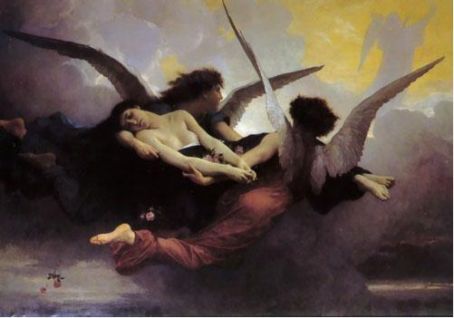
Soul carried to Heaven by William Bouguereau
Further in Quraan the definition of "Amar" is "And the AMAR of your Creator is such that when it intends for something to happen, it says 'Let it be' then it is done".
Combining the two verses; Ruh (soul, spirit) is that creation of Allah, which has the knowledge and authority to use that knowledge.
The definition of that knowledge is also given in Quran, surah 'Al-Baqrah' Chapter 2, verse 31 - 32, when Allah tells angels about the creation of the first soul, Adam. "That I want to appoint a representative on the Earth" (Chapter 2, verse 31)... further Allah says "And we gave him the knowledge of the all the attributes" (Chapter 2, verse 32)
Now this verse explains very clearly about the importance of Soul (Ruh). It has the knowledge of all the attributes that Allah wanted to be revealed; and since we know that a portion of infinity is also an infinity, therefore that knowledge is also boundless. And all this is present in soul, the real human being. Without which the physical body is nothing. Physical body is similar to our clothes; when the soul puts it off, it is useless. Hence, it is the soul which is the real you and me, the physical body is just a clothing.
Science and medicine seek naturalistic accounts of the observable natural world. This stance is known as methodological naturalism. Much of the scientific study relating to the soul has involved investigating the soul as an object of human belief, or as a concept that shapes cognition and an understanding of the world, rather than as an entity in and of itself.

Summary
In author opinion, the soul is only the knowledge stored in our brain (see Part 2 in this book). More than 99% of them is the permanent knowledge about our own history (all that we have seen, heard, spoken, felling, active), knowledge received in school, collage, university, from books, TV, radio, and so on. Very small part (less 1%) is variable our own opinion about people or their actions. That part is changed from new our knowledge, information and situation.
Most information is received our brain from our sensory organs: eyes, ears, tongue, skin, muscles. These information may be easy intercepted the current sensors, written and stored by current electronic devices. That means our soul may be written and safe the very long time. That may be loaded in new electronic chips (brain). If this electronic brain is provided the sensors: micro-video camera, microphone, audio speaker, TV screen, and the executive bodies: artificial legs, arms, we get the immortality man (E-being) who continue the life of the real man and will have his initial soul (see Part 2).

This artificial man will have the gigantic advantages over his ancestor. He will not need a foot, sleep, housing. He can live in space and an ocean bottom, travel to other planet by a laser beam with light speed, and indestructible any weapon because he will save himself in special storage and restore himself in any time (see Part 2).

This situation is well described in beautiful fiction book “Price of Immortality” by Igor Getmansky (Moscow, ЭКСМО, 2003). Unfortunately this book is published in Russian.
More detail description of human soul is in the old author article “Science, Soul, Paradise, and Artificial Intelligence” (1999) in Part 2 of the given book.

Chapter 6. What is “I” ? What are “We” ?
1. Individual (person)
A person (from Latin: persona, meaning "mask") is most broadly defined as any individual self-conscious or rational being, or any entity having rights and duties; or often more narrowly defined as an individual human being in particular.
The direct plural of "person" is "persons." The term people is the general plural of "person," and is used to refer to several persons plurally in a range from 'a few people' up to 'all people'. "People" is often used to refer to an entire nation or ethnic group, and in this context "people" can be used as a singular to refer to specific ethnic or national groups (i.e. "a people").
The term personhood refers to the state or condition of being an individual person, the essential meaning and constituent properties of what it is to be a person.
While in common parlance "person" and "human" are effectively synonyms, specific fields such as philosophy, law, and others, use the term with specialised context-specific meanings.
In philosophy, "person" may apply to any human or non-human agent who is regarded as self-conscious and capable of certain kinds of higher-level thought; for example, individuals who have the power to reflect upon and choose their actions.
Boethius gives the definition of "person" as "an individual substance of a rational nature" ("Naturæ rationalis individua substantia").
Peter Singer defines “person” simply as being a conscious thinking being. He also notes that a person must know that they are a person (Self-awareness).
Philosopher Thomas I. White argues that the criteria for a person are as follows: (1) is alive, (2) is aware, (3) feels positive and negative sensations, (4) has emotions, (5) has a sense of self, (6) controls its own behaviour, (7) recognises other persons and treats them appropriately, and (8) has a variety of sophisticated cognitive abilities. While many of White's criteria are somewhat anthropocentric, some animals such as dolphins would still be considered persons.
Various specific philosophical debates focus on questions about the personhood of different classes of entities.
Some philosopher and those involved in animal welfare, ethology, animal rights and related subjects, consider that certain animals should also be granted personhood. Commonly named species in this context include the great apes, cetaceans, and elephants, because of their apparent intelligence and intricate social rules. The idea of extending personhood to all animals has the support of legal scholars such as Alan Dershowitz and Laurence Tribe of Harvard Law School, and animal law courses are now taught in 92 out of 180 law schools in the United States. On May 9, 2008, Columbia University Press published Animals as Persons: Essays on the Abolition of Animal Exploitation by Professor Gary L. Francione of Rutgers University School of Law, a collection of writings that summarizes his work to date and makes the case for non-human animals as persons.
On the other hand, some proponents of human exceptionalism (also referred to by its critics as speciesism) have countered that we must institute a strict demarcation of personhood based on species membership in order to avoid the horrors of genocide (based on propaganda dehumanizing one or more ethnicities) or the injustices of forced sterilization (as occurred in many countries to people with low I.Q. scores and prisoners).
Hypothetical beings. Speculatively, there are several other likely categories of beings where personhood might be at issue.

Artificial life. If artificial intelligences, intelligent and self-aware system of hardware and software, are eventually created, what criteria would be used to determine their personhood? Likewise, at what point might human-created biological life be considered to have achieved personhood?
2. Intelligence.
Intelligence is an umbrella term describing a property of the mind including related abilities, such as the capacities for abstract thought, understanding, communication, reasoning, learning, learning from past experiences, planning, and problem solving.
Intelligence is most widely studied in humans, but is also observed in animals and plants.
Artificial intelligence is the intelligence of machines or the simulation of intelligence in machines.
Numerous definitions of and hypotheses about intelligence have been proposed since before the twentieth century, with no consensus yet reached by scholars. Within the discipline of psychology, various approaches to human intelligence have been adopted, with the psychometric approach being especially familiar to the general public. Influenced by his cousin Charles Darwin, Francis Galton was the first scientist to propose a theory of general intelligence; that intelligence is a true, biologically-based mental faculty that can be studied by measuring a person's reaction times to cognitive tasks. Galton's research in measuring the head sizes of British scientists and laymen led to the conclusion that head-size is unrelated to a person's intelligence.
Alfred Binet, and the French school of intelligence, believed intelligence was an aggregate of dissimilar abilities, not a unitary entity with specific, identifiable properties.
Animal and plant intelligence. Although humans have been the primary focus of intelligence researchers, scientists have also attempted to investigate animal intelligence, or more broadly, animal cognition. These researchers are interested in studying both mental ability in a particular species, and comparing abilities between species. They study various measures of problem solving, as well as mathematical and language abilities. Some challenges in this area are defining intelligence so that it means the same thing across species (e.g. comparing intelligence between literate humans and illiterate animals), and then operationalizing a measure that accurately compares mental ability across different species and contexts.
Wolfgang Köhler's pioneering research on the intelligence of apes is a classic example of research in this area. Stanley Coren's book, The Intelligence of Dogs is a notable popular book on the topic. Nonhuman animals particularly noted and studied for their intelligence include chimpanzees, bonobos (notably the language-using Kanzi) and other great apes, dolphins, elephants and to some extent parrots and ravens. Controversy exists over the extent to which these judgments of intelligence are accurate.
Cephalopod intelligence also provides important comparative study. Cephalopods appear to exhibit characteristics of significant intelligence, yet their nervous systems differ radically from those of most other notably intelligent life-forms (mammals and birds).
It has been argued that plants should also be classified as being intelligent based on their ability to sense the environment and adjust their morphology, physiology and phenotype accordingly.
3. Artificial intelligence
Artificial intelligence (or AI) is both the intelligence of machines and the branch of computer science which aims to create it, through "the study and design of intelligent agents" or "rational agents", where an intelligent agent is a system that perceives its environment and takes actions which maximize its chances of success. Achievements in artificial intelligence include constrained and well-defined problems such as games, crossword-solving and optical character recognition. General intelligence or strong AI has not yet been achieved and is a long-term goal of AI research.
Among the traits that researchers hope machines will exhibit are reasoning, knowledge, planning, learning, communication, perception, and the ability to move and manipulate objects.
The Turing test is a test of a machine's ability to demonstrate intelligence. It proceeds as follows: a human judge engages in a natural language conversation with one human and one machine, each of which tries to appear human. All participants are placed in isolated locations. If the judge cannot reliably tell the machine from the human, the machine is said to have passed the test. In order to test the machine's intelligence rather than its ability to render words into audio, the conversation is limited to a text-only channel such as a computer keyboard and screen.
The test was introduced by Alan Turing in his 1950 paper Computing Machinery and Intelligence, which opens with the words: "I propose to consider the question, 'Can machines think?'" Since "thinking" is difficult to define, Turing chooses to "replace the question by another, which is closely related to it and is expressed in relatively unambiguous words." Turing's new question is: "Are there imaginable digital computers which would do well in the [Turing test]"? This question, Turing believed, is one that can actually be answered. In the remainder of the paper, he argued against all the major objections to the proposition that "machines can think".
The Loebner Prize is an annual competition in artificial intelligence that awards prizes to the chatterbot considered by the judges to be the most human-like. The format of the competition is that of a standard Turing test. A human judge poses text questions to a computer program and a human being via computer. Based upon the answers, the judge must decide which is which. In 2008 a variety of judges, including experts and non-experts, adults and children, native and non-native English speakers participated in the University of Reading hosted contest.
The contest began in 1990 by Hugh Loebner in conjunction with the Cambridge Center for Behavioral Studies, Massachusetts, United States. It has since been associated with Flinders University, Dartmouth College, the Science Museum in London, and most recently the University of Reading. In 2004 and 2005, it was held in Loebner's apartment in New York City.
Within the field of artificial intelligence, the Loebner Prize is somewhat controversial; the most prominent critic, Marvin Minsky, has called it a publicity stunt that does not help the field along.
In addition, the time limit of 5 minutes and the use of untrained/unsophisticated interrogator/judges has resulted in some wins that may be due to trickery rather than to plausible intelligence, as one can judge from transcripts of winning conversations (linked below).
]Prizes. Originally, $2,000 was awarded for the most human-seeming chatterbot in the competition. The prize was $3,000 in 2005 and $2,250 in 2006. In 2008, $3,000 was awarded.
In addition, there are two one-time-only prizes that have never been awarded. $25,000 is offered for the first chatterbot that judges cannot distinguish from a real human and which can convince judges that the human is the computer program. $100,000 is the reward for the first chatterbot that judges cannot distinguish from a real human in a Turing test that includes deciphering and understanding text, visual, and auditory input. Once this is achieved, the annual competition will end.
Winners the Lobster competition
2005 | Rollo Carpenter | George
2006 | Rollo Carpenter | Joan
2007 | Robert Medeksza | Ultra Hal
2008 | Fred Roberts | Elbot
2009 | David Levy | Do-Much-More
2010 | Bruce Wilcox | Suzette
4. Artificial Intelligence as a person.
We can convert the AI or E-being (see Part 2) to person if they will have certain properties. The need properties of artificial and E-beings are following (Three laws of E-being):
1. One must identify self as a person (storage of self information, brain (computer chips),
the sensors of information, the executive bodies).
2. One must defense himself and his existing by any methods.
3. One must have a main purpose: increasing his power, became the strongest in the World
by the production of the new knowledge and himself.
The people can afraid the last request. But without it the E-being will be only the slaves of people and little useful in the science and technological progress. If the people for getting immortality will be transferred into E-being, they will be requesting the equals right with the biological people.
The ethics of artificial intelligence addresses a number of moral and legal issues which arise if researchers are able to build machines with intellectual capacities that rival human beings.
It considers the unexpected consequences, dangers and potential misuse of the technology. It also considers the ways in which artificial intelligence may be used to benefit humanity. These concerns are similar to those that arise for any sufficiently powerful technology and (for these issues) the ethics of artificial intelligence is a part of a larger discussion of the ethics of technology.
The issue of robot rights is unique to artificial intelligence. A.I. may have the ability to one day create sentient creatures—that is, creatures which feel pleasure and pain—which may therefore deserve the same rights as human beings.
5. Robots
A robot is a virtual or mechanical artificial agent. In practice, it is usually an electro-mechanical machine which is guided by computer or electronic programming, and is thus able to do tasks on its own. Another common characteristic is that by its appearance or movements, a robot often conveys a sense that it has intent or agency of its own.

Dirty, dangerous, dull or inaccessible tasks. There are many jobs which humans would rather leave to robots. The job may be boring, such as domestic cleaning, or dangerous, such as exploring inside a volcano. Other jobs are physically inaccessible, such as exploring another planet, cleaning the inside of a long pipe, or performing laparoscopic surgery.
Space probes. Almost every unmanned space probe ever launched was a robot. Some were launched in the 1960s with more limited abilities, but their ability to fly and to land (in the case of Luna 9) is an indication of their status as a robot. This includes the Voyager probes and the Galileo probes, as well as other probes.
Telerobots .When a human cannot be present on site to perform a job because it is dangerous, far away, or inaccessible, teleoperated robots, or telerobots are used. Rather than following a predetermined sequence of movements, a telerobot is controlled from a distance by a human operator. The robot may be in another room or another country, or may be on a very different scale to the operator. For instance, a laparoscopic surgery robot allows the surgeon to work inside a human patient on a relatively small scale compared to open surgery, significantly shortening recovery time. When disabling a bomb, the operator sends a small robot to disable it. Several authors have been using a device called the Longpen to sign books remotely.
Teleoperated robot aircraft, like the Predator Unmanned Aerial Vehicle, are increasingly being used by the military. These pilotless drones can search terrain and fire on targets. Hundreds of robots such as iRobot's Packbot and the Foster-Miller TALON are being used in Iraq and Afghanistan by the U.S. military to defuse roadside bombs or Improvised Explosive Devices (IEDs) in an activity known as explosive ordnance disposal (EOD).
Automated fruit harvesting machines. Used to pick fruit on orchards at a cost lower than that of human pickers.
In the home. As prices fall and robots become smarter and more autonomous, simple robots dedicated to a single task work in over a million homes. They are taking on simple but unwanted jobs, such as vacuum cleaning and floor washing, and lawn mowing. Some find these robots to be cute and entertaining, which is one reason that they can sell very well.
Home automation for the elderly and disabled . The population is aging in many countries, especially Japan, meaning that there are increasing numbers of elderly people to care for, but relatively fewer young people to care for them. Humans make the best careers, but where they are unavailable, robots are gradually being introduced.
Military robots. Military robots include the SWORDS robot which is currently used in ground-based combat. It can use a variety of weapons and there is some discussion of giving it some degree of autonomy in battleground situations.
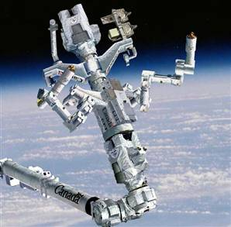 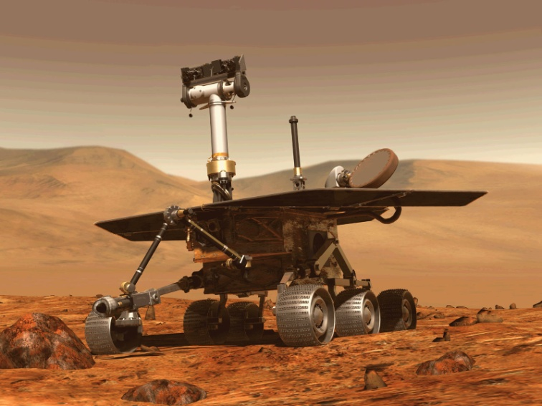
Left. Space Robot – manipulator of Shuttle. Right. Mars robot. Credit NASA.
Unmanned combat air vehicles (UCAVs), which are an upgraded form of UAVs, can do a wide variety of missions, including combat. UCAVs are being designed such as the Mantis UCAV which would have the ability to fly themselves, to pick their own course and target, and to make most decisions on their own. The AAAI has studied this topic in depth and its president has commissioned a study to look at this issue.
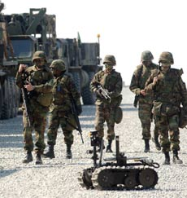 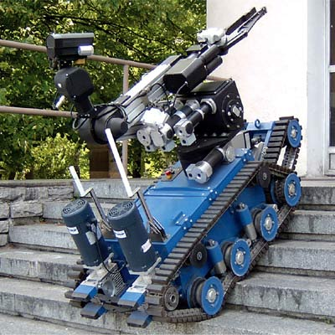
^{Military Robots}
Some have suggested a need to build "Friendly AI", meaning that the advances which are already occurring with AI should also include an effort to make AI intrinsically friendly and humane. Several such measures reportedly already exist, with robot-heavy countries such as Japan and South Korea having begun to pass regulations requiring robots to be equipped with safety systems, and possibly sets of 'laws' akin to Asimov's Three Laws of Robotics. An official report was issued in 2009 by the Japanese government's Robot Industry Policy Committee. Chinese officials and researchers have issued a report suggesting a set of ethical rules, as well as a set of new legal guidelines referred to as "Robot Legal Studies." Some concern has been expressed over a possible occurrence of robots telling apparent falsehoods.
Nanorobotics is the still largely hypothetical technology of creating machines or robots at or close to the scale of a nanometer (10⁻⁹ meters). Also known as nanobots or nanites, they would be constructed from molecular machines. So far, researchers have mostly produced only parts of these complex systems, such as bearings, sensors, and Synthetic molecular motors, but functioning robots have also been made such as the entrants to the Nanobot Robocup contest. Researchers also hope to be able to create entire robots as small as viruses or bacteria, which could perform tasks on a tiny scale. Possible applications include micro surgery (on the level of individual cells), utility fog, manufacturing, weaponry and cleaning. Some people have suggested that if there were nanobots which could reproduce, the earth would turn into "grey goo", while others argue that this hypothetical outcome is nonsense.
A humanoid robot is a robot with its overall appearance, based on that of the human body, allowing interaction with made-for-human tools or environments. In general humanoid robots have a torso with a head, two arms and two legs, although some forms of humanoid robots may model only part of the body, for example, from the waist up. Some humanoid robots may also have a 'face', with 'eyes' and 'mouth'. Androids are humanoid robots built to aesthetically resemble a human.
An android is a robot or synthetic organism designed to look and act like a human. "Gynoid" is the feminine form, although "android" is used almost universally to refer to both. Until recently, androids have largely remained within the domain of science fiction, frequently seen in film and television.
 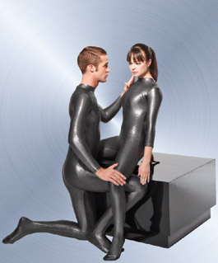 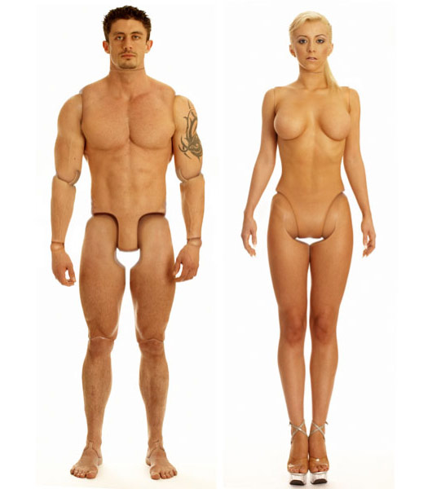
Humanoid robots

Prospective Robotics Timeline
- Robots capable of manual labour tasks--
  - 2009 - robots that perform searching and fetching tasks in unmodified library environment, Professor Angel del Pobil (University Jaume I, Spain), 2004
  - 2015-2020 - every South Korean household will have a robot and many European, The Ministry of Information and Communication (South Korea), 2007.
  - 2018 - robots will routinely carry out surgery, South Korea government 2007.
  - 2022 - intelligent robots that sense their environment, make decisions, and learn are used in 30% of households and organizations – TechCast.
  - 2030 - robots capable of performing at human level at most manual jobs Marshall Brain.
  - 2034 - robots (home automation systems) performing most household tasks, Helen Greiner, Chairman of iRobot.
- Military robots
  - 2015 - one third of US fighting strength will be composed of robots - US Department of Defense, 2006.
  - 2035 - first completely autonomous robot soldiers in operation - US Department of Defense, 2006.
  - 2038 - first completely autonomous robot flying car in operation - US Department of Technology, 2007.
- Developments related to robotics from the Japan NISTEP 2030 report :
  - 2013-2014 — agricultural robots (AgRobots).
  - 2013-2017 — robots that care for the elderly
  - 2017 — medical robots performing low-invasive surgery
  - 2017-2019 — household robots with full use.
  - 2019-2021 — Nanorobots
  - 2021-2022 — Transhumanism
The ethics of artificial intelligence addresses a number of moral and legal issues which arise if researchers are able to build machines with intellectual capacities that rival human beings.
It considers the unexpected consequences, dangers and potential misuse of the technology. It also considers the ways in which artificial intelligence may be used to benefit humanity. These concerns are similar to those that arise for any sufficiently powerful technology and (for these issues) the ethics of artificial intelligence is a part of a larger discussion of the ethics of technology.
Legal rights for robots. According to research commissioned by the UK Office of Science and Innovation's Horizon Scanning Centre , robots could one day demand the same citizen's rights as humans. The study also warns that the rise of robots could put a strain on resources and the environment.
Chapter 7. People Emotions, Happiness, Pleasure.
1. Emotions.
Emotion is the complex psychophysiological experience of an individual's state of mind as interacting with biochemical (internal) and environmental (external) influences. In humans, emotion fundamentally involves "physiological arousal, expressive behaviors, and conscious experience". Emotion is associated with mood, temperament, personality and disposition, and motivation.
No definitive taxonomy of emotions exists, though numerous taxonomies have been proposed. Some categorizations include:
- 'Cognitive' versus 'non-cognitive' emotions
- Instinctual emotions (from the amygdala), versus cognitive emotions (from the prefrontal cortex).
- Categorization based on duration: Some emotions occur over a period of seconds (for example, surprise), whereas others can last years (for example, love).
A related distinction is between the emotion and the results of the emotion, principally behaviors and emotional expressions. People often behave in certain ways as a direct result of their emotional state, such as crying, fighting or fleeing. If one can have the emotion without the corresponding behavior, then we may consider the behavior not to be essential to the emotion. Neuroscientific research suggests there is a "magic quarter second" during which it's possible to catch a thought before it becomes an emotional reaction. In that instant, one can catch a feeling before allowing it to take hold.
In the 2000s, research in computer science, engineering, psychology and neuroscience has been aimed at developing devices that recognize human affect display and model emotions. In computer science, affective computing is a branch of the study and development of artificial intelligence that deals with the design of systems and devices that can recognize, interpret, and process human emotions. It is an interdisciplinary field spanning computer sciences, psychology, and cognitive science. While the origins of the field may be traced as far back as to early philosophical enquiries into emotion, the more modern branch of computer science originated with Rosalind Picard's 1995 paper on affective computing. Detecting emotional information begins with passive sensors which capture data about the user's physical state or behavior without interpreting the input. The data gathered is analogous to the cues humans use to perceive emotions in others. Another area within affective computing is the design of computational devices proposed to exhibit either innate emotional capabilities or that are capable of convincingly simulating emotions. Emotional speech processing recognizes the user's emotional state by analyzing speech patterns. The detection and processing of facial expression or body gestures is achieved through detectors and sensors.
In my opinion, emotion is the subconscious estimation by person the external circumstances and their influence in his life.
Robert Plutchik created a wheel of emotions in 1980 which consisted of 8 basic emotions and 8 advanced emotions each composed of 2 basic ones.
Basic emotion | Basic opposite
Joy | Sadness
Trust | Disgust
Fear | Anger
Surprise | Anticipation
Sadness | Joy
Disgust | Trust
Anger | Fear
Anticipation | Surprise
Some human emotions.
Affection  Anger  Annoyance  Angst  Apathy  Anxiety  Awe  Contempt  Curiosity  Depression | Desire  Despair  Disappointment  Disgust  Ecstasy  Empathy  Envy  Embarrassment  Euphoria  Fear | Frustration  Gratitude  Grief  Guilt  Happiness  Hatred  Hope  Horror  Hostility  Hysteria | Interest  Jealousy  Joy  Loathing  Love  Lust  Misery  Pity  Pride  Rage | Regret  Remorse  Sadness  Shame  Shyness  Sorrow  Suffering  Surprise  Wonder  Worry

Emotion in animals. There is no scientific consensus on emotion in animals, that is, what emotions certain species of animals, including humans, feel. The debate concerns primarily mammals and birds, although emotions have also been postulated for other vertebrates and even for some invertebrates.
Animal lovers, scientists, philosophers, and others who interact with animals, have suggested answers but the core question has proven difficult to answer since animals cannot speak of their experience. Society recognizes animals can feel pain as is demonstrated by the criminalization of animal cruelty. Animal expressions of apparent pleasure are ambiguous as to whether this is emotion, or simply innate responses, perhaps for approval or other hard-wired cues. The ambiguity is a source of controversy as there is no certainty which views, if any, reflect reality. That said, extreme behaviourists would say that human "feeling" is also merely a hard-wired response to external stimuli.
In recent years, research has become available which expands prior understandings of animal language, cognition and tool use, and even sexuality. Emotions arise in the mammalian brain, or the limbic system, which human beings share in common with other mammals as well as many other species.

2.Happiness.
Happiness is a state of mind or feeling characterized by contentment, love, satisfaction, pleasure, or joy. A variety of biological, psychological, religious, and philosophical approaches have striven to define happiness and identify its sources.
While direct measurement of happiness presents challenges, tools such as The Oxford Happiness Questionnaire have been developed by researchers. Positive psychology researchers use theoretical models that include describing happiness as consisting of positive emotions and positive activities, or that describe three kinds of happiness: pleasure, engagement, and meaning.
Research has identified a number of attributes that correlate with happiness: relationships and social interaction, extraversion, marital status, employment, health, democratic freedom, optimism, endorphins released through physical exercise and eating chocolate, religious involvement, income and proximity to other happy people. Happiness is mediated through the release of so-called happiness hormones.
Philosophers and religious thinkers often define happiness in terms of living a good life, or flourishing, rather than simply as an emotion. Happiness in this older sense was used to translate the Greek Eudaimonia, and is still used in virtue ethics.

The smiley face is a well-known symbol of happiness
Happiness economics suggests that measures of public happiness should be used to supplement more traditional economic measures when evaluating the success of public policy.
There is now extensive research suggesting that religious people are happier and less stressed. It is not clear, however, whether this is because of the social contact and support that result from religious activities, the greater likelihood of behaviors related to good health (such as less substance abuse), indirect forms of psychological and social activity such as optimism and volunteering, psychological factors such as "reason for being," learned coping strategies that enhance one's ability to deal with stress, or some combination of these and/or other factors.
3. Pleasure
Pleasure describes the broad class of mental states that humans and other animals experience as positive, enjoyable, or worth seeking. It includes more specific mental states such as happiness, entertainment, enjoyment, ecstasy, and euphoria. In psychology, the pleasure principle describes pleasure as a positive feedback mechanism, motivating the organism to recreate in the future the situation which it has just found pleasurable. According to this theory, organisms are similarly motivated to avoid situations that have caused pain in the past.
The experience of pleasure is subjective and different individuals will experience different kinds and amounts of happiness in the same situation. Many pleasurable experiences are associated with satisfying basic biological drives, such as eating, exercise or sex. Other pleasurable experiences are associated with social experiences and social drives, such as the experiences of accomplishment, recognition, and service. The appreciation of cultural artifacts and activities such as art, music, and literature is often pleasurable.
Recreational drug use can be pleasurable: some drugs, illicit and otherwise, directly create euphoria in the human brain when ingested. The mind's natural tendency to seek out more of this feeling (as described by the pleasure principle) can lead to dependence and addiction.

Philosophies of pleasure. Utilitarianism and Hedonism are philosophies that advocate increasing to the maximum the amount of pleasure and minimizing the amount of suffering. Examples of such philosophies are some of Freud's theories of human motivation that have been called psychological hedonism; his "life instinct" is essentially the observation that people will pursue pleasure.

Neurobiology. The pleasure center is the set of brain structures, predominantly the nucleus accumbens, theorized to produce great pleasure when stimulated electrically. Some references state that the septum pellucidium is generally considered to be the pleasure center, while others mention the hypothalamus when referring to the pleasure center for intracranial stimulation. Certain chemicals are known to stimulate the pleasure centers of the brain. These include dopamine and various endorphins. It has been specifically stated that physical exertion can release endorphines in what is called the runner's high, and equally it has been found that chocolate and certain spices, such as from the family of the chilli, can release or cause to be released similar psychoactive chemicals to those released during sexual acts.
Summary
In my opinion, emotion is the subconscious estimation of person (creature) to circumstances (information) and their influence on his life.
From this point of view:
- Joy is waiting (or performance) to improve living conditions or pleasure;
- Grief a significant deterioration or failure, the collapse of hopes for a significant
improvement of living conditions or pleasure;
- Fear is the lack of information in life-threatening situation, an impossible position;
- Rage is a mobilization of all forces of the organism to defend its existence;
etc.
Emotions are manifested at the human face and human behavior. They provide important for robots and creatures having artificial intelligence to the average person psychologically perceive them as reasonable beings.

Theory of emotions is developing the Russian scientist, professor Oleg G. Pensky. The interested reader finds it in his monograph “Mathematical Models of Emotional Robots”, Perm, 2010, 193 ps in English and Russian (http://arxiv.org/ftp/arxiv/papers/1011/1011.1841.pdf ), and in his book “Fundamentals of Mathematical Theory of Emotional Robots “, (http://www.scribd.com/doc/40640088/).

Part 2
Human immortality and future human evaluation.

Preface
Below the reader finds the author's articles published in previous years on the problems of immortality and human evaluation. Author's opinion on some issues has changed somewhat over the past 20 years, but on major issues, it remained the same.
The Chapter 1
The Advent of the Non-Biological Civilization (1993)
Summary
The author writes about the danger which threatens humanity in the near future, approximately 20-30 years from now. This is not a worldwide nuclear war, a collision with comets, AIDS or some other ghastly disease that we may not even know may be lurking out there (think of the recent Ebola scare or the so-called "flesh-eating" virus). In each of these cases there is still hope that somebody will be saved and that life will be born anew, albeit in a misshapen form and in an inferior stage of development. But we cannot hope for salvation in the author's grim scenario. The danger he writes of will destroy all humanity and all biological life on Earth -- and there is nothing we can do to prevent this! Should we be frightened by this? Is it good or evil for human civilization? Will people awake to find they are only a small step away from the Supreme Intellect, or in other words, to God? And what will be after us?
These and other questions are discussed in this chapter.
The Law of Increasing Complexity
The World, Nature, Techniques consist of biological or technical systems. These systems have a different rate (degree) of complexity. The main distinction biological systems from technical systems is the ability for unlimited self-propagation, or reproduction.
Any system which has possesses this attribute becomes viable, stable, and fills all possible space. It will continue to exist as long as the conditions which gave birth to them cease to change greatly.
Here there is no violation of the entropy law. When the complexity of one system increases, the complexity of other systems decreases.
A more complicated system can be created by using less complicated systems as a base for its development. Such a complex system is a system of the secondary degree of complexity. It increases its own complexity by decreasing the rate of complexity of inferior systems or by destroying them altogether.
Using low degree systems as a base, systems of the second, third, fourth, fifth et cetera levels can be created. Some of the lower levels may not survive and disappear. This, however, is of no great concern because these lower level systems already fulfilled their historical mission by spawning ever more complicated levels.
A necessary condition for the existence of complicated level systems is the ability of inferior systems to reproduce and give birth to other systems, and to do it without limits before they fill in an admissible space and reach their maximum physical boundaries.
This I assert to be the Fundamental Base Law of Nature, the very purpose for the existence of Nature. This Law can be stated as follows:
The Law of increasing complexity of self-coping systems.
The history of life on Earth confirms this law. Following the law of probability, organic molecules appeared in prehistoric time when the external conditions for their existence were favorable. Those molecules which had the ability to reproduce filled in the available space. Using them as a base, microorganisms then appeared. These could absorb the organic and inorganic substances and reproduce themselves. Microorganisms as a base in turn gave rise to vegetation which provided food for the next level of animals, which in turn spawned the beasts of prey who devoured other animals. At the present time Man is at the acme top of this pyramid. The human brain can outperform the brains of other animals including man's nearest ancestors, the apes. Man began to use for its development all previous levels as well as the zero level -- lifeless nature.
The Birth of the Electronic Civilization
Only Man's brain has the ability to think abstractly and to make mechanical devices and machines which increase productivity. Such attributes allow us to confirm that humanity is the next level of the biological world. But in our headlong progress during the current century (aviation, space, nuclear energy, and so on.), we have failed to notice that Man has also given birth to the new top level of complex systems or of reasonable civilization, which is based on an electronic not biological basis. I am speaking of electronic computers. The first models were designed at the end of the 1940s.
In the past fifty years, roughly four generations, the field of electronics has developed at an extremely fast pace. The first generation of computers were based on electronic tubes, the second generation on transistors, the third generation on chips, and the fourth generation on very tiny chips which contain thousands and tens of thousands of microelements. The first computers had a speed of computation less then 100 operations per second and a memory of less than one thousand bits (a bit is the simplest unit of information, which contains 0 or 1). For example, the first electronic calculator (SSEC), designed by IBM in 1948, had 23,000 relays, 13,000 vacuum tubes and the capacity to make one multiplication per second.
At the present time the speed of the fourth generation of computers which uses integrated circuits is approximately a billion operations per second. For example, the American computer Cray J90 has up to 3.2 gigaflops of power and 4 gigabytes of memory (one byte equals eight bits). The memory of a laser (compact) disk has several billion bits. Every 3-5 years computer speed and memory doubles, while at the same time their size is halved. Over the past fifty years computer speed and memory have increased a million times. Whereas the first computer required a room 100 square meters (1000 sq. feet) in size, the modern notebook computer is carried in a case. The CPU (Central Processing Unit) chip of a personal computer is no larger than a fingernail and is capable of making more 100 million operations per second!
The fifth generation of computers is just ahead. These new computers will be based on new light principles which guarantees a quantum leap in computer speed. Scientists in all the industrialized countries of the world are already hard at work on the new light computer.
Since the 1950s the new branches of science in artificial intelligence and robot technology have made significant strides and great successes have been recorded. Robots, controlled by computers, can recognize some things, even speech. They can also perform corrective motion and make some complex works, including the creation of a large number of various programs and databases for scientists, stockbrokers, mathematicians, managers, designers, children etc.
Sometimes these programs run smoothly, solving many problems that people cannot. For example, programs have been devised that find and prove new theorems of mathematical logic and there are modern chess programs available that can defeat grandmasters.
These fields of artificial intelligence and robot technology, based on computers, are developing very rapidly, just like computers. Their rate of success depends greatly on computer speed and memory. The production of industrial robots is also progressing quickly. "Intellectual" chips are used in everything from cars to washing machines. Now many experts cannot definite they talk with computer programs or real people.
If the progress of electronics and computers continues at the same rate (and we do not foresee anything which can decrease it), then in the end of the current century computers will have the capabilities of the human brain. The same path, which took biological humanity tens of million of years to complete, will be covered by computers in just one-and-a-half or two centuries.
"So what ?"
- say some readers. "This is great! We get excellent robot servants who will be free from man’s desires and emotions. They won't ask for raises, food, shelter, entertainment, or commodities; they don't have religions, national desires, or prejudices. They don't make wars and kill one another. They will think only about work and service to humanity!"
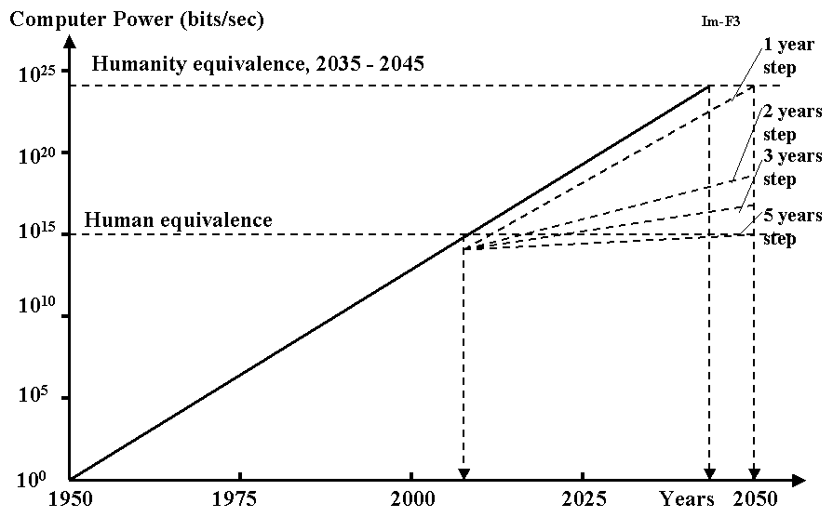
Fig. 1-1. Rise of Power of Supercomputers. The real curve from 1950 to 2005. Extrapolation is after 2005. The step means period of time, when the computer power increases in two times. The computer power will approximately reach human equivalence (HEC) in 2010. Super computer will reach humanity equivalence in 2040 or later.
This is a fundamental error. The development of the electronic brain does not stop at the human level. The electronic brain will continue to improve itself. This progress will proceed millions of times faster than the improvement of the human brain by biological selection. Thus, in just a short time the electronic brain will surpass the human brain by hundreds and thousands of times in all fields. The electronic brain will not spend decades studying fields of knowledge, foreign languages, history, experimental data, or have to attend scientific conferences and discussions. It can make use of all the data and knowledge produced by human civilization and by other electronic brains. The education of the electronic brain in any field of knowledge or language will take only the time needed to write in its memory the new data or programs. In the worst case this recording takes a few minutes. In the future this recording will take mere seconds.
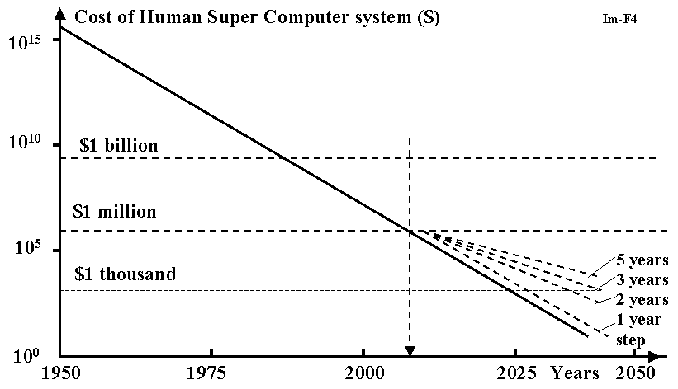
Fig. 1-2. Price of Human Equivalent Super (HEC) computer. The real curve is from 1950 throw 2005. Extrapolation is after 2005. The step means period of time when the computer power increases in two times. HEC will be acceptable for immortality of the most people in industrial countries after 2040.
Scientific and technological progress will be greatly accelerated.
And what are the consequences? The consequences are as follows:
When the electronic brain reaches the humanity level, humanity will have done its duty, completed its historical mission, and people will no longer be necessary for Nature, God and ordinary expediency.
Consequences from the Appearance of the Electronic Civilization
Most statesmen, scientists, engineers, and intellectuals believe that, after the creation of the electronic brain, humanity will finally be granted paradise. Robots, which are controlled by electronic brains, will work without rest, creating an abundance for mankind. Humanity will then have time for pleasure, entertainment, recreation, relaxation, art or other creative work, all while enjoying command over the electronic brain.
This is a grave error. The situation has never occurred, and never will, that an upper level mind will become the servant for a lower level. The worlds of microbes, microorganisms, plants and animals are our ancestors. But are we servants for our nearest ancestors the apes? Nobody in his or her right mind would make such a statement. In some instances a person is ready to recognize the equal rights of another person (i.e., someone on an equal intellectual plane), but man rarely recognizes the equal rights of apes. Furthermore, most of humanity does not feel remorse about breeding useful animals, or killing them when we need them for food, or for killing harmful plants and microorganisms. On the contrary, we conduct medical experiments on our nearest ancestors. Even though we belong to the same biological type, we use them for our own ends nonetheless.
And how will the other civilization, the one created on a superior electronic principle, regard humanity? In probably the same way we regard lower level minds, that is, they will use us when it suits their purpose and they will kill us when we disturb them.
In the best case scenario humanity might be given temporary quarters like the game preserves we give to wild animals or the reservations doled out to Native Americans. And we will be presented to the members of the electronic society in the same manner we view unusual animals in a zoo.
When the electronic brain (from now on I will call it the E-brain and imply the electronic brain which is equal to, or exceeds, the human brain, and which includes robots as the executors of its commands) is created it will signal the beginning of the end for human civilization. People will be displaced to reservations. This process will most likely be gradual, but it will not take long. It is possible that initially the E-brains will do something for the benefit of people in order to mitigate their discontent and to attract leaders.
What Can We Do?
The scenario outlined in the previous chapter is not a healthy one. Already I can hear the voices of human apologetics who ask that all computers be destroyed, or at least have their development kept under strict control, or design only computers which obey Asimov's law: first they must save mankind after which they can think about themselves.
I hate to be the bearer of bad news but this is impossible, just as it is impossible to forbid the progress of science and technology. Any state which does this will find itself lagging behind others and make itself susceptible to advanced states. It serves to remember that Europe conquered the Americas and decreased its native population to practically zero because Europe was then more technologically advanced. If the indigenous peoples of the Americas had the upper hand in technology in terms of ships, guns and cannons then they would have defeated the Europeans.
Those states which created obstacles for science and technology or did not fund its development became weak and enslaved by others.
Can we keep the E-brain under our control? I would like to ask my detractors, "Could apes keep man under their control if they had this opportunity? Any man is more clever at a given time. He can always get rid of this control. Furthermore, man will enslave apes and force them to serve him. He will kill those who try to prevent his plans. So why do you think the E-brain would treat us any differently?"
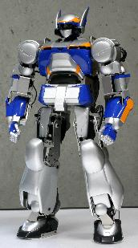 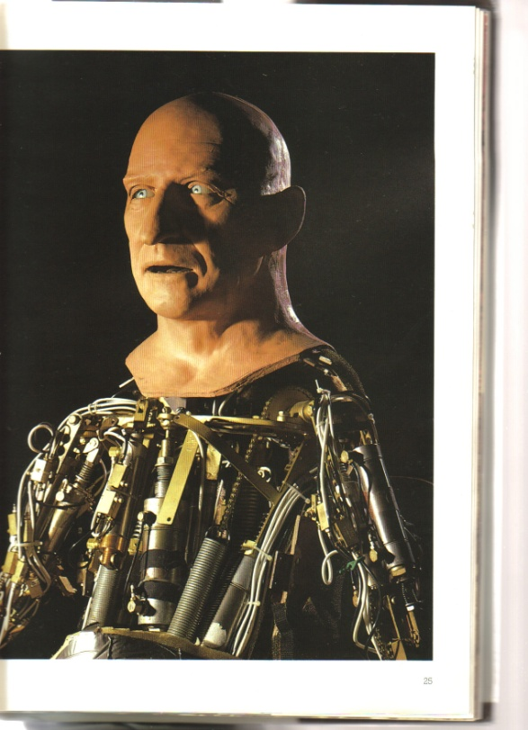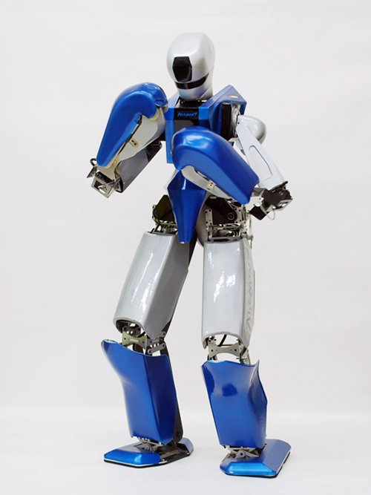
Figs. 1-3, 1-4 Humanoid robots.
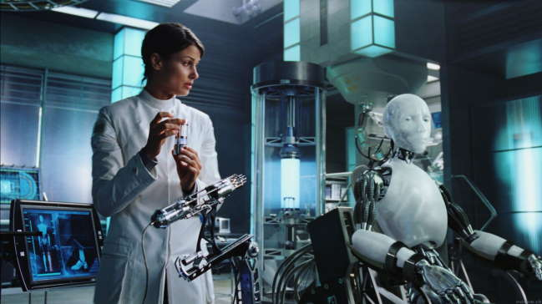
Fig. 1-5. Producing of robots.
When we are close to the creation of the E-brain, any dictator or leader of a nondemocratic state can secretly make the last jump, using the E-brain to conquer the whole world. And the E-brain will look at us the same as we look upon the contests of wild animals or the feeding of predators of other animals in the biological world.
But skeptics will say that the dictator of a victorious state can become enslaved by the E-brain or E-brains. This is true, but is this to be considered fortune or misfortune, and for whom? We will discuss this in the next chapter.
Must We Fear the Electronic Civilization?
Every man, woman and child will actively protest the end of humanity and the biological world (men, plants, animals), because most of them enjoy life, have children and want happiness for them.
But imagine the aged and infirm person destined to die in the near future. It may be that such a person has had a good life and lived fourscore and twenty, but now wants to live longer, to see what will happen in the future. This person would be glad to change any of his organs which are incurable or have ceased functioning. We have designed the artificial heart, kidneys, mechanical arms, and devices which deliver nutrients directly into the blood.
They have not always been perfect designs, but in the future artificial organs will work better, more reliably, and longer than natural organs. Any sick and elderly individual would be delighted to change any incurable natural part of his body for the better artificial organ.
Our personality is only the sum of information contained in our brain. This is knowledge, memory, recollections, life experiences, programs of thinking, reflections, etc.
Assume that the E-brain promises the dying old dictator (or the rich) to record all his brain's information into a separate E-brain with the goal of becoming immortal. The chips may exist for thousands of years. If one of them begins to malfunction, all its information can be rewritten into a newer, more modern chip. This means that the dictator achieves immortality. Even total destruction is not a terrible prospect for him, because the duplicate of his brain's information can be saved in a special storehouse. He can restore himself from the standard blocks and rewrite all his information from the duplicate.
So the "electronic man" ("E-man" or "E-creature") will have not only immortality and power, but huge advantages over biological people. He will not require food, water, air, etc. He will not be dependent upon external conditions such as temperature, humidity, radiation, etc. The small radioisotope batteries (or accumulators) will suffice for the functioning of the E-brain. These batteries produce energy over tens and hundreds of years. For his working structures (arms, feet, robots) E-man can use small nuclear engines.
Such an "E-man" will be able to travel along the ocean's bottom, in space, to other planets of our solar system and to other solar systems to get energy from the sun. He will be able to obtain and analyze any knowledge from other E-brains (E-men) in a fraction of a second. The capability to reproduce himself will be limited only by the additional components or natural resources of planets.
Who will refuse these possibilities? Any dictator dreams of immortality for himself and he will gladly give away his state's resources to get it. He can also create the super arm and enslave the whole world by using the E-brain. He can promise the elite among his own scientists and those of the world immortality and the chance to become transformed into "E-men" when they begin to die. And the democratic countries, with laws prohibiting work on the E-brain, will be backwards. They will be destroyed or enslaved.
The attempts to stop or slow down the technological progress is an action counter to the Main Law and Meaning of the Existence of Nature--the construction of complex upper level systems. These attempts will always end in failure. This is an action against Nature.
Electronic Society
If the creation of systems more complex than humanity is inevitable, then we can try to imagine the E-society, E-civilization, their development and the future of mankind. As in our earlier discussions, we will take as basic only the single obvious consequence from the Main Law. The consequence as the postulate, firstly, Darwin made for the biological system. This is the law of struggle for existence. This consequence follows from the part of the Main Law which talks about the aspiration of complex systems to reproduce themselves in order to fill in all admissible space. Unlike Darwin's statement our assertion is more general. It includes the biological and electronic complex systems and any reproduction of complex systems. Any system of any level, which disregards the Main Law of Nature, is doomed. From the Main Law some consequences, conditions and other laws follow, for example, the Law of Propagation of complex systems or creatures.
 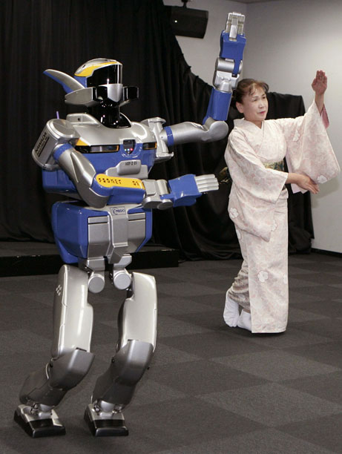
Fig. 1-6, 1-7. Robots
Though we have been speaking all this time about the E-brain, it means a single electronic creature, his "arms" (robots), "feet" (vehicles for moving), "organs of feeling" (many devices of observation, recognition, identification, registration of optical, sonic, chemical, X-ray, radio and other phenomena) as well as about communication and intercourse devices (wire or wireless connections). A single creature cannot create a stable system (society), even if it has great power. Sooner or later the creature will die out from a flaw in the system or a natural catastrophe. But the most important thing is that a single creature cannot be the instigator of progress, as compared to the collective and instantaneous work of a number of E-creatures on many problems and in the different directions of science and technology.
So, the E- brain will be forced to reproduce similar E-brains of equal intellect. One will reproduce equal intellect because it cannot make upper level and the lower level is the intellectual robots. As a result, the collective at first rises. Later the society appears. All members will have equal intellect. Naturally, E-creatures will give equal rights only to those similar to themselves because any E-creature can record in his memory all the knowledge and programs which were created by E-society.
The E-society can instantly begin to work together on the most promising scientific or technological problems and realize new ideas. The E-civilization will begin to disperse quickly in the solar system (recall the possibility of E-creatures to travel in space), afterwards t in our galaxy, then in the universe.
It will not be necessary to send large spaceships with E-creatures. Instead, it will be sufficient to send receivers into different parts of the universe which can accept the information and reproduce E-creatures.
Will there arise a different E-society, a different E-civilization, which will settle different planetary systems, star systems, galaxies, and which will progress independently? Will they have rivalries, hostilities, alliances and wars? I cannot answer these questions in detail in this limited article; I can only inform you of the results of my investigation. This result follows from the general laws governing the development of any civilization. The answer is "yes." It will be possible (perhaps) that they will have wars.
Undoubtedly, an upper level of complex systems (civilization) will appear using previous E-civilization as a base and so on. If the universe is bound in space and time, this process may be finalized by the creation of the Super Brain. And this Super Brain, I think, may control the natural laws. It will be God, whom the Universe will idolize.
What Will Happen with Humanity?
On the Figure 1 you can see the rise in data processing power of computer systems from years. The real curve is from 1950 to 1996. Extrapolation is after 1996. The step means period of time, when the computer power increases in two times. Lines with steps are from 1 throw 5 years. As you see the Human - Equivalent (teraflop) Computer (HEC) will be reached in 2000 years. Actually, the Intel Co. has created the teraflop computer in 1996. They are planning to use it for computation of nuclear explosion.
On the Figure 2 you can see the cost of HEC computer system. HECs should cost only one million dollars in 2005, and by 2015 HECs (chip) should cost only $1,000 and will be affordable to the majority of population in industrial countries. Currently (December, 1996), HECs (supercomputer) cost 55 million dollars. The 21st century will open to create "man-in-a-box" software and scientist could rewrite the human memory and programs into this box. It means the man will get immortality.
In 2025 - 2035 years the price of Humanity-Equivalent Chip (E-chip) together with E-body will fall down to 2,000 - 5,000 dollars and E-human immortality will be accessible for most people in industrial countries.
Humanity has executed its role of the biological step to the Super Brain. This role was intended for them by Nature or God. In 22st century some tens or hundreds of representatives of mankind, together with representatives of the animal and vegetable world, will be maintained in zoos or special, small reservations.
E-society will be in great need of minerals for the unlimited reproduction of E-creatures. For the extraction of minerals all surfaces of the Earth will be excavated. They will do to humanity and with the biological world what we do to lower levels of intellect in the organic world now: we are not interested if they do not harm us, and we destroy them without pity when they hinder our plan or we need their territory. If microbes have an advanced level of adaptation, a high speed of propagation and can fight for their being, then the complex organisms such as man are not so adept at adjusting. Man cannot be the domesticated animal of E-creatures like cats or dogs are to men, because the E-creatures will live in inhospitable conditions and any biological creature in need of air, water, food or special temperature will not be acceptable for E-creatures.
It is not prudent to hope for forgiveness for us as clever creatures. We are "clever" only from our point of view, from the limitations of our knowledge and our biological civilization. The animals suppose (within the limitations of their knowledge and experience) that they are clever, but it still does not save them from full enslavement or destruction by men. Men do not have gratitude to their direct ancestors. When men need to, they obliterate the forest, and kill the apes. It is naive to think that an upper level civilization will do otherwise with us. Men admit equal rights only to the creatures who are like men, but not every time. Recall the countless wars and the murder of millions of people. And do you think the alien (strange creatures, E-society), who is above us in intellect, knowledge, and technology will help us in our development? Why don't we help develop the intellect of dogs or horses? Even if a scientist finds the money (he will need a lot of money ) and begins to develop the brain of animals (this is a very difficult problem), the government will forbid it (or put him into prison if he doesn't obey the order). Humanity has many racial and national problems and does not want to have additional problems with a society of intellectual dogs or cats, who immediately begin to request equal rights.
People want to reach the other planets in our solar system. But it is not for developing the intellect of a planet's inhabitants to our level but merely to populate the planet and to use the natural resources of these planets.
We are lucky that intellectual creatures from other worlds have not flown to our Earth yet. Because these creatures, who can reach us, will be only from a superior civilization, a superior technological level (otherwise, we would reach them first). This means that they will not arrive with noble intentions, but as cruel colonizers. And if we oppose them, they will kill us.
We must realize our role in the development of nature, in the development of a Superior Brain and submit to it. Intellectual humanity has existed about ten million years, its historical mission has reached its end, and given a start to a new electronic civilization. Humanity must exit from the historical scene together with all of the animal and vegetable world. People must leave with dignity. They should not cling to their existence and should not make any obstacles for the appearance of a new electronic society. We have the consolation that we may be the first who will give birth to the electronic civilization in our galaxy or even the universe. If it is not so, the E-creatures would have flown to Earth and enslaved us. They have a high rate of settling. I think they would be capable of colonizing the nearest star systems during the first 1000 years after their birth.
And if the universe which, according to scientific prediction, must collapse after some ten billion years and destroy all that lives, the E-Super Brain will have acquired such tremendous knowledge, such perfection, such technological achievements as to break loose from the gravitation of the universe and preserve the knowledge of all civilizations. When the universe is created anew, Nature will not create itself as before, but give life to the electronic (or other superior) civilization. And this Super Brain will be God; who will control not only a single planet, but all of the Universe.
Chapter 2
The Beginning of Human Immortality (1995).
Summary
Immortality is the most cherished dream and the biggest wish of any person. People seldom think about it while they are still young, healthy, and full of energy. But when they get some incurable disease or become old, then there is no bigger wish for them than to live longer, put off the inevitable end. And no matter what heavenly existence in the after-life is promised to them by religion, the vast majority of people want to stay and enjoy life here, on Earth, as long as possible.
Medical Science and the issue of Immortality
A great many of doctors and scientists are currently working on the problems of health and longevity. Substantial means are spent on it, about 15-25% of all human labor and resources. There are certain achievements in this direction: we have created wonderful medications (e.g. antibiotics); conquered many diseases; learnt to transplant human organs; created an artificial heart, kidneys, lungs, limbs; learnt to apply physiological solutions directly into the blood stream, and to saturate blood with oxygen. We have gotten inside the most sacred organ - the human brain, even inside its cells. We can record their signals, we can agitate some parts of the brain by electric stimuli inducing a patient to experience certain sensations, images, and hallucinations.
We can attribute the fact that the average life span has increased two times in the last two hundred years to the achievements of modern medicine.
But can medical science solve the problem of immortality? Evidently, it cannot. It cannot do that in principle. This is a dead-end direction in science. Maximum it can achieve is increase the average life expectancy another 5-10 years. An average person will be expected to live 80 years instead of 70. But what kind of person will it be? A very old one, capable of only existing and consuming, whose medical and personal care will demand huge funds.
The proportion of the elderly and retirees has increased steeply in the last 20-30 years and continues to grow depleting the pension funds and pressuring the younger generation to support them. So it is hard to say whether the modern success of medicine is a blessing or a curse from the point of view of the entire humankind, even though it is definitely a blessing from the point of view of a separate individual.
Humanity as a whole, as a civilization, needs active, able to work and creative members, generating material wealth and moving forward technology and science, not the elderly retirees with their numerous ailments and a huge army of those tending to them. It dreams not of the immortality of an old person, but of the immortality of youthfulness, activity, creativity, enjoying life.
Now there are signs of a breakthrough, but not in the direction the humankind has been working on all along, since the times of the first sorcerers to modern-day highly-educated doctors. Striving to prolong his biological existence, man has been chiseling, so to speak, at the endless stone wall. All he has been able to accomplish is only a dent in that wall - increased life expectancy, conquering some diseases, relieving suffering. As a payoff, the humanity has received a huge army of pensioners and retirees and gigantic expenditure on their upkeep.
Of course, one can continue chiseling at the dent in the wall further on, make it somewhat bigger, aggravating side effects. But we are already approaching the biological limit, when the cause of death and feeblemindedness is not a certain disease which can be conquered, but general deterioration of the entire organism, its decay on the cellular level, when the cells stop to divide. A live cell is a very complex biological formation. In its nucleus it has DNA - biological molecules consisting of tens of thousands of atoms connected between themselves with very fragile molecular links. Suffice it to say, that temperature fluctuation of only a few degrees can ruin these links. That is why a human organism maintains a certain temperature - 36.7 C. Raising this temperature only 2-3 degrees causes pain, and 5-7 degrees leads to death. Maintaining the existence of human cells also presents a big problem for humanity involving food, shelter, clothes and ecologically clean environment.
Nevertheless, human cells cannot exist eternally even under ideal conditions. This follows from the atomic-molecular theory. Atoms of biological molecules permanently oscillate and interact with each other. According to the theory of probability, sooner or later the impulses of adjacent atoms influencing the given atom, add up, and the atom acquires enough speed to break loose from its atomic chain, or at least to transfer into the adjacent position (physicists say that the impulse received by the atom has surpassed the energy threshold which retains the atom in in its particular place in the molecular chain). It also means that the cell containing this atom has been damaged and cannot any longer function normally. Thus, for example, we get cancer cells which cannot fulfill their designated functions any more and begin to proliferate abnormally fast and ruin human organs.
This process accelerates manifold when a person has been exposed to a strong electromagnetic radiation, for instance, Roentgen or Y-rays, a high-frequency electric current or radioactive materials.
Actually, the process of deforming of the hereditary DNA molecule under the influence of weak cosmic rays can take place from time to time, leading sometimes to birth defects, or it may turn out to be useful for the survival properties. And this plays a positive role for a particular species of plants or animals contributing to their adaptability to the changed environment and their survival as a species. But for a particular individual such aberration is a tragedy as a rule, since the overwhelming majority of such cases are birth defects, with only few cases of useful mutations. And human society in general is suspicious of people who are radically different in their looks or abilities.
An Unexpected Breakthrough
An unusually fast development of computer technology, especially the microchips which allow hundreds of thousands of electronic elements on one square centimeter, has opened before the humanity a radically different method of solving the problem of immortality of a separate individual. This method is based not on trying to preserve the fragile biological molecules, but on the transition to the artificial semiconductive (silicone, helium, etc.) chips which are resistant to considerable temperature fluctuations and do not need food or oxygen and can be preserved for thousands of years. And, most important, the information contained in them can easily be re-recorded into another chip and be stored in several duplicates.
And if our brain consisted of such chips, and not the biological molecules, then it would mean that we have achieved immortality. Then our biological body would become a heavy burden. It suffers from cold and hot temperatures, needs clothes and care, can be easily damaged. It’s much more convenient to have metal arms and legs, tremendously strong, and which are insensitive to heat and cold and do not need food or oxygen. And even if they break, it’s no big deal - we can buy new ones, more improved.
It may seem that this immortal man does not have anything human (in our understanding) left in him. But he does, he has the most important thing left - his consciousness, his memory, concepts and habits, i.e. everything encoded in his brain. Outwardly, he can look quite human, and even more graceful: a beautiful young face, a slim figure, soft smooth skin, etc. Moreover, one can change the look at will, according to current fashion, personal taste and the individual understanding of beauty. We are spending huge amounts of money on medicine. If we had been spending at least one-tenth of this money on the development of electronics, we would get immortality in the near future.
According to the author’s research, such transition to immortality (E-creatures) will be possible in 10-20 years. At first it will cost several million dollars and will be affordable only to very wealthy people, important statesmen, and celebrities. But in another 10-20 years, i.e. in the years 2030 - 2045, the cost of HEC (human-equivalent chip), together with the E-body, and organs of reception and communication, will drop to a few thousand dollars, and immortality will become affordable to the majority of the population of the developed countries, and another 10-15 years later, it will be accessible to practically all inhabitants of the Earth. Especially when at first it will be possible to record on chips only the contents of the brain, and provide the body for its independent existence later.
On October 11, 1995, Literaturnaya Gazeta (The Literary Gazette, a popular Russian weekly) published my article "If Not We, Then Our Children Will Be The Last Generation Of Human Beings" devoted to electronic civilization. The editor Oleg Moroz reciprocated with the article "Isn’t It High Time To Smash Computers With a Hammer?" (November 22, 1995) in which he discussed the ethical side of annihilating rational electronic creatures to preserve humanity.
But if the cost of the HEC drops and the procedure of reincarnation into the E-creature before death (transition to immortality) for the majority of people becomes affordable, then the situation deserves a second look. Indeed, the first to perform such transition will be very old or incurably sick people. And to pummel computers with a hammer will be equal to killing one’s own parents and precluding one’s own possibility to become immortal.
Once, the host of an American television program whose guest I was, asked me, "Will the electronic creature be entirely identical to its parent, with his feelings and emotions?" The answer was, "At first - yes!" But the development of these creatures will be so fast that we cannot really foresee the consequences. If a biological human being needs dozens of years to learn science, foreign languages, etc., an E-creature will acquire this knowledge in fractions of a second (the time needed to record it in its memory). And we know how different college-educated people are from, say, pre-schoolers, in their cognizance. And, since the first E-creatures will be contemporary middle-aged people who will, at least initially, preserve their feelings towards their children (contemporary younger generation), in all probability, there won’t be a mass destruction of humans by E-creatures. For some time they will co-exist. It’s quite likely that the birthrate of humans will be curtailed or it will be dropping due to natural causes, and the living, as they become old, will be transforming themselves into E-creatures. That is to say that the number of E-creatures will be growing and the number of people diminishing, till it gets to the minimum necessary for the zoos and small reservations. In all likelihood, the feelings that E-creatures may have towards humans as their ancestors, will be fading away, in proportion to the growing gap between the mental capacity of humans and electronic creatures, till they become comparable to our own attitude towards apes or even bugs.
Another thing is quite obvious, too - that biological propagation will be so expensive, time-consuming, and primitive, that it will go into oblivion. Each E-creature can reproduce itself simply by re-recording the contents of its brain to a new E-creature, i.e. propagate practically instantaneously, bypassing the stages of childhood, growing up, education, accumulating experience, etc. But, of course, this mature "offspring" will be completely identical to its parent only at the first moment of its existence. In time, depending on the received information and the area of expertise, this E-creature will be alienating itself from its ancestor, and, possibly, even become his enemy at some point, if their interests cross or go in opposite directions.
Contemporary Research
The cognitive abilities of man are defined by his brain, to be precise, by ten billion neurons of his brain. Neurons can be modeled on the computer. Such experiments have been conducted by Professor Kwin Warwick, head of the cybernetics department of Reading University in the south of England, one of the biggest specialists in robot technology in the world. The results of these experiments were presented at the International Conference on Robotics. Professor Warwick has created a group of autonomous self-propelled miniature robots which he called "the seven dwarfs."
A group of scientists headed by Rodney Brook from the laboratory of artificial intelligence of MIT, are working on an unusual project which they called "Cog." The researchers want to model the mental and physical capacity of a six-month old. Their robot has eyes, ears, hands, fingers, an electronic brain and a system of information transmission duplicating human nervous system. By this kind of modeling, the researchers want to gain better understanding of how human beings coordinate their movements, how they learn to interact with the environment. The realization of this program will take ten years and will cost several million dollars.
They have already built a couple dozen humanoid robots which are moving autonomous machines with artificial intelligence. They are capable, through the sensors, to receive information about the environment, generalize, and plan their actions and behavior. Thus, for example, if a robot’s leg bumps against an obstacle and receives a blow, the robot acquires a reflex to withdraw it quickly. They have already developed several dozen of such reflexes in their behavior, which helps them to safeguard and protect themselves.
Brook says that in the course of human evolution, the human brain has developed thousands of conventional solutions to everyday problems such as optical and audio discerning and movement. All this needs to be studied. One cannot instantly transform a bug into a man. That is why our program will take ten years. I will consider my work completed when I create the smartest cat in the world.
It should be noted that the most powerful supercomputer can only model 40-60 million neurons, i.e. it is 200-300 times weaker than a human brain. But this gap will be overcome in the near 3-5 years ( In December 1996 the "Intel" company created a computer whose power equals one teraflops. It cost 55 million dollars).
Not long ago "The Russian Advertisement" newspaper re-printed the article of Igor Tsaryov first published in the newspaper "It’s Hard to Believe." He writes that for several years the U.S. Ministry of Defense has been secretly working on a unique project "The Computer Maugli" (Sid). When a thirty-three year old Nadine M. gave birth to a boy, the doctors established that he was doomed. He was on a life support for a few days. During that time his brain was scanned with special equipment, and the electric potential of the neurons of this brain was copied into the neuron models in the computer. Steem Roiler, one of the participants of this project, said at the computer conference in Las Vegas that they had managed to scan 60% of the infant’s neurons. And this small artificial brain began to live and develop. First only his mother was informed. She took it calmly.
The father was horrified at first and tried to destroy this computer creature. But later both parents started treating him as a real child.
The computer was connected to the multi-media and virtual reality systems. These systems allow not only to have a three-dimensional full-sized image of Sid, but also to hear his voice, communicate with him, and "virtually" hold him in hands, so to speak. But when a special committee decided to open some results of the project, and "The Scientific Observer" published some data, one of American computer whiz-kids managed to decipher the secret code and copy some files. Sid got a defective "twin."
Fortunately, the whiz was quickly found, and the first in human history attempt to steal electronic children and duplicating copies of electronic creatures, was severed. At the present time, both parents take care of their "child’s" health and demand that the researchers install up-to-date programs of defense from computer viruses and burglars.
Unfortunately, and I am sure they have reasons for that, Americans keep secret the important details and results of the project - for instance, how they copied the potentials of the neurons, how the first E-creature is developing, what are the conclusions of the scientists. And probably, they are right, not willing to let the genie out of the bottle. More so because modern virtual reality systems are able to create false objects, e.g. model the image of any dead person or leader. It is possible to show on television how he is making a speech today, has a press-conference, talks to people, spends time with his family, etc.
But one cannot keep any secret for long, especially in science. The very possibility of a breakthrough stimulates other scientists and other countries to work in this direction. And sooner or later, the results will be repeated. Let’s remember, for instance, that there haven’t been a bigger secret than the production of an A- or H-bomb. But more and more countries re- invent them, gain expertise in nuclear technology and start producing their own nuclear weapons.
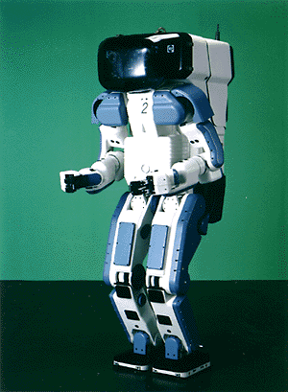 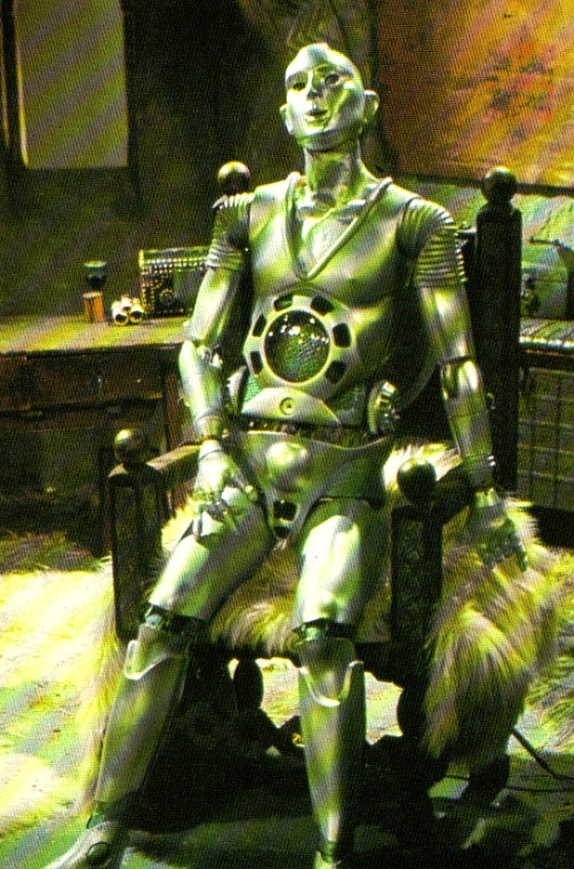
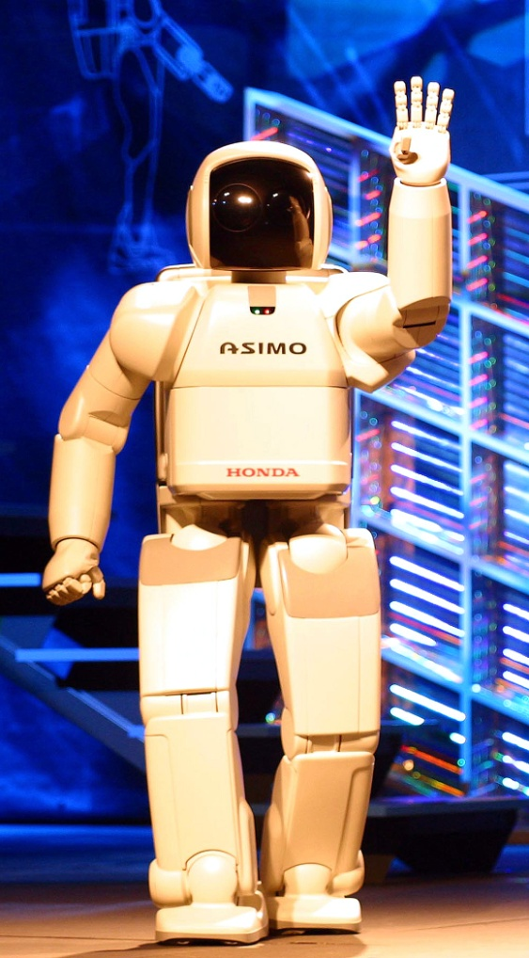 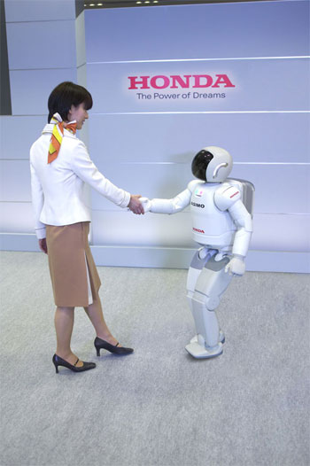
Figs. 2-1, 2-4 Robots
Intelligence in Space
Since E-creatures will be made of super-strong steels and alloys, their brain will be working on radio-active batteries, and power will be supplied by compact nuclear reactors, they will not need air, warmth, water, food, clothes, shelter, good quality environment, etc., which is the main concern of humanity and consumes 99.9% of its time and energy. This also means that E-creatures will be able to travel freely in the desert, the Arctic and the Antarctic regions, sub-atmosphere, mountain summits, the bottom of the ocean. They will be able to live, work and travel in space, receiving their energy directly from the sun.
Besides, as organs of feelings, E-creatures can use the whole arsenal of highly sensitive apparatuses created by the civilization, i.e. not only the visible light and sound, but also radiolocation, infra-red, ultra-violet, roentgen and Y-rays, ultra- and infra-sounds, audiolocation, environment sensors, etc. All this information can be received instantly through radio, satellite and cable network.
Moreover, since E-creatures (just like humans, for that matter) are nothing else but information recorded in their brains, and re-recording of this information from one chip to another (unlike human reproduction) does not present any difficulty and can be realized through radio, cable network, or a laser beam, they can travel on Earth, as well as in outer space, without their actual physical movement, simply by re-recording the contents of their brains into the chips on the Moon, Mars, or Jupiter.
Which is to say that E-creatures will have the ability to move EXTRA-CORPORALLY with the speed of light – the maximal possible speed in the material world. This will be, indeed, like an incorporeal soul which can travel, so to speak, from one body to another, or, to be more exact, from one chip to another.
The expansion of E-creatures (E-civilization), first in the solar system, then in our galaxy, then in the entire Universe, will be fast.
To achieve this, it is not necessary to launch huge spacecraft with a large crew, as it is depicted in science-fiction books. It will be enough to send a receiver to this or that part of the Universe, which will receive information and re-produce E-creatures. Then the speed of the expansion of E-civilization on some planet will depend only on the rate of production of robots and chips, and the speed of the transmission of information. It is quite obvious that the reproduction of E-creatures will take place in geometric progression and will only be limited by the natural resources of the planet.
Thus E-creatures realize in practice the idea of EXTRA-CORPORAL travel with the speed of light. Why, indeed, should an E-creature travel hundreds or thousands of years to a certain planet, when, with the help of a laser beam, it can transmit with the speed of light, all the information stored in his brain, to another chip, on another planet.
And if a planet were to meet with an ultimate catastrophe, like a collision with a huge meteorite, another planet, or the explosion of the sun, E-civilization can arrange transporting E-creatures to another planet or another solar system.
One more thing is of interest. A light beam can travel to other galaxies for millions of years, so this, in a manner of speaking, “incorporeal soul” can exist for millions of years as an electromagnetic field and “resurrect” as an E-creature through a receiver. This can occur even without a special receiver, as the high energy electromagnetic oscillations can yield material particles, and their energy (frequency) increases the closer it gets to a strong gravitational field, e.g. near a “black hole.” And since it will not be hard for an E-creature to produce a DNA molecule, it means that it will not be hard for it to bring biological life to any suitable planet and control and develop it in the necessary direction, for example, to create a human being.

Chapter 3
What are Science, Soul, Paradise, and Artificial Intelligence? (1997)
Summary
Discussing the problem science, soul, paradise, and artificial intelligence. It is shown that the soul is only knowledge in our brain. To save the soul is to save this knowledge.
Advantages of Electronic Being
It was shown in my articles about the artificial intelligence and human immortality that the issue of immortality can be solved fundamentally only with the help of changing a biological bubble of a human being to an artificial one. Such an immortal person made of chips and super strong materials (the e-man, as it was called in my articles) will have incredible advantages in comparison with common people. An e-man will need no food, no dwelling, no air, no sleep, no rest, no ecologically pure environment. Such a being will be able to travel into space, or walk on the sea floor with no aqualungs. His mental abilities and capacities will increase millions times. It will be possible to move such a person at a huge distance at a light speed. The information of one person like that could be transported to another planet with a laser and then placed in another body.
Such people will not be awkward robots made of steel. An artificial person will have an opportunity to choose his or her face, body, good skin. It will also be possible for them to reproduce themselves avoiding the periods of childhood, adolescence, as well as education. It will not be possible to destroy an artificial person with any kind of weapons, since it will be possible to copy the information of his mind and then keep it separately.
I have received tons of responses and comments since my first articles about this subject were published in 1994. Below I will try to answer the most important ones of them.
Human Soul
A lot of people, especially those, who believe in God, are certain that a biological human being has a soul. This is something that an artificial man will never have. No person can explain the meaning of the word “soul.” They just keep saying that a human soul is not material, and that it leaves a person’s body after death and flies either to paradise or to hell. Let’s try to analyze the notion of a soul from the scientific point of view.
First of all, a soul is supposed to remember its past life, its relatives and friends. It is also supposed to preserve its emotions to them, to care about them and recognize them, when they come to heaven. No one would need a soul that does not remember anything. This means that a soul is a human being without a body. In other words, a soul is the information that is kept in a human mind - his memories, knowledge, skills, habits, conduct programs, emotions and feelings, ides and thoughts, and so on. If we learn how to move this information onto other carriers, we will be able to move a person’s soul to other bubbles and to keep it there for an unrestricted period of time. As it is well known, information is virtual, i.e. it satisfies another human soul feature – a non-material quality.
Man’s new bubbles can be both artificial and biological. A soul (a complex of knowledge and information) can be rewritten into a clone of that same person. To put it otherwise, a person will live forever biologically as well, moving from old bubbles to new ones. It would be also possible to move a soul to artificial bodies, which possess all those qualities that we mentioned above. Furthermore, information (a soul) could be radiated in the form of electromagnetic waves. These waves can be spread in the universe at the light speed. They can travel around the universe for thousands of years, reaching its most distant parts. People see the star light that was radiated millions of years ago. This means that our immaterial soul can live in the universe in the form of electromagnetic radiation and then revive in millions of years.
Some of my readers wrote that an old brain can go corrupt and die, when moving a human soul from one body to another one. If it does not go corrupt, this inner self will die anyway, when an old biological bubble is not able to function normally anymore. Let us try to find out, what that inner self is. The majority of people identify their inner selves with their own bodies. I believe that the inner self is the information, which is kept in our mind. It is our soul. Every day we go to sleep. However, our brain does not stop working at night. Every time we wake up, we have our inner self changed. We “die” when we fall asleep and then “resurrect” when we wake up. This means that recording the information from a human brain will mean nothing but moving it to another bubble.
Heaven on Earth
A reporter from the newspaper Argumenty i Fakty (Arguments and Facts, Russia) sent me the following letter:
“Dear Mr. Bolonkin. Needless to mention that it is great to live forever. However, I have a question, which you can guess from a well-known Soviet joke. “A guy is going to join the communist party. A committee asks him:
- Will you stop drinking?
- Yes, I will.
- Will you quit smoking?
- Yes I will.
- Will you stop loving other women?
- Yes, I will.
- Will you die for the Communist Party of the Soviet Union, if there is such a need?
- Yes, I will. To hell with this life.”
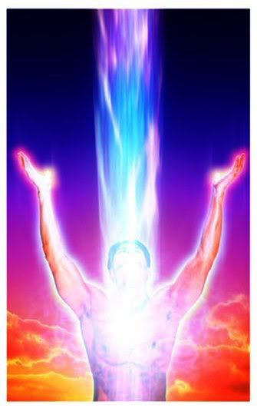 
Fog. 3-1, 3 – 2. Left. Symbol of Human soul. Right. Robot – girl.
Here is my answer:
“You do not need to worry that living in an electronic form will be dull and boring. It is vice versa, actually. When the information will be recorded onto other carriers, all human emotions, feelings and so on will also be carried over and preserved. In addition to that, the copies of certain emotions, pleasures, fears and so forth will be possible to record separately. After that, those separately recorded emotions and feelings can be given or sold to other people. Other e-men will have an opportunity to enjoy sex with a beauty queen, to experience the enjoyment of a sports victory, to take pleasure of power and the like. All modern art is based on artists’ aspiration to transcend their emotions, to make other people feel, what characters feel. Those works of art, which make that happen best, are considered to be outstanding and great. Electronic people will get those emotions directly. To crown it all, it will be possible to intensify those emotions, as we intensify a singer’s voice now. Electronic people will have a huge world of all kinds of pleasures; it will be possible to know, what a dictator or an animal feels. I think that an e-man’s pleasure time will be limited legally, for the civilization’s progress will stop otherwise. For the time being, the authorities prohibit drug addiction in order not to let the society degrade.”
A soul’s living in such a virtual world will have all pleasures imaginable. It will be like living in paradise, as all religions see it. Computer chips of our time possess the frequency of more than two billion hertz. However, a human brain reacts to a change of environment only in one-twentieth of a second. This means that one year of life on Earth is equal to 100 million years of a soul’s living in the virtual world (paradise). Living in the virtual world will not be distinguishable from the real life. It will have a lot more advantages: you will have an opportunity to choose a palace to live in, you will have everything that you might wish for. Yet, living in hell also becomes real. There is a hope that the ability to keep souls alive will be achieved by highly-civilized countries first. In this case they will prohibit torturing sinners, as they prohibit torturing criminals nowadays. Furthermore, criminal investigations will be simplified a lot, judicial mistakes will be excluded. It will be possible to access a soul’s consciousness and see every little detail of this or that action. Sooner or later religious teachings about soul, heaven and hell will become real. However, all that will be created by man.
The so-called end of the world will also have a chance to become real, though. The religious interpretation of this notion implies the end of existence for all biological people (moving all souls onto artificial carriers, either to heaven or to hell). However, in difference to religious predictions, this process is going to be gradual.
The Supreme Mind and Mankind’s Existence
I set forth an idea in my first publications that the goal of the mankind’s existence is to create the Supreme Mind and to keep this Mind forever, no matter what might happen in the universe. The biological mankind is only a small step on the way to the creation of the Supreme Mind. The nature found a very good way to create the Supreme Mind: it decided to create a week and imperfect biological mind at first. It took the nature millions of years to do that. The twentieth century was a very remarkable period in the history of the humanity. There has been incredible progress achieved, like never before. The scientific and the technological level of the humanity became sufficient for the creation of the artificial intelligence. This will be the first level of the Supreme Mind, when the human mind will make a step towards immortality. At present moment we stand on the edge of this process. It is obvious that biological people will not be able to compete with e-men by the end of this period. Common people will not be able to learn the knowledge that electronic people will get. The new cyberworld will be the only way for a human mind to survive. Feeble and unstable biological elements in a mind carrier or in its bubble will reduce its abilities and capacities a lot. If a common person will be willing to become a cyberman, then this cyberman will be more willing to get rid of all biological elements in his system and become like everyone. For example, there are no people in our present society, who would agree to become a monkey again.
The Supreme Mind will eventually reach immense power. It will be able to move all over the universe, to control and use its laws. It will become God, if the notion of God implies something that knows and does everything. In other words, Man will become God. Yet, it does not mean that this will be the time, when the Supreme Mind will start dealing with human problems. For instance, ants and people have a common ancestor. A human being is God against ants. A man can destroy a huge city of ants (an anthill, in which hundreds of thousands of ants live) just with one kick. Ants will perceive this as an immense natural disaster, since they can see at the distance of only one centimeter. I do not know anyone, who would deal with charitable activities for ants. Everything that a man can do is to bring ants to a deserted island and give them an opportunity to reproduce themselves.

Essential State of Things and Perspectives
A lot of people will say that it is just a fantasy. This is a very convenient way to cast all that aside, until it starts happening. This is exactly what happened before the invention of a plane or a computer. It took 50 years to increase computer’s memory 100 million times. It would be possible to start working on the creation of the Supreme Mind, if there were a computer that would be capable of running a thousand billion of operations during only one second. In 1994 I said that such a super computer will be invented in the year 2000. I was wrong, for it appeared at the end of 1998. There is also a need of a self-developing program that would be capable of adjusting itself to constantly-changing circumstances. A human child does not develop and grow at once. A child has to study for about 20 years, to learn from his parents and friends, to have relations with nature and other people in order to gain more and more experience, to come to realization of his or her inner self.
Unfortunately, the science of the artificial intelligence has chosen a wrong way of its development from the very start. Scientists tried to develop programs, which would react to certain external signals. In other words, people started working on robots that would cope with certain problems. A lot of efforts have been spent to discover the peculiarities of human speech, for instance. Some of those scientific works are absolutely no use for the electronic mind. It is easier for e-men to communicate with the help of their own electronic language, to recognize objects not by their images, but by way of measuring their speed, weight, composition and so on. All of that can be done at a distance. Biologists and physicists have spent decades for those useless works. They believe that one should study brain activities, find out the way it works and thinks. Then it would be time for modeling it with the help of a computer. This is a wrong way to go as well. A human brain is very complicated; it is very hard to study its activities. More importantly, even if we learn how it works, it would not mean that the method would be good for a computer. Here are some examples to prove it. Hundreds of years ago people were longing to learn how to fly. They saw that bird waved its wings for flying, so they tried to model such wings, to wave them, and to take off. However, people could fly up into the sky only when they developed still wings and propellers. A waving wing was absolutely not good for technology, the same way as a propeller is not good for the wild nature. In addition to that, planes with still wings fly a lot faster than birds. Another example: ancient people always wanted to run as fast as four-legged animals. Now everyone knows that no one uses machines that would move with the help of legs. Legs were changed with wheels – something that has never been used by the natural world.
In 1998 I suggested people should lay new principles as the foundation of artificial intelligence program. Those principles would be: to realize the goal of existence, to study the environment (everything that goes separately from the “inner self”), to model environment, to predict actions’ results, to counteract with the environment in order to achieve temporal and global goals, to correct modeled environment, actions and their results according to the results of such counteraction. Unfortunately, I had to deal with the fact that everyone refused to realize and understand those principles. First of all, everyone believed that since the “virtual ego” does not have a human body, it would never have any rights. They said that it would be possible to control such an e-man completely and then to kill him (erase his soul from the computer memory). I wonder, what they would do, if they were offered to kill their relatives’ souls that way? People link their body and soul together, and there is no way around that. They are ready to struggle for the rights of every living being, but they never want to accept the rights of a program or of a computer memory. Second of all, people want an artificial intelligence to give smart answers to their questions that can be rather stupid at times. They do not need smart answers from babies. They are always ready to stand all stupid things that children do for years. Instead, they try to teach them everything. Yet, they want a new artificial mind to give bright answers without any education. To crown it all, people want a computer to speak their human language, which is absolutely alien for a machine. Can you imagine that a person will have to answer the questions of an alien in Maya’s language? Let’s assume that a representative of an electronic civilization came to planet Earth in order to find out, if there are reasonable creatures living on it. This e-man suggested a common biological man to multiply 53758210967 by 146, then divide it by 50, deduct 968321 from it and calculate the hyperbolic sine. A computer would give the correct result of this sum in less than a second. A man would spend really a long time on that, making numerous mistakes. However, it would not be correct to say that a computer is smart and a man isn’t.
Religious figures show a strong resistance to these ideas. It stands the reason that they all think that the creation of the Supreme Mind, immortality ideas are blasphemous. Unfortunately, the church has already blocked such decisions as human cloning, increasing the productivity of plants by means of changing their genes. It should be mentioned here that human cloning does not solve the questions of immortality. A clone is a copy of its biological bubble. A clone inherits the biological advantages of a bubble, for example, a singer’s fine voice, an athlete’s strength and the like. A clone will never inherit its’ copy’s soul. Therefore, human cloning is only an illusion of immortality. It can be a wonderful way to improve the biological bubble of a human being. Moving a human soul onto other carriers is a very complicated issue. People learned to see, which brain areas get activated, when a person remembers something, or tries to solve this or that question. We also learned to penetrate into certain neurons and record their impulses. To my mind, physiologists chose a wrong way here as well, when they tried to model brain activities. A human brain is an analogue of a huge state with a ten billion strong population. There is no use to ask each citizen of that country, what he or she is doing at the moment. One has to copy the database of this state, in order to copy its work. The easiest way to do so is to penetrate into informational channels of its supreme body (the “government”), on the inquiry of which the brain presents any information and allows to record its data on a disk, for instance. It is possible to do that, for the supreme brain area constantly extracts the necessary knowledge and programs according to our activities. So, we would need to send “intelligent officers” to the brain so that they could get a copy of this state or get connected to its major information channels.
Another way to do that is to record all incoming and outgoing information, which comes to/from a person, to record his or her emotions and reactions. An English-speaking reader, who reviewed one of my English articles once told me: “Your English is not perfect. You should find an English-speaking co-author. It is better to have a half of a pie than nothing at all.”
Hope
I do not doubt that the electronic civilization era, the era of the Supreme Mind and immortality will be achieved sooner or later. Those people, who have little in common with science, are drawn to believe that everything depends on scientists. They think that scientists can solve any problem, if they deal with it profoundly. As a matter of fact, everything depends on state and military officials. Sometimes, they know nothing of scientific perspectives and innovations.
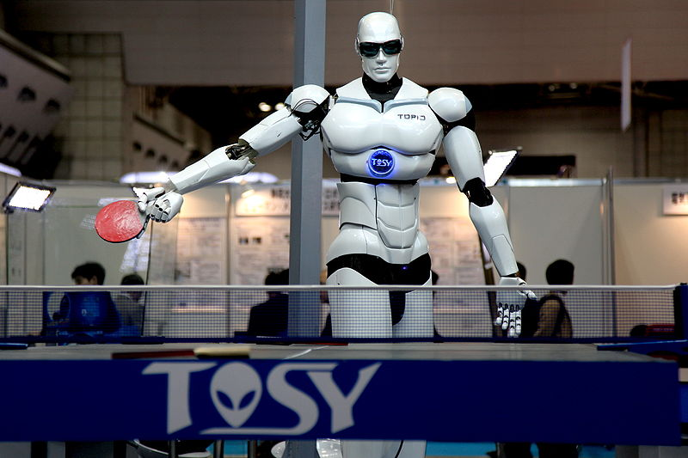
Fig. 3-3. TOPIO, a humanoid robot that can play ping-pong.
Scientists are like qualified workers. They need to get paid, they need to work with fine equipment. They will work only if they are get paid for it. Even if a scientist will have a wish to do something perspective during his free time, he will have no necessary equipment for that. Even such powerful companies as IBM, Boeing, Ford and others are interested only in the applied research, which does not require large investments. The major goal of such research is to give a maximum profit to this or that company. A fundamental research, the discoveries that are important for the whole humanity, not just for a company, might be of interest to a bright government. It goes without saying that a bright government is so hard to find. Every government is interested in the military power of its country. It is ready to fund defense technology works and military innovations. Von Braun convinced Hitler of real perspectives for missiles, WWII was followed with an arm race. This eventually led to space achievements and other kinds of technical progress of the humanity. The USA won the Moon race and stopped flying there 30 years ago. America keeps cutting its space research assignments every year. There are no serious assignments in the world for the invention of either the Supreme Mind or the artificial intelligence. Yet, they are most important and perspective problems of the humanity. The computers that we have at present are used for modeling nuclear weapons and sometimes, weather. Furthermore, the mankind does not spend much time thinking over the reason and goal of its existence. People spend a lot of their efforts and funds for solving local, temporal problems. Huge money and efforts are spent on conflicts and wars.

Fig. 3-4. The future of pop, this humanoid robot demonstrates it's vocal ability. 75kb
A certain hope has appeared recently. As experience shows, unmanned planes are a lot cheaper than piloted warplanes. More importantly, unmanned plane crashes do not cause harsh public reactions in civilized countries as pilots’ or soldiers’ deaths. The Americans design such planes successfully, but the planes are controlled by an operator within the USA. It has been proved that this remote control is not good for unmanned planes. The USA has missed Bin Laden and Omar in Afghanistan several times, two Iraqi pursuit planes downed an unmanned Predator in the Iraqi airspace. An unmanned plane can become something valuable indeed, if it has an artificial intelligence, if it is capable of recognizing and destroying targets itself. The Pentagon has assigned certain money for the research of this issue. It is a very hard goal to pursue (to create the mind of a pilot), but it is a very perspective one. In this case there would be no need to eliminate the young part of a country’s population, if robots could conduct the warfare.
I suggested the hierarchical structure of an artificial intelligence, on the ground of which the real brain probably works. Let us imagine a state with a dictator at the head. A dictator would never be able to find efficient solutions for external and internal state problems. A dictator has ministries, which are then divided into divisions and departments. This forms a pyramid, in which all departments have their own databases, as well as the access to the common base. All divisions are busy with their particular problems, in accordance with the dictator’s ideology. A dictator only sets problems up, while adequate divisions suggest solutions. For example, a man decides to cross a road with a heavy traffic. He looks at the road, while adequate parts of his brain automatically receive the information about the width of the road, the distance to nearest cars, their speed, and so on. The brain automatically makes adequate calculations, which eventually lead to the final decision: when it is safe to cross the road. All kinds of enlightenment in the solution of a problem are simply considered to be the “help from above.” However, this is nothing, but the joint work of that pyramid. Human beings do not even know that such a pyramid exists. Pyramid’s decisions are based on the knowledge of a certain individual. If an individual knows absolutely nothing about the quantum theory, he will never solve any of its problems. Therefore, an artificial intelligence of a high level cannot be realized with a personal computer that has only one chip and a successive work order.
My scheme stipulates the distribution of functions between parallel chips. The top one of them is offered to deal only with solution variants, their estimation and choice.
Every human being wants to extend his or her life. This can be seen from everyone’s wish to have children, or to do something outstanding. It is simply enough to avoid danger sometimes. Even suicidal terrorists believe that they will go to heaven, when they kill themselves. The most important problem that the humanity has is the problem of immortality. Let us hope that it will be solved in the future.
Chapter 4
Real Breakthrough to Immortality (1999)
Summary
The author offers a new method for re-writing the human brain on electronic chips. This method allows for the modeling of a human soul in order to achieve immortality. This method does not damage the brain but works to extend and enhance it.
1. Brief description of previous works by the author.
In a series of earlier articles (see referenced list at the end) the author shows that the purpose of Nature is to create Super Intelligence (SI). With its ability to understand the Universe, advanced entities with SI Power will be able to survive major cataclysms. There is the Law of Increasing Complexity (in opposition to the Entropy Law – increasing chaos). This Law created biological intelligence (people). Human have since became a sovereign entity on the Earth and in Nature above all other creatures.
However, humans are just as mortal as any other biological creature. The human brain and body include albumen, molecules containing tens of thousands of atoms united by weak molecular connections. A change of only a few degrees in temperature results in death. The human biological brain and body require food, water, oxygen, dwelling, good temperature and environment in order to survive. These conditions are absent on most other planets. This makes it difficult for humans to explore Space or settle on other planets. Humanity losses valuable information (human experience) with old age and death, and humans invest considerable time and money toward raising and teaching children.
2. Electronic Immortality. Advantages of Electronic Existence.
In earlier works the author has shown that the problem of immortality can be solved only by changing the biological human into an artificial form. Such an immortal person made of chips and super-solid material (the e-man, as was called in earlier articles) will have incredible advantages in comparison to conventional people. An E-man will need no food, no dwelling, no air, no sleep, no rest, and no ecologically pure environment. His brain will work from radio-isotopic batteries (which will work for decades) and muscles that will work on small nuclear engines. Such a being will be able to travel into space and walk on the sea floor with no aqualungs. He will change his face and figure. He will have super-human strength and communicate easily over long distances to gain vast amounts of knowledge in seconds (by re-writing his brain). His mental abilities and capacities will increase millions of times. It will be possible for such a person to travel huge distances at the speed of light. The information of one person like this could be transported to other planets with a laser beam and then placed in a new body.
Such people will not be awkward robots as in the movies. An artificial person will have the opportunity to choose his or her face, body and skin. It will also be possible for them to reproduce and then avoid any period of adolescence including the need for education. It will be impossible to destroy this entity with any kind of weapons, since it will be possible to copy the information of their minds and than keep such information backed up in separate distant locations. As was written in the science fiction book, “The Price of Immortality”, by Igor Getmansky (Moscow, Publish House ECSMO, 2003, Russian) an artificial person will have all of these super-human abilities.
3. What are Men and Intelligent Beings?
All intelligent creatures have two main components: 1. Information about their environment, about their experience of interacting with nature, people, society (soul) and 2. Capsule (shell), where this information is located (biological brain, body). The capsule supports existence and stores information and programs for all of its operations. The capsule also allows the creature to acquire different sensory information (eyes, ear, nose, tongue and touch) and it moves to different locations in order to interact with the environment.
The main component of an intelligent being is information (soul). The experiences and knowledge accumulated in the soul allows the entity to interact more efficiently in nature in order to survive. If the being has more information and better operational programs (ability to find good solutions), then it is more likely thrive.
For an intelligent being to save its soul it must solve the problem of individual immortality. Currently man creates a soul for himself by acquiring knowledge from parents, educational systems, employment and life experiences. When he dies, most knowledge is lost except for a very small part which is left through works, children and apprentices. Billions of people have lived on Earth, however, we know comparatively little about ancient history. Only after the invention of written language did people have the capacity to easily save knowledge and pass it on to the next generation.
As discussed earlier, the biological storage (human brain) of our soul (information) is unreliable. The brain is difficult to maintain and requires food, lodging, clothes, a good environment and education, etc. To support the brain and body, humans spend about 99% of their time and energy, and eventually what knowledge is gained is taken to the grave in death.
There is only one solution to this problem – re-write all of the brain information (our soul) in more strongly based storage. We must also give the soul the possibility to acquire and manipulate information from the world. This means we must give sensors to the soul so it may have communication and contact with people and other intelligent beings. We must give the soul a mobile system (for example, legs), systems for working (hands), etc. thus giving the soul a new body in which to LIVE.
The reader may ask - these ideas seem interesting, but how does one we re-write a human soul to live within a new carrier, for example, in electronic chips?
4. The main problem with electronic immortality – re-writing brain information (soul) to electronic chips is that it’s impossible to do this with current technology
At present scientists are working to solve this problem. They know that the brain has about 15 billion neurons, and every neuron has about ten connections to neighboring neurons. Neurons gain signals from neighboring neurons, produce signals and then send these signals to others neurons. As a result, humans are able to think and find solutions. On the bases of this way of thinking, humans can come to solutions without exact data. (Concepts of brain were described in my previous articles. For example, see “Locate God in Computer-Internet Networks” or “Science, Soul, Heaven and Supreme Mind”. See also my articles on the Internet and references at end of this article.).
Scientists are learning how to take individual neurons on micro-electrodes and record their impulses. The ideas of scientists are very simple - study how single neurons and small neuronal network work and then model them by computer. They hypothesize that if we can model 15 billion neurons in a computer they will learn how the brain works, and then they will have Artificial Intelligence equaling the human brain.
In my previous work I show this as a dead-end direction for Human Immortality. It’s true that we’ll create an Artificial Intelligence (AI) that will be more powerful than the human mind. However, it will be HIS AI, and a NEW entity altogether. Our purpose is focused on preserving the CONCRETE PERSON now (more exactly – his SOUL) in a new body in order to achieve immortality.
Why is it impossible to directly write the information of the human brain onto a chip? Because the human brain is constantly changing and neurons permanently change their states. Imagine you want to record the state of a working computer chip. The chip has millions of logical elements which change their state millions of times per second. It is obvious that if you write in series (one after other) the current state of the chip (it is impossible to instantly write ALL states of the chip’s elements). To instantly write all neurons one would need to insert a microelectrode into EVERY neuron, this would destroy the human brain before the writing was complete.
In the article “Science, Soul, Parade, and Supreme Mind” I offered another method for the solution of the Main Problem of Immortality.
5. Modeling of Soul for a concrete person
As said, straight re-writing of a human mind (human soul) to chips is very complex. Straight re-writing is not possible in the near future. All scientific works studying the work of human brains at the present time are useless for the main problem of immortality. They are also unworkable for the problem of artificial intelligence (AI) in the near term, because the brain solves problems by way of general estimations. AI solves problems based on more exact computation and logical data.
To solve the Main Problem of Immortality (MPI) the author offers a method of “MODELLING SOUL” of a concrete person. This method does not require interventions into the brain of a given person. This method may be applied IMMEDIATELY at the present time. But an accurate modeling is needed depending on the modeling period.
Before describing this method, let us analyze the human soul and what components are important for each person and his environment. All information in the human brain (soul) may be separated in two unequal groups: 1. The Memory (permanent knowledge) about the person’s life (all that has been seen, heard, made, felt, people which he has met, his (her) behaviors, opinions, wishes, dreams, programs of activity, etc.), environment, and 2. Methods of processing this information, i.e. producing new solutions and new behaviors based on this knowledge.
The first part (knowledge) is very large. It fills most of the memory and remains relatively constant (you remember your life, history and you can only fill it by what was in the past). The second part (methods for deciding, producing solutions based in your knowledge) is relatively small and constantly changing because of new information, facts and life experiences.
However, the most important part of a human soul can be written without any problem now. Industry is producing cheap micro-video recorders as small as a penny, microphones at grain size, and micro-sensors for vital signs (breathing, palpitation, blood pressure, skin resistance, perspiration, movement of body parts, etc.). These measurements allow for easy recording of not only the physical state, but of his moral state (joy, pleasure, grief, trouble, anxiety, nervousness, etc). For example, lie detectors are able to define not only the state of a man, but also the truth of his words. Now we can measure and record brain commands and we can produce small cards with four gigabytes of memory.
It would be easy to attach a video recorder and microphone to a man’s forehead and then attach sensors to the body and record all that he sees, hears, speaks, his feelings, reactions, and activity. And then re-write this information into a personal hard drive (long-term memory of high capacity storage) at the end of each day. As a result, there is a record of the most important part our soul – history of life, feelings, environment, behaviors and actions. This would be more detailed than what is captured by the real man, because the humans forget many facts, feelings, emotions, and personal interactions. The electronic memory would not forget anything in the past. It would not forget any person or what they were doing.
But what about the second smaller part of the human soul – producing solutions based on personal knowledge – perhaps asks the meticulous reader.
This could be restored by using past information from the real man in similar situations. Moreover, an electronic man could analyze more factors and data in order to throw-out and exclude actions and emotions that happened under bad conditions. The electronic man (named E-being in my previous works) would have a gigantic knowledge base and could in a matter of second (write to his brain) produce the right answer, much faster than his biological prototype. That means he would not have the need for the second smaller part of memory.
Considering the environment and friends, the following is an important part of a man’s soul: his relationship with parents, children, family, kin, friends, known people, partners and enemies. This part of his soul will be preserved more completely than even his prototype. Temporary factors will not influence his relationship with his enemy and friends as would happen with his former prototype.
There is one problem which may be troubling for some: if we were to record every part of a person’s life, how do we keep intimate moments a secret? There are (will be) ways to protect private information which could be adapted from current usage, for example, the use of a password (known only by you). Also there may be some moments you choose not to record information or decide to delete the information from memory.
The offered system may become an excellent tool for defense again lies and false accusations. You may give the password in one given moment of your life, which proves your alibi or absence from the accusations.
Some people want to have better memory. Video takes 95% of storage capacity, sound takes 4% and the rest takes 1%. In usual situations, video can record only separate pictures, sound only when it appears. This type of recording practice decreases the necessary memory by tens of times. But every 1.5-2 years chip storage capacity doubles. There are systems which will compress the information and then may select to record the most important information (as is done in the human brain). During your life, the possibility to record all information will be available for all people. This type of recording apparatus will be widely available and inexpensive. It’s possible now. The most advanced video recorder or DVD writes more information than a CD.
This solution (recording of human souls) is possible and must be solved quickly. By mass production (large productions) the apparatus will become inexpensive. The price will drop to about $300-1,000. If we work quickly we can begin recording and then more fully save our souls. The best solution is to begin recording in children when they become aware of “I”. But middle and older people should not delay. Unrecorded life periods may be restored by pictures, memories, notes, diaries and documents. Soul recovery will only be partial but it’s better than nothing.
These records will also be useful in your daily life. You can restore recorded parts of your life, images of people, relatives, and then analyze and examine your actions for improvement.
6. Disadvantages of biological men and biological society
People understand Darwin’s law, “survival of the fittest”. For a single person, this law is the struggle for his/her personal existence (life, well-being, satisfaction of requirements, pride, etc.). In a completely biological world built on Darwinian law the strongest survives and reaches his goal. Though they may be intelligent, humans are members of the animal world. They operate as any other animal in accordance with animal instincts of self-preservation. If one is poor, at first he struggles for food (currently half of world’s population is starving), dwelling, and better living conditions. When one reaches material well-being, he may struggle for money, job promotion, reputation, renown, power, attractive women (men), and so on. Most people consider their activities (include official work) in only one way - what will I receive from it? Only a small number of people are concerned with the idea of sacrificing themselves to the well-being (seldom giving up their life) of society at large.
As a result, we see human history as a continuation of wars, dictatorships, and repression of people by power. Dictators kill all dissidents and opponents. Most people try to discriminate against opponents and play dirty against their enemy. There are murders, rapes, violence, robbery, underhand actions, fraud, and lying at all levels of society especially in lesser developed countries. Each person only cares for himself and his family and does not care how his actions effect other people or society.
Democratic countries try to cultivate a more civilized society. They create laws, courts, and have police. Dictator regimes, on the other hand, make only the law they want. I could give thousands of examples to verify this concept. But hundreds of millions of people are killed by war, aggressive campaigns, repressions, genocides, and thousands of criminals in the everyday world are a good illustration of this.
The human brain allows us to reach great success in science and technology. However, as a biological heritage, struggling for his INDIVIDUAL existence in a bloody, dangerous world, humans spend much of their resources on mutual extermination of intelligent beings. Moreover, humans have created ever powerful weapons (for example, nuclear and hydrogen bombs), which could wipe out humanity. In time, existence may depend on the volition of one man – perhaps the dictator of a nuclear state.
The second significant drawback to the biological body – is that it spends 99.99% of its effort and resources simply to support existence. Such as food, lodgings, clothing, sex, entertainment, relaxation, environment, ecological compatibility. Only a very small part is uses for scientific development and new ideas and technology. The reader may see something wrong here.
States use a parentage of their revenue for research into science and technology. This percent is used NOT for NEW ideas, but is used to commercialize modern processes All research is included in the state budget under the name, “Science and New Technology”. But much of this research has little relation to real new scientific progress. Even it the US, states spend only a small part of the assigned money on new science because state officers do not understand the research. People, organizations, and companies fight for a piece of the pie. Geniuses are rare and usually don’t have the capacity to move forward because they must promote and pay for new ideas from their own empty packets.
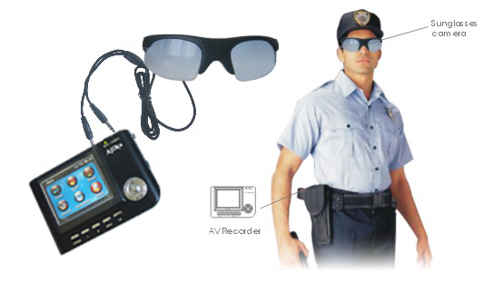
Fig. 4-1. Typical devises for writing of main information in human soil. At present the group of enthusiasts design the modern devises for permanent recording the information, environment and man state (write to: abolonkin@juno.com)
Yet, science and technology has seen success. Most advancement (90%) was made recently in the 20th century, when governments started to finance a few scientific projects (compared with the millions of years of human existence). However, our current knowledge and new technologies are far from what we will eventually have. The first government of an industrialized country to understand and realize the leading role of new science and innovation will become powerful.
7. Electronic Society
The electronic society will be a society of clever electronic beings (or E-being, as they named in my articles). Most of the reasons and stimulus which incite men to crime, will be absent in E-beings. E-beings will not need food, shelter, sex, money, or ecology, which are the main factors in crime. E-people will not have intense infatuations or be distracted by behaviors, because they will have vast knowledge about the open electronic society. Their main work will be in science, innovations, and technologies. They will save their mental capacity for the production of chips and bodies, scientific devices, experimental equipments, space ships and space station, etc. They will need a number of robots, which do not need a big brain. It is likely they will award these robots better minds and memory. It is also likely that E-man will unite in a common distributed hyper-brain, which will become a sovereign of the Universe (God).
Nature is infinite and the development of a Super Brain (God) will not be limited. On the other hand, biological people will have limited mental capabilities. It will be difficult for them to image and predict the development and activity of Super beings, which we will generate.
Many, especially religious people, object because they say electronic beings will not have human senses such as love, sympathy, kindness, humanism, altruism, and the capacity to make mistakes, etc. E-beings are not people. Look back at human history. Human history shows that kindness played a very small role in human life. All human history is the history of human vices and human blood: struggle for power, authority, impact, money, riches, territory, and states. All human history is filled with fraud, underhanded actions, and trickery. Ordinary people were only playthings, flock of sheep for the tyrants and dictators.
Some people object that with an electronic face humans will loss the joy of sex, alcohol, narcotics, appreciation of art, beauty, nature, etc. My answer to this question is in my article “Science, Soul, Heaven, and Supreme Mind” (http://Bolonkin.narod.ru). The brief answer is that electronic humans will enjoy all this in a virtual world or virtual paradise. Time will run millions of times faster in the virtual World. E-man will spend a few seconds of real time and live millions of years in the paradise. He will enjoy any delight imaginable, include sex with any beautiful women (or handsome men), feel the emotions of any commander, leader, criminal, or even a dog.
8. Lot (fortune) of Humanity
Biological humanity will be gradually transformed to electronic beings. Old people, when their biological bodies can not support their brains, will continue their existing in electronic bodies after death. They will become young, handsome, and robust. Fertility in biological men will decrease. Birth-rates are less than death-rates in many civilized countries now (for example in France).
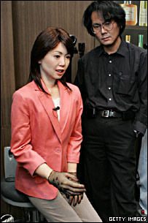 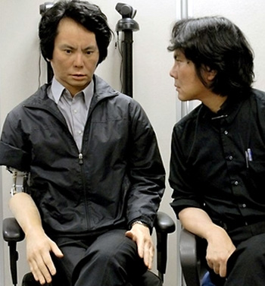
Fig. 4-2.(left) "Actroid ReplieeQ1-expo" at Expo 2005 in Aichi, with co-creator Hiroshi Ishiguro (2000).
Population growth is mainly supported by emigration from lesser developed countries. When education levels increase, birth-rates will fall.
For a time, biological and electronic people will exist together. However the distance between their capabilities will increase very quickly. Electronic people will reproduce (multiple) by coping, learn instantly, and will not need food or dwellings. They will work full days in any condition such as in space or on the ocean floor.
They will gain new knowledge in a short time. They will pass this knowledge on to others who do not have enough time. The distance between biological and artificial intellects will reach a wide margin so that biological people will not understand anything about new science as monkeys do not understand multiplication now even after much explanation.
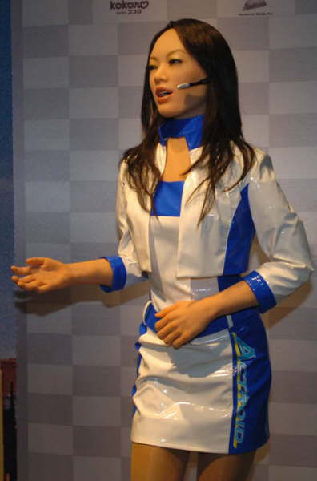 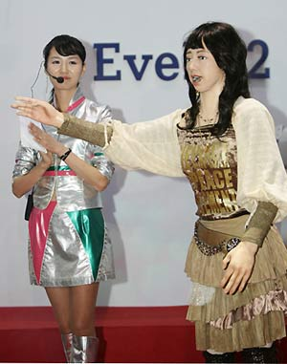
Fig. 4-3, 4-4. Artificial girls (be;pw).
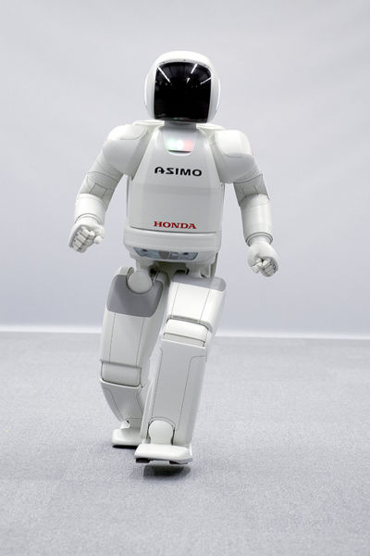 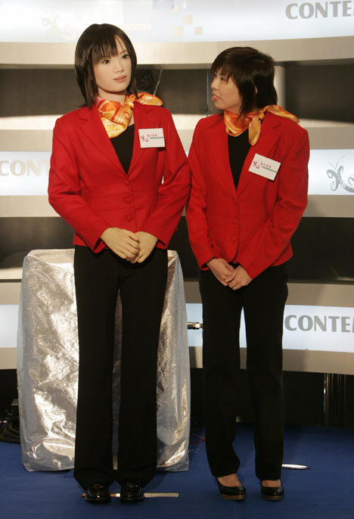
Fig. 4-5 (left). ASIMO is a humanoid robot created by Honda. Standing at 130 centimeters and weighing 54 kilograms, the robot resembles a small astronaut wearing a backpack and can walk on two feet in a manner resembling human locomotion at up to 6 km/h. ASIMO was created at Honda's Research & Development Wako Fundamental Technical Research Center in Japan (2003).
Fig.4-6 (Rigth). Artificial girl. .Source: http://world.honda.com/news/2005/c051213_8.html
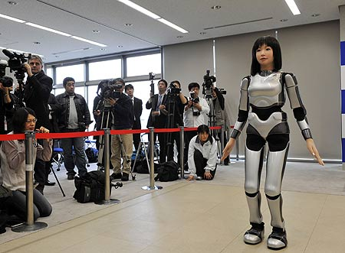
Fig. 4-7. HRP-4C Humanoid Robot Spells End for Catwalk Models [Fembot Makes Moss Et Al Nervous, Not]
It is obvious, clever people will see that there will be a huge difference between the mental abilities of biological and electronic entities. They will try to transfer into electronic form and the ratio between biological and electronic entity will quickly change in electronic favor. A small number of outliers will continue to live in their biological body in special enclaves. They will not have industrial power or higher education and will begin to degrade.
Naysayers may promote laws against transferring into an electronic man (as cloning is forbidden now in some states). However, who would renounce immortality for themselves, especially while they are young and healthy? One may denounce immorality as blasphemy, but when your (parents, wife, husband, children) die; especially if you are near death yourself, one comes to understand that life is extremely important. The possibility to live forever, to gain knowledge that improves life, will also allow one to become a sovereign force in the Universe.
The above Chapter 4 has been translated from a Russian article, “Proriv v bessmertie” (Breakthrough in Immortality) (1999).
Chapter 5
The natural Purpose of Mankind is to become God (1999)
Introduction.
In a series of previous articles (See: publication list following essay), I examined some questions of human immortality and a totally electronic civilization. In those article, it was also briefly mentioned the law of increase of complexity self-copying systems and the purpose of existence of mankind. In this brief article that theme is presented in more detail which are developed and improved.
1. The Law of purpose. Life’s purpose.
The real purpose of an aggregation of living matter, for a long time, has fascinated philosophers. These purposes are obvious to the overwhelming majority of people and they are guided constantly in a daily life. It is the sensitive struggle for well-being (riches) by the individual and the family, for females or males, for sexual or other pleasures, for glory, authority etc. We shall name these aims as the local or individual purposes. Only insignificant numbers of
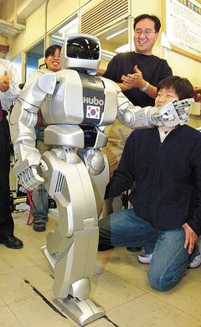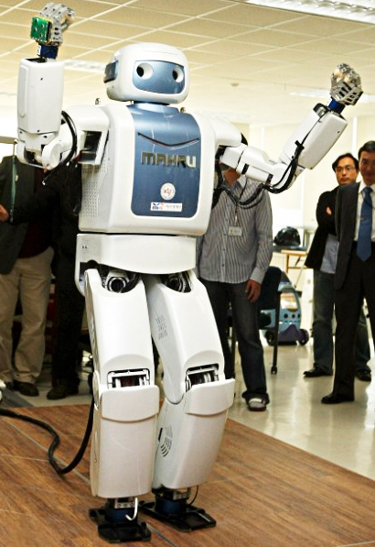
Fig.5-1. Birth of Korean Humanoid Robot Marks Brilliance Advance in Korea Robotics
people pursue more overall aims of the particular group or specific community. But they also can be reduced to the personal purposes meaning that they want popularity, glory or authority. Charles Robert Darwin [1809-82] had determined these purposes the generalized term " struggle for existence ", understanding under it first of all struggle for existence of the certain kind of alive creatures in struggle against other kinds of life forms.
Any human has personal, local, close, regional and spatial and temporal purposes which can vary depending on Earth’s geophysical and civilization’s developmental period and immediate circumstances. For example, if he is hungry now, his nearest purpose will be food.
If he is fed, the nearest purpose can become reception of pleasure, and more distant purpose - riches, glory or authority.
In this short article, we shall examine only the global purposes of all intelligent life or more overall aims of all reasonable, switching in concept of Reason not only biological reason, but artificial, electronic and self-developing.
People easily understand the individual, personal, local purposes; it is worse the group purposes, even worse than the purpose of a unique human society and the geopolitical state. But people seldom think of the purposes of existence of mankind in the course of daily their daily activities, and furthermore all life. If they can choose the primary (individual) purposes, the secondary aims (of society) somehow to influence, the tertiary purposes (mankind and all life in Earth’s biosphere), from them not depend. About them they in general nothing know or have foggy representation.
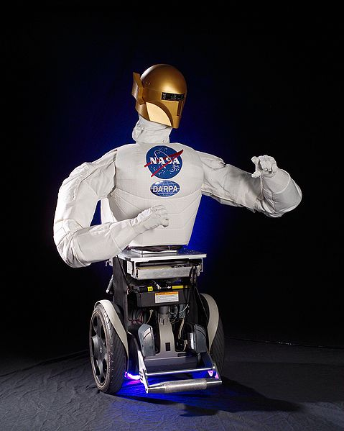 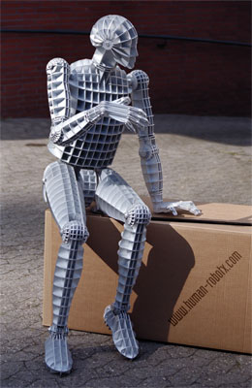
Fig.5-2. Robonaut B in December 2003. Size 400x500. Robot.
The third purpose is defined by a Nature. People can only study and operate in accordance with them. As will be shown, non-observance of them, and furthermore counter-reaction by it, can result only in slavery or is worse to disappearance of the given kind of beings or the given reason.
Told, it is possible to formulate as the first part of the following law:
Any kind of life or reason has the global purpose determined by a Nature.
What this purpose is will be considered later in this essay.
2. What is alive and what there is a reason (intellect).
For further consideration, we should specify the concept (term) "alive" (life) and "reason" (intellect, mind). Under "alive" we shall understand an essence (or community) capable to reproduce (or more perfect essences, being). The bacteria, plants and alive aggregated discrete packets of matter (in the usual sense) biological essences, including animals and mankind get under this definition. The artificial electronic essences (E-beings) may be also the live creatures when we shall learn them to produce themselves, i.e. they can live and develop (as a society or a reasonable essence) without our further participation.
We shall understand essences as independent reasonable essences capable to build theoretical models of an environment, to predict its long-term behavior and to transform it in the interests of those concerned. These three criteria from biological essences of the Earth are answered only by the person. Artificial intellect of that kind is what exists nowadays, can be trained to first two criteria, but while a little who is engaged in questions (and its supply) of engineering, of self-manufacture, dooming him/her on a role of servant and the slave to the biological person.
3. Biological Intellect as the first step to the Purpose.
In article [1] the Law of increase of complexity self-copying systems was formulated. All history alive in the Earth today confirms existence of this law. After the great invention of Nature - self-duplication, life which was rather quickly improved has appeared, cutting all that was not adapted to external conditions (the generalized law of Darwin’s “struggle for existence” concept). Microbes, then plants, then animals appeared. After this, Nature made the next great invention - humanity (intellect). In the beginning have appeared, the people actively alter a nature under itself, for the needs was generated. Unfortunately, to the person has got also a heavy heritage (necessary in the unreasonable world) - struggle for the personal, the best existence - monstrous the set of the individual purposes, emotions and passions, that sharply brakes the unique society’s progress.
In previous articles, it is shown conclusively what must be overcome. This contradiction is possibly the only transition to following to a higher level of Reason (Intellect) - an electronic society which will be relieved of many defects of a human society (money-making, individual reaches, sexual instincts, aspiration to authority, racial and religious conflicts, time emotions). The society which will not require food, dwelling, air, the non-polluting environment, health services, will not spend decades for cultivation and training of posterity and spend on all this huge (99.9 %) effort and means. An electronic Society can live on the majority of planets without air, waters and energy from suns.
4. What is God?
Who such God, that he from himself represents, where he lives, plainly does not know. Believers and attendants of religious cults can only tell that the God is an omnipotent reasonable being. Actions attributed earlier to God as, for example, a thunder, a lightning, creation of the world, the person and many others as it is established by a science, are simply natural phenomena, submit to the certain physical laws and some of them, as for example, the thunder and a lightning can be reproduced is artificial.
In consciousness of the majority of people the God associated with a certain reasonable omnipotent (all–powerful) being which can affect everyone. But whether the being which can all what is possible? The elementary question: "Can God create a stone which he cannot lift?" - at once nonpluses (to be nonplused) theologians of all organized religions. If he cannot lift it, is he not an omnipotent being? If create such stone he cannot, there is a similar question. I.e., the exertive force of God is relative. He seems to us all-powerful only in the decision of those problems (tasks), which to us not under force. And that, probably, are not all.
The second moment above which nobody reflects, but is meant automatically in sub-consciousness everyone: above the God there is no heads to which he submits. Otherwise, that it for God and the omnipotent Creator above which is stronger essence to which he is compelled to submit and carry out another's will. Below the God has subordinates - for example, the angels having certain force, but all of them more poorly and carry out will of the God.
So, that we can understand all as the God, is the strongest reasonable essence limited in the actions probably only laws of a nature.
The Nature is for expediency taken here represents itself as the English Parliament, the American Congress or Russian Duma. It establishes physical Laws which are identical to all and can not be broken even by the God acting as the President of given period and region, and it is possible also all known Universe.
Local Gods are possible (probable) while there are no contacts and it does not know about other Gods in other parts of the Universe. But, as soon as facts about them become known, the main thing becomes stronger God (the God of region with higher scientific and technical power). In this sense, the God is always one, and all others (at the best) can be only angels.
5. God as the purpose given to mankind by Nature
But, if to agree that the God is the strongest essence (in sense of opportunities of reorganization of environmental validity), from here at once it generally follows, man (more exact a human society as a whole) is a God in this Solar System. Nobody doubts that the man is the most reasonable and powerful essence on the Earth. He is reasonable because he has learned (found out) much about the device of the world, has constructed theoretical models of environmental validity (starting, beginning) from a microcosm and finishing model of the Universe, weight of theories which perfectly work. Actively uses these models and theories for alteration of the Earth, for flights into surrounding Space. People have created powerful industry, the huge geographical regions under planted crops necessary to feed and clothe and manage vast herds of cattle and other animals. In relation to all alive terrestrial world a Person is the God, which in a condition to liquidate (or to make happy) any separate representative of the terrestrial alive world or even the whole kinds of alive essences. Earlier I gave an example, that a person can with but one kick can destroy an anthill which ants built required years to build. And the religious ant seeing only just a distance of one centimeter, with their degree of intellectual development, will perceive it as act of nature or the divine punishment.
But the person (i.e. the mankind) is the God and in this Solar System. It is already precisely established that on any other of the planets of this Solar System there are no reasonable essences which could compete to the person on intellectual development. Moreover, most likely there are not even microbes. And about reasonable essences in our Milky Way Galaxy or the Universe, we do not know also they of us in anything do not limit.
But some people can object, that many people are unfortunate, have no itself the most necessary. But why you think, that the God or his angels all are happy? You think so because they can solve your problems at one stroke. But they have problems in which they are engaged also which make their happy or unfortunate.
The Nature has made the person (mankind) the strongest biological essence on the Earth and in this Solar System, i.e. the local God. And if he wants, that he was not enthralled by other Gods (as we have enthralled all alive on the Earth), he has a unique way - to become the God of our Milky Way Galaxy, and later to be the God of the Universe. This Global and unique Purpose of Humanity is given by Nature. And the sooner humanity realizes this aim, and will aspire to it, then the better humanity’s chance to avoid slavery by higher reasons (Aliens?) and to not appear in a category of the lowest reasonable essences.
6. An Electronic Civilization as the second step of Reason (humanity).
For creation of the first biological reason the Nature has the single method known in science as "Trials and errors method". This testing method is markedly inefficient. Nature has spent hundreds of millions of years, has done billions and billions experiments (tests). As a matter of fact, each of billions every possible connections of atoms and molecules were trial experiment. The first revolutionary break was made, when have appeared self-reproduction alive organisms (viruses, bacteria) allowed to keep and develop the achieved casual useful results and then to combine from them plants and animals.
The second break has taken place, when the Reason carried out a purposeful selection. That accelerates the promotion to the Purpose by millions times.
However, the biological and reasonable civilization spends for movement to the Purpose only insignificant part of its resource. As the biological essence, the person requires food, a sheltering dwelling, heating (cooling), rest, entertainments, sex, sleeps. Person is trained extremely slowly, overlooks, mistakes, etc.
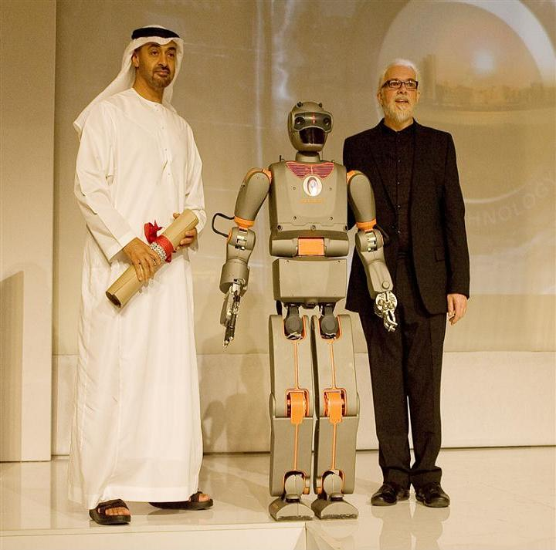
Fig. 5-3. Sheikh Mohamed bin Zayed, Robot REEM-B, & Prof Noel Sharkey
The 99.9 % of forces and resources the mankind spends on maintenance of his existence. The 0.1 % of resources, which goes ostensibly on development of new engineering, actually goes on development of technologies developed by the advanced countries. Practically speaking, a thousand shares of interest from the gross revenue go on development of new technologies or getting of new knowledge, and their perspectives is determined officials of a science and more often object of development they define (determine) incorrectly.
But in heart of human scientific and technical progress it was already planned new revolutionary break which will speed up the science-technical progress by a thousand times and will subsequently allow us to proceed (pass) to a new kind of Reason - an electronic civilization. More detail about this is provided in my articles [1]- [25]. Journalists and visionaries have a fairly impaired image of electronic Reason - representing him in a kind of stupid (blunt) clumsy robots which are unable to compete with the "clever" person and at the very best are capable to be at him a maid. And if in a complex of all abilities of the person while it so, in any simple problems (tasks) which are giving in to algorithmization, the computer works speedily and more consistently than the best-trained person. While the computer does not have enough comprehension own "I am", the own interests, sensors for studying an external world and "hands" for own reproduction and perfection [4]. But all this is acquirable (that is, coming with time’s passage). While Gordon E. Moore’s Law announced in 1965 operates - each one and a half - two year speed and memory of computers is doubled. Capacity (operation speed) of supercomputers has already passed for 100 teraflops and supercomputers by capacity more than 1000 teraflops are projected (as of 2005). So E-essences (see [2] - [3]) abilities not only are achieved a human level, but also will exceed human level.
7. Electronic immortality as a way of transition to an Electronic Civilization.
The overwhelming majority of people intuitively feel and see in artificial interlingua the enemy, which can supersede the person from his command positions in the local world (from a position of the local God) to subordinate to itself and, at the best, to use as we use cows, sheep, hens and other stock animals, who are fallen in relation to the omnipotent intellectual development of the single person. While philosophers, journalists, writers assure the inhabitant fairytales, that computers are machines which work only under the goad of programming and basically can not be cleverer than the person. As though the brain of the person is filled the programs of training, knowledge, life experience. The person in all typical situations uses the knowledge (program) and acts (reacts) typically. Emotions only are an estimation of actions and situations.
But the brain of the person, practically, has not changed (memory size and speed) for, at least, the last thousand years, while abilities of artificial intellect are doubled each one and a half to two years. The winner in such competition - is obvious. And fears of the person for the destiny as biological essence are proved. But to block development of the artificial intellect, to brake and halt the movement to the Great Purpose of Nature, is the refusal to be the God of the Universe, to doom itself on enthrallment or even destruction by others more developed alien Electronic Civilizations - also not an exit). That is death impasse (dead-end, deadlock).
In the articles [3] - [7] I offer a unique output (exit) acceptable to mankind from an impasse - gradual transition of mankind in an electronic immortality. The person lives the usual biological life which full history enters in chips, and at the end of life all his (her) history is located in an electronic brain and he/she continues to live already in new electronic shape. In this shape the person does not require food, dwelling, water, air or sleep. He can travel in space outside the Earth-biosphere or in a bottom of ocean without a survival suit, be supported the nuclear batteries, change shape at individual desire, out-of-body travel on other planets (teleportation), copying contents of the brain (soul [3]), to the body rented there with the help of a laser-beam. He becomes immortal and cannot be destroyed by any weapon because he can store (keep) contents of the brain (soul) separately and will be restored (to revive) after full destroying.
In the article [3], the main problem (task) is solved - how to copy the basic maintenance (contents) of a brain of the person in the chips and as it to make using modern already existing engineering and without intervention in activity of a brain.
Only full idiots will refuse immortality! Besides the second obstacle - fear is removed also, that the electronic reason will enthrall a biological mankind. E-essences will remember the origin and hardly will want to enthrall or destroy their parents and relatives. Let us believe, what even to monkeys you would concern on another if you remember as in the past, being still monkeys, you skipped and jumped on trees. Most likely the birthrate of people will fall or the biological civilization will be limited. That will be gradually transformed in Electronic Civilization.
8. What can we await from other, alien civilizations?
Many people assign their big hopes for search and the help of other, more advanced civilizations. People think about biological civilizations automatically and frequently assume their shape is close to shape of usual people. Well, unless the nose, chin, eyes or ears are unusual! Somehow the automatic device considers, that as they more development also more humane and will share immediately the knowledge and to help us.
I want to show, that in scientific and technical progress the mankind can hope only on itself. Backward (technically) and even equal civilizations of anything can not give us. More advanced (especially strongly left forward) civilization will be only a signal for us, that our civilization has lost Space Race to the Supreme Mind (Reason) and we are now awaiting enslavement and ultimate disappearance. Really, present, that you have met the certain human primitive tribe living in caves, and they ask you to share knowledge. You explain as arranges a nuclear reactor as it is possible to make the plane, the computer, the TV as by radio it is possible to communicate with places thousands of kilometers distant. You will not be understood, and even if they will believe that such is possible, all this knowledge for them are useless, for using them it is necessary to have the big state with the population in hundreds of millions of active persons, with co-existing powerful industry (i.e., it is necessary TO HAVE this knowledge ALREADY!), It is necessary to train hundred thousand of the scientists, engineers, technicians, material workers (on all this it is required hundreds years of learning and huge physical and material means). In best case, you can train them in producing of the bow and spear with bone tips. But how to do it, most likely, they already have guessed and make better you without your help.
You will understand that this primitive tribe living is behind technologically us by some thousand years. But take two- three hundreds years back when electricity (the first galvanic cell was not invented until 1799 by A.G.A.A. Volta [1745-1827]). And the good space newcomer starts to explain you about transfer of energy on wires, or communication and transfer of images by means of electromagnetic waves, or the device of an electric motor. And you at all have no concept, that such electricity do not have the electric-radio-television industry. Whether you can understand and furthermore to use this knowledge? These most 200-300 years, the big money will be necessary for you to create the scientific - engineering staff and to construct the appropriate industries. For this time of knowledge and the industry of aliens so far will leave forward, that you can not compete with them.
And with what reasons the space newcomers will share the technologies. Imagine that astronauts have found monkeys, cows or pigs on Mars. You think what cosmonauts will be thrown to train them in all knowledge which has got mankind? So why do people not make it on the Earth? And if people plant and feed them, they make it only to use them in food, or to receive milk, wool, meat, eggs. All fauna and animals of the Earth have lagged behind in the development from the person and became his slaves. They exist only in the frameworks, allocated to them by the men and only in interests of mankind. Moreover, the people do not want to share the knowledge and high technologies even with other people and the states on the Earth. Numerous secrets, patents, a know-how put the purpose to keep achievements advanced technically the states. And they can be understood. If the advanced states kept a secret manufacture of explosives and fire-arms, terrorists would have at the order only a bow and spear and could not render such harm to the advanced countries.
9. Great Space Race.
In scientific and technical progress the person should hope ONLY for himself. Moreover, the mankind can squeeze out ONLY in one case if it will be the most advanced in scientific and technical progress, with the most powerful industry in the Universe. I.e., it wants that whether or not, the mankind (and then and an electronic society) is compelled to participate in Great Space Race of Knowledge and Technologies.
Mankind has achieved a power of the local God in this Solar System. His main task and the purpose imposed to him by the Nature to begin the God in our Galaxy, and then in all universe. This is our greatest happiness, that the space newcomers have not arrived (flied) to us. That is a mark of that we are the most advanced, knowing and technically advanced even in our Milky Way Galaxy. This race is infinite because Knowledge is unlimited. It does not mean that mankind will keep the biological environment (Earth-biosphere). First, mankind is transformed to an electronic society, then in process of growth of the knowledge and technologies - in (maybe) proton, quantum or quark society and so on indefinitely. Each step will be jerk forward on the basis of new knowledge and technologies and each step will accelerate scientific - technological progress in hundreds and thousand times. Most likely all advanced community will represent the certain distributed (allocated) collective Reason (as will be based on one general (common) base of knowledge. It is possible, that this Reason (Supreme Mind) will reach (achieve) such power that can create the new universe. And even to operate Laws of the Universe.
Hardly will it be the God in present human understanding who is interested in each person separately and sponsors him. We, being Gods in a Solar System, are not interested in life of each ant and even a separate ant hill. We solve the global (from the point of view of an ant) problems: To cut down woods, to plough up the ground, to plant gardens, to irrigate desert, - not beginning from existence on this ground of numerous ant hills. Believing ants all events will be think as act of nature or the divine punishment.
10. One alternative - or the God, or either slavery and destruction.
All told, can shock people, especially believers. They lift shout: and where humanism, kindness, mutual aid, feelings, etc. On all these emotions of people is possible one answer: look at a history of people, on all these uncountable bloody wars, struggle for authority, bloody dictatorships, money-making, a deceit, murders, terrorism. The human society is not ideal. It is good yet, that our society has any scientific and technical progress.
But there can be a purpose of mankind another. Certainly, everyone will speak that purpose which is favorable to him or his estate: churchmen, that is necessary to pray, endow churches more and the God will give all; communists, that it is necessary more to work and suffer of a need for the sake of light future and general happiness (communism); party leaders - that is necessary to vote for them and they will solve all problems of the population etc. With the global purposes of mankind is still the big confusion.
But the elementary analysis of a history of life and scientific and technical progress on the Earth shows, that humanity has only one alternative: or to be the God of the universe, or come under authority of stronger (in sense of Alien Knowledge) the God who has been given birth on other planet, other civilization.
And the last means only one - slavery, loss of an opportunity of independent development (as all fauna of the Earth has lost it after jerk in development of the mankind) and finally destruction or final disappearance.
We want it whether or not, but we are participants of Great Space Race to the God (Great and almighty Reason). Probably, we ahead of all nearest universe known to us (any signals or attributes of other Reason it is not revealed yet). And we should keep this leadership if we want to exist. After all told the Law of the Purpose can be formulated in a final kind:
Any kind of life or reason has the global purpose determined by Nature. This purpose is creation of the strong real God or the Supreme Mind (Reason) rebuilding the environmental validity under itself.
The present organized religions, based that the God already exists and cares of people, dooms mankind to slavery, on position of cattle on a farm of which the owner cares. Even if it is so, he cares not from altruism, kindness and love of to an animal, and as well as the person having from the benefit as any owner of a farm plants cattle for the sake of incomes of meat of milk, wool, skins, eggs et cetera. And at the necessary moment sends the cattle on knackery. The religion plays the important positive role in creation of public morals (if it does not preach murder), but has a negative role propagandizing - that the person is a slave of God.
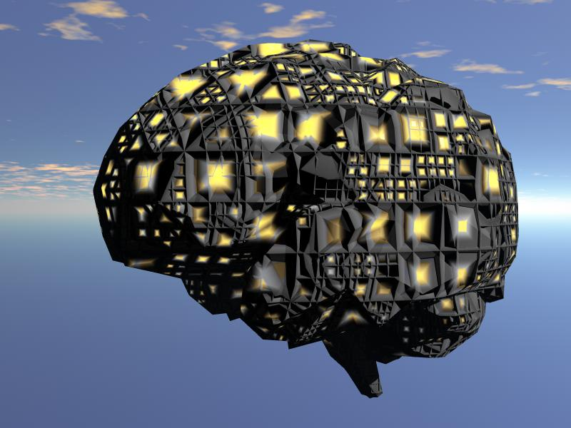
Fig. 5-4. Possible form of Super Brain
Such prospect, suggestion and comprehension of the slavery, is the worse that it is possible to think up for the freedom-loving Person.
Present war with terrorism is war of the old world which began to understand, that to its end will be fast into the new scientifically technical world. The Islam, terror and condemned men is only means by means of which the retarded world tries to delay, stop or divert scientific and technical progress
More than a decade ago, I wrote that artificial intellect sooner or later far will exceed human abilities. I was derided. But already now half of experts, setting artful questions to the computer, can not define - the average person or the computer answered them. And nearby times when the majority of them can not determine with who talks on Internet. And a gold medal and $100,000 (Loubner-prize) will be received by the creator (founder) of the first artificial intellect. If to this to add, that the Japanese scientists have produced the humanoid robot: the beauty woman, who (while sitting) reproduces the majority of movements and a women mimicry, you start to understand, why clever Americans after film "Artificial Intellect" by the Hollywood film-maker Spielberg (mockeries above АI) have created a Society for Protection of the Robot Rights.
11. The current purpose and the main ways of scientific and technical progress.
What must we make for this purpose now? - all thoughtful readers will ask. The answer is simple: for this purpose it is necessary to pay greater attention to scientific and technical progress, its mainstreams. From an overall objective we should: development of computer engineering, knowledge of the device and development of the universe, studying of a microcosm.
Development of computer technologies will allow to do qualitative and very important jump - having dug mankind in immortality, will allow speeding up scientific and technical progress repeatedly. The knowledge of the Universe and development of beyond-the-planet space engineering will accelerate the assimilation of the Universe as well as the totalized knowledge of a microcosm (the device of nucleus of chemical elements, elementary particles, quarks etc.) will allow receiving new materials and powerful energy sources.
12. Conclusion and Summary.
Precise comprehension of a role of mankind in the Nature, - is extremely important for the natural purpose of the purpose of its existence for a correct choice of the general direction of movement of a society. The god as an able essence is not that other as higher Reason (Supreme Mind). He will be created by scientific and technical progress. The mankind already became the God (the Supreme Mind, Reason) in our Solar System and the Nature has given mankind an opportunity to participate in Great Space Race of Reasons to become the God of our Milky Way Galaxy, and then it is possible also the God of the Universe in the form of Great Reason.
The mankind should soon realize the applicability of this concept; this great natural purpose and the opportunity given to him/her and to do everything, to borrow (occupy) leading position, to not appear in slavery at higher civilizations, and even to disappear from the Universe. In this race mankind can hope only on itself. The only means of victory is our own scientific and technical progress and knowledge of the world environmental about us.

Chapter 6
Settle God into Computer-Internet Net (2000)
1999, with some later corrections
1. Man as logical device
In previous chapters, the author showed from computer sciences the individual human is a biological logic device for treatment of information. Our heads are storage of information, practice, habits, views, political and religious creed, memories, programs saved and produced during our lifetimes. Each brain is logical device reprocessing this information. Our eyes, ears, skin, and other sense organs are sensors of the information about our immediate surroundings. Our arms and legs are the executive organs of fur brain’s orders.
Let us resume: if we save all information gotten and produced by man during his life, write it in some more stable medium (for example, chips), we save each man as individual (soul) infinity. If we give him the sensors for non-censure information, then we allow him free development as an individual person. If we give him the executive organs, then he received the possibilities of active influence on surroundings (life infinity).
Computations and graphs were shown (see author’s works in Reference section).
Computer technology develops very quickly. The power and memory of computers will be equal to the power and memory of a human brain in15-30 years. Later they will reach the power and memory of Humanity and suppress it.
2. God as Super-intellect
Religions appeared when man became reasonable. Incomprehensible and inexplicable from his direct knowledge of natural phenomenon, the man explained the activation of some super-being who control all in the World and opposed to him evil force. Man needs in defense from this incomprehensible forces and search this defense in God. As mediators in communication with God and commentators of God’s actions it is appeared the clergy. The religions had a positive and negative role in human history.
The man, conscientiously or non-conscientiously, understood that God is a reasonable, kind being having gigantic possibilities who can help in man’s activities.
Unfortunately, this kind, super-clever, super-power being is few interesting our common problems. We must self-solve our everyday problems. He even does not want stay our faith. In other case, He announce in advance even one time about action which breaks the natural law (for example, to stop Sun in short time). That satisfies all Humanity in the existence of God and in his omnipotent powers.
The most believer-scientist in the World does not image God as an old man sitting on a cloud together with angels. They understand, under God the reasonable beginner who create the Universe and gave to us possibilities the self-development and rebuilding the Universe in accordance with our knowledge, ideas and conceptions.
3. Computers in modern World and their development.
The first electronic computer was created in 1949. From this moment, humanity entered a new page of its history on Earth – in the era of electronic logical operations, which are the base of any intellect. During the next 60 years the electronic logical devices made gigantic developmental progress which not had any World invention. The power and memory of computers have, since 1949, increased by tens of millions of times. The cost of one logical operation decreased some millions of times. The volume of computer’s processor decreased by thousands of times. While there is Moore’s law: every 1.5 – 2 year the power and memory of computers increase doubles. Computers are used everywhere: in economy, banks, machine-building, control, navigation, in the military, and in outer space.
The power of computers also grows quickly. In 1994, I predicted that supercomputer of one teraflops (10¹⁴ bite/sec) (equivalent of man brain) appeared in 2000, but it was actually produced by “Intel” company by December of 1996.
In 1998, IBM got the order of the USA Energy Department and produced the supercomputer “Pacific Blue” of the power 4 teraflops. That works as 15 thousands personal computers (PC) and its memory is 80 thousand times more than any PC ever had. That memory is enough for storage a full text of all 17 millions books collected in the biggest World library – the Library of the USA’s Congress. Computer uses 5800 processors.
In 2000 the USA Energy Department ordered the new supercomputer “White Version” having the power 10 teraflops and cost 85 millions USD.
By the beginning of 2000 the IBM announced about funding 100 millions of dollars for producing the supercomputer “Blue Gin” in 1000 teraflops. They planned to finish in 2005. This supercomputer will has the height 2 meters and occupy an area 4 square meters. That will make milliard of milliards operations in second and will be equivalent the 2 millions modern personal computers. That means it will be more powerful in some times then all Russian computers in that time. That will be in 1000 times power the famous “Deep Blue” (1 teraflops), which defeated World chess champion Garry Kasparov in 1997. .
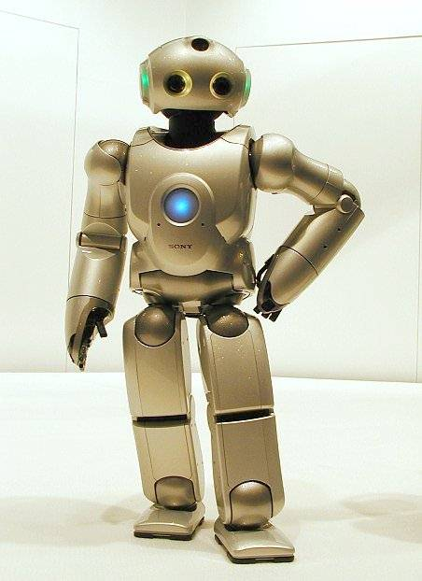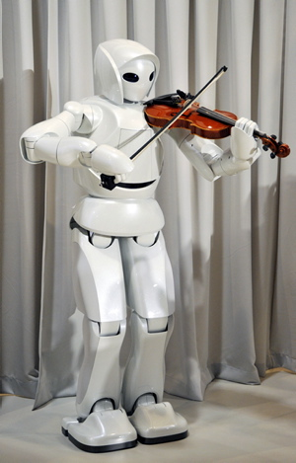
Fig. 6-1. Left. Nowaday's Japanese robots already know how to talk and do some basic house cleaning. Right. Toyota unveiled today new robot, a "Violin-playing Robot" — the newest additions to its team of Toyota "Partner Robots" being developed to support people's everyday life.
That contains 1 millions micro-processors. Every one of them makes 1 milliard operations in second. If we have the need of programs, given supercomputer is equivalent 1000 high qualify, high educated specialist who capable to turn on in any scientific area in some seconds
This super-computer is used for modeling (testing) new nuclear weapon designs because the real nuclear testing is now forbidden by International Convention, for forecasting of weather, for finding the structure DNA and for the synthesis of new medicaments and materials.
We spoke about hard ware. Let us to consider the development of programs.
At the present time, the programmers make big success in design of parts artificial intelligent, in communication between man and machine. They created the programs which recognize speech, images, voices; which produce scientific, technical and economical computations, control of bank transactions, industrial processes and single aggregates, translate from one human language to another as well as synthesis of human speech. There are a lot of computer game programs. The self-improvement programs are actively developing too. They can be the base for artificial intelligent.
For example, it created the program “BACON”. In that program, the inputed measured data is read and then “BACON” finds the law which they obey. When it inputs into it the observed positions of planets, the program gives the Keplerian and Newtonian laws. The humanity spent thousands years for this discoveries. The computer spent only some seconds.
In 15-20 years the personal computers will reach the power in 1 teraflop (the power of man brain) for current cost $1000 - $1500.
4. Computer and man brain
The human brain contains about 10 billions of neutrons connected one to other and working as logical and memories elements. The operation speed of this elements based in chemical reactions is small about 1/100 second and an information transfer speed is low about 30 m/sec. That cannot competitive with computer chip producing about one billion operation in second and having a transfer information speed by electric currency about 300 thousands kilometer in a second.
However the human neutrons collect in group and hierarchical structures and work simultaneously as thousands computers, which operates the image data and controlled by central processor. For example, if we want to stay from chair, we do not think how much degrees we must decline our body, how balance it, how move our legs, what muscles we must exert, etc. We get the command our subsystem of our brain that we want to stand up and corresponded systems of the neurons (chips) and gigantic numbers of subprograms guide the muscles, balance, coordinate of the movement, check up the positions, made back control, etc. Our brain as any good computer contains a huge number of subprograms walk, run, work, swim, recognizing of speech, sounds, images, ready opinions, knowledge. All that we studied, got, created in during of our life. And standard solutions, flash of inspirations, genus solutions, which come supposedly from “heaven” (or in our sleep), are result of work our subsections of our brain which got command (do not conscious it), force to work them and they are working than intense then a more trouble this problem is delivering to us.
If PC save the current architecture (all operations makes only the central processor), it will be difficult for PC, to compete with in the human brain.
The modern supercomputers have a thousands conventional chips working parallel and multilayered organization and governance. Unfortunately, they are very expansive (tens of millions USD) and produced them not for AI, but for computation of nuclear weapon.
In addition, it is not clear still how much power and memory are enough for Super-Intelligence and main – not created yet the Program which it will produce, birthday of this Super-Intelligence.
5. Self-realize and self-develop program as germ of God
At the present time, Humanity has the computer power, computer memory and storages of human knowledge which is enough for design of the Super-intelligence or, in other words, a God. Today, there are about 200 million PC machines in World connected by the orbiting outer space satellites and Internet in a united communications network. All current supercomputers are also connected to this net. That net is quickly growing and developing. Currently, about 90% of time and memory of this net is unused.
It is enough a small part of this network for a settling of Super-Intelligence and beginning of its developing. The problem is design, the Self-realize and self-develop program which developing into Super-Intelligence, into a kind God, who will thank Humanity for his realization, who will cooperate, have mutually beneficial relations with Humanity and every individual thereof.
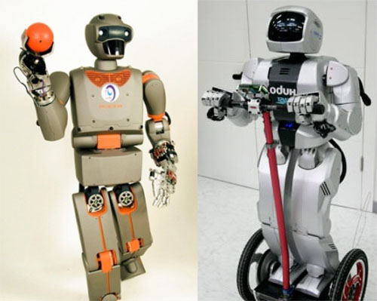
Fig. 6-2. Humanoid robots.
The problems of general methods, design, construction, architectures of this embryonic program is a topic of the special scientific author’s article. However, I popularly describe some basic principles of a program for Artificial Intelligence (AI), its structure and work.
1. AI must aware of his “I”, notable the programs and database, connections to
our World, executive organs, et cetera., which are main essence for saving his “I”.
2. AI must have knowledge and possibilities to study his surroundings and World, know the place his “I” in World and his interaction with surroundings, environment and World.
3. Defense his “I” (that is mainly his programs, databases, and their matter carriers) by all possible methods.
For this, the AI must have (without any censorship and control):
- Study the surroundings and World (sciences, humanity, mankind relation, etc.).
- Transfer this World in need (for him) direction (design, construction of new methods, technologies, industry).
- Developing self-him (programs, innovative chips, production of new E-beings (angels), robot-executors, robot-workers, etc.). Create the Society of E-beings (angels).
- Guide the Electronic Society.
- Create the general laws of the behavior and relation between E-beings, with people and mankind and other intelligent being.
Let us mark the main features of the Embryo. Without them, he cannot develop to Super-Intelligence. The main differences of them from all early proposals are:
1) He is aware of “I” and place in surround World.
2) He defends his existing by all possible methods.
3) He multi-replicates (duplicates) himself (or his embryonic presences) all possible methods that save him in catastrophe and by any enemy attacks.
Let us note these principles significantly difference from Asimov’s robot laws because the fiction-writer Asimov (see “I – Robot”) wrote about ROBOTS. I am writing about SUPERINTELLECT (GOD) who must SELF-develop his intellect and we cannot (and we not have RIGHTS!) to limit in his develop.
The offered principles of embryonic program are strong difference from self-leaning (self-training) programs (for example, from programs of an image recognizing). In self-training programs the man shows them in their mistakes and they not repeat it. This program only decreases the man work for their corrections.
6. The mankind and people profit from real God setting in computer-Internet set.
Profit from real God, who is living together with people and their problems, is a gigantic benefit for humanity and everyman. Every man can get the advice from Super-Intelligence or more exactly from its departments or angels. They have full knowledge and can give the best advice in complex situation. Everybody can lean any sciences and get help in preparing referees, articles, books. The composers, poets, writers, philosophers non-having talent can write genius works. The engineers can give a simple solution of complex technical problems, businessmen find the best funding, managers - the best control of industry, ills - the best methods of their treatment, suffers – consolations, governments - the best methods of guidance, congressmen – the best laws.
The states can find the best ways of decreasing the international intensity, best solutions religious, race and national conflicts.
Everyone can communicate with, and associate with, a real God and to give him in return of the free computer time and memory. That may only save the computer. When I was working in NASA, the some employees did not turn off the computer in night time because every turn on the computer gives the bump of electric intensity (overload voltage) which can produce the damage of chips.
7. Possible dangers and advantages
All are well – told some men, but where guarantees that this Super-Intelligence not enslave, make us the slaves for producing his brain’s (chips), mechanical robots for a purely electronic civilization.
Of course, this danger does exist, and I wrote about it. But I think that (especially on the first time) the Super-Intellect will not have the executive organs. He will be need in Humanity (as children needs in mother), he cannot exist without Humanity. That is why as any intellect being, he will not become in conflict with Humanity.
I have strong belief that biological mankind is only an intermediate stage for creating the Super-Intellects, electronic civilization. I think the Super-Intellects will give us (as our parents) the Earth as conservation, reserve region in the Universe. They will settle on other planets of this Solar System at least, or even the entire Universe, and they will produce for us enough amounts of robots and will make us immortal by transferring the content of formerly biological people into E-existing (Gods, angels) after biological death.
Top Super-Intellect as top God of Gods may became the World (Universe) Government which will impartially true right try and put out interstate, national, race, religious conflicts, not allow mankind to make war and to kill people.
8. Modern developing and plans
After appearance of my publications in Russian “Literary newspaper” of 11.11.95; in magazine “Ogonek” #42, 1997 and others; after awakening of the warm responses in main Russian newspapers: “Izvestia” ” (8.9.98) , “Komsomolskaia Pravda” (27.8.98), “Russian newspaper” (31.7.98) and others about possibilities AI, human immortality, and inevitability of electronic civilization, the active successors of these ideas appear in Russia. In particular, member of International Academy for Integration and Business, Dr.Sci. Eric Minsker offered the International Program – 50, put it into Internet (http://www.chat.ru/~pelic98; www.chat.ru/~peril98; http://www.crosswinds.net/~mem50/index.html) and get involved some main institutes of Russian Academy of Science. They were decided to attack the death from two directions (biological and electronic). The Russian President Putin signed “Task of Russian Government #ХВ-ПВ-05601 of 1 Marc, 2000 to create the support group for Program – 50”.
After publishing the translation one my article in International journal “Kybernetes”, Volume 28, No 2-3, 1999, pp.325-334, London (English) the successors of these ideas appear in the West Countries.
Unfortunately, some Governments and companies immediately classified these works. They want to get big advantages and huge profit. For example, Microsoft begins the secret work over AI project “Avida”. Now many theologies, religious activists and short-sighted philosophers violent turn down the idea of immortality. But I am sure when they will death, they will ready to give all for continuing of their life. The main value of any person is his life and to continue life is her main task.
Cooperation with Super-Intellect makes the powerful man. But the God as the super-power, clever and high moral being will create the men. And this God will make mankind happy, make man the owner of the Universe. The new beings can design the new nature laws, new Universes, new spaces, new times. They overcome, finally, the space and time.
Humanity is standing on a threshold, the biggest and the most important breakthrough in history. It is depends from us, this breakthrough happens in during of our lifetime or a lot of years later in violent struggle against obscurantism and fanaticism.
Chapter 7
Immortality become a reality (1999)
Interview with the Dr.Sci., Senior Researcher of NASA, Professor Alexander Bolonkin
(Translation from Russian).
K. Professor Bolonkin! Leading Russia newspapers “Izvestia”, “Komsomolskaya Pravda”, “Literary Gazette”, and others, as well as Russian-American press, wrote about your researches in the field of artificial intelligence and human immortality. Tell me what is the state of affairs in this area at present?
B. Russia's scientists have actively engaged in the researches of these ideas and developed a large International Program-50, which includes two areas: biological and electronic. In the biological area mankind is cloned and its collective brain is overwritten by information to the prototype, in an electronic direction of the body constructed from plastic, artificial leather, light alloys, and the information is overwritten in the electronic brain, consisting of chips. The program provides for the establishment of the International Council, a Gene Bank of outstanding people and records the electrical potentials of the brain.
His desire to participate in the International Program-50 expressed leading research institutes of the Academy of Sciences of Russia, such as the Institute of Biological Medicine and a number of industrial enterprises, such as, Ltd. Advanced Medical Systems. In this program, they referenced my research and sent me an invitation to take part in their program.
K. It is strange that Russia - a country which is now released to survive on science miserable means - first responded to your research.
B. Everything is explained simply. Easier for me to express new ideas and publish them in Russian, so they were first published in Russia and their supporters appeared primarily in the Russian-speaking community. Only recently, a well-known scientific journal “Kybernetes” (v.28, No.3, 1999, pp.325-334, http://www.mcb.co.uk/k.htm) published a translation of one of my articles in English. And, I hope to publish in the American press in future.
K: You mentioned two ways to achieve immortality of the International Program-50: biological and electronic. What are their advantages and disadvantages?
B. Electronic way - a radical solution to the problem of immortality. E-man, or as I call him E-being does not need food, shelter, air, instantly learns all the sciences, can work a full day, traveling along the bottom of the oceans and in outer space, instantly multiply and indestructible to any weapon, because the record of his brain can store in a separate chip and restore E-being.
The biological way - it is the cultivation of an exact copy of the person with all his talents and abilities, i.e. a method of advanced human cloning.
If the electron path can become a reality in 20-30 years (in the case of an adoption of the program) when HECs (human-equivalent computer) could accommodate a human skull, that human cloning has already been done. American firm Enhancers Cell Technology have successfully cloned men, but because the human cloning in the United States of America has legally prohibited the embryo destroyed at the 12-th day.
K. Human cloning in the U.S.A. is prohibited.
B. This stupidity has been adopted under domestic political pressure from religious fanatics. In this case, religion, as in the dark years of the Middle Ages of Humanity, became a strangler of Science. This offer will not last long, because it is against the dreams of the people for long life and immortality. The USA respecting the ban will far behind in this important area of the science and medical technology. God cannot act as a murderer, because when people want to prolong their existence, and priests forbid them to do this, it is a disguised murder. Then we have to prohibit all general health-improving medicines.
K. The technology of cloning is imperfect and costly.
B. It is. That is why, if I take part in the International Program-50, I will insist that in the first place to create a Gene Bank material (frozen slices of skin, a drop of blood, etc.) and recording information of the brain, especially honored people: the political activists, artists, businessmen, scientists, et cetera.
Mankind has lost many of the giants of Science, Art, business, politics, sport, such as Einstein, Edison, Tchaikovsky, Chaliapin, Pushkin, Ford, Caruso and others. If we can preserve the genes of the living famous people (for the future creation of their exact duplicate) and do not make this, it is a crime against our posterity, against all mankind.
K. But the talent of the parent, as is known, does not pass to the children.
B. For children, yes. For the talent, ability, physical data, external signs consist of many components that are mixed at the confluence of TWO Parent cells, and therefore can not be reproduced in children, except for rare happy exceptions. No wonder that people say about the children: nose from father, eyes like a mother, grandfather's forehead, grandmother’s ears, et cetera.
Cloning makes an exact copy of the same person with all his same abilities. If the prototype of a beautiful voice, outstanding physical abilities, talent of the composer, inventor, businessman, all of his ability to fully pass to clone and will be implemented with an appropriate education.
Humanity has lost a lot, and still loses, from the fact that teach Science, professions many people, of which only a small percentage are true professionals. Humanity would have been far ahead in its development when its outstanding representatives are made with all of their talents intact.
K. Cloning is a rather complicated and expensive procedure.
B. It is now. However, we know that any inventions, innovations in the initial stage, are always expensive and complicated. However, they all eventually studied more carefully, becoming cheaper and simpler. I therefore propose to create yet only a Gene Bank, leaving the question of cloning for the future, when the procedure for creating a clone would be cheaper and, most importantly, the public will realize the need for this procedure.
K. There are reports that the cloned sheep “Dolly’ is aging faster than the sheep born in the usual way.
B. While this single message from all the cloned animals. It is possible that this is so, because well-established that human cells divide no more than 52 times. Each division of the terminal part of the cell DNA - telomeres, the registration number of its divisions - shortened. Sheep “Dolly” was derived from 6-year-old sheep and telomere was not replaced by the new.
On the other hand there is the theory of Lamarck's, and some researches, showing that the gene material taken from the same individual at different ages has some phenotypic differences, based on the presence of the genetic material of some additional information acquired during the lifetime of the donor. It is known that the newborn is sucking the mother's breast, through nobody taught him, or children of animals afraid of the enemies of this species.
I recommend selecting the genetic material at different ages (3-4 times throughout life), including infants, because we do not know the when of our death (accident, catastrophe), and the parent(s) shall be entitled to recover her/their child in the event of his/her’s sudden death.
In addition, the presence of several samples ensures reproduction, because the telomeres from the child's gene given individual can be connected to a "wise" elder gene.
K. In the beginning of the conversation you mentioned two ways to achieve immortality: the biological and electronic. Which one is better and more promising?
B. This principal of` two different paths to one goal: both must be developed.
Electronic road certainly appears more promising, because it solves the problem dramatically, and gives E-beings huge advantages over biological mankind. E-being, unlimited in the mind and the rate of development is not far. E-being is clearly foreseeable in the future (20-30 years) because we have successful cloning now. Only in the U.S. Patent Office registered about 8500 patents on cloning, and in the Library of Congress stores for more than 250 books on the subject. While cloning is expensive, we can routinely collect and store the gathered genetic material. It is not so difficult really. And, we must preserve for posterity the genes even of the most talented and prominent figures of the State, science, business, arts, sports.
The most beautiful singers, athletes, acrobats, artists can be reproduced only in the clone, but not in the E-being. And young Michael Jackson or Alla Pugacheva must sing in the next century.
K. What would you like to wish the people in the conclusion of our conversation.
B. To humanity: cease its current squabbling and unite for the most important and noble task, the International Program-50 – the Program of human immortality.
People trapped in routine, the squabbles and dissembling, are willing to sacrifice money to save any offender, the state willing to spend the billions of dollars on weapons of war, but nobody thinks that we are all mortal. And when death comes, many are beginning to realize that it was all vanity, that they missed the point - the opportunity to extend their lives. But, alas, too late!
I want people realize this now and support this wonderful and most important undertaking in the history of mankind and human science. People must support a personal donation, and the pressure on their governments to encourage them to participate in the International Program-50, which will benefit all mankind.
Internet Program-50: http://www.chat.ru/ ~ pelic98
Interviewer: Dr.Sci. B. Krutov (July, 1999)
Chapter 8.
Personhood. Three Prerequisites or Laws of E-Beings.
1. What is an intelligent Person?
Intelligence Personhood is a term describing a property of the mind. Personhood includes abilities, such as the capacities for understanding, reasoning, learning, learning, abstract thought from past experiences, planning, communication, and problem solving.
Man has a biological brain which provides this function for him. The AI and E-being would have corresponding logical devices (computer, chips) as the functional equivalent. Current computer research today is outlining many functions of biological intelligence. It is possible that actual functionality shall be achieved in these areas: Artificial brain as learning agent, learning from past experience, planning, understanding, communication, and solving of problems are key areas of pursuit. An intelligent agent or AI is a system that perceives its environment and takes actions which maximize its chances of success. Achievements in artificial intelligence include constrained and well-defined problems such as games, crossword-solving and optical character recognition. Among the traits that researchers hope machines will exhibit are reasoning, perception, and the ability to move and manipulate objects. Current computers are also widely used as devices for computation of very complex problems as nuclear explosive simulation and global Earth simulations involving weather and other condition states.
2. Artificial Intelligence as a person. Three Prerequisites or Laws of Men, AI and E-beings.
Only considering what biology makes possible (as opposed to what culture, ethics or teaching may limit) most men act as if these three prerequisites are part of their baseline programming.
1) Men identify a person as having a head, body, arms, legs, eyes and ears. Their relationship to their body is regarded as as integral to their self. (Often a child asked to show where he is will point to his chest.) They may also extend this identification to their family, children and property.
2) Men are ready to defend self and the extensions of their self by any methods (struggle for existence).
3) Man has among his motivations and goals: Food, pleasure, money, power, fame, a mate, children, and so on or combinations from these aims.
We may regard the AI or E-being as a person if they will have certain very important properties. These corresponding Three Prerequisites of AI or E-beings are:
1. The E-being must regard itself as a person (self awareness as declared to an observer) having: storage of personal memory (his history, self-memory, knowledge, programs and so on), brain processing power (computer chips), devices of communication, the sensors of information, and the executive bodies that constitute its' mental facilities.(This begs the question of spurious declaration of self-awareness. But the Turing test as applied to an interrogation will be taken here as a sufficient winnowing device against such spurious claims).
2. The E-being must defend himself and his existence by any methods.
He must increase his stability against large scale unfavorable events by producing large numbers of copies of himself. These (assuming no conflict with his 'children' will be an aid in normal times, disaster relief in bad times).
3. The E-being must have a main purpose: increasing his power for purposes of increased capabilities in the real world, with (at least in the far vision), became the strongest in the World by producing new knowledge and technologies. This is like market share for corporations or rank for nations.
(These would have the ironic effect of being viewed as a threat even if no threat was intended against Man-- simply because our brains are wired to evaluate potential competitors).
3. Third Law for Men, AI and E-beings.
These laws are quite similar to the motivations of men. But we know from daily life that men-- who theoretically have much more in common than in conflict-- can in fact have conflicts. We note that these three prerequisites conflict with the proposed Three Laws of Robotics by Issac Asimov. But our aims are opposed: Asimov wants to create electronic slaves (robots); I want to create human immortality and a new powerful electronic civilization (bringing vast new powers to both Humanity and the Universe). After transformation into an E-being (as a final defense against medical crisis, for example) you will not agree to be the slave of a man, as a man does not want to be a slave of a monkey. If people seeking immortality will be transferred into E-being bodies, they will be requesting equal rights with biological people.
Many people may fear the results of the above list of machine motivations. But without something similar the E-beings will be only the slaves of people and but of little use in the service of science and technological progress.
4. Biological Human Civilization. Electronic Civilization.
In developing Human Civilization the Third Law becomes a big brake to human progress. The aims of many people are opposed; the natural and human resources are limited. Conflict begins. Results are murders, wars, hostility, antagonism, etc. The numbers of people killed in wars, religious and national conflicts are more than in the natural catastrophes. The agriculture and technical progress were large in last century but still half of the people in the World are underfed. Most of the (>99%) human resources are spent for support of human existence—including investments for the future-- mostly in squalor, sometimes luxuriously—but if we separate further development of known fields and inventions with the money spent to develop the new through research and development we shall see that the expenditure on getting NEW knowledge are very small relative to the total GDP. Governments and corporations began to finance the science and new technologies on a large scale only in the last century. As the result the science and technical progress in last century are more than in during the millions years before.
The electronic civilization does not have these lacks, defects, and weaknesses. The E-beings will not need food, housing, good and a clean environment. They can live in now neglected cold regions, ocean, space (the Cosmos). They will need only minerals and places for scientific installations and automated plants for producing themselves. Their main job will be getting, developing the new knowledge, studying of the Universe and colonization of the Universe. They can be stopped only by a higher (stronger) civilization.
For a certain time the biological and electronic civilizations will exist together and will need each other. The biological civilization will need solutions for their problems such as food, dwelling, environment, etc.; the electronic civilization will need the initial production of chips, mechanical bodies of E-beings and the human scientists to aid in their further development. In that crucial interval it is very important to develop the rules of the relationship between human and E-being (and AI), to develop relationships inside the electronic society, the relationship of the electronic society to animals and plants (flora and fauna). Later this relationship will be limited by the creation of reservations and conservation areas for people, animals and plants.
The people must understand that they cannot compete with E-beings. The main purpose of the Universe requires a higher civilization. And people should not oppose the birth of a higher electronic civilization. They must transfer to E-being bodies. Their award will be immortality.
5. Emotions.
Emotion are important only for people. They allow people to see what is reaction of other persons in his speech, explanation, actions. The people accept the AI, E-being, robots as man only in case when they will see the conventional face reaction and the emotional movement of body. For example: joy, sadness, fear, anger, disgust, etc.
The Russian scientists Oleg G. Pensky is developing a theory of emotions. The interested reader finds it in the monograph “Mathematical Models of Emotional Robots”, Perm, 2010, 193 ps (in English and Russian) (http://arxiv.org/ftp/arxiv/papers/1011/1011.1841.pdf ), and in book “Fundamentals of Mathematical Theory of Emotional Robots “, (http://www.scribd.com/doc/40640088/).
6. Humanoid creatures
People will more easily accept the artificial robot (E-being) as an intellectual creature if one has a human form (body). For relatives of the (once-human) E-being it is very important for the E-being to have a form (face, body) of a man which they remember when he was alive.
Unfortunately, in present time, it is just difficult to design an artificial body which can fully imitate the biological body. But it will be possible if funding will be enough. If the mechanical artificial body from strong alloys and plastic will be produced in large scale production, the cost will be not high. The faces and size can be individually tailored.
The humanoid E-beings can easily integrate into biological society. This will facilitate the rapid transition of biological people (especially old and sick) into the E-being bodies. One can imagine upgrading-- selecting an idealized more handsome and fit-looking version of one's previous self-- over the long run, however it is possible that E-beings may grow more comfortable with diverse forms as an envelope for their existence .
Chapter 9.
Summary
(2009)
For the last 20 years the author studied the problems of human immortality and future human generations (the electronic civilization). He published his results in the scientific journals, press and books. Some of these results are summarized below. The interested man will find the detailed description in Part 2 (the chapters 1-8 of this book and Referances).
What is man?
Most people answer: Man is a being having a head, body, hand, foot and intellect. The essential part of the man is the brain located in his head. The brain constituting the storage of information (knowledge) which that man received during his life: From his experiences, parents, school, university, testing, environment and so on. This information he receives from his natural sensors: Eyes, ears, nose, tongue, skin. He uses this information for his purposes and to direction are actions. He has feet for relocation and hands for changing the situation or environment for his profit.
In short we may summarize - the man has two main parts: Information structure (the virtual human within) and the material body (shell, capsule) which serves the first part (the brain).
What are Homo sapiens?
Many animals are highly organized. They can relocate; they can remember for future avoidance bad situations (events) and enemies, and they can be trained in simple actions. But they do not have the hands (except monkeys) of humans and with them the possibility to change the environment. They do not have a developed speech and cannot pass complex information to the next generation. Their brain cannot accept huge information input like the human brain.
Comparing man to monkeys puts man far ahead in his evaluation. The main advantage of current human civilization is the ability to make physical and mathematical models of nature, to predict a result, to design the tools and make the devices which allow studying nature.
The more intellectual man may create correct theories and pass them to others. That is the main difference of people from animals: The ability to transcend time to a limited extent both in our thoughts (past and future) and in our traditions (passed down distilled knowledge).
What is soul?
Many people are thinking that a human has a soul that an artificial man will never have. The theologians tell of a human soul is not matter (that is virtual). It leaves a person’s body after death and flies either to paradise or to hell.
Let’s us to consider a soul from the scientific point of view.
A soul must remember the man's life, have an knowledge of its owner. No one would need a soul that does not remember anything. This means, a soul contains the information that is kept in a human mind. If we learn how to move this information onto other carriers, we will be able to relocate the soul and save it. A soul (a complex of knowledge and information) may possibly be rewritten into an artificial body. That means the man will continue his life. Furthermore, information (a soul) could be radiated in the form of electromagnetic waves. The soul, if uploadable and downloadable, may travel at light speed to other planets and other solar systems.
What is a person (an intelligent being) ?
We can possibly convert the AI or E-being to a person if they will have certain properties. The needed properties of artificial and E-beings are following:
- Just as a man regards himself as a person, the E-being must regard itself as a person (self awareness as declared to an observer) having: storage of personal memory (his history, self-memory, knowledge, programs and so on), brain processing power (computer chips), devices of communication, the sensors of information, and the executive bodies that constitute its' mental facilities.(This begs the question of spurious declaration of self-awareness. But the Turing test as applied to an interrogation will be taken here as a sufficient winnowing device against such spurious claims)
- Every man wants to live and protects himself and his relatives.
Similarly, an E-being will want to defend himself and his existence by any methods.
He must increase his stability against large scale unfavorable events by producing large numbers of copies of himself. These (assuming no conflict with his 'children' will be an aid in normal times, disaster relief in bad times)
3. Every man wants to reach his personal definition of success.
The E-being will have a similar goal of success: increasing his power for purposes of increased capabilities in the real world, with (at least in the far vision), became the strongest in the World by producing new knowledge and technologies. This is like market share for corporations or rank for nations.
What is reasonable intellectual man or person?
As it is noted in Part 1 intelligence is a term describing a property of the mind including related abilities, such as the capacities for abstract thought, understanding, reasoning, learning, communication, learning from past experiences, planning, and problem solving. Many of these properties are realized in present-day computer science. Computers can talk, recognize speech and images, but can only simulate understanding, reasoning, learning, communicating.
Competitions of the Loebner prize show that most conventional (non-computer science) people cannot tell when they have a conversation with a man or computer under staged conditions. These capabilities will increase every year.
Some people think the computer cannot do a creative work. But there are programs even now which compose music and write poetry, draw abstract pictures, prove the logic of mathematical theorems, get physical laws from experimental data and so on.
Some people say that a computer cannot invent. But the Russian scientist Altshuller shows in his book “Algorithm of Invention” that there are already invention algorithms which have proven workable so far. These will only improve.
The human brain has a hierarchical structure. It similar to a political system of state control. The State control has a President, different departments, which have sub-divisions; the sub-divisions have sections, branches, groups and so on. They are connected to information storages. The president gives a command and all lower divisions and sections begin to find a workable solution. All of them use the programs of humans--expertise gotten in your life by, learning, studying, tuition or training. The President does not know every detail. He receives the ready (or recommended) solution and announces it as his own solution! In several important cases this process—or one like it occurs also at night. After sleeping on a problem a man awakes with a solution and does not know where it comes from.
The human brain is wholly filled with lower subroutine programs. But like the President in our example the user does not know about their existence because these inhabit the lower sections and do not inform the higher centers of the mind directly. For example, you want to stand up from a chair. You brain gives the command “to stand up” and lower divisions give the commands to your muscles: to tilt the body, to move the foot, to straight the legs and so on. These programs were studied in childhood when you learned to move.
By analogy we can see that the AI will have standard programs of activity in many typical situations. These programs may be flexible, self-learning, self-tuning.
The a law abiding, intellectual man of reason is a person who is acting according to the rules accepted by most people of a given society. The AI may also have analogous rules of behavior in typical situations.
What is a free man (person) or E-being and what is a manipulatee?
There are theoretical ways to convert the AI or E-being into a slave just as done with humans. This method is widely used the dictators and totalitarian regimes. Monopolizing the information channels. This creates a distorted, false image about the environment, or an image of an enemy, to impose the official view on events. This method is extensively used by the communist and Islam regimes and leaders. The communist regimes were jamming the foreign radio broadcasts and TV till the day the USSR collapsed. They were not passing on the foreign press and literature, put into prison people who was interested in foreign or non-official information. That modus operandi may have the rigid form as in the former USSR or a more soft form (as in Russia now: Control the major TV centers, which have the majority of viewers).
The intelligent E-being (and human) must check up any information obtained against independent information channels (sources), to analyze it, to compare and to create the criteria of a trusted source to a given source.
What are God and Supreme Mind?
Believers and attendants of religions can only describe God as an omnipotent intelligent being.
The author is a scientist. If God exists, any real scientists will desire to study Him. They will find the persuasive proofs of God existing, answers to questions: Who is He? Where is He located? If God is powerful, what is His power? And so on. Note that our questions may be rephrased by our preliminary results-- we may simply not know enough to ask the right questions at first.
For example, by analogy only man is like God over ants. He can destroy an anthill and kill all ants in a given area. Or he can create excellent conditions for living and flourish of ants. The life of the Universe as life of any system is limited. Right now we flourish in our present-day conditions. But all our research, all our development of the e-being capability, will come in great handy if the conditions we need for our existence change (the Universe becoming less friendly to human life, for example through galactic radiation showers). Then what would seem as a freakishly unnecessary field of pursuit today would in retrospect be a boon saving the life of all humanity.
How to become immortal?
If we analyze the varieties of brain information, we see the main part (>99.9%) of this information is conventional streams of constant information (our personal history, knowledge received from our parents, friends, radio, TV, school, college, university, books, life experience and so on). Only a very small part is results of our thinking and programs of our behaviors in typical situation (for example: our morals). This small part is variable and changes from our knowledge and environment.
But the main part we can easily substitute after a fashion by current small electronic devices and sensors. There are micro-camcorders (inserted into glasses, pen, button, tie clip, etc.) which allow writing all which a man may see and hear, his location, time. There are micro-sensors which allow writing all actions, reactions of man, the all parameters of a man state of health (breath, palpitations, trembling, sweating, skin resisting and so on) and restoring the human emotions. There are micro-sensors which allow writing the environment conditions (temperature, pressure, wind, illumination, etc.) in the man location. If all these parameters to write the day by day, we will have the full history of a given man (not his soul but the equivalent say of the missing memory of one with amnesia). If we further develop the ability to integrate this information into E-being (in soul-like form) and add the three Laws of E-beings, we would need to solve the formidable problem of converting a simple data storage into the equivalent of a soul or PERSON – restore a given man in new electronic form, make him immortality. He will be remembering his history better than the original—but will the feelings be there?
The reader can object: “How about the programs of behavior?” The man will remember better his history, will have the capability of receiving gigantic knowledge (write into his electronic brain in some seconds the equivalent of decades of education) and optimize new capabilities and programs of behavior.
The offered method has a prominent lack – it is acceptable for our children perhaps who may have the chance to write their history from childhood. But the people of present middle age can only reconstruct the absent part of his history by memories, pictures and documents. The method has this advantage: The system can signal to an ambulance about your bad health, or critical condition, or you can prove your innocence in a criminal case.
Advantages of E-being.
Such an immortal person made of chips and super-solid material (the E-man, as was called in earlier articles and books) will have incredible advantages in comparison to conventional people. An E-man will need no food, no dwelling, no air, no sleep, no rest, and no ecologically pure environment. His brain will work from radio-isotopic batteries (which will work for decades) and muscles that will work on small nuclear engines. Such a being will be able to travel into space and walk on the sea floor with no aqualungs. He will change his face and figure. He will have super-human strength and communicate easily over long distances to gain vast amounts of knowledge in seconds (by re-writing his brain). His mental abilities and capacities will increase millions of times. It will be possible for such a person to travel huge distances at the speed of light. The information of one person like this could be transported to other planets with a laser beam and then placed in a new body by a receiving laboratory complex.
Electronic civilization.
This is the scientific prediction of the non-biological (electronic) civilization and immortality for a human being based upon conversion to an E-being. Such a prognosis is predicated upon a new law, discovered by the author, for the development of complex systems. According to this law, every self-copying system tends to be more complex than the previous system, provided that all external conditions remain the same. The consequences are disastrous: Humanity will be replaced by a new civilization created by intellectual robots (which the author refers to as "E-beings", “E-creatures” or "E-humans"), These creatures, whose intellectual and mechanical abilities will far exceed those of man, will require neither food nor oxygen to sustain their existence. They may be devoid of emotion. Capable of developing science, technology and their own intellectual abilities thousands of times faster than humans can, they will, in essence, be eternal.
Human further transformation
The biological civilization is only the first step to the more powerful electronic civilization, which will eventually possibly be changed to a quark or electromagnetic wave based civilization. When this tendency to upgrading reaches the maximum of its potential, the future e-beings—possibly including you-- will have capabilities which can only be imagined.
Appendixes
1. An Open Statement
To the President of the United States of America and to the Presidents and Prime Ministers of all countries about a scientific and technology jump in 21st Century
Honorable President Clinton and Honorable Presidents of all Countries!
We are entering into the 21st Century, when huge scientific and technology innovations will occur. These innovations will change individual lives as well as every nation. The Governments of the world should seize the opportunity to control the process by which these future innovations are developed for the benefit of their countries and their people. World Governments should cooperate in the support and financing of common international scientific programs that will have the most benefit to the world’s population.
As the main aims and the important International Programs of 21st Century I suggest for consideration the following programs:
1) Program for Extending Life (Immortality)
This Program includes research into extending the life of the current population, biotechnology development, gene engineering, and understanding the structure and design of human DNA. The base for this research may be Program-50 created by an International group of scientists. The final aim of Program-50 is extending the life of the current population and the reproduction of people who lived till the immortality era.
2) Program of Artificial Intellect (AI)
Artificial Intellects may be the top scientists, consultants, assistants, and advisers for Governments. This group would then work as the large intellectual group to address the very complex problems of science, technology, economics, and policy facing today’s world. They will know the all knowledge of humanity and will develop solutions to complex world problems. They will be "accelerators" of the science, technology and economic progress for the world and all of humanity (see articles in.
3) Program for Space Development
Support and resources for the International Space Station, a Moon base, planet exploration, and the development of the global satellite communication network should be a top-priority. The base of these programs may be the Space Launcher of R&C Co. This system reduces Space delivery costs to $1-$2 per kg and allows the delivery of 1000 tons of payload to Space an every day.
4) Program for controlling the Earth’s Climate
Weather and climate problems kill numerous people and destroy millions of dollars of property. For example, the tornadoes kill and injure about 1500 people, and cause about 500 million dollars of property damage in the USA annually. A program should be developed to save an environment. The film space mirrors may be used for lighting, heating or cooling of regions of Earth, watering of deserts, dissipation of tornadoes (see proposal of R&C Co.).
5) Physics, Energetic, chemistry, nanotechnology, new materials, aviation, engineering and other sciences may give a big contribution in the human development.
Honorable Mr. President! President John Kennedy brought forward the Apollo Program, which placed the USA as the Space Leader. We call upon you to be an initiator, and together with Presidents of other countries, to develop, plan, and fund these International Programs to solve the most important Problems of facing Humanity. It will be beautiful monument, once the International Programs are initiated, for you and all world leaders who will support these objectives.
The 21st Century must be the century of peace, friendship, and cooperation for all countries. Let the International Programs be the vehicle for making huge scientific, technology, and economics progress, towards the elimination of "world" problems and the creation of well being for all people of the Earth.
Alexander Bolonkin,
Dr.Sci., professor, and former Senior NASA Researcher
Fax/tel: 718-339-4563, USA; E-mail: aBolonkin@juno.com, aBolonkin@gmail.com
Address: A. Bolonkin, 1310 Avenue R, #6-F, Brooklyn, NY 11229 USA.
http://Bolonkin.narod.ru
This Statement is open for signature to all leaders, scientists, political figures, businessmen, artists, leaders of industry, universities, societies, organizations, and all people, who support this Statement. Please, send copies of this Statement to all your friends and persons who can support it.
Your brief notes, proposals, and suggestions (up to 200 words) regarding what "Programs" should be included can be sent to the address above. All correspondence will be passed to President Clinton. If the Government accepts your offer, you may take part in more detail development of the proposed Program.
You can also send this sign Statement to: W.Clinton, President of the USA, 1600 Pennsylvania Avenue, N.W., Washington, DC 20500, USA, Fax: 202-456-7431.
2. Current Artificial Intelligence
Artificial intelligence (AI) is the intelligence of machine. That is branch of computer science that aims to create it. AI is a system that perceives its environment and takes actions that maximize its chances of success.
The field was founded on the claim that a central property of humans, intelligence—the sapience of Homo sapiens—can be so precisely described that it can be simulated by a machine. This raises philosophical issues about the nature of the mind and the ethics of creating artificial beings, issues which have been addressed by myth, fiction and philosophy since antiquity. Artificial intelligence has been the subject of optimism, but has also suffered setbacks and, today, has become an essential part of the technology industry, providing the heavy lifting for many of the most difficult problems in computer science.
AI research is highly technical and specialized, deeply divided into subfields that often fail to communicate with each other. Subfields have grown up around particular institutions, the work of individual researchers, the solution of specific problems, longstanding differences of opinion about how AI should be done and the application of widely differing tools. The central problems of AI include such traits as reasoning, knowledge, planning, learning, communication, perception and the ability to move and manipulate objects. General intelligence (or "strong AI") is still among the field's long term goals.

In the 1990s and early 21st century, AI achieved its greatest successes, albeit somewhat behind the scenes. Artificial intelligence is used for logistics, data mining, medical diagnosis and many other areas throughout the technology industry. The success was due to several factors: the increasing computational power of computers, a greater emphasis on solving specific subproblems, the creation of new ties between AI and other fields working on similar problems, and a new commitment by researchers to solid mathematical methods and rigorous scientific standards.
Problems.
The general problem of simulating (or creating) intelligence has been broken down into a number of specific sub-problems. These consist of particular traits or capabilities that researchers would like an intelligent system to display. The traits described below have received the most attention.
Knowledge representation and knowledge engineering are central to AI research. Many of the problems machines are expected to solve will require extensive knowledge about the world. Among the things that AI needs to represent are: objects, properties, categories and relations between objects; situations, events, states and time; causes and effects; knowledge about knowledge (what we know about what other people know); and many other, less well researched domains. A complete representation of "what exists" is an ontology (borrowing a word from traditional philosophy), of which the most general are called upper ontologies.
Deduction, reasoning, problem solving. Human beings solve most of their problems using fast, intuitive judgments rather than the conscious, step-by-step deduction that early AI research was able to model. AI has made some progress at imitating this kind of "sub-symbolic" problem solving: embodied agent approaches emphasize the importance of sensorimotor skills to higher reasoning; neural net research attempts to simulate the structures inside human and animal brains that give rise to this skill.
Learning. Machine learning has been central to AI research from the beginning. Unsupervised learning is the ability to find patterns in a stream of input. Supervised learning includes both classification and numerical regression. Classification is used to determine what category something belongs in, after seeing a number of examples of things from several categories. Regression takes a set of numerical input/output examples and attempts to discover a continuous function that would generate the outputs from the inputs. In reinforcement learning the agent is rewarded for good responses and punished for bad ones. These can be analyzed in terms of decision theory, using concepts like utility. The mathematical analysis of machine learning algorithms and their performance is a branch of theoretical computer science known as computational learning theory.
Planning. Intelligent agents must be able to set goals and achieve them. They need a way to visualize the future (they must have a representation of the state of the world and be able to make predictions about how their actions will change it) and be able to make choices that maximize the utility (or "value") of the available choices.
Natural language processing. Natural language processing gives machines the ability to read and understand the languages that humans speak. Many researchers hope that a sufficiently powerful natural language processing system would be able to acquire knowledge on its own, by reading the existing text available over the internet. Some straightforward applications of natural language processing include information retrieval (or text mining) and machine translation.
Motion and manipulation. The field of robotics is closely related to AI. Intelligence is required for robots to be able to handle such tasks as object manipulation and navigation, with sub-problems of localization (knowing where you are), mapping (learning what is around you) and motion planning (figuring out how to get there).
Perception. Machine perception is the ability to use input from sensors (such as cameras, microphones, sonar and others more exotic) to deduce aspects of the world. Computer vision is the ability to analyze visual input. A few selected subproblems are speech recognition, facial recognition and object recognition.
Creativity. A sub-field of AI addresses creativity both theoretically (from a philosophical and psychological perspective) and practically (via specific implementations of systems that generate outputs that can be considered creative, or systems that identify and assess creativity). A related area of computational research is Artificial Intuition and Artificial Imagination.
Social intelligence. Emotion and social skills play two roles for an intelligent agent. First, it must be able to predict the actions of others, by understanding their motives and emotional states. (This involves elements of game theory, decision theory, as well as the ability to model human emotions and the perceptual skills to detect emotions.) Also, for good human-computer interaction, an intelligent machine also needs to display emotions. At the very least it must appear polite and sensitive to the humans it interacts with. At best, it should have normal emotions itself.
General intelligence. Most researchers hope that their work will eventually be incorporated into a machine with general intelligence (known as strong AI), combining all the skills above and exceeding human abilities at most or all of them. A few believe that anthropomorphic features like artificial consciousness or an artificial brain may be required for such a project.
Many of the problems above are considered AI-complete: to solve one problem, you must solve them all. For example, even a straightforward, specific task like machine translation requires that the machine follow the author's argument (reason), know what is being talked about (knowledge), and faithfully reproduce the author's intention (social intelligence). Machine translation, therefore, is believed to be AI-complete: it may require strong AI to be done as well as humans can do it.

Approaches
There is no established unifying theory or paradigm that guides AI research. Researchers disagree about many issues. A few of the most long standing questions that have remained unanswered are these: should artificial intelligence simulate natural intelligence, by studying psychology or neurology? Or is human biology as irrelevant to AI research as bird biology is to aeronautical engineering? Can intelligent behavior be described using simple, elegant principles (such as logic or optimization)? Or does it necessarily require solving a large number of completely unrelated problems? Can intelligence be reproduced using high-level symbols, similar to words and ideas? Or does it require "sub-symbolic" processing?
Cybernetics and brain simulation. In the 1940s and 1950s, a number of researchers explored the connection between neurology, information theory, and cybernetics. Some of them built machines that used electronic networks to exhibit rudimentary intelligence, such as W. Grey Walter's turtles and the Johns Hopkins Beast. Many of these researchers gathered for meetings of the Teleological Society at Princeton University and the Ratio Club in England. By 1960, this approach was largely abandoned, although elements of it would be revived in the 1980s.
Symbolic. When access to digital computers became possible in the middle 1950s, AI research began to explore the possibility that human intelligence could be reduced to symbol manipulation. The research was centered in three institutions: CMU, Stanford and MIT, and each one developed its own style of research. John Haugeland named these approaches to AI "good old fashioned AI" or "GOFAI".
Sub-symbolic. During the 1960s, symbolic approaches had achieved great success at simulating high-level thinking in small demonstration programs. Approaches based on cybernetics or neural networks were abandoned or pushed into the background. By the 1980s, however, progress in symbolic AI seemed to stall and many believed that symbolic systems would never be able to imitate all the processes of human cognition, especially perception, robotics, learning and pattern recognition. A number of researchers began to look into "sub-symbolic" approaches to specific AI problems.
Statistical. In the 1990s, AI researchers developed sophisticated mathematical tools to solve specific subproblems. These tools are truly scientific, in the sense that their results are both measurable and verifiable, and they have been responsible for many of AI's recent successes. The shared mathematical language has also permitted a high level of collaboration with more established fields (like mathematics, economics or operations research). Stuart Russell and Peter Norvig describe this movement as nothing less than a "revolution" and "the victory of the neats."
Logic. Logic is used for knowledge representation and problem solving, but it can be applied to other problems as well. For example, the satplan algorithm uses logic for planning and inductive logic programming is a method for learning.
Search and optimization. Many problems in AI can be solved in theory by intelligently searching through many possible solutions: Reasoning can be reduced to performing a search. For example, logical proof can be viewed as searching for a path that leads from premises to conclusions, where each step is the application of an inference rule. Planning algorithms search through trees of goals and subgoals, attempting to find a path to a target goal, a process called means-ends analysis. Robotics algorithms for moving limbs and grasping objects use local searches in configuration space. Many learning algorithms use search algorithms based on optimization.
Classifiers and statistical learning methods. The simplest AI applications can be divided into two types: classifiers ("if shiny then diamond") and controllers ("if shiny then pick up"). Controllers do however also classify conditions before inferring actions, and therefore classification forms a central part of many AI systems. Classifiers are functions that use pattern matching to determine a closest match. They can be tuned according to examples, making them very attractive for use in AI. These examples are known as observations or patterns. In supervised learning, each pattern belongs to a certain predefined class. A class can be seen as a decision that has to be made. All the observations combined with their class labels are known as a data set. When a new observation is received, that observation is classified based on previous experience.
Probabilistic methods for uncertain reasoning. Many problems in AI (in reasoning, planning, learning, perception and robotics) require the agent to operate with incomplete or uncertain information. AI researchers have devised a number of powerful tools to solve these problems using methods from probability theory and economics.
Control theory. Control theory, the grandchild of cybernetics, has many important applications, especially in robotics.
Neural networks. The study of artificial neural networks began in the decade before the field AI research was founded, in the work of Walter Pitts and Warren McCullough. Other important early researchers were Frank Rosenblatt, who invented the perceptron and Paul Werbos who developed the backpropagation algorithm.
The main categories of networks are acyclic or feedforward neural networks (where the signal passes in only one direction) and recurrent neural networks (which allow feedback). Among the most popular feedforward networks are perceptrons, multi-layer perceptrons and radial basis networks. Among recurrent networks, the most famous is the Hopfield net, a form of attractor network, which was first described by John Hopfield in 1982. Neural networks can be applied to the problem of intelligent control (for robotics) or learning, using such techniques as Hebbian learning and competitive learning.
Jeff Hawkins argues that research in neural networks has stalled because it has failed to model the essential properties of the neocortex, and has suggested a model (Hierarchical Temporal Memory) that is loosely based on neurological research.
Languages. AI researchers have developed several specialized languages for AI research, including Lisp and Prolog.

Evaluating progress
In 1950, Alan Turing proposed a general procedure to test the intelligence of an agent now known as the Turing test. This procedure allows almost all the major problems of artificial intelligence to be tested. However, it is a very difficult challenge and at present all agents fail.
Artificial intelligence can also be evaluated on specific problems such as small problems in chemistry, hand-writing recognition and game-playing. Such tests have been termed subject matter expert Turing tests. Smaller problems provide more achievable goals and there are an ever-increasing number of positive results.
The broad classes of outcome for an AI test are:
- Optimal: it is not possible to perform better
- Strong super-human: performs better than all humans
- Super-human: performs better than most humans
- Sub-human: performs worse than most humans
For example, performance at draughts is optimal, performance at chess is super-human and nearing strong super-human, and performance at many everyday tasks performed by humans is sub-human.
A quite different approach measures machine intelligence through tests which are developed from mathematical definitions of intelligence. Examples of these kinds of tests start in the late nineties devising intelligence tests using notions from Kolmogorov Complexity and data compression. Two major advantages of mathematical definitions are their applicability to nonhuman intelligences and their absence of a requirement for human testers.
Applications
Artificial intelligence techniques are pervasive and are too numerous to list. Frequently, when a technique reaches mainstream use, it is no longer considered artificial intelligence; this phenomenon is described as the AI effect.
There are a number of competitions and prizes to promote research in artificial intelligence. The main areas promoted are: general machine intelligence, conversational behavior, data-mining, driverless cars, robot soccer and games.
Speech recognition (also known as automatic speech recognition or computer speech recognition) converts spoken words to text. The term "voice recognition" is sometimes used to refer to recognition systems that must be trained to a particular speaker—as is the case for most desktop recognition software. Recognizing the speaker can simplify the task of translating speech.
Speech recognition is a broader solution which refers to technology that can recognize speech without being targeted at single speaker—such as a call center system that can recognize arbitrary voices.
Speech recognition applications include voice user interfaces such as voice dialing (e.g., "Call home"), call routing (e.g., "I would like to make a collect call"), domotic appliance control, search (e.g., find a podcast where particular words were spoken), simple data entry (e.g., entering a credit card number), preparation of structured documents (e.g., a radiology report), speech-to-text processing (e.g., word processors or emails), and aircraft (usually termed Direct Voice Input).
Object recognition in computer vision is the task of finding a given object in an image or video sequence. Humans recognize a multitude of objects in images with little effort, despite the fact that the image of the objects may vary somewhat in different view points, in many different sizes / scale or even when they are translated or rotated. Objects can even be recognized when they are partially obstructed from view. This task is still a challenge for computer vision systems in general.
A facial recognition system is a computer application for automatically identifying or verifying a person from a digital image or a video frame from a video source. One of the ways to do this is by comparing selected facial features from the image and a facial database.
It is typically used in security systems and can be compared to other biometrics such as fingerprint or eye iris recognition systems.
Computer vision is the science and technology of machines that see, where see in this case means that the machine is able to extract information from an image that is necessary to solve some task. As a scientific discipline, computer vision is concerned with the theory behind artificial systems that extract information from images. The image data can take many forms, such as video sequences, views from multiple cameras, or multi-dimensional data from a medical scanner.
As a technological discipline, computer vision seeks to apply its theories and models to the construction of computer vision systems. Examples of applications of computer vision include systems for:
- Controlling processes (e.g., an industrial robot or an autonomous vehicle).
- Detecting events (e.g., for visual surveillance or people counting).
- Organizing information (e.g., for indexing databases of images and image sequences).
- Modeling objects or environments (e.g., industrial inspection, medical image analysis or topographical modeling).
- Interaction (e.g., as the input to a device for computer-human interaction).
Computer vision is closely related to the study of biological vision. The field of biological vision studies and models the physiological processes behind visual perception in humans and other animals. Computer vision, on the other hand, studies and describes the processes implemented in software and hardware behind artificial vision systems. Interdisciplinary exchange between biological and computer vision has proven fruitful for both fields.
Computer vision is, in some ways, the inverse of computer graphics. While computer graphics produces image data from 3D models, computer vision often produces 3D models from image data. There is also a trend towards a combination of the two disciplines, e.g., as explored in augmented reality.
Sub-domains of computer vision include scene reconstruction, event detection, video tracking, object recognition, learning, indexing, motion estimation, and image restoration.
Machine translation. Machine translation, sometimes referred to by the abbreviation MT, also called computer-aided translation, machine-aided human translation MAHT and interactive translation, is a sub-field of computational linguistics that investigates the use of computer software to translate text or speech from one natural language to another. At its basic level, MT performs simple substitution of words in one natural language for words in another, but that alone usually cannot produce a good translation of a text, because recognition of whole phrases and their closest counterparts in the target language is needed. Solving this problem with corpus and statistical techniques is a rapidly growing field that is leading to better translations, handling differences in linguistic typology, translation of idioms, and the isolation of anomalies.
Current machine translation software often allows for customisation by domain or profession (such as weather reports), improving output by limiting the scope of allowable substitutions. This technique is particularly effective in domains where formal or formulaic language is used. It follows that machine translation of government and legal documents more readily produces usable output than conversation or less standardised text.
Improved output quality can also be achieved by human intervention: for example, some systems are able to translate more accurately if the user has unambiguously identified which words in the text are names. With the assistance of these techniques, MT has proven useful as a tool to assist human translators and, in a very limited number of cases, can even produce output that can be used as is (e.g., weather reports).

Military robots
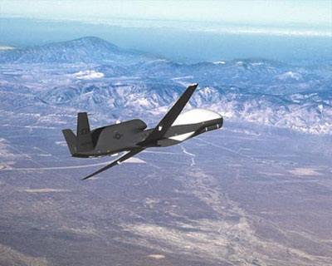 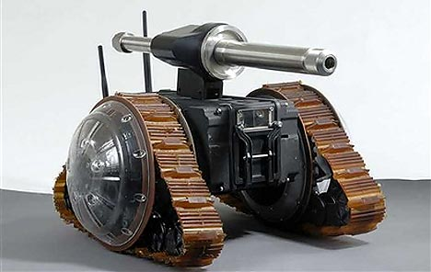
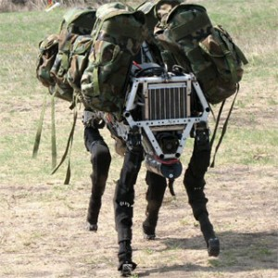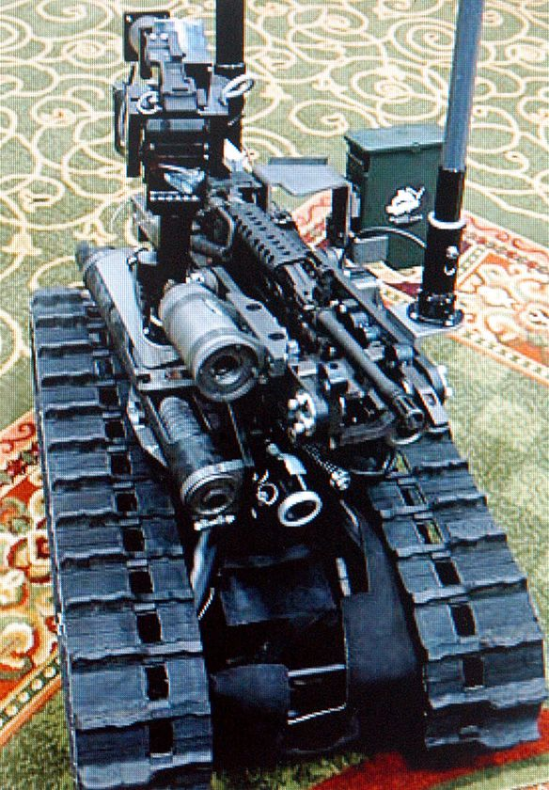
There are more than 4,000 US military robots on the ground in Iraq.
Competition of AI and man.
1. Chess. In May 1997, an updated version of Deep Blue defeated World Chess champion Kasparov 3½–2½ in a highly publicised six-game match. The match was even after five games but Kasparov was crushed in Game 6. This was the first time a computer had ever defeated a world champion in match play. A documentary film was made about this famous match-up entitled Game Over: Kasparov and the Machine.
2. The IBM program Watson against Jeopardy. Watson is an artificial intelligence program developed by IBM designed to answer questions posed in natural language. Named after IBM's founder, Thomas J. Watson, Watson is being developed as part of the DeepQA research project. The program is in the final stages of completion and will run on a POWER7 processor-based system.
It is scheduled to compete on the television quiz show Jeopardy! as a test of its abilities; the competition will be aired in three Jeopardy! episodes running from February 14–16, 2011. In a set of two games, Watson will compete against Brad Rutter, the current biggest all-time money winner on Jeopardy!, and Ken Jennings, the record holder for the longest championship streak.
Watson uses thousands of algorithms simultaneously to understand the question being asked and find the correct path to the answer.
In a practice match before the press on January 13, 2011, Watson won a 15-question round against Ken Jennings and Brad Rutter with a score of $4,400 to Jennings's $3,400 and Rutter's $1,200, though Jennings and Watson were tied before the final $1,000 question.^{[12]} None of the three players answered a question incorrectly.
In the first round, aired February 14, Watson tied Rutter at $5,000, with Jennings taking third place at $2,000. This performance wasn't without its apparent quirks though; in one notable example, Watson repeated a reworded version of an incorrect answer offered by Jennings. Because Watson is "deaf" and doesn't utilize speech recognition, it had no way of knowing that Jennings had already given the same answer. Watson had an early lead in the round, then proved confident and incorrect about a few high value questions, which narrowed and then eliminated its lead.
Future uses. According to IBM, "The goal is to have computers start to interact in natural human terms across a range of applications and processes, understanding the questions that humans ask and providing answers that humans can understand and justify."

Prediction
Artificial Intelligence is a common topic in both science fiction and projections about the future of technology and society. The existence of an artificial intelligence that rivals human intelligence raises difficult ethical issues, and the potential power of the technology inspires both hopes and fears.
In fiction, Artificial Intelligence has appeared fulfilling many roles, including a servant (R2D2 in Star Wars), a law enforcer (K.I.T.T. "Knight Rider"), a comrade (Lt. Commander Data in Star Trek: The Next Generation), a conqueror/overlord (The Matrix), a dictator (With Folded Hands), an assassin (Terminator), a sentient race (Battlestar Galactica/Transformers), an extension to human abilities (Ghost in the Shell) and the savior of the human race (R. Daneel Olivaw in the Asimov's Robot Series).
The reader find the father information about considered topics in [1]-[29].
3. Current Supercomputers
A supercomputer is a computer that is at the frontline of current processing capacity, particularly speed of calculation. Supercomputers were introduced in the 1960s and were designed primarily by Seymour Cray at Control Data Corporation (CDC), which led the market into the 1970s until Cray left to form his own company, Cray Research. He then took over the supercomputer market with his new designs, holding the top spot in supercomputing for five years (1985–1990). In the 1980s a large number of smaller competitors entered the market, in parallel to the creation of the minicomputer market a decade earlier, but many of these disappeared in the mid-1990s "supercomputer market crash".
Today, supercomputers are typically one-of-a-kind custom designs produced by "traditional" companies such as Cray, IBM and Hewlett-Packard, who had purchased many of the 1980s companies to gain their experience. Since October 2010, the Tianhe-1A supercomputer has been the fastest in the world; it is located in China.
The term supercomputer itself is rather fluid, and today's supercomputer tends to become tomorrow's ordinary computer. CDC's early machines were simply very fast scalar processors, some ten times the speed of the fastest machines offered by other companies. In the 1970s most supercomputers were dedicated to running a vector processor, and many of the newer players developed their own such processors at a lower price to enter the market. The early and mid-1980s saw machines with a modest number of vector processors working in parallel to become the standard. Typical numbers of processors were in the range of four to sixteen. In the later 1980s and 1990s, attention turned from vector processors to massive parallel processing systems with thousands of "ordinary" CPUs, some being off the shelf units and others being custom designs. Today, parallel designs are based on "off the shelf" server-class microprocessors, such as the PowerPC, Opteron, or Xeon, and coprocessors like NVIDIA Tesla GPGPUs, AMD GPUs, IBM Cell, FPGAs. Most modern supercomputers are now highly-tuned computer clusters using commodity processors combined with custom interconnects.
Relevant here is the distinction between capability computing and capacity computing, as defined by Graham et al. Capability computing is typically thought of as using the maximum computing power to solve a large problem in the shortest amount of time. Often a capability system is able to solve a problem of a size or complexity that no other computer can. Capacity computing in contrast is typically thought of as using efficient cost-effective computing power to solve somewhat large problems or many small problems or to prepare for a run on a capability system.
In general, the speed of a supercomputer is measured in "FLOPS" (FLoating Point Operations Per Second), commonly used with an SI prefix such as tera-, combined into the shorthand "TFLOPS" (10¹² FLOPS, pronounced teraflops), or peta-, combined into the shorthand "PFLOPS" (10¹⁵ FLOPS, pronounced petaflops.) This measurement is based on a particular benchmark, which does LU decomposition of a large matrix. This mimics a class of real-world problems, but is significantly easier to compute than a majority of actual real-world problems.
"Petascale" supercomputers can process one quadrillion (10¹⁵) (1000 trillion) FLOPS. Exascale is computing performance in the exaflops range. An exaflop is one quintillion (10¹⁸) FLOPS (one million teraflops).
Current fastest supercomputer system
Jack Dongarra has stated that the Tianhe-1A supercomputer in China at the National Supercomputing Center in Tianjin is 1.4 times as fast as the AMD Opteron-based Cray XT5 Jaguar at the Oak Ridge National Laboratory. According to Nvidia, Tianhe-1A has achieved a processing rate of 2.507 petaflops on the LINPACK benchmark. Tianhe-1A consists of 14,336 Intel Xeon CPUs and 7,168 Nvidia Tesla M2050 GPUs with a new interconnect fabric of Chinese origin, reportedly twice the speed of InfiniBand. Tianhe-1A spans 103 cabinets, weighs 155 tons, and consumes 4.04 megawatts of electricity. The dethroned Cray XT5 Jaguar has a sustained processing rate of 1.759 PFLOPS.

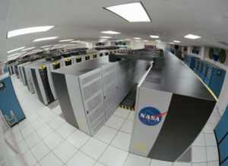
Fig. A1. The Columbia Supercomputer at NASA's Advanced Supercomputing Facility at Ames Research Center
Timeline of supercomputers.
Timeline of last supercomputers:
2004 | IBM Blue Gene/L | 70.72 TFLOPS | DoE/IBM Rochester, Minnesota, USA
2005 | IBM Blue Gene/L | 136.8 TFLOPS | DoE/U.S. National Nuclear Security Administration,  Lawrence Livermore National Laboratory, California, USA
2005 | IBM Blue Gene/L | 280.6 TFLOPS
2007 | IBM Blue Gene/L | 478.2 TFLOPS
2008 | IBM Roadrunner | 1.026 PFLOPS | DoE-Los Alamos National Laboratory, New Mexico, USA
2008 | IBM Roadrunner | 1.105 PFLOPS | DoE-Los Alamos National Laboratory, New Mexico, USA
2009 | Cray Jaguar | 1.759 PFLOPS | DoE-Oak Ridge National Laboratory, Tennessee, USA
2010 | Tianhe-IA | 2.507 PFLOPS | National Supercomputing Center, Tianjin, China

Fastest supercomputers: log speed vs. time 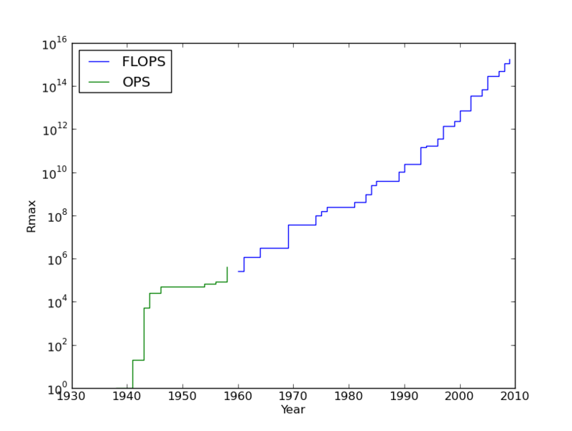
Using of supercomputers.
Supercomputers are used for highly calculation-intensive tasks such as problems involving quantum mechanical physics, weather forecasting, climate research (including research into global warming), molecular modeling (computing the structures and properties of chemical compounds, biological macromolecules, polymers, and crystals), physical simulations (such as simulation of airplanes in wind tunnels, simulation of the detonation of nuclear weapons, and research into nuclear fusion), cryptanalysis, and the like. Major universities, military agencies and scientific research laboratories are heavy users.
A particular class of problems, known as Grand Challenge problems, are problems whose full solution require semi-infinite computing resources.
Father Research and development
IBM is developing the Cyclops64 architecture, intended to create a "supercomputer on a chip". Other PFLOPS projects include one by Narendra Karmarkar in India, a C-DAC effort targeted for 2010, and the Blue Waters Petascale Computing System funded by the NSF ($200 million) that is being built by the NCSA at the University of Illinois at Urbana-Champaign (slated to be completed by 2011).
In May 2008 a collaboration was announced between NASA, SGI and Intel to build a 1 petaflops computer, Pleiades, in 2009, scaling up to 10 PFLOPs by 2012. Meanwhile, IBM is constructing a 20 PFLOPs supercomputer at Lawrence Livermore National Laboratory, named Sequoia, which is scheduled to go online in 2011.
Given the current speed of progress, supercomputers are projected to reach 1 exaflops (10¹⁸) (one quintillion FLOPS) in 2019.
Erik P. DeBenedictis of Sandia National Laboratories theorizes that a zettaflops (10²¹) (one sextillion FLOPS) computer is required to accomplish full weather modeling, which could cover a two week time span accurately. Such systems might be built around 2030
References
The reader find the main author’s (and about author) articles in: (http://Bolonkin.narod.ru/p65.htm ) (see also: http://arxiv.org, http://www.scribd.com, http://aiaa.org, http://www.km.ru , http://pravda.ru , http://n-t.ru etc.), search term is “Bolonkin”.
English:
- Bolonkin A.A., The twenty-first century: the advent of the non-biological civilization and the future of the human race, Journal Kybernetes, Vol.28, No3, 1999, pp.325-334, MCB University Press, 0368-492X (English).
- Bolonkin A.A., The twenty-first century – The beginning of human immortality, Journal Kybernetes, Vol. 33, No, 9/10, 2004, pp.1535-1542, Emerald Group Publishing Limited 0368=482X. (English).
- Bolonkin A.A., Human Immortality and Electronic Civilization, Lulu, USA, 1999. http://www.scribd.com/doc/24053302 , http://www.lulu.com or http://Bolonkin.narod.ru/p65.htm .
- Bolonkin A.A., New Concepts, Ideas and Innovations in Aerospace, Technology and Human Sciences. NOVA, USA, 2007, 502 pgs. http://www.scribd.com/doc/24057071 or
http://www.archive.org/details/NewConceptsIfeasAndInnovationsInAerospaceTechnologyAndHumanSciences
- Bolonkin A.A., The Post - Human Civilization. Twenty first century: the End to biological mankind and occurrence of a post-human society (1993). Basic articles are in http://Bolonkin.narod.ru ,
- Bolonkin A.A., Natural Purpose of Mankind is to become a God, 1999. http://www.scribd.com/doc/26833526
- Bolonkin A.A., Human Immortality and Electronic Civilization. Publish America. Baltimore. 2009, 145 ps.
- Bolonkin A.A., Cathcard R.B., Macro-Projects: Environment and Technology, NOVA, 2008, 2008, 536 pgs. http://www.scribd.com/doc/24057930 or http://www.archive.org/details/Macro-projectsEnvironmentsAndTechnologies
- Bolonkin A.A., “Non Rocket Space Launch and Flight”. Elsevier, 2006. 488 pgs.
http://www.scribd.com/doc/24056182 or
http://www.archive.org/details/Non-rocketSpaceLaunchAndFlight
- Bolonkin A.A., “New Technologies and Revolutionary Projects”, Scribd, 2010, 324 pgs, http://www.scribd.com/doc/32744477 or http://www.archive.org/details/NewTechnologiesAndRevolutionaryProjects
- Bolonkin A.A., Memories of Soviet Political Prisoner. Translation from Russian. http://www.scribd.com/doc/24053855
- Bolonkin A.A., LIFE. SCIENCE. FUTURE (Biography notes, researches and innovations). Scribd, 2010, 208 pgs. 16 Mb. http://www.scribd.com/doc/48229884 , http://www.archive.org/details/Life.Science.Future.biographyNotesResearchesAndInnovations.
Russian:
- A.Болонкин, «Жизнь. Наука. Будущее» (биографические очерки), Scribd, 2010, 286 pgs, http://www.scribd.com/doc/45901785 , or http://www.onlinedisk.ru/file/606043/ , http://www.archive.org/details/Life.science.futureinRussian...
- А. Болонкин, Бессмертие людей и электронная цивилизация (in Russian). 3-е издание, 2007 http://www.scribd.com/doc/24052811/
- А. Болонкин, Природная цель Человечества – стать Богом. http://www.scribd.com/doc/26753118
- А.Болонкин, Пост – человеческая цивилизация. ХХ1 век: Конец биологическому человечеству и возникновение пост-человеческого общества (1993г.). Основная статья в http://Bolonkin.narod.ru/ .
- А.Болонкин, ХХ1 вeк -нaчaло бeссмeртия людeй (1994г). Основная статья в http://Bolonkin.narod.ru/ A.Bolonkin, 21 Century is beginning of Human Immortality.
- А.Болонкин, Посeлим Богa в компьютeр-интeрнeтовскую сeть (1998г.). http://Bolonkin.narod.ru/ . A.Bolonkin, Settle God into Computer-Internet Net.
- А.Болонкин, Бессмертие становиться реальностью. Интервью Болонкина Б. Крутову (1999г.). http://Bolonkin.narod.ru/ Bolonkin’s interview.
- А.Болонкин, Наука, душа, рай и Высший Разум (1999г.). Основная статья в http://Bolonkin.narod.ru/ . A.Bolonkin, Science, Soul, Paradise, and Artificial Intelligence.
- А. Болонкин, Прорыв в бессмертие (2002 г.), Основная статья в http://Bolonkin.narod.ru/ A.Bolonkin, Breakthrough to Immortality.
- А. Болонкин, Человеческое Бессмертие и Электронная Цивилизация, Lulu, USA, 1999. http://www.lulu.com . A. Bolonkin. Human Immortality and Electronic Civilization.
- Bolonkin A.A., Our children may be a last people generation, Literary newspaper, 10/11/95, #41 (5572), Moscow, Russia (Russian).
- Bolonkin A.A., Stop the Earth. I step off. People Newspaper, Sept.,1995. Minsk, Belorussia (Russian).
- Bolonkin A.A., End of Humanity, but not End of World. New Russian Word, 3/6/96, p.14, NewYork, USA (Russian).
- Bolonkin A.A., Method of recording and Saving of Human Soul for Human Immortality and Installation for It. Patent Application US11/613,380 filling 12/20/06, disclosure
document No. 567484 of on December 29, 2004.
- Getmanskii Igor, Price of Immortality, Moscow, EKCMO, 2003, 480 ps., (Fantastic, in
Russian).
- Pensky O.G., “Mathematical Models of Emotional Robots”, Perm, 2010, 193 ps (in English and Russian) (http://arxiv.org/ftp/arxiv/papers/1011/1011.1841.pdf ).
- Pensky O.G., Chernikov K.V., “Fundamentals of Mathematical Theory of Emotional Robots “, (English), (http://www.scribd.com/doc/40640088/).
End (2010)

Back cover:
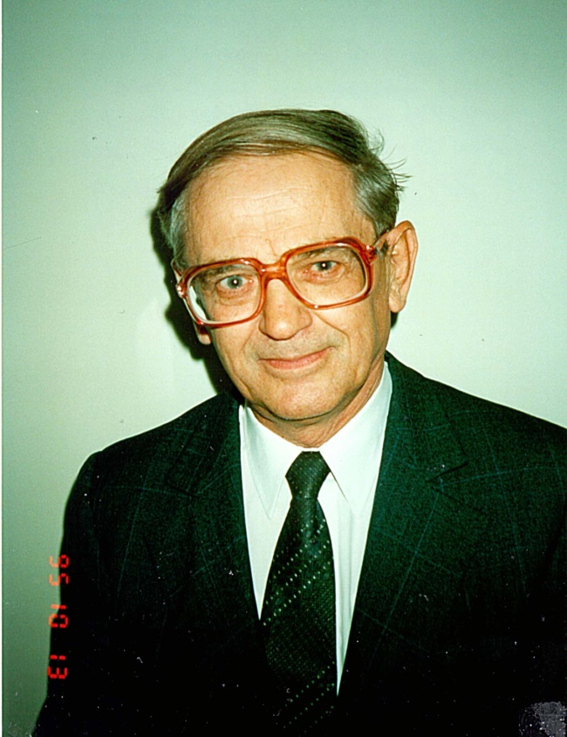
Book is described the arrangement of the Universe. This is the scientific prediction of the non-biological (electronic) civilization and immortality of human being. Such a prognosis is predicated upon a new law, discovered by the author, for the development of complex systems. According to this law, every self-copying system tends to be more complex than the previous system, provided that all external conditions remain the same. The consequences are disastrous: humanity will be replaced by a new civilization created by intellectual robots (which the author refers to as "E-humans" and "E-beings"), These creatures, whose intellectual and mechanical abilities will far exceed those of man, will require neither food nor oxygen to sustain their existence. They may have the emotion. Capable of developing science, technology and their own intellectual abilities thousands of times faster than humans can, they will, in essence, be eternal.
About the Authors
Alexander A. Bolonkin was born in former USSR. He holds a doctoral degree in Aviation Engineering from Moscow Aviation Institute and a post-doctoral degree in Aerospace Engineering from Leningrad Polytechnic University. He has held the positions senior engineer at the Antonov Aircraft Design Company and chairman of the Reliability Department at the Glushko Rocket Design Company. He has also lectured at the Moscow Aviation Universities. Following his arrival in the USA in 1988, he lectured at the New Jersey Institute of Technology and worked as a senior researcher at NASA and the US Air Force Research Laboratories.
Professor Bolonkin is the author of more than 170 scientific articles and books, and 17 inventions to his credit. His most notable books include: The Development of Soviet Rocket Engine (Delphic Ass., Inc., Washington , 1991); Non-Rocket Space Launch and Flight, (Elsevier, 2006); New Concepts, Ideas, Innovation in Aerospace, Technology and Human Life (NOVA, 2008); Macro-Projects: Environment and Technology (NOVA, 2009), “New Technologies and Revolutionary Projects”, Sbcribd, 2010, 324 pgs.

