Yan Zhang
Senior Manager
Suzhou, China
Electromagnetic Resonance Quality Control of Liquid Products
Subtitle:
Non-contact electromagnetic resonance quality control of liquid products, including liquid food products
Keywords:
Quality control of liquid products; Electromagnetic resonance quality control; Sensors based on magnetic resonance principles; Electromagnetic resonance spectroscopy; Genetically modified liquid products; Composite liquid products; Deep global processes; Liquid food products; Increasing use of chemical fertilizers; Alternating electromagnetic field; Vortex electromagnetic field; Generation of an alternating electromagnetic field in the space containing the test sample
Abstract:
Non-contact electromagnetic resonance quality control of liquid products, including liquid food products, is one of the modern smart technologies that has attracted significant interest among entrepreneurs and specialists.
The quality of liquid products, particularly liquid food products, has become especially important in our time due to numerous profound global processes, including global warming, the use of genetically modified products, and many other risk factors such as the continuous increase in the use of chemical fertilizers.
As technologists emphasize, in order to effectively monitor the quality of food products, particularly composite or multi-component products, traditional control methods are no longer sufficient.
To ensure quality control of liquids at a level that meets the requirements of the present time, a system of sensors operating on the principles of magnetic resonance has been developed.
Non-contact electromagnetic resonance quality control of liquid products, including liquid food products, is one of the modern smart technologies of high interest to both entrepreneurs and specialists.
The quality of liquid products, and especially liquid food products, has become of particular importance in our time due to numerous profound global processes, including global warming, the use of genetically modified products, and the presence of many other risk factors, such as the constant increase in the use of chemical fertilizers.
As technologists emphasize, in order to adequately monitor the quality of food products, especially composite or multi-component ones, traditional control methods are no longer sufficient.
To achieve a level of liquid quality control that meets the demands of the present time, a system of sensors operating on the principles of magnetic resonance has been developed.
It is worth considering the essence of this method in more detail:
The method involves the creation of an alternating electromagnetic field in the space where the sample under examination is located. This field acts as an intermediary or linking element between the resonance circuit and the tested sample.
On the one hand, the resonance circuit functions as the emitter of this field; on the other, it acts as the acceptor (sensitive element) of those changes in the electromagnetic field that are introduced by the tested sample.
Even in the absence of a sample, the alternating electromagnetic field generated by the solenoid is a combined superposition of two electromagnetic fields that vary in antiphase with each other. One field is produced by changes in the magnetic induction of the solenoid of the control element of the system, resulting in a vortex electric field (Maxwell–Faraday equation).
The other is produced by changes in the electric field created by the potential difference between the most distant turns of the solenoid (if the sample is placed inside the solenoid), or by the potential difference between the turn closest to the surface of the measured element and the element itself (if the element is placed opposite the end of the solenoid). This results in a vortex magnetic field (Ampère’s circuital law with Maxwell’s correction).
Under the influence of this external alternating electromagnetic field, depending on the nature of the tested sample, the following electrical phenomena may be simultaneously induced: linear and eddy conduction currents, linear and eddy displacement currents (caused by dielectric polarization), as well as linear and eddy ionic currents (ordered motion of ions).
In accordance with the principle of field superposition, these electrical phenomena distort the external alternating electromagnetic field. These distortions are registered by the solenoid of the control element — the resonance sensor.
  - The resonance circuit of the specified control element, which includes the solenoid, under the influence of the indicated distortions, changes its behavior in a manner analogous to the addition of extra elements such as a capacitor, inductance, and resistor.
  - The combination of these additional capacitive, inductive, and resistive components represents an additional impedance introduced into the system by the tested sample. This additional impedance is precisely what the control element — the resonance sensor — measures.
  - Changes in the parameters of the resonance circuit are reflected in variations of its amplitude-frequency characteristic. Specifically, such changes alter the resonant frequency and amplitude of the resonance circuit that is part of the system’s control element. By analyzing the magnitude and nature of these variations, one can determine the impedance of the tested sample.
  - The device for magnetic resonance quality control of water or aqueous solutions consists of a section of pipeline on the outer surface of which an annular sensor is mounted, connected to a power source, as well as to a system of control, amplification, and signal identification.
  - The system optionally includes a transmission unit for transferring the amplified and identified signal to the operator’s console or to a mobile phone.
  - The system is calibrated to a reference sample of water or any other liquid, taking into account all local conditions. The system’s sensor records any changes in the state of water or any other liquid; the signal is identified and transmitted to the operator’s console, a computer monitor, or a mobile phone.
  - The frequency of control tests can be adjusted during calibration in the range from one test every 0.1 seconds to one test per minute.
  - Among the key parameters of the sensor for resonance quality control of water are accuracy and sensitivity. The main parameter — sensitivity — is defined as the ability to distinguish, record, and identify a difference equivalent to 0.000001 grams per liter.
  - Performing similar control operations based on existing technologies requires specially trained qualified personnel, whose labor costs exceed 35 USD per hour. Personnel are unable to perform more than one test per day, and between tests the state of the water or liquid material is not monitored, leading to emergency situations.
  - The time from the moment a problem is detected to its elimination is extended because continuous monitoring of water quality is not available. The transmission of information is not operational, which also increases the time required to eliminate emergency situations.
  - The proposed method of remote monitoring of the parameters of a material object includes:
- the formation of a three-dimensional spatial system in which the control element encompasses the monitored element;
- the alignment of the centers of symmetry of the cross-sections of the control and monitored elements of the specified three-dimensional spatial system;
- the stabilization of a uniform gap between the outer surface of the monitored element and the control element of the specified three-dimensional spatial system;
- the formation around and within the volume occupied by the control element of an energy-saturated space in the form of an alternating electromagnetic field with controlled and regulated intensity;
- the impact of the specified alternating electromagnetic field on the monitored element and the induction within it of linear and eddy conduction currents, linear and eddy displacement currents, and linear and eddy ionic currents;
- the identification and comparative analysis of distortions arising in the specified alternating electromagnetic field and their perception by the resonance circuit of the control element as additional components — a capacitor, an inductance, and a resistor;
- the recording of the levels of distortions and changes in the parameters of the specified resonance circuit in terms of its amplitude-frequency characteristic in the form of changes in the resonance frequency and amplitude, and the evaluation on this basis of the impedance of the monitored element, which determines the parameters of the state of the material object.
In addition, the proposed method of remote monitoring of the parameters of a material object, primarily in the form of a liquid or a mixture of liquids, or a mixture of liquids and gases, or in the form of aerosols, includes:
- the formation of a three-dimensional spatial system in which the control element encompasses the monitored element placed in a shell that defines and maintains the geometric shape of the monitored element;
- the alignment of the centers of symmetry of the cross-sections of the control and monitored elements of the specified three-dimensional spatial system;
- the stabilization of a uniform gap between the outer surface of the monitored element placed in the specified shell and the inner surface of the control element of the specified three-dimensional spatial system;
- the formation around and within the volume occupied by the control element of an energy-saturated space in the form of an alternating electromagnetic field with controlled and regulated characteristics;
- the excitation and induction in the volume of the monitored element placed in the specified shell, connected with the resonance circuit of the control element through the alternating electromagnetic field, of linear and eddy conduction currents, linear and eddy displacement currents, and linear and eddy ionic currents.
- identification and comparative analysis of distortions arising in the specified alternating electromagnetic field and ensuring their perception by the resonance circuit of the control element as additional components — a capacitor, an inductance, and a resistor;
- recording the levels of the resulting distortions and changes in the parameters of the specified resonance circuit in terms of its amplitude-frequency characteristic in the form of changes in the resonance frequency and amplitude, and, on this basis, evaluating the impedance of the monitored element, which determines the parameters of the state of the material object;
- sequential variation — equal to the number of constituent components of the material object placed in the specified shell — of the values of the characteristics of the energy-saturated space in the form of an alternating electromagnetic field formed around and within the volume occupied by the control element;
- identification and comparative analysis of distortions arising in the specified alternating electromagnetic field and ensuring their perception by the resonance circuit of the control element as additional components — a capacitor, an inductance, and a resistor;
- sequential recording of the levels of distortions and changes in the parameters of the specified resonance circuit in terms of its amplitude-frequency characteristic in the form of changes in the resonance frequency and amplitude, and, on this basis, evaluating the impedance of the monitored element, which determines the parameters of the state of the constituent components of the monitored material object.

The energy-saturated space in the proposed technical solution is an alternating electromagnetic field characterized by frequency and intensity.
Control and adjustment of the parameters of the alternating electromagnetic field make it possible to ensure the required accuracy and flexibility in measuring and monitoring the parameters of material objects in their various forms.
Since the proposed method makes no distinction between solid or soft materials, liquids or solids, or mixtures of liquids and gases, the adaptation and adjustment of the method to different conditions require only minimal technological factors.
If we consider the problem of monitoring liquid food products from a practical standpoint, for the application of the latest non-contact monitoring and quality control methods, it can be assumed that the accuracy of control and the sensitivity of the sensors entirely depend on the number of components in the liquid mixture.
In this regard, the transition of the food industry, even a partial one, to multi-component containers or packaging would minimize the number of components subjected to simultaneous monitoring or control. This would significantly improve the accuracy and quality of control and open the way for innovative measurement technologies without direct contact with the liquid being measured.
Let us now move on to the description of the design and advantages of multi-component packaging for liquid products, including liquid food products and beyond. The most thoroughly conceived and implemented, both from a structural and technological standpoint, are the variants of plastic two-component packaging and the methodology of non-contact measurement of liquids contained therein, in accordance with the integrative inventions of Aleksandr Mikhalevich.
Since, according to his invention, the bottle has two coaxial cylindrical chambers with the same outer diameter, it is evident that by placing such a bottle into a vertical or horizontal sensor-solenoid, one can obtain highly accurate values of the integral amplitude index for each liquid separately contained in each chamber.
For each liquid, a reference integral amplitude index is determined under laboratory conditions, and during testing, for example in a store warehouse, it is sufficient to compare the reference and actual integral amplitude indices.
Any deviation of this index in either direction indicates that the liquid is contaminated, degrading, or possibly undergoing fermentation or biological decomposition.
Given that the monitoring process does not require special training, practically any operator can perform control functions, which allows for continuous quality monitoring of liquids and, ultimately, leads to a significant improvement in consumer quality of life without the need for substantial investment.
To demonstrate the possibility of monitoring liquids using the integral amplitude index, experimental laboratory equipment was developed, in which ionized water was used as the test liquid.
To ensure that the water samples differed only in acidity or alkalinity levels, the preparation of the samples was carried out in a flow-through electrochemical reactor. In this system, an upward flow of ordinary tap water (the mineralization of tap water in San Francisco is only 40 milligrams per liter) was separated during ionization into two parallel streams — one with an acidic background and the other with an alkaline background.
In order to also trace the influence of water layer thickness on the results, the sensor was immersed in communicating cylindrical vessels whose diameters differed by a factor of two.
As shown by the tests and measurements, the amplitude in the measured samples of the same water, with an acidity level of 3 units and an alkalinity level of 11 units (at the same initial mineralization of 40 milligrams), differed by 1000 millivolts.
This simple experiment demonstrates the possibility of monitoring even the slightest changes in the state of liquids in each chamber of a two-component package.
The achieved sensitivity of the sensor makes it possible not only to detect changes in each component separately but also to monitor the smallest variations in the components when compared sequentially with each other.
Such a comparison method allows predicting possible variations in the qualitative composition of the mixture obtained after mixing both components.
The following photographs show samples of experimental prototypes in which the solenoid is made of red-insulated wire for contrast.

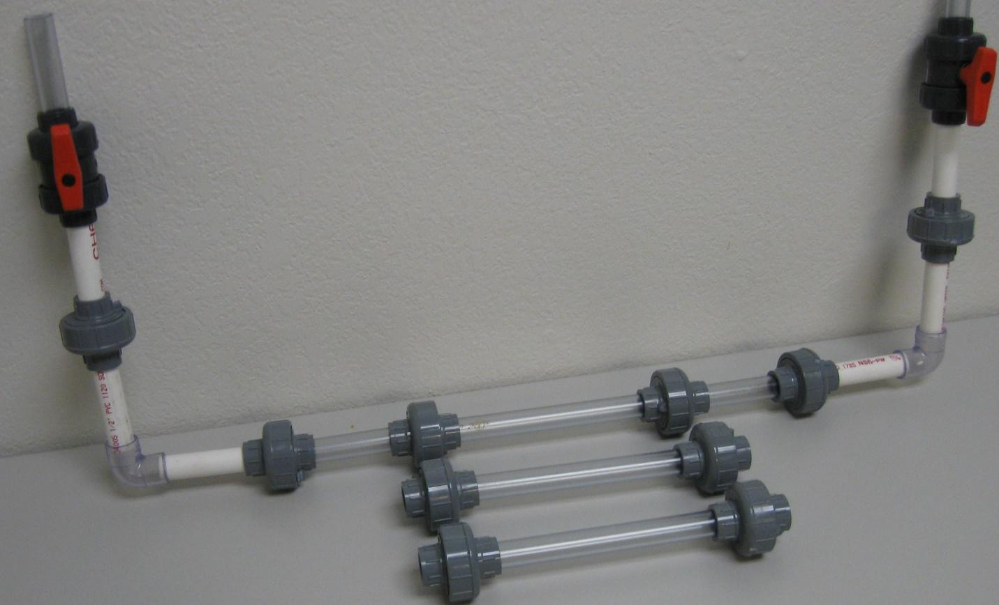

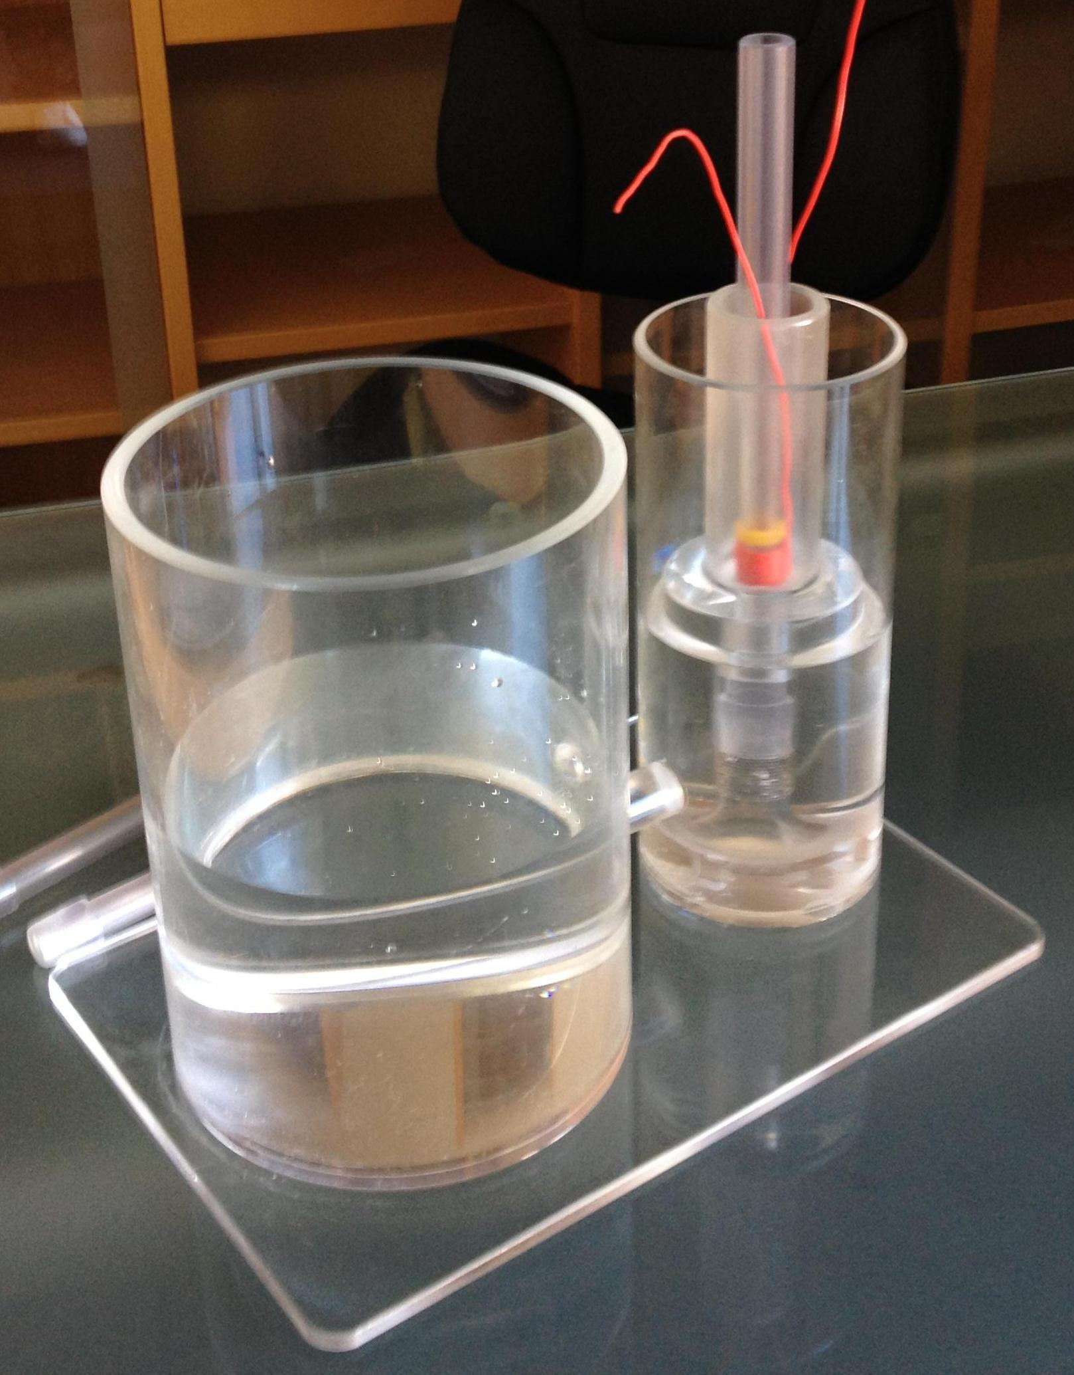
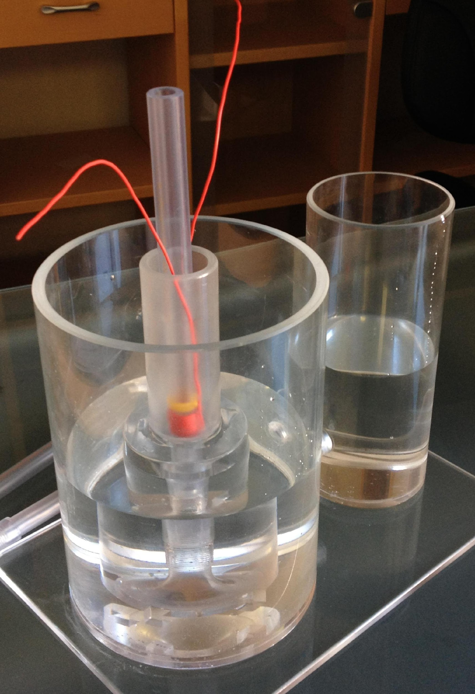
Thus, the conclusion becomes entirely realistic that, in order to improve the level and accuracy of detection and identification of the slightest changes in the quality of liquid food products, it is advisable to use multi-component packaging for storage, transportation, and effective mixing prior to consumption.
List of References, Patent and Licensing Information:
APPENDIX 1
United States Patent Application | 20210094846
Kind Code | A1
CONNOR, JR.; Michael James ; et al. | April 1, 2021

HYBRID ELECTROCHEMICAL AND MEMBRANE-BASED PROCESSES FOR TREATING WATER WITH HIGH SILICA CONCENTRATIONS
Abstract
Provided are hybrid electrochemical and membrane-based systems for removing silica from water stream to achieve ultra-pure water. The silica concentration of a feed water stream may dictate the most effective and economical variation of disclosed hybrid processes to use. For example, for a feed water stream having a silica concentration of 1-30 ppm, a hybrid system for treating the feed water includes an electrodialysis reversal unit, the electrodialysis reversal unit comprising an inlet stream and a product outlet stream; a reverse osmosis unit, the reverse osmosis unit comprising an inlet stream and a product outlet stream, wherein the inlet stream of the reverse osmosis unit comprises the product outlet stream of the electrodialysis reversal unit; and an electro-deionization unit, the electro-deionization unit comprising an inlet stream and a product outlet stream, wherein the inlet stream of the electro-deionization unit comprises the product outlet stream of the reverse osmosis unit.
APPENDIX 2
United States Patent Application | 20210078887
Kind Code | A1
YANG; Qifeng ; et al. | March 18, 2021

TREATMENT PROCESS AND TREATMENT SYSTEM OF ENHANCED UP-FLOW MULTIPHASE WASTEWATER OXIDATION
Abstract
The present disclosure discloses a treatment process and treatment system of enhanced up-flow multiphase wastewater oxidation. The treatment process includes the following steps: 1) the wastewater is fed into the up-flow multiphase wastewater oxidation system for oxidation treatment; 2) the wastewater is fed to the solid-liquid separation system for solid-liquid separation, the separated heterogeneous catalytic carrier (5) is fed back to the up-flow multiphase wastewater oxidation system, and the wastewater is fed to the neutralization and degassing system; 3) the wastewater is fed to the neutralization and degassing system to adjust a pH of the wastewater to 5.5-7.5, and then is degassed by stirring; 4) the wastewater is fed to the flocculation and sedimentation system for sludge-water separation, a supernatant is discharged, and an outward harmless treatment is performed after a pressure filtration of a sedimentary iron sludge.
APPENDIX 3
United States Patent Application | 20210060522
Kind Code | A1
EL-SHALL; M. Samy ; et al. | March 4, 2021

GRAPHENE-BASED MATERIALS FOR THE EFFICIENT REMOVAL OF POLLUTANTS FROM WATER
Abstract
Materials and methods for removing contaminants from liquids such as water are provided. The materials are graphene oxide-based materials that are chemically modified to comprise functional groups that adsorb a wide variety of pollutants such as heavy metals, nitrates, and phosphates.
APPENDIX 4
United States Patent Application | 20210029977
Kind Code | A1
Alcantar; Norma Arcelia ; et al. | February 4, 2021

COMPOSITIONS AND METHODS TO REMOVE AMMONIA IN FRESHWATER AND SALTWATER FISH STORAGE SYSTEMS
Abstract
Compositions, systems and methods of removing ammonia from fish storage systems are presented. A chemical water conditioner comprised of sodium formaldehyde bisulfite, cornstarch, dye and alcohol was found to have a high ammonia removal efficiency in seawater. A combination of this chemical water conditioner with modified chabazite and phosphate buffer exhibited high ammonia removal efficiency in both seawater and freshwater.
APPENDIX 5
United States Patent Application | 20210002151
Kind Code | A1
HAO; Xiaogang ; et al. | January 7, 2021

METHOD AND DEVICE FOR REMOVING CHLORIDE ION IN DESULFURIZED WASTEWATER BY ELECTROCHEMICAL COUPLING
Abstract
The present invention discloses a method and device for removing chloride ions in desulfurized wastewater by electrochemical coupling. In the device, an electrolyte tank is used as a separator in a separation process and as an electrode regenerator in an electrode regeneration process; two electrodes are a hydrogen evolution electrocatalysis function electrode and an electrochemically switched ion exchange (ESIX) function electrode respectively, and the electrodes are connected with each other by a wire; two DC circuits have opposite electric field directions and are alternately used in the separation process and the electrode regeneration process respectively; the bottom of the electrolyte tank is provided with a purified high-concentration chloride ion wastewater inlet and a flocculation product outlet, and the top is provided with a dechlorination treatment water outlet and a hydrogen collecting port; and in the electrode regeneration process, the electrolyte tank is connected to an electrode regeneration liquid storage tank through a pump and a pipeline. In the present invention, by utilizing the synergistic reinforcement of reactions of an anode and a cathode, the chloride ion removal efficiency and energy utilization efficiency can be improved, and finally the chloride ions in wastewater are present in flocculation products in a solid form, which facilitates recycling.

