DYNAMIC HOMOGENIZATION DEVICE
DESCRIPTION, TYPES, APPLICATION

Marat Khaitbaev,
Independent researcher
Professional Member of New York Academy of Sciences
Porsche Pulkovo
Saint Petersburg, Russia

DYNAMIC EMULSION
Using a mixture of gasoline and ethanol as fuel, there is always a risk of decomposition of this mixture into organic fractions and water contained in ethanol.
The higher the percentage of ethanol in the mixture, the more significant the damage from the decomposition of the mixture into organic components and water.
The Dynamic Homogenization Device (DHD) does not have moving parts, which is mounted on the fuel pipeline of the car between the fuel pump and the high pressure pump. The outlet of the fuel pump is connected to a separating tee, which divides the fuel flow into two flows, which are homogenized in the device according to the level of turbulence, and, if the mixture, for example, gasoline with ethanol contains water, forms Dynamic Emulsion during the homogenization process.
Dynamic Emulsion, after being withdrawn from the device, enters the engine high pressure pump, in which, under the influence of high pressure, it transforms into a nano-emulsion, which, when burned in the combustion chamber of the engine cylinders, does not form soot and nitrogen oxides, while not reducing engine power.

SECOND FUEL INPUT
FIRST FUEL INPUT
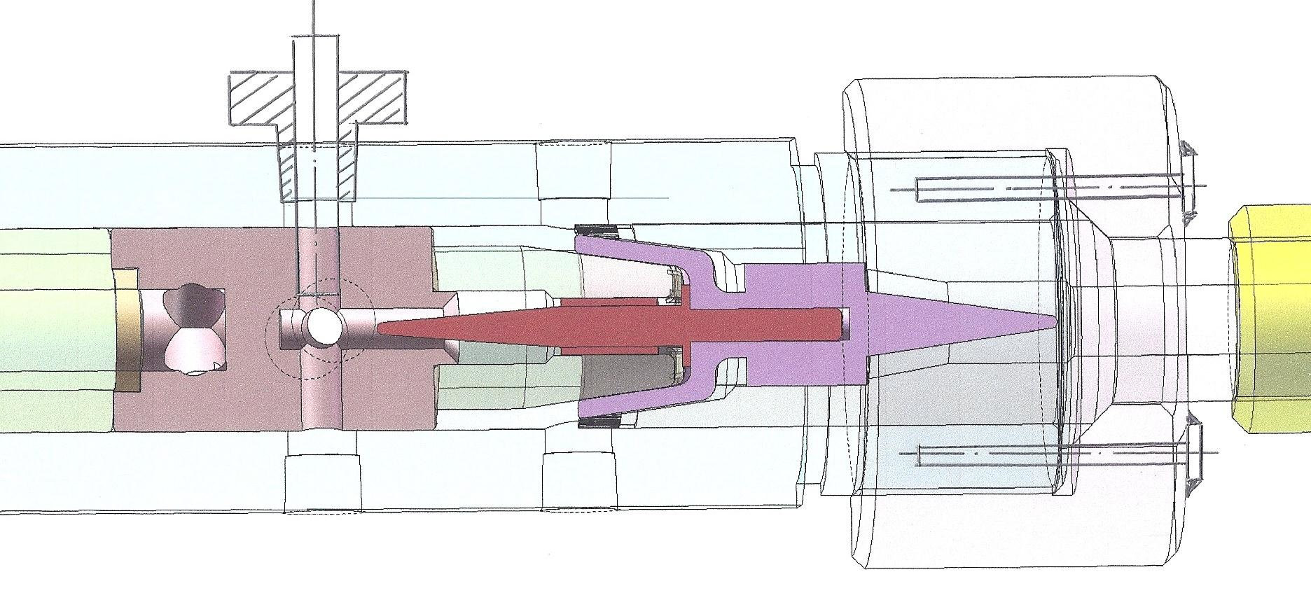
HOMOGENIZATION OF TURBULENCE LEVEL

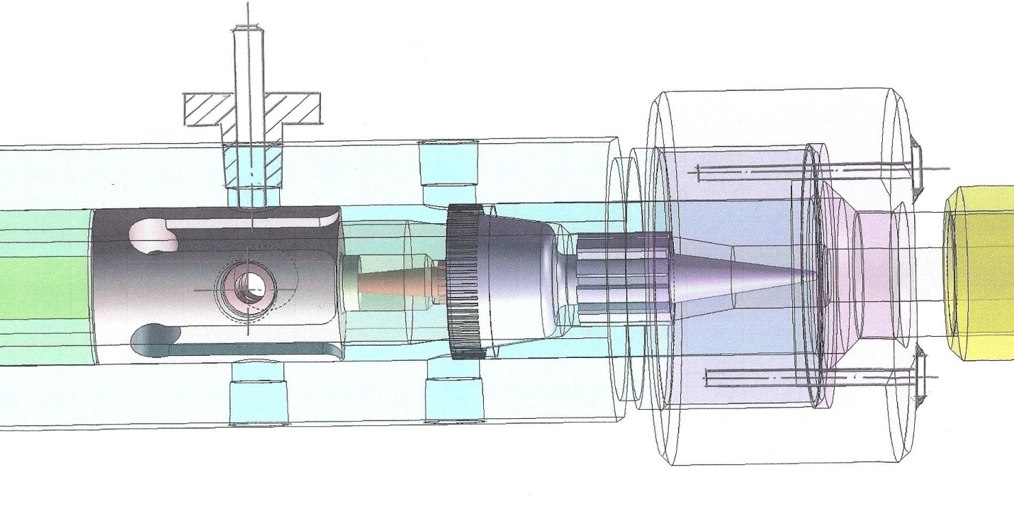
COLLECTION SECTION
ADDITIONAL INPUTS (OPTIONAL)

Figure 1. Example of device design for mass - production
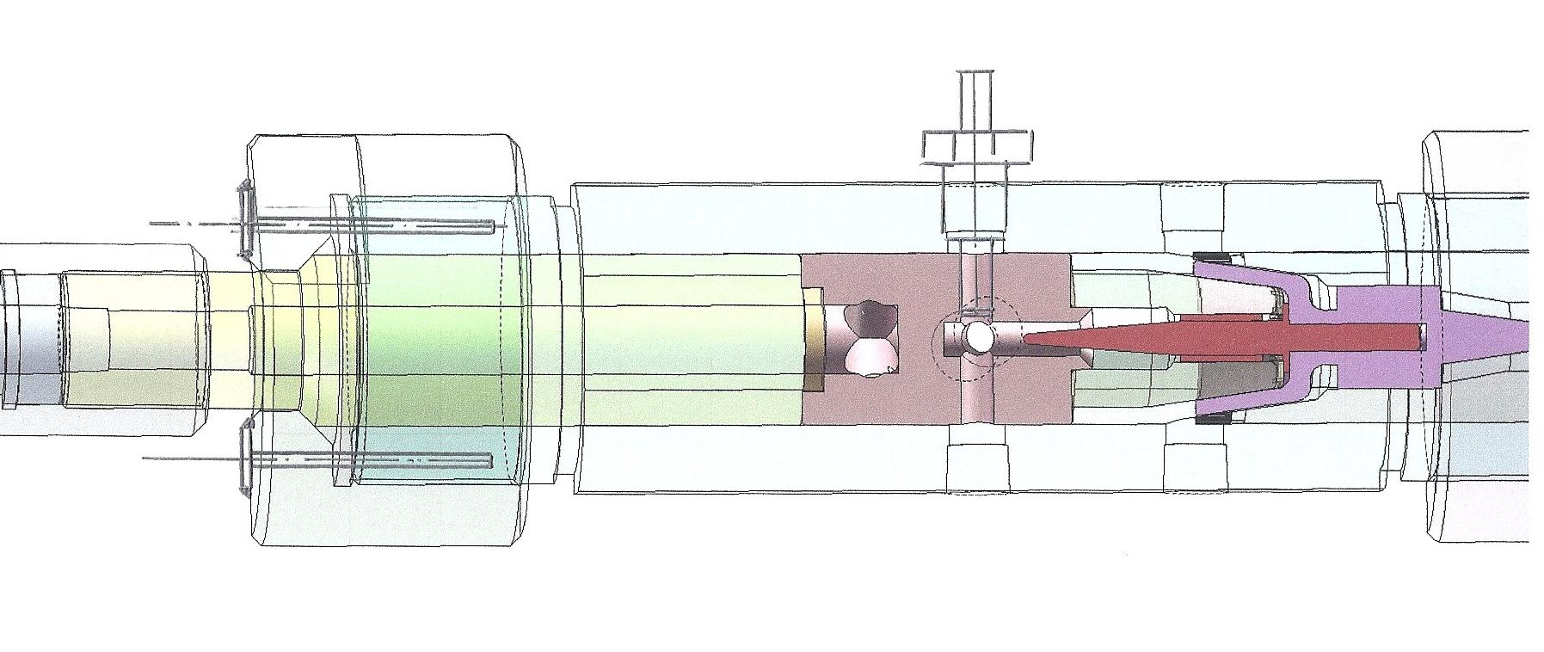
INPUT TO HIGH PRESSURE PUMP OF THE INTERNAL COMBUSTION ENGINE
OUTPUT FROM THE DYNAMIC HOMOGENIZATION DEVICE
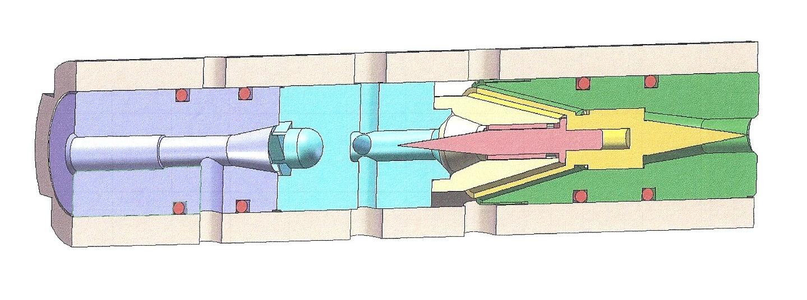
FIRST FUEL INPUT
INTEGRATED HOMOGENIZATION SECTION
SECOND FUEL INPUT
PRESSURE MULTIPLICATION SECTION
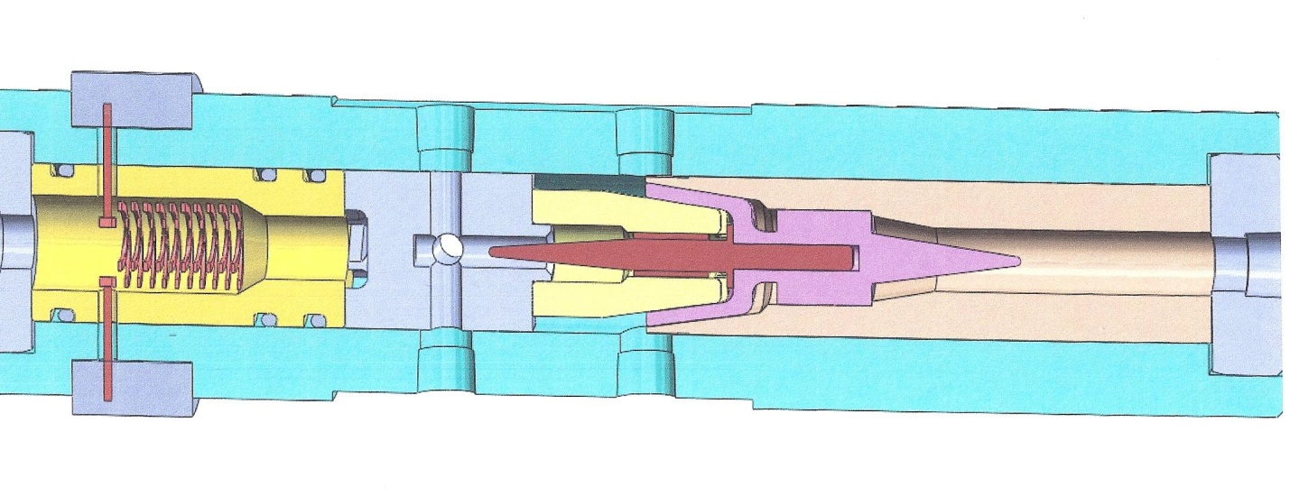
DYNAMIC HOMOGENIZATION DEVICE WITH QUALITY SENSOR (OPTIONAL)

Figure 2. Example of device design for mass - production
Figure 3,4. Examples of device installation for blends preparation in gas station
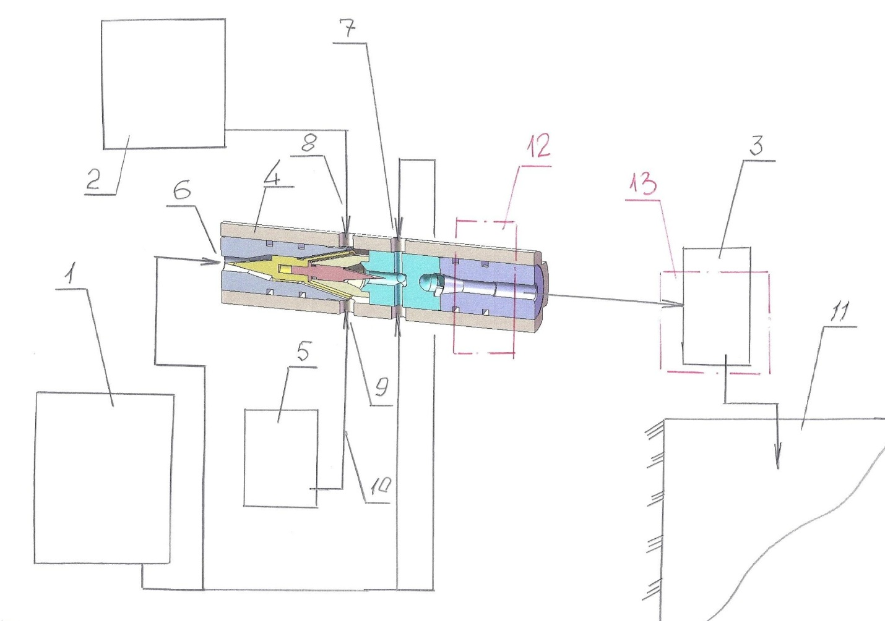
5-WATER TANK (OPTIONAL);
6-FIRST FUEL (GASOLINE) INPUT
5-DHD; 6-OPTIONAL WATER TANK;
7-FIRST FUEL INPUT; 8-ETHANOL/ METHANOL INPUT;
11-TANK FOR BLEND;
12-END OF FIRST HOMOGENIZATION STAGE;
13-SECOND HOMOGENIZATION STAGE
7-SECOND FUEL INPUT;
8-ETHANOL INPUT;
9-OPTIONAL WATER INPUT;
10- OPTIONAL WATER PIPING SYSTEM
1-GASOLINE TANK;
2- ETHANOL TANK;
3-HIGH PRESSURE PUMP;
4-DEVICE FOR DYNAMIC HOMOGENIZATION
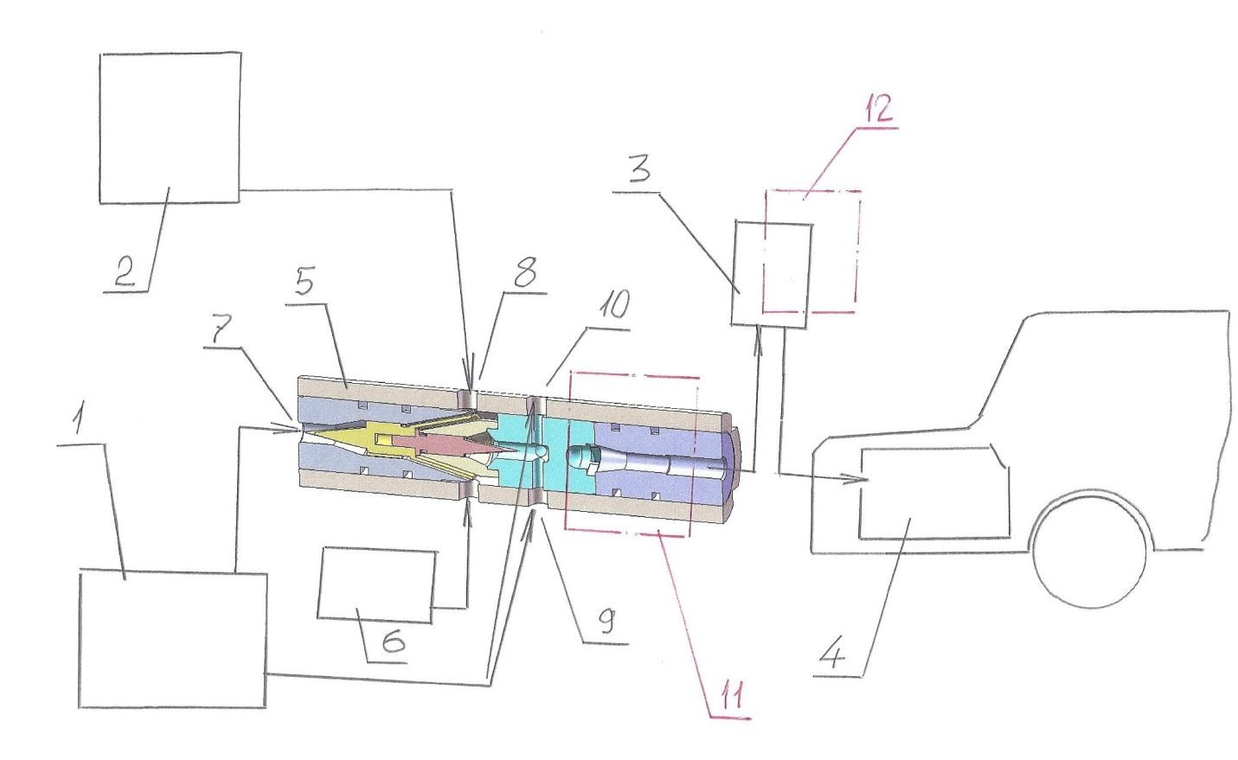
3-HIGH PRESSURE PUMP OF THE GAS STATION;
4-FUEL TANK OF THE CAR;
9,10 – SECONDARY INPUTS OF THE FUEL;
11-FIRST STAGE OF HOMOGENIZATION;
12-SECOND STAGE OF HOMOGENIZATION;

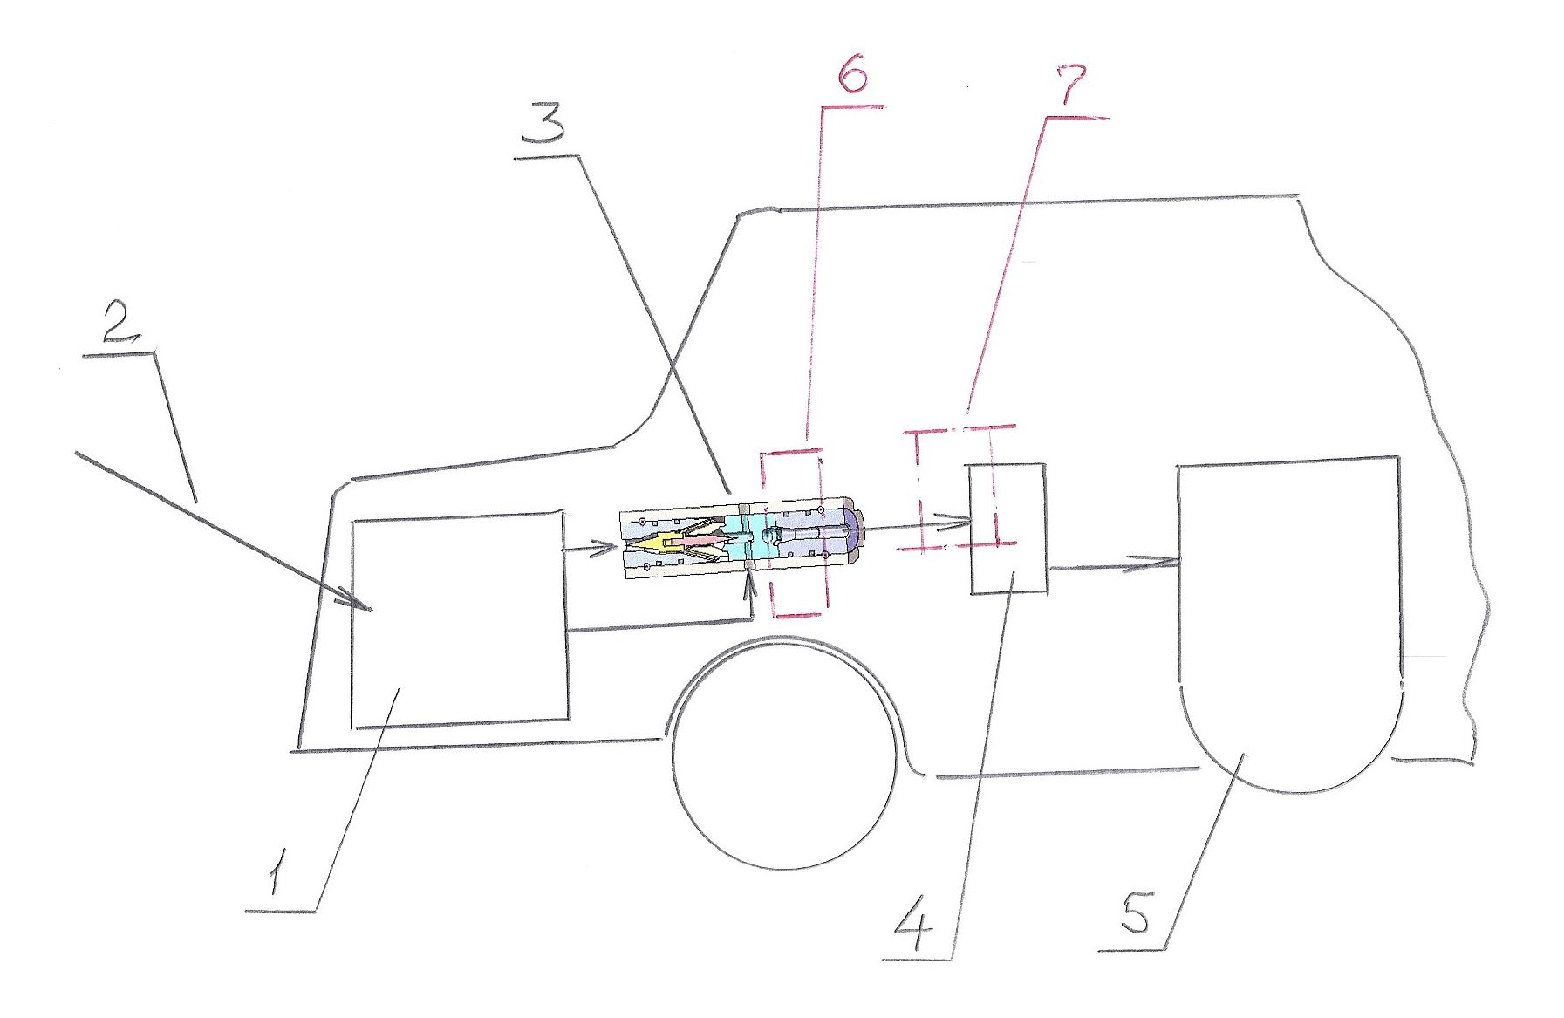
1 – CAR FUEL TANK;
2-FUEL/BLEND INPUT TO TANK;
3-DYNAMIC HOMOGENIZATION DEVICE;
4-HIGH PRESSURE PUMP OF THE CAR ENGINE;
5- CAR ENGINE
6-FIRST HOMOGENIZATION STAGE;
7-SECOND HOMOGENIZATION STAGE

Figure 5. Dynamic homogenization device installation in car fuel system

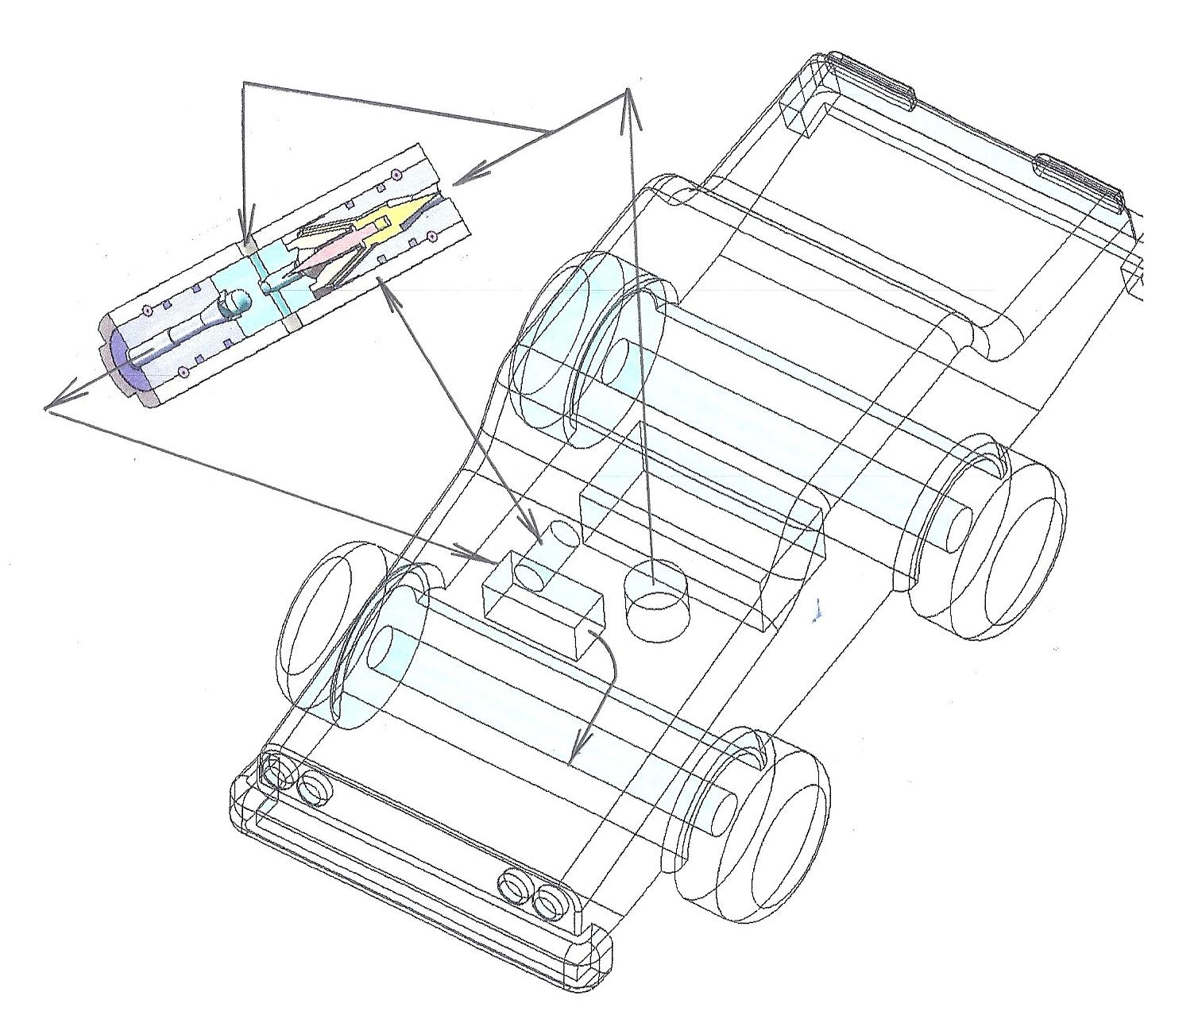
DYNAMIC HOMOGENIZATION DEVICE
FUEL PUMP
HIGH PRESSURE PUMP
FUEL TANK
Figure 6. Example of dynamic homogenization device installation in car construction

PRODUCT DESCRIPTION
Characteristics of a product that can be named Dynamic Emulsion are:
- the product is formed within a short period of time. This time can be equal to at least a few milliseconds, during which the product receives all the necessary characteristics and properties and immediately becomes suitable for further use;
- the product retains its properties for a long time if the pressure under which it is formed does not change;
- the product is able to maintain its properties and characteristics with a sharp increase in pressure. During testing, a product pressure of up to 2000 bar was obtained, and no destructive changes in the structure and properties of the product were found. On the contrary, when burning the resulting emulsion in the combustion chambers of the engine, results comparable to the results of the combustion of a nano-emulsion were obtained;
- the product is able to significantly improve and retain its properties and characteristics for a long period of time with a sharp increase in pressure in the product flow after mixing the components. During tests, before injection into the cylinders of an internal combustion engine, a product pressure of up to 2000 bar was obtained. At the same time, photographs of the emulsion were visually obtained under a microscope, which made it possible to preliminarily classify the resulting emulsion as a nano-emulsion, and the results of changes in the structure and properties of the exhaust gases of an internal combustion engine comparable to the theoretical parameters of the combustion of a nano-emulsion were obtained;
- the product has a flexible hydrodynamic structure;
- the product has a flexible chemical structure;
- the product can consist entirely of liquids of homogeneous properties, while all liquid components can be mixed in various proportions and combinations;
- the product may consist of liquids that are heterogeneous in properties, while all liquid components can be mixed in various proportions and combinations;
- various chemicals that are part of Dynamic Emulsion can be added to the product after formation;
- various chemicals that are not part of Dynamic Emulsion may be added to the product during formation.

DESCRIPTION OF THE PREFERRED EMBODIMENTS
Dynamic Emulsion can have many varieties.
Varieties of Dynamic Emulsion include:
- Dynamic Emulsion consisting of at least two homogeneous liquids
- Dynamic Emulsion, consisting of at least two dissimilar fluids
- Dynamic Emulsion, consisting of at least two homogeneous liquids and at least one gas
- Dynamic Emulsion, consisting of at least two dissimilar liquids and at least one gas
- Dynamic Emulsion, consisting of at least one liquid solution and at least one liquid
- Dynamic Emulsion, consisting of at least two homogeneous liquid solutions
- Dynamic Emulsion, consisting of at least two dissimilar liquid solutions
- Dynamic Emulsion, consisting of at least two homogeneous solutions of liquids and at least one gas
- Dynamic Emulsion, consisting of at least two dissimilar solutions of liquids and at least one gas
Chemical reagents can be added to Dynamic Emulsion both during and after formation
These types of Dynamic Emulsion can also have many varieties:
- Dynamic Emulsion consisting of at least two homogeneous liquids with the addition after formation, additional chemicals
- Dynamic Emulsion, consisting of at least two dissimilar liquids with the addition after formation, additional chemicals
- Dynamic Emulsion, consisting of at least one solution of liquids and at least one liquid with the addition after formation, additional chemicals
- Dynamic Emulsion, consisting of at least two homogeneous solutions of liquids with the addition after formation, additional chemicals
- Dynamic Emulsion, consisting of at least two dissimilar solutions of liquids with the addition after formation, additional chemical reagents.
EXPLANATION OF THE TECHNOLOGY
The essence of the technology, which is the basis for the formation of a new Dynamic Emulsion product, is as follows:
- at the time of formation of Dynamic Emulsion, the level of turbulence at all points of the cross-section of the flows of the basic components of Dynamic Emulsion is equalized, due to which the required level of state uniformity throughout the volume and the required level of particle sizes of Dynamic Emulsion components are achieved;
- the kinetic energy of the particles of all Dynamic Emulsion components is conserved, and this energy is released if the pressure under which the emulsion is located decreases or becomes equal to atmospheric pressure;
- the number of components in Dynamic Emulsion is practically unlimited, since the apparatus for forming Dynamic Emulsion can be adapted to the required number of components without changing the fundamental principles of technology;
- if a gas or a mixture of gases is used as one or more components, the fundamental principles of the technology make it possible to obtain an aerosol in the form of Dynamic Emulsion or allow mixing Dynamic Emulsion with compressed gas or air;
- the technology allows sequential input of additional components into Dynamic Emulsion. moreover, the number of such components and their chemical composition are not limited;
- Since all Dynamic Emulsion parameters depend on the flow pressure of the Dynamic Emulsion components, the properties and parameters of the Dynamic Emulsion can be adjusted by adjusting the pressure.

USED LITERATURE
1
United States Patent Application | 20190069225
Kind Code | A1
NATHANSON; Martin | February 28, 2019

VEHICLE COMMUNICATIONS VIA WIRELESS ACCESS VEHICULAR ENVIRONMENT
2
United States Patent Application | 20190051167
Kind Code | A1
Malkes; William A. ; et al. | February 14, 2019

SYSTEM AND METHOD OF ADAPTIVE TRAFFIC MANAGEMENT AT AN INTERSECTION
3
United States Patent Application | 20190027018
Kind Code | A1
Corpus; Roy C. ; et al. | January 24, 2019

ARTIFICIAL INTELLIGENCE BASED SERVICE CONTROL AND HOME MONITORING
4
United States Patent Application | 20190012909
Kind Code | A1
MINTZ; Yosef | January 10, 2019

SYSTEM AND METHODS TO APPLY ROBUST PREDICTIVE TRAFFIC LOAD BALANCING CONTROL AND ROBUST COOPERATIVE SAFE DRIVING FOR SMART CITIES

5
United States Patent Application | 20180376305
Kind Code | A1
Ramalho de Oliveira; Patricia Cristina | December 27, 2018

METHODS AND SYSTEMS FOR DETECTING ANOMALIES AND FORECASTING OPTIMIZATIONS TO IMPROVE SMART CITY OR REGION INFRASTRUCTURE MANAGEMENT USING NETWORKS OF AUTONOMOUS VEHICLES
6
United States Patent Application | 20180330307
Kind Code | A1
Anderson; Evelyn R. ; et al. | November 15, 2018

METHOD AND SYSTEM TO ASSIST PEOPLE TRAVELING TOGETHER THROUGH A TRANSPORT HUB
7
United States Patent Application | 20180330294
Kind Code | A1
Anderson; Evelyn R. ; et al. | November 15, 2018

PERSONAL TRAVEL ASSISTANCE SYSTEM AND METHOD FOR TRAVELING THROUGH A TRANSPORT HUB

