Article Stability AB matter 11 13 13
Stability and Production Super-Strong AB-matter
Alexander Bolonkin
C&R, abolonkin@juno.com
Abstract
In works [1-3] author offered and considered possible super strong nuclear matter. In given work he continues to study the problem of a stability and production this matter. He shows the special artificial forms of nuclear AB-matter which make its stability and give the fantastic properties. For example, by the offered AB-needle you can pierce any body without any damage, support motionless satellite, reach the other planet, and research Earth’s interior. These forms of nuclear matter are not in nature now, and nanotubes are also not in nature. The AB-matter is also not natural now, but researching and investigating their possibility, properties, stability and production are necessary for creating them.
Key words- Femtotechnology; FemtoTech; AB-matter; AB-needle; Stability AB-matter; Production of AB-matter;
- introduction
- Brief History
Physicist Richard Feynman offered his idea to design artificial matter from atoms and molecules at an American Physical Society meeting at Caltech on December 29, 1959. If he was not well-known physicist, the audience laughed at him and drove away from the podium. All scientists accepted his proposal as joke. Typical question are: How can you see the molecule? How can you catch the molecule? How can you connect one molecule to other? How many hundreds of years you will create one milligram of matter? And hundreds of same questions having no answers may be asked. Any schoolboy has seen that Feynman proposal is full of fantasy which does not have relation to real technology. About 40 years the scientists had not found a way for implementation of this idea. But only in the last 15 years we have initial progress in nanotechnology. On the other hand, progress is becoming swifter as more and better tools become common and as the technical community grows. On 14 February 2009 the author offered the idea of design of new matter from protons, neutrons and electrons, made initial research and published the article about it [1]. These particles in million times are smaller than molecules. He researched and showed the new AB-matter will have the fantastic properties. That will be in millions times stronger than nanotubes and can keep the millions degrees of temperature. That may be invisible and permeable to ordinary matter. The many readers, who did not read carefully the author’s article and who remembered from school course that the nucleus became unstable if number of protons is more than 92 or number of nucleons is more than 238, raised the cry that the AB-matter is impossible. They have not seen the main difference between conventional matter (conventional nucleus) and AB-matter. The conventional matter has nucleus which has a chaotic spherical LUMP (nucleus) of nucleons, the AB-matter is line from nucleons not having the lump. The author considered the AB-lines and shows in work [2] that lines is stable and has surprise property: one is a high rigid rod (needle), of which the compressed force does not depend on rod length! With this AB-rods (needles) you can support the Earth’s satellite, reach the other planets, penetrate into the Earth interior and into any molecules of man without damage of its body.
- Short Information About Offered Matter
In [1], it is shown the AB-matter may have forms (Fig. 1).
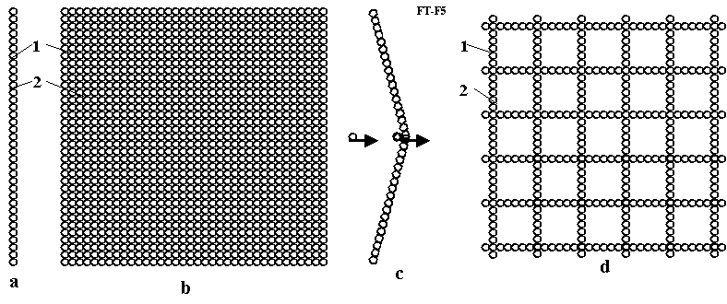
Fig.1. The main forms are: “a”- single AB-string (AB-needle), “b”- AB-film (plate), and “d” is net.
From AB-needles may be design the many other forms (Fig. 2, taken from [1, Fig. 6]). That is net, cube, columns, tube and so on.
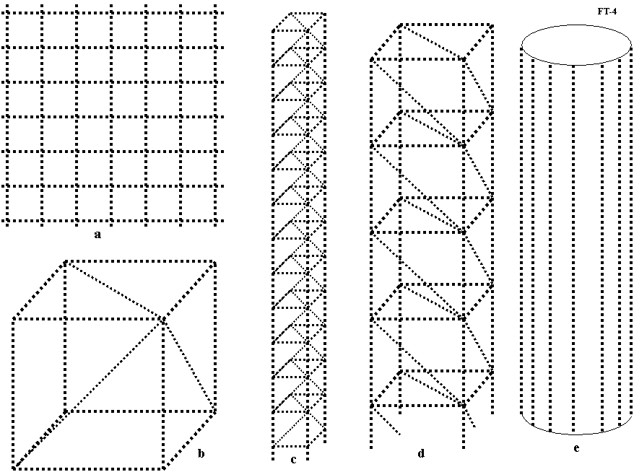
Fig. 2 Structures from nuclear AB-strings (AB-needles) (a) nuclear net (netting, gauze); (b) primary cube from matter strings; (c) primary column from nuclear strings; (d) large column where elements are made from primary columns; (e) tubes from matter strings (AB-needles) or matter columns.
- AB-Matter
In conventional matter made of atoms and molecules the nucleons (protons, neutrons) are located in the nucleus, but the electrons rotate in orbits around nucleus in distance in millions times more than diameter of nucleus. Therefore, in essence, what we think of as solid matter contains a relatively ‘gigantic’ vacuum (free space) where the matter (nuclei) occupies only a very small part of the available space. Despite this unearthly emptiness, when you compress this (normal, non-degenerate) matter the electrons located in their orbits repel atom from atom and resist any great increase of the matter’s density. Thus it feels solid to the touch.
The form of matter containing and subsuming all the atom’s particles into the nucleus is named degenerate matter. Degenerate matter is found in white dwarfs, neutron stars and black holes. Conventionally this matter in such large astronomical objects has a high temperature (as independent particles) and a high gravity adding a forcing, confining pressure in a very massive celestial objects. In nature, degenerate matter exists stably (as a big lump) to our knowledge only in large astronomical masses (include their surface where gravitation pressure is zero) and into big nuclei of conventional matter.
Our purpose is to design artificial small masses of synthetic degenerate matter in form of an extremely thin strong thread (fiber, filament, string, needle), round bar (rod), tube, net (dense or non-dense weave and mesh size) which can exist at Earth-normal temperatures and pressures. Note that such stabilized special form matter in small amounts does not exist in nature as far as we know. Therefore author has named this matter AB-matter. Just as people now design the thousands variants of artificial materials (for example, plastics) from usual matter, we soon (historically speaking) shall create many artificial, designer materials by nanotechnology (for example, nanotubes: SWNTs (amchair, zigzag, ahiral), MWNTs (fullorite, torus, nanobut), nanoribbon (plate), grapheme, buckyballs (ball), fullerene). Sooner or later we may anticipate development of femtotechnology and create such AB-matter. Some possible forms of AB-matter are shown in Fig. 3.

Fig. 3. Design of AB-matter from nucleons (neutrons, protons, etc.) and electrons (a) linear one string (monofilament) (fiber, whisker, filament, thread, needle); (b) ingot from four nuclear monofilaments; (c) multi-ingot from nuclear monofilament; (d) string made from protons and neutrons with electrons rotated around monofilament; (e) single wall femto tube (SWFT) fiber with rotated electrons; (f) cross-section of multi wall femto tube (MWFT) string; (g) cross-section of tube; (h) single wall femto tube (SWFT) string with electrons inserted into AB-matter. Notations: 1–nuclear string; 2-nucleons (neutrons, protons, etc.). 3-protons; 4-orbit of electrons; 5-nucleons; 6-cloud of electrons around tube.
The main difference between the AB-matter and conventional matter is a strict order of location the proton and neutrons (for example: proton-neutron-proton-neutron) in line (string) or in the super thin (in one nucleon) plate (nuclear graphene). That gives the strong tensile stress (electrostatic repulse force) which does not allow the nucleons to mix in messy clump (ball). This force is less than a nuclear force if the AB-matter has a form where the most protons are located far from one another, where the nuclear force from the far protons is absent. That is in line, net and plate (Fig. 1a, b, d), but that may be absent in the solid beam, rod (Fig. 3c, d) if their cross-section area contains a lot of nucleons. The other problem: compensation of the positive charges is solved by rotating electrons around the AB string, rod, tube, net (grid) or an electron cloud near the plate [1] or the electron locates near nucleons.
- Using the AB-matter
The simplest use of AB-matter is strengthening and reinforcing conventional material by AB-matter fiber. As is shown in the ‘Computation’ section [1], AB-matter fiber is stronger (has a gigantic ultimate tensile stress) than conventional material by a factor of millions of times, can endure millions degrees of temperature, and does not accept any attacking chemical reactions. We can insert (for example, by casting around the reinforcement) AB-matter fiber (or net) into steel, aluminum, plastic and the resultant matrix of conventional material increases in strength by thousands of times—if precautions are taken that the reinforcement stays put! Because of the extreme strength disparity design tricks must be used to assure that the fibers stay ‘rooted’. The matrix form of conventional artificial fiber reinforcement is used widely in current technology. This increases the tensile stress resistance of the reinforced matrix matter by typically 2–4 times. Engineers dream about a nanotube reinforcement of conventional matrix materials which might increase the tensile stress by 10–20 times, but nanotubes are very expensive and researchers cannot decrease its cost to acceptable values yet despite years of effort. Another way is to use a construct of AB-matter as a continuous film or net (Fig. 2b, d) or as the AB-needles (Fig. 2) [3].
These forms of AB-matter have such miraculous properties as invisibility, superconductivity, zero friction, etc. The ultimate in camouflage, installations of a veritable invisible world can be built from certain forms of AB-matter with the possibility of being also interpenetable, literally allowing ghost-like passage through an apparently solid wall. Or the AB-matter net (of different construction) can be designed as an impenetrable wall that even hugely destructive weapons cannot penetrate.
The AB-matter film and net may be used for energy storage which can store up huge energy intensities and used also as rocket engines with gigantic impulse or weapon or absolute armor (see computation and application sections in [1-3]). Note that in the case of absolute armor, safeguards must be in place against buffering sudden accelerations; g-force shocks can kill even though nothing penetrates the armor!
The AB-matter net (which can be designed to be gas-impermeable) may be used for inflatable construction of such strength and lightness as to be able to suspend the weight of a city over a vast span the width of a sea. AB-matter may also be used for cubic or tower solid construction as it is shown in Fig. 3. Detailed computation of properties of the AB-matter is in [1-3]. Our purpose is to show that the curtain forms of AB-matter will be stable and may be produced.
- About stability of the nuclear ab-matter
- Short Information About Atom and Nuclei
Conventional matter consists of atoms and molecules. Molecules are collection of atoms. The atom contains a nucleus with proton(s) and usually neutrons (except for Hydrogen-1) and electrons revolve around this nucleus. Every particle may be characterized by parameters as mass, charge, spin, electric dipole, magnetic moment, etc. There are four forces active between particles: strong interaction, weak interaction, electromagnetic charge (Coulomb) force and gravitational force. The nuclear force dominates at distances up to 1.5 ÷ 2 fm (femto, 1 fm = 10⁻¹⁵ m). They are hundreds of times more powerful than the charge (Coulomb) force and million-millions of times more than gravitational force. Charge (Coulomb) force is effective at distances over 2 fm. Gravitational force is significant near and into big masses (astronomical objects such as planets, stars, white dwarfs, neutron stars and black holes). Strong force is so overwhelmingly powerful that it forces together the positively charged protons, which would repel one from the other and fly apart without it. The strong force is key to the relationship between protons and neutrons. Electric force can keep electrons near nuclei. Scientists conventionally take into attention only the strong force when they consider the nuclear and near nuclear size range, and the other forces on that scale are negligible by comparison for most purposes.
Strong nuclear forces are anisotropic (non-spherical, force distribution not the same in all directions equally), which means that they depend on the relative orientation of the nucleus. The proton has a magnetic moment which produces the magnetic force. This force orients the proton in magnetic field and helps to keep the form of AB-matter.
Typical nuclear energy (force) is presented in Fig. 4. The nuclear and electric forces can be attractive and repulsive. When it is positive the nuclear force repels the other atomic particles (protons, neutrons). When nuclear energy is negative, it attracts them up to a distance of about 2 fm. The value r₀ is usually taken as radius of nucleus.
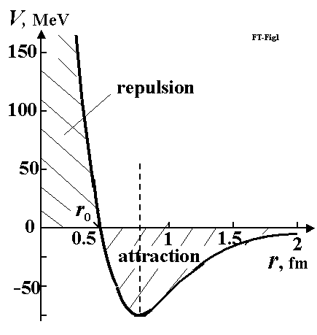
Fig. 4 Typical nuclear force of nucleus. When nucleon is at distance less than 1.8 fm, it is attracted to nucleus.
When nucleon is very close, it is repulsed from nucleus [11].
- Law (Necessary Conditions) of Stability the AB-matter
The necessary conditions (prerequisite law) of stability the AB-matter are as following:
1) The number of protons must be less approximately 90 into a local sphere of radius 3 fm in any point of AB-matter;
2) The number of nucleons must be less approximately 240 into a local sphere of radius 3 fm in any point of AB-matter;
3) The AB-matter contains minimum two protons.
4) Any neutron has minimum one contact with proton.
That law follows from relation between attractive nuclear and repulsive electrostatic forces into nucleus. The nuclear force is short distance force (2 fm), the electrostatic force is long distance force. When number of protons is more than 92 (in lamb), the repulsive electrostatic force may become more than nuclear force and electrostatic force may destroy the AB-matter. That law means the number of nucleons in any perpendicular cross-section area AB-matter design of Fig. 3 must be less than 37.
The press strong possibilities of the AB-matters are very large because AB-needles has the surprising property discovered by author – keep the huge press force in any length of AB-needle (transfer the pressure to any long distance). That properties are described in [3] and shortly in below.
- ab-needles
The most important design of AB-matter is connection of nucleons in string (Fig. 5a, b, c). That may be only protons pppp…. (Fig. 5a), proton-neutron-proton-neutron-…. (pnpn….)(Fig. 5b), proton-neutron-neutron-proton-neutron-neutron-…. (pnnpnn….)(Fig. 5c). The ends of AB-string contains the protons. The electrostatic repulse force of these end protons is not balanced and creates the strong repulsive force 3 (Fig. 5c,d,e) which stretches the AB-string. That helps to keep the string form and other forms (plate, tube, beam, shaft, rod, etc.) of AB-matter presented in Figs. 3, 5. This is very important properties. This property does not have the conventional molecular matter, because the conventional matter contains the neutral molecules. The charges of ions in conventional matter locate far from one another and repulsive force is small. That property discovered by author gives the AB-string the amusing feature: an independence of the safety press stress from length of the nuclear string. Remand: the safety press force of long conventional matter strong depends on length of wire, beam, shaft, etc. According to the Euler’s law the safety compressive force in the ordinary matter is inversely proportional to the square of the length of the rod. If the length of rod is more than the safety length, the construction losses the stability (one is bending). You cannot push the car a thread or thin wire having one km length. They bend. The AB thin string can pass the compressive force for any length of string. That is why it is named the AB-needle. AB-needle allows penetrating into any conventional matter, into the interior of Earth, planets, Sun. They allow making the interplanetary trips and investigations of planet from Earth.
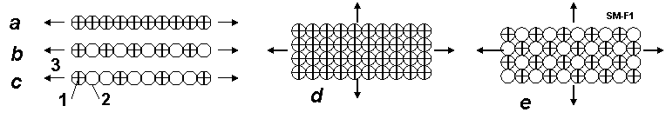
Fig. 5 Connection of nucleons in string (needle) (Fig. 2a, b, c) and film, plate (Fig.5d, e) and Coulomb (electrostatic, repulse)
force. Notations: 1-protons, 2-neutrons, 3-repulse (Coulomb) force from protons.
Theory of AB-needles
Estimation of magnetic force the nucleons.
Proton and neutron have the magnetic momentum p_{m}. That means they are magnets. Magnets have North and Source poles and have ability connecting one to other in line. Let us to calculate this force and compare it with the nuclear and electrostatic forces.
The magnetic momentum p_{m} (J/T) is creating the circle currency I (fig. 6). It is
p_{m} = Is , (1)
where I is electric currency, A; s = πr² is a circle area of electric currency, m²; r is radius of circle, m.
Magnetic momentum of proton, neutron are known. The radius of the proton charge is also measured. In any case it is less than the radius of particles. From (1) we calculate the minimal electric currency of nucleon
I = p_{m}/s . (2)
The magnetic intensity H in point “A” located in circle axis OA (fig.5) is
. (3)
For b = 0 the magnetic intensity in circle center is
(4)
Fig.6. For theory of the magnetic intensity in an axis of the circle currency having the magnetic momentum p_{m} . Notations: A is point where we measure the magnetic intensity H; 1 – current circle is creating the electric charge: r is radius, I is electric currency, p_{m} is magnetic momentum; b is distance of line OA; ρ is distance AB.
The charge of proton is e = +1.6.10⁻¹⁹, C. That allows to calculate the number of charge revolutions n (1/s) and speed of charge V (m/s):
(5)
where V must be less than the light speed c = 3.10⁸ m/s.
If we know the magnetic intensity, we can estimate the attractive force F (N) of opposed pole same (closed) magnet
(6)
where μ_{o} ≈ 4π.10⁻⁷ is magnetic constant (permeability) ( N/A²). F₀ is force (N) in center of the currence circle.
The computation shows: the magnetic forces have the significantly value.For example, the proton has p_{m} = 1.41×10⁻²⁶ J/T, the radius r = 0.8775×10⁻¹⁵ m. From (6) we get F₀ = 16.9 N. This force is closed to the nuclear + electric forces. The spherical distribution (as dot lines) of these forces along the radius are shown in fig. 7. As the result the attractive forces along the magnetic momentum axis is considerable more than in perpendicular axis. The force body has a form of rotated oval or ellipsoid. In result the protons and neutrons may be orientated in outer magnetic field and connected into AB-needle or filament as shown in fig.7d.
Fig.7. For computation of the magnetic force from the magnetic momentum of a nucleon (proton or neutron). Notations: a – nucleon: 1 – nucleon having radius R, 2 –electric currency ring having radius r, 3 – magnetic lines from the magnetic momentum. b – magnitudes of forces near nucleon: 4 – nuclear and electrostatic forces, 5 - magnetic force. Magnitudes equal a distance from the center to the dot line. c – form of forces in isometric view. Form is closed to a rotated oval or rotated ellipsoid. d – is AB needle from nucleons connected in line as magnets.
The magnetic forces of nucleons may be significantly increased when they connected one to other (fig.8a). In this case they work as solenoid having the summary electric currency and an inverse linear relationship from a length of solenoid d (not inverse relationship of the third order as in (4)-(3)).
Fig.8. Left: Two connected nucleus work as solenoid. Their magnetic force is increases. 3 is common magnetic lines. Right: AB-needles: Notations: 1 – AB-needle from protons (pppp…); 2 – AB-needle from one proton + one neutron (pnpn…); 3 – AB-needle from one proton + two neutrons (pnnpnn…); 4 – AB-needle from one proton + three neutron (pnnnpnnn…), 5 - AB-needle from two protons + two neutrons (ppnnppnn…)(ends have one proton).
The magnetic intensity (H) and force between two nucleons as solenoid may be computed the equations:
(7)
where I₁ is circle electric currency in the first nucleon (A), I₂ is circle electric currency in the second nucleon (A); d is distance between circles (m), d ≈ 2R; F_{d} is force, N; s = πr² is a circle area of the electric currency, m². If solenoid row have n same nucleons, the summary magnetic intensity of long solenoid changes as:
. (8)
The AB-needles can have the different structures. Some of them are sown in fig. 8b. For example: The first AB-needle (fig.8b-1) contains only protons (pppp…). The second (fig. 8b-2) - contains the proton-neutron (pnpn…). The third (fig. 8b-3) - contains proton and two neutrons (pnnpnn…). The fourth (fig.8b-4)– contains proton + three neutrons (pnnnpnnn…). The fifth (fig.8b – 5) - contains two protons + two neutrons (ppnnppnn…). I think for stability AB-needle (include many row needles about every neutrons must be proton because some theory propose the proton and neutron are exchanging the charge.
The repulse electrostatic force between two protons is
(9)
where k = 9×10⁹ N.m²/C² is electrostatic constant; d is distance between two protons, m. If row (thread) contains only protons the maximal summary electrostatic force is
(10)
The average nuclear force F_{N} (N) equals approximately
(11)
where E is avarage nuclear connection (binding) energy (J), l is average distance of the active force (m).
For the hydrogen nucleus ²H (proton + neutron) the nuclear binding energy equals 1 MeV [12, p.547] . That means E = 1,6×10⁻¹³ J. The active distance of the nuclear force is about l = 10⁻¹⁵ m.
Substitute it into equation (11) we get the average nuclear force
F_{N} = 160 N. (12)
Numerical estimation.
- Let us estimate the forces between proton - proton. It is known the radius R (m) of nucleon approximately equals
(11)
where A is number of nucleons into nucleus. In our case A = 1 and m for all nucleons (proton and neutron). The radius of positive charge into proton is known and equal r = 0.8775×10⁻¹⁵ m. The magnetic momentum of proton is p_{m} = 1.41×10⁻²⁶ J/T.
Using the equation above we can compute magnetic force and next parameters of solenoid from couple neutrons:
(12)
(13)
. (14)
For solenoid having two protons we get:
(15)
Note: the attractive nuclear force F_{N} =160 N (12) is significantly more than repulsive electrostatic force F_{e} = - 40N.
2. Let us estimate the solenoid magnetic force in couple proton + neutron. The magnetic momentum of neutron is p_{m} = - 0.966×10⁻²⁶ J/T. Sign minus means the vector of magnetic moment and vector of mechanical momentum (spin) is opposed. It is not important for us because we can turn the vector of the magnetic force in a need direction by an outer magnetic field.
Let us take the radius of neutron equals the radius of proton R = 1.2×10⁻¹⁵ m and radius
of charge into neutron equal to radius of charge of proton r = 0.8775×10⁻¹⁵ m.
Using the equation above we can compute the next values and force in neutron:
(16)
(17)
. (18)
For solenoid having two protons we get:
(19)
The attractive nuclear force F_{N} =160 N (12).
3. Let us estimate the solenoid magnetic force in couple neutron + neutron. The magnetic momentum of neutron is p_{m} = - 0.966×10⁻²⁶ J/T. Sign minus means the vector of magnetic moment and vector of mechanical momentum (spin). Let us take the radius of neutron equals the radius of proton R = 1.2×10⁻¹⁵ m and radius of charge into neutron equal to radius of charge of proton r = 0.8775×10⁻¹⁵ m.
Using the equation above we can compute the next values and force in neutron:
(20)
(21)
. (22)
For solenoid having two protons we get:
(23)
The attractive nuclear force F_{N} =160 N (12).
This computations show: the magnetic forces of protons and neutrons allow to design from them the long AB-treads if we connect them by the corresponding magnetic poles. We can make their need orientation by the outer magnetic field. If AB-thread contains the correct located protons one became the springy AB-needle.
IV. SOME APPLICATION of AB-needles
Some constructions from AB-string are shown in Fig.9.
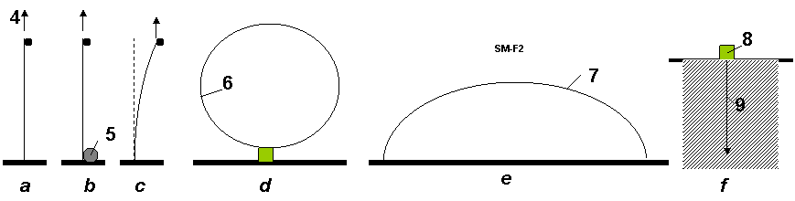
Fig. 9. Some construction from AB-string. Notations: a – vertical string (AB-needle). The big lift (support) force 4 does not depend from length; b – lifting the load to any altitude. 5 - spool of AB-string; c – stability of AB-string; d – ring 6 from AB-string; e – bridge (long arm) from AB-string; f – research of the Earth crust interior: 8 - installation (spool of AB-needle), 9 – AB-needle (string, cable).
AB-needles may be illustrated by a children long inflatable air-balloon (Fig. 10a). This press force also does not depend on length of balloon. The force is transferred by compressed air. This idea was used by author in designing the inflatable space tower [5].
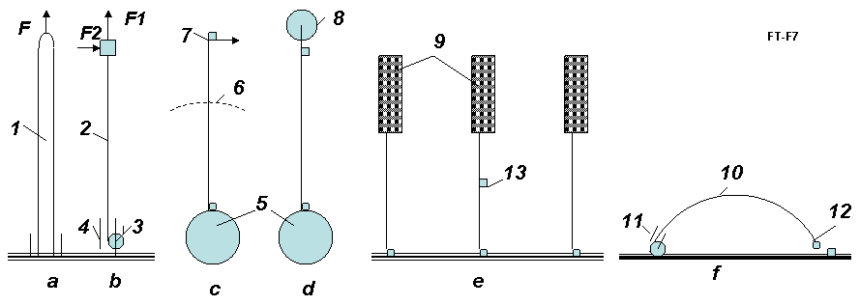
Fig. 10. Applications of AB-needles. Notations: a – conventional children inflatable long tube illustrated the capability to accept the pressure in end of tube (F – force); b – illustration of AB-needle to lift the load, accepts the vertical and horizontal forces (F1, F2 = 0.5F1); c – AB-needles as the over GSO Space Elevator; d – AB-needles as space ship and the investigator of the planet interior (for example Moon); e – the building suspended at high altitude by AB – needles, f – the investigation of interior of building, men, etc. by AB-needles. 1- conventional children inflatable long tube (air balloon); 2 – AB-needles; 3 – reel of AB-needles; 4 – the guides of AB-needles; 5 – Earth; 6 – Geosynchronous orbit; 7 – space ship; 9 - building; 10 – AB-needle; 11 - the guides of AB-needles; 12 – devices (TV-camera, capture grid, weapon, etc.); 13 – elevator.
The tension F_{p} activates along all lengths of AB-needle and does not allow to curl the AB-string into the lamb – conventional nucleus. This tension works when there are no other closed protons with a side of the string. When AB-needle is created, the outside protons cannot joint to AB-needle because the protons repel each other.
The proton and neutron have the magnetic dipole moments. Magnetic dipole moment of proton equals +1.41·10⁻²⁶ J/T, and magnetic dipole moment of neutron equals -0.966·10⁻²⁶ J/T. They are small magnets having magnetic force some newtons. That also allows creating the stable AB-needles, to arrange them in a certain position and order.
The AB-needle can also keep the maximal side force F2 ≈ 0.5F1 (Fig. 10b). That allows accelerating anybody (for example space ship) in side direction, to produce an elastic design (for example, air bridge, storage of mechanical energy, long arm (hand), etc.). AB-matter designs do not have the drawbacks of the ordinary matter as fatigue, residual strain and the susceptibility to the external environment.
One meter of AB-needle has line having n = 5.7.10⁻¹⁴ nucleons with mass m = 1.67. 10⁻²⁷ kg. Total mass of one meter AB-needle equals only 10⁻¹² kg/m.
M₁ = nm = 5.7.10⁻¹⁴ ×1.67.10⁻²⁷ = 10⁻¹² kg/m.
One million kilometers of AB-needle weights only 10⁻³ kg/Mm. For transferring the large force we can take the thin cable from AB-needles.
- Summary
Four above necessary conditions, repulsive force of protons and magnetic force of nucleons can make the stability of AB-matter.
v.production of ab-needles
The charged particles interact with electric and magnetic fields. The magnetic moment interacts with magnetic field. That allows designing the technologies for production of artificial AB-matter. Some offered technologies were described in [1]. Here the author offers some new technologies.
The possible particles are shown in Table 1.
table 1. charge, impulse and magnetic moments of some nucleus
Z | Nucleus  (particles) | Charge  +e=1.6·10^{─19} C | Mass  number | Impulse  moment, ћ | Magnetic*  moment, µ_{N}
0 | n | 0 | 1 | 1/2 | -1.9125
1 | p | 1 | 1 | 1/2 | 2.7828
1 | ²H = D | 1 | 2 | 1 | 0.8565
2 | ³He | 2 | 3 | 1/2 | -2.121
2 | ⁴He | 2 | 4 | 0 | 0
3 | ⁶Li | 3 | 6 | 1 | 0.821
3 | ⁷Li | 3 | 7 | 3/2 | 3.2332
*Nuclear magnetron µ_{N} = 5.051·10^{─27} J/T. Sign “-“shows: magnetic moment is opposite the impulse moment.
- Notes About Possible Form AB-needles
The possible form of AB-needles is shown in Fig. 11.
The first form marked 1 (pppp…) contains only line of protons. This form is cheapest and has maximum pressure strength. But it is unknown whether this form is possible or not. It is known the single hydrogen and single proton are stable. In other side the fusion of two single hydrogen nuclei ¹H (protons) produces deuterium ²H= D (pn) releasing a positron and a neutrino as one proton changes into a neutron:
¹H + ¹H → ²H + e⁺ + ν_{e} + 0.42 MeV (24)
The fusion reaction released in this step produces energy up to 0.42 MeV. The most of this energy is taken away by neutrino.
The positron immediately annihilates with an electron, and their mass energy is carried off by two gamma ray photos:
e⁺ + e⁻ → 2γ + 1.02 MeV . (25)
But most nucleuses have a lot of protons and they do not rely on the reaction (24). The AB-needle also has a lot of protons. If reaction (24) is released, the form 1 transfers in form 2 (Fig. 11) and the process produces a lot of nuclear energy. The ionized conventional hydrogen ¹H may be used for production of AB-matter. I remain: the Universe is composed of about 80% hydrogen. As a result we will have the AB-needle in form npnp… .
The second form of AB-needle is pnpn… marked 2 (Fig. 11). This form may be produced directly from deuterium D oriented by magnetic field along axis of AB-needles. The third form of the double AB-needles marked 3 (Fig. 10) may be also produced directly from deuterium D oriented by magnetic field perpendicular of axis of AB-needles. The forth form of four-needles marked 4 (Fig. 11) may be produced directly from helium ⁴He oriented by magnetic field perpendicular of axis of AB-needles.
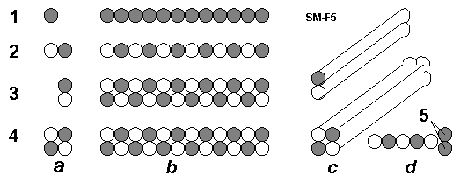
Fig.11 Types of AB-needles. Notations: a – Nucleus: black is p, white is n; b – AB-needles (side view); c – AB-needles in isometrical view; d – increasing the internal tensile stress by the double protons (5) located in the end of single AB-needle from protons (for increasing the tensile stress); 1- protons (p). Single AB-needles from proton; 2 – deuterium ²H = D (pn). Single AB-needles from deuterium; 3 - deuterium ²H (pn). Double AB-needles from deuterium; 4 – helium ⁴He. 4 – square AB-needles from helium. 5 – double protons in end of single AB-needle.
- Installations for Production AB-needles
1) The First Method: Toroid Method:
One of installation for production of AB-needles is shown in Fig. 12. The installation has a vacuum topoid 1 and particles gun 4 which injects charged particles into toroid. The perpendicular (to fig.) magnetic lines 2 penetrate the toroid. As a result the charged particles 3 move in circles inside the toroid. This electric current of particles produces the magnetic field 5 (pinch-affect). This field pulls the particles in a cord and helps to keep them into the toroid ring.
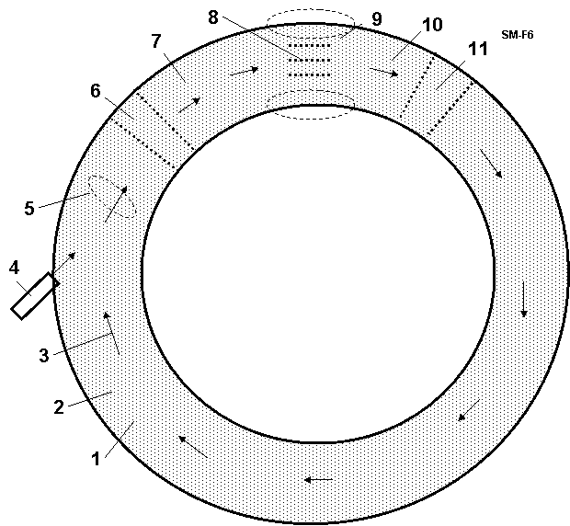
Fig. 12 Toroid producer of AB-needles (AB-matter). Notations: 1 – vacuum toroid; 2 – perpendicular (to sketch) magnetic lines; 3 – particles; 4 - particles gun; 5 – round magnetic lines from motion charged particles; 6 – electric accelerator; 7 – electric focuser; 8 – AB – needles; 9 – magnetic field keeping the AB-needles; 10 – electric focuser; 11 – electric accelerator.
The producing AB-needles 8 locate inside the toroid ring and are kept by special local magnetic field 9 in position along the circle axis of the toroid ring. That means the moving particles can connect to AB-needles only to end nucleus when they collide the forward end of AB-needle and their energy is sufficient to overcome the Coulomb repulsion. The toroid ring has the accelerators 6, 11 and focusers 7, 10 of particles. Their electric fields collect the scattered charged particles back to toroid axis.
Probability of hitting in the front end of the AB-needles is small. But the charged particles rotate into toroid a lot (millions) of times and join to end of AB-needles. Note they can connect only to end of AB-needle. Their perpendicular speed to the toroid circle axis is not enough to overcome the nuclear repulsion force.
Author wrote only the principal scheme (schematic diagram) of the AB-needle producing. The developing of this method may request a big research and work.
2) The Second Method: Method Particles Traps:
That is shown in Fig. 13. That is closed to method described in [1-3]. Feature is the net of traps 8 (Fig. 13a and 13b). They catch the particles and direct them to end of creating AB-needles. Advantage is high efficiency of production AB-matter (every charged particle will be used, small of energy consumption). Lack is the request of a special form of AB-matter (see 8 in Fig. 13b). That method may be useful when we have enough AB-matter.
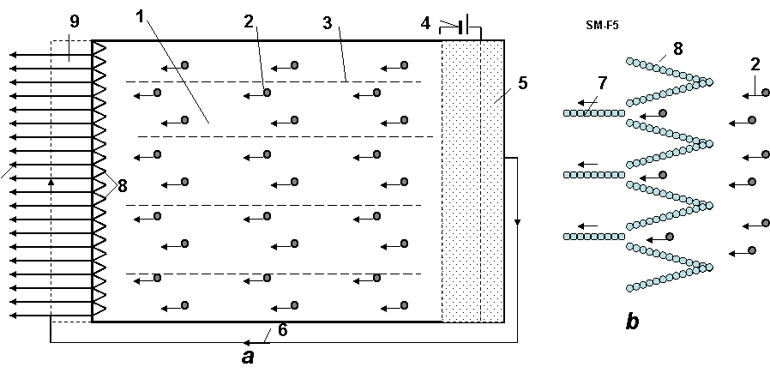
Fig. 13. Method particle traps for production of the AB-needles. Notations: a – device; b – particle traps; 1 - vacuum cell; 2- charged particles; 3 – magnetic lines; 4 – electric issue for the acceleration nets; 5 - plasma from particles; 6 – flow of electrons; 7 – AB-needles; 8 – trap made from AB-matter for the charged particles (p, ²H, ⁴He, etc.); 9 – cell for cover the AB-needles by electrons.
3) The Third Method: Method Standing Waves:
The current special mirrors [4, Ch.12] and lasers allow to create the net of electromagnetic traps for AB-matter producer (Fig. 14) from the monochromatic polarized electromagnetic standing waves (Fig. 14a, b). That net may partially change the net of AB-matter traps of the Fig. 14b and increase the efficiency. This method may be useful for AB-matter producer in [1-3].
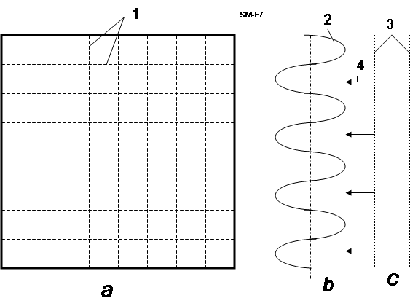
Fig. 14. Net of electromagnetic traps for AB-matter producer. Notations: a – forward view; b – the monochromatic polarized electromagnetic standing waves (electrostatic part, side view); c – particles storage and accelerator; 1 – net from the perpendicular monochromatic polarized electromagnetic standing waves; 2 - the electromagnetic monochromatic polarized standing wave; 3 – electric accelerator of particles; 4 – particles.
The threads from AB-matter are stronger by millions of times than normal materials. They can be inserted as reinforcements, into conventional materials, which serve as a matrix, and are thus strengthened by thousands of times (see computation section in [1]).
The offered AB-producers can be used for producing the new NANO-matters. Now the scientist offers to produce nano-matters by nano-robots. I think that is a very difficult way. The nano-robot must have the devices for searching, recognizing, catching the flying molecules, deliver them in given place, and connect to other selected molecules. That means the nano-robot must have a million molecules. It is difficult to get an elephant to catch the flies and glue them from the device. This productivity will be very low. The production of AB-matter may be easy.
Also we can ionize the molecules (create the charged particles!) and apply the modified offered methods for design and production of the nano-matters.
vi. discussion
The humanity will make a gigantic jump in technology when one will produce AB-matter. We consider unconventional application of AB-matter.
- Super Micro-World from AB-Matter: An Amusing Thought-Experiment
AB-matter may have 10¹⁵ ÷ 10⁴³ times more particles in a given volume than a single atom. A human being, man is made from conventional matter, contains about 5×10²⁶ molecules. That means that ‘femto-beings’ of equal complexity from AB-matter (having same number of components) could be located in the volume of one microbe having size 10 μ = 10^{─5} m. It is difficult to make the nano-robot (one is large for Nano World). But the smart small femto-robot is suitable for Nano World. In future the people could make the artificial intelligent super micro F-beings which can withstand a huge temperature, acceleration of electric field, travel to other stars, other galactic, live in stars and travel through black holes to other universes and times.
- Stability of AB-matter
Readers usually ask: the connection (proton to proton) gives a new element when, after 92 protons, this element is unstable?
Answer: That depends entirely on the type of connection. If we conventionally join the carbon atom to another carbon atom a lot of times, we then get the conventional piece of a coal. If we join the carbon atom to another carbon atom by the indicated special forms, we then get the very strong single-wall nanotubes, graphene nano-ribbon (super-thin film), armchair, zigzag, chiral, fullerite, torus, nanobud and other forms of nano-materials. That outcome becomes possible because the atomic force (van der Waals force, named for the Dutch physicist Johannes Diderik van der Waals, 1837-1923, etc.) is non-spherical and active in the short (one molecule) distance. The nucleon nuclear force is also non-spherical and they may also be active about the one nucleon diameter distance (Fig. 1). Moreover, the nucleus are tensile electrostatic force which allows designing the long linear structures. Moreover, the proton and neutron are the small magnets. The magnets (and nucleus) connect one to other specific side. That means we may also produce with them the strings, tubes, films, nets and other geometrical constructions.
The further studies are shown that AB-matter will be stable if:
1) The any sphere having radius R ≈ 6×10⁻¹⁵ m in any point of structure Figs. 1- 4 must contain no more than 238 nucleons (about 92 of them must be protons). That means any perpendicular cross-section area of the solid rod, beam and so on of AB-structure (for example figs. 1b,c,g) must contain no more than about 36 nucleons in any circle with R ≈ 6×10⁻¹⁵ m.
2) AB-matter must contain the proton in a certain order because the electrostatic repel forces of them give the stability of the given structure.
3) The magnetic force of protons and neutrons also allows giving the different forms of AB-matter.
VII. conclusion
The author offers a design for a new form of nuclear matter from nucleons (neutrons, protons), electrons, and other nuclear particles. He also suggests the necessary conditions of stability of AB-matter. He shows that the new AB-matter has most extraordinary properties (for example, (in varying circumstances) remarkable tensile strength, stiffness, hardness, critical temperature, superconductivity, super-transparency, ghostlike ability to pass through matter, zero friction, etc.), which are millions of times better than corresponded properties of conventional molecular matter. He shows (in [2]) how to design aircraft, ships, transportation, thermonuclear reactors, and constructions, and so on from this new nuclear matter. These vehicles will have correspondingly amazing possibilities (invisibility, passing through any wall and amour, protection from nuclear bombs and any radiation, etc).
People may think this is fantasy. But fifteen years ago most people and many scientists thought nanotechnology is fantasy. Now many groups and industrial labs, even startups, spend hundreds of millions of dollars for development of nanotechnological-range products (precise chemistry, patterned atoms, catalysts, metamaterials, etc) and we have nanotubes (a new material which does not exist in Nature!) and other achievements beginning to come out of the pipeline in prospect. Nanotubes are stronger than steel by a ten times—surely an amazement to a 19th century observer if he could behold them.
Nanotechnology, in near term prospect, operates with objects (molecules and atoms) having the size in nanometer (10⁻⁹ m). The author here outlines perhaps more distant operations with objects (nuclei) having size in the femtometer range, (10⁻¹⁵ m, millions of times smaller than the nanometer scale). The name of this new technology is femtotechnology.
I want to explain the main thrust of this by analogy. Assume some thousands of years ago we live in a great river valley where there are no stones for building and only poor timber. In nature we notice that there are many types of clay (nuclei of atom—types of element). One man offers to people to make from clay bricks (AB-Matter) and build from these bricks a fantastic array of desirable structures too complex to make from naturally occuring mounds of mud. The bricks enable by increased precision and strength things impossible before. A new level of human civilization begins.
The author calls upon scientists and the technical community to research and develop femtotechnology [10]. We can reach progress more quickly than in the further prospects of nanotechnology in this field, because we have fewer (only 3) initial components (proton, neutron, electron) and interaction between them is well-known (3 main forces: strong, weak, electrostatic). The different conventional atoms number about 100, most common molecules are tens of thousands and interactions between them are very complex (e.g. Van der Waals force).
What time horizon might we face in this quest? The physicist Richard Feynman offered his idea to design artificial matter from atoms and molecules at an American Physical Society meeting at Caltech on December 29, 1959. But only in the last 15 years we have initial progress in nanotechnology. On the other hand, progress is becoming swifter as more and better tools become common and as the technical community grows.
Now we are in the position of trying to progress from the ancient ‘telega’ haywagon of rural Russia (in analogy, conventional matter composites) to a ‘luxury sport coupe’ (advanced tailored nanomaterials). The author suggests we have little to lose and literal worlds to gain by simultaneously researching how to leap from ‘telega’ to ‘hypersonic space plane’. (Femotech materials and technologies, enabling all the wonders outlined here) [1 – 10].
acknowledgement
The author wishes to acknowledge Joseph Friedlander (of Shave Shomron, Israel) for correcting the English and offering useful advices and suggestions.
references
(The reader may find some of these articles at the web storages: http://www.scribd.com , http://arxiv.org , http://vixra.org, http://aiaa.org , search “Bolonkin” and in the author’s books: "Non-Rocket Space Launch and Flight", Elsevier, London, 2005, 488 pages; “New Concepts, Ideas, Innovations in Aerospace, Technology and Human Science”, NOVA, 2006, 502 pages and “Macro-Projects: Environment and Technology”, NOVA 2007, 536 pages; “New Technologies and Revolutionary Projects”, Scribd, 2008, 324 pgs; Innovations and New Technologies. Scribd, 2013. 309 pgs. 8 Mb.).
- Bolonkin A.A., Femtotechnology. Nuclear AB-Matter with Fantastic Properties, American Journal of Engineering and Applied Sciences. 2 (2), 2009, p.501-514. Presented as paper AIAA-2009-4620 to 7th Annual International Energy Convention Conference, 2-5 August 2009, Denver, CO, USA. [On line]: http://www.scribd.com/doc/24045154. http://viXra.org/abs/1309.0201 .
- Bolonkin A.A., Femtotechnology: Design of the Strongest AB-Matter for Aerospace. Presented as paper AIAA-2009-4620 to 45 Joint Propulsion Conference, 2-5 August, 2009, Denver CO, USA. See also closed paper AIAA-2010-1556 in 48 Aerospace Meeting, New Horizons, 4 – 7 January, 2010, Orlando, FL, USA. http://www.archive.org/details/FemtotechnologyDesignOfTheStrongestAb-matterForAerospace . Published in “Journal of Aerospace Engineering”, Oct. 2010, Vol. 23, No. 4, pp.281-292. http://www.archive.org/details/FemtotechnologyDesignOfTheStrongestAb-matterForAerospace http://www.scribd.com/doc/57369206/Femtotechnology-Design-of-the-Strongest-AB-Matter-for-Aerospace
- Bolonkin A.A., AB-needles: Fantastic Properties and Application in Energy. International Journal of Energy Engineering (IJEE), December, 2013.
- Bolonkin A.A., Converting of Matter to Nuclear Energy by AB-Generator. American Journal of Engineering and Applied Sciences. 2 (4), 2009, p.683-693. [on line] http://www.scribd.com/doc/24048466. http://viXra.org/abs/1309.0200
- Bolonkin A.A., "Non-Rocket Space Launch and Flight", Elsevier, 2005, 488 pgs. ISBN-13: 978-0-08044-731- 5, ISBN-10: 0-080-44731-7 . http://www.archive.org/details/Non-rocketSpaceLaunchAndFlight, http://www.scribd.com/doc/24056182.
- Bolonkin A.A., “New Concepts, Ideas, Innovations in Aerospace, Technology and the Human Sciences”, NOVA, 2006, 510 pgs. ISBN-13:978-1-60021-787-6.http://www.scribd.com/doc/24057071 , http://www.archive.org/details/NewConceptsIfeasAndInnovationsInAerospaceTechnologyAndHumanSciences, http://viXra.org/abs/1309.0193,
- Bolonkin A.A., Cathcart R.B., “Macro-Projects: Environments and Technologies”, NOVA, 2007, 536 pgs. ISBN 978-1-60456-998-8. http://www.scribd.com/doc/24057930 . http://viXra.org/abs/1309.0192 , http://www.archive.org/details/Macro-projectsEnvironmentsAndTechnologies
- Bolonkin A.A., “New Technologies and Revolutionary Projects”, Scribd, 2008, 324 pgs, http://www.scribd.com/doc/32744477, http://www.archive.org/details/NewTechnologiesAndRevolutionaryProjects.
- Bolonkin A.A., LIFE. SCIENCE. FUTURE (Biography notes, researches and innovations). Lambert, 2010, 208 pgs. 16 Mb. ISBN: 978-3-8473-0839-3 . http://www.scribd.com/doc/48229884, http://www.archive.org/details/Life.Science.Future.biographyNotesResearchesAndInnovations, http://viXra.org/abs/1309.0205 , http://www.lulu.com, search “Bolonkin”.
- Bolonkin A.A., Femtotechnologies and Revolutionary Projects. Lambert, USA, 2011. 538 p. 16 Mb. ISBN: 978-3-8473-0839-0. http://www.scribd.com/doc/75519828/, ISBN 078-1-105-64111-4; http://viXra.org/abs/1309.0191, http://www.archive.org/details/FemtotechnologiesAndRevolutionaryProjects .
- http://www.physicum.narod,ru, Vol. 5., p.670.
- AIR Physics Desk Reference, Third Edition, p. 547.

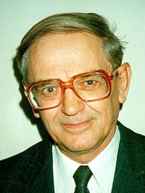
Short biography of Bolonkin, Alexander Alexandrovich (1933-)
Alexander A. Bolonkin was born in the former USSR. He holds doctoral degree in aviation engineering from Moscow Aviation Institute and a post-doctoral degree in aerospace engineering from Leningrad Polytechnic University. He has held the positions of senior engineer in the Antonov Aircraft Design Company and Chairman of the Reliability Department in the Clushko Rocket Design Company. He has also lectured at the Moscow Aviation Universities. Following his arrival in the United States in 1988, he lectured at the New Jersey Institute of Technology and worked as a Senior Scientist at NASA and the US Air Force Research Laboratories.
Bolonkin is the author of more than 200 scientific articles and books and has 17 inventions to his credit. His most notable books include The Development of Soviet Rocket Engines (Delphic Ass., Inc., Washington , 1991); Non-Rocket Space Launch and Flight (Elsevier, 2006); New Concepts, Ideas, Innovation in Aerospace, Technology and Human Life (NOVA, 2007); Macro-Projects: Environment and Technology (NOVA, 2008 LIFE; Human Immortality and Electronic Civilization, 3-rd Edition, (Lulu, 2007; Publish America, 2010): LIFE. SCIENCE. FUTURE (Biography notes, researches and innovations). Scribd, 2010, 208 pgs. 16 Mb. http://www.scribd.com/doc/48229884 ; Innovations and New Technologies. Scribd, 2013. 309 pgs. 8 Mb. http://viXra.org/abs/1307.0169.
Home page: http://Bolonkin.narod.ru .

