Electron Hydro Electric Generator
by Alexander Bolonkin

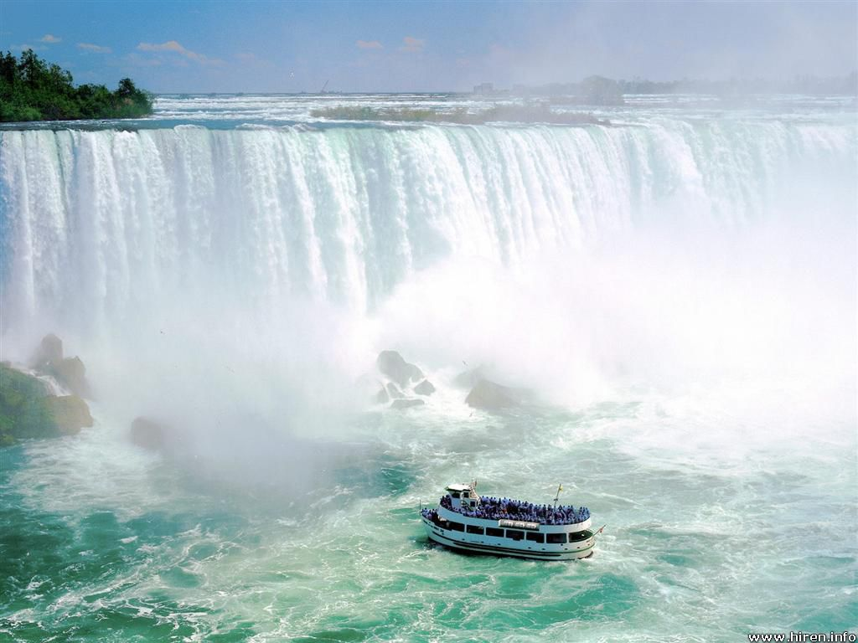

New York, USA,
June, 2013

Electron Water generator 6 13 13
Electron Hydro Electric Generator
by Alexander Bolonkin
C@R ,1310 AvenueR,#6-F, Brooklyn, NY, 11229, USA.
abolonkin@juno.com
Abstract
Author offers a new method of getting electric energy from moving water. A special injector injects electrons into water. Water stream picks up the electrons and moves them in the direction of stream which is against the direction of electric field. At some distance from injector a unique grid acquires the electrons, thus charging and producing electricity. This method does not require, as does other water energy devices, strong dams, water turbines, or electric generators. The proposed water installation is very cheap. The area of water braking may be large and produces a great deal of energy. This electron water installation may be in river or ocean stream (as Gulf Stream).
------------------------------------------------------------------------------------------------------------
Keywords: water energy, utilization of water energy, electronic water electric generator, WABG, Bolonkin.
Introduction
Water energy
Hydropower or water power is power derived from the energy of falling water and running water, which may be harnessed for useful purposes. Since ancient times, hydropower has been used for irrigation and the operation of various mechanical devices, such as watermills. Since the early 20th century, the term is used almost exclusively in conjunction with the modern development of hydro-electric power, which allowed use of distant energy sources. Hydro power is a renewable energy source.
Rivers. Volumetric flow rate, also known as discharge, volume flow rate, and rate of water flow, is the volume of water which passes through a given cross-section of the river channel per unit time. It is typically measured in cubic meters per second (cumec) or cubic feet per second (cfs), where 1 m³/s = 35.51 ft³/s; it is sometimes also measured in liters or gallons per second. Volumetric flow rate can be thought of as the mean velocity of the flow through a given cross-section, times that cross-sectional area. Mean velocity can be approximated through the use of the Law of the Wall. In general, velocity increases with the depth (or hydraulic radius) and slope of the river channel, while the cross-sectional area scales with the depth and the width: the double-counting of depth shows the importance of this variable in determining the discharge through the channel.
Data of Some World Rivers.
Amazon: elevation 5170 m (16,962 ft), length 7,000 km (4300 mi), average discharge 209,000 m³/s (7,381,000 cu ft/s).
Mississippi: elevation 450 m (1,475 ft), length 3,734 km (2320 mi), average discharge 16,792 m³/s (593,000 cu ft/s). The Mississippi River discharges at an annual average rate of between 200 and 700 thousand cubic feet per second (7,000–20,000 m³/s). Although it is the 5th largest river in the world by volume, this flow is a mere fraction of the output of the Amazon, which moves nearly 7 million cubic feet per second (200,000 m³/s) during wet seasons. On average, the Mississippi has only 8% the flow of the Amazon River.
Niagara Falls is the collective name for three waterfalls that straddle the international border between the Canadian province of Ontario and the U.S. state of New York. They form the southern end of the Niagara Gorge. Located on the Niagara River, which drains Lake Erie into Lake Ontario, the combined falls form the highest flow rate of any waterfall in the world, with a vertical drop of more than 165 feet (50 m). Horseshoe Falls is the most powerful waterfall in North America, as measured by vertical height and also by flow rate. While not exceptionally high, the Niagara Falls are very wide. More than six million cubic feet (168,000 m³) of waterfalls over the crest line every minute in high flow, and almost four million cubic feet (110,000 m³) on average.
Marine energy (also sometimes referred to as ocean energy or ocean power) also refers to the energy carried by ocean waves, tides, salinity, and ocean temperature differences. The movement of water in the world’s oceans creates a vast store of kinetic energy, or energy in motion. This energy can be harnessed to generate electricity to power homes, transport and industries. The term marine energy encompasses both wave power — power from surface waves, and tidal power — obtained from the kinetic energy of large bodies of moving water. The oceans have a tremendous amount of energy and are close to many if not most concentrated populations. Ocean energy has the potential of providing a substantial amount of new renewable energy around the world.
Marine current power is a form of marine energy obtained from harnessing of the kinetic energy of marine currents, such as the Gulf Stream. Although not widely used at present, marine current power has an important potential for future electricity generation. Marine currents are more predictable than wind and solar power.
A 2006 report from United States Department of the Interior estimates that capturing just ¹/_{1,000th} of the available energy from the Gulf Stream, which has 21,000 times more energy than Niagara Falls in a flow of water that is 50 times the total flow of all the world’s freshwater rivers, would supply Florida with 35% of its electrical needs.
Marine currents are caused mainly by the rise and fall of the tides resulting from the gravitational interactions between earth, moon, and sun, causing the whole sea to ﬂow. Other effects such as regional differences in temperature and salinity and the Coriolis Effect due to the rotation of the earth are also major inﬂuences. The kinetic energy of marine currents can be converted in much the same way that a wind turbine extracts energy from the wind, using various types of open-ﬂow rotors. The potential of electric power generation from marine tidal currents is enormous. There are several factors that make electricity generation from marine currents very appealing when compared to other renewables:
- The high load factors resulting from the ﬂuid properties. The predictability of the resource, so that, unlike most of other renewables, the future availability of energy can be known and planned for.
- The potentially large resource that can be exploited with little environmental impact, thereby offering one of the least damaging methods for large-scale electricity generation.
- The feasibility of marine-current power installations to provide also base grid power, especially if two or more separate arrays with offset peak-ﬂow periods are interconnected.
Gulf Stream. As a consequence, the resulting Gulf Stream is a strong ocean current. It transports water at a rate of 30 million cubic meters per second (30 sverdrups) through the Florida Straits. As it passes south of Newfoundland, this rate increases to 150 million cubic meters per second. The volume of the Gulf Stream dwarfs all rivers that empty into the Atlantic combined, which barely total 0.6 million cubic meters per second. It is weaker, however, than the Antarctic Circumpolar Current. The Gulf Stream is typically 100 kilometers (62 mi) wide and 800 meters (2,600 ft.) to 1,200 meters (3,900 ft.) deep. The current velocity is fastest near the surface, with the maximum speed typically about 2.5 meters per second (5.6 mph).
Tidal power, also called tidal energy, is a form of hydropower that converts the energy of tides into useful forms of power - mainly electricity. Although not yet widely used, tidal power has potential for future electricity generation. Tides are more predictable than wind energy and solar power. Among sources of renewable energy, tidal power has traditionally suffered from relatively high cost and limited availability of sites with sufficiently high tidal ranges or flow velocities, thus constricting its total availability.
Wave energy is the transport of energy by ocean surface waves, and the capture of that energy to do useful work – for example, electricity generation, water desalination, or the pumping of water (into reservoirs). Machinery able to exploit wave power is generally known as a wave energy converter (WEC). Wave power is distinct from the diurnal flux of tidal power and the steady gyre of ocean currents. Wave-power generation is not currently a widely employed commercial technology, although there have been attempts to use it since at least 1890. In 2008, the first experimental wave farm was opened in Portugal, at the Aguçadoura Wave Park.
The realistically usable worldwide resource has been estimated to be greater than 2 TW. Locations with the most potential for wave power include the western seaboard of Europe, the northern coast of the UK, and the Pacific coastlines of North and South America, Southern Africa, Australia, and New Zealand. The north and south temperate zones have the best sites for capturing wave power. The prevailing westerly’s in these zones blow strongest in winter.
The reader can find the authors ideas about various innovations in harnessing wind energy in [1]-[7], and additional information about water energy in [8]-[11].

Description of Innovation
Design. One simplest version of the offered electron water generator (WABG) is presented in fig.1. Installation contains: electron injectors 2 established in column 6 and electron collector having the high voltage ring 8 and inside net 4. Net 4 are having the conductive leaves 5 (metallic foil, for example, aluminum foil). They have a large surface which helps to collect the electrons from a large area and send to the ring 8. Network connects with the electron injectors through a useful load 7.
Work of WABG. The WABG generator works the following way: injector injects the electrons into water, the water stream catches them and moves to network 4 of the electron collector 8. Ring 8 has negative charge, electron injector has positive charge. The electric field of ring 8 breaks the electrons (negative ions) and decreases the water speed. But the electric ion speed is significantly less than water stream speed and electrons when they reach the net of collector settle into net 4 and move to ring 8 of the collector and increase its negative charge of the ring 8. Those additional charges (electrons) return through the electric load 7 and make the useful work.

Fig.1. One version of Electron Water Electric Generator (WABG). a – side view of the installation; b – front view of the electron injector column; c – front view of the collect net. Notations: 1 is water stream; 2 is electron injector; 3 is trajectories of electrons; 4 is net for collecting the electrons; 5 is conductive leaves (metallic foil, for example, aluminum foil); 6 is column (post) for supporting of the electron injectors; 7 is the outer electric load; 8 – electron high voltage ring collector.
If river is navigable, the collector is located on the river bottom (fig.2). The injectors may be up on a mast (fig. 2a) or located also on river bottom (fig. 2b). The efficiency of these will be different. The surface collector is conductivity film 11 (fig.2) (for example, aluminum foil) which pass them to isolated high voltage ring 8. For increasing the efficiency of collector we can (optionally) place under net of collector the isolated positive charge 12 (or positive electrets) (fig. 2).
Fig.2. The horizontal conductivity film as collector of electrons. a – injectors in column; b - injectors at a bottom of river. Notations: 1 – 8 are same with fig.1; 11 - conductivity film (for example, aluminum foil); 12 (optional) positive isolated charge (for example, electrets).
Advantages of the proposed electron wind systems (WABG) in comparison with the conventional hydropower systems.
The suggested new principle electron water generator (WABG) has the following advantages in comparison with conventional hydro dam systems used at present time.
Advantages:
1. Offered installations are very simple.
2. Offered system is very cheap (by hundreds of times). No dam, hydro-turbines, electric generators,
special canals for ships, fish, filling the fertile land and so on.
3. The WABGs may be invisible for population.
4. Offered installations produce direct electricity. That may be advantage.
5. Many WABGs may be installed along river, falls or sea stream and give big energy.
Estimations and Computation
1. Power of a water flow is N [Watt, Joule/sec]:
N = 0.5ηρ AV³ or N = ηρBgh [W]. (1)
The coefficient of efficiency,η, equals about 0.3 ÷ 0.5 for WABG; A - front (forward) area of the electron collector, [m²]. ρ - density of liquid: ρ ≈ 1.000 kg/m³ for water; V is average annually stream speed, m/s; B is the flow in cubic meters per second; g = 9.81 m/s² is Earth gravity; h is the height difference between inlet and outlet of installation.
Example, if V = 1 m/s, A = 1 m², η = 0.5, ρ = 1000 kg/m³, than N = 250 W/m².
The h and V connected by equation
h = V²/2g . (2)
Example, if V = 1 m/s, than h = 0.05 m.
The flow speed of river significantly depends upon width, depth, discharge and elevation. The speed conventionally increases in narrow riverbed and into depth. Speed may be from 0.1 m/s up 3 m/s and more. For example, the Volga has (after dam about Volgograd) speed 1 – 1.5 m/s, width 4 - 7 km and depth 5 - 15 m. The Gulf Stream (in ocean!) has maximal speed 2.5 m/s.
The energy, E, produced in one year is (1 year ≈ 30.2×10⁶ work sec) [J]
E = 3600×24×350N ≈ 30×10⁶N, [J]. (3)
2. Electron speed. The electron speed about the water, wind, gas (air) jet may be computed by equation:
j_{s} = en₋b₋E + eD₋(dn₋/dx) , (4)
where j_{s} is density of electric currency of jet, A/m²; e = 1.6×10⁻¹⁹ C is charge of single electron, C; n₋ is density of injected electrons (negative charges) in 1 m³; b ₋ is charge mobility of negative charges, m²/sV; E is electric intensity, V/m; D₋ is diffusion coefficient of charges; dn₋/dx is gradient of charges. For our estimation we put dn₋/dx = 0. In this case
j_{s} = en₋b₋E , Q₁ = en , v = bE , j_{s} = Q₁v , (5)
where Q₁ is density of the negative charge in 1 m³; v is speed of the negative charges about stream, m/s.
One liter of sea water has 35 grams of calt NaCl. The Cl (Chlorine) is 1.9% , the Na (Sodium) is 1.05% of water mass . The calt (saline) dissociates in ions Na⁺, Cl⁻ . Concentration of ions: Cl⁻ is 0.546 mol/kg, Na⁺ is 0.469 mol/kg.
The charge mobility is:
Cl⁻ is 0.667×10⁻⁷ m²/sV, Na⁺ is 0.450 ×10⁻⁷ m²/sV. (6)
As you see the mobility of ions in water is very small. The applied voltage in water is also small. That means the ion speed is small in the comparison with water speed. In many case we can put v = 0
If v > 0, the electrons accelerate the water (E > 0 and installation spends energy, works as engine). If v < 0, the electrons brake the water (E < 0 and the correct installation can produce energy, works as electric generator). If v = 0 (electron speed about installation equals water speed V), the electric resistance is zero.
3. Resistance of water. Salt water conducts an electric currency. That means the part of currency will flows back to cathode. The specific electric resistance of water is significantly depends from salinity of water. When we have the plates (nets) with both sides (cathode and anode), the specific electric resistance are:
1. Distilled water R ≈ 10⁶ Ωm.
2. Fresh water R = 40 ÷ 200 Ωm (depends from water salinity). (7)
3. Sea water R ≈ 0.2 Ωm.
In our case in one side we have the electron injector (cathode) which has conventionally a small area. In this case the specific electric resistance is:
R_{o} = R/ 4π a , (8)
where a is radius of needle (or cathode), m; this radius conventionally is very small (mm). That means the R_{o} has an electric resistance of hundreds Ohms. We can neglect their influence in the installation efficiency .
4. The efficiency of installation from back electric currency may be estimated by equation:
η ≈ 1/(1+ R_{u}/R_{o}) , (9)
where R_{u} is an useful electric resistance. Ratio R_{u}/R_{o} conventionally is small and η is closed to 1.
5. Specific power of Installation N₁ [W/m²]. The specific power of the offered installation may be estimated by a series of equations:
N₁ ≈ η A₁/t = ηQ₁EL/t = ηQ₁EV = j_{s}U = ηρB₁gh =0.5ηm₁V², (10)
where A₁ is energy of flow through 1 m², J/m²; t is time, sec; B₁ is flow in m³ through cross section area of flow 1 m²; E is electric intensity, V/m; L is distance between injector and net (cathode and anode); V is flow speed, m/s; j_{s} is density of electric currency, A/m²; U is electric voltage, V; m₁ is flow mass per second through area 1 m²; Q₁ is density of the negative charge in 1 m³;
g = 9.81 m/s² is Earth gravity; h is the height difference between inlet and outlet of installation (between electron injector and net, between cathode and anode), m.
Projects
Project 1. Small river
Assume we have a small river having the width 100 m, the depth 10 m and speed 1 m/s (slope 0.05), our electronic installation has the electric efficiency η = 0.5 , L = 1 m. That the power of flow through the cross section area 1 m² of flow is
N₁ = N/A = 0.5ηρ V³ = 0.5·0.5·1000·1³ = 250 W/m² .
The total power is
N = N₁A = 250·100·10 = 250 kW.
If we install the voltage U = 100 V, the density of electric currency will be
j_{s} = N₁/U = 250/100 = 2.5 A/m² or I = j_{s}A = 2500 A.
If L = 1 m, the electric intensity is E = U/L = 100 V/m and the difference of water levels is h = 0.05 m. If we take the distance between cathode and anode L = 10 m that for the given electric intensity we can increase the voltage up U = 1000 V, the power of installation up
N = 2500 kW.
But the difference of water levels increases up h = 0.5 m. That is equivalent the small dam h = 0.5 m.
For increasing the power we can increase the distance between cathode and anode (if the size of the river allows it) or use a series of installation along the river.
If we use the simple bottom electron collector (fig.2b), they do not interfere with ships navigation but their electric efficiency may be less.
For Gulf Stream having V = 2.5 m/s the result may be better by a factor of hundreds of times.
Project 2. Niagara Falls
If we install the electron injectors (cathodes) (charged positive) at top level of Niagara Fall and metal sheets and collection ring at bottom (charged negative) we get the electric power up 275 MW (for electric efficiency η = 0.3). Tourists will not see any changes in view of Niagara Fall.
Conclusion
Relatively no significant progress has been made in renewable energy technology in the last years. While the energy from hydro-electric station is free, its building is very expensive (dam, hydro and electric generators) and take a big time. Conventional hydroelectric stations have approached their maximum energy extraction potential relative to their installation cost. They produce the problems for ship navigation, for fish productivity and flood a large area of fertile land. Current large dam installations cannot significantly decrease a cost of kWh.
The hydro-electric energy industry needs revolutionary ideas that improve performance parameters (installation cost) and that significantly decrease (by many times) the cost of energy production. The electron water installations delineated in this paper can move the water energy industry from stagnation to revolutionary potential.
The following is a list of benefits provided by the proposed new electron water systems compared to current dam installations:
- Offered installations are very simple.
- Offered system is very cheap (by tens or hundreds of times). No dam, hydro-turbines, electric generators, special canals for ships, fish, filling the fertile land and so on.
- Many WABGs may be installed along river or sea stream and give big energy.
- No problems with ships, fish and fertile riversides.
- The WABGs may be invisible for population.
- Offered installations produce direct electricity. That may be advantage.
The same method may be applied to tidal, wave and fall powers. As with any new idea, the suggested concept is in need of research and development. The theoretical problems do not require fundamental breakthroughs. It is necessary to design small, cheap installations to study and get an experience in the design electron water generator.
This paper has suggested some design solutions from patent application [2]. The author does not show some important details of this method. He has more detailed analysis in addition to these presented projects. Organizations or investors are interested in these projects can address the author (http://Bolonkin.narod.ru , aBolonkin@juno.com , abolonkin@gmail.com).
The other ideas are in [5]-[7].
Acknowledgement
The author wishes to acknowledge Professor Shmuel Neumann for correcting the English and offering useful advices and suggestions.
References
(Reader can find part of these articles in WEBs: http://Bolonkin.narod.ru/p65.htm, http://www.scribd.com(23); http://arxiv.org , (45), http://vixra.org (15); http://www.archive.org/ (20) and http://aiaa.org (41) and http://intellectualarchive.com, search "Bolonkin" ).
- Bolonkin A. A., Utilization of Wind Energy at High Altitude, AIAA-2004-5756, AIAA-2004-5705. International Energy Conversion Engineering Conference at Providence, RI, USA, Aug.16-19, 2004.
- Bolonkin, A. A, ”Method of Utilization a Flow Energy and Power Installation for It”, USA patent application 09/946,497 of 09/06/2001.
- Bolonkin, A. A., Flight Wind Turbines. http://www.scribd.com/doc/138350864/, http://viXra.org/abs/1304.0159
- Bolonkin A. A., Electronic Wind Generator. http://viXra.org/abs/1306.0046, http://www.scribd.com/doc/146177073/
- Bolonkin, A. A., “New Concepts, Ideas, Innovations in Aerospace, Technology and the Human Sciences”, NOVA, 2006, 510 pgs. http://www.scribd.com/doc/24057071, http://www.archive.org/details/NewConceptsIfeasAndInnovationsInAerospaceTechnologyAndHumanSciences.
- Bolonkin, A. A., “New Technologies and Revolutionary Projects”, Lulu, 2008, 324 pgs,
http://www.scribd.com/doc/32744477 ,
http://www.archive.org/details/NewTechnologiesAndRevolutionaryProjects,
- Bolonkin, A. A., Cathcart R. B., “Macro-Projects: Environments and Technologies”, NOVA, 2007, 536 pgs. http://www.scribd.com/doc/24057930 . http://www.archive.org/details/Macro-projectsEnvironmentsAndTechnologies .
- Micro-hydro power, Adam Harvey, 2004, Intermediate Technology Development Group, retrieved 1 January 2005.
- Microhydropower Systems, US Department of Energy, Energy Efficiency and Renewable Energy, 2005.
- "Hydroelectric Power". Water Encyclopedia. http://www.waterencyclopedia.com/Ge-Hy/Hydroelectric-Power.html
- Wikipedia. Water Energy.
5 June 2013

