Article En Low Inductive and Resistance Energy Capacitor 11 20 18
Low Inductive and Resistance Energy Capacitor
Alexander Bolonkin
abolonkin@gmail.com
Abstract
The paper considers the design of a powerful electric capacitor with a very small induction and resistance. Such capacitors are necessary in many branches of technology, when all the energy of a capacitor must be given out for millionths (10⁻⁶) of a second to an object with low electrical resistance.
The proposed capacitor allows you to reduce the installation of energy supply to a nuclear reactor and its cost a thousand times.
Key words: Low Inductive Capacitor, Low Resistance Capacitor, Energy Capacitor, Capacitor for Fusion Reactor.
Introduction
In the middle of the last century, there was a need for considerable storage of energy (radar, lasers, nuclear power, etc.) capable of delivering this energy in millionths of a second. Naturally, scientists turned to powerful capacitors. But it turned out to give all the energy to an object with a small electrical resistance in a short time is not so simple. The energy of the simplest triangular pulse is
E = 0.5IUt, (1)
where E is energy, J; I - electric current, A; U - voltage, V; t - time, sec.
If you try to give a small energy of 50 kJ even at a high voltage of 100 thousand volts per 0.1 micro seconds, then a giant current pulse I = 2E / Ut = 100 / (100x0.0000001) = 10 million amperes will occur, which will create a giant magnetic field. This field will inhibit the transfer of energy to the object, return energy back to capacitor. Begin fluctuations in voltage and current, the loss of energy in the wires. The transmission time will increase many times and only a small fraction of the energy will reach the object. Wires and contacts may burn out. That is why scientists began to invent schemes that would help circumvent this obstacle. One of the latest structures was the Linear Transformer Driver (LTD) - a giant installation with a diameter of 120 meters, a height of three floors and a cost of more than 300 million (Fig. 1). Installation is built in Sandia National Laboratories (USA) and used Z-machine. But Z-machine is not reaching the stable nuclear energy more than it is spending.
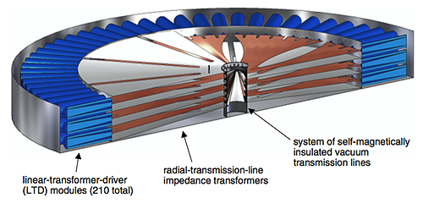
Fig.1. (LTD) - Linear Transformer Driver. Installation for compressing and transfer energy from capacitors to nuclear capsule. Human being (the black line just left of the center of the LTD) for scale.
The purpose of this article is to propose a new capacitor and show that a new capacitor design can significantly reduce the internal inductance and electrical resistance of a powerful power capacitor, shorten the pulse time, protect the internal wires and capacitor contacts from giant current pulses. And most importantly reduce the size and cost of installation thousands of times.
Description of the installation.
The entire design of the proposed capacitor is subject to the same goal - to reduce the discharge time of the capacitor, bring it to at least 0.1 ÷ 0.5 micro seconds and transfer a significant part of this energy to the desired object. Such an object can be, for example, a very small capsule with a nuclear fuel of an inertial thermonuclear reactor, which must be heated to 100 million degrees (10 keV), in order to start a confident thermonuclear reaction. Short transmission time is dictated by the requirement of inertia. With a large heating time the capsule will scatter and the thermonuclear reaction will not start.
The time of the issuance of energy by the capacitor is equal to
t = 0.5π√CL (2)
where t is time, sec; C is capacity of capacitor, F; L is an inductance of installation, H.
Since the energy is given, we can only influence the inductance. But the required short discharge time leads to the fact that the current pulse becomes very large - millions of amperes, which can lead to the burning of conductors, contacts and capacitor. In the case of a single pulse, it is not terrible if the cross section of the conductors and contacts is large, because the energy of the capacitor is limited. For example, if the energy of the capacitor is 50 kJ, the transverse conductors of the system are 10 cm² and 400 cm long, then when the capacitor is short-circuited, the heating of the copper conductors from a single pulse is about 0.5 degrees, about 7 degrees aluminum.
It is very important that the capacitor energy goes to heat the plasma in the capsule, and not to heat the capacitor, the system conductors (including the wires in the capacitor), the external conductors of the system, the switch, the contacts, and the capsule case.
The ratio r / R has a significant influence on the distribution of energy, where r is the resistance of the capsule and R is the ohmic resistance of the entire system. This ratio shows what proportion of the energy of the capacitor can reach the capsule.
Thus, we see that the only means to quickly discharge a capacitor with a given capsule and the energy of a capacitor is to reduce the inductance and resistance of the system. Otherwise, a large proportion of the energy will go to heating the system and creating a powerful magnetic field. True energy of the internal magnetic field does not disappear. It returns in the form of reverse current and voltage after discharge of the capacitor. But in the inertial reactor it is difficult to use, because the opposite voltage inhibits accelerated fuel cores, i.e. reduces temperature and the likelihood of a thermonuclear reaction.
The inductance of the system can be significantly reduced by arranging the conductors of the forward and reverse currents in the capacitor and the system so that they are as close as possible and have the same opposite current. Then they will create opposite fields and strongly weaken the total magnetic field, i.e. reduce the energy in it. The main magnetic field will be between them. This space should be made minimal. But the conductors are charged in the opposite way and the distance between them is determined by the breakdown ability of the insulator and the configuration of the conductors.
Figure 2a shows two wires (direct and reverse), located side by side to reduce inductance. The minimum distance between them is determined by the penetrating ability of the medium (insulator) in which they are located. Another form of such configurations is a coaxial cable, shown in fig. 2b. It consists of a central wire, insulation and external conductive sheath. Used for protection against radio interference.
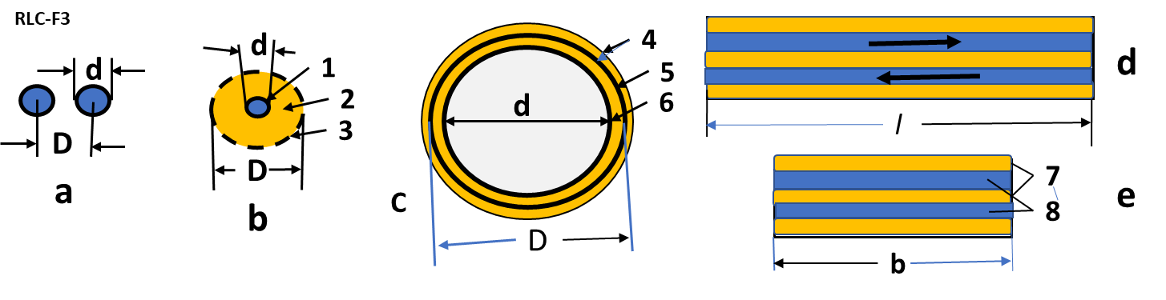
Fig. 2. Cross-sections of conductors for the delivery of electrical energy to the consumer.
Legend: a - two round conductor, located alongside; b - coaxial cable: 1 - center wire, 2 – insulator, 3 - surface wire (fly-through); с - coaxial cylinders: 4 - insulator, 5 - outer cylinder, 6 - inner cylinder; e, d - two lanes located one above the other at the minimum distance: 7 – insulator, 8 - conductive strips, l - long strip, b - strip width.
The author proposes the other two configurations with low inductance (Fig. 2c). One of them is two isolated conductive cylinders located one in another. The other is two molded conductive strips, one above the other. With the right construction, both solutions (c, d) give better results on inductance than the known solutions (a, b).
Reducing the electrical resistance of a system (without a capsule) can be done quite simply - by increasing the cross sections of the conductors. This requires the creation of new capacitors. Powerful capacitors with low inductance are also not produced even by US factories, since before they were not required by industry. Manufacturers can only offer a parallel connection of capacitors, which reduces the inductance of a capacitor bank (reduces the magnetic field energy by reducing the current in individual capacitors when connected in parallel), but increases the inductance of external connections.
Estimates show that the required power capacitor can measure 1.1 × 1.1 × 1.6 m and weigh about 2.5 tons.
Note that the abandonment of huge, very expensive LTD structures and their replacement with capacitors with the correct design can reduce the cost of installing energy delivery to a nuclear capsule by a factor of about a thousand.
Designing a capsule for such a reactor is also not an easy task. This is not Ohm's task. Plasma resistance is strongly dependent on its temperature. The voltage applied to it causes the collective acceleration of separately positive and negative particles in opposite directions. They freely pass between them and strike the electrodes by heating them, causing X-ray and bremsstrahlung. This task will be considered by the author in other papers.
The theory of the proposed energy transfer.
The theory of radar (discharge of a capacitor) is used for the calculation with the difference that the electrical resistance is variable, since the specific electrical resistance of the plasma is very dependent on its temperature, and the temperature strictly depends on the energy received.
The electrical circuit for discharging a capacitor is shown in Fig. 3. Please note that for our design of the capsule L and R1 we consider constant, R2 is the resistance of the capsule variable, and the inductance of the capsule is so small that it can be neglected.
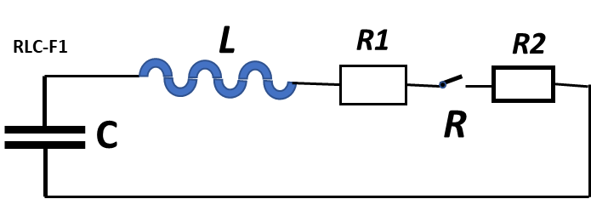
Fig.3. The schematic diagram of our installation. Notation: C is capacitor, L is Internal inductance of capacitor and external wiring; R1 is Internal resistance of the capacitor and external wiring; R2 is resistance of the fusion fuel capsule; R = R1+R2(t).
Calculated formulas.
The main well-known calculation formulas and some calculation results for a capacitor having a voltage of V = 100 kV, energy E = 50 kJ are given below.
The initial voltage capacitor is U(0) = 100kV, energy is E(0) = 50 kJ:
${E=0.5CU}^{2} kJ, C=\frac{2E}{U^{2}}=\frac{2×50}{{100}^{2}}={10}^{-5} F,$ (3)where C is capacity of condenser, F.
Charge of capacitor is:
$q=\frac{2E}{U} \left[C\right].$ (4)
Capacity of plat capacitor is:
$C=\frac{ε_{o}εS}{a} ,$ (5)
where $ε_{o}=8.85·{10}^{-11} F/m$ – electric constant; ε is dielectric constant of isolator, S is capacitor area, sq. m; a is distance between sheets, m.
Differential equations of discharging the capacitor is [4] p. 450:
$ri-U=-L\frac{di}{dt} , U=\frac{q}{C} , i=-\frac{dq}{dt} .$ (6)
where r is electric resistance , Ohm; i is electric current, A; L is induction, H; t is time, sec.
This system we can re-write as one equation of the second order:
$L\frac{d^{2}q}{{dt}^{2}}$ +r$\frac{dq}{dt}+\frac{q}{C}=0 or \frac{d^{2}q}{{dt}^{2}}+2α\frac{dq}{dt}+ω_{o}^{2}q=0$ . (7)
Where
$α=\frac{r}{2L} , ω_{o}^{2}=\frac{1}{LC}$ . (8)
Electric resistance of wire is:
$R1=ρ\frac{l}{s} ,$ (9)
Here ρ is specific resistance, $Ω.cm$ (for copper ρ=1.7$5×{10}^{-6}$, $Ω.cm$); l is wire length, cm; s is cross section of wire, sq. sm.
Spitzer resistance of plasma is:
$R2=η\frac{l}{s} where η=\frac{o.1Z}{T^{-3/2}}$ , (10)
Here Z is charge of nuclear fuel: for nuclear fuel T+D, D+D Z = 1; T is plasma temperature in eV.
1 eV = 1.6·10⁻¹⁹ J. 1 eV = 11,604 K.
A typical curve for charging and discharging a capacitor V = V(t) is shown in Fig. 4 .
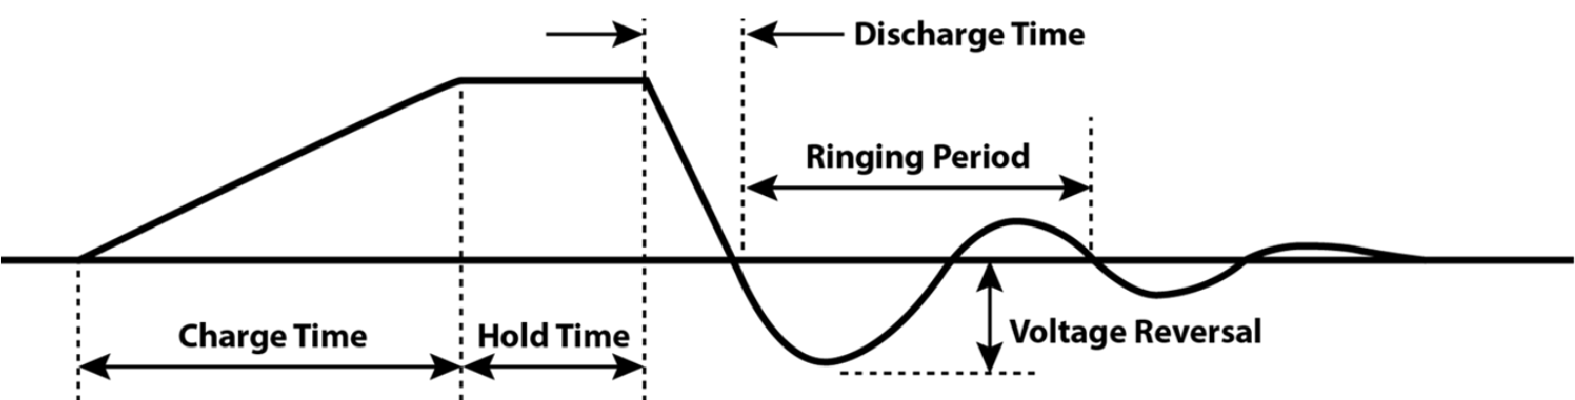
Fig.4. A typical curve for charging and discharging a capacitor V = V(t), where V is voltage, V.
A useful parameter is the damping factor, ζ, which is defined as the ratio of these two; although, sometimes α is referred to as the damping factor and ζ is not used.
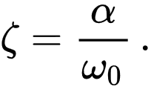 (11)
In the case of the series RLC circuit, the damping factor is given by
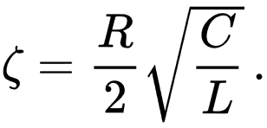 (12)
The value of the damping factor determines the type of transient that the circuit will exhibit.^{[6]}

Transient response
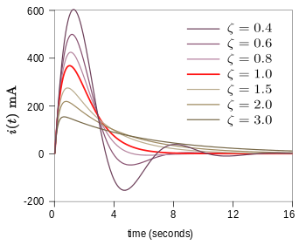
Fig.5. Influence of damping factor in the discharge curve. Plot showing underdamped and overdamped responses of a series RLC circuit. The critical damping plot is the bold red curve. The plots are normalized for L = 1, C = 1 and ω₀ = 1.
The differential equation for the circuit solves in three different ways depending on the value of ζ (Fig.5). These are underdamped (ζ < 1), overdamped (ζ > 1) and critically damped (ζ = 1). The differential equation has the characteristic equation [5].

Estimation of inductivity and electric resistance.
The inductivity of different wires design which are shown in Fig.2 may be estimated by equations:
1. Two round column/wires (Fig. 2a):
$L=\frac{μ_{o}l}{π}(\frac{1}{2}+\ln{\frac{D}{0.5d}})$ . (13)
Here $μ_{o}=4π{10}^{-7}$ - magnetic constant, H/m; l – length of tape, m. In conventional
capacitor the insulated long foil tape rolls into a roll. This simplifies production, but greatly
increases the inductance.
2. Коаксиальный кабель (Fig.2b).
$L=\frac{μ_{o}l}{π}\ln{\frac{D}{d}}$ . (14)
This design decreases the inductivity and protect radio lines from interference.
3. Big cylinder into cylinder (Fig.2c). This design offers the author.
$L=\frac{μ_{o}l}{π}\ln{\frac{D}{d}=}\frac{μ_{o}l}{π}\ln{\frac{r+δ}{r}}$ . (15)
Here r is radius small cylinder, m; $δ$is thickness of isolator, m.
For$δ$ << r the equation (13) we can re-write in form:
$L≈\frac{μ_{o}l}{π}\frac{δ}{r}$ . (16)
For big r the ratio $δ/r$ will be small and L small.
4. Electric energy can deliver by two thin sheets having thin isolator layer between them (Fig.2d,e). If $δ_{1}$ is the thickness of isolator, $δ_{2}$ is the thickness of sheet and b is width of the sheet, m, for $(δ_{1}+δ_{2})≪b$ , the estimation of inductivity is:
$L≈\frac{μ_{o}l}{π}\frac{δ_{1}+δ_{2}}{b}$. (17)
This is not big, because the magnetic field will be only between sheets.
Example: For l = 1 m, $δ_{1}=δ_{2}=0.004 m$ , b = 0.5 m, from (15) we get L = 6.4·${10}^{-9}$ H. This value we must sum with others.
The Inductivity from thin film/folk and capsule we can neglect because thin folk connected parallel one to other, inductivity of capsule is small.
For average triangle peak of the current may be large.
Example: for energy E = 50 kJ, time t = ${10}^{-6}$ sec, ${V_{max}=10}^{5} V$ the maximum pick current is
$I_{max}≈\frac{4E}{V_{max}t}≈2 MA$ . (18)
In our capacitor any current peak is not problem, because the heating of the capacitor depends not on the current peak, but only on the energy of the capacitor itself and the mass of conductors inside it and the correctness of the design.
Example: Let us the estimate the heating from single “shot” the capacitor having the size of the central copper conduction Fig.7b. Mass of this conductor is 27 kg. If all energy of capacitor will be spent only for heating this conductor its temperature will increases only in:
$∆T=\frac{E}{C_{p}M}=\frac{50 }{7×27}=0.26 degree of C$. (19)
Here $C_{p}≈7 kJ/kgK$ is heap capacity of copper. That means that we can test our capacitor in short circuit and we can measure its internal resistance of capacitor as
$r=\frac{U(0)}{I_{max}}$ , (20)
where r is internal capacitor resistance, Ohm; U(0) is initial voltage of capacitor, V; $I_{max}$ is maximum of current, A. If we measure the $I_{max}$ in short circuit, we calculate the internal capacitor resistance.
The author draws attention to another problem of power capacitors with a very short pulse and a large pulse current. Inertial thermonuclear reactors are needed in very short pulse. This problem does not exist in conventional capacitors for ordinary industrial needs. Therefore, such a problem is not written in textbooks and many manufacturers do not know about it.
The problem is that a strong opposite current in two adjacent wires generates a very significant repulsive force. This force is used in the railgun to accelerate the projectile to hypersonic speeds.
For two round conductors, located side by side, with the opposite direction of the current, this force is equal to:
$F=\frac{μ_{o}i^{2}l}{2πd}$ , (21)
where $μ_{o}$= 4$π{10}^{-7}-magnetic constant, H/m$; i – current, A; l – wire length, m; d – distance between of wire centers, m.
If we take the average current i = 1 MA, wire length l = 1 m and d = 0.008 m (Fig.8b), the force is F = 2.5x10⁷ N/m =2.5x1000 ton/m.
This is gigantic force, which can destroy the contacts. They must have a special design.
Fortunately, the duration of the action is very small and the wire shift is small. If all the energy of the capacitor E = 10⁵ J will be spent on moving two vertical plates of Fig. 8b with a force F (19), then the displacement s of each plate will be only
s = E/(2F) = 1 mm. (22)
Such an offset can compensate for folds at the point of contact and elastic rubber rivets (3) as shown in Fig. 8c(c2).
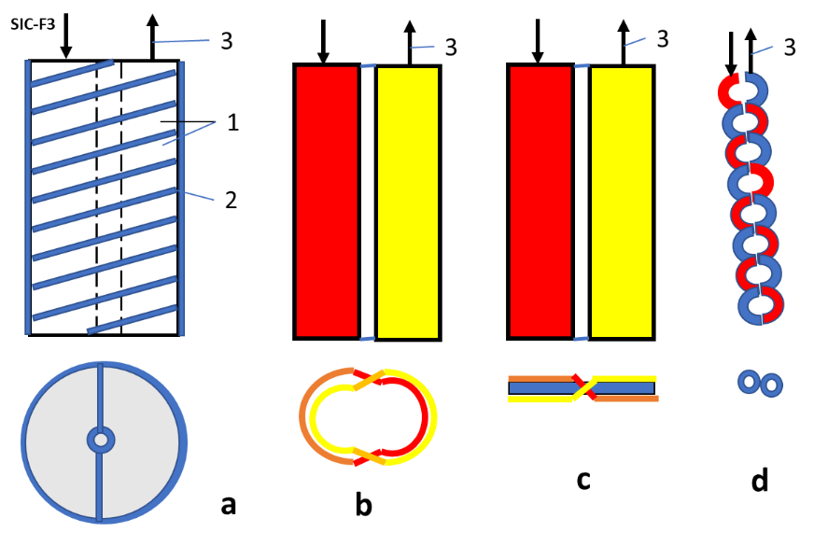
Fig.6. Reduction of inductance (reduction of magnetic fields) by interlacing conductors with equal opposite current. Legend: a - two twisted spirals, c - two intersecting cylinders, c - two intersecting planes, two twisted wires. 1 - two spirals, 2 - insulator, 3 - current direction.
Example
Small inductance capacitor having low resistance and short impulse (SIC)
We want to create the capacitor with can deliver the impulse of the energy about 30 kJ in a small object (the length is <1 cm) having the small electric resistance (<0.0001 Ohm) of Installation in a very small time 100 nsec (10⁻⁷ sec, 0.0000001 sec). That request the very small inductance (<2*10⁻⁸ Hz), the very small electric resistance (<10⁻⁴ Ohm) of the installation and very high impulse of current (MA).
The most current capacitors not satisfy these requirements. They have inductance >10⁻⁶ Hz and the resistance > 0.1 Ohm. They and their contacts burn in a short circuit of capacitors.
The scientists of thermonuclear engineering try to solve this problem by the gigantic very expensive Max generators (MG) or the Linear Transformer Driver (LTD). For example, the LTD for Z-machine has diameter 120 m and cost the hundreds of millions of dollars (Fig.1). But the current design of MG or LTD do not alloy to get the stable or good thermonuclear reaction.
Attention! This material is not a detailed instruction for construction SIC. Only the IDEA of such a condenser is stated here. It is supposed that an experienced creative engineer (or group) will make detailed drawings and computed parameters (Bolonkin A.A., Low Inductive and Resistance Energy Capacitors): Initial data are: Voltage U = 100 kV, capacity C = 10⁻⁵ F, energy E = 50 kJ. Final data: Inductance L<2 × 10⁻⁸ Hz, resistance <10⁻⁴ Ohm, discharge time about <4x10⁻⁷ sec, heating of object is >10 keV.
It is desirable that the developer pre-agreed their drawings and data with the author Alexander Bolonkin (<abolonkin@gmail.com>).
For example, any patent lays out only the idea of ​​innovation, placing the detailed design and manufacturing on the user of the invention.
Short description of problem.
The schematic diagram of our installation is shown in Fig. 3. Here: C is capacitor, L is
Internal inductance of capacitor and external wiring; R1 is Internal resistance of the capacitor and external wiring; R2 is resistance of the fusion fuel capsule; R = R1 + R2.
Our goal is to heat 0.0001 grams of fuel to a temperature of 10 keV. To do this, we have to deliver 30 kJ of energy to the capsule fuel from 50 kJ of energy, that is in the capacitor, ASAP (< 4x10⁻⁷ sec). Otherwise, the capsule will have time to explode, expand, and the ignition of thermonuclear fuel will not occur.
The schematic diagram of our installation is sown in Fig. 3.
A typical curve for charging and discharging a capacitor is shown in Fig.4.
We are satisfied with the data:
Charge time about 10 min (now) and 1 sec (in future).
Hold time about 1 - 5 min.
Discharge Time 4x10⁻⁷ sec.
Ringing Period – any now.
Voltage Reversal <10 ÷ 20%.
Author offer new innovation design of the capacitor which allow to get the need requirements and alloy to have any single impulse of the electric current.
He reaches these by:
1) The opposed closed currents which create the opposed magnetic fields. These
fields neutralize each other and spend little energy on their creation. These
made in main sheets and all wiles.
2) All wires are made in the form of wide strips with the opposite direction of the
currents and with a minimum distance between them.
3) The capacitor is divided into the maximum number of individual parallel films/plates with
alternating current directions.
4) Special low-ohm strip contacts of the thin films to the main plates with the main wiring are
made.
5) Wiring has a small equal resistance everywhere except for two cuts and the contact area
of ​​the plates in the output wire.
6) The mass and thickness of the plates of wires is sufficiently for the permissible heating.
Conventional capacitors are made of a long-insulated tape rolled into a roll (Fig. 7a).
The proposed capacitor is made from a set of insulated thin plates/films. These plates have a special arrangement and a separate connection with special central leads/sheets.
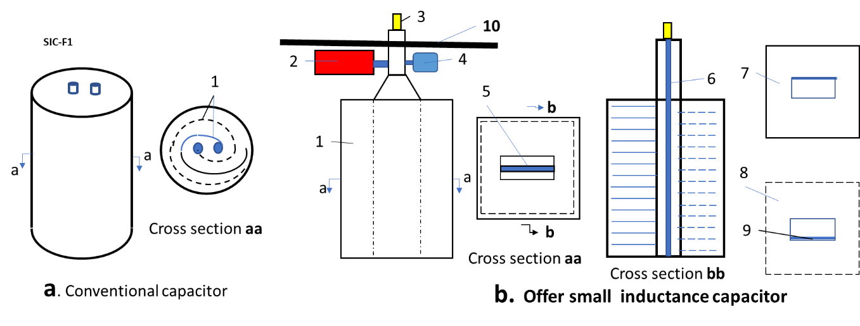
Fig.7. Conventional and offered capacitor. Notifications: a – conventional capacitor. 1- a long insulated tape rolled into a roll; b - proposed small inductance capacitor. Capacitor is made from a set of insulated thin plates: 1 – capacitor, 2 –high voltage switch, 3 – connection to variable object, 4 – charger, 5 – insulator between main exit/enter plates; 6 – insulator of the main plate; 7 – the first thin film, 8 – the second thin film, connection film, 9 – the second thin film, 10 – steel plate (10 mm), which separate the capacitor, high voltage switch and charger from an explosive area.
Estimation. Example of the proposed Installation
Recommended (computed) sizes, thickness and material (electric engineers and designers can offer the better):
Voltage U = 100 kV, capacity C =10⁻⁸ F, energy E = 50 kJ, discharge time t <4x10⁻⁷ sec.
Offered material:
1) Electric copper for the thin film and main plate. Data: specific electric resistance ρ =1.7x10⁻⁶ Ohm.cm; specific mass γ = 8.91 gr/cm³; Heat capacity Cp =1.99 kJ/kg·K.
2) Isolator PTFE. Teflon (C₂F₄)_{n}: dielectric strength (1 MHz) 60 ÷ 173 MV/m; ε = 2.1; specific electric resistance ρ =1x10²³ ÷ 1x10²⁵ Ohm·m; specific mass γ = 2200 kg/m³; yield strength 23 MPa, melting temperature is 327ºC.
Computed parameters (see theory and computation in given article Bolonkin A.A., Low Inductive and Resistance Energy Capacitor): Inductive of installation is <2×10-8 Hz, resistance <10⁻⁴ Ohm, discharge time about <4x10⁻⁷ sec, heating of object is about 10 keV.
Requested area of thin film for capacitor is:
S=$\frac{Cd}{ε_{o}ε}$=215 sq.m, (23)
where S – area of capacitor, m²; C = 10⁻⁵– capacity of capacitor, F; d = 4 mm – thickness of isolator, m; ε_{o}= 8.85x10⁻¹¹ F/m – electric constant; ε = 2.1 – dielectric constant of Teflon.
This area requests about 215 thin copper film/foil 105x105 cm (or 430 copper film 57.5x 105 cm) and > 216 the 110x110 cm sheets of Teflon having the thickness 4 mm.
Size (option) of the capacitor/installation box is about 120x120x120 cm. Mass is about 3.5 tons. Average R2$≈5×10e-3 Ohm.$ (R2 < 5·10⁻³ Ω).
Let us estimate the thickness of the coper thin film/foil and main plate.
If we take the cross section area of internal wires 20 sq.cm and width of main sheet is 50 cm, then thickness if the thin film will be about 0.25 mm and main sheet is about 4 mm, the R1$≈0.0001 Ohm, L≈2×10e-8$ Hz (2·10⁻⁸), $time of "\text{shot"} ∆t=10e-6 sec.$ (<10⁻⁶). The heating of main sheets is about 0.2ºC after “shot”. Connection 3 (Fig.8) must be checkup in tensile stress because the strong impulse current will try disconnect them. That may reach hundreds kg.
1
b
2
c
C-1
C-2

3
4
6
6
500
12
4
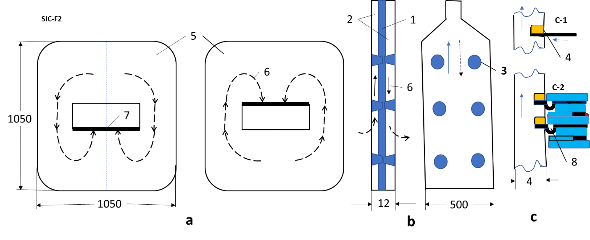
Fig.8. Direction of current in the first and second thin films (a) and main plates (b). (c) – connection the thin films to the main plates. Notification: 1 – insulator; 2 - insulator of the main plate, insulator between thin film/foil has form “a”; 3 – connection main plates by insulator; 4 (c1, c2) – connection (by copper) thin film and main plate; 5 – thin films; 6 – direction of current; 7 – connection thin film to main plate; 8 – compensation of the thin film.
Selected initial data are not optimal. Creative electric engineer can offer and recalculate the better version. I think the thin film 145x145 cm $≈2 sq.m$ decrease the capacitor height up 80 cm. Decreasing the Teflon thickness from 4 mm to 3 mm decreases the mass in 25%. Decreasing the wire cross section to 10 sq.cm decrease the foil thickness up 0.13$÷0.15$ mm. (Voids at the ends are filled with Teflon tape of the same thickness). Increasing of voltage can improve the main parameters of heating and time of “shot”. And so on.
Offered capacitor must be tested in a short circuit. Capacitor inductive and resistance must be measured.
Look also attention in the high voltage (100 kV) switch (and charger). Switch must work very fast (10⁻⁷ sec) and have a small resistance.
Some Results of Computations
Below some results of computation, the heating of thermonuclear fuel into capsule and influence of inductive and electric resistance are presented. Assume, the volume of capsule is constant in heating, the fuel is LiD – sold crystals, mass of fuel is about 0.0001 grams.
The result of integration system differential equations (4)-(8) are below:
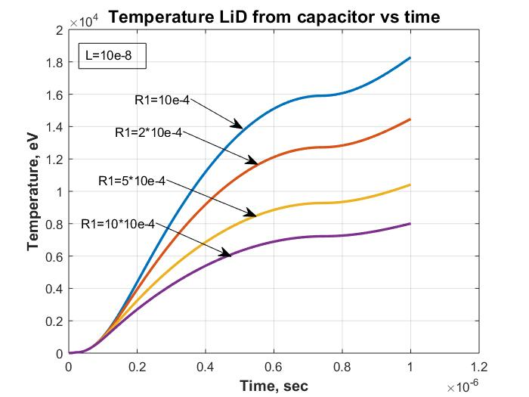
Fig.9. Temperature into capsule vs time from capacitor having C=20 µF, V(0)=100 kV for induction
10⁻⁸H and different outer resistance R₁ =10⁻⁴ – 10⁻³ Ohm.
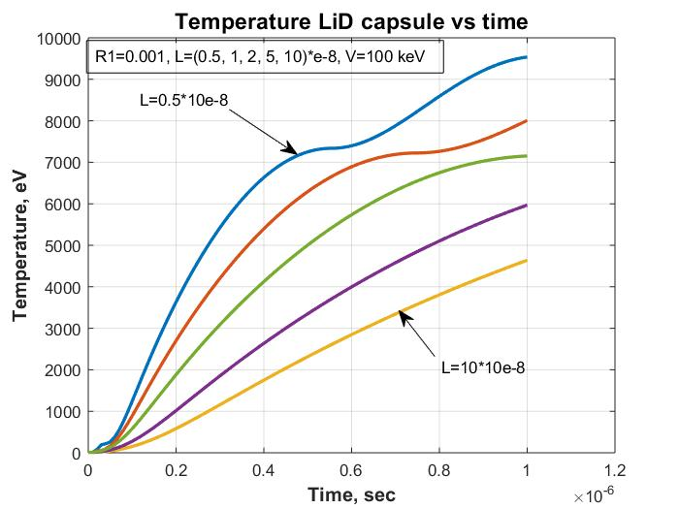
Fig.10. Temperature into capsule vs time from capacitor having 20 µF, V(0)=100 kV for resistance
R₁ = 0.001 Ohm. and different induction L = (0.5 ÷ 10).10⁻⁸ H .
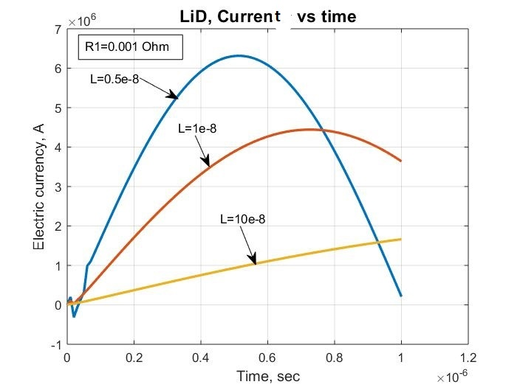
Fig.11. Electric current vs time from capacitor having C = 20 µF, V(0)=100 kV for resistance R₁ =0.001
Ohm. and different induction L = (0.5 ÷ 10).10⁻⁸ F.
Fig.12. Peak of capacitor current vs time for initial voltage U(0)=100 kV and 200 kV. Capacity
is C = 20.10⁻⁶ Farad. R1= 0, L= 0, R2(t)= 0.1·Z/T(t)^{-3/2}.
Fig.12 shows, the heat time may be decreased the maximum up 0.5x10⁻⁸ sec, if we decrease the inductive up zero.
Description of capacitors and thermo-reactors are in [1]-[5].
References
1. Bolonkin A.A., Small non-Expensive Electric Cumulative Thermonuclear Reactors, USA, Lulu, 2017.
2. Bolonkin A.A., Femtotechnologies and Innovative Projects, USA, Lulu, 2011, p.140.
3. Кошкин Н.И., Ширкевич М.Г., Справочник по элементарной физике, Москва, Наука, 1982.
Koshkin N.I., Shirkevich M.G., Handbook of elementary physics, Moscow, Science, 1982.
4. Калашников С.Г., Электричество. Москва, Наука, 1985.
Kalashnikov C.G., Electricity, Moscow, Nauka, 1985.
5. Wikipedia, Inertial Thermonuclear Reactor.

