Electric Theory of Tornado.
Protection from Tornado.
By Alexander Bolonkin
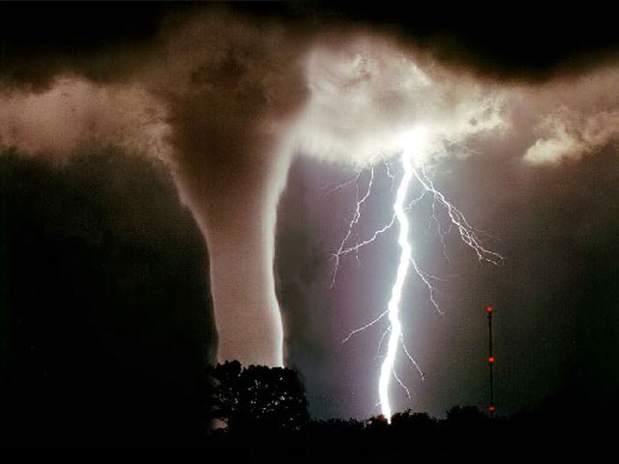

New York, USA,
2013

Article Electric Theory of Tornado after Shmuel 7 9 13
Electric Theory of Tornado. Protection from Tornado.
By Alexander Bolonkin
C&R, USA, abolonkin@juno.com
Abstract
The author develops a new theory of tornado stability. He show that it is the high electric voltage between clouds and ground surface which produces the intensive electron/ion flow which creates the air stream which sucks off (pumping) air from the inside tornado channel and makes the tornado stable.
If we want to destroy tornado stability we must decrease the electric intensity into the tornado channel. The simplest method is using conductive wire to connect the top funnel of tornado with ground.
For this method, the top end of wire must have a large conductive area (air balloon or wing dirigible with conductive layer), the lower end of wire must have good contact with wet ground.
The row from these conductive wires having step 150 – 200 m and altitude 200 – 300 m can protect villages, towns and important installations such as the nuclear electric station and military bases from tornados.
--------------------------------------------------------------------------------------------------------------------------
Keywords: Tornado, stability of tornado, protection from tornado, hurricane, Bolonkin.
Introduction
Tornado.
A tornado is a violently rotating column of air that is in contact with both the surface of the earth and a cumulonimbus cloud or, in rare cases, the base of a cumulus cloud. Tornadoes come in many shapes and sizes, but they are typically in the form of a visible condensation funnel, whose narrow end touches the earth and is often encircled by a cloud of debris and dust. Most tornadoes have wind speeds less than 110 miles per hour (177 km/h), are about 250 feet (76 m) across, and travel a few miles (several kilometers) before dissipating. The most extreme tornadoes can attain wind speeds of more than 300 miles per hour (483 km/h), stretch more than two miles (3.2 km) across, and stay on the ground for dozens of miles (more than 100 km).
Tornadoes have been observed on every continent except Antarctica. However, the vast majority of tornadoes occur in the Tornado Alley region of the United States, although they can occur nearly anywhere in North America. They also occasionally occur in south-central and eastern Asia, northern and east-central South America, Southern Africa, northwestern and southeast Europe, western and southeastern Australia, and New Zealand. Tornadoes can be detected before or as they occur through the use of Pulse-Doppler radar by recognizing patterns in velocity and reflectivity data, such as hook echoes or debris balls, as well as by the efforts of storm spotters
In the United States, tornadoes are around 500 feet (150 m) across on average and travel on the ground for 5 miles (8.0 km).
Lighting conditions are a major factor in the appearance of a tornado. Night-time tornadoes are often illuminated by frequent lightning.
There is mounting evidence, including Doppler on Wheels mobile radar images and eyewitness accounts, that most tornadoes have a clear, calm center with extremely low pressure, akin to the eye of tropical cyclones.
Tornadoes emit on the electromagnetic spectrum, with sferics and E-field effects detected. There are observed correlations between tornadoes and patterns of lightning. Tornadic storms do not contain more lightning than other storms and some tornadic cells never produce lightning. More often than not, overall cloud-to-ground (CG) lightning activity decreases as a tornado reaches the surface and returns to the baseline level when the tornado lifts. In many cases, intense tornadoes and thunderstorms exhibit an increased and anomalous dominance of positive polarity CG discharges. Electromagnetic and lightning have little or nothing to do directly with what drives tornadoes (tornadoes are basically a thermodynamic phenomenon), although there are likely connections with the storm and environment affecting both phenomena.
In addition to winds, tornadoes also exhibit changes in atmospheric variables such as temperature, moisture, and pressure. For example, on June 24, 2003 near Manchester, South Dakota, a probe measured a 100 mbar (hPa) (2.95 inHg) pressure decrease. The pressure dropped gradually as the vortex approached then dropped extremely rapidly to 850 mbar (hPa) (25.10 inHg) in the core of the violent tornado before rising rapidly as the vortex moved away, resulting in a V-shape pressure trace. Temperature tends to decrease and moisture content to increase in the immediate vicinity of a tornado.
Damage from tornado.
The tornadoes killed thousands, injured ten thousands peoples, damages ten billions USD dollars. Some data about tornado disaster are below.
Tornado Disaster Statistics from 1980 – 2008
Number of events: | 182
Number of people killed: | 4,780
Average people killed per year: | 165
Number of people affected: | 12,710,204
Average number of people affected per year: | 438,283
Economic Damage | $31,510,661,000
Economic Damage per year | $1,086,575,000
Issue: http://www.statisticbrain.com/tornado-statistics/
This article lists various tornado records. The most extreme tornado in recorded history was the Tri-State Tornado, which roared through parts of Missouri, Illinois, and Indiana on March 18, 1925. It was likely an F5, though tornadoes were not ranked on any scale in that era. It holds records for longest path length at 219 mi (352 km), longest duration at about 3.5 hours, and fastest forward speed for a significant tornado at 73 mph (117 km/h) anywhere on Earth. In addition, it is the deadliest single tornado in United States history (695 dead). It was also the second costliest tornado in history at the time, but has been surpassed by several others non-normalized. When costs are normalized for wealth and inflation, it still ranks third today.
The deadliest tornado in world history was the Daulatpur-Salturia Tornado in Bangladesh on April 26, 1989, which killed approximately 1,300 people. Bangladesh has had at least 19 tornadoes in its history kill more than 100 people, almost half of the total for the rest of the world (fig.1).
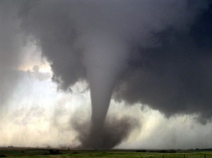
Fig.1. Typical tornado.
The United States gets about 1000 recorded tornadoes every year. From May 2 to 8, 1999, a large tornado outbreak took place across much of the Central and parts of the Eastern United States. During this week-long event, 152 tornadoes touched down, including one in Canada. The most dramatic events unfolded during the afternoon of May 3 through the early morning hours of May 4 when more than half of these storms occurred. Oklahoma experienced its largest tornado outbreak on record, with 70 confirmed. The most notable of these was the F5 Bridge Creek–Moore tornado which devastated suburban communities to the southwest of Oklahoma City. The tornado killed 36 people and injured 583 others; losses amounted to $1 billion, making it the first billion-dollar tornado in history. Overall, 50 people lost their lives during the outbreak and damage amounted to $1.4 billion.
Lighting.
Cloud-Ground (CG) lightning can occur with both positive and negative polarity. The polarity refers to the polarity of the charge in the region that originated the lightning leaders. An average bolt of negative lightning carries an electric current of 30,000 amperes (30 kA), and transfers 15 coulombs of electric charge and 500 megajoules of energy. Typically, lightning at up to 100 million volts, large bolts of lightning can carry up to 120 kA and 350 coulombs. Positive lightning typically makes up less than 5% of all lightning strikes. . Plasma temperatures in lightning can approach 28,000 kelvins and electron densities may exceed 10²⁴/m³. A bolt of positive lightning may carry an electric current of 300 kA and the potential at the top of the cloud may exceed a billion volts — about 10 times that of negative lightning (fig.3).
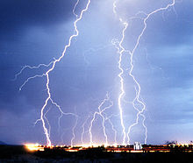
Fig.2. Lighting.
Atmospheric electricity.
Experiments have shown that the intensity of this electric field is greater in the middle of the day than at morning or night and is also greater in winter than in summer. In 'fine weather', the potential, aka 'voltage', increases with altitude at about 30 volts per foot (100 V/m), when climbing against the gradient of the electric field. This electric field gradient continues up into the atmosphere to a point where the voltage reaches its maximum, in the neighborhood of 300,000 volts. This occurs at approximately 30-50 km above the Earth's surface. From that point in the atmosphere up to its outer limit, nearly 1,000 km, the electric field gradient produced in the lower atmosphere either ceases or has reversed.
A simple calculation gives the result that when such a collector is arranged for example on the ground, and a second one is mounted vertically over it at a distance of 2000 meters and both are connected by a conducting cable, there is a difference in potential in summer of about 2,000,000 volts and in winter even of 6,000,000 volts and more.
Hurricane.
A tropical cyclone (hurricane) is a rapidly-rotating storm system characterized by a low-pressure center, strong winds, and a spiral arrangement of thunderstorms that produce heavy rain. Tropical cyclones typically form over large bodies of relatively warm water. They derive their energy from the evaporation of water from the ocean surface, which ultimately re-condenses into clouds and rain when moist air rises and cools to saturation.
At the center of a mature tropical cyclone, air sinks rather than rises. For a sufficiently strong storm, air may sink over a layer deep enough to suppress cloud formation, thereby creating a clear "eye" (fig.3). Weather in the eye is normally calm and free of clouds, although the sea may be extremely violent. The eye is normally circular in shape, and is typically 30–65 km (19–40 mi) in diameter, though eyes as small as 3 km (1.9 mi) and as large as 370 km (230 mi) have been observed.
The cloudy outer edge of the eye is called the "eyewall"(fig.6). The eyewall is where the greatest wind speeds are found, air rises most rapidly, clouds reach to their highest altitude, and precipitation is the heaviest. The heaviest wind damage occurs where a tropical cyclone's eyewall passes over land.
Scientists estimate that a tropical cyclone releases heat energy at the rate of 50 to 200 exajoules (10¹⁸ J) per day, equivalent to about 1 PW (10¹⁵ watt). This rate of energy release is equivalent to 70 times the world energy consumption of humans and 200 times the worldwide electrical generating capacity, or to exploding a 10-megaton nuclear bomb every 20 minutes.
The most intense storm on record was Typhoon Tip in the northwestern Pacific Ocean in 1979, which reached a minimum pressure of 870 mbar (652.5 mmHg) and maximum sustained wind speeds of 165 knots (85 m/s) or 190 miles per hour (310 km/h). Likewise, a surface-level gust caused by Typhoon Paka on Guam was recorded at 205 knots (105 m/s) or 235 miles per hour (378 km/h).
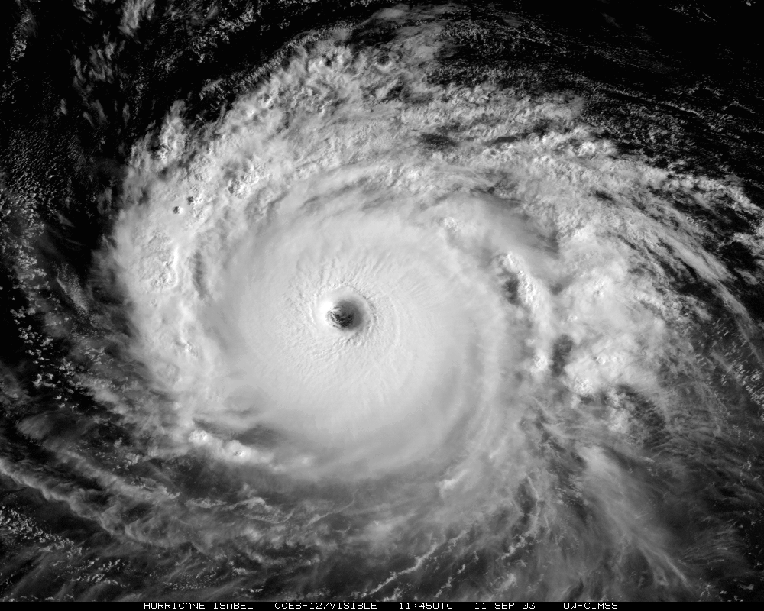
Fig.3. Typical hurricane. Photo from outer space.
Electric Theory of Tornado
Tornados (vortexes) killed, wounded, crippled thousands of people, destroyed, and damaged thousands of homes, made billions of dollars of losses. The theory of tornado has been researched for more than a hundred years. Only in the USA, the large state Agency NOAA, studied tornado and weather since 1807. We have an excellent mathematical theory of a vortex. However, we don’t have a clear understanding of the nature and activity of tornados. The mathematical theory of the stability of the vortex requires the data of the outlet, influent the air. But researchers do not see the forces which pump or suck out the air from the internal core of tornado.
The author shows in this article that it is the electric intensity between clouds and ground (especially storm clouds and ground) which produces the electron (ion) strong vertical wind (flow) into tornado, which works as a pump inside tornado and makes the tornado stable.
Everyone can make this simple experiment in a kitchen sink or bathroom. If you fill the sink with a layer of water (2 – 3 cm) and open the drain, the water, at some point, creates a stable vortex. Opening the drain is important element of system. If you close it, the vortex disappears.
In the atmosphere, air has friction and typically a vortex losses energy. The air flow (leak of air inside vortex) compensates for the loss of vortex energy and supports its rotation. The flow of electrons (ions) inside of tornado creates the electric current which produces the circular magnetic field which also helps the vortex and his stability.
The schemata of a tornado is shown in fig. 4. It is a vortex located between charged clouds and the ground. The vortex contains a wall which rotates with high speed. According to the Law of Angular Conservation the linear speed of rotation increases and air pressure is lowered when the tornado radios decreases.
According this author’s theory (see computation in theoretical section) a strong electric intensity between an altitude layer (clouds) atmosphere and the ground produces a powerful electro (ion) flow inside of tornado along its axis. The air suck off from inside wall of tornado. When electrons reach the surface, they go into ground the ions are neutralized and air go out between low end of tornado and ground surface. If ground has negative charge (cloud has positive charge), the electric intensity works as pump sucked off the air flow into cloud.
Fig. 4. Sketch of tornado. Notations: 1 – charged clouds; 2 – body of tornado; 3 – rotated wall of tornado; 4 – electric intensity; 5 – electron (ion) wind; 6 – exit of electron (discharged) wind; 7 – ground.
Estimations and Computation
1. Theory of vortex. The speed into a vortex wall may be estimated by equations (conservation of angular momentum):
V = r_{o}V₀/ r , (1)
where V₀ is speed on a vortex surface, m/s; V is speed into vortex wall, m/s; r_{o} is radius of on a vortex surface, m; r is radios into the vortex wall, m.
The pressure into the vortex wall is
p = p_{o} – V²/2 , (2)
Where p is pressure into the vortex wall, N/m²; p_{o} is an atmospheric pressure, p_{o} ≈ 10⁵ N/m².
2. Energy of cloud.
The vaporization energy of 1 km² is
E_{v1} = mλ (3)
where E_{v1} is the vaporization energy of 1 km², J; m is water mass in 1 km² of cloud, kg; λ = 2.2·10⁶ is specific energy of vaporizing, J/kg.××
The lift energy at altitude is
E_{L1} = mgh , (4)
where g = 9.81 m/s² is Earth gravity; h is altitude of cload, m.
The electric energy as condenser having area 1 km², distance 1 km and voltage 100 million volts the cloud has energy
E_{e1} = 0.5ε_{o}SU²/h , (5)
where ε_{o} = 8.85·10⁻¹² is electrostatic constant; S is area of condenser, m²; U is voltage, V; h is altitude, m.
Example 1: For the rain gives 0.1 m water, the cloud of area 1 sq. km, located at altitude 1 km and charged up 100 million volts has energy:
1. Evaporation (condensation) energy is E_{v1} = mλ = 10⁸×2.2·10⁶ = 2.2·10¹⁴ J/km² .
2. Lift energy is E_{L1} = mgh =10⁸·9.81·1000 ≈ 10 ¹² J/km².
3. Electric energy E_{e1} = 0.5ε_{o}SU²/h = 0.5·8.85·10^{-12·}10⁶·10¹⁶·10⁻³ ≈ 4.42·10⁷ J/km².
For conventional cloud 10×10 km² the energy is in 100 times more. The clouds can has altitude 200 m and energy in 5 times more.
The electric energy is small in comparison with evaporation and lifting energy but one is used only for stabilization of tornado.
3. Electron (ion) speed. The electron speed about the air flow, gas (air jet) may be computed by equation:
j_{s} = qn₋b₋E + qD₋(dn₋/dx) , (6)
where j_{s} is density of electric currency about flow (jet), A/m²; q = 1.6×10⁻¹⁹ C is charge of single electron, C; n₋ is density of electrons (negative charges) in 1 m³; b ₋ is charge mobility of negative charges, m²/sV; E is electric intensity, V/m; D₋ is diffusion coefficient of charges; dn₋/dx is gradient of charges. For our estimation we put dn₋/dx = 0. In this case
j_{s} = qn₋b₋E , Q = qn , v = bE , j_{s} = Qv , (7)
where Q is density of the negative charge in 1 m³; v is speed of the negative charges about flow, m/s.
The negative charge mobility for normal pressure and temperature T = 20ºC is:
In dry air b₋ = 1.9×10⁻⁴ m²/sV, in humid air b₋ = 2.1×10⁻⁴ m²/sV. (8)
If the air pressure is from 13 to 6×10⁶ Pa, then the mobility follows the law
bp = const, (9)
where p is air pressure. When air density decreases, the charge mobility increases. The mobility strength depends upon the purity of gas.
For normal air density the electric intensity must be less than 3 MV (E < 3 MV). Otherwise the electric breakdown may be.
If v > 0, the electrons (ions) accelerate the air (E > 0 the cloud spends energy (charge), works as ventilator). If v < 0 (E < 0), the cloud works as suck pump (back ventilator). If v = 0 (electron speed about air flow equals null), the electric resistance is zero.
Example 2. Assume a voltage between a cloud and earth ground is U = 100 millions volt. Distance is D = 500 m. Than the average electric intensity is E = U/D = 10⁸/500 = 2·10⁵ V/m. The average air speed inside the tornado is v = bE ≈ 2·10⁻⁴×2·10⁵ = 40 m/s. In reality the speed may be same or more in less voltage because the voltage (acceleration) is acting long time.
3. Magnetic field. The electric currency flowing along the tornado produces the circular magnetic field around tornado, which also may influence in the tornado stability. This influence may be estimated by equations:
(10)
(11)
where H is magnetic intensity A·m; p_{m} is pressure, N/m²; B is magnetic intensity in T; q is charge of particles, C; V_{e} is speed charged particles. m/s; r_{e} is moving speed of particles, m/s; m is mass of charged particles, kg; U is energy of the charged particles in eV; T is rotated period of the charged particles, sec. Motion of the charged particles is perpendicular to magnetic lines.
Protection from Tornado.
Using the offered theory the author offers a method of protection from tornado. If we temporarily can break the stability of the tornado, we can destroy the tornado. To do this we must deprive the energy of the tornado pump. It is possible, if the time, when the tornado pump cannot work, will be enough for its distraction. The easiest way is a connection the tornado cloud (funnel) to ground. If we fence the important object (military base, nuclear station, village, etc.) by row of small balloons (better wing dirigibles (fig. 5)) good connected by the conductivity wire to ground, the electric currency will flows directly to ground and will not pumps the air from tornado.
For good contact with cloud the entire surface of dirigible (air ballroom) must have the conductive layer and the lower end of wire should be buried into a moist ground (fig. 5a). Distance between dirigibles is about 150 – 200 m, altitude 200 – 250 m.
Fig.5. Protection against tornado. Notations: 1 – wing dirigible covered by conductivity layer; 2 – wire;
3 – grounding lightning rod.
It is easy to build a small model of check up the theory and protection method.
Note about hurricane
The hurricane is gigantic vortex (fig.6) typically having diameter 300 and more km. Photo of hurricane from out space is shown in fig.3. Into center the hurricane has a calm area having the diameter about 50 - 60 km. That area is named “Eye”. “Eye” has “Eyewall” having the thickness about 40-50 km.
At the center of a mature tropical cyclone, air sinks rather than rises. For a sufficiently strong storm, air may sink over a layer deep enough to suppress cloud formation, thereby creating a clear "eye". Weather in the eye is normally calm and free of clouds, although the sea may be extremely violent.
The cloudy outer edge of the eye is called the "eyewall". The eyewall is where the greatest wind speeds are found, air rises most rapidly, clouds reach to their highest altitude, and precipitation is the heaviest. The heaviest wind damage occurs where a tropical cyclone's eyewall passes over land.
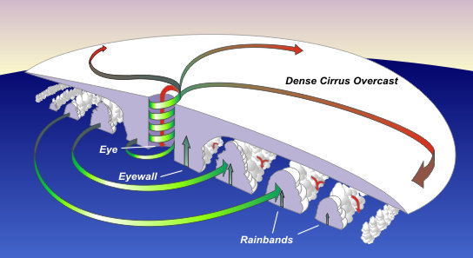
Fig. 6. Scheme of hurricane.
The static electricity produces the strong vertical air flows. The including them into the hurricane theory allow more exactly compute the hurricane.
SUMMARY
The author proposes a new theory of the tornado stability. He shows: the high electric voltage between clouds and ground surface produces the intensive electron/ion flow into tornado. That flow creates the air stream which sucks off (pumping) air from the inside tornado channel and make the tornado stability.
If we want to destroy the tornado stability we must decrease the electric intensity into the tornado channel. The simplest method is connection by a conductive wire the funnel of tornado with ground.
For this the top end of fire must has a large conductive area (air ballroom or wing dirigible with conductive layer), the lower end of wire must has the good contact with wet ground.
The row from these conductive wires having step 150 – 200 m and altitude 200 – 300 m allows protecting from tornado the villages, towns and important objects as the nuclear electric station and military bases.
The research papers relating to this topic are presented in [1]-[20].
ACKNOWLEDGEMENT
The author wishes to acknowledge Professor Shmuel Neumann for correcting the English and offering useful advices and suggestions.
References
[1] A.A.Bolonkin, Electron Air Hypersonic Propulsion.2013. http://viXra.org/abs/1306.0003
http://www.scribd.com/doc/145165015/Electron-Air-Hypersonic-Propulsion
http://www.scribd.com/doc/146179116/Electronic-Air-Hypersonic-Propulsion
[2] A.A.Bolonkin, Electronic Wind Generator. http://viXra.org/abs/1306.0046,
http://www.scribd.com/doc/146177073/
[3] A.A.Bolonkin, Electronic Hydro Electro Generator. 2013. http://viXra.org/abs/1306.0196,
http://www.scribd.com/doc/149489902/Electron-Hydro-Electric-Generator ,
http://archive.org/details/ElectronHydroElectricGenerator_532
[4] A.A.Bolonkin, Electron Super Speed Hydro Propulsion. 2013. http://viXra.org/abs/1306.0195
http://www.scribd.com/doc/149490731/Electron-Super-Speed-Hydro-Propulsion
http://archive.org/details/ElectronSuperSpeedHydroPropulsion
[5] A.A. Bolonkin, “Bolonkin’s Method Movement of Vehicles and Installation for It”, US Patent
6,494,143 B1, Priority is on 28 June 2001.
[6] A.A. Bolonkin, “Non-Rocket Space Launch and Flight”, Elsevier, 2005, 468 pgs. ISBN-13: 978-0-
08044- 731-5, ISBN-10: 0-080-44731-7 .
http://www.archive.org/details/Non-rocketSpaceLaunchAndFlight ,
http://www.scribd.com/doc/24056182
[7]. A.A. Bolonkin, “New Concepts, Ideas, Innovations in Aerospace, Technology and the Human
Sciences”, NOVA, 2006, 510 pgs. ISBN-13: 978-1-60021-787-6.
http://www.scribd.com/doc/24057071 , http://www.archive.org/details/NewConceptsIfeasAndInnovationsInAerospaceTechnologyAndHumanSciences
[8]. A.A. Bolonkin, R. Cathcart, “Macro-Projects: Environments and Technologies”, NOVA, 2007, 536
pgs. ISBN 978-1-60456-998-8. http://www.scribd.com/doc/24057930 .
http://www.archive.org/details/Macro-projectsEnvironmentsAndTechnologies .
[9]. A.A. Bolonkin, Femtotechnologies and Revolutionary Projects. Lambert, USA, 2011. 538 p.,16 Mb.
ISBN: 978-3-8473-0839-0. http://www.scribd.com/doc/75519828/ ,
http://www.archive.org/details/FemtotechnologiesAndRevolutionaryProjects
[10]. A.A. Bolonkin, LIFE. SCIENCE. FUTURE (Biography notes, researches and innovations).
Scribd, 2010, 208 pgs. 16 Mb. ISBN: 978-1-4512-7983-2, http://www.scribd.com/doc/48229884,
http://www.archive.org/details/Life.Science.Future.biographyNotesResearchesAndInnovations
[11]. A.A. Bolonkin, Universe, Human Immortality and Future Human Evaluation. Scribd. 2010г.,4.8
Mb. http://www.archive.org/details/UniverseHumanImmortalityAndFutureHumanEvaluation,
http://www.scribd.com/doc/52969933/
[12]. A.A.Bolonkin, Universe (Part 1). Relations between Time, Matter, Volume, Distance, and Energy.
JOURNAL OF ENERGY STORAGE AND CONVERSION, JESC : JuLy-December 2012, Vol.
3, # 2, pp. 141-154. http://viXra.org/abs/1207.0075, http://www.scribd.com/doc/100541327/ ,
http://archive.org/details/Universe.RelationsBetweenTimeMatterVolumeDistanceAndEnergy
Universe (Part 2): Rolling of Space (Volume, Distance), Time, and Matter into a Point.
http://www.scribd.com/doc/120693979
http://viXra.org/abs/1207.0075, http://www.scribd.com/doc/100541327/ ,
http://archive.org/details/Universe.RelationsBetweenTimeMatterVolumeDistanceAndEnergy
[13] W.J. Hesse and el. Jet Propulsion for Aerospace Application, 2-nd Edition, Pitman Publ. Corp. NY.
[14] N.I. Koshkin and M.G. Shirkebich, Directory of Elementary Physics, Nauka, Moscow, 1982
(in Russian).
[15] I.K. Kikoin. Table of Physics Values. Atomisdat, Moscow, 1976 (in Russian).
[16] S.G. Kalashnikov, Electricity, Textbook, Nauka, Moscow, 1985,576 pps. (in Russian).
[17] Wikipedia. Tornado.
29 June 2013

