Evolution and continuity in the automotive industry

Marat Khaitbaev,
Independent researcher
Professional member of
New York Academy of Sciences
Porsche Center Pulkovo
Saint Petersburg, Russia

Abstract: research of the preservation of traditions and their application in modern automotive industry
Keywords: automotive industry, design, traditions

Part 1. Perfect car body.

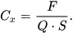
The origin of ideas about a car that was perfect from a visual and technical point of view began in the 19th century. Over time, the imagination and ideas of designers and inventors developed, and the body lines of manufactured vehicles began to acquire both a concise form and go in progress with newfangled technologies. The concept of body aerodynamics, which originated in the 1800s, gained practical value after the First World War and has been relentlessly developed today. The wind tunnel blowing technology of the new model's body structure was taken from larger vehicles, such as a locomotive in a train. The principle of a gradual increase in the speed of a headwind flow, simulating the movement of a car along the road, revealed absolutely unaccounted for physical indicators when creating cars at the beginning of the 19th century. In the automotive world, a race broke out among manufacturers who sought to attract more scientists to the factories and design offices of the auto giants to reduce the drag coefficient of the car: ,
where F is the drag force of the car, Q is the velocity head, S is the midsection area of the car. And by the end of the 30s of the XX century, ideas were generated for the shape of the body with aerodynamic performance close to perfect.

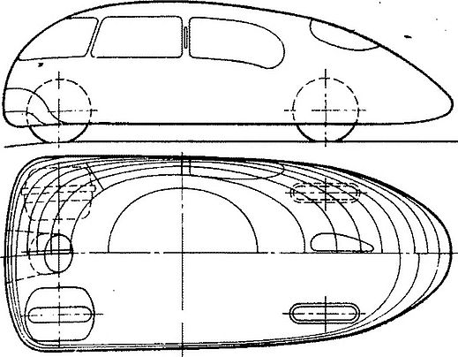
Figure 1. The ideal aerodynamic body shape of a car from the 1930s.

In the era of modern automotive manufacturing, the use of wind tunnel technology remains an indispensable process in the creation of new car models. Evolution has forced the one-piece body lines to acquire many separated, movable or overlaid elements for two purposes: to reduce the drag coefficient of the body and increase handling at high speeds. The continuity of the use of similar technologies through time can be clearly seen in the world of motorsport after the Second World War and in cars today. Anti-wings with adjustable angle of attack, spoilers to increase downforce, tires of different widths on the axles and additional air intakes on the body are used to this day and have a wide development and modernization of the technologies and materials used. A striking example of the continuity of generations in the field of design is the famous auto giant Porsche, who achieved unprecedented results in the Le Mans 24 Hours race in the late 1960s with his undefeated Porsche 917, the solutions and technologies of which were successfully applied in the modern Porsche model 919 Hybrid 2020, with wide body, low center of gravity and refined aerodynamics, is a direct nod to the mid-20th century exemplary model.

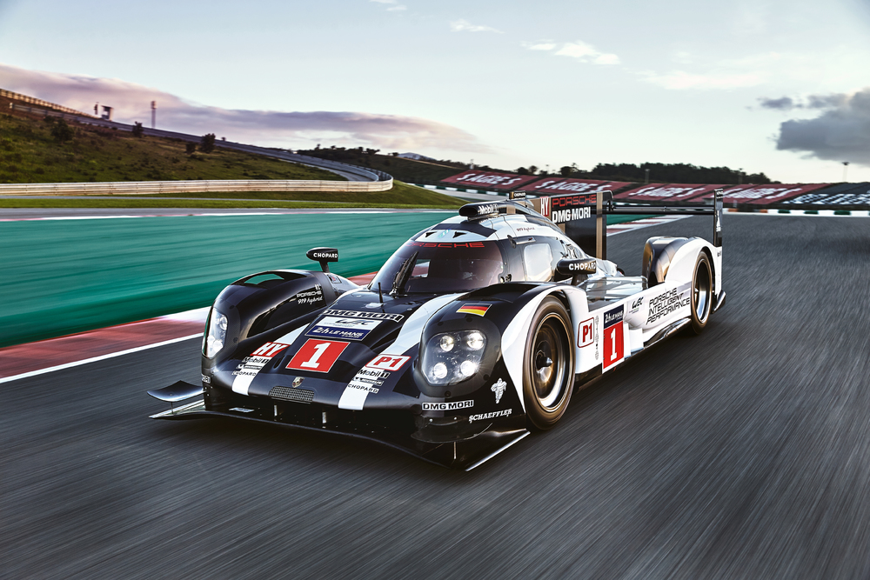
Figure 2. The form of a modern aerodynamic body on the example of the Porsche 919 Hybrid.

Part 2. Ideal technique.

The first self-moving vehicle in history, later called the "Automobile", was released in Germany by Karl Benz in 1885 and was called the Benz Patent Motorwagen. There were several tasks for the inventor: to make this device move without a harness and travel as far as possible using the available fuel.
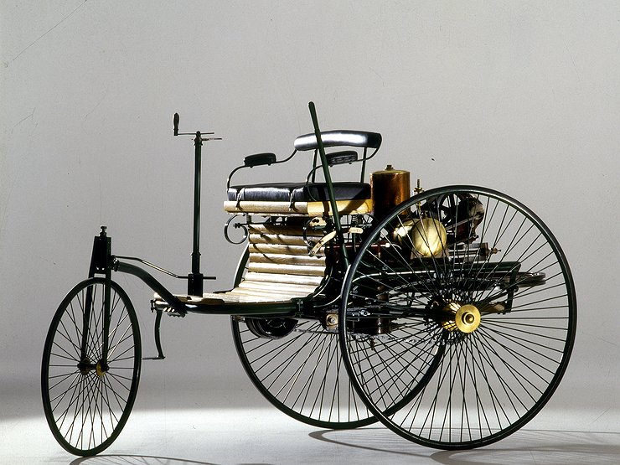
Figure 3. Benz Patent Motorwagen.

Time passed, technologies and inventions began to reach a new level of development. The emergence of motor racing in Europe posed a new challenge, in addition to those mentioned above, namely the achievement of maximum speed and acceleration in the minimum dimensions of the body of a sports car. But structurally, the cars of the mid-20th century were the same developments as the world's first copy of the late 19th century – body, chassis, wheels, engine, gas tank, steering and gearbox. To date, the continuity of technological solutions is also seamlessly present in modern cars produced. Designers of automotive brands painstakingly test new engines, reducing the volume, but achieving greater power through third-party devices (turbines and compressors). And the task of reducing fuel consumption while keeping the weight of the car low is a long-standing goal of all automotive engineers. At the same time, the largest tire manufacturers, who have established their companies since the end of the 19th century, have been and are still testing various designs and mixtures for tires both for urban traffic on broken pavements of pre-war Europe, sports races, Le Mans 24 hours endurance races in their prime 1960s and 1970s, and highly environmentally friendly highways today. The automatic transmission (automatic transmission), created in 1935, has become the main subject of admiration and thirst for improvement among auto giants, because it was it that gave a reduction in the acceleration time of the car at the start, and it also made it possible to reduce fuel consumption. From the first 2-speed automatic transmissions at the dawn of the invention to 10-speed automatic transmissions today, the original principle of combining a gearbox combined with a torque converter has remained the main and most in demand. This combination is used and improved by automakers throughout the automotive industry.

Part 3. Traditions and succession.

Historically, the traditions of the automotive industry from different manufacturers can be traced. These features are both a tribute to the original ideas and uniqueness among today's competitors. Vivid examples are a number of auto giants, whose distinctive features are well known by many motorists and connoisseurs.

PORSCHE

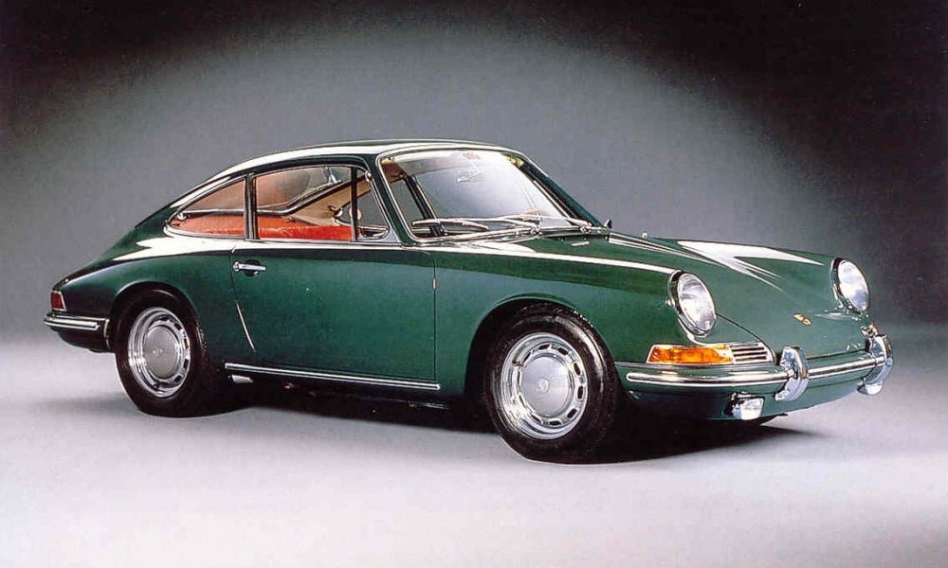
Figure 4. Design of Porsche 911 (1963).

A unique, individual and very conservative brand that has always followed the current trends in automotive trends, but prioritized the preservation of historical traditions. The ignition cylinder for the key to the left of the steering column caused a storm of discussion in the 1950s. A substantive explanation for the unusual side of the location was the active and constant involvement of Porsche in motorsport. The decision to place it on the left side of the steering wheel was explained by saving time when changing drivers during the race. This tradition remains in modern Porsche models and is their signature attribute to this day. The same as the world-famous Porsche 911, whose name has become a legend in the world of both motorsport and civilian collectors, possessing from the first day of its creation a gasoline opposed (camber angle 180º) internal combustion engine located behind the rear axle of the car. This feature gave unique high-level driving and performance during the model's introduction in 1963 and is the benchmark for a sports car in the 2020s.
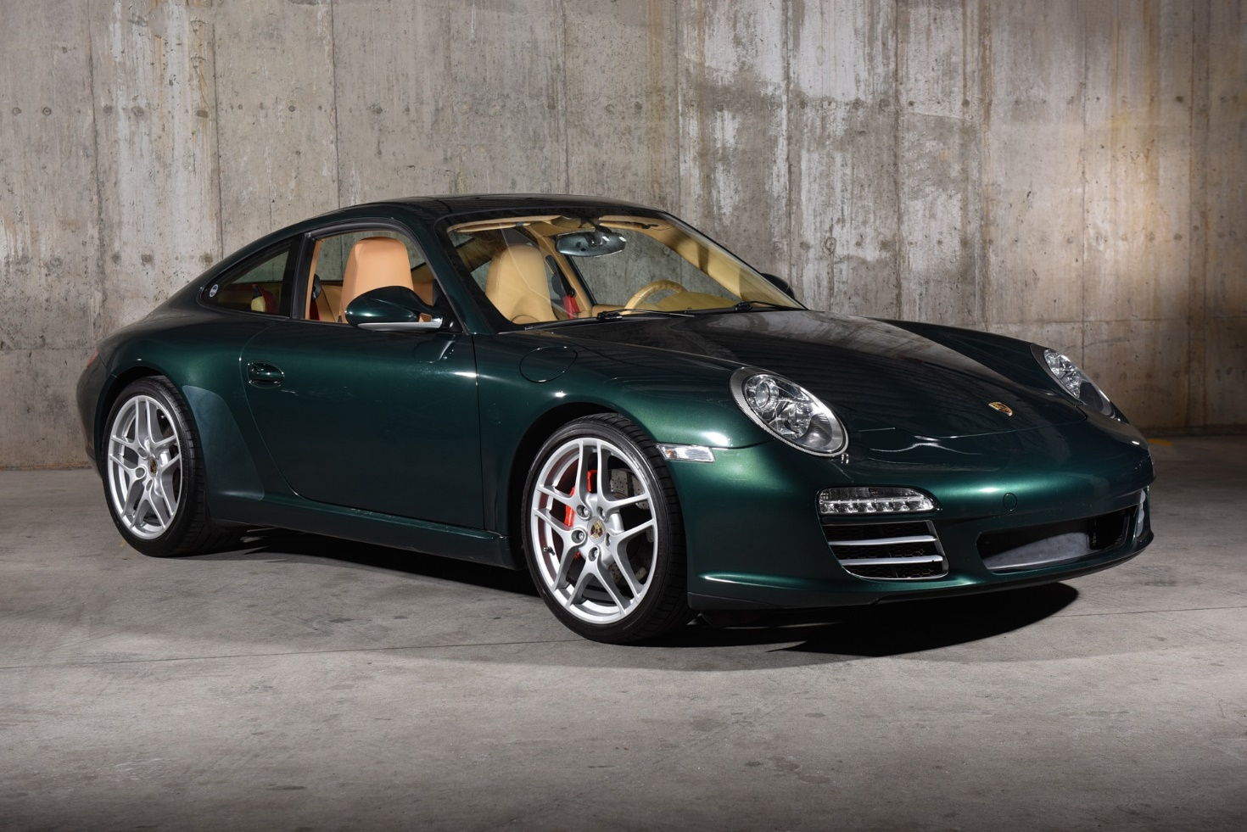
Figure 5. Design of Porsche 911 (2010).

СHEVROLET

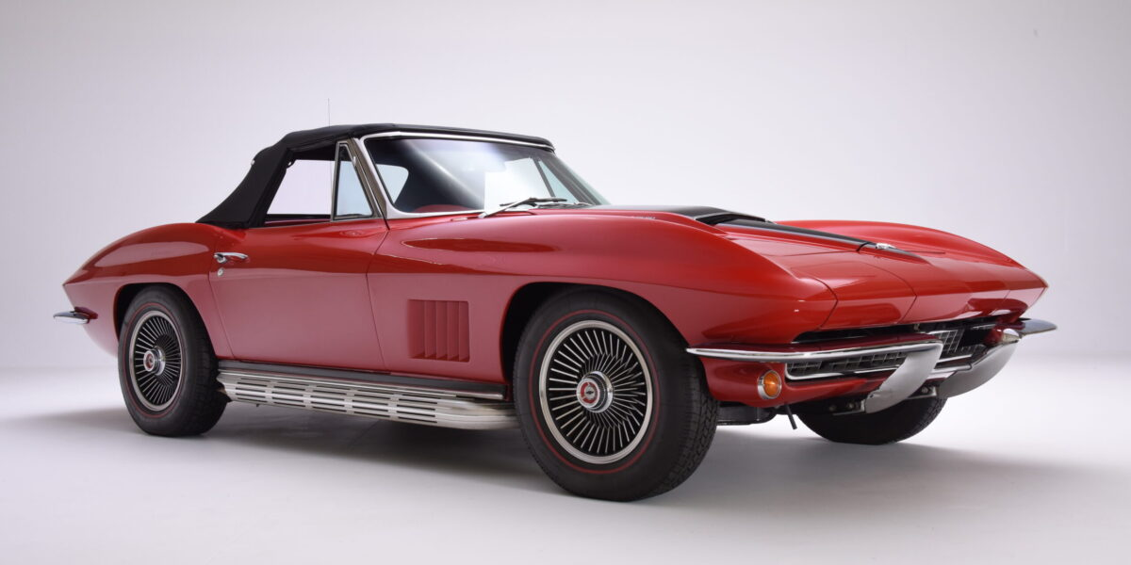
Figure 6. Design of Chevrolet Corvette (1967).

In 1967, the famous Corvette model under the Chevrolet brand gained multiple popularity in the world, because its owner was the first man to set foot on the moon - Neil Armstrong. In those years, the term that sounded on every corner - muscle car became a household name. Huge in size and volume, a multi-liter 8-cylinder engine, a simple but hardy 4-speed automatic transmission, a swollen wide body and a formidable roar of the engine became the dream of an entire generation. What can we say about the middle of the 20th century, if in the 2020s the American continent, and many other fans of the Muscle Car category, are eager to own modern Chevrolet Corvette or Ford Mustang models. The design of which was abundantly replenished with electronic systems and comfort elements, but still respecting the excellent formula "Volume - power - appearance". The continuity of generations is most noticeable here.

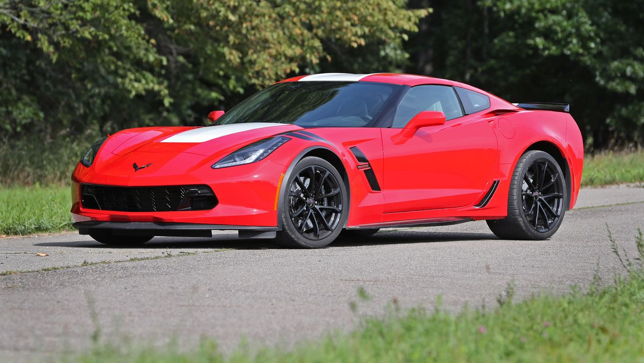
Figure 7. Design of Chevrolet Corvette (2019).

Bibliography:
- Car aerodynamic. Е. V. Mikhailovskiy, 1973
- Cars special body cars. Y.А. Dolmatovskiy, 1946
- Mythos Le Mans: die Porsche-sieger: autos-technik-fahrer. René Staud & Bernd Ostmann, 2011
- Porsche in LeMans - The complete success story since 1951. Michael Cotton & Ekkehard Zentgraf, 2001
- First human. Life of Nil Armstrong. James Hanssen, 2019
- Saga of Porsche. Family and cars history. Tomas Amman, Stephan Aust, 2002
- Porsche 911 book. teNeues, 2017
- Corvette Life Legend. David H. Jacobs, 1998

© Marat Khaitbaev, 2023

