Utilization of Nuclear Energy 2 9 19
Problems of Energy Utilization the Inertial Fusion Reactor
C&R, Alexander Bolonkin,
<abolonkin@gmail.com>
Abstract
The paper proposes and considers the utilization of an inertial electro-kinetic thermonuclear reactor. Such a rector turns the kinetic energy of charged particles directly into electricity or thrust. This greatly simplifies, facilitates, increases efficiency and reduces the cost of construction of the reactor and its entire electrical installation, since electrical energy can be easily transmitted over long distances and converted to any other type of energy. Author also considers the inertial thermo-nuclear reactor as propulsion system in space.
-----------------------------------------
Key words: Inertial thermonuclear reactor, Electro-kinetic generator, electric generator of the thermonuclear reactor, propulsion system of inertial thermo-nuclear reactor.
Introduction
Any nuclear reactor produces nuclear particles with high kinetic energy. In a conventional fission nuclear reactor, charged particles appear in a solid or liquid medium and, colliding with the almost stationary surrounding matter, quickly lose their kinetic energy by heating the environment. It turns out the circuit: kinetic energy → thermal energy → electricity. The link "thermal energy" (for example, steam engine) requires complex expensive devices and mechanisms (for example, heaters, boilers, pumps, turbines) and has a low efficiency. In addition, the fission reactor is based on neutrons with high penetrating power and, therefore, must be bulky and heavy.
Thermonuclear fusion reactor has one important feature - the reacting fuel is small (micrograms) and is located in a vacuum or highly rarefied plasma, which has virtually no braking effect (resistance) to the movement of the charged particle.
This circumstance makes it possible to create an Electro-Kinetic Generator (EKG or KEG - Kinetic Electric Generator) that allows to separate negatively and positively charged particles (electrons and nuclei) and to create a difference in electrical potentials on the electrodes. The electric current, although it turns out to be pulsed, but it has one direction (from center). The work of KEG is described in more detail below.
An ordinary electric generator turns mechanical work into electricity. It is extensively researched and widely applied in industry. But in our case, it is not applicable, because we have the kinetic energy of the nuclei, not the mechanical energy of devices created by man.
The kinetic energy of charged particles can be concentrated in a given direction and used to create thrust.
Description of KEG and his work. Innovation and advantages.
This is a typical spherical chamber of an inertial fusion reactor described in [1]. It added electron collectors 2 and positively charged nuclei 3, a current and voltage Converter 8 and a layer of insulation 4 from the neutron absorber 5.
KEG works as follows. The fuel chamber 1 explodes and forms a plasma clot (electrons + positive particles). But their average speeds are different. Electrons have the energy (temperature) of the ignition reaction (about 10 Kev). The particles have energy (temperature) resulting from a nuclear reaction, i.e. millions of eV. This means that the speed of electrons is much less than the speed of particles, even if their speed during the explosion have time to be compared, the speed of electrons cannot exceed the speed of particles, because the electron mass is 1836 times less than the proton – the minimum mass of charged particles. This means that the energy (temperature) of the electron will be at least (1836)^{0.5} = 43 times less than any charged particle and electrons from the plasma flow flowing from the epicenter of the explosion (capsule) can be detained by a thin conductive film 2 (for example, aluminum). Massive charged particles having the same speed will easily break through the thin film and will be detained by a thicker conductive wall 3. As a result, the film 2 will be charged negatively, and the wall 3 is positive. Between them there will be a current used by the payload 7. Since the current and voltage of the generator pulsate, an 8 Converter can be included in the electrical circuit, which smoothies these pulsations.
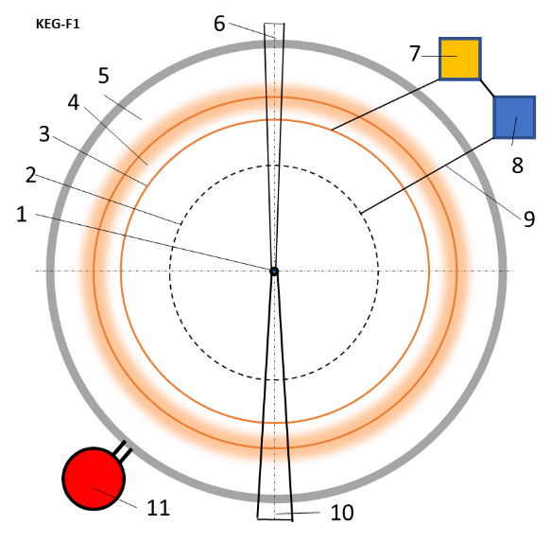
Fig.1. Kinetic electric generator for thermonuclear reactor. Notations: 1 – fuel capsule of inertial fusion reactor; 2 – the conductive thin film for collection electron; 3 – the conductive wall (film) for collection positive nucleus; 4 – insulator; 5 – collector of neutrons (heater); 6 - deliver of fuel capsule; 7 – electrical useful load; 8 - current and voltage converter; 9 – wire connection; 10 – holder of fuel capsule; 11 – customer of heat energy.
Other types of KEGS are shown in Fig. 2A, b. It is an electric generator that uses solar wind energy and is designed for spacecraft. The idea of this generator is similar to the idea of an engine that uses solar wind energy to create traction. The theory of this engine is developed in [2], Chapter 12, pp. 245-270. It is known that the Sun emits a rarefied plasma flow (protons and electrons) at an average speed of 500 km/s, called the solar wind. On the path of the wind (Fig. 2A) perpendicular to the flow put two conductive films 3, 4. The first film retards the electrons and negatively charged, the second film keeps the protons and positively charged. Between the films is included a payload of 5. For stability, the films are rotated and connected by a Central spacer.
Unfortunately, to obtain significant energy, the film should be large. The author therefore offers the option of two (Fig. 2B), in which space the generator includes two powerful charge 8-9 forming Dipole. These charges attract to the films 3 – 4 electrons and protons from huge areas.
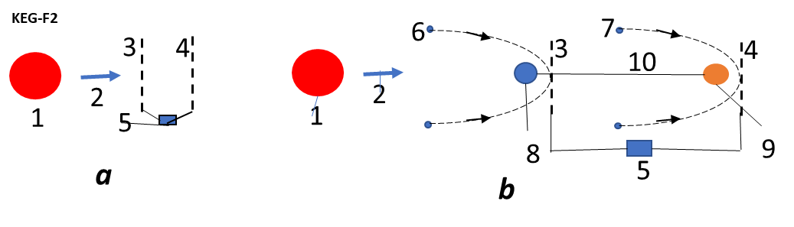
Fig.2. Kinetic electric generator for solar wind. Notations: a – simple case; b – complex case; 1 – Sun, 2 – solar wind, 3 – film-collector of electrons, 4 – film-collector of protons, 5 – electrical load, 6 – electrons, 7 – protons, 8 – positive charge, 9 – negative charge, 10 – connection negative and positive charges.
There are other unusual applications of the proposed generator. For example, obtaining electric energy from the wind on Earth (or another planet) without a propeller and a Dynamo [3]. In the wind, electrons are injected, which are picked up, carried away by the wind and settle, for example, to the ground. As a result, there is a potential difference between the injector (electron source) and the Earth.
KEGs, when they produce energy, they always slow down the flow. But it can be reversed. When it consumes energy, it accelerates the flow. This is the basis of the air-jet engine proposed by the author [4]. In the air flow in a pipe having an electric field, charged particles are injected, which are accelerated by the field and transmit their kinetic energy to the air molecules (accelerate the air flow), i.e. create traction. This method is suitable for hypersonic engines, where the traction and economic characteristics are limited by the temperature of the incoming air. For hypersonic engines, this temperature is high and modern combustion chamber materials do not allow it to significantly increase due to fuel. As a result, the efficiency of a conventional jet engine is reduced.
Theory and calculations
As already mentioned, the idea of direct conversion of the kinetic energy of plasma into electrical energy (voltage and current) is based on different permeability of thin conductive films by charged plasma particles. It was proposed by the author about 35 years ago. This method is fundamentally different from the electromagnetic generator (EMG) method, since it does not require a powerful magnetic field and all related problems (for example, heating heavy magnets with neutrons and infecting them with radioactive isotopes). The high speed and pulse power of charged particles is also big problem for EMG.
Let us consider the evaluation of this method by the example of the most popular reaction: tritium + deuterium with laser compressing and heating.
T + D → 4He(3.5 MeV) + n(14.1 MeV), (1)
The result of this reaction appears positively charged helium with energy of 3.5 of the MeV and a neutron with energy 14.1 the MeV. Although the methods of neutron energy utilization are complex, they are technologically well developed at existing nuclear fission reactors, and we will not consider them. In this method, neutron energy is utilized through the heat cycle. The kinetic energy of charged particles can also be utilized through the heat cycle, which is complex and has a low efficiency (about 30%). But there are nuclear reactions that do not produce neutrons (for example: ¹¹B + p → 3⁴He (8.7 MeV)). And it makes sense to look for methods that allow you to directly convert nuclear energy into electricity.
First of all, pay attention to the fact that the plasma particles can have a different temperature (energy). If the particles are dispersed (accelerated) by an electric field, the energy (temperature) of electrons and nuclei will be the same, because they pass the same potential difference. But if there is a reaction with the release of nuclear energy, the plasma nuclei receive huge kinetic energy (speed), and the electrons get nothing. However, at the first collision with the nuclei electrons get the speed of the nucleus. But their mass in 1836 is less than the mass of a proton. This means that the velocity of the electron is equal to the velocity of the nucleus, and the kinetic energy in
(m_{p}/m_{e})^{0.5} = (1836)^{0.5} ≈ 43 times (2)
less energy core (at the same speed). Since the explosion is almost point, and the plasma soon becomes very sparse, this speed becomes a group, i.e. the same for all nuclei and electrons moving along the radius, and constant speed.
The breakdown ability of the aluminum film by electrons and protons is shown in Fig. 44.3, p. 953, Fig. 44.17, p. 857 [5] . It can easily be converted to other mass by the formula
R_{x} (E) = (m_{x}/m_{p})· R_{p} ((m_{p}/m_{x})E), gr / cm² (3)
and other films material
r = R / γ, cm, (4)
where γ is specific weight of film, gr/cm³; r is thickness of film, cm. For aluminum
γ = 2.7 g / cm³.
The penetration capacity of the aluminum film by protons is shown in Table 1.
The range of protons in atmospheric air is given in Table 2.
The breakdown capacity of the aluminum film electrons is shown in Table 3.
A mileage of α-particles in air under normal conditions is shown in Table 4.
The tables are made on the basis of the figures 44.3, 44.17 and 44.8 (Kikoin [5], p. 953 - 957).
Penetration of electrons can also be estimated on the basis of the formula of Flammersfeld [5], p.957:
E = 1.92(r² + 0.22r)^{0.5}, (5)
here E – energy of electron, MeV; r - the extrapolated mileage, cm.
Table 1. Proton mileage in aluminum
Energy [MeV] | 10⁻¹ | 1 | 10 | 10² | 10³
Mileage R g/cm² | 2·10⁻⁴ | 3·10⁻² | 2·10⁻¹ | 10 | 3·10³
Table 2. Proton mileage in atmospheric air
Energy [MeV] | 10⁻¹ | 1 | 10¹ | 10² | 10³
Mileage r, cm | 10⁻¹ | 2 | 10 | 8·10³ | 3·10⁵

Table 3. Extrapolated mileage of electron in aluminum
Mileage R mg/cm² | 0.1 | 1 | 10 | 10² | 10³ | 10⁴
Energy [MeV] | 8·10⁻⁴ | 2·10⁻² | 8·10⁻² | 0.4 | 2.5 | 15
Table 4. Mileage of α-particles (helium) in atmospheric air
Energy [MeV] | 0.1 | 0.5 | 1 | 5 | 10 | 20
Mileage [cm] | 0.1 | 0.2 | 0.5 | 5 | 10 | 20

Estimates made for typical fusion reactions show that the permeability of electrons with energy (temperature) equal to the energy of nuclei is about 10 times higher than that of nuclei. But electron, having the same speed with proton, has energy in 43 time less that proton. It means, that the first film should delay the electrons and pass nucleus. But in TR the nucleus carry a huge energy flux density is large, and they will immediately destroy (burn) the film. However, in the expanding plasma flow after nuclear synthesis, the group velocity of electrons cannot exceed the velocity of nuclei. This according to (2) 43 times reduces their energy and allows to make the first film as a collector of electrons. But nevertheless the first film will continue to slow down 15-30% of high-energy nuclei and their heat will immediately melt and destroy the film.
Therefore, with the dream of using this direct method of extracting electrical energy from the plasma flow of a thermonuclear reaction, it is necessary to temporarily part.
Remains the magneto-dynamic method. But it is so complex and difficult that it is unlikely to be feasible in the near future.
It is known that the practical use of the thermonuclear reaction (1), even if it can be carried out in full, is unprofitable because of the huge cost (10 times higher than the energy from fossil fuels (see [1], Chapter 8).
But attempts to investigate in detail the possibility of using inertial thermonuclear energy for transport have revealed a new problem, which will be a serious obstacle to such use regardless of nuclear fuel.

Future major obstacle to the use of inertial thermonuclear energy for transport.
The obstacle is due to the inertial nature of the explosive method of obtaining energy. Suppose an aircraft or a ship needs an engine with a capacity of 10,000 kW. This means that in 1 second it should produce E = 10 MJ of energy. It is easy to calculate that M = 10⁻⁷ kg of nuclear fuel T + D reacting according to the formula (1) once per second produce energy
E₁ = M·17.6·10⁶/(5·1.67·10⁻²⁷) = 2.11·10²⁶ eV = 2.11·10²⁶·1.6·10⁻¹⁹ J= 3.38·10⁷ J. (6)
Taking into account the efficiency and all sorts of losses is enough. If you need more power, we can increase the frequency of the cycles.
Now determine the average current at efficiency equal to 1, the frequency of 1 Hz. and the typical reaction time is t = 10⁻⁷ sec. in the complete transformation of all energy into electricity and the voltage is 14.1 MB (see (1)):
I = E₁/Vt = 3.38·107/(14.1·106·10⁻⁸) = 2.4·10⁸ A (7)
Here V is the voltage, Volts. If we take into account the transformation of the capsule shell with a mass of 1 gram into plasma, the voltage will drop 10⁴ times (up to 1410 volts), but the current pulse will increase 10⁴ times to 2.4·10¹² A, and the pulse time will remain negligible 10⁻⁷ seconds.
The resulting energy E we must save and use until the next cycle. But the problem is that modern technology does not have the means to instantly take on the storage of such a huge amount of energy and its rapid issuance to the user. You need a huge capacitor Bank or a large superconducting magnetic toroid, which is unacceptable, for example, for an aircraft. In addition, the superconducting magnetic toroid itself requires a long development.
The author considered the case of transformation of all energy instantly into water vapor under high pressure and further transformation into an acceptable form of energy with the help of powerful steam turbines. This is acceptable for large fixed installations and large ships, although it requires large amounts of distilled water.
Inertial thermonuclear reactor as a driving system in space.
One of the promising areas of use of the inertial thermonuclear reactor is its use as a highly economical pulse controlled engine for space flights with low fuel consumption in near solar space. Like the nuclear engine of collapse it is unlikely to be used for interstellar
flights with the man. But because of the simplicity can deliver spacecraft over long distances and, importantly, can use any matter that will occur on the way (meteorites, asteroids, planets, etc.) to increase their capabilities.
The scheme of the inertial thermonuclear rocket engine is shown in Fig. 3. It consists of a microcapsule with a thermonuclear fuel capable of exploding, releasing nuclei with huge kinetic energy; a parabolic electrostatic mirror consisting of a double conductive grid with an adjustable electrical voltage between the grids, 100V ÷ 4 MV.
The mirror reflects the cores in a given direction. The thrust is regulated by the composition and frequency of explosions of microcapsules.
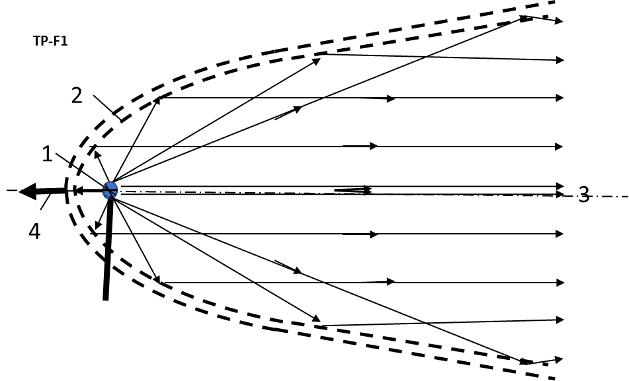
Fig.3. Scheme of inertial thermonuclear rocket engine on charged nuclei. Designations: 1- fuel microcapsule, 2 - parabolic electrostatic mirror, 3 - the flow of nuclei with captured electrons, 4 -engine thrust.
To estimate the momentum acquired by the aircraft, the amount of thermonuclear fuel in the capsule is taken m₁ = 0.0001 grams, the capsule shell has a weight m₂ = 1 gram, and the mass of the aircraft is taken M = 1000 kg. Reaction (1):
T + D → ⁴He (3.5 MeV) + n (14.1 MeV).
Only ⁴He having energy 3.5 MeV helium is emitted in the specified direction.
The speed of ejection of the fuel, mass flow and get the Space Apparatus momentum (velocity increment ∆V) was calculated according to the formulas:
1. Initial speed of nuclear
V = (2E/m)^{0.5}. (8)
Here E is energy of fuel nuclear in J; m is ejected mass, kg.
2. Numbers of nuclear ⁴He in 10⁻⁷ kg fuel is
n = m₁/(µm_{p}) = 10⁻⁷/(5·1.67·10⁻²⁷) = 1.2·10¹⁹. (9)
Here m_{p} = 1.67·10⁻²⁷ kg is mass of 1 nucleon.
3. Massa of nuclear ⁴He in 10⁻⁷ kg fuel is
m = 4·m_{p}·n = 8·10⁻⁸ kg. (10)
4. Energy of nuclear ⁴He in 10⁻⁷ kg fuel is
E = E₁n = 3.5·10⁶·1.2·10¹⁹ eV = 3.5·10⁶·1.2·10¹⁹·1.6·10⁻¹⁹ = 6.72 MJ. (11)
Here 1 eV =1.6·10⁻¹⁹ J.
5. Speed Increment of space apparatus, having mass M = 1000 kg is
∆V = (2Em)^{0.5}/M. (12)
where m is an ejected mass, kg.
Let us to consider 3 cases:
1. Fuel capsule (FC) without cover.
2. Fuel capsule having the 1-gram cover
3. Cover of fuel capsule having any cover mass 1 kg.
Cover of fuel capsule increases the burning time, efficiency of nuclear reaction, but increases the mass consumption.
Result of computation is presented in Table 5.
Table 5. Result of computation the jet speed, jet mass, increment of apparatus speed, apparatus is having mass M = 1000 kg, initial mass of jet needed for increasing apparatus speed in 1 m/s for reaction T+D, fuel mass 0.0001 gram and energy of charge particle fuel E = 8·10⁸ J, frequency cycle 1 Henry.
Case/Value | Case 1, FC without cover | Case 2. FC having  1 gram cover | Case 3. Cover of FC includes any mass 1 kg
Jet speed, V km/sec | 130,000 | 116 | 3,67
Jet mass, m kg | 8·10⁻⁸ | 10⁻³ | 1
Increment speed of  apparatus 1000 kg, ∆V m/s | 10⁻³ | 0.116 | 3.67
Mass needs for increasing apparatus speed 1 m/s, kg | 7.7·10⁻⁵ | 8.62·10⁻³ | 0.272
Case 1 may be used (for special Thermo-reactor) for flight to end of Solar system, Case 2 is suitable for flight inside Solar system, case 3 may be used for staring from planets, asteroids.
For starting from Earth, the additional any mass must be in 4 – 10 times more than mass of apparatus. In start time from Earth the frequency cycle must be increased in 5 – 10 times.
Discussion
A detailed study of thermonuclear energy began about 60 years ago. It generated great enthusiasm and great hopes for rapid development and breakthrough in the field of energy. Most of the leading technology States have allocated billions of dollars to research thermonuclear installations. Space scientists began to ask for grants for the development of nuclear spacecraft in the hope of rapid advances in thermonuclear technology.
But 60 years of hard work did not allow to obtain even a stable thermonuclear energy exceeding the energy expended. Attempts to heat the plasma in a strong grip – the laser beam is started the problem (as it came to be recognized more and more scientists) to a standstill, requiring further huge amounts of money, time with an uncertain outcome. Scientists thought that it is necessary to overcome the difficulties encountered on the way, and they will get the desired result. There was no in-depth study of possible difficulties. The author tried to draw attention to them [1], Chapter 8. But the editor of the leading magazine on nuclear energy, said that this topic is not interested in them.
The author believes that sooner or later, thermonuclear energy will be widely developed. In this article, he draws attention to another obstacle that will inevitably arise on the way to the realization of the energy of the transport inertial thermonuclear reactor and calls to start looking for ways to overcome this obstacle. This obstacle is the explosive nature of inertial thermonuclear fusion and the instantaneous release of a huge amount of energy, for the storage of which at least a fraction of a second, the technology of the present time has no means.
References.
1. Bolonkin A.A., Small Non-Expensive Electric Cumulative Thermonuclear Reactors, LULU,
USA, 2017, 143 ps.
2. Bolonkin A.A., Non-Rocket Space launch and Flight. Ch. 13, Electrostatic Solar Wind
Propulsion, Elsevier, 2002, pp.245-270.
3. Bolonkin A.A., Innovations and New Technology (v.2). Ch. 7. Non-Turbo Electric Wind
Generator, LULU, USA, 2005, pp.102-112.
4. Bolonkin A.A., ., Innovations and New Technology (v.2). Ch. 8. Electron Air Hypersonic
Propulsion, LULU, USA, 2005, pp.113-120.
5. Kikoin I.K., (red.) Tables of Physical Values, Moscow, Atomizdat, 1976. Russian, 1007 ps. (Кикоин И.К.,(редактор). Таблицы Физических Величин, Справочник. Москва, Атомиздат, 1976, 1007 стр.).
9 February 2019
Application. Run of electrons in aluminum (Григорьев И.С. Физический Справочник, Москва, 1991)
