Fractal-Сluster Theory and Thermodynamic Principles of Biological Systems Control and Analysis
V.T. Volov
Samara Institute of Fundamental Research, Samara, Russia
e-mail: vtvolov@mail.ru
Abstract
In this article we suggest the results of using of the fractal-cluster theory and thermodynamics for the biological organism evolution and protein-water dehydration analysis. As a result of the analysis three fractal - cluster laws for biological organisms were formulated: energy law, probability law and evolutional law. It was shown that self-organized energy of water-protein system approximately equals 1% percent from ATF (АТP) energy per one of weight.
On the basis of the living organisms empirical data and fractal-cluster criteria we have formulated three fractal-cluster laws: energy, evolutional and stochastic. The article presents the results of the fractal-cluster theory [1, 2] used for the analysis of the biological organisms [3] and biological systems protein-water [4] genesis. According to [2] the values ​​of fractal-cluster entropy criteria (H), F-criterion and the effectiveness criterion D were determined.
Three fractal - cluster laws for biological organisms were formulated as a result of the analysis carried out:
1) probability law, which determines the probability of biological organisms appearance (as shown in Fig. 1, there is a bijection - the most ancient biological organisms - hlamidomonas, Hydra, had the highest probability of ~ 0.01);
2) the evolutional law (Fig. 2), illustrating the increasing complexity and perfection of the emerging organisms;
3) energy law (Fig. 3), which characterizes the energy perfection of biological organisms (the dependence of the fractal-cluster entropy H or F- criterion on the energy consumption per 1 kg body weight per day).
Another illustration of the use of thermo-dynamic methods is the application of the thermodynamics apparatus to the study of the dehydration processes in the protein-water system.
Professor E.G. Rapis’ work first showed that the protein study exclusively by classical crystallographic methods is absolutely unjustified. As it is shown in her study, the process of liquid evaporation in protein-water system (in vitro) leads to the processes of protein structures self-assembly in the form of complex fractal structures for micro- (protein nano films), as well as for macro-level. In this case there exists the identity of the structural pattern of protein self-assembly in vivo and in vitro (Fig. 4).
In connection with this fact the study of "protos" (protein + H₂O) system self-organization should be carried out as an object representing an open thermodynamic system. To analyze the processes of protein self-organization as an open thermodynamic system, it is convenient to use the developed apparatus of fractal-cluster theory (FCT) [1] based on the fundamental laws and theorems of non-equilibrium thermodynamics. The paper shows that in the "protos" system a solid residue is, in terms of FCT, the energy cluster. This allows us to calculate the conditional entropy (FC-entropy of the system), D-criterion and the F-criterion. By measuring the content of H₂O in the "protos" system at different points of time, you can analyze the stability of protein self-organization processes during the evaporation.
To estimate the upper energy limit of protein self-organization (self-assembling three-dimensional macro protein structures, [4]) the respective work A_{selforg} is calculated on the basis of Carnot theorem:
, 1
where T_{sur}, T_{sub}- surrounding environment temperature and substrate temperature.
The total energy of "protos" system is
, 2

where c_{i} (i = 1, 2) - heat capacity of protein and water respectively, T - temperature of the "protos" system, m_{i} (i = 1, 2) - mass of the protein and H₂O respectively.
The work of self-assembly (self-organization) of three-dimensional protein structures from nano-to macro-level will be equal
, 3
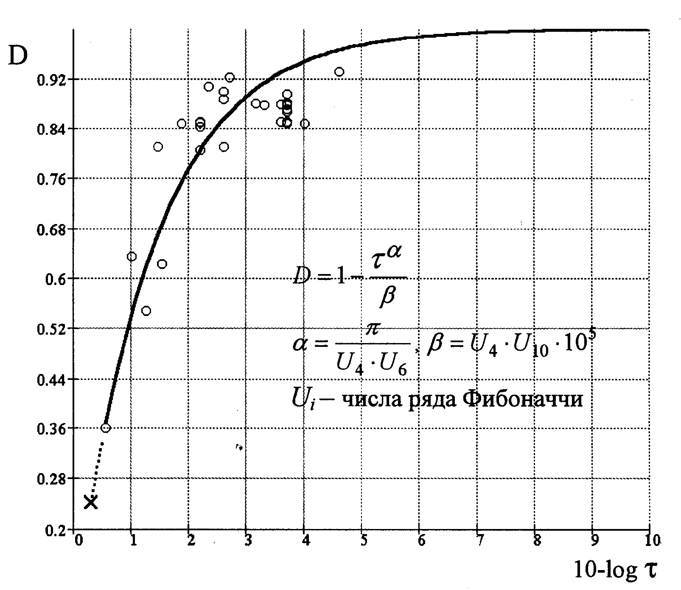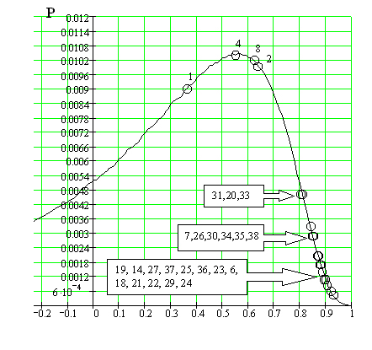 The calculations show that the specific energy of protein structures self-organization is commensurate with Adenosine-5'-triphosphate (ATP) specific energy. When the "protos" system was investigated as an open thermodynamic system, ATP was absent. From this fact, given the identity of the protein structure in vivo and in vitro (Fig. 4), we can assume that in the living there is not one energy information system (ATP), but two (ATP and energy information system of protein structures self-organization).
D_{eff}

Fig. 1. Probability law of biological organisms appearance Fig. 2. Evolutionary FC law for biological organisms

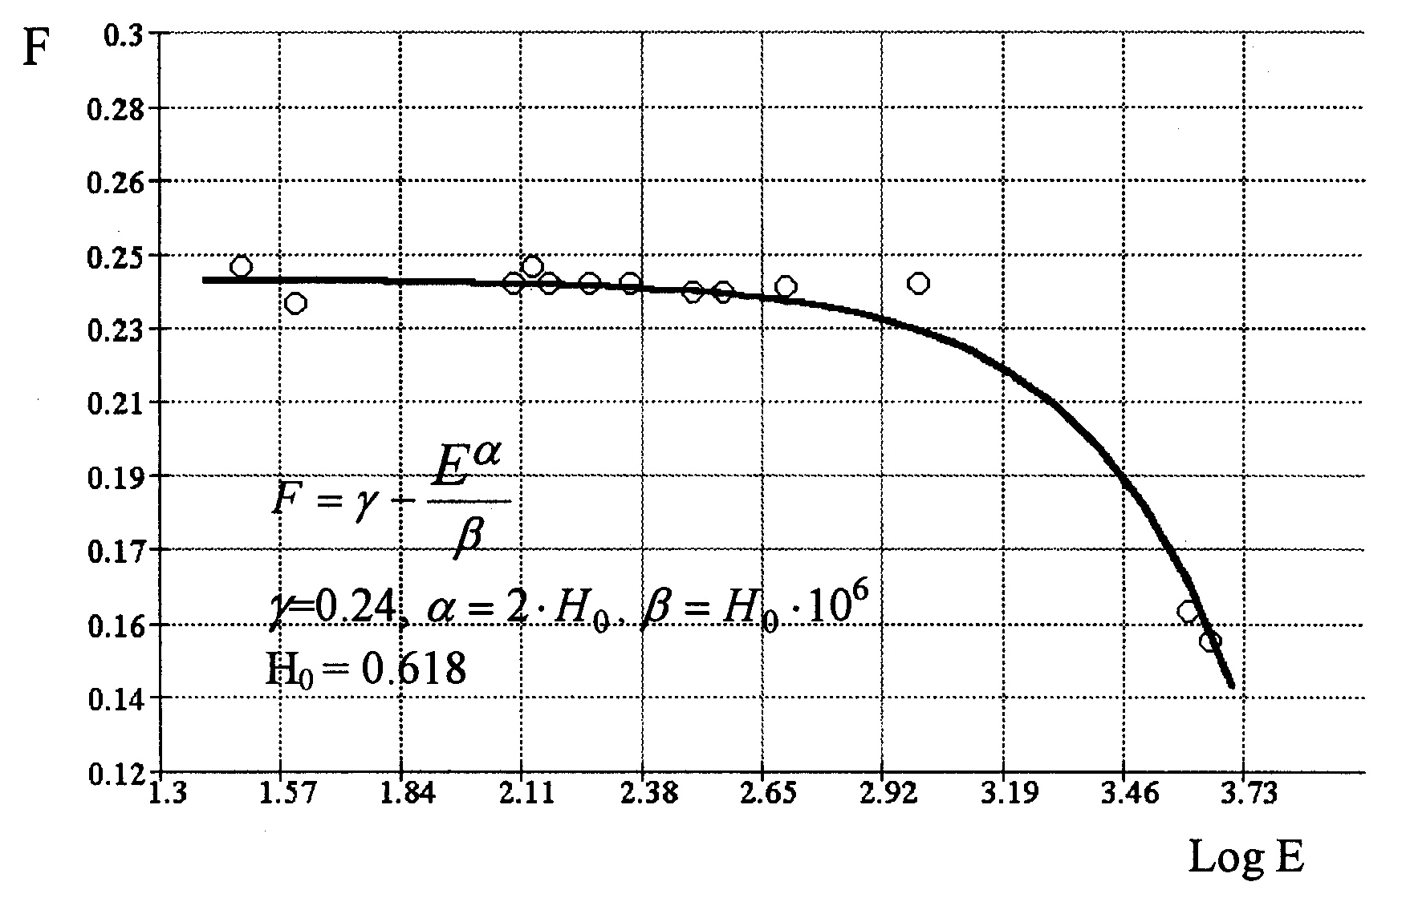

Fig. 3. Energy FC law for biological organisms
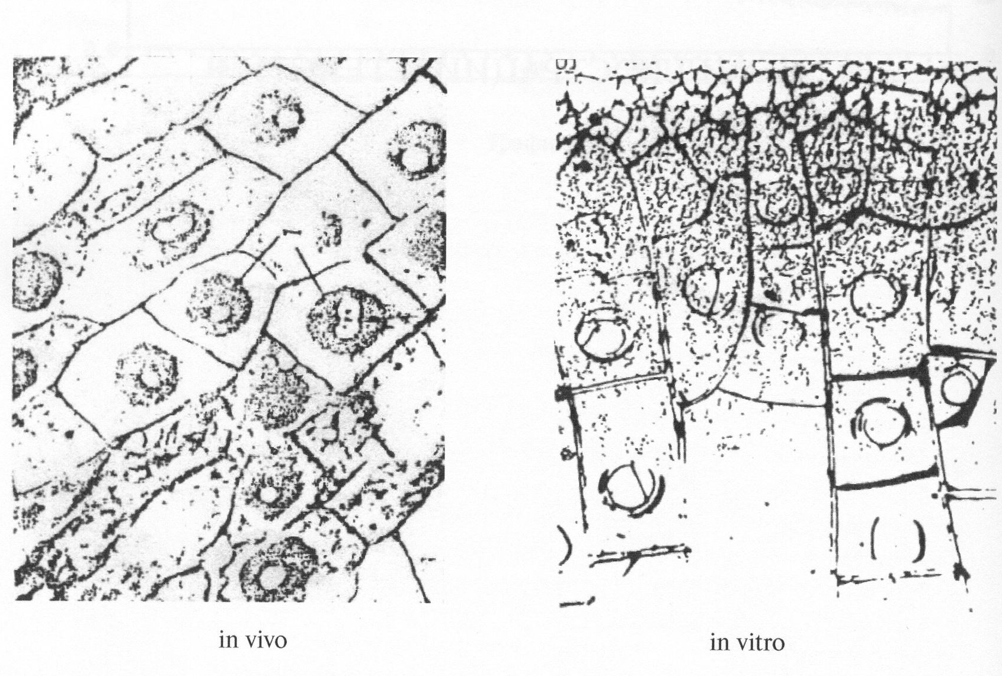

Fig. 4. Non-equilibrium film of “protos" protein
(lysozyme – water system ) in vivo and in vitro.
Optical microscop. zoom 200.

Table 1

 | Species of Biological organism | D |  | H |  | J | K_{э} | F
1 | Chlamidomonas | 0,361 | 0,914 | 0,622 | 0,324 | 0,939 | 0,387 | -0,235
2 | Hydra vulgaris | 0,636 | 0,953 | 0,637 | 0,619 | 0,538 | 0,4 | -0,237
3 | Scorpiones mingrelicus | 0,833 | 0,957 | 0,561 | 0,726 | 0,333 | 0,338 | -0,223
4 | Oligochaeta | 0,549 | 0,858 | 0,342 | 0,281 | 0,911 | 0,19 | -0,152
5 | Anisoptera libellula depressa | 0,832 | 0,965 | 0,832 | 0,827 | 0,252 | 0,4 | -0,238
6 | Micromys minitus | 0,882 | 0,973 | 0,639 | 0,886 | 0,177 | 0,4 | -0,239
7 | Rona ridibunda | 0,849 | 0,971 | 0,639 | 0,852 | 0,22 | 0,4 | -0,239
8 | Testudo horsefieldi | 0,624 | 0,94 | 0,614 | 0,579 | 0,571 | 0,38 | -0,234
9 | Cucules canorus | 0,882 | 0,973 | 0,639 | 0,886 | 0,177 | 0,4 | -0,239
10 | Procellariida | 0,872 | 0,968 | 0,662 | 0,904 | 0,177 | 0,42 | -0,242
11 | Larus argentatus | 0,883 | 0,974 | 0,627 | 0,872 | 0,185 | 0,39 | -0,237
12 | Heroestes edwardsi | 0,879 | 0,973 | 0,639 | 0,882 | 0,182 | 0,4 | -0,239
13 | Ciconia ciconia | 0,868 | 0,97 | 0,664 | 0,902 | 0,18 | 0,421 | -0,243
14 | Lepus timidus | 0,871 | 0,973 | 0,639 | 0,875 | 0,192 | 0,4 | -0,239
15 | Grus grus | 0,868 | 0,97 | 0,664 | 0,902 | 0,18 | 0,421 | -0,243
16 | Paralithodes camtchatica | 0,553 | 0,859 | 0,359 | 0,282 | 0,9 | 0,2 | -0,159
17 | Pelecanida onocrotalus | 0,871 | 0,973 | 0,639 | 0,875 | 0,192 | 0,4 | -0,239
18 | Vulpes vulpes | 0,895 | 0,974 | 0,639 | 0,9 | 0,16 | 0,4 | -0,239
19 | Castor fiber | 0,868 | 0,97 | 0,664 | 0,902 | 0,18 | 0,421 | -0,243
20 | Acinonyx jubatus | 0,811 | 0,968 | 0,639 | 0,81 | 0,278 | 0,4 | -0,239
21 | Canis lipus | 0,9 | 0,975 | 0,639 | 0,905 | 0,153 | 0,4 | -0,239
22 | Pan troglodytes | 0,907 | 0,976 | 0,627 | 0,897 | 0,152 | 0,39 | -0,237
23 | Orycturopus afer | 0,881 | 0,976 | 0,633 | 0,879 | 0,182 | 0,395 | -0,238
24 | Homo sapiens | 0,932 | 0,977 | 0,614 | 0,906 | 0,13 | 0,38 | -0,234
25 | Ursus arctos | 0,879 | 0,973 | 0,639 | 0,882 | 0,182 | 0,4 | -0,239
26 | Cervina nippon | 0,852 | 0,971 | 0,639 | 0,855 | 0,218 | 0,4 | -0,239
27 | Sus scrofa | 0,878 | 0,973 | 0,639 | 0,881 | 0,183 | 0,4 | -0,239
28 | Pongo pygmaeus | 0,883 | 0,974 | 0,627 | 0,871 | 0,186 | 0,39 | -0,237
29 | Gorilla gorilla | 0,922 | 0,976 | 0,627 | 0,913 | 0,133 | 0,39 | -0,237
30 | Equida burchelli | 0,849 | 0,969 | 0,636 | 0,845 | 0,228 | 0,4 | -0,239
31 | Tursiops | 0,806 | 0,965 | 0,659 | 0,827 | 0,272 | 0,42 | -0,242
32 | Equus caballus | 0,849 | 0,969 | 0,636 | 0,845 | 0,228 | 0,4 | -0,239
33 | Galeocerdo cuvieri | 0,811 | 0,968 | 0,639 | 0,81 | 0,278 | 0,4 | -0,239
34 | Camelus bactrianus | 0,851 | 0,971 | 0,639 | 0,853 | 0,221 | 0,4 | -0,239
35 | Giraffa cameleopardalis | 0,852 | 0,972 | 0,639 | 0,854 | 0,219 | 0,4 | -0,239
36 | Hippopotamus amphibius | 0,878 | 0,973 | 0,639 | 0,881 | 0,183 | 0,4 | -0,239
37 | Loxodonta africana | 0,878 | 0,973 | 0,639 | 0,881 | 0,183 | 0,4 | -0,239
38 | Balaena mysticetus | 0,849 | 0,969 | 0,663 | 0,881 | 0,206 | 0,42 | -0,243
39 | Balaenoptera musculus | 0,849 | 0,969 | 0,663 | 0,881 | 0,206 | 0,42 | -0,243

