Floka Liudmyla Valeriivna
Associate Professor, Candidate of Agricultural Sciences
Poltava University of Economics and Trade
Poltava, Ukraine

General information on integrated innovative water treatment technologies.
An innovative concept for the development of electrochemical water treatment technologies without the use of chemical reagents, successfully developed by multidisciplinary technologist Vladyslav Meleshko based on his professional industrial experience.

Abstract:
The integration of advanced technologies often requires fundamentally new approaches to solving the challenges posed by the ongoing development of engineering and technological systems. A key question is what tools are currently available to assist inventors at the stage of conceptualizing innovative ideas - enabling them to analyze, verify, evaluate, and model the complex interdependencies that arise during the synthesis and implementation of such ideas.
One of the most effective, flexible, and precise solutions is the use of engineering design software systems, particularly the SolidWorks family of programs.
The extensive capabilities of these software systems, their flexibility and adaptability to various conditions and criteria, as well as the ability to create animated models and simulate the operational processes of technical solutions, make it possible to clearly visualize the novelty and realistically assess the level of integration with modern design capabilities without resorting to the costly process of prototype manufacturing.
As an example, modeling versions of a component of an integrative technical solution—a vortex generator—are presented. This device enables the formation of a vortex tube within a flow composed of two or more gaseous components.
As demonstrated by the model, all complex geometric elements of the generator, including transitions between surfaces, dimensional relationships, and surface interactions, are developed with high precision. Furthermore, all necessary tolerances, material properties, cutting tool capabilities, and the kinematic characteristics of CNC machining centers are digitally embedded within the model. As a result, for implementation and manufacturing, it is sufficient to transfer the complete digital dataset directly to the machining center.

Keywords:
Water treatment; Innovative concept for technology development; Electrochemistry; Electrochemical reactor; Electrochemical cell; Electrochemical reactor with a single electrochemical cell; Electrochemical reactor with two electrochemical cells; Symmetrical electrochemical reactor; Asymmetrical electrochemical reactor; Extensive capabilities of software systems, their flexibility and adaptability to various conditions and criteria; Capability to construct animated models and simulate the operational process of a technical solution; Prototype manufacturing process; Kinematic capabilities of CNC machining centers; Development of processor-based control systems; Algorithms, software, and feedback between structural or circuit elements have become or are becoming an integral part of the technical solution; Aerodynamic pulsation of compressed gas; Technological purification scheme; Technology based on water oxidation in an upward flow within an electrode cell with neutral electrodes separated by a permeable polypropylene membrane.

Introduction:
The significant increase in the complexity of modern technology, particularly in electronic and microelectronic devices, has fundamentally transformed the principles of their protection as objects of complex, multifaceted, and multifunctional intellectual property.
For such objects, distinctions based solely on structural features, circuit solutions, or combinations thereof no longer fully define all aspects of an invention. Today, these characteristics can often be realized in a functioning system or prototype only under specific manufacturing and control conditions. In many cases, it is precisely the production process that determines the key properties of the invention.
Vladyslav Meleshko has successfully derived, from the characteristics and technical parameters of water treatment modules, the methods and approaches that enable the prediction of key performance parameters and the feasibility of achieving an ideal final result already at the stage of developing technical and technological documentation.
The development of processor-based control systems also determines the viability of a technical solution. Consequently, algorithms, software, and feedback mechanisms between structural or circuit elements have become, or are becoming, an integral part of the technical solution underlying the claimed invention.
Thus, it becomes necessary to integrate multiple technologies within a single description. This integration, along with the identified channels and interconnections between the technologies, must be presented in the claims in such a way that it does not allow a patent examiner to question the unity of the integrated distinguishing features or to divide the invention into separate local technical solutions based on a single technological direction.
The emergence of new technological fields—such as nanoscale metrology, nanoscale metallurgy, nanoscale ceramics, nanostructured metal-ceramics, and the widespread use of composite materials - has fundamentally altered the approach to evaluating technical solutions in terms of their compliance with the criteria of patentability.
Inventors, in order to keep pace with technological progress and to develop solutions demanded by the market, are compelled to seek ways to integrate both established, classical methods of idea synthesis and their practical implementation, as well as new approaches enabled by the unprecedented capabilities of modern complex technological fields and the results of advanced scientific research and experimental studies.
This is particularly relevant for technical innovations that can be integrated into the broader technological landscape only in combination with software, computer modeling and simulation, programmable processor-based systems, and high-sensitivity sensors operating at angstrom-level precision rather than micrometer scales.

General information on potential applications of water treatment technologies.
Brief description of electrochemical water purification technologies:
Technology for water purification from radioactive contamination.

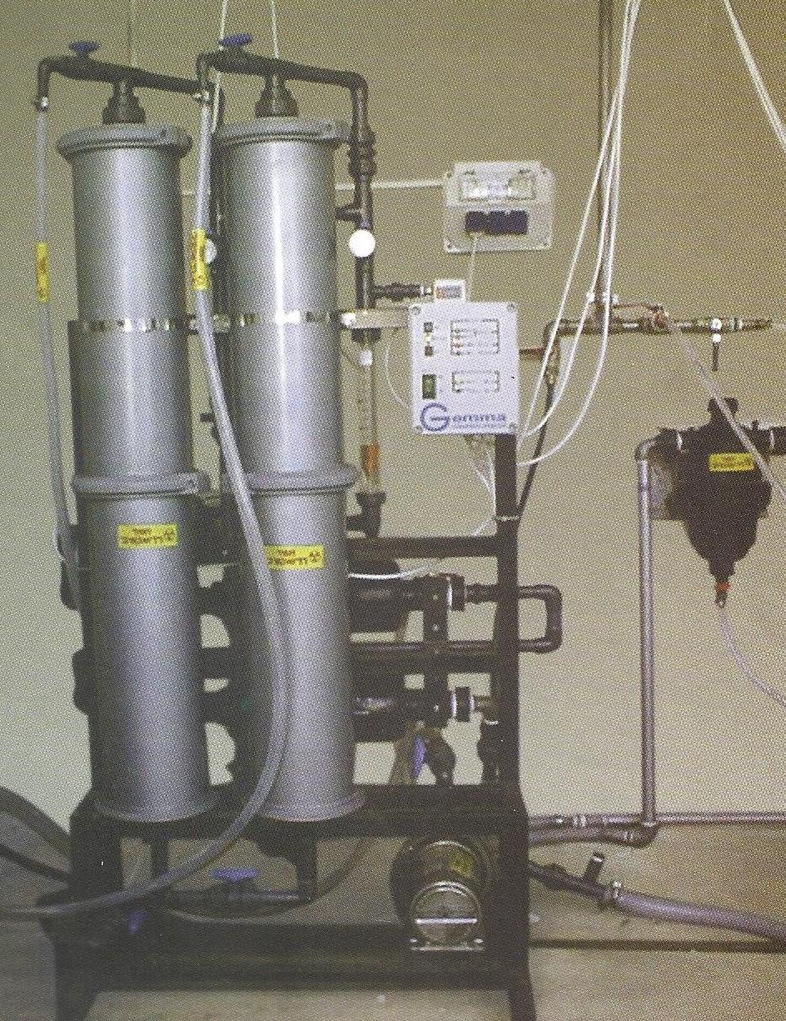
Figure 1. Water purification system for the removal of radioactive isotopes. At the first stage (in the upper section of the columns), natural zeolite in granular form is used. The system capacity is 2 cubic meters per hour.

- The technology represents a combination of sequential stages of electrochemical and biological purification.
- Electrochemical purification, taking into account the properties of water contaminated with radioactive isotopes, is based on two stages. The first stage involves воздействие on the water volume through aerodynamic pulsation of compressed gas, facilitating the separation of foam composed of organic substances and other low-conductivity contaminants from the treated water volume. The second stage involves воздействие on the water flow using neutral electrodes made of carbon composite materials, stimulating the formation of oxides of radioactive substances present in the water, followed by their separation from the flow.
- Biological purification is based on the principle of absorption of radioactive isotope ions contained in water by finely dispersed particles of algae (for example, Azolla-type algae).
- The purification scheme proposed by Vladyslav Meleshko makes it possible to reduce the concentration of radioactive contaminants to levels as low as one trillionth of a gram, exceeding current regulatory requirements.
- The technology of seawater desalination is based on the method of accelerated electrochemical processes.

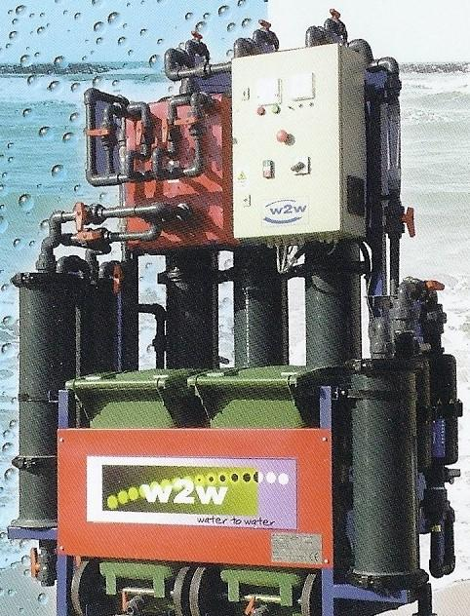

Figure 2. Installation with three ion-exchange columns.

The technology represents a process of electrolytic salt deposition on a continuously operating endless conveyor (cathode) made of carbon composite fabric.
Seawater is directed over specially designed insoluble anodes, which guide it onto the surface of the cathode conveyor.
In this process, seawater is considered as an electrolyte with a salinity of 35–42 grams per liter.
At such sodium content levels, when an electric current with a density of 35–50 amperes per square decimeter of electrode surface is applied to the treatment zone, a sufficiently high deposition rate can be achieved, ensuring the economic feasibility of the project.
The installations are designed according to a modular construction principle.
The projected effective capacity of a single module is approximately 50 cubic meters per hour.
These modules can be used either as pre-treatment systems for seawater prior to reverse osmosis in order to extend membrane service life, or as standalone desalination units.
Technology for reducing hardness salts concentration in water.
This technology is based on the principle of sequential electrochemical adjustment of acidity and alkalinity levels in the water flow, followed by the separation of the formed precipitate and final regulation of parameters according to end-user requirements.
Water purification is carried out in electrochemical reactors equipped with various types of electrodes and electrode cartridges. The selection and replacement of electrode types and materials depend on the type of hardness salts, their concentration, and the requirements of the final consumer.
As a final stage of purification, the application of ultrafiltration or an equivalent membrane technology is предусмотрено.
The proposed technological complex of specialized equipment may also include flotation modules, aeration systems, and various types of filtration.
After electrochemical treatment, for deeper removal of hardness salts, it is necessary to use specialized column modules containing capsules filled with natural coarse-grained zeolite that has undergone preliminary thermal treatment.
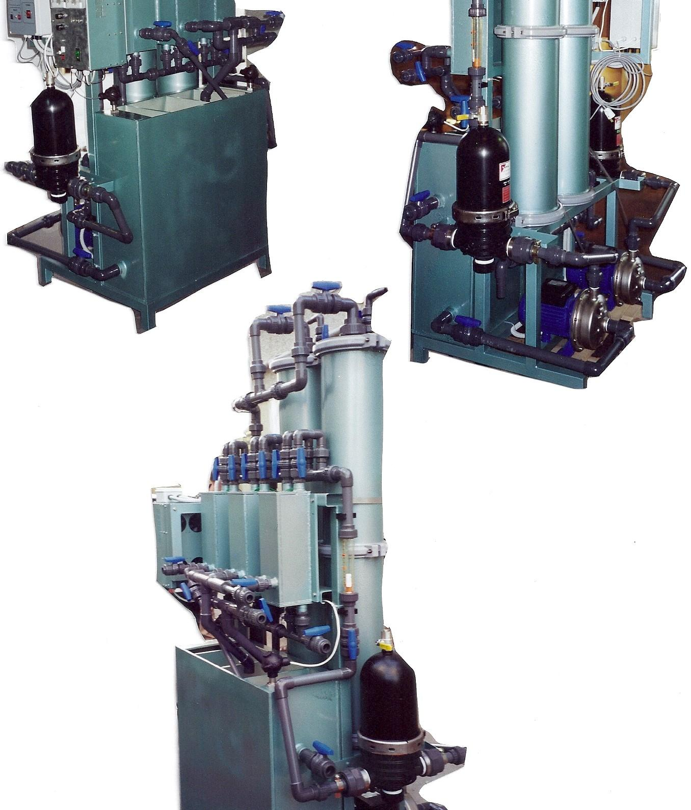

Figure 3. Installation with automatic mechanical filters.
Technology for regulating the acidity or alkalinity level of water or aqueous solutions.

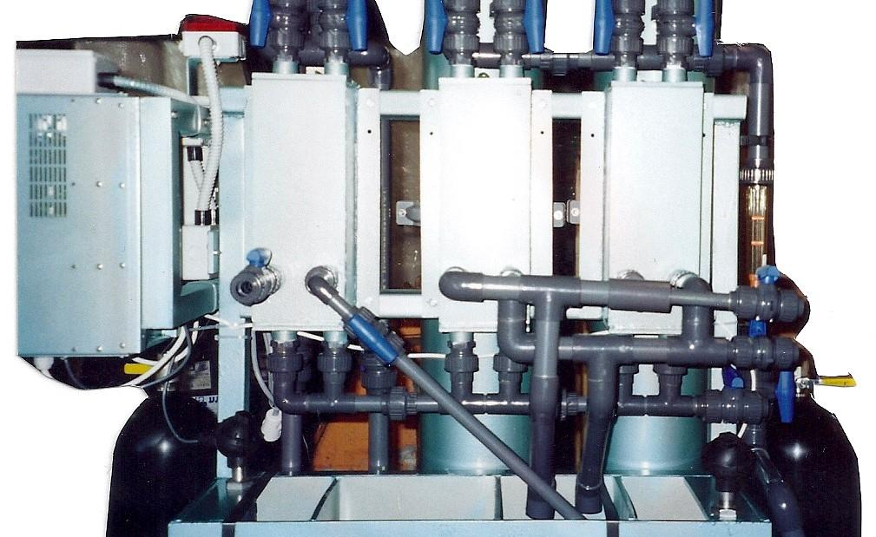

Figure 4. Installation with three electrochemical reactors.
The technology is based on the oxidation of water in an upward flow within an electrode cell with neutral electrodes separated by a permeable membrane made of polypropylene fabric; the electrodes are insoluble; variations in electrode materials and electrode surface coatings are possible.
Based on this technology, it is possible to propose the design of original technological equipment, as well as a variant of an integrated system combining electrocoagulation and regulation of acidity or alkalinity. In this case, the anodes of the electrode cell should be soluble. The technological solutions have been tested on electrode cells with polarizable and selectively soluble electrodes; the test results are positive, and it is assumed that, for the first time, the effect of acidity and alkalinity correction is achieved through the use of polarizable electrodes.
Technology for electrochemical disinfection of water or aqueous solutions.
This technology is based on the introduction of high-density current pulses into an upward flow of water or aqueous solution, combined with localized electrode воздействия at the inlet and outlet of the interelectrode space. This approach has been repeatedly validated using insoluble electrodes. The proposed development of the technology enables the application of new composite materials and new configurations of electrochemical cells for disinfection purposes. Based on this concept, an original technological equipment design has been developed, which, according to preliminary assessments, possesses the required level of novelty, non-obviousness, and utility. A previously filed patent application may serve as a prototype for this technology and equipment.

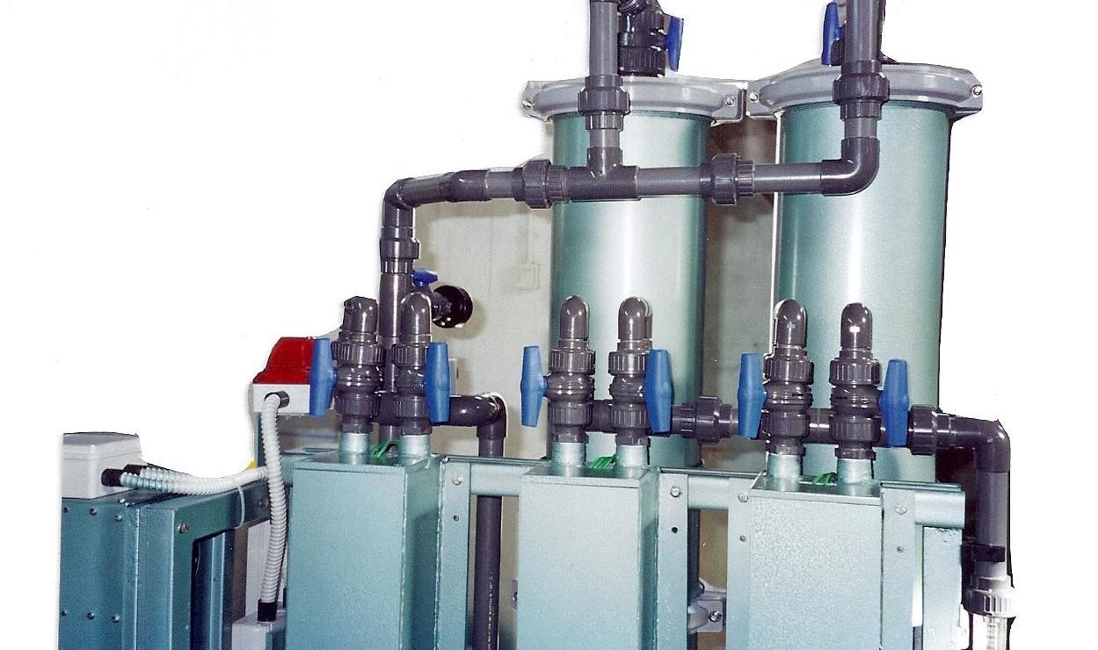

Figure 5. Installation with three electrochemical reactors.
Technology for surface deactivation using a combination of water flows charged with positive and negative electrical potentials.
The technology is based on the capabilities of electrochemical reactors to separate a flow of water or aqueous solution into two streams with different levels of acidity and alkalinity, respectively carrying positive and negative electrical potentials from the anode and cathode.
The process is based on the oxidation of water in an upward flow within an electrochemical reactor cell equipped with neutral electrodes separated by a permeable polypropylene membrane. The electrodes are insoluble; variations in electrode materials and specialized coatings of the working electrode surfaces are possible when enhanced deactivation quality and chemical purity are required.
After separation, both streams are discharged through a specially designed injector into a single point on the surface, where they neutralize static electricity and simultaneously perform surface deactivation. During surface scanning, static electricity is neutralized across the entire treated area, resulting in complete deactivation of the surface.

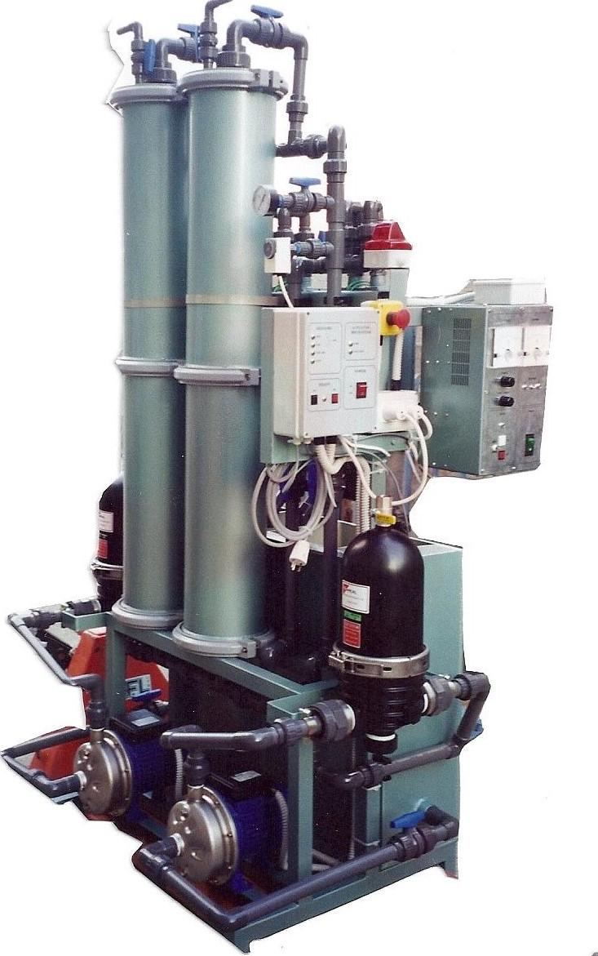

Figure 6. Automated installation with a sedimentation tank.

Technologies for neutralizing static electricity on surfaces through the combination of water flows charged with positive and negative electrical potentials.
The technology is based on the capabilities of electrochemical reactors to separate a flow of water or aqueous solution into two streams with different levels of acidity and alkalinity.
The process is based on the oxidation of water in an upward flow within an electrode cell equipped with neutral electrodes separated by a permeable polypropylene membrane. The electrodes are insoluble; variations in electrode materials and electrode surface coatings are possible.
After separation, both streams are discharged through a specially designed injector into a single point on the surface, where they neutralize static electricity. During surface scanning, static electricity is neutralized across the entire treated surface.

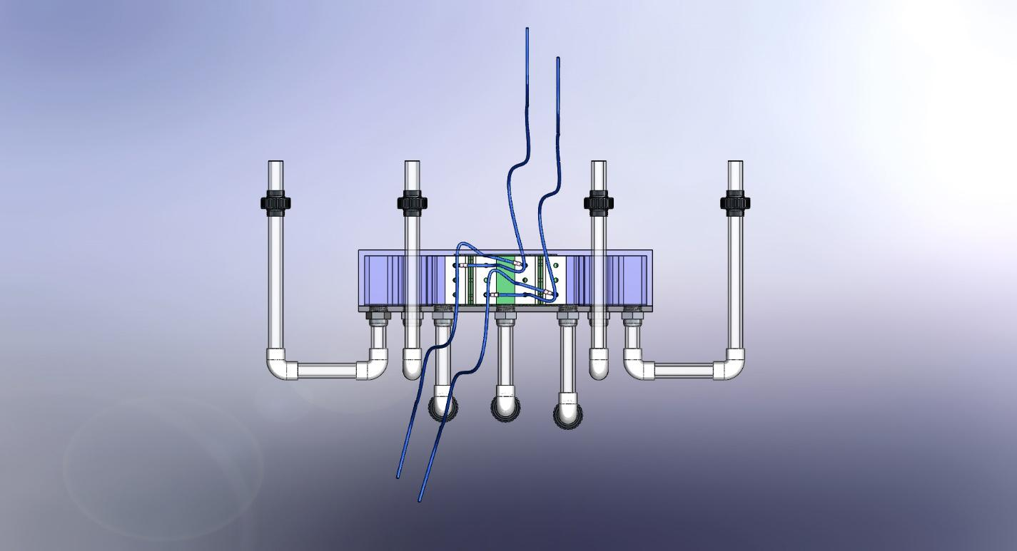

Figure 7. Electrochemical reactor with two parallel electrochemical cells.
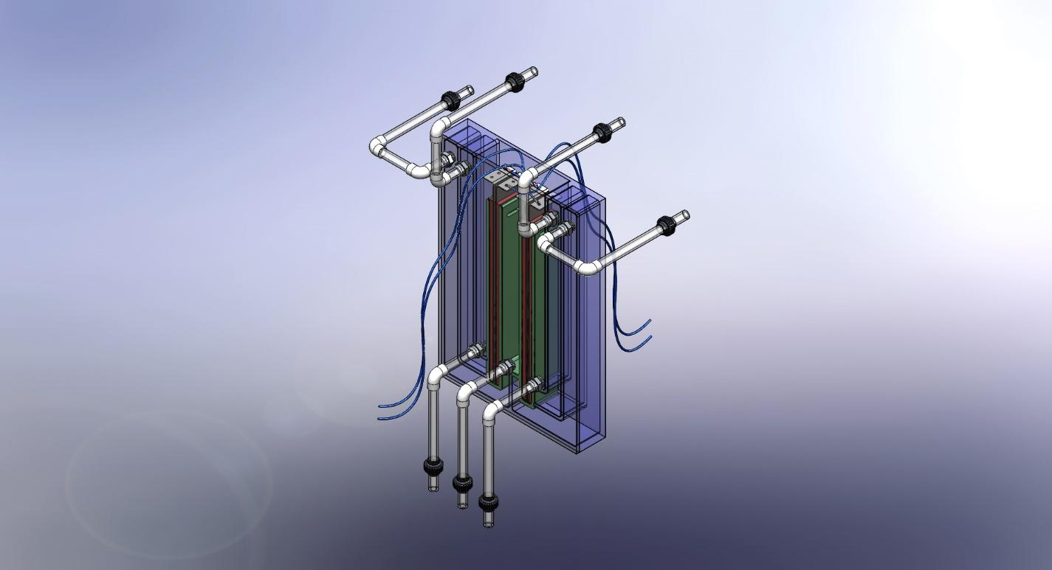

Figure 8. Electrochemical reactor with two parallel electrochemical cells and an upward flow of treated water.

Технология реализуется посредством электрохимического реактора с коаксиальными The reactor is equipped with tubular electrodes; such a configuration is characterized by extremely compact dimensions relative to the volume of treated liquid.
In other respects, the operating principle of the electrochemical reactor is analogous to conventional reactors developed by the company and offers the same technological and operational advantages.
The key operational advantage of this technology is the ability to adjust the relative position of the cathode and anode during operation without interrupting the coagulation process.
Technologies for electrochemical treatment of water and other liquids using electrochemical reactors with flexible polarizable strip electrodes.
This technology is implemented in an electrochemical reactor incorporating flexible porous strip electrodes made of carbon composite fabric.
Such electrodes exhibit exceptional chemical resistance, and the treatment process does not introduce any electrode degradation products into the purified water.
The process is highly precise and characterized by an extremely low level of secondary contamination, ensuring high efficiency with full regeneration and recirculation of working solutions and process fluids. This process and its conceptual framework were proposed and implemented by Vladyslav Meleshko, significantly reducing dependence on laboratory testing, as his real-time online non-contact monitoring system is based on the principles of electromagnetic resonance spectroscopy.
Technologies for electrochemical treatment of water and aqueous solutions using electrochemical reactors with planar polarized electrodes.
The combination of planar polarizable electrodes with carbon composite materials provides, in comparison with conventional electrochemical reactor designs using standard electrodes, significant economic and performance advantages.
Technology for domestic production of drinking water that neutralizes gastric acidity and reduces appetite for weight management without the use of diets.
This technology is based on increasing the alkalinity of drinking water through electrochemical treatment without the use of chemical reagents. The device is connected to the water supply system and is equipped with its own portable power source. Electrodes may be manufactured from various materials, including composites and titanium coated with ruthenium oxide. The system capacity is approximately 10 liters per hour.
The potential for appetite reduction through partial neutralization of gastric acid has been discussed with specialists in alternative medicine and has received positive evaluation. A conceptual design of a household device has been developed, which, in combination with the technological approach, demonstrates novelty, non-obvious technical solutions, and practical utility.
These developments are based on innovative technical solutions proposed by Vladyslav Meleshko. Considering the importance of real-time online monitoring, his unique advancements in this field have enabled the achievement of an equivalent of the ideal final result.

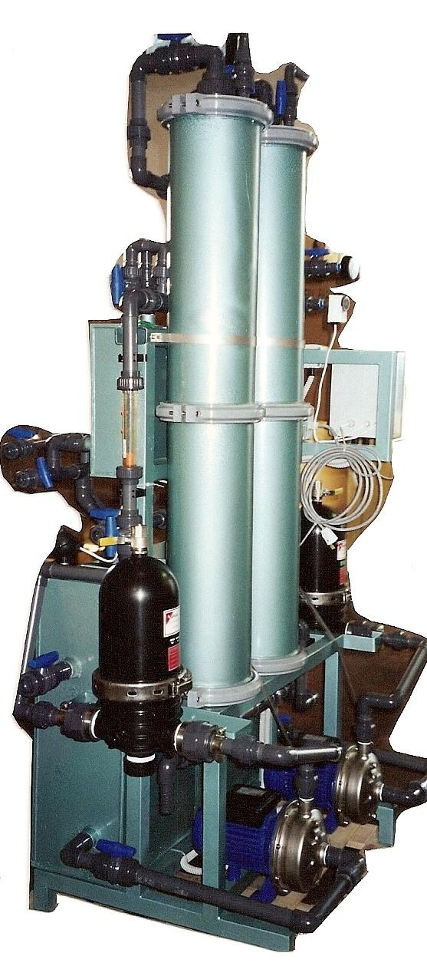
Figure 9. Fully automated installation with the capability to connect non-contact monitoring sensors operating based on the principles of electromagnetic resonance spectroscopy.
Technology for the extraction of heavy metal ions from water used in technological processes by means of galvanic deposition onto an extended active working surface of the cathode in an electrochemical cell, featuring composite volumetric-porous electrodes and permeable elastic contacts made of carbon–carbon composite fabric.
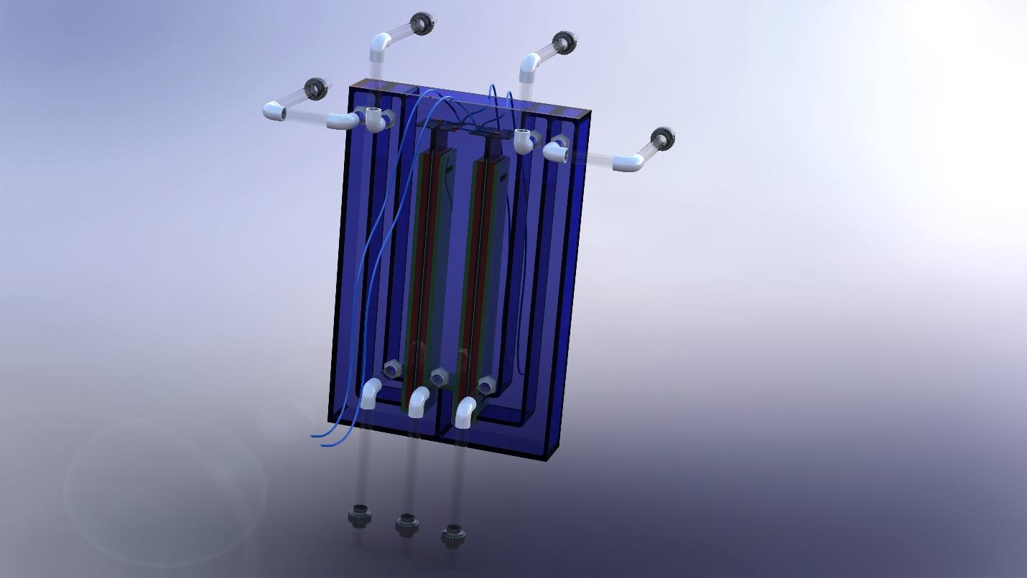
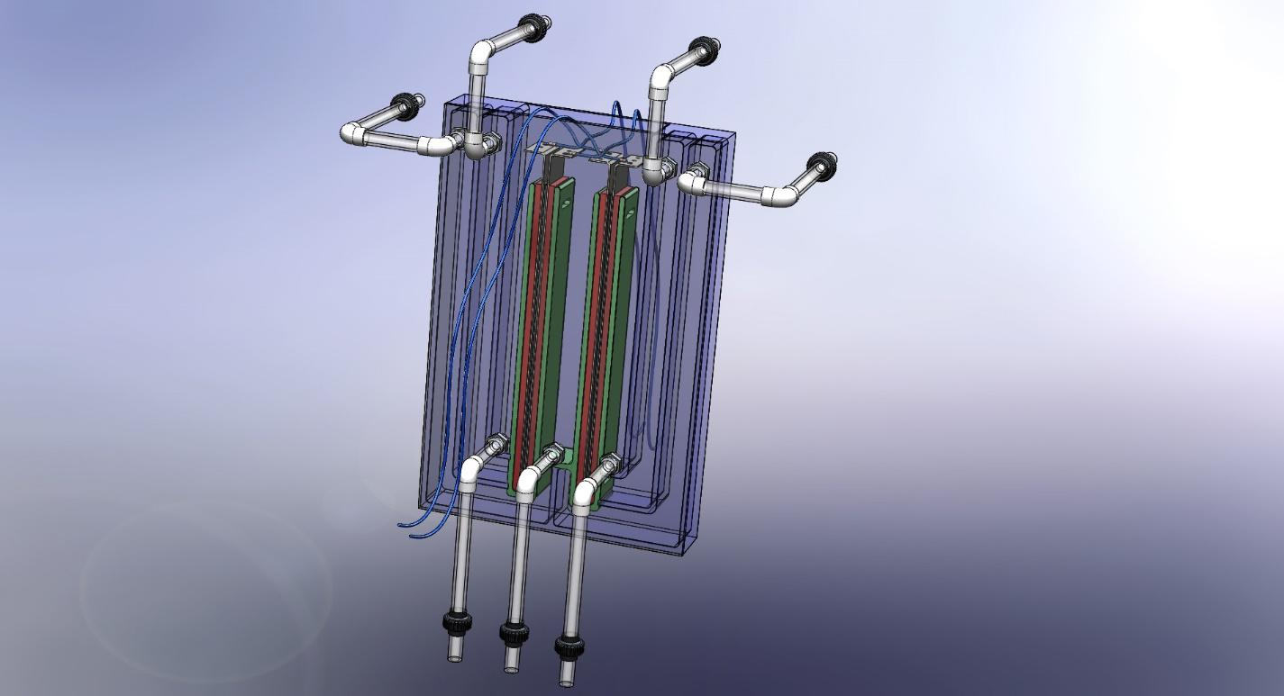

Figure 10. Figure 11.

Figures 10 and 11.
Models of an electrochemical reactor with two parallel electrochemical cells.
List of References, Patent and Licensing Information
- United States Patent No. 10,071,918. Ackerman. Water harvester and purification system. Published: September 11, 2018.
- United States Patent No. 4,594,082. Catherwood, Sr. Dehydrating air-filtering apparatus. Published: June 10, 1986.
- United States Patent No. 10,767,659. Rolandson. Exhaust gas recirculation compressor inlet thermal separation system. Published: September 8, 2020.
- United States Patent No. 10,759,677. Hedlund. Self-contained photovoltaic distillation apparatus. Published: September 1, 2020.
- United States Patent No. 10,731,880. Kow. Humid air stream generator. Published: August 4, 2020.
- United States Patent No. 10,583,389. Stuckenberg. Atmospheric water generation systems and methods. Published: March 10, 2020.
- United States Patent No. 10,718,101. Panda et al. Economically viable atmospheric water generator. Published: July 21, 2020.
- United States Patent No. 10,422,112. Bravo et al. Modular apparatus for water production. Published: September 24, 2019.
- United States Patent No. 10,385,549. Bravo et al. Water production apparatus for rigorous climates. Published: August 20, 2019.
- United States Patent No. 9,821,263. Hering et al. Advanced laminar flow water condensation technology for ultrafine particles. Published: November 21, 2017.
- United States Patent No. 9,976,769. Shinoda et al. Indoor unit of air-conditioning apparatus. Published: May 22, 2018.
- United States Patent No. 10,161,114. Vaughen. Fresh water generation system using coastal atmosphere and ocean water. Published: December 25, 2018.
- United States Patent No. 10,337,175. Chen. Water generation system for deserts. Published: July 2, 2019.
- United States Patent No. 9,758,948. Heller. Humidity collector apparatus. Published: September 12, 2017.
- United States Patent No. 9,216,379. Elliott. Method and apparatus for drying compressed air. Published: December 22, 2015.
- United States Patent No. 8,967,096. Mayr et al. Condensation device. Published: March 3, 2015.
- United States Patent No. 8,685,144. Claridge et al. System and method for efficient air dehumidification and liquid recovery. Published: April 1, 2014.

