Vladimir Nikiforov
Laser equipment and complex technical systems in devices and tools for ophthalmology, that use elements of artificial intelligence interlinked with artificial neural networks
There are a number of medical technologies and a number of technologies related to them to one degree or another, where the application of the features of the above invention brings a tangible technical and economic effect.
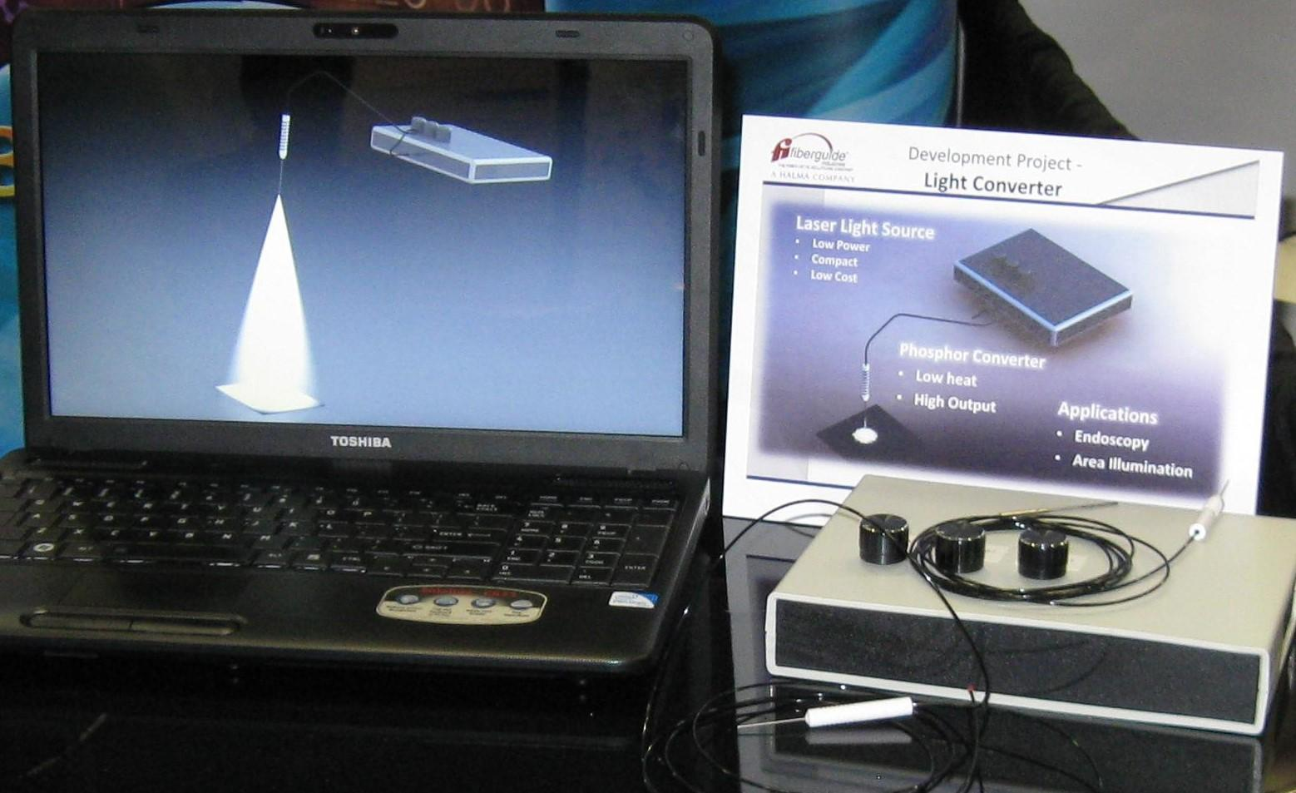
Figure 1. The figure shows the integrated technical laser illumination system for needs of ophthalmology, which implements a product using artificial intelligence elements interlinked with artificial neural networks under the general name Light Emitting Apparatus with Integrated Emitter.

Possible applications of the Light Emitting Apparatus with Integrated Emitter invention
1. Machine Vision
For a number of processes - medical and all kinds of automated production processes - it is necessary to illuminate the operating area with even monochromatic light.
Under certain conditions, standard-type lasers form point distorted structures and are not suitable for creating, for example, an even monochromatic light flux in the operating area.
LEDs do not give and do not create distorted structures, but they have a lower brightness.
In addition, the LED emission is not uniform in the far zone.
Above-mentioned invention with a luminophoree droplet on the fiber end would be a comprehensive solution to this problem; the size of the glow body will be determined by the diameter of the droplet - 100-150 microns or the diameter of fiber core - 30-50 microns.

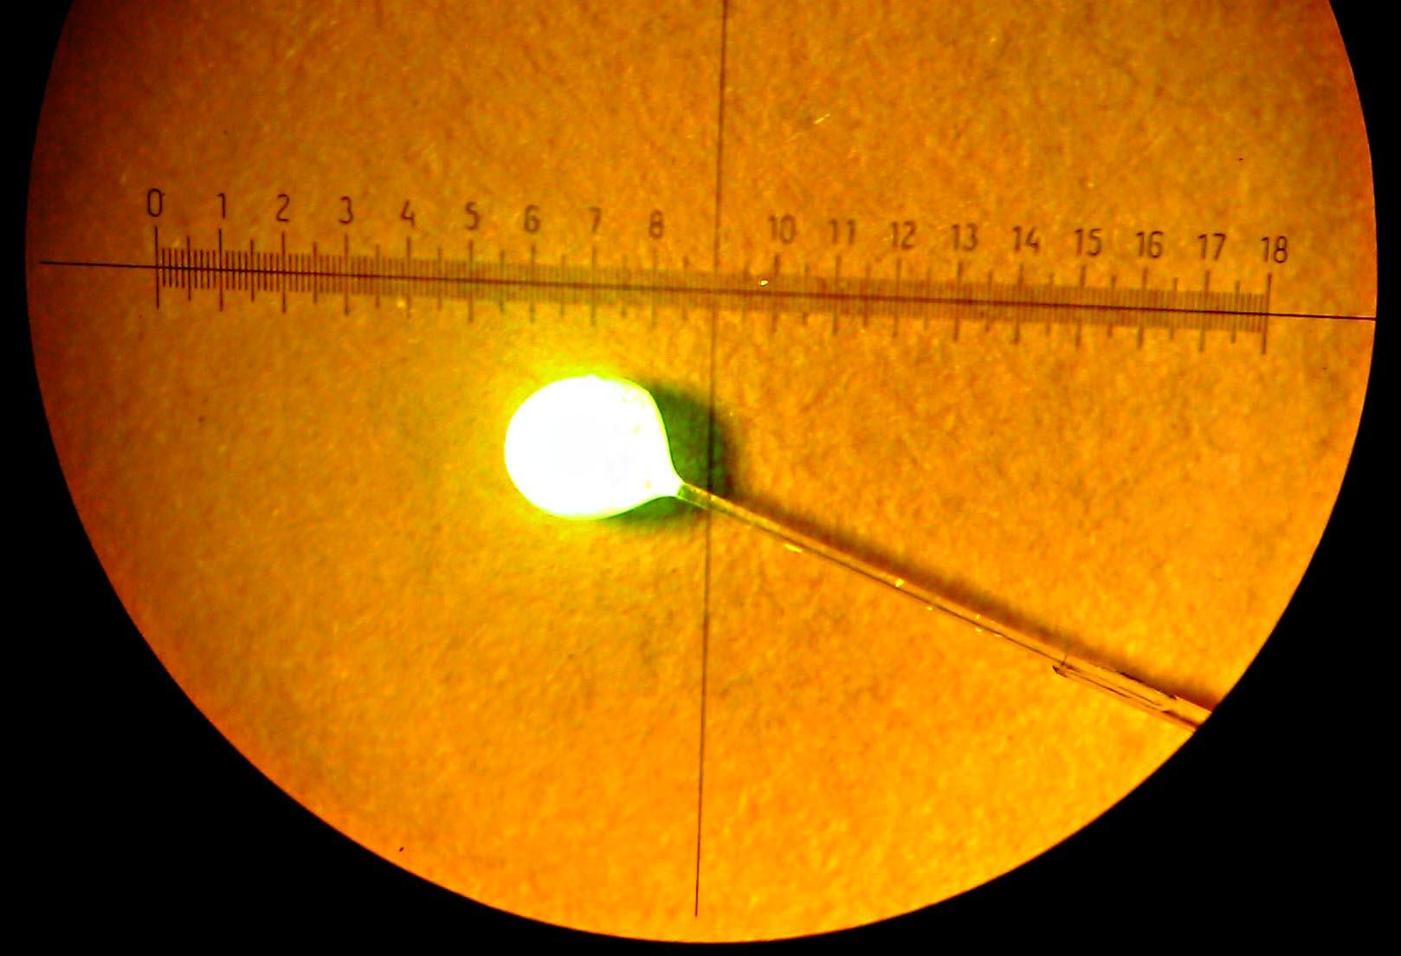
Figure 2. The figure shows a droplet of a luminophoree mixed with a transparent optical varnish at the end of the fiber, placed into the microscope at the generation threshold, with the microscope lamp turned on.
The use of the features of the above invention allows you to fundamentally change the situation.
The size of the drop is 3 times smaller than that of the LED. In addition, the light will be more uniform and stable.
The cost of a standard machine vision system ranges from $2-3,000 to $25-50,000.
According to preliminary estimates, the proposed apparatus for light emission should be 35-50% cheaper in any design and in any version of the component parts of the apparatus.
The durability of the proposed device is determined by the durability of the laser diode.
Due to the fact that the laser diode in the proposed device has all the possible variants of increasing durability in terms of intensive cooling, modified installation module with control and regulation electronics operating in the radio frequency range, longevity in the preassembly selection of materials and special coatings, including artificial diamond films, can be assumed to be equal to 10,000 hours or more.
2. Lighting systems in microscopes, primarily in microscopes used in various medical laboratories.
First of all, it is necessary to compare the complexity and labor intensity for manufacturing the invented technical system with traditionally used technical systems.
The invented technology, integrated into the technical supersystem, is so flexible and adaptive that it allows the most efficient and new local technical systems to be used in the formation of the system, including: electronic boards with a high level of operational speed (the so-called - RITM boards) and the most efficient structural materials , including composites - carbon-carbon compositions among other things (obtained by vacuum pyrolysis on viscose fabrics) and including films made of artificial diamond.
The use of these innovative subsystems allows you to get the benefits associated purely with the specifics of laser diodes.
The monochromatic factor of light emission allows to remove chromatic aberration and increase resolution when using the invention.
The cost of the lighting system at present in various types of microscopes can range from $2-3,000.
When using the proposed invention, the energy consumption for lighting should be reduced by 85-95% and the cost of the proposed version of the invention is lower than the existing one by at least 50-60%.

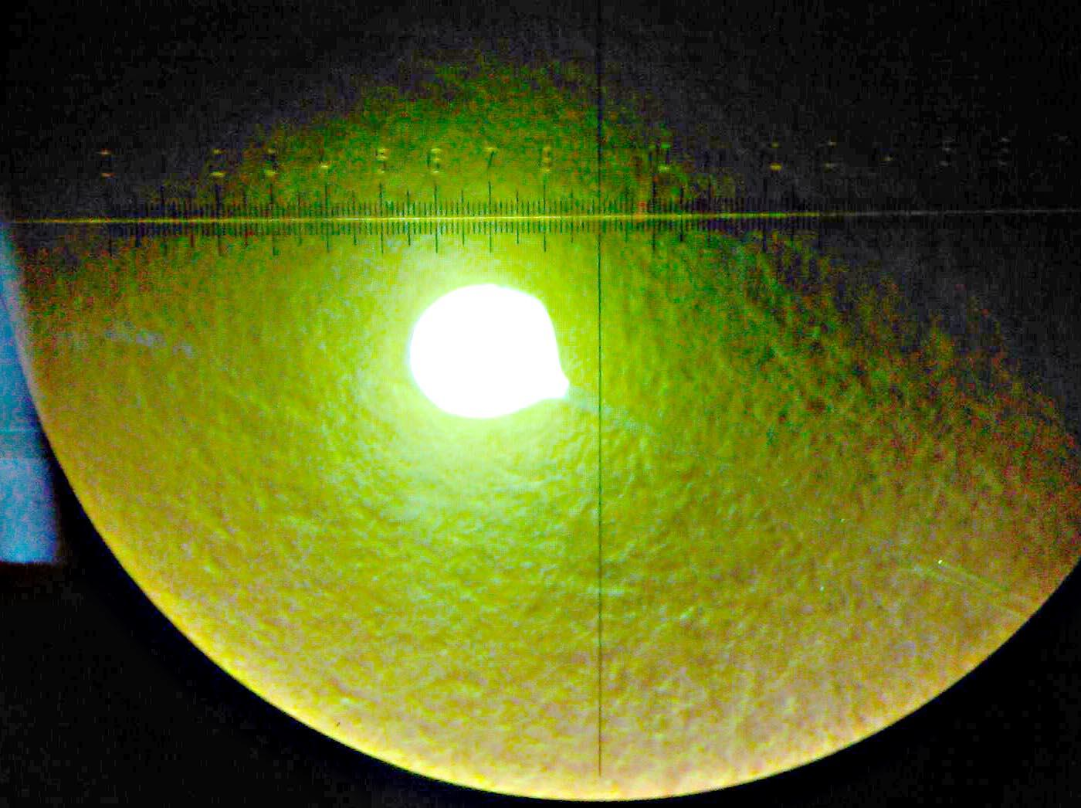
Figure 3. The figure shows a droplet of the luminophoree mixed with a transparent optical varnish mounted at the end of the fiber, placed into the microscope at the generation threshold, with the microscope lamp turned off.

When applying the invention, the general technical characteristics of microscopes fundamentally change and improve, which in turn determines the expansion of the field of use in all areas of engineering and technology and, to a large extent, in medicine.
The durability of the proposed design of the device is also determined by the durability of the laser diode.
Due to the fact that the laser diode in the proposed device has all the possible variants of increasing durability in terms of intensive cooling, modified installation module with control and regulation electronics operating in the radio frequency range, longevity in the preassembly selection of materials and special coatings, including artificial diamond films, can be assumed to be equal to 10,000 hours or more.
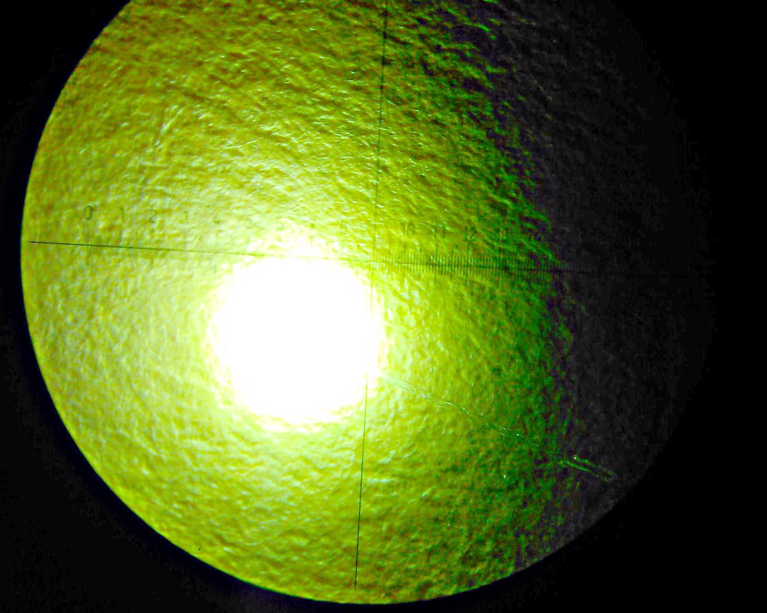
Figure 4. The figure shows a drop at the end of the fiber transferred to the microscope in a state equivalent to 2 milliwatts of generation with the microscope lamp turned off.
3. The use of the proposed device in medicine, medical technology, and medical equipment.
Endoscopy of all kinds and types - an optical fiber with a drop of luminophoree allows you to illuminate the entire space around, as the rays will go in all directions.
When using a standard optical fiber, only a narrow region is illuminated, determined by the divergence of the radiation from the fiber. In our case, when using the version of the invented device, it is possible to make illumination with all colors, including white, that is, conduct, for example, photodynamic therapy and ultraviolet irradiation (these are additional diagnostic and treatment options).
According to preliminary estimates, the cost of the lighting system for the endoscope, made in accordance with the proposed invention will be 35-45% lower, and the effectiveness of the endoscope and the entire operation of endoscopy will increase significantly.
The durability of the proposed design of the device is also determined by the durability of the laser diode. Due to the fact that the laser diode in the proposed device has all the possible variants of increasing durability in terms of intensive cooling, modified installation module with control and regulation electronics operating in the radio frequency range, longevity in the preassembly selection of materials and special coatings, including artificial diamond films, can be assumed to be equal to 10,000 hours or more.
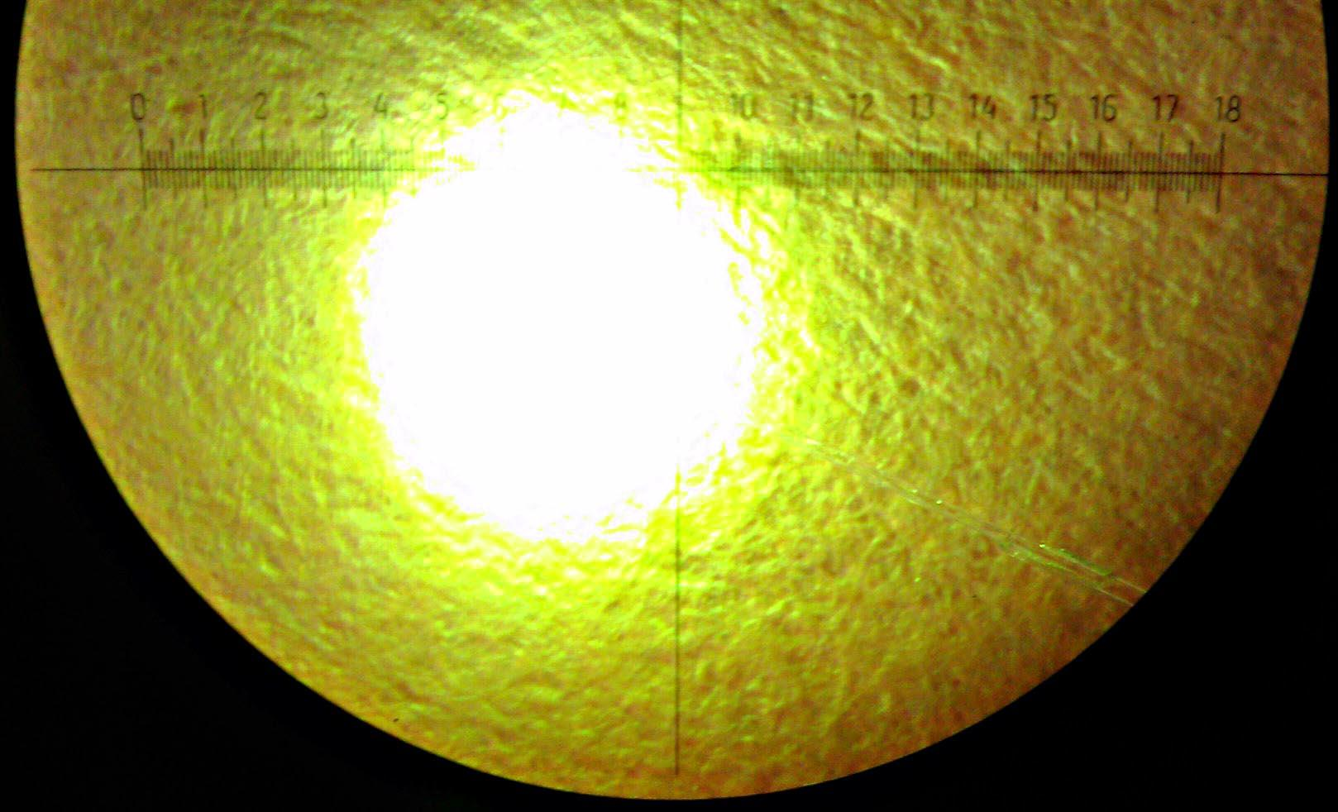
Figure 5. The figure shows a formed drop at the end of the fiber placed to the microscope in a state equivalent to 2 milliwatts of generation with the microscope lamp turned on.
4. Another use of the invention in medicine is the illumination of the surgical field.
The optical fiber is easy to attach to your finger or instrument (scalpel, clamp). It can be particularly important in ophthalmology.
In ophthalmology, it is necessary to evenly illuminate the sclera of the eye. The fiber used for this is thin - 100 microns in diameter. It is easy to insert into the eye without injury and illuminate the sclera in all directions. This is considered a very important factor for the success of the operation.
The cost of the proposed system of local lighting of the operating field may be about $3,000.
The durability of the proposed design of the device is also determined by the durability of the laser diode. Due to the fact that the laser diode in the proposed device has all the possible variants of increasing durability in terms of intensive cooling, modified installation module with control and regulation electronics operating in the radio frequency range, longevity in the preassembly selection of materials and special coatings, including artificial diamond films, can be assumed to be equal to 10,000 hours or more.

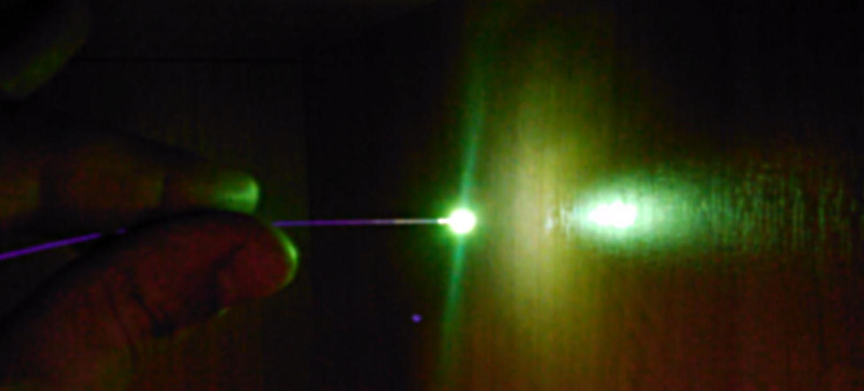
Figure 6. The figure shows the distinctive glow of the technical subsystem in a darkened place.
As the first experiments showed - everything goes easy and confirms all the calculated assumptions even on a module composed of standard components.
The light-to-light conversion coefficient is very high, even with a poor luminophoree that is not preassembly selected.
The image in Figure 6 immediately induces new applications to the device based on the obvious lightweight and small size of the illuminator - illumination in hard-to-reach places and illumination of local areas.
Dentistry - the illumination of the oral cavity by compact illuminators, mounted on standard medical instruments.
Such a local illumination system can be mounted in a dental mirror, in a saliva suction system, etc.
In laboratory studies - lighting with endoscopic methods.
Moreover, it is possible to combine it with fluorescence-diagnostic research methods, including blood vessels. You can do local operations with photochemical reactions by introducing a flood exposure of the desired wavelength.
An illuminator can also be used in surgery - illumination of darkened areas during diagnostic laparoscopy.
In addition, when preparing new applications of the technology, it must be taken into account that luminophorees retain their luminescent ability to very high temperatures of about 600 degrees Celsius.
That is, you can make applications for local or any special illumination of hot zones. For example, insert a fiber with a luminophoree into the tip of a hot soldering machine for visual feedback and real-time control of soldering conditions and quality.
The developers took new photos of the same module with the same luminophoree. Now they have formed a droplet of transparent optical varnish mixed with the necessary type of luminophoree on the tip of a fiber with a diameter of 125 microns.
In the initial phase of the experiment, to obtain a comparative indication of the effectiveness of the technical solution, the phosphor was simply poured near the tip of the fiber.
To the researchers' surprise, the power of the reradiated light was 1 milliwatt, and the laser pumping light power was 2 milliwatt.
This is an exceptionally good result, given the fact that the luminophoree was not preassembly selected.
Other design options are available:
The diameter of the optical fiber is 125 microns.
The radiant may have a different geometric shape. Emitter material, luminophoree or a mixture of luminophorees mixed with optically transparent (after polymerization or immobilization) glue (as an option). The most preferred option is mixing luminophorees or their mixtures with the monomer of an optically transparent and chemically resistant polymer material, such as polymethyl methacrylate, polycarbonate and others, and polymerization via non-contact heating in vacuum or using microwave technology.
The outer diameter of the emitter may not exceed 0.45 mm.

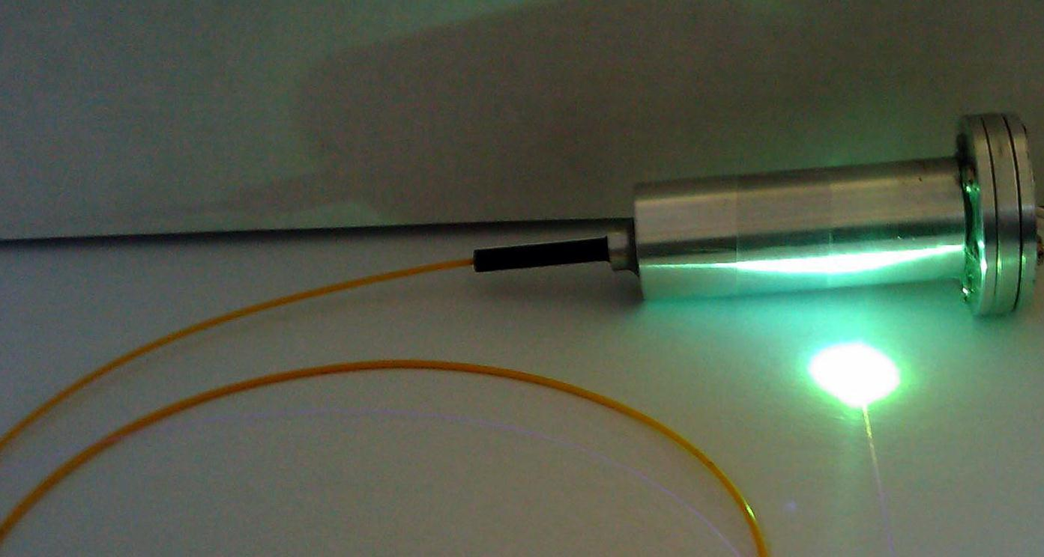
Figure 7. The figure shows the appearance of the same module, an optical fiber with a drop of luminophore mixed with transparent optical varnish, while the laser is in an oscillation state.
As shown by the results of a comprehensive analysis, the same technical system can have effective applications in many other technologies of various design options, as well as at the junction of various technologies.
5. System for on-line inspection of the state of the containment shell and systems near nuclear reactors.
Presumably, the proposed form of the invention may cost several hundred thousand dollars.
We need several hundred such devices around the world. Also, several hundred of such devices are necessary for the inspection of nuclear reactors in submarines and other facilities with a nuclear power plant.
The durability of the proposed design of the device is also determined by the durability of the laser diode.
Due to the fact that the laser diode in the proposed device has all the possible variants of increasing durability in terms of intensive cooling, modified installation module with control and regulation electronics operating in the radio frequency range, longevity in the preassembly selection of materials and special coatings, including artificial diamond films, can be assumed to be equal to 10,000 hours or more.
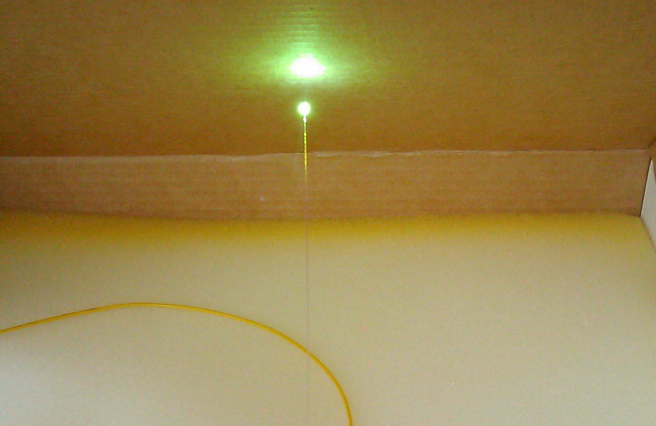
Figure 8. Light falling from the luminophore onto the screen.
6. Underwater illumination systems, in particular for bathyscaphes and divers.
Estimated cost can reach up to $100,000.
There are also options for standalone products built on the same principle.
Standalone product - light source.
The need in case of delivery in single-use version is more than 5000 pieces per month; single-use version of a product is possible at a low price, lower than the cost of a similar product manufactured and used at present.
When delivered in reusable versions, the forecasted demand is about 3,000 modules per month. There is considerable potential for the development of numerous special product applications.
A standalone product for which, at present time, the demand is at least 5,000 sets per month.
Potential of market demand - more than 1,000,000 sets per month; single-use product. The disadvantage of the product produced and sold at present is insufficient light intensity.

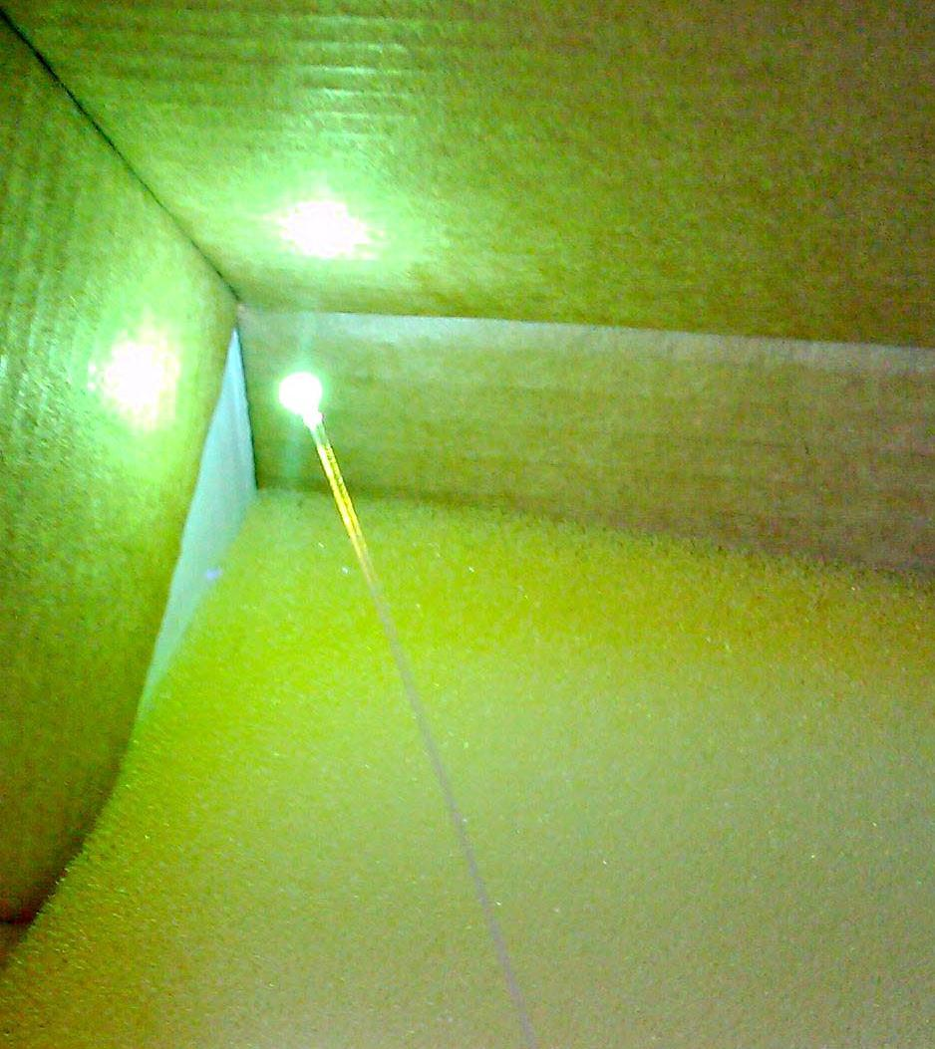
Figure 9. The direction of the light from the luminophore to the corner of the box.
The durability of the proposed version of the device has many constituent elements, but the durability of the illumination system itself is also determined by the durability of the laser diode. Due to the fact that the laser diode in the proposed device has all the possible variants of increasing durability in terms of intensive cooling, a modified installation module with control and regulation electronics operating in the radio frequency range, in the selective selection of materials and special coatings, including artificial diamond films, longevity can be assumed to be equal to 10,000 hours or more.
In case of specific interest, this system can be worked out in more detail.
7. Underwater communication between the divers, vessel, and submarines.
Green light in the coastal zone, blue in the ocean. The communication range is up to 100 m. Communication from the vessel to the bathyscaphe is up to 10,000 meters.
Here, the price of an integrated system is approximately a million dollars, especially if this system is necessary for use in war conditions or in emergency situations and technological disasters.
The durability of the proposed version of the device has many constituent elements, but the durability of the illumination system itself is also determined by the durability of the laser diode.
Due to the fact that the laser diode in the proposed device has all the possible variants of increasing durability in terms of intensive cooling, a modified installation module with control and regulation electronics operating in the radio frequency range, in the selective selection of materials and special coatings, including artificial diamond films, longevity can be assumed to be equal to 10,000 hours or more.
In case of specific interest, this system can be worked out in more detail.
Other variants:
1. The diameter of the optical fiber is - 125 microns
The outer diameter of the tube (tube material - stainless steel (12X 18P10 T type) - 0.6 mm;
The inner diameter of the tube is 0.45 mm; the length of the tube may vary, but this does not limit the product since the change in the length of the tube is compensated by the length of the optical fiber
The emitter can have a different geometric shape; Emitter material, luminophore or a mixture of luminophores mixed with optically transparent (after polymerization or immobilization) glue (as an option).
The most preferred option is mixing luminophores or their mixture with the monomer of an optically transparent and chemically resistant polymer material, such as polymethyl methacrylate, polycarbonate and others, and polymerization by non-contact heating in vacuum or using microwave technology.
The outer diameter of the emitter may not exceed 0.45 mm.

2. The diameter of the optical fiber is 125 microns
The radiant may have a different geometric shape.
Emitter material, luminophore or a mixture of luminophores mixed with optically transparent (after polymerization or immobilization) glue (as an option).
The most preferred option is mixing luminophores or their mixture with the monomer of an optically transparent and chemically resistant polymer material, such as polymethyl methacrylate, polycarbonate and others, and polymerization by non-contact heating in vacuum or using microwave technology.
To obtain complete neutrality and chemical resistance, it is assumed that the emitter and the associated part of the optical fiber are coated with a 5-micron-thick synthetic diamond film.
The outer diameter of the emitter with a diamond coat may not exceed 0.45 mm.

3. The diameter of the optical fiber is 125 microns (supposed)
The outer diameter of the tube (tube material - stainless steel (12X 18P10 T type) - 0.6 mm.
The inner diameter of the tube is 0.45 mm; the length of the tube may vary, but this does not limit the product since the change in the length of the tube is compensated by the length of the optical fiber.
The emitter can have a different geometric shape; Emitter material, luminophore or a mixture of luminophores mixed with optically transparent (after polymerization or immobilization) glue (as an option).
The most preferred option is mixing luminophores or their mixture with the monomer of an optically transparent and chemically resistant polymer material, such as polymethyl methacrylate, polycarbonate and others, and polymerization by non-contact heating in vacuum or using microwave technology.
The outer diameter of the emitter may not exceed 0.45 mm.

4. The diameter of the optical fiber is - 125 microns
The outer diameter of the tube (tube material - stainless steel (12X 18P10 T type) - 0.6 mm. The inner diameter of the tube is 0.45 mm; the length of the tube may vary, but this does not limit the product since the change in the length of the tube is compensated by the length of the optical fiber.
The emitter may have a different geometric shape.
Emitter material, luminophore or a mixture of luminophores mixed with optically transparent (after polymerization or immobilization) glue (as an option).
The most preferred option is mixing luminophores or their mixture with the monomer of an optically transparent and chemically resistant polymer material, such as polymethyl methacrylate, polycarbonate and others, and polymerization by non-contact heating in vacuum or using microwave technology.
The outer diameter of the emitter may not exceed 0.45 mm.

List of reference literature, patent, and licensed materials

Annex 1
United States Patent Application | 20190133502
Kind Code | A1
GOMI; SHINICHIRO; et al. | May 9, 2019

OPTICAL APPARATUS AND INFORMATION PROCESSING METHOD
Abstract
The present technology relates to an optical apparatus and an information processing method capable of more easily obtaining an indicator value. In the optical apparatus according to the present technology, irradiation light including a predetermined irradiation wavelength band is emitted, first reflected light being a reflected light in a first wavelength band obtained by reflection of the emitted irradiation light on a predetermined object and second reflected light being reflected light in a second wavelength band obtained by reflection of the irradiation light on the object are received at a plurality of pixels; and a value of a predetermined indicator relating to a region in a predetermined range of the object is obtained on the basis of a received light amount of each of the received first reflected light and the received second reflected light. For example, the present technology can be applied to optical apparatuses, electronic apparatuses, imaging apparatuses, and information processing apparatuses.

Annex 2
United States Patent Application | 20190150247
Kind Code | A1
Eisele; Eric Jon | May 16, 2019

SYSTEM AND METHOD FOR ADVANCED HORTICULTURAL LIGHTING
Abstract
Embodiments can provide a system and method of light validation in a lighting device, comprising communicating setpoint to a lighting device comprising a plurality of emitters; generating control signals for the plurality of emitters in response to the setpoint; calculating an estimate of the intensity and spectral power distribution of the composite radiant flux emitted by the lighting device through computing the control signals relative to lifetime performance data and a reference dataset. Embodiments can further provide a system and method for quality control and reporting, comprising transmitting, via a lighting device, validation signals comprising operating conditions, initial measurements, lifetime operating data, reference datasets, and spectrum and intensity estimates, and a device identifier to a central controller; receiving, via the central controller, one or more condition measurements comprising light measurements, temperature measurements, humidity measurements, moisture measurements, and nutrient chemistry measurements, and device identifiers from one or more light sensing devices and growth condition sensors.

Annex 3
United States Patent Application | 20190109973
Kind Code | A1
Riza; Nabeel Agha | April 11, 2019

SMART PHOTONIC IMAGING METHOD AND APPARATUS
Abstract
The present invention provides a method for performing high dynamic range optical image detection of a scene comprising: imaging incident light from a scene onto an object plane; determining the locations of those pixels in the object plane of higher brightness; detecting the optical irradiance values of those pixels of higher brightness to produce a first detected image; detecting the optical irradiance values of those pixels of lower brightness to produce a second detected image; and generating a high dynamic range optical irradiance map of the scene by combining the first detected image and the second detected image into a single image.

Annex 4
United States Patent Application | 20190121141
Kind Code | A1
Dykaar; Douglas R. | April 25, 2019

FREE SPACE MULTIPLE LASER DIODE MODULE WITH FAST AXIS COLLIMATOR
Abstract
Systems, devices, and methods for optical engines and laser projectors that are well-suited for use in wearable heads-up displays (WHUDs) are described. Generally, the optical engines of the present disclosure integrate a plurality of laser diodes (e.g., 3 laser diodes, 4 laser diodes) within a single, hermetically or partially hermetically sealed, encapsulated package. The optical engines include an optical director element that includes a curved reflective surface (e.g., parabolic cylinder) that redirects laser light beams and collimates the same along the fast axes thereof. Such optical engines may have various advantages over existing designs including, for example, smaller volumes, better manufacturability, faster modulation speed, etc. WHUDs that employ such optical engines and laser projectors are also described.

Annex 5
United States Patent Application | 20190125191
Kind Code | A1
Siedenburg; Clinton T. | May 2, 2019

LIGHT-BASED NON-INVASIVE BLOOD PRESSURE SYSTEMS AND METHODS
Abstract
Light-based non-invasive blood pressure measurement systems and methods that include a sensor having a light emitter and a light detector are disclosed. The light emitter emitting coherent or non-coherent light that is transmitted into and reflected from the tissues of the patient, including reflecting from moving blood. The light reflected from the moving blood being having a Doppler shift and detected by the light detector to generate a non-invasive blood pressure signal. The non-invasive blood pressure signal is processed to determine the instantaneous velocity of the blood. Additionally, pulse wave velocity data is obtained nearly, or substantially, simultaneously with the acquisition of the non-invasive blood pressure signal. Using the pulse wave velocity, the instantaneous velocity of the blood and a density of the blood, an instantaneous blood pressure can be determined.

Annex 6
United States Patent Application | 20190133424
Kind Code | A1
Patel; Neal; et al. | May 9, 2019

ENCASEMENT PLATFORM FOR SMARTDEVICE FOR ATTACHMENT TO ENDOSCOPE
Abstract
A case or encasement for use with a smart - device, such as a smartphone or tablet and an endoscope is disclosed. The encasement includes a power supply, logic for controlling wireless communications, a light source, and other accessories, for use with an endoscope. In an embodiment, the encasement includes a power supply that may be used to charge a smart - device, power a light source and a wireless communications module. Other embodiments include a mechanism for communicating between the smart - device and the encasement to control the light source and any other accessories coupled to the encasement.

Annex 7
United States Patent Application | 20190131491
Kind Code | A1
LEE; Duhyun; et al. | May 2, 2019

LIGHT EMISSION DEVICE INCLUDING OUTPUT COUPLER AND OPTICAL APPARATUS ADOPTING THE SAME

Abstract
Provided are light emission devices including an output coupler and optical apparatuses having the same. The light emission device may include a QD layer containing quantum dots and a nano-antenna structure including an output coupler configured to control an output characteristic of light emitted from the QD layer. The output coupler may be configured to output an emission wavelength of the QD layer. The nano-antenna structure may include one of a metallic antenna, a dielectric antenna, and a slit-containing structure, or may have a multi-patch antenna structure or a fishbone antenna structure.

Annex 8
United States Patent Application | 20190117993
Kind Code | A1
Lundmark; David C.; et al. | April 25, 2019

SYSTEM AND METHOD FOR OPTOGENETIC THERAPY
Abstract
Configurations are described for utilizing light-activated proteins within cell membranes and subcellular regions to assist with medical treatment paradigms, such as hypertension treatment via anatomically specific and temporally precise modulation of renal plexus activity. The invention provides for proteins, nucleic acids, vectors and methods for genetically targeted expression of light-sensitive proteins to specific cells or defined cell populations. In particular the invention provides systems, devices, and methods for millisecond-timescale temporal control of certain cell activities using moderate light intensities, such as the generation or inhibition of electrical spikes in nerve cells and other excitable cells.

Annex 9
United States Patent Application | 20190145585
Kind Code | A1
VAN DE VEN; Antony Paul; et al. | May 16, 2019

LIGHTING DEVICES THAT COMPRISE ONE OR MORE SOLID STATE LIGHT EMITTERS
Abstract
Light engine modules comprise a support member and a solid state light emitter, in which (1) the emitter is mounted on the support member, (2) a region of the support member has a surface with a curved cross-section, (3) the emitter and a compensation circuit are mounted on the support member, (4) an electrical contact element extends to at least two surfaces of the support member, and/or (5) a substantial entirety of the module is located on one side of a plane and the emitter emits light into another side of the plane. Also, a module comprising means for supporting a light emitter and a light emitter. Also, a lighting device comprising a housing member and a light emitter mounted on a removable support member. Also, a lighting device comprising a module mounted in a lighting device element. Also, a method comprising mounting a module to a lighting device element.

Annex 10
United States Patent Application | 20190109260
Kind Code | A1
Khatibzadeh; Mohammad Ali; et al. | April 11, 2019

ULTRA-WIDEBAND LIGHT EMITTING DIODE AND OPTICAL DETECTOR COMPRISING ALUMINUM GALLIUM ANTIMONIDE AND METHOD OF FABRICATING THE SAME
Abstract
Devices, systems, and methods for providing wireless personal area networks (PANs) and local area networks (LANs) using visible and near-visible optical spectrum. Various constructions and material selections are provided herein. According to one embodiment, a light-emitting diode (LED) includes a substrate, a carrier confinement (CC) region positioned over the substrate, an active region positioned over the CC region, and an electron blocking layer (EBL) positioned over the active region. The CC region includes a first CC layer comprising aluminum gallium antimonide and a second CC layer position over the first CC layer. The second CC layer and the electron blocking layer (EBL) also each include aluminum gallium antimonide. The active region is configured to have a transient response time of less than 500 picoseconds (ps).

Annex 11
United States Patent Application | 20190145891
Kind Code | A1
Waxman; Allen M.; et al. | May 16, 2019

SYSTEMS AND METHODS FOR MULTISPECTRAL IMAGING AND GAS DETECTION USING A SCANNING ILLUMINATOR AND OPTICAL SENSOR
Abstract
Presented herein are systems and methods directed to a multispectral absorption-based imaging approach that provides for rapid and accurate detection, localization, and quantification of gas leaks. The imaging technology described herein utilizes a scanning optical sensor in combination with structured and scannable illumination to detect and image spectral signatures produced by absorption of light by leaking gas in a quantitative manner over wide areas, at distance, and in the presence of background such as ambient gas and vapor. Moreover, the specifically structured and scannable illumination source of the systems and methods described herein provides a consistent source of illumination for the scanning optical sensor, allowing imaging to be performed even in the absence of sufficient natural light, such as sunlight. The imaging approaches described herein can, accordingly, be used for a variety of gas leak detection, emissions monitoring, and safety applications.

Annex 12
United States Patent Application | 20190128808
Kind Code | A1
ASHRAFI; SOLYMAN | May 2, 2019

SYSTEM AND METHOD FOR MULTI-PARAMETER SPECTROSCOPY

Abstract
An apparatus for detecting a material within a sample includes a light emitting unit for directing at least one light beam through the sample. A plurality of units receive the light beam that has passed through the sample and performs a spectroscopic analysis of the sample based on the received light beam. Each of the plurality of units analyze a different parameter with respect to the sample and provide a separate output signal with respect to the analysis. A processor detects the material with respect each of the provided separate output signals.

Annex 13
United States Patent Application | 20190129206
Kind Code | A1
LEE; Duhyun; et al. | May 2, 2019

OPTICAL MODULATING DEVICE AND APPARATUS INCLUDING THE SAME
Abstract
An optical modulating device may include a plurality of quantum dot (QD)-containing layers having QDs and a plurality of refractive index change layers. The QD-containing layers may be disposed between the refractive index change layers, respectively. The optical modulating device may be configured to modulate light-emission characteristics of the plurality of QD-containing layers. At least two of the QD-containing layers may have different central emission wavelengths. At least two of the plurality of refractive index change layers may include different materials or have different carrier densities.

