Maksim Strelchenko
Components of the wastewater treatment system

CONTENT

FIELD AND BACKGROUND OF THE INVENTION 3
SUMMARY OF THE INVENTION 5
BRIEF DESCRIPTION OF THE DRAWNGS 14
DESCRIPTION OF THE PREFERRED EMBODIMENTS 32
CLAIMS 47
REFERENCES, PATENT AND LICENSE INFORMATION 57

FIELD AND BACKGROUND OF THE INVENTION
The present invention relates to a wastewater treatment system and, in particular, it concerns a wastewater treatment system using laminar flow through an electric field.
By way of introduction, electrolysis of wastewater is performed as part of a water treatment process to remove metals and remove and/or neutralize organic and other impurities from a wastewater. Electrolysis is a preferred method to remove metals from wastewater, as it does not require the use of hazardous chemicals, unstable bacteria treatment or expensive treatment by catalysts. The electrolysis process normally involves passing the wastewater between at least one pair of electrodes to produce hydroxyl ions that precipitate metal ions from the wastewater as metal hydroxides. The wastewater stream is then filtered to remove the metal ions and other impurities. However, for the electrolysis process to be successful, the electrodes need to pass sufficient energy to the water.
According to the prior art, if wastewater is to be activated electrolytically, the wastewater should be made to flow turbulently past electrodes. Representative prior art patents include U.S. Patent No. 5,928,493 and U.S. Patent No. 6,294,061, both to Morkovsky et al., and U.S. Patent No. 6,346,197, to Stephenson et al. These patents teach electrocoagulation initiated by having the wastewater flow in a serpentine path around interleaved electrode plates. Representative prior art patents also include U.S. Patent No. 6,328,875, to Zappi et al., who teach electropurification in electrolytic cells in which the wastewater flows through and around the electrodes.
Also of relevance to the present invention is U.S. Patent No. 6,358,39to Schorzman et al. Schorzman et al. teach the conditioning of drinking water by reverse osmosis, followed by electrolysis. The electrolysis is performed in a vertical electrolytic cell in which electrode plates are mounted vertically. After the water leaves the area between the electrode plates, the water enters a dissolving chamber, which is directly above the electrode plates. The dissolving chamber contains water in a quiet zone, undergoing preferably laminar flow. Within this quiet zone, additional room is provided for the oxygen gas to dissolve into the water. First, Schorzman et al. uses the electrolysis to condition the water and not to purify the water.
Second, Schorzman et al. does not teach laminar water between the electrodes, rather Schorzman et al. teaches laminar flow after the water has left the electrodes.
Also of relevance to the present invention is U.S. Patent No. 6.139.714 to Livshits, which teaches an apparatus for adjusting the pH of an aqueous flowable fluid. The apparatus includes two columns which are interconnected. One column which contains a pair of electrodes has a smaller volume than the other column. Therefore, the addition of water to the column without the electrodes causes an acceleration of the water between the electrodes in the other column. There is also a membrane between the electrodes. U.S. Patent No. 6,139,714 does not refer to whether the water flow is laminar or turbulent. However, it is evident from the square edges of the design of the columns (Fig. 3 and Fig. 4) that maintaining laminar flow was not considered important, as the square edges of the columns will generally set up turbulence within the water.
A shortcoming of the aforementioned systems is due to water flowing turbulently through an electric field to purify water. First, if the water is flowing turbulently, air pockets form in the water, causing parts of the water to remain untreated or subject to different levels of treatment. Second, air pockets create electrical resistance and reduce the effect of the transfer of electrical energy by the electrodes to the water. It should be noted that the success of electrolysis in purifying water depends on the electrical energy transfer to the water during the process. Third, if the water is flowing turbulently, different portions of the water will travel through the electric field at different speeds resulting in different levels of treatment to different portions of the water.
There is therefore a need for a wastewater treatment system which employs laminar flow of wastewater through an electric field while giving a high throughput of wastewater treatment.

SUMMARY OF THE INVENTION
The present invention is a wastewater treatment system and method of operation thereof.
According to the teachings of the present invention there is provided, a treatment system for wastewater, comprising: (a) a first chamber; (b) a second chamber having a pair of electrodes configured to produce a first electric field; and (c) a conduit configured to connect the first chamber to the second chamber, wherein at least one of the first chamber, the second chamber and the conduit are formed such that a flow of the wastewater through the first electric field is substantially laminar.
According to a further feature of the present invention, there is also provided: (d) a semi-permeable membrane which is disposed between the pair of electrodes.
According to a further feature of the present invention, the semi-permeable membrane substantially separates at least a part of the wastewater which is in the second chamber into a first flow and a second flow; and wherein the second chamber includes a first outlet and a second outlet such that the first flow exits from the second chamber via the first outlet and the second flow exits from the second chamber via the second outlet.
According to a further feature of the present invention. the wastewater is configured to flow first substantially parallel and then substantially perpendicular to the first electric field.
According to a further feature of the present invention, the wastewater is configured to flow first substantially perpendicular and then substantially parallel to the first electric field.
According to a further feature of the present invention, at least one of the pair of electrodes is configured so that upon at least one of entering and exiting the second chamber, the wastewater flows substantially parallel to the first electric field.
According to a further feature of the present invention, at least one of the pair of electrodes has two major surfaces and a hole extending between the two major surfaces so that upon at least one of entering and exiting the second chamber, at least part of the wastewater flows through the hole.
According to a further feature of the present invention, there is also included: (d) an edge protector having a length perpendicular to the major surfaces; the length being longer than a depth of the one electrode measured perpendicular to the major surfaces, the edge protector being configured to enhance an energy transfer between the one electrode and the wastewater which is flowing through the hole.
According to a further feature of the present invention, at least one of the first chamber, the second chamber and the conduit are formed such that separate flows of the wastewater through the first electric field are treated substantially identically.
According to a further feature of the present invention, there is also included: (d) a third chamber; and (e) a second conduit configured to connect the third chamber to the second chamber, wherein at least one of the first chamber, the second chamber, the third chamber, the conduit and the second conduit are formed such that a flow of the wastewater through the first electric field is substantially laminar and separate electric field are treated substantially identically. According to a further feature of the present invention, there is also included: (f) a fourth chamber having a second pair of electrodes configured to produce a second electric field; wherein the system is configured such that the wastewater is treated substantially identically by the first electric field and the second electric field.
According to a further feature of the present invention, there is also included a filtration apparatus which includes: (a) a plurality of filtration elements configured to cooperate to filter the wastewater of an impurity; and (b) an air pump configured to clean the filtration elements of at least a part of the impurity during a normal operation of the filtration apparatus.
According to a further feature of the present invention, each of the filtration elements includes a member having a plurality of grooves thereon.
According to a further feature of the present invention, there is also included a precious metal recovery apparatus which includes: (a) a first electrode formed from a material having a high surface area to volume ratio; and (b) a second electrode, the first electrode and the second electrode being configured for connection to a power supply to enable recovery of the precious metal from the wastewater by electroplating of the first electrode with at least part of the precious metal.
According to a further feature of the present invention, the material is an absorbent conducting material.
According to a further feature of the present invention, the material is a carbographite material.
According to a further feature of the present invention, there is also included a semipermeable envelope for filtering an impurity from the wastewater, the envelope including: (a) an inlet configured to allow the wastewater to enter the envelope; and (b) a plurality of holes configured to: (i) allow exit of the wastewater from the envelope; (ii) trap at least part of the impurity inside the envelope; wherein the envelope is configured to stretch to maintain a substantially constant filtering throughput of the envelope when the at least part of the impurity adheres near the holes.
According to a further feature of the present invention, the envelope is substantially formed of a knitted fabric.
According to a further feature of the present invention, the laftted fabric includes a polyamide thread.
According to a further feature of the present invention, there is also included a wastewater sedimentation apparatus which includes: (a) a plurality of deflecting elements configured to cooperate to enhance sedimentation of impurities from the wastewater: and (b) a distribution member configured to distribute the wastewater among the deflecting elements.
According to a further feature of the present invention, each of the deflecting elements is shaped substantially as a truncated cone.
According to a further feature of the present invention, the truncated cone has at least one projection.
According to a further feature of the present invention, the projection is substantially radial.
According to a further feature of the present invention, the distribution member is a perforated pipe.
According to a further feature of the present invention, the deflecting elements and the distribution member are co-axially arranged.
According to a further feature of the present invention, there is also provided a plurality of spacer members, each of the spacer members being disposed between the distribution member and two of the deflecting elements, the spacer members configured to maintain a laminar flow of the wastewater in order to enhance sedimentation of impurities from the wastewater.
According to a further feature of the present invention, there is also included a filtration apparatus to filter an impurity from the wastewater, the filtration apparatus including: (a) a first surface having a plurality of ridges and grooves; and (b) a second surface having a plurality of ridges and grooves wherein the first surface is disposed facing the second surface such that, the grooves of the first surface are nonparallel to the grooves of the second surface in order to cause at least part of the wastewater to take a non-linear path between the first surface and the second surface thereby filtering at least part of the impurity.
According to a further feature of the present invention, the grooves of the first surface are substantially cross-aligned with the grooves of the second surface.
According to a further feature of the present invention, there is also included a filtration apparatus for filtering an impurity from wastewater, the filtration apparatus including: (a) a granular catalyst configured to remove at least part of the impurity from the wastewater; and (b) a semi-permeable envelope having a plurality of holes, the envelope being configured to contain the granular catalyst, the plurality of holes being configured to allow exit of the waste water from the envelope, wherein the envelope is configured to stretch to maintain a substantially constant filtering throughput of the envelope when at least part of the impurity adheres near the holes.
According to a further feature of the present invention, the envelope has an upper surface, the filtration apparatus further including: (c) a tank configured to hold the envelope; and (d) a water disperser configured to distribute the wastewater entering the tank over the upper surface of the envelope in order to maximize contact of the wastewater with the granular catalyst.
According to a further feature of the present invention, the water disperser includes an element having a plurality of holes therein, wherethrough the wastewater flows.
According to a further feature of the present invention, the filtration apparatus further includes: (c) a tank configured to hold the envelope, the tank having an outlet configured to allow a drainage of the wastewater from the tank; and (d) a water integrator configured to prevent the envelope from obstructing the drainage of the wastewater via the outlet.
According to a further feature of the present invention, the water integrator is an element having a plurality of holes therein, wherethrough the wastewater flows.
According to a further feature of the present invention, the envelope is substantially formed of a knitted fabric.
According to a further feature of the present invention, the knitted fabric includes a polyamide thread.
According to a further feature of the present invention, there is also included an apparatus for aerating the wastewater, the apparatus including: (a) a pipe configured for connection to a fluid supply; and (b) a discharge head operationally connected to the pipe, the discharge head including at least one channel having a cross-sectional area, at least part of the channel being configured for insertion into the wastewater, the cross-sectional area being small enough that when a flow of a fluid from the fluid supply is activated, a low pressure region is set up in the wastewater, thereby producing a plurality of micro-bubbles which aerate the wastewater. According to a further feature of the present invention, the fluid is air.
According to a further feature of the present invention, the fluid is recycled water.
According to a further feature of the present invention, there is also included an apparatus for aerating wastewater, the apparatus including: (a) a first pipe configured to introduce the wastewater to the apparatus; (b) a second pipe configured for connection to a fluid supply; and (c) a discharge head having at least one channel, the channel being configured to operationally connect the second pipe to the first pipe, the channel having a cross-sectional area that is small enough that when a flow of a fluid from the fluid supply is activated, a low pressure region is set up in the first pipe that: (i) produces a plurality of microbubbles which aerate the wastewater; and (ii) quickens a flow of the wastewater into the apparatus.
According to a further feature of the present invention, the second pipe is at least partially disposed within the first pipe.
According to a further feature of the present invention, the discharge head has a conical surface having an apex that points opposite to a direction of flow of the wastewater in the first pipe.
According to the teachings of the present invention there is also provided a filtration apparatus, comprising: (a) a plurality of filtration elements configured to cooperate to filter wastewater of an impurity; and (b) an air pump configured to clean the filtration elements of at least a part of the impurity during a normal operation of the filtration apparatus.
According to a further feature of the present invention, each of the filtration elements includes a member having a plurality of grooves thereon.
According to the teachings of the present invention there is also provided a precious metal recovery system, comprising: (a) a first electrode formed from a material having a high surface area to volume ratio; and (b) a second electrode, the first electrode and the second electrode being configured for connection to a power supply to enable recovery of the precious metal from wastewater by electroplating of the first electrode with at least part of the precious metal.
According to a further feature of the present invention, the material is an absorbent conducting material.
According to a further feature of the present invention, the material is a carbographite material.
According to the teachings of the present invention there is also provided a semipermeable envelope for filtering an impurity from wastewater, comprising: (a) an inlet configured to allow the wastewater to enter the envelope; and (b) a plurality of holes configured to: (i) allow exit of the wastewater from the envelope; and (ii) trap at least part of the impurity inside the envelope; wherein the envelope is configured to stretch to maintain a substantially constant filtering throughput of the envelope when the at least part of the impurity adheres near the holes.
According to a further feature of the present invention, the envelope is substantially formed of a knitted fabric.
According to a further feature of the present invention, the knitted fabric includes a polyamide thread. According 'to the teachings of the present invention there is also provided a wastewater sedimentation apparatus, comprising: (a) a plurality of deflecting elements configured to cooperate to enhance sedimentation of impurities from the wastewater; the deflecting elements being shaped substantially as a truncated cone; the truncated cone having at least one projection; and (b) a distribution member configured to distribute the wastewater among the deflecting elements; the distribution member being a perforated pipe, wherein the deflecting elements and the distribution member are co-axially arranged.
According to a further feature of the present invention, the projection is substantially radial.
According to a further feature of the present invention, there is also included a plurality of spacer members, each of the spacer members being disposed between the distribution member and two of the deflecting elements, the spacer members configured to maintain a laminar flow of the wastewater in order to enhance sedimentation of impurities from the wastewater.
According to the teachings of the present invention there is also provided a filtration apparatus to filter an impurity from wastewater, comprising: (a) a first surface having a plurality of ridges and grooves; and (b) a second surface having a plurality of ridges and grooves wherein the first surface is disposed facing the second surface such that, the grooves of the first surface are nonparallel to the grooves of the second surface in order to cause at least part of the wastewater to take a non-linear path between the first surface and the second surface thereby filtering at least part of the impurity.
According to a further feature of the present invention, the grooves of the first surface are substantially cross-aligned with the grooves of the second surface.
According to the teachings of the present invention there is also provided a filtration apparatus for filtering an impurity from wastewater, comprising:
(a) a granular catalyst configured to remove at least part of the impurity from the wastewater; (b) a semipermeable envelope having a plurality of holes, the envelope being configured to contain the granular catalyst, the plurality of holes being configured to allow exit of the wastewater from the envelope, wherein the envelope is configured to stretch to maintain a substantially constant filtering throughput of the envelope when at least part of the impurity adheres near the holes.
According to a further feature of the present invention, the envelope has an upper surface, the apparatus further comprising: (c) a tank configured to hold the envelope; and (d) a water disperser configured to distribute the wastewater entering the tank over the upper surface of the envelope in order to maximize contact of the wastewater with the granular catalyst.
According to a further feature of the present invention, the water disperser includes an element having a plurality of holes therein, wherethrough the wastewater flows.
According to a further feature of the present invention, there is also included: (e) a tank configured to hold the envelope, the tank having an outlet configured to allow a drainage of the wastewater from the tank; and (f) a water integrator configured to prevent the envelope from obstructing the drainage of the wastewater via the outlet.
According to a further feature of the present invention, the water integrator is an element having a plurality of holes therein, wherethrough the wastewater flows.
According to a further feature of the present invention, the envelope is substantially formed of a knitted fabric.
According to a further feature of the present invention, the knitted fabric includes a polyamide thread.
According to the teachings of the present invention there is also provided an apparatus for aerating wastewater, comprising: (a) a pipe configured for connection to a fluid supply; and (b) a discharge head operationally connected to the pipe, the discharge head including at least one channel having a cross-sectional area, at least part of the channel being configured for insertion into the wastewater, the cross-sectional area being small enough that when a flow of a fluid from the fluid supply is activated, a low pressure region is set up in the wastewater, thereby producing a plurality of micro-bubbles which aerate the wastewater.
According to a further feature of the present invention, the fluid is air.
According to a further feature of the present invention, the fluid is recycled water.
According to the teachings of the present invention there is also provided an apparatus for aerating wastewater, comprising: (a) a first pipe configured to introduce the wastewater to the apparatus; (b) a second pipe configured for connection to a fluid supply; and (c) a discharge head having at least one channel, the channel being configured to operationally connect the second pipe to the first pipe, the channel having a cross-sectional area that is small enough that when a flow of a fluid from the fluid supply is activated, a low pressure region is set up in the first pipe that: (i) produces a plurality of micro-bubbles which aerate the wastewater; and (ii) quickens a flow of the wastewater into the apparatus.
According to a further feature of the present invention, the second pipe is at least partially disposed within the first pipe.
According to a further feature of the present invention, the discharge head has a conical surface having an apex that points opposite to a direction of flow of the wastewater in the first pipe.
According to the teachings of •the present invention there is also provided a method for treating wastewater, comprising the steps of: (a) providing an electric field; and (b) causing a substantially laminar flow of the wastewater through the electric field in order to precipitate a plurality of metal ions from the wastewater.
According to a further feature of the present invention, there is also included the step of: (c) ensuring that separate flows of the wastewater through the electric field are treated substantially identically.
According to a further feature of the present invention, there is also included the step of: (c) performing at least one operation selected from the group consisting of filtering of the wastewater and causing sedimentation from the wastewater.
According to a further feature of the present invention, there is also included the step of: (c) substantially separating at least part of the wastewater prior to leaving the electric field into a first flow which includes the metal ions and a second flow.
According to a further feature of the present invention, the step of causing the laminar flow of the wastewater includes causing the substantially laminar flow of the wastewater first substantially parallel and then substantially perpendicular to the electric field.
According to a further feature of the present invention, the step of causing the laminar flow of the wastewater includes causing the substantially laminar flow of the wastewater first substantially perpendicular and then substantially parallel to the electric field.
According to the teachings of the present invention there is also provided a method to filter an impurity from wastewater, comprising the steps of: (a) filtering the wastewater of an impurity using a filter; and (b) cleaning at least part of the filter of the impurity using air pressure.
According to the teachings of the present invention there is also provided a method to recover a precious metal from wastewater, comprising the steps of: (a) electroplating an electrode with at least part of the precious metal; and (b) destroying the electrode in a manner that leaves behind the precious metal that is electroplated thereon.
According to a further feature of the present invention, there is also provided the step of: (c) forming the electrode from a material having a high surface area to volume ratio.
According to a further feature of the present invention, the material is an absorbent conducting material.
According to a further feature of the present invention, the material is a carbographite material.
According to the teachings of the present invention there is also provided a method to aerate wastewater comprising the steps of: (a) providing a fluid; and (b) injecting the fluid into the wastewater such that a low-pressure region is set up.in the wastewater producing a plurality of micro-bubbles which aerate the wastewater.
According to the teachings of the present invention there is also provided a method for treating wastewater, comprising the steps of: (a) providing an electric field; (b) causing a flow of the wastewater through the electric field in order to precipitate metal ions from the wastewater; (c) substantially separating at least part of the wastewater prior to leaving the electric field into a first flow which includes the metal ions and a second flow; and (d) subsequent to the step of separating, performing at least one operation, selected from a group consisting of filtering of the wastewater and causing a sedimentation from the wastewater, the operation being performed separately and selected from the group separately, for the first flow and the second flow.
According to a further feature of the present invention, there is also included the step of: (e) only passing the wastewater of the first flow through a catalyst.

BRIEF DESCRIPTION OF THE DRAWNGS
The invention is herein described, by way of example only, with reference to the accompanying drawings, wherein:

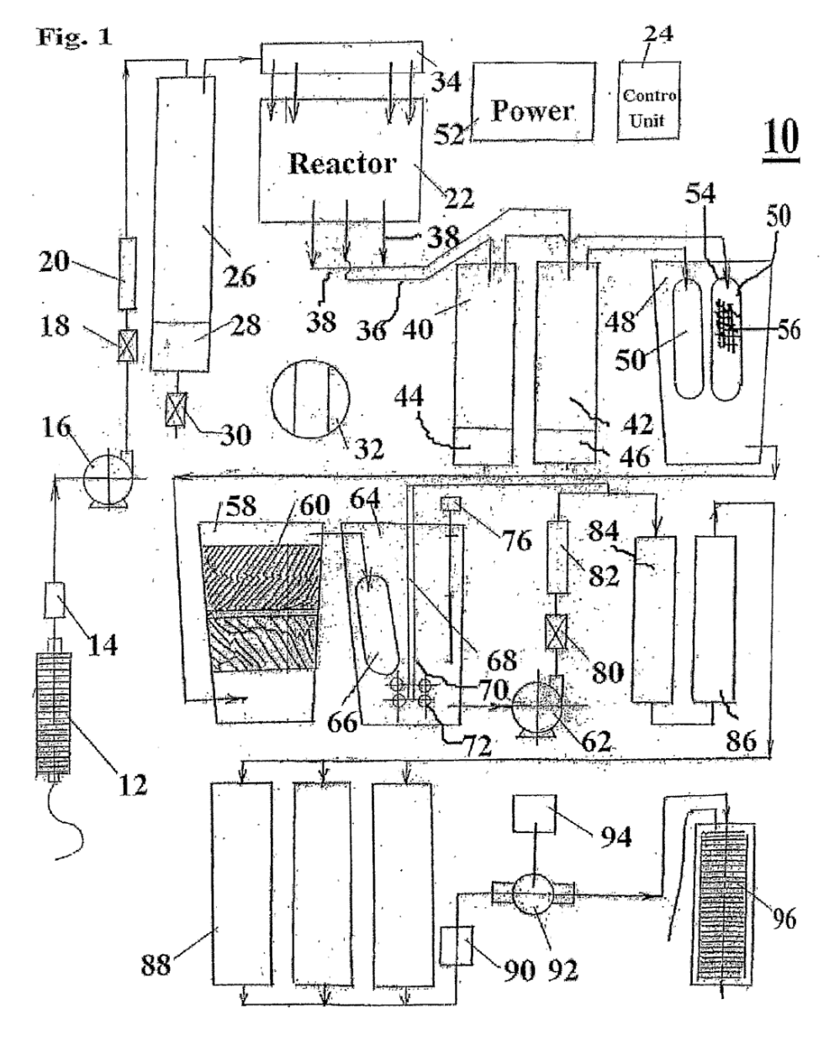
Fig. 1. A schematic diagram of a wastewater treatment system that is constructed and operable in accordance with a preferred embodiment of the present invention

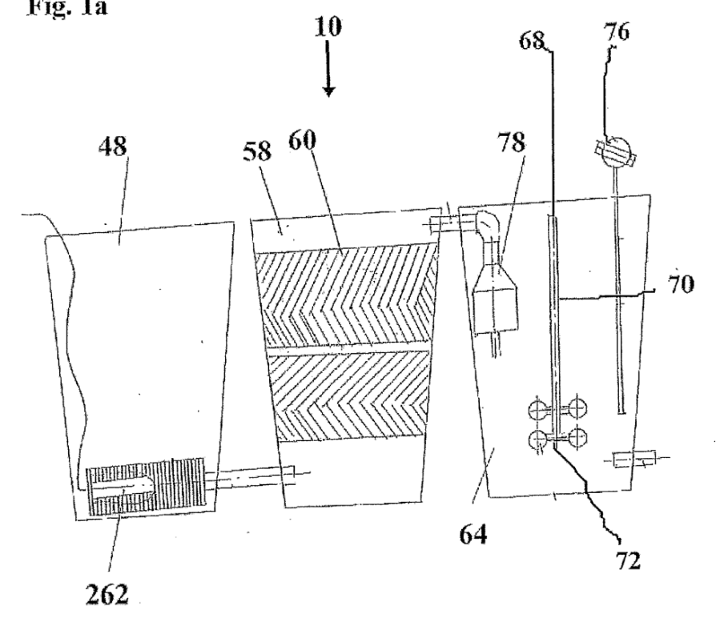
Fig. 1a. A schematic diagram of a section of the wastewater system of Fig. 1 that is constructed and operable in accordance with an alternate embodiment of the present invention;

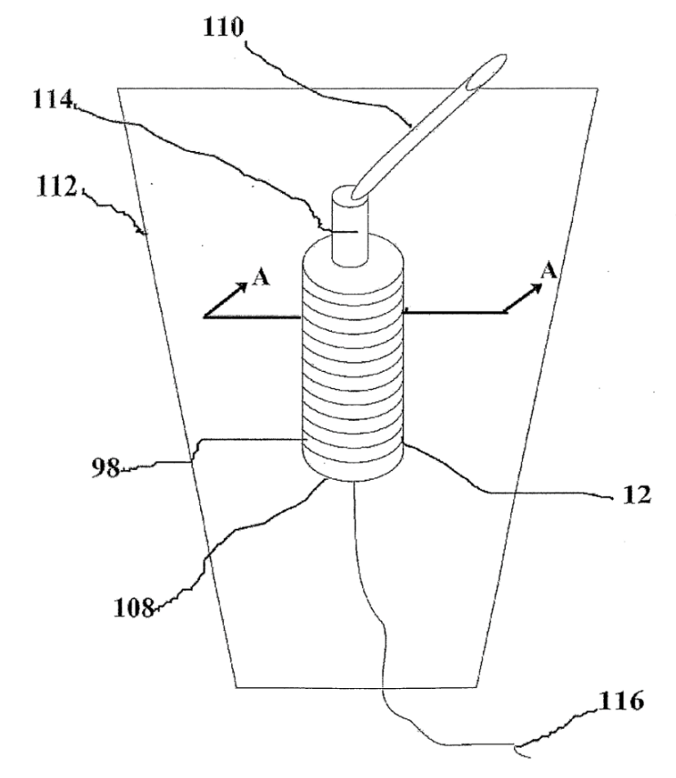
Fig. 2. An isometric view of a filtration apparatus for use with the wastewater treatment system of Fig. 1;
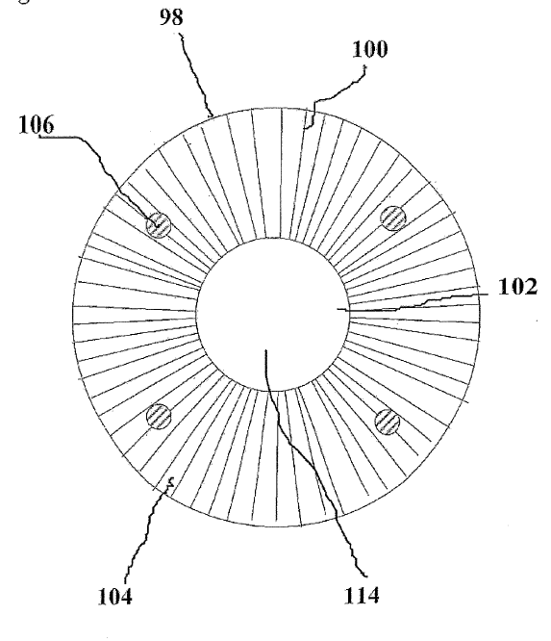
Fig. 3. A top view of a filtration element of the filtration apparatus of Fig. 2;
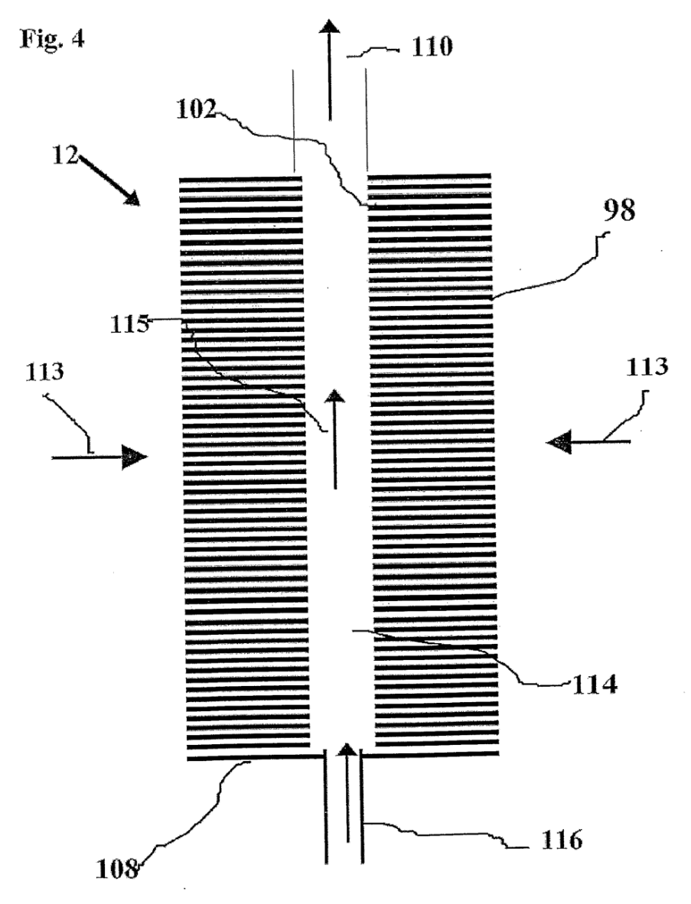
Fig. 4. An axial-sectional view of the filtration apparatus of Fig. 2 along line A-A;

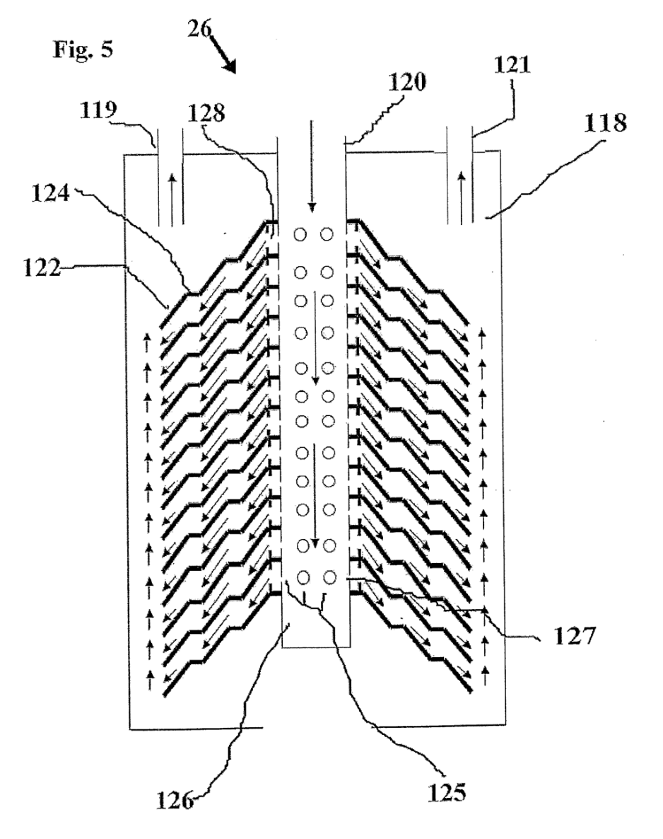
Fig. 5. An axial-sectional view of a wastewater sedimentation apparatus for use with the wastewater treatment system of Fig. 1;

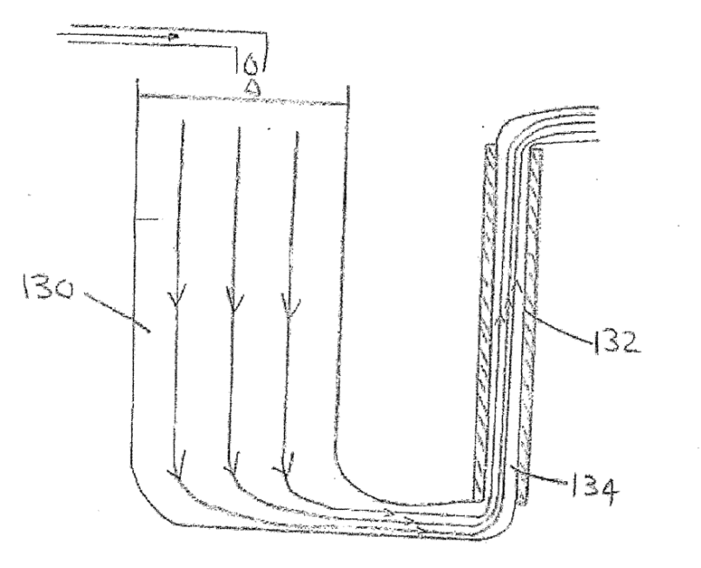
Fig. 6. A schematic illustration of laminar flow through an electric field for use with a wastewater treatment system that is constructed and operable in accordance with a preferred embodiment of the present invention;

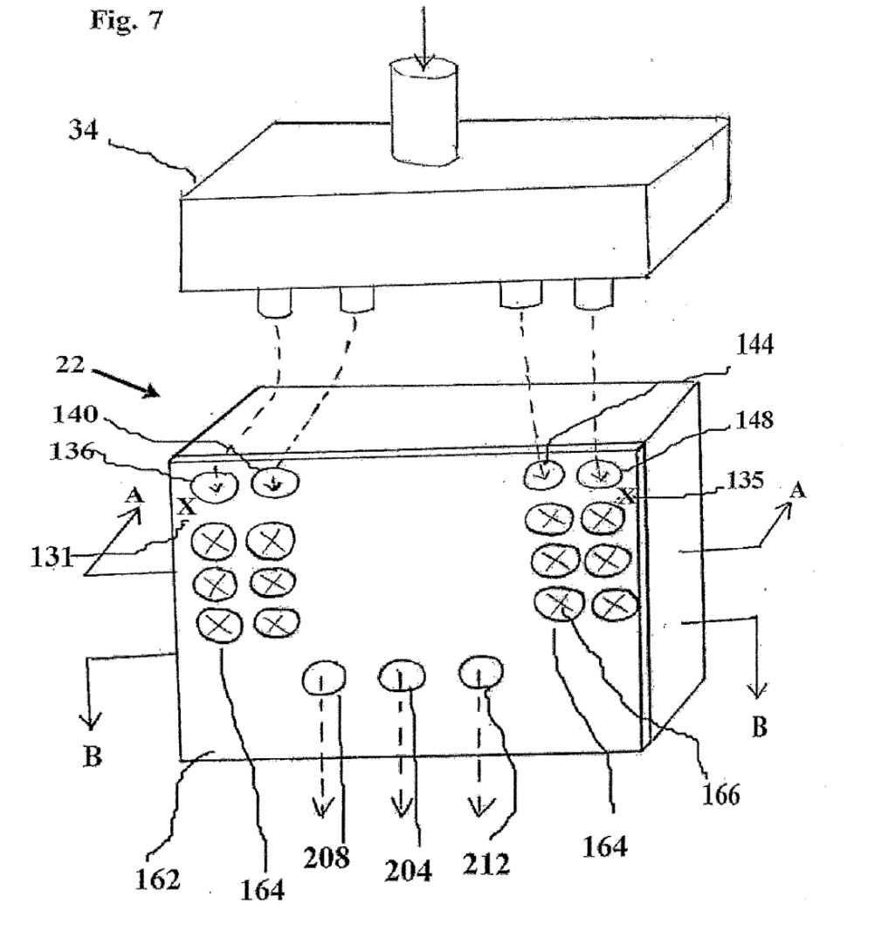
Fig. 7. An isometric view of an electrolytic reactor for use with the wastewater treatment system of Fig. 1;

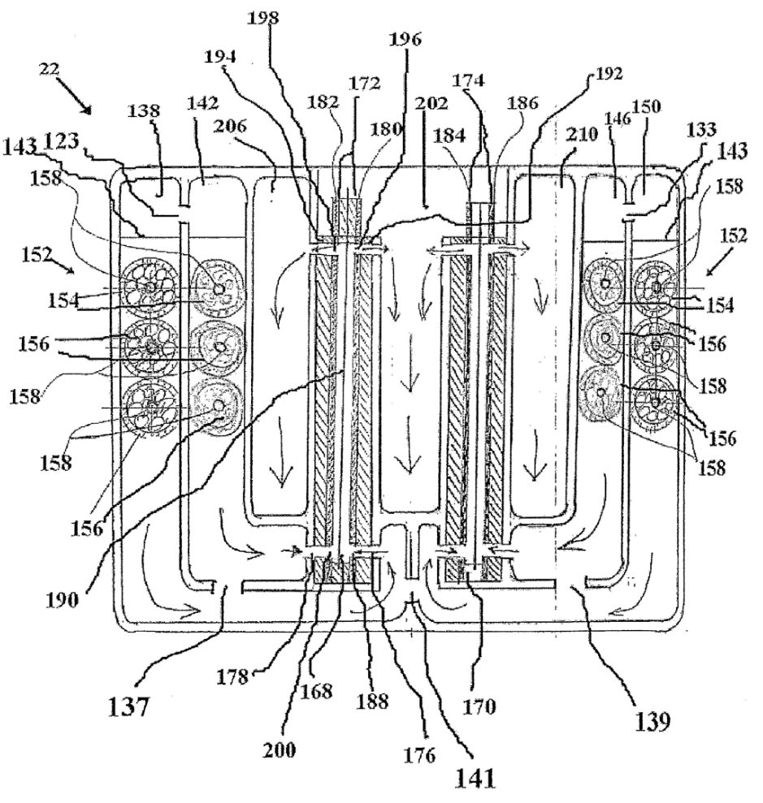
Fig. 8. A cross-sectional view of the electrolytic reactor of Fig. 7 along line A-A;

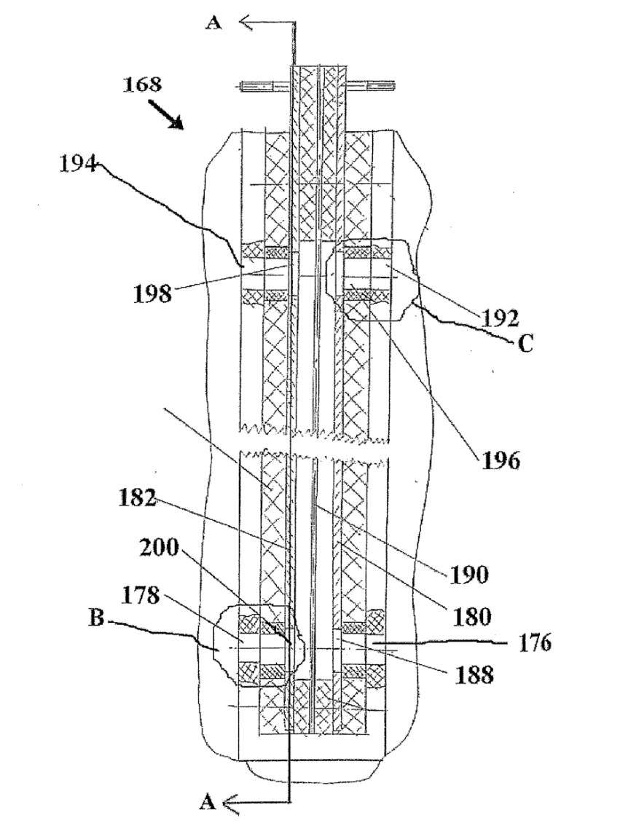
Fig. 9. An expanded cross-sectional view of an electrolytic cell of the electrolytic reactor of Fig. 8;

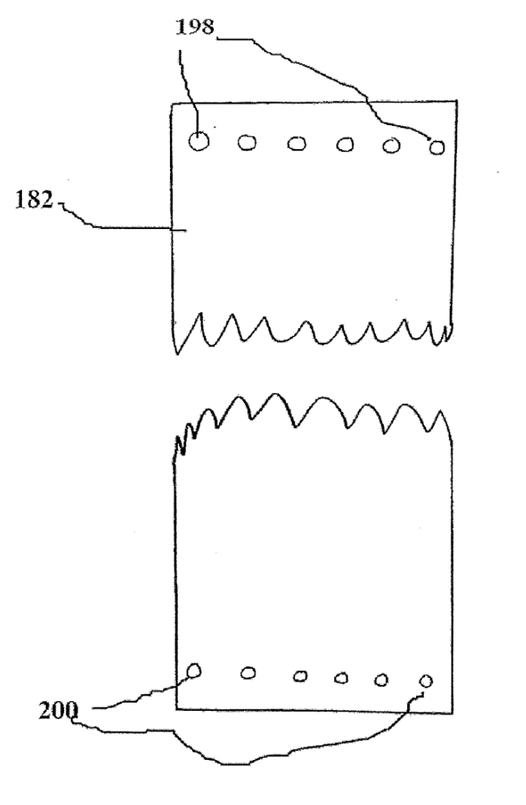
Fig. 10. A cross-sectional view of the electrolytic cell of Fig. 9 along line A-A;

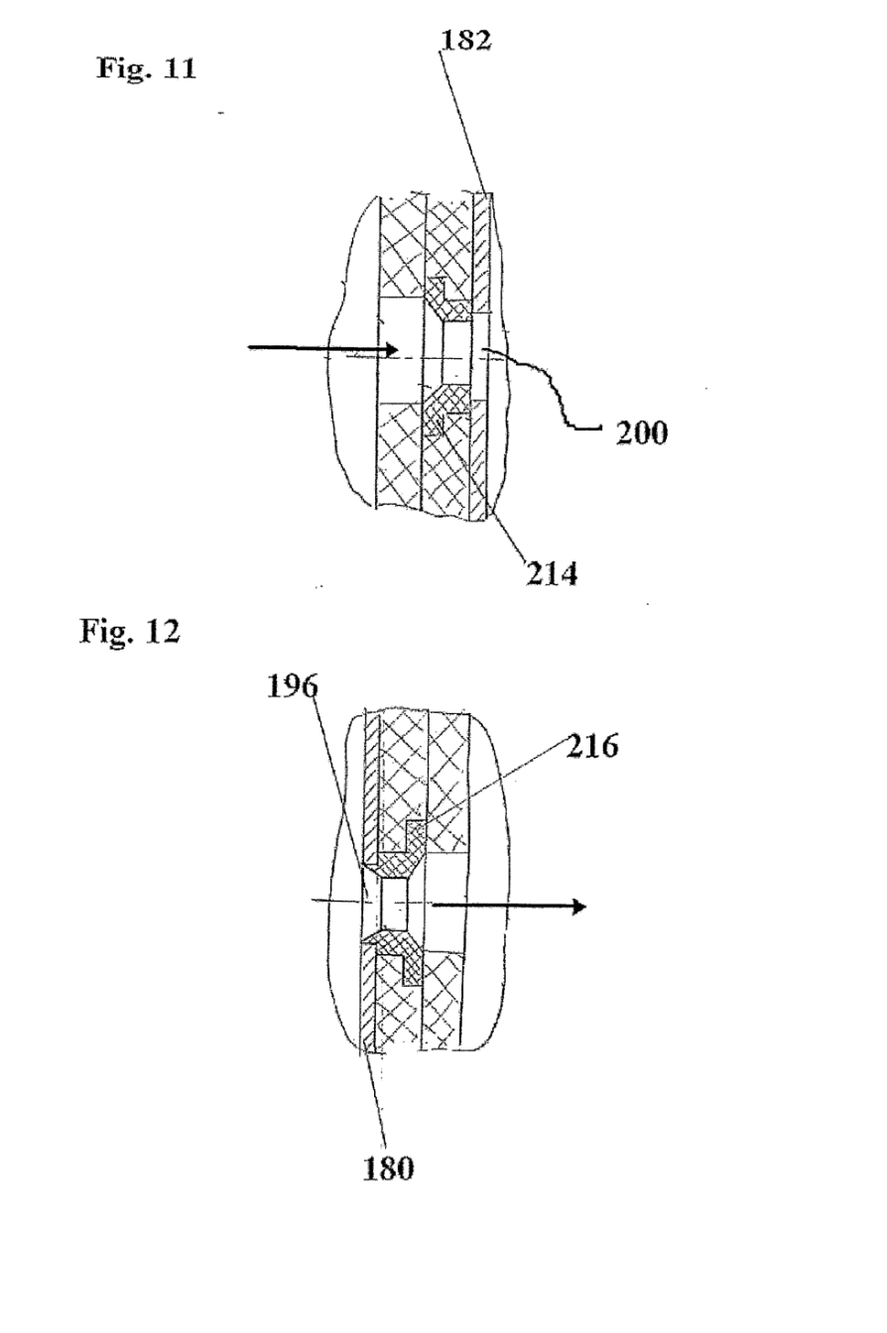
Fig. 11. An expanded view of the region labeled with a letter B in Fig. 9;

Fig. 12. An expanded view of the region labeled with a letter C is Fig. 9;

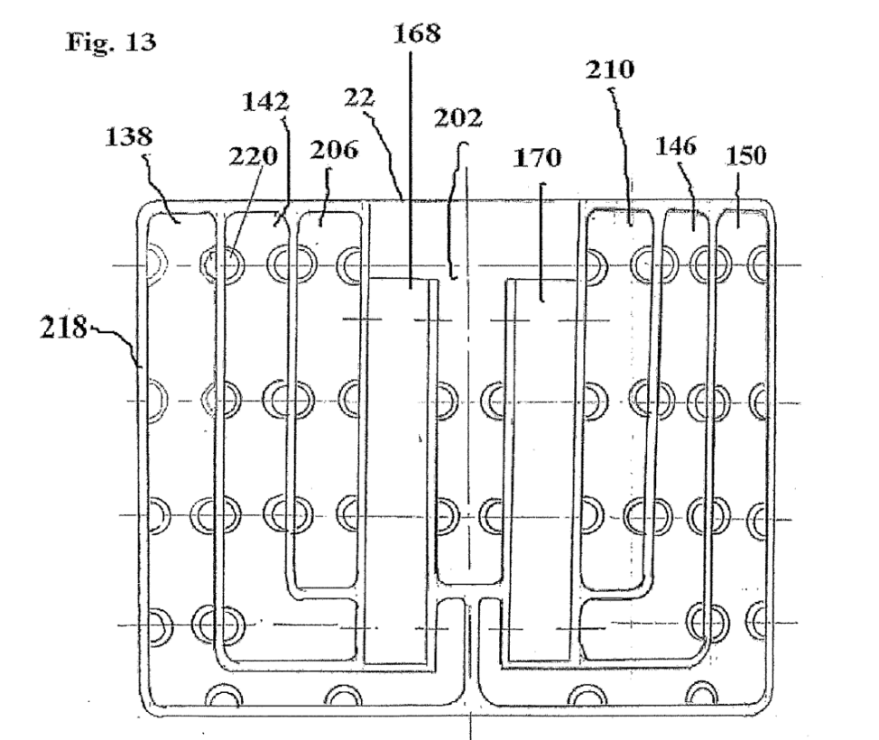
Fig. 13. A front view of the electrolytic reactor of Fig. 7 with its front cover removed;
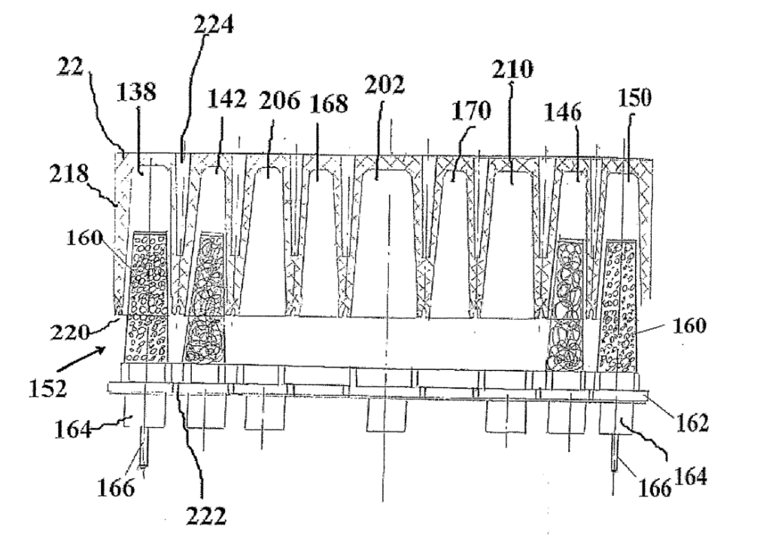
Fig. 14. A cross-sectional view of the electrolytic reactor of Fig. 7 along line B-B not showing the cell contents in the central cells;
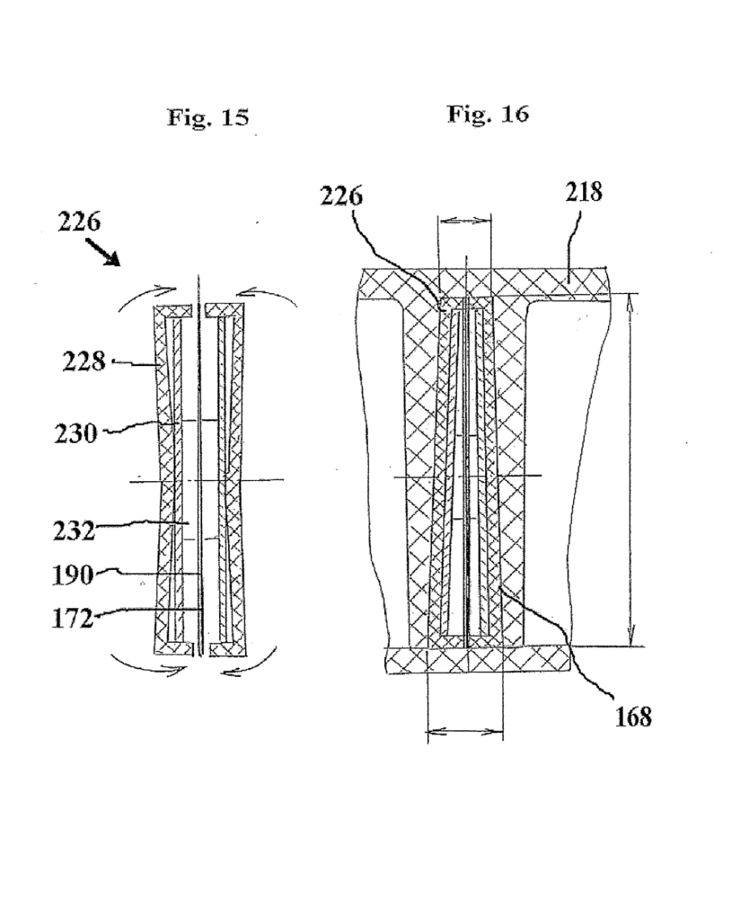
Fig. 15. Atop view of an electrolytic cell ready for insertion into the electrolytic reactor of Fig.14

Fig. 16. A cross-sectional view of the electrolytic reactor of Fig. 7 along line B-B only showing one electrolytic cell;

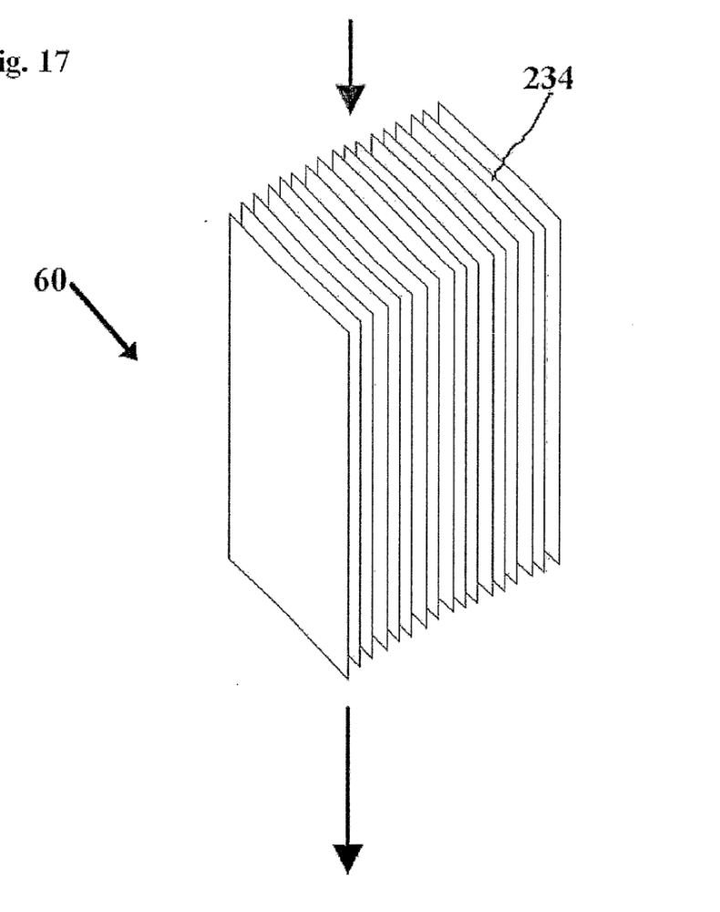
Fig. 17. An isometric view of a filtration apparatus for use with the wastewater treatment system of Fig. 1;

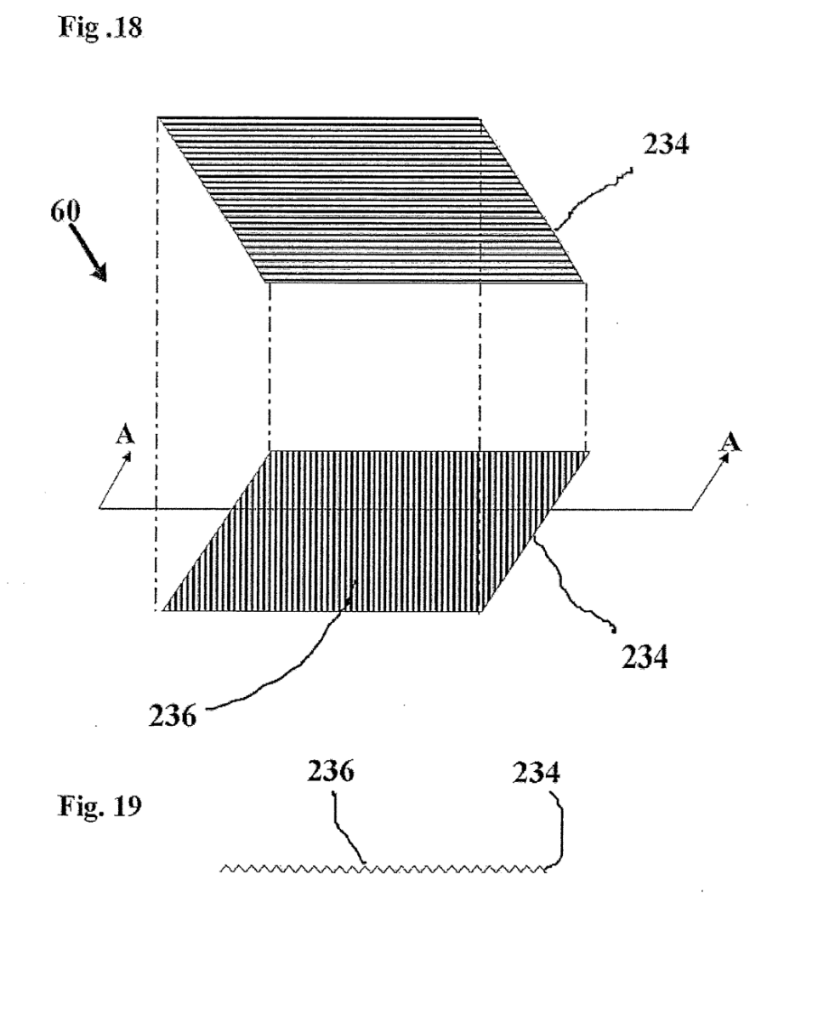
Fig. 18. An exploded view of two plates of the filtration apparatus of Fig. 17;

Fig. 19. A cross-sectional view of a plate of the filtration apparatus of Fig. 18 along line A-A;

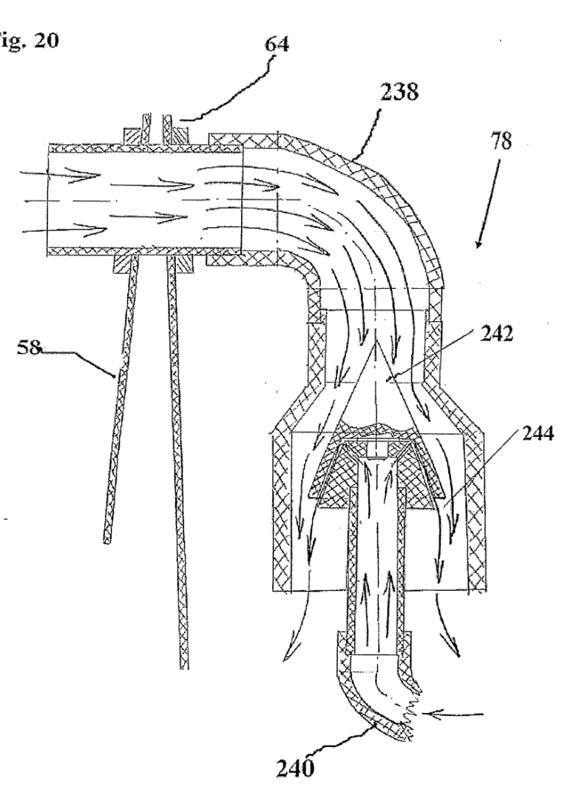

Fig. 20. A cross-sectional view of a wastewater aerator for use with the wastewater treatment system of Fig. la;

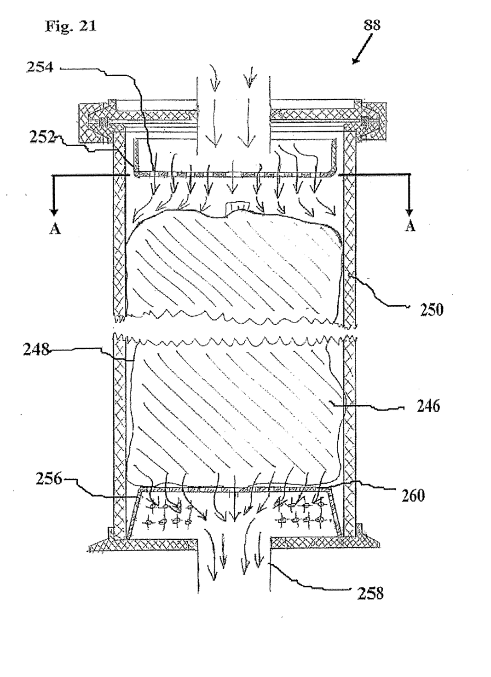
Fig. 21. A cross-sectional view of catalytic filtration apparatus for use with the wastewater treatment system of Fig. 1;
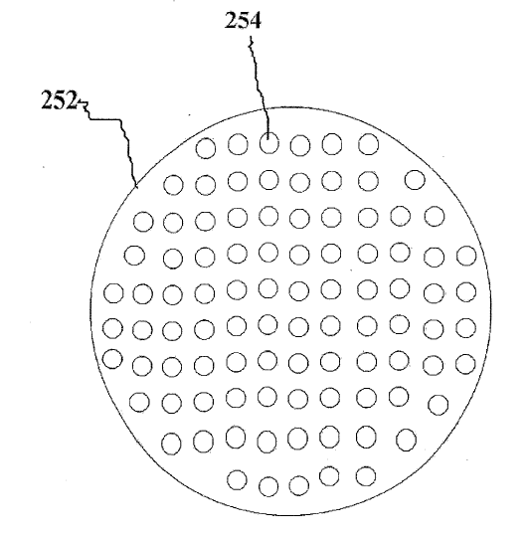
Fig. 22. A cross-sectional view of the catalytic filtration apparatus of Fig. 21 along line A-A.

DESCRIPTION OF THE PREFERRED EMBODIMENTS
The present invention is a wastewater treatment system and method of operation thereof.
The principles and operation of the wastewater treatment system according to the present invention may be better understood with reference to the drawings and the accompanying description.
Reference is now made to Fig. 1, which is a schematic view of a wastewater treatment system that is constructed and operable in accordance with a preferred embodiment of the invention. Wastewater, typically produced by an industrial process is initially filtered by a filtration apparatus 12. It should be noted that although the term wastewater typically refers to water containing impurities due to an industrial process, the terminology wastewater as used herein implies any water which contains impurities independent of how the impurities became disposed therein, including a process stream. Filtration apparatus 12 is configured to filter particles which are 0 microns or larger. Therefore, filtration apparatus 12 removes large particles, including grease particles which could damage other parts of wastewater treatment system, especially the electrolytic reactor 22 discussed below. Filtration apparatus 12 is discussed in more detail with reference to Fig. 2. The wastewater filtered by filtration apparatus 12 is pumped through a one-way valve 14 by a pump 16. One-way valve 14 prevents the wastewater from flowing back into filtration apparatus 12. Pump 16 is typically a stainless-steel centrifugal pump which is capable of pumping 5000 liters of liquid per hour. Pump 16 pumps the wastewater at a very low pressure of approximately 10 bars to ensure that the flow of the wastewater through wastewater treatment system is kept laminar for the sections of wastewater treatment system relating to electrolysis of the wastewater and sedimentation filters. After the wastewater flows through pump 16, the flow rate of the wastewater is controlled by a regulation valve 18. The flow rate of the wastewater at this stage is checked by a flow-meter. The flow rate of the wastewater entering electrolytic reactor 22 is very important. If the flow rate is too low, the temperature of the wastewater in electrolytic reactor 22 overheats and reduces the effectiveness of the purification process. The typical working range of electrolytic reactor 22 is between 1 degree centigrade and 50 degrees centigrade. If the flow rate is too high, the wastewater may flow turbulently, as will be described in more detail with respect to Fig. 6. In accordance with a most preferred embodiment of the present invention, regulation valve 18 is operated automatically by a computerized control unit 24 which processes flow rate measurements taken in various parts of wastewater treatment system, for example by flow-meter, as well as temperatures in electrolytic reactor 22. In accordance with an alternate embodiment of the present invention, regulation valve 18 is operated manually based on flow rate and temperature measurements. Electrolytic reactor 22 as well as all the other apparatus of wastewater treatment system are powered by a central power unit 52.
The wastewater then enters a wastewater sedimentation apparatus 26. Particles in the wastewater settle to the bottom of wastewater sedimentation apparatus 26 into a sludge tank 28. Sludge tank 28 has an outlet valve to allow emptying of sludge tank 28 of sludge. Wastewater sedimentation apparatus 26 is discussed in more detail with reference to Fig. 5.
The wastewater is then pushed out of the top of sedimentation apparatus 26 due to water build therein. The wastewater then enters a water divider 34 which divides the wastewater into four separate streams for processing by electrolytic reactor 22. It is important for the flow rates of each stream to be substantially identical so that all the wastewater undergoes the same amount and type of processing within electrolytic reactor 22. The means for achieving substantially identical flow rates is described in more detail with respect to Fig.8. The wastewater is processed by electrolytic reactor 22 which first recovers any precious metal ions, such as gold, silver, cobalt and platinum from the wastewater and then performs an electrolysis process which produces hydroxyl ions which precipitate the positive base metal ions or cations from the wastewater as metal hydroxides. Protons produced by the electrolysis process precipitate the negative ions or anions from the wastewater. The anions may include complexes which include ammonia. The process of precipitation of the metal ions and anions from the wastewater continues after the wastewater has exited electrolytic reactor 22. Therefore, after the wastewater exits electrolytic reactor 22, the wastewater flows through a series of filtration and sedimentation chambers for long enough for all the metal to precipitate and be removed from the wastewater. Electrolytic reactor 22 is described in more detail with reference to Figs. 6 to 16. The wastewater exits electrolytic reactor 22 in three streams. One stream 36 contains mainly metals and the other two streams 38 contain non-metal substances such as organic substances. Stream 36 is a high pH level (alkaline) and two streams 38 have a low pH level (acidic). Stream 36 now enters a sedimentation apparatus 40 which is configured to cause the precipitated metals to sediment to the bottom of sedimentation apparatus 40. Sedimentation apparatus 40 has a sludge tank 44. Sedimentation apparatus 40 is substantially the same as wastewater sedimentation apparatus 26. Stream 38 now enters a sedimentation apparatus 42 which is configured to cause the non-metal substances to sediment to the bottom of sedimentation apparatus 42. Sedimentation apparatus 42 has a sludge tank 46. Sedimentation apparatus 42 is substantially the same as wastewater sedimentation apparatus 26.
In accordance with a most preferred embodiment of the present invention, stream 36 is treated separately from stream 38. The main reason for treating stream 36 and stream 38 separately is that stream 36 which contains the metals typically requires a more aggressive process which typically includes using catalysts for removing metals from the wastewater. These catalysts are very expensive and if they are used with stream 38, these catalysts are wasted on removing organic substances which do not require such an aggressive treatment. Additionally, the wastewater is generally processed to a higher degree of purity when stream 36 and streams 38 1are treated separately. This is because the metal hydroxides in stream 36 may be dissolved back into the wastewater if mixed with the acidic wastewater of streams 38. Therefore, it is desirable according with this most preferred embodiment of the present invention to treat stream 36 and stream 38 separately. In accordance with an alternate embodiment of the present invention, the metal stream 36 and the non-metal stream 38 are now combined for the remainder of the wastewater treatment processing.
It should be noted that for the sake of simplicity, the description hereinbelow assumes that stream 36 and two streams 38 are now combined in a tank 48 after being filtered by a semi-permeable envelope 50. Semi-permeable balloon 50 is especially effective at filtering the metal hydroxide gels, but is also effective for filtering more crystalline structures. Semi-permeable envelope 50 has an inlet 54 configured to allow the wastewater to enter semipermeable envelope 50. Semi-permeable envelope 50 has a plurality of holes 56. The diameter of the holes is within the range of 0 to 0 microns. When the impurities in the wastewater adhere near holes 56, the water pressure inside semi-permeable envelope 50 increases. This increased water pressure causes semi-permeable envelope 50 to stretch whereby the cross-sectional area of holes 56 parallel to the surface of semi-permeable envelope 50 enlarge in order to maintain a substantially constant filtering throughput of the wastewater through semipermeable envelope 50. Semi-permeable envelope 50 is typically formed from a jersey knit fabric which uses polyamide thread. Polyamide is a preferred fiber as it has good stretching qualities.
The wastewater leaves tank 48 from the bottom thereof and enters a tank 58. Tank 58 has a sedimentation apparatus 60 therein. The wastewater is pumped up through tank 58 and tank 64 successively by a pump 62. Impurities within the wastewater are caused to sediment within sedimentation apparatus 60. Sedimentation apparatus 60 is described in more detail with reference to Figs. 17, 18 and 19. Pump 62 is typically a centrifugal pump. Pump 62 is substantially the same as pump 16. Pump 62 pumps the wastewater from the top of tank 58 into a tank 64.
In accordance with a preferred embodiment of the present invention, a semi-permeable envelope 66 is used to filter the wastewater which is entering tank 64. Semi-permeable envelope 66 is formed substantially the same way as semi-permeable envelope 50.
The wastewater is aerated within tank 64 by an aeration apparatus 68. It should be noted that aeration apparatus 68 is also optionally installed within tank 48. Aeration apparatus 68 includes a pipe 70 configured for connection to a fluid supply, such as water which is pumped back by pump 62 after this water has already left tank 64 or air via a central air compressor 32. It is important for the wastewater to be aerated at this stage in order to prepare the wastewater for later treatment by catalysts, in catalytic columns 88 as described below, which require oxygenated water for their effective performance at removing metals.
Aeration apparatus 68 also includes a discharge head 72 which has a plurality of very narrow channels disposed therein. The discharge head 72 is configured for insertion into the wastewater which is in tank 64. Aeration apparatus 68 is operationally connected to pipe 70 such that, when the fluid supply is activated, the fluid from the fluid supply flows through pipe 70 and through the channels of discharge head 72 into the wastewater which is in tank 64.
The cross-sectional area of the channels of discharge head 72 is small enough that when the fluid supply is activated, a low pressure region is set up in the wastewater adjacent to the channels of discharge head 72 caused by the fast speed of the fluid exiting the channels of discharge head 72. Each of these channels typically has a diameter of approximately 0.8mm.
This low-pressure region causes the wastewater to enter this low-pressure region at high speed so that parts of the wastewater collide with other wastewater and/or the fluid supply producing a plurality of micro-bubbles which aerate the wastewater.
A wastewater level sensor 76 is disposed in tank 64. Level sensor 76 is configured in conjunction with computerized control unit 24 to stop pump 62 when the wastewater level in tank 64 is down to the top of discharge head 72 of aeration apparatus 68. When tank 64 is half full with the wastewater, level sensor 76 in conjunction with computerized control unit 24 activates pump 62. When tank 64 is nearly full with the wastewater, level sensor 76 in conjunction with computerized control unit 24 stops pump 16 until the wastewater level within tank 64 drops to the half full level.
Reference is now made to Fig. la which is a schematic diagram of a section of wastewater treatment system that is constructed and operable in accordance with an alternate embodiment of the present invention. In accordance with this alternate embodiment, a filtration apparatus 262 which is substantially the same as filtration apparatus 12 filters the wastewater in tank 48 as it leaves tank 48. It should be noted that filtration apparatus 262 generally has a filtration specification of 50 micron. Sedimentation apparatus 60 removes impurities from the wastewater within tank 58. In this alternate embodiment, filtration apparatus 262 replaces semi-permeable balloons 50. A wastewater aerator 78 is disposed between tank 58 and tank 64. Aerator 78 oxygenates the wastewater as well as quickening the flow of the wastewater from tank 58 to tank 64. Aerator 78 is described in more detail with reference to Fig.15. Tank 64 also includes aeration apparatus 68 with pipe 70 and discharge head 72. Tank 64 also includes level sensor 76.
Reference is again made to Fig. l. After the wastewater is pumped out of tank 64 by pump 62, the wastewater travels through pump 62, a one-way valve 80 and a flow meter 82.
One-way valve 80 prevents the wastewater flowing back into tank 64. Flow meter 82 measures the flow rate of the wastewater to ensure that the wastewater is not flowing too fast for processing by the next stages of wastewater treatment system which include catalyst processing. Flow meter 82 is configured in conjunction with computerized control unit 24 to regulate the flow of the wastewater by controlling pump 62. It will be apparent to those skilled 2 in the art of water treatment by catalysts how the flow rate of the wastewater needs to be adjusted depending on the volume and type of catalyst as well as the number of impurities still within the wastewater.
The wastewater now enters a mechanical filter 84 having a filtering specification of 50 microns. The wastewater then enters a second mechanical filter 86 having a filtering specification of microns. Mechanical filters meeting these specifications are known to those skilled in the art.
After exiting mechanical filter 86, the wastewater enters a series of catalytic columns 88. The pipe carrying the wastewater to catalytic columns 88 has a gas release valve to enable escape of accumulated gas from catalytic columns 88. This gas release valve can either be manually operated or automatically operated by computerized control unit 24. Catalytic columns 88 are either arranged in: (i) parallel, as illustrated, such that the wastewater exiting mechanical filter 86 is divided among catalytic columns 88 for processing; or (ii) in series, such that the wastewater exiting mechanical filter 86 flows through each of catalytic columns 88. It will be apparent to those skilled in the art that appropriately placed bypass pipes and valves will enable switching between a serial and parallel set up of catalytic columns 88. If catalytic columns 88 are arranged in parallel it is important to ensure that each catalytic column 88 processes the same amount of the wastewater so that the catalysts within catalytic columns 88 are exhausted at the same time so that the catalysts can be replaced at the same time. This can be achieved by varying the quantity of the catalysts within catalytic columns 88 to adjust for the non-uniform flow of the wastewater among the catalytic columns 88, such that the catalysts are exhausted at the same time. It should be noted that between 80% to 90% of the impurities within the wastewater have been removed before the wastewater arrives at catalytic columns 88. Catalytic columns 88 are configured to remove the metals which still remain in the wastewater. Catalytic columns 88 are described in more detail with reference to Figs. 21 and 22.
The wastewater now flows through a series of diagnostic equipment including a flow rate meter 90 and a water analyzer 92, which is configured to analyze the conductivity and pH level of the exiting wastewater. The information recorded by flow rate meter 90 and water analyzer 92 is typically sent by a modem 94, which is controlled by computerized control unit 24. to a service control center to monitor the performance of wastewater treatment system. Finally, the wastewater flows through a filtration apparatus 96. Filtration apparatus 96 is constructed in the same way as filtration apparatus 12, but filtration apparatus 96 is configured to filter particles which are microns or larger.
Reference is now made to Fig. 2, which is an isometric view of filtration apparatus 12 for use with wastewater treatment system of Fig. 1. Reference is also made to Fig. 3, which is a top view of a filtration element 98 for use with filtration apparatus 12. Reference is also made to Fig. 4, which is an axial-sectional view of filtration apparatus 12 of Fig. 2 along line A-A. Filtration apparatus 12 includes a plurality of filtration elements 98 which are configured to filter the wastewater of an impurity. Filtration elements 98 are generally formed from polypropylene. Each filtration element 98 has two major surfaces 4 which are annular. There is a hole 2 in the center of each filtration element 98 which connects surfaces 4 of one filtration element 98. Each of surfaces 4 has a plurality of grooves 0 thereon which connect the outer circumference of surface 4 to the inner circumference of surface 4. Grooves 0 typically have a depth and width of 0 microns. Filtration elements 98 are stacked so that grooves 0 of one surface 4 of one filtration elements 98 are non-aligned with grooves 0 of an adjacent surface 4 of another filtration element 98. Filtration elements 98 are mechanically connected by four rods 6. Filtration apparatus 12 has a base 8 which is mechanically connected to the lowest filtration element 98 in the stack. At the top of the stack, a pipe 1 connects filtration apparatus 12 to pump 16. Pump 16 pumps the wastewater from a tank 112 via filtration apparatus 12. The wastewater in tank 112 enters filtration apparatus 12 through the outer circumference of surfaces 4 via grooves 0, represented by arrows 113. Grooves 0 prevent large particles from passing through surfaces 4. The wastewater then enters a central column 114 of filtration apparatus 12 and is then pumped out of central column 114 by pump 16 represented by an arrow 1. Base 8 prevents the wastewater from entering central column 114 without first flowing through filtration elements 98. Any dirt or grease particles which are lodged in or near grooves 0 of filtration elements 98 are cleaned by compressed air which is blown in pulses, during normal operation of filtration apparatus 12, via an air tube 116 into central column 114 by central air compressor 32.
Reference is now made to Fig. 5, which is an axial -sectional view of sedimentation apparatus 26 for use with wastewater treatment system of Fig. 1. Sedimentation apparatus 26 includes a water tank 118 having an inlet 1 which is configured to allow entry of the wastewater into tank 118. Sedimentation apparatus 26 also includes a plurality of deflecting elements 122 disposed within tank 118. Deflecting elements 122 are configured to enhance sedimentation of the wastewater within tank 118. Each of deflecting elements 122 is substantially a truncated cone which has one or more radial projections 124 configured to enhance the sedimentation process. There are typically thirty-five deflecting elements 122 in tank 118. Deflecting elements 122 typically have a diameter of 170 mm. Each radial projections 124 typically has a height of 50mm. Sedimentation apparatus 26 also includes a distribution member 126 disposed within tank 118. Distribution member 126 is configured to distribute the wastewater which enters tank 118 among deflecting elements 122. Distribution member 126 is a perforated pipe. The holes of distribution member 126 typically have a diameter of 4 mm. There are typically six holes in distribution member 126 for distributing the wastewater to each deflecting element 122. Deflecting elements 122 and distribution member 126 are co-axially arranged. Sedimentation apparatus 26 also includes a plurality of spacer members 128. Each spacer member 128 is disposed between distribution member 126 and two of deflecting elements 122. Distribution member 126 has a group of one or more entry holes 1 for each spacer members 128. to allow the wastewater to enter each spacer members 128. Each spacer member 128 has an equal number of exit holes 127 corresponding to entry holes 1. Exit holes 127 allow water to exit from each spacer member 128 to between two deflecting elements 122. Exit holes 127 have a larger cross-sectional area than entry holes 1 thereby preventing turbulent flow of the wastewater when it exits distribution member 126. Therefore, spacer members 128 maintain a laminar flow of the wastewater within tank 118 in order to enhance sedimentation of the wastewater. the wastewater exits tank 118 via a pipe 119. Any gas accumulating at the top of tank 118 is removable by opening a gas release valve 121. Release valve 121 is either manual or automatically operated by computerized control unit 24.
Reference is now made to Fig. 6, which is a schematic illustration of laminar flow through an electric field for use with a wastewater treatment system that is constructed and operable in accordance with a preferred embodiment of the present invention. As discussed above, it is important to maintain a laminar flow of wastewater during electrolytic purification. It is also important that the wastewater comes into contact with the electrodes as much as possible. This is generally difficult with a laminar flow of wastewater. Additionally, for the process to be commercially viable it must allow for a high throughput of wastewater. A high velocity of water flowing between the electrodes enhances the electrolytic purification process. Therefore, it is important to maintain a fast laminar flow of wastewater where the wastewater comes into contact with the electrodes and all portions of the wastewater are travelling with the same speed between the electrodes. By way of example, according to the present invention, wastewater enters a first vertical chamber 1. A pair of electrodes 132 is disposed inside a second vertical chamber 134. Electrodes 132 are very close to each other and therefore the wastewater flowing through second vertical chamber 134 comes into close contact with electrodes 132. The horizontal cross-sectional area of first vertical chamber 1 is much greater than the horizontal cross-sectional area of second vertical chamber 134. Therefore, even if water is added laminarly to first vertical chamber 1, this introduction causes a highspeed laminar flow of the wastewater in second vertical chamber 134 between electrodes 132. The flow of wastewater from first vertical chamber 1 to second vertical chamber 134 is caused by air pressure in first vertical chamber 1 and second vertical chamber 134 equalizing the water levels of the wastewater in first vertical chamber 1 and second vertical chamber 134. As the outlet of second vertical chamber 134 is lower than the inlet of first vertical chamber 1, an addition of water to second vertical chamber 134 causes the wastewater to flow through and out of second vertical chamber 134. Therefore, high speed, laminar flow of wastewater is achieved using the above principle. It is important to note that first vertical chamber 1 should have contours which do not promote turbulent water flow. If first vertical chamber 1 has sharp corners. such as square corners, then these corners may set up a turbulent water flow within first vertical chamber 1 as is the case with prior art reactors such as that of U.S. Patent No.6.139.71.
Reference is now made to Fig. 7, which is an exploded isometric view of electrolytic reactor 22 for use with wastewater treatment system of Fig. 1. Reference is also made to Fig. 8. which is a cross-sectional view of electrolytic reactor 22 of Fig. 7 along line A-A. The wastewater is divided by water divider 34 into four streams. The first stream enters electrolytic reactor 22 through an inlet 136 into a vertical chamber 138 of electrolytic reactor 22. Vertical chamber 138 as well as the other vertical chambers of electrolytic reactor 22 are typically 4mm wide, up to 600 mm high and 1 mm deep. The second stream enters electrolytic reactor 22 through an inlet 140 into a vertical chamber 142 of electrolytic reactor 22. The third stream enters electrolytic reactor 22 through an inlet 144 into a vertical chamber 146 of electrolytic reactor 22. The final stream enters electrolytic reactor 22 through an inlet 148 into a vertical chamber 0 electrolytic reactor 22. Inlets 136, 140, 144, 148 are disposed within a front cover 162 of electrolytic reactor 22. There is an air hole 123 disposed between vertical chamber 138 and vertical chamber 142. Air hole 123 allows accumulated gas within vertical chamber 142 to exit periodically through a gas release valve 131. It is important to remove gas periodically to prevent trapped gas causing turbulence within the system. Gas release valve 131 is disposed in front cover 162 adjacent to vertical chamber 138. Likewise, gas accumulated within vertical chamber 138 exits through gas release valve 131. Gas release valve 131 is either manually operated or automatically operated by computerized control unit 24. Additionally, air hole 123 ensures that the air pressure at the top of vertical chamber 138 and vertical chamber 142 are substantially identical. Similarly, there is an air hole 133 disposed between vertical chamber 146 and vertical chamber 150. Similarly, there is a gas release valve 13disposed in front cover 162 adjacent to vertical chamber 150. Vertical chambers 138, 142, 146 and 150 are configured for accumulating the wastewater therein. The flow of the incoming wastewater is controlled by computerized control unit 24 such that the wastewater level within vertical chamber 138, 142, 146 and 0 does not exceed the level of air holes 123 and 133, shown by a line 143.
It should be noted that vertical chambers 138, 142, 146 and 0 do not have sharp corners which might induce turbulence within the wastewater. Moreover, the contours of vertical chambers 138, 142, 146 and 0 are shaped and rounded in order to maintain a laminar flow of the wastewater within vertical chambers 138, 142. 146 and 0 for the complete flow of the wastewater therein.
Electrolytic reactor 22 includes four precious metal recovery apparatuses 2, which recover precious metal ions -from the wastewater by electroplating before the electrolytic purification process begins. Each precious metal recovery apparatus 2 includes an anode 4 and two cathodes 6. One precious metal recovery apparatus 2 is disposed within each of vertical chamber 138, vertical chamber 142, vertical chamber 146 and vertical chamber 0. Precious metal recovery apparatuses 2 are configured to electroplate cathodes 6 with any precious metal ions which are present in the wastewater. Cathodes 6 are typically formed from a material having a high surface area to volume ratio which cannot be achieved with classic solid cathodes such as metals and other conducting materials. The material is typically an absorbent and/or fibrous conducting material formed from a treated fabric or fibers such as a Carbographite material. An absorbent and/or fibrous material increases the available electroplating surface area of cathodes 6. Carbographite is chosen for its strength, long life.
Moreover. Carbographite does not significantly decompose, which would add contaminants to the wastewater. Cathodes 6 and anode 4 are typically formed by pyrolysis of discs of viscose fabric. The processed discs of viscose fabric are then stacked in groups of five and each group is then subjected to pyrolysis again. The processed groups of discs are then stacked to form a cylinder 160 which extends to the depth of vertical chambers 138, 142, 146, 0 (see Fig. 14). A conducting metal rod 8, generally formed of solid stainless steel or titanium, is then disposed along the axis of cylinder 160. Precious metal recovery apparatus 2 is powered by connecting conducting metal rod 8 to central power unit 52. When the surface area of cathodes 6 is completely coated with precious metal, the Carbographite discs of cathodes 6 are placed in a furnace which destroys the Carbographite discs in order to recover the precious metal that is deposited on the discs. Cathodes 6 and anode 4 are connected to central power unit 52 via a plurality of contacts 166 disposed in front cover 162. Cathodes 6 and anode 4 are removed from electrolytic reactor 22 through a plurality of openings 164 in front cover 162.
Reference is additionally made to Fig. 9, which is an expanded cross-sectional view of an electrolytic cell of electrolytic reactor 22 of Fig. 8. Electrolytic reactor 22 includes a vertical chamber 168. A pair of electrodes 172 which are configured to produce an electric field are disposed within vertical chamber 168. Pair of electrodes 172 are powered by a DC voltage.
Computerized control unit 24 (Fig. 1) in conjunction with central power unit 52 (Fig. 1) is configured to direct high voltage peaks of electricity to pair of electrodes 172. The voltage peaks are typically up to 0 V and up to 50A. The duration of the voltage peaks is typically one fiftieth of a second with a frequency of 50 Plz. Pair of electrodes 172 includes two electrodes, a cathode 180 and.an anode 182. Negative voltage peaks can be applied to pair of electrodes 172 to prevent electroplating of cathode 180. Cathode 180 and anode 182 are typically formed from stainless steel, titanium, carbon-carbon, stainless steel with titanium nitrate plating or stainless steel with a conducting polymer plating. Combinations of the above are possible, for example, a stainless steel cathode and a titanium anode, a carbon-carbon cathode and a titanium anode, a titanium cathode and a carbon-carbon cathode. In addition, the surface of cathode 180 and anode 182 can be protected using a carbon-carbon fabric which also increases the conducting surface area of the electrodes with the wastewater. Cathode 180 and anode 182 can also be protected with an aluminum or iron coating which also aids electrocoagulation. The distance between cathode 180 and anode 182 is typically 6 mm. A plurality of conduits 176 connect vertical chamber 138 with vertical chamber 168 via a plurality of holes 188 which connect the major surfaces of cathode 180. There are typically between 4 to 8 of holes 188. Each hole 188 has a diameter of between 8 mm to 14 mm and a spacing between the centers of holes 188 of between 12 mm to 16 mm. A plurality of conduits 178 connect vertical chamber 142 with vertical chamber 168 via a plurality of holes 0 which connect the major surfaces of anode 182. Vertical chamber 168 includes a 2 plurality of outlet conduits 192 configured to allow exit of the wastewater from vertical chamber 168 via a plurality of holes 196 which connect the major surfaces of cathode 180, after processing of the wastewater by the electric field. Vertical chamber 168 also includes a plurality of outlet conduits 194 configured to allow exit of the wastewater from vertical chamber 168 via a plurality of holes 198 which connect the major surfaces of anode 182, after processing of the wastewater by the electric field. Reference is additionally made to Fig., which is a cross-sectional view of anode 182 of Fig. 9 along line A-A showing the positioning of holes 0 and holes 198 in anode 182. Vertical chamber 168 also includes a semi-permeable membrane 190 which is disposed half way between pair of electrodes 172. Semi-permeable membrane 190 substantially separates the wastewater which is in vertical chamber 168 into two flows as is discussed below. Semi-permeable membrane 190 is described as "substantially separating" as there is a migration of ions on a micro level which is also discussed below. Semi-permeable membrane 190 is generally formed of polypropylene. The thickness of semi-permeable membrane 190 depends on the current and voltage applied across pair of electrodes 172. By way of illustration: (i) semi-permeable membrane 190 needs to be approximately 0.mm thick when a voltage of V and a current of A is applied across pair of electrodes 172; (ii) semi-permeable membrane 190 needs to be approximately 1.0mm thick when a voltage of V and a current of 60 A is applied across pair of electrodes 172; and (iii) when a voltage of V and a current of A is applied across pair of electrodes 172 two of semi-permeable membrane 190 are required, each having a thickness of 0.mm.
An addition of the wastewater in vertical chamber 138 causes a substantially laminar flow of a part of the wastewater through conduits 176 via holes 188 into and up through vertical chamber 168. This is due to air pressure causing an equalization of the water levels between vertical chamber 138 and vertical chamber 168. As the wastewater enters vertical chamber 168 via holes 188 the wastewater flows parallel to the electric field of pair of electrodes 172. As the wastewater flows up between pair of electrodes 172, the wastewater flows perpendicular to the electric field of pair of electrodes 172. The wastewater travels with a very low pressure and a high speed of approximately 2 meters per second. The wastewater then exits vertical chamber 168 via holes 196 and outlet conduits 192 into a vertical chamber 2. The wastewater then flows down vertical chamber 2 to exit electrolytic reactor 22 via an outlet 4 in front cover 162. Similarly, an addition of the wastewater in vertical chamber 142 causes a substantially laminar flow of a part of the wastewater through conduits 178 via holes 0 into and up through vertical chamber 168. As the wastewater enters vertical chamber 168 via holes 0 the wastewater flows parallel to the electric field of pair of electrodes 172. As the wastewater flows up between pair of electrodes 172, the wastewater flows perpendicular to the electric field of pair of electrodes 172. The wastewater then exits vertical chamber 168 via holes 198 and outlet conduits 194 into a vertical chamber 6. The wastewater then flows down vertical chamber 6 to exit electrolytic reactor 22 via an outlet 8 in front cover 162. The energy transferred by pair of electrodes 172 when the wastewater is flowing through holes 188, 0, 198, 196, parallel to the electric field, represents 80% of the energy transfer by pair of electrodes 172 to the wastewater. The electrolysis of the wastewater by pair of electrodes 172 initiates the precipitation metal ions from the wastewater. Oxidants of up to 0 mg per liter are produced by the electrolysis.
When the wastewater enters vertical chamber 168, positive ions (cations) are attracted to cathode 180 and negative ions (anions) are attracted to anode 182. Positive ions in the wastewater which are on anode 182 side of semi-permeable membrane 190 migrate across semi-permeable membrane 190 to cathode 180 side of semi-permeable membrane 190. Negative ions in the wastewater which are on cathode 180 side of semi-permeable membrane 190 migrate across semi-permeable membrane 190 to anode 182 side of semi-permeable membrane 190. The ions in the wastewater only have enough energy to migrate across semi-permeable membrane 190 once. Therefore, the wastewater which flows out of vertical chamber 168 through holes 198 in anode 182 contain negative ions, balanced by H ions, and the wastewater which flows out of vertical chamber 168 through holes 196 in cathode 180 contains positive ions, balanced by OH- ions. It should be noted that metals are generally positive ions. The second side of electrolytic reactor 22 includes a vertical chamber 170 having a pair of electrodes 174 which are configured to produce an electric field are disposed within vertical chamber 170. Pair of electrodes 174 includes two electrodes, a cathode 184 and an anode 186. An addition of the wastewater to vertical chamber 146 and vertical chamber 0 is processed in vertical chamber 170 by pair of electrodes 174 in the same way as described above. The wastewater processed by pair of electrodes 174 includes a flow which contains positive metal ions which exits vertical chamber 170 into vertical chamber 2, and a flow which contains negative ions which exits vertical chamber 170 into a vertical chamber 2. The wastewater in vertical chamber 2 flows downward to exit electrolytic reactor 22 via an outlet 212 in front cover 162.
There is a water hole 137 disposed between the bottom of vertical chamber 142 and 2 vertical chamber 138. There is similarly a water hole 139 disposed between the bottom of vertical chamber 146 and vertical chamber 0. There is also a water hole 141 disposed between vertical chamber 138 and vertical chamber 0. Water holes 137, 139, 141 typically each have a diameter of between mm and 40 mm. Air holes 123, 133, water holes 137, 139, 141 as well as gas release valves 131, 13ensure that separate flows of the wastewater entering electrolytic reactor 22 via vertical chamber 138, 142, 146 and 0 are treated substantially identically by pair of electrodes 174 and pair of electrodes 172 even if the wastewater enters vertical chamber 138, 142, 146 and 0 at different rates and even if gas accumulates at different rates within vertical chamber 138, 142, 146 and 0. This is because air holes 123, 133, water holes 137, 139, 141 as well as gas release valves 131, 13ensure that the water level within vertical chamber 138, 142, 146 and 0 is kept at substantially the same level, shown by line 143.
In accordance with an alternate embodiment of the present invention, inlet 136 and inlet 148 are not included. Instead, the wastewater enters via inlet 140 to vertical chamber 142. The wastewater then enters vertical chamber 138 from vertical chamber 142 via water hole 137. Similarly, the wastewater enters via inlet 144 into vertical chamber 146. The wastewater then enters vertical chamber 0 from vertical chamber 146 via water hole 139.
Reference is now made to Fig. 1 1, which is an expanded view of the region labeled with a letter B in Fig. 9. Reference is also made to Fig. 12, which is an expanded view of the region labeled with a letter C, which is Fig. 9. To enhance energy transfer from anode 182 and to prevent the wastewater eroding the edges of anode 182 when entering vertical chamber 168 via holes 0, an edge protector 214, typically formed from carbon, is disposed around holes 0. Edge protector 214 typically has a length which is longer that the depth of 1 anode 182 measured perpendicular to the major surfaces of anode 182. Similarly, an edge protector 216, typically formed from carbon is disposed around holes 196 of cathode 180 when the wastewater exits vertical chamber 168. All entry and exit holes of all the electrodes of electrolytic reactor 22 are protected similarly with edge protectors.
Reference is now made to Fig. 13, which is front view of electrolytic reactor 22 of Fig. 7 with front cover 162 removed. Reference is also made to Fig. 14, which is a cross-sectional view of electrolytic reactor 22 of Fig. 7 along line B-B. Note that neither Fig. 13 nor Fig. 14 shows the contents of vertical chambers 168 and 170. Electrolytic reactor 22 includes a shell structure 218 which is typically formed from molded plastic. Shell structure 218 forms vertical chambers 138, 142, 146, 150, 168, 170, 2, 6 and 2. All the vertical chambers have 2 slanted sides, as seen in Fig. 14. The slant angle of the sides is approximately 125 degrees. The reason for the slant angle is due to the method of molding shell structure 218 as well as the need for a tight fit for the contents of vertical chamber 168 and vertical chamber 170 which is described in more detail with reference to Fig. and 16. Shell structure 218 also has a plurality of holes 224 at the back of shell structure 218. Holes 224 help electrolytic reactor 22 maintain a low temperature by dissipating heat. Reference is now made to Fig., which is a top view of an electrolytic cell 226 ready for insertion into shell structure 218 of electrolytic reactor 22 of Fig. 14. Electrolytic cell 226 includes pair of electrodes 172, semi-permeable membrane 190, two flexible plastic outer walls 228, two inner plastic walls 2, and two spacer members 232. Spacer members 232 are formed from a resilient material, such as polyurethane or other resilient plastics. Electrolytic cell 226 is constructed such that when electrolytic cell 226 is inserted into shell structure 218 a pressure fit between flexible plastic outer walls 228, inner plastic walls 2, spacer members 232, pair of electrodes 172 and shell structure 218 ensures that all the wastewater which flows through vertical chamber 168 flows between pair of electrodes 172 and not bypassing pair of electrodes 172. Reference is now made to Fig. 16, which is a cross-sectional view of electrolytic reactor 22 of Fig. 7 along line B-B only showing electrolytic cell 226 inserted into vertical chamber 168 of shell structure 218. The other electrolytic cell of electrolytic reactor 22 is formed and inserted in the same way as electrolytic cell 226.
Reference is again made to Figs. 13 and 14. Shell structure 218 has a plurality of threaded screw holes 2 disposed therein configured to enable front cover 162 to be fastened securely to shell structure 218 providing a watertight fit. Front cover 162 has a plurality of holes 222 corresponding to threaded screw holes 2 of shell structure 218. In addition to1fastening front cover 162 with screws to shell structure 218, polyurethane glue is applied to all contact surfaces between front cover 162 and shell structure 218. The polyurethane glue forms a foam which provides a very good watertight protection.
Reference is now made to Fig. 17, which is an isometric view of sedimentation apparatus 60 for use with wastewater treatment system of Fig. 1. Sedimentation apparatus 60 includes a plurality of plates 234 which are stacked to form sedimentation apparatus 60. Plates 234 are configured to cause the wastewater to take a non-linear path between the surfaces of plates 234 thereby causing impurities in the wastewater to sediment on the surfaces of plates 234. Plates 234 are typically formed from plastic sheeting with a thickness of approximately 0.2mm. Plates 234 are generally spaced between 8 mm to mm between 2 adjacent plates 234. Reference is now made to Fig. 18, which is an exploded view of two of plates 234 of sedimentation apparatus 60 of Fig. 17. Each of plates 234 has a surface which has a plurality of ridges and grooves 236 thereon. Grooves 236 of one of the surfaces are nonparallel, preferably cross-aligned, with grooves 236 of an adjacent surface in order to cause the wastewater to take a non-linear path between the surfaces of plates 234 thereby causing impurities in the wastewater to sediment on the surfaces of plates 234.
Reference is now made to Fig. 19, which is a cross-sectional view of one of plates 234 of sedimentation apparatus 60 of Fig. 18 along line A-A. Grooves 236 of plates 234 are generally formed by formed by vacuum forming of plastic. The grooves typically have a width and depth of between 8 mm to mm. It should be noted that the exact shape of the grooves is not important, various shapes can be used such as square and rounded shapes. Reference is now made to Fig.20, which is a cross-sectional view of aerator 78 for use with wastewater treatment system of Fig. la. Aerator 78 includes a pipe 238 configured to carry the wastewater from tank 58 to tank 64. Aerator 78 also includes a pipe 240 configured for connection to a fluid supply. Pipe 240 is partially disposed within pipe 238. The fluid supply is either water which is pumped back by pump 62 (Fig. 1) after this water has already left tank 64, air via central air compressor 32 (Fig. 1) Aerator 78 also includes a discharge head 242 having at least one. Channel 244. Discharge head 242 has a conical outer surface having an apex that points opposite to the direction of the wastewater in pipe 238. Discharge head 242 is mechanically connected to pipe 240. Channel 244 is configured to operationally connect pipe 240 to pipe 238. Channel 244 has a cross-sectional area which is small enough that when the fluid supply is activated, a low-pressure region is set up in pipe 238. This low-pressure region causes the wastewater to enter this low-pressure region at 1 high speed so that parts of the wastewater collide other wastewater and/or the fluid supply producing a plurality of micro-bubbles which aerate the wastewater. This low-pressure region also quickens the flow of the wastewater from tank 58 to tank 64.
Reference is now made to Fig. 21, which is a cross-sectional view of a catalytic column 88 for use with wastewater treatment system of Fig. 1. Catalytic column 88 includes a tank 0 and a granular catalyst 246 which is configured to remove impurities, specifically, metals, from the wastewater. Granular catalyst 246 is generally activated carbon, titanium phosphate, zirconium phosphate, cationite, or anionite. Granular catalyst 246 is contained within a semi-permeable envelope 248. Semi-permeable envelope 248 prevents granular catalyst 246, as it becomes contaminated, leaking into the wastewater which leaves tank after processing by catalytic column 88. Semi-permeable envelope 248 is configured to stretch when impurities in the wastewater adhere near holes of semi-permeable envelope 248 thereby maintaining a substantially constant throughput of the wastewater through semi-permeable envelope 248. Semi-permeable envelope 248 is formed in a similar manner to semi-permeable envelope 50 described with reference to Fig. 1. Reference is also made to Fig. 22, which is a cross-sectional view of catalytic column 88 of Fig. 21 along line A-A. Catalytic column 88 includes a water disperser 2 which is configured to distribute the wastewater entering tank 0 over the upper surface of semi-permeable envelope 248 in order to maximize the use of granular catalyst 246. Water disperser 2 is a plate which has a plurality of holes 4 therein. Water disperser 2 is disposed horizontally below the inlet of tank 0. Catalytic column 88 also includes an outlet 8 at the base of tank 0 configured to allow drainage of the wastewater from tank 0. Catalytic column 88 also includes a water integrator 6 configured to prevent any part of semi-permeable envelope 248 from obstructing drainage of the wastewater via outlet 8. Water integrator 6 is a plate, similar to water disperser 2, which has a plurality of holes 260 therein. Water integrator 6 is disposed horizontally above outlet 8.
It will be appreciated by persons skilled in the art that the present invention is not limited to what has been particularly shown and described hereinabove. Rather, the scope of the present invention includes both combinations and sub-combinations of the various features described hereinabove, as well as variations and modifications thereof that are not in the prior art which would occur to persons skilled in the art upon reading the foregoing description.

CLAIMS
What is claimed is:
1. A treatment system for wastewater, comprising:
- a first chamber;
- a second chamber having a pair of electrodes configured to produce a first electric field;
- a conduit configured to connect said first chamber to said second chamber, wherein at least one of said first chamber, said second chamber and said conduit are formed such that a flow of the wastewater through said first electric field is substantially laminar.
2. The system of claim 1, further comprising a semi-permeable membrane which is disposed between said pair of electrodes.
The system of claim 2, wherein said semi-permeable membrane substantially separates at least a part of the wastewater which is in said second chamber into a first flow and a second flow; and wherein said second chamber includes a first outlet and a second outlet such that said first flow exits from said second chamber via said first outlet and said second flow exits from said second chamber via said second outlet.
- The system of claim 1, wherein the wastewater is configured to flow first substantially parallel and then substantially perpendicular to said first electric field.
- The system of claim 1, wherein the wastewater is configured to flow first substantially perpendicular and then substantially parallel to said first electric field.
- The system of claim 1, wherein at least one of said pair of electrodes is configured so that upon at least one of entering and exiting said second chamber, the wastewater flows substantially parallel to said first electric field.
- The system of claim 1, wherein at least one of said pair of electrodes has two major surfaces and a hole extending between said two major surfaces so that upon at least one of entering and exiting said second chamber, at least part of the wastewater flows through said hole.
- The system of claim 7, further comprising: an edge protector having a length perpendicular to said major surfaces; said length being longer than a depth of said one electrode measured perpendicular to said major surfaces, said edge protector being configured to enhance an energy transfer between said one electrode and the wastewater which is flowing through said hole.
- The system of claim l, wherein at least one of said first chamber, said second chamber and said conduit are formed such that separate flows of the wastewater through said first electric field are treated substantially identically.
- The system of claim 9, further comprising:
- a third chamber;
- a second conduit configured to connect said third chamber to said second chamber, wherein at least one of said first chamber, said second chamber, said third chamber, said conduit and said second conduit are formed such that a flow of the wastewater through said first electric field is substantially laminar and separate flows of the wastewater through said first electric field are treated substantially identically.
l1. The system of claim, further comprising a fourth chamber having a second pair of electrodes configured to produce a second electric field; wherein the system is configured such that the wastewater is treated substantially identically by said first electric field and said second electric field.
12. The system of claim 1, further comprising a filtration apparatus which includes a plurality of filtration elements configured to cooperate to filter the wastewater of an impurity;
- an air pump configured to clean said filtration elements of at least a part of said impurity during a normal operation of said filtration apparatus. The system of claim 12, wherein each of said filtration elements includes a member having a plurality of grooves thereon.
- The system of claim 1, further comprising a precious metal recovery apparatus which includes:
- a first electrode formed from a material having a high surface area to volume ratio;
- a second electrode, said first electrode and said second electrode being configured for connection to a power supply to enable recovery of the precious metal from the by electroplating of said first electrode with at least part of the precious metal.
- The system of claim 14, wherein said material is an absorbent conducting material.
- The system of claim 14, wherein said material is a carbographite material.
- The system of claim 15, further comprising a semi-permeable envelope for filtering an impurity from the wastewater, said envelope including:
- an inlet configured to allow the wastewater to enter said envelope;
- a plurality of holes configured to:
- allow exit of the wastewater from said envelope;
- trap at least part of the impurity inside said envelope; wherein said envelope is configured to stretch to maintain a substantially constant filtering throughput of said envelope when said at least part of the impurity adheres near said holes.
- The system of claim 17, wherein said envelope is substantially formed of a knitted fabric.
- The system of claim 18, wherein said knitted fabric includes a polyamide thread.
- The system of claim 15, further comprising a wastewater sedimentation apparatus which includes:
- a plurality of deflecting elements configured to cooperate to enhance sedimentation of impurities from the wastewater;
- a distribution member configured to distribute the wastewater among said deflecting elements.
- The system of claim, wherein each of said deflecting elements is shaped substantially as a truncated cone.
- The system of claim 20 f, wherein said truncated cone has at least one projection.
- The system of claim 22, wherein said projection is substantially radial.
- The system of claim, wherein said distribution member is a perforated pipe.
- The system of claim 24, wherein said deflecting elements and said distribution member are co-axially arranged.
- The system of claim, further including a plurality of spacer members, each of said spacer members being disposed between said distribution member and two of said deflecting elements, said spacer members configured to maintain a laminar flow of the wastewater in order to enhance sedimentation of impurities from the wastewater.
- The system of claim 1, further comprising a filtration apparatus to filter an impurity from the wastewater, said filtration apparatus including:
- a first surface having a plurality of ridges and grooves;
- a second surface having a plurality of ridges and grooves wherein said first surface is disposed facing said second surface such that, said grooves of said first surface are nonparallel to said grooves of said second surface in order to cause at least part of the wastewater to take a non-linear path between said first surface and said second surface thereby filtering at least part of the impurity.
- The system of claim 27, wherein said grooves of said first surface are substantially cross-aligned with said grooves of said second surface.
- The system of claim 1, further comprising a filtration apparatus for filtering an impurity from wastewater, said filtration apparatus including:
- a granular catalyst configured to remove at least part of the impurity from the wastewater;
- a semi-permeable envelope having a plurality of holes, said envelope being configured to contain said granular catalyst, said plurality of holes being configured to allow exit of the wastewater from said envelope, wherein said envelope is configured to stretch to maintain a substantially constant filtering throughput of the envelope when at least part of the impurity adheres near said holes.
The system of claim 29, wherein said envelope has an upper surface, said filtration apparatus further including:
- a tank configured to hold said envelope;
- a water disperser configured to distribute the wastewater entering said tank over said upper surface of said envelope in order to maximize contact of the wastewater with said granular catalyst.
- The system of claim, wherein said water disperser includes an element having a plurality of holes therein, wherethrough the wastewater flows.
- The system of claim 29, wherein said filtration apparatus further includes:
- a tank configured to hold said envelope, said tank having an outlet configured to allow a drainage of the wastewater from said tank;
- a water integrator configured to prevent said envelope from obstructing the drainage of the wastewater via said outlet.
- The system of claim 32, wherein said water integrator is an element having a plurality of holes therein, wherethrough the flows.
- The system of claim 29, wherein said envelope is substantially formed of a knitted fabric.
- The system of claim 34. wherein said knitted fabric includes a polyamide thread.
- The system of claim 1, further comprising an apparatus for aerating the wastewater, said apparatus including:
- a pipe configured for connection to a fluid supply;
- a discharge head operationally connected to said pipe, said discharge head including at least one channel having a cross-sectional area, at least part of said channel being configured for insertion into the wastewater, said cross-sectional area being small enough that when a flow of a fluid from said fluid supply is activated, a low pressure region is set up in the wastewater, thereby producing a plurality of micro-bubbles which aerate the wastewater.
- The system of claim 36, wherein said fluid is air.
- The system of claim 36, wherein said fluid is recycled water.
- The system of claim 1, further comprising an apparatus for aerating wastewater, said apparatus including:
- a first pipe configured to introduce the wastewater to said apparatus;
- a second pipe configured for connection to a fluid supply;
- a discharge head having at least one channel, said channel being configured to operationally connect said second pipe to said first pipe, said channel having a cross-sectional area that is small enough that when a flow of a fluid from said fluid supply is activated, a low pressure region is set up in said first pipe that:
- produces a plurality of micro-bubbles which aerate the wastewater;
- quickens a flow of the wastewater into said apparatus.
- The system of claim 39, wherein said second pipe is at least partially disposed within said first pipe.
- The system of claim 39, wherein said discharge head has a conical surface having an apex that points opposite to a direction of flow of the wastewater in said first pipe.
- A filtration apparatus, comprising:
- a plurality of filtration elements configured to cooperate to filter wastewater of an impurity;
- an air pump configured to clean said filtration elements of at least a part of said impurity during a normal operation of the filtration apparatus.
- The filtration apparatus of claim 42, wherein each of said filtration elements includes a member having a plurality of grooves thereon.
- A precious metal recovery system, comprising:
- a first electrode formed from a material having a high surface area to volume ratio;
- a second electrode, said first electrode and said second electrode being configured for connection to a power supply to enable recovery of the precious metal from wastewater by electroplating of said first electrode with at least part of the precious metal.
- The system of claim 44, wherein said material is an absorbent conducting material.
- The precious metal recovery system of claim 44, wherein said material is a carbographite material.
- A semi-permeable envelope for filtering an impurity from wastewater, comprising:
- an inlet configured to allow the wastewater to enter the envelope; and
- a plurality of holes configured to:
- allow exit of the wastewater from the envelope;
- trap at least part of the impurity inside the envelope; wherein the envelope is configured to stretch to maintain a substantially constant filtering throughput of the envelope when said at least part of the impurity adheres near said holes.
- The apparatus of claim 47, wherein said envelope is substantially formed of a knitted fabric.
- The apparatus of claim 48, wherein said knitted fabric includes a polyamide thread.
- A wastewater sedimentation apparatus, comprising:
- a plurality of deflecting elements configured to cooperate to enhance sedimentation of impurities from the wastewater; said deflecting elements being shaped substantially as a truncated cone; said truncated cone having at least one projection;
- a distribution member configured to distribute the wastewater among said deflecting elements; said distribution member being a perforated pipe, wherein said deflecting elements and said distribution member are co-axially arranged.
- The apparatus of claim 50, wherein said projection is substantially radial.
- The apparatus of claim 50, further comprising a plurality of spacer members, each of said spacer members being disposed between said distribution member and two of said deflecting elements, said spacer members configured to maintain a laminar flow of the wastewater in order to enhance sedimentation of impurities from the wastewater.
- A filtration apparatus to filter an impurity from wastewater, comprising a first surface having a plurality of ridges and grooves;
- a second surface having a plurality of ridges and grooves wherein said first surface is disposed facing said second surface such that, said grooves of said first surface are nonparallel to said grooves of said second surface in order to cause at least part of the wastewater to take a non-linear path between said first surface and said second surface thereby filtering at least part of the impurity. The apparatus of claim 53, wherein said grooves of said first surface are substantially cross-aligned with said grooves of said second surface.
- A filtration apparatus for filtering an impurity from wastewater. comprising:
- a granular catalyst configured to remove at least part of the impurity from the wastewater:
- a semi-permeable envelope having a plurality of holes, said envelope being configured to contain said granular catalyst, said plurality of holes being configured to allow exit of the wastewater from said envelope, wherein said envelope is configured to stretch to maintain a substantially constant filtering throughput of the envelope when at least part of the impurity adheres near said holes.
56. The apparatus of claim 55, wherein said envelope has an upper surface, the apparatus further comprising:
- a tank configured to hold said envelope;
- a water disperser configured to distribute the wastewater entering said tank over said upper surface of said envelope in order to maximize contact of the wastewater said granular catalyst.
- The apparatus of claim 56, wherein said water disperser includes an element having a plurality of holes therein, wherethrough the wastewater flows.
- The apparatus of claim 55, further comprising:
- a tank configured to hold said envelope, said tank having an outlet configured to allow a drainage of the wastewater from said tank;
- a water integrator configured to prevent said envelope from obstructing the drainage of the wastewater via said outlet.
- The apparatus of claim 58, wherein said water integrator is an element having a plurality of holes therein, wherethrough the wastewater flows.
- The apparatus of claim 55, wherein said envelope is substantially formed of a knitted fabric.
- The apparatus of claim 60. wherein said knitted fabric includes a polyamide thread.
- A apparatus for aerating wastewater, comprising:
- a pipe configured for connection to a fluid supply;
- a discharge head operationally connected to said pipe, said discharge head including at least one channel having a cross-sectional area, at least part of said channel being configured for insertion into the wastewater, said cross-sectional area being small enough that when a flow of a fluid from said fluid supply is activated, a low pressure region is set up in the wastewater, thereby producing a plurality of micro-bubbles which aerate the wastewater.
- The apparatus of claim 62, wherein said fluid is air.
- The apparatus of claim 62, wherein said fluid is recycled water.
- An apparatus for aerating wastewater, comprising:
- a first pipe configured to introduce the wastewater to the apparatus;
- a second pipe configured for connection to a fluid supply;
- a discharge head having at least one channel, said channel being configured to operationally connect said second pipe to said first pipe, said channel having a cross-sectional area that is small enough that when a flow of a fluid from said fluid supply is activated, a low pressure region is set up in said first pipe that:
- produces a plurality of micro-bubbles which aerate the wastewater; and
- quickens a flow of the wastewater into the apparatus.
- The apparatus of claim 65, wherein said second pipe is at least partially disposed within said first pipe.
- Discharge head has a conical surface having an apex that points opposite to a direction of flow of the wastewater in said first pipe.
- A method for treating "wastewater, comprising the steps of:
- providing an electric field;
- causing a substantially laminar flow of the wastewater through said electric field in order to precipitate a plurality of metal ions from the wastewater.
69. The method of claim 68, further comprising the step of ensuring that separate flows of the wastewater through said electric field are treated substantially identically.
70. The method of claim 68, further comprising the step of performing at least one operation selected from the group consisting of filtering of said wastewater and causing sedimentation from said wastewater.
71. The method of claim 68, further comprising the step of substantially separating at least part of the wastewater prior to leaving said electric field into a first flow which includes said metal ions and a second flow.
- The method of claim 68, wherein said step of causing said laminar flow of the wastewater includes causing said substantially laminar flow of the wastewater first substantially parallel and then substantially perpendicular to said electric field.
- The method of claim 68, wherein said step of causing said laminar flow of the wastewater includes causing said substantially laminar flow of the wastewater first substantially perpendicular and then substantially parallel to said electric field.
- A method to filter an impurity from wastewater, comprising the steps of:
- filtering the wastewater of an impurity using a filter;
- cleaning at least part of said filter of the impurity using air pressure.
75. A method to recover a precious metal from wastewater, comprising the steps of:
- electroplating an electrode with at least part of the precious metal;
- destroying said electrode in a manner that leaves behind the precious metal that is electroplated thereon.
76. The method of claim 75, further comprising the step of forming said electrode from a material having a high surface area to volume ratio.
- The method of claim 76, wherein said material is an absorbent conducting material.
- The method of claim 76, wherein said material is a carbographite material.
- A method to aerate wastewater comprising the steps of:
- providing a fluid;
- injecting said fluid into the wastewater such that a low-pressure region is set up in the wastewater producing a plurality of micro-bubbles which aerate the wastewater.
80. A method for treating wastewater, comprising the steps of:
- providing an electric field;
- causing a flow of the wastewater through said electric field in order to precipitate metal ions from the wastewater;
- substantially separating at least part of the wastewater prior to leaving said electric field into a first flow which includes said metal ions and a second flow; and
- subsequent to said step of separating, performing at least one operation, selected from a group consisting of filtering of said wastewater and causing a sedimentation from said wastewater, said operation being performed separately and selected from said group separately, for said first flow and said second flow.
81. The method of claim 80, further comprising the step of only passing said wastewater of said first flow through a catalyst.

REFERENCES, PATENT AND LICENSE INFORMATION
APPENDIX 1
INTERNATIONAL SEARCH REPORT |  |  | International application No.  PCT/IL02/00911
A. CLASSIFICATION OF SUBJECT MATTER
IPC(7) :C02F 1/46, 1/52; B01D 29/00, 29/62, 39/08
US CL : 204/228.1,229.4,229.8,230.2
According to International Patent Classification (IPC) or to both national classification and IPC
B. FIELDS SEARCHED
Minimum documentation searched (classification system followed by classification symbols)
U.S. : 210/702, 74-8, 108, 252, 259, 295, 321.69, 393, 4110, 500.21, 500.38, 513, 912; 204/554
Documentation searched other than minimum documentation to the extent that such documents are included in the fields searched
Electronic data base consulted during the international search (name of data base and, where practicable,
search terms used)
EAST: power adj supply and current adj sensor and voltage adj sensor and water adj treat$4 and slave adj power
C. DOCUMENTS CONSIDERED TO BE RELEVANT
Category * | Citation of document, with indication, where appropriate, of the  relevant passages |  |  | Relevant to claim No.
Y  A  Y | uS 5,060,167 A (TICCIONI et al) 22 October 1991 (22.10.1991),  col. 2, lines 30-40, lines  63-68; column 3, lines 10-35; column 4, lines 1-10; column 8,  lines 45-60  US 5,007,993 A (HULL et al) 16 April 1991 (16.04.1991)  US 5,389,214 A (ERICKSON) 14 February 1995 (14.02.1995),  column 3, lines 10-45;  column 5, lines 25-50; column 8, lines 11-59; column 9, lines 1-60. |  |  | 1-4  1-4
___ Further documents are listed in the continuation of Box C. ___ See patent family annex.
Special categories of cited documents:  «A» document defining the general state of the art which is not considered to be of particular relevance  «E» earlier application or patent published on or after the international filing date  «L» • document which may throw doubts on priority claimfs) or which is cited to establish the publication date of another citation or other special reason (as specified)  «O» document referring to an oral disclosure, use, exhibition or other means  «P» document published prior to the international filing date but later than die priority date claimed |  | «T» later document published after the international filing  date or priority date and not in conflict with the application but cited to understand the principle or theory underlying the invention  «Х» document of particular relevance; the claimed invention cannot be considered novel or cannot be considered to involve an inventive step  when the document is taken alone  «Y». document of particular relevance; the claimed  invention cannot be considered to involve an inventive  step when the document is combined with one or more other such documents, such combination being obvious  to a person skilled in the art  «&». document member of the same patent family
Date of the actual completion of the international search  01 October 2004 (01.10.2004) |  | Date of mailing of the international search report  10 OCT 2004
Name and mailing address of the ISA/US  Mail Stop PCT, Attn: ISA/US  Commissioner for Patents  P.O. Box 1450  Alexandria, Virginia 22313-1450  Facsimile No. (703) 305-3230 |  | Authorized officer  Donald R. Valentine  Telephone No. 571-272-12^/

