Algae Domes: Expedient Method Augmenting Biofuel Supply

Alexander Bolonkin, Shmuel Neumann, Joseph Friedlander and Zarek Newman
abolonkin@juno.com; strategictechno@gmail.com; jjfriedlander@gmail.com; zerachy@gmail.com
Strategic Solutions Technology Group;
PO Box 34217, Jerusalem, Israel; Phone/Fax 02-567-2313;
Email: strategictechno@gmail.com

Abstract
Pioneering the development of dome technology, the authors have devised an algae dome where the algae are grown between the walls of two transparent domes, one inside the other, with only 10 cm between the outer and inner walls. These domes are inflatable and are held up only by air pressure. Circulating water in the 10 cm between the outer and inner dome is the breeding ground for the algae. It has the advantage of the bioreactors as it is insulated from outside contaminants but is inexpensive and has more area exposed than the breeding pond. Further, inside the dome, the floor space of the dome can be a shielded pond increasing the algae crop yield or can be used as a greenhouse.
--------------------------------------------
Key Words: algae production, inflatable domes,bioreactor, algae, biofuel feedstock

Introduction
It is a well-established fact that usable liquid fuels can be made directly from biomass. After all, the vast underground deposits of oil are only decayed biomass under pressure for a long period. This process can be replicated by actively growing vast amounts of algae and directly converting it to oily feedstock definable to fuel. There are direct, fast and cheap processes to convert algae to components of vehicle fuel. The problem is growing sufficient quantities of algae. To grow enough algae to supply the gasoline needs of the United States, you would need algae ponds the size of 1/10 of New Mexico.
There are two contemporary processes for producing algae open pond and bioreactor. The advantage of open pond technology is that it is cheap. The problem is that it is open to contaminants that easily kill algae. Algae are extremely vulnerable to numerous biological and chemical agents that can kill an entire crop. In bioreactors the algae are safely insulated from those bugs, but it is extremely expensive per unit of volume and has limited exposure to the sun.
The open-pond vs. closed-bioreactor debate has gone on for decades. DOE chose the open-pond process because they concluded that the bioreactor approach could never be economical. One study concluded that the cost of algal oil from bioreactors -- even at a large scale, with the most optimistic assumptions -- would become competitive with petro-oil only when it hits $800/barrel. [1]
Bill Shields who runs an algae bioreactor facility in Mexico,claims that his algae production system can produce 6,000 gallons of ethanol per acre per year, far more than corn's rate of 370 gallons per acre per year or sugar cane's rate of 890 gallons per acre per year. The Mexican site is located a few miles away from a power generation station. By pumping carbon dioxide from the station into the algae bioreactors, the saltwater algae farm can boost production to 10,000 gallons of ethanol per acre per year, he said. [2]
There are numerous facilities which generate algae biofuel in closed-algae bioreactors but, require man-made structures throughout the entire solar collection area. To replace gasoline it would take facilities the size of 1/10th of New Mexico or about 12,000 square miles. That’s a lot of man-made structures. To put it in perspective, consider that all of the commercial buildings in the entire U.S. -- built up over centuries -- add up to a little over 1,000 square miles.
“Another obstacle preventing widespread mass production of algae for biofuel production has been the equipment and structures needed to begin growing algae in large quantities. Diversified Energy Corporation have avoided this problem by taking a different approach, and growing the algae in thin walled polyethylene tubing called Algae Biotape, similar to conventional drip irrigation tubing, which can be incorporated into a normal agricultural environment”[3]. Their site displays this system as follows:
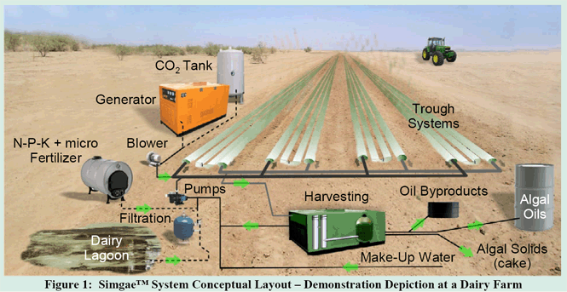
Figure 1. Simgate System Conceptual Layout – Demonstration Depiction of a Dairy Farm
Imagine the biotape or a similar type tube lying in a spiral inside the dome walls and you have the Algae Dome. The Algae Dome approach is to put the algae inside the walls of the dome, which is an inexpensive structure and has almost three times the area for photosynthesis than the floor, the area an open pool algae pond would use. It also insulates the algae from contaminants that have wrecked hazard on open pond facilities. Of course the growth of algae either in open ponds or enclosed bioreactors is not new. However, the advantages of the bioreactors have always been outweighed by its astronomical cost. By growing the algae in the enclosed dome walls made of plastic we can circumvent the crippling costs of the bioreactor and glean its advantages. The Algae Dome is an economically feasible way to generate large quantities of algae and by locating this near power plants, it has the additional benefit that it can consume the CO² generated by those power plants and at the same time accelerate algae production. The dome technology has been developed by Bolonkin in numerous publications [4][5][6][7][8][9][10][11][12][13][14][15][16][17][18][19].
Theory and Computation of Algae Dome
The Algae Dome is comprised of two transparent domes situated one within the other with each dome having controlled reflectivity. The upper transparent dome has a thickness of about 0.05 – 0.3 mm and supports the algae tubing which are attached to this layer. To control temperature each, dome must be comprised of five layers:1)transparent dielectric layer, 2) conducting layer (about 1 -- 3nm), 3μ), liquid crystal layer (about 10 -100 μ), conducting layer (for example, SnO₂), and transparent dielectric layer. Common thickness is 0.05-0.5 mm. Control voltage is 5 -10 V. This film can be produced by industry relatively cheaply.
1. Liquid crystals (LC) are substances that exhibit a phase of matter that has properties between those of a conventional liquid, and those of a solid crystal. Liquid crystals find wide use in liquid crystal displays (LCD), which rely on the optical properties of certain liquid crystalline molecules in the presence or absence of an electric field. The electric field can be used to make a pixel switch between clear or dark on command. Color LCD systems use the same technique, with color filters used to generate red, green, and blue pixels. Similar principles can be used to make other liquid crystal based optical devices. Liquid crystal in fluid form is used to detect electrically generated hot spots for failure analysis in the semiconductor industry. Liquid crystal memory units with extensive capacity were used in Space Shuttle navigation equipment. It is also worth noting that many common fluids are in fact liquid crystals. Soap, for instance, is a liquid crystal, and forms a variety of LC phases depending on its concentration in water. The conventional controlled clarity (transparency) film reflected a superfluous energy back to space. If the film has solar cells it can convert the superfluous solar energy into electricity.
2. Transparency. In optics, transparency is the material property of allowing light to pass through. Though transparency usually refers to visible light in common usage, it may correctly be used to refer to any type of radiation. Examples of transparent materials are air and some other gases, liquids such as water, most glasses, and plastics such as Perspex and Pyrex. The degree of transparency varies according to the wavelength of the light trying to pass the material. From the theory of electrodynamics it results that only a vacuum is really transparent in the strict meaning. All matter has a certain amount of absorption level for electromagnetic waves. Certain crystals are transparent because there are straight lines through the crystal structure. Light passes unobstructed along these lines. There is a complicated theory which allows us to "predict" (calculate) absorption and its spectral dependence of different materials
3.Electrochromism is the phenomenon displayed by some chemical species of reversibly changing color when a burst of charge is applied. As the color change is persistent and energy need only be applied to effect a change, electrochromic materials are used to control the amount of light and heat allowed to pass through windows ("smart windows"), and has also been applied in the automobile industry to automatically tint rear-view mirrors in various lighting conditions. . Another example of electrochromics at work is the transparent glass wall that can be made opaque by the application of an electric charge. One good example of an electrochromic material is polyaniline which can be formed either by the electrochemical or chemical oxidation of aniline. If an electrode is immersed in hydrochloric acid which contains a small concentration of aniline, then a film of polyaniline can be grown on the electrode. Depending on the redox state, polyaniline can either be pale yellow or dark green/black. Other electrochromic materials that have found technological application include the viologens and polyoxotungstates. Tungsten oxide (WO₃) is the main chemical used in the production of electrochromic windows or smart windows. Viologen is used in conjunction with titanium dioxide (TiO₂) in the creation of small digital displays. It is hoped that these will replace LCDs as the viologen (which is typically dark blue) has a high contrast to the bright color of the titanium white, thereby providing a high visibility of the display.
Here is a depiction of the Algae dome’s top layer with its constituent parts.
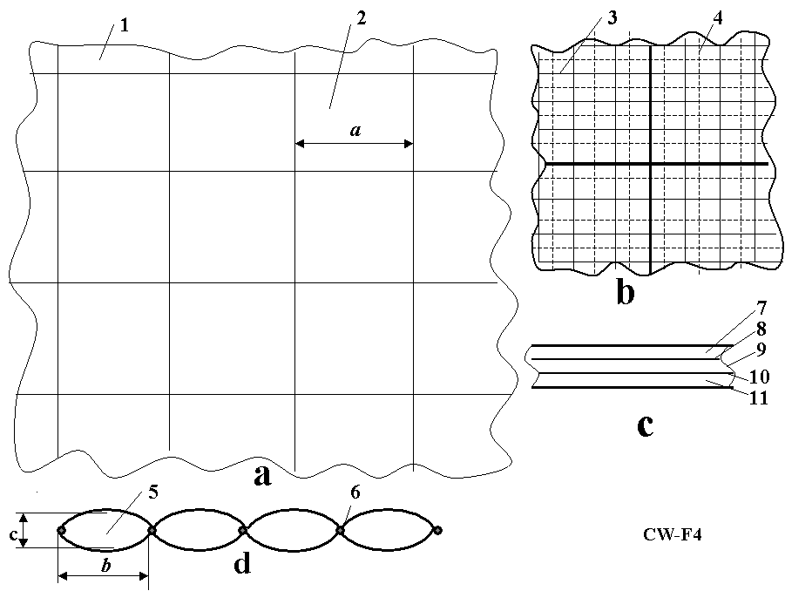
Figure2. Design of covering membrane. Notations: (a) Large fragment of cover with controlled clarity (reflectivity, carrying capacity) and heat conductivity; (b) Small fragment of cover; (c) Cross-section of cover (film) having 5 layers; (d) Longitudinal cross-section of low height cover for cold and hot regions (optional); 1 - cover; 2 -mesh; 3 - small mesh; 4 - thin electric net; 5 - cell of cover; 6 - tubes; 7 - transparent dielectric layer, 8 - conducting layer (about 1 - 3 μ), 9 - liquid crystal layer (about 10 - 100 μ), 10 - conducting layer, and 11 - transparent dielectric layer. Common thickness is 0.1 - 0.5 mm. Control voltage is 5 - 10 V.
4. Film and cable properties Artificial fibers are currently being manufactured, which have tensile strengths of 3-5 times more than steel and densities 4-5 times less than steel. There are also experimental fibers (whiskers) which have tensile strengths 30-100 times more than a steel and densities 2 to 5 times less than steel. For example, there is a fiber (whisker) C_{D}, which has a tensile strength of σ= 8000 kg/mm² and density (specific gravity) of γ = 3.5 g/cm³. If we use an estimated strength of 3500 kg/mm²(σ =7.10¹⁰ N/m², γ = 3500 kg/m³), than the ratio is γ/σ = 0.1×10⁻⁶ or σ/γ = 10×10⁶. Although the described (1989) graphite fibers are strong (σ/γ = 10×10⁶), they are at least still ten times weaker than theory predicts. A steel fiber has a tensile strength of 5000 MPA (500 kg/sq. mm), the theoretical limit is 22,000 MPA (2200 kg/mm²)(1987); the polyethylene fiber has a tensile strength 20,000 MPA with a theoretical limit of 35,000 MPA (1987). The very high tensile strength is due to its nanotube structure.
Apart from unique electronic properties, the mechanical behavior of nanotubes also has provided interest because nanotubes are seen as the ultimate carbon fiber, which can be used as reinforcements in advanced composite technology. Early theoretical work and recent experiments on individual nanotubes (mostly MWNT’s, Multi Wall Nano Tubes) have confirmed that nanotubes are one of the stiffest materials ever made. Whereas carbon-carbon covalent bonds are one of the strongest in nature, a structure based on a perfect arrangement of these bonds oriented along the axis of nanotubes would produce an exceedingly strong material. Traditional carbon fibers show high strength and stiffness, but fall far short of the theoretical, in-plane strength of graphite layers by an order of magnitude. Nanotubes come close to being the best fiber that can be made from graphite.
For example, whiskers of Carbon nanotube (CNT) material have a tensile strength of 200 Giga-Pascals and a Young’s modulus over 1 Tera Pascals (1999). The theory predicts 1 Tera Pascals and a Young’s modulus of 1-5 Tera Pascals. The hollow structure of nanotubes makes them very light (the specific density varies from 0.8 g/cc for SWNT’s (Single Wall Nano Tubes) up to 1.8 g/cc for MWNT’s, compared to 2.26 g/cc for graphite or 7.8 g/cc for steel). Tensile strength of MWNT’s nanotubes may reach 150 GPa.
Specific strength (strength/density) is important in the design of the systems presented in this paper; nanotubes have values at least 2 orders of magnitude greater than steel. Traditional carbon fibers have a specific strength 40 times that of steel. Since nanotubes are made of graphitic carbon, they have good resistance to chemical attack and have high thermal stability. Oxidation studies have shown that the onset of oxidation shifts by about 100⁰ C or higher in nanotubes compared to high modulus graphite fibers. In a vacuum, or reducing atmosphere, nanotube structures will be stable to any practical service temperature (in vacuum up to 2300 º C, in air up to 750ºC).
In theory, metallic nanotubes can have an electric current density (along axis) more than 1,000 times greater than metals such as silver and copper. Nanotubes have excellent heat conductivity along axis up 6000 W/m.K. By comparison, copper has only 385 W/m.K.
Companies such as CNano, Showa Denko and Bayer are producing hundreds of tons of nanotubes per year, although their actual capacity exceeds production. Prices of MWNTs now range from $45-70/kg, depending on quality, with Chinese manufacturers offering MWNTs at lower prices
Artificial fibers are cheap and widely used in tires and everywhere. The author has found only old information about textile fiber for inflatable structures (Harris J.T., Advanced Material and Assembly Methods for Inflatable Structures, AIAA, Paper No. 73-448, 1973). This refers to DuPont textile Fiber B and Fiber PRD-49 for tire cord. They are 6 times strong as steel (psi is 400,000 or 312 kg/mm²) with a specific gravity only 1.5. Minimum available yarn size (denier) is 200, tensile module is 8.8×10⁶ (B) and 20×10⁶ (PRD-49), and ultimate elongation (percent) is 4 (B) and 1.9 (PRD-49). Some data are in Table 1.
Table 1: Properties of alternative materials for the dome walls
Material | Tensile  strength | Density  g/cm³ | Fibers | Tensile  strength | Density  g/cm³
Whiskers | kg/mm² |  |  | kg/mm²
AlB₁₂ | 2650 | 2.6 | QC-8805 | 620 | 1.95
B | 2500 | 2.3 | TM9 | 600 | 1.79
B₄C | 2800 | 2.5 | Allien 1 | 580 | 1.56
TiB₂ | 3370 | 4.5 | Allien 2 | 300 | 0.97
SiC | 1380-4140 | 3.22 | Kevlar or Twaron | 362 | 1.44
Material |  |  | Dynecta or Spectra | 230-350 | 0.97
Steel pre-stressing strands | 186 | 7.8 | Vectran | 283-334 | 0.97
Steel Piano wire | 220-248 |  | E-Class | 347 | 2.57
Steel A514 | 76 | 7.8 | S-Class | 471 | 2.48
Aluminum alloy | 45.5 | 2.7 | Basalt fiber | 484 | 2.7
Titanium alloy | 90 | 4.51 | Carbon fiber | 565 | 1,75
Polypropylene | 2-8 | 0.91 | Carbon nanotubes | 6200 | 1.34
Industrial fibers have σ = 500-600 kg/mm², γ = 1800 kg/m³, and σ⁄γ = 2,78x10⁶. But we are using in all of our projects only the cheapest films and cables (safety σ= 50 - 100 kg/mm²).
5. Wind effect. As wind flows over and around a fully exposed, nearly completely sealed inflated dome, the weather affecting the external film on the windward side must endure positive air pressures as the wind stagnates. Simultaneously, low air pressure eddies will be present on the leeward side of the dome. In other words, air pressure gradients caused by air density differences on different parts of the dome’s envelope is characterized as the “buoyancy effect”. The buoyancy effect will be greatest during the coldest weather when the dome is heated and the temperature difference between its interior and exterior are greatest. In extremely cold climates such as the Arctic and Antarctic Regions the buoyancy effect tends to dominate dome pressurization.
6. Solar radiation. Solar radiation impinging the orbiting Earth is approximately 1400 W/m². The average Earth reflection by clouds and the sub-aerial surfaces (water, ice and land) is about 0.3. The Earth-atmosphere absorbs about 0.2 of the Sun’s radiation.That leaves about q₀ = 700 W/m²s of solar energy (heat) to reach our planet’s surface in cloudy weather at the Equator. That means we can absorb about 30 - 80% of solar energy. It is enough for normal plant growth in wintertime (up to 40-50º latitude) and in circumpolar regions with a special variant of the dome design.
The solar spectrum is graphically portrayed in Fig. 5.
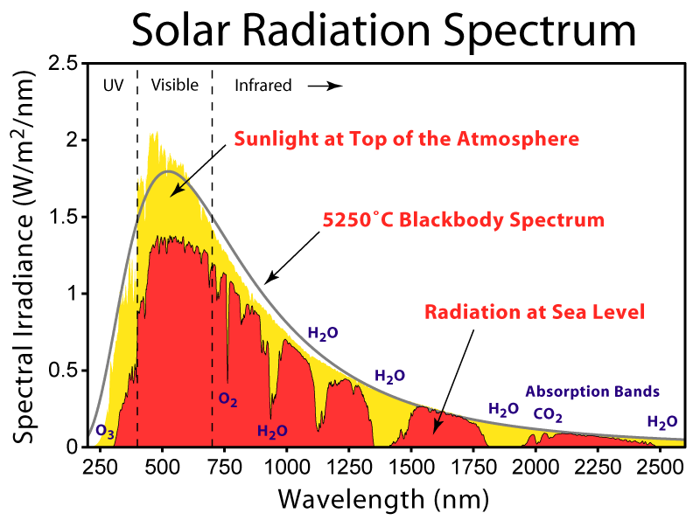
Figure3. Spectrum of solar irradiance outside atmosphere and at sea level with absorption of electromagnetic waves by atmospheric gases. Visible light is 0.4 - 0.8 μ (400 – 800 nm).
The visible part of the Sun’s spectrum is only λ = 400 – 800 nm (0.4 to 0.8 μ.). Any warm body emits radiation. The emission wavelength depends on the body’s temperature. The wavelength of the maximum intensity (see Fig. 5) is governed by the black-body law originated by Max Planck (1858-1947):
, (1)
whereT is body temperature, º K. For example, if a body has an ideal temperature 20 ºC (T = 293 º K), the wavelength is λ_{m} = 9.9 μ.
The energy emitted by a body may be computed by employment of the Josef Stefan-Ludwig Boltzmann law:
, [W/m²], (2)
whereε is coefficient of body blackness (ε = 0.03 ÷ 0.99 for real bodies), σ_{s} = 5.67×10 ⁻⁸ [W/m^{2.}K] Stefan-Boltzmann constant. For example, the absolute black-body (ε = 1) emits (at T = 293 ⁰K) the energy E = 418 W/m².
7. Earth’s atmosphere. The property of Earth’s atmosphere needed for computations are presented in Table 2 below.
Table 2. Standard Earth atmosphere
H km | 0 | 1 | 2 | 3 | 4 | 5 | 6 | 7
=p_{h}/p_{o} | 1 | 0.887 | 0.784 | 0.692 | 0.609 | 0.533 | 0.466 | 0.406
H km | 8 | 9 | 10 | 11 | 12 | 13 | 14 | 15
=p_{h}/p_{o} | 0.362 | 0.304 | 0.261 | 0.224 | 0.191 | 0.164 | 0.14 | 0.12

8.Thethickness and weight of the Algae Dome envelope, its sheltering shell of film, is computed by formulas (from equation for tensile strength):
, (3)
where δ₁ is the film thickness for a spherical dome, m; δ₂ is the film thickness for a cylindrical dome, m; R is radius of dome or radius of cover cell between cable (it may be half of distance between top cable, m; p is additional pressure into the dome, N/m², (p depends from altitude); σ is safety tensile stress of film, N/m².
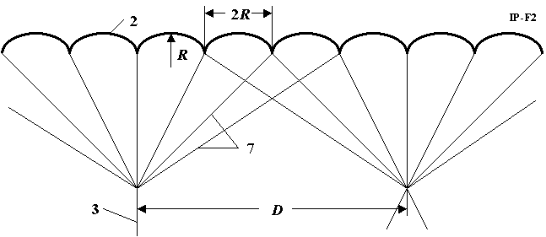
Figure4. Cable support system. Radius R spherical cell of dome cover and distance D between main cable.
For example, compute the film thickness for a dome having radius R = 100 m (distance between top cable 7 is 400 m), additional air pressure p = 0.01 atmosphere (p = 1000 N/m²), safety tensile stress σ = 50 kg/mm²(σ = 5×10⁸ N/m²), spherical dome. We receive δ₁ = 0.1 mm. Distance between main cable 3 is D = 0.8kilometers (Fig. 5).
The computation for others case are presented in Fig. 6 below.
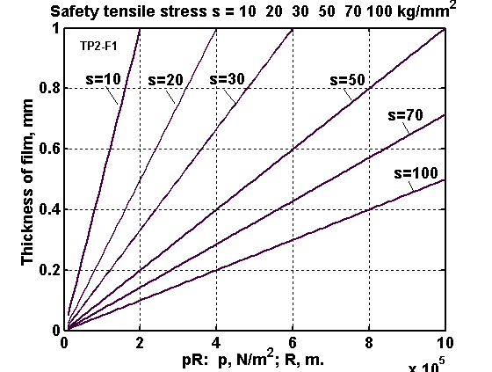
Figure 5. The thickness of top cover via the production of overpressure and radius spherical dome cell (distance between top cables for different safety film tensile stress.
The cover weight (mass) of 1 m² is computed by the equation:
, (4)
wherem is 1 m² film mass, kg/m²; γ is cover density, m. For example, if the cover thickness is δ = 0.2 mm = 0.0002 m and γ = 1500 kg/m³, the m = 0.3 kg/m².
Area S_{c} of semi-sphere diameter R, film cover mass M_{f} and cost C of Dome cover are
, (5)
whereR is radius of semi-sphere, m; m_{f}is average cover area of 1 m² ; c is cost of 1 m², $US/m²; c_{m} is cover cost of 1 kg, $US/m²; C is cost of total cover, $US.
The mass of support cable for 1 m² projection of dome cover. The mass of the support cable for every projection 1 m² of dome cover may be computed by the equation:
, (6)
where m_{c} is cable mass supported the projection one m² of the dome cover, kg/m²; M_{c} is total mass of cable, kg; S=πR² is projection of cover on ground, m²; γ_{c} is density of cable, kg/m³; p is overpressure, N/m²; σ is safety cable tensile stress, N/m²; H is height of cable, m; is relative air pressure at given altitude (Table 2); p_{a} is average overpressure, N/m²; H_{a} is average height of the support cable, m.
We can design the dome cover without the support cable. In this case we compute the thickness of dome cover for radius R of a full Dome (see Eq.(3)). The cover thickness will be more. If we want to compute more exactly and spend less cover mass, we must compute the variable overload (from altitude). In this case we must take into account the variable thickness of dome cover. If the dome doesn’t have the support cable, one can have suspended cables, which allow reaching any part of Dome. The non-cable Algae Dome would require 3-4 times thicker cover.
9. Lift force of1 m² projection of dome cover. The lift force of 1 m² projection of dome cover is computed by equation:
, (7)
whereL₁ is lift force of 1 m² projection of dome cover, N/m²; p is overpressure, N/m²; is relative air pressure at a given altitude (Table 2).
Example, for p = 0.01 atmosphere = 1000 N/m², H = 10kilometers ( = 0.261, Table 2) we get L₁ = 261 N = 26 kg.
Result of computation for different p is shown in Fig.6.
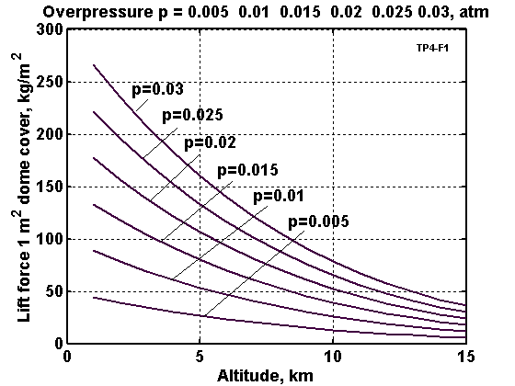
Figure 6. Lift force 1 m2 of vertical projection the Dome cover versus altitude for different overpressures.
10. Leakage of air through hole. The leakage of air through a hole, requested power of levitation fans (ventilator), and time of sinking of Dome cover (in case of large hole) may be estimated by the equation:
, (8)
whereV is speed of air leakage, m/s; p is overpressure, N/m²; ρ is air density at given altitude, ρ = 1,225 kg/m³ at H = 0; S_{h} is area of hole, m; N is motor power, W; η is coefficient efficiency of motor.
Example. The area of hole equals S_{h}= 10² m² (10×10 m) at H = 0 m, p = 0.001 atmosphere = 100 N/m², η = 0.8 . Computation gives the V = 12.8 m/s, M_{a} = 1568 kg/s, N =161 kW.
Estimate of the time required for the Algae Dome cover to sink if no air is pumping it upward. Take the sphere radius R = 500 m. The volume of semi-sphere is v = 262×10⁶ m³ , the air rate is q = VS_{h} =12.8×100 = 1280 m³. The time of the full sinking is t = v/q = 204.10³ s = 57 hours.
11. Inflation supporting 10 cm water between inner and outer walls of algae dome.
For a 75 meter high dome with a circumference of 150 meters, the air pressure required to support the double dome with 10 cm water between the walls are as follows:
- 14.7 psi is ordinary atmospheric pressure
- 1 percent overpressure would be .147 psi.
- Total pressure difference is calculated as follows:
.147 psi x 1600 (40 inches squared, 1 m is 39.37") =
235.2 pounds or >100 kilos per square meter
weight of water, 10 cm thick 1 square meter in area, = 100 kilos
- So 1% overpressure will support 100 kilos per square meter
- The amount of fans needed can be computed as follows:
- A 1000 meter dome would take 57 hours to inflate with a 161 kw array of fans
- total power required is 9177 kw h about 10 mw hours $1000
- A 150 m diameter = 6.66 cubed smaller or 296 times less air to move
- 700 m is less by 1.42 cubed is 2.915 times less
- 7 km diameter, 3.5 km high is 7 x 343x more volume $343000 to inflate
- Also to inflate a 7 km diameter dome in 6 days needs not 50 kw but 17150 kw fans
- 700m diameter dome needs say 18 kw fans to inflate in 6 days costs under $400 to inflate
- A 150 diameter dome in theory under $4 to inflate but recommend at least 30 hp fan suitable for 700 m because as you get smaller domes margins get tighter.
12.As far as calculations on amount of algae produced in a pond vs. in the dome, we take as the basis the numbers from Wikopedia [20]
- “The per unit area yield of oil from algae is estimated to be from between 5,000 to 20,000 gallons per acre, per year (4.6 to 18.4 l/m2 per year).”
- That is OIL from algae not algae
- Using the median number of 10,000 tons/km2
ALGAE DOME PRODUCTION
- 150 diameter pond produces 176.7 tons algae oil
- 75 m high x 150 diameter dome produces 353.42 tons algae oil
- 700 diameter pond produces 3,800 tons algae oil
- 100 m high x 700 diameter dome produces 7,600 tons algae oil

Discussion
There are various proprietary methods of converting algae by products to biodiesel or ethanol and it appears that there is a shortage of algae suppliers that can produce it cheaply enough to make the end product, the fuel to be economically viable. At a conference Martin Tobias, CEO of the biodiesel company Imperium Renewables said, "I'll buy 1,000,000 gallons of algae oil today if anyone here on the panel can deliver it" [21].
Specialized strains of algae at some point may be commercially available to any grower who wants them. Now, however they are proprietary. On the other hand, the growing environment can be even more important than the genetic strain of the algae. In horizontal cultivator systems, light penetrates the suspension only to 5 cm, leaving most of the algae in darkness. The top layer of algae requires only about 1/10th the intensity of full sunlight to maximize growth, so the remaining sunlight is wasted [22].
The bottom line is that algae is very delicate process if you want the yield high as only a thin layer can grow properly, as little as 5 cm. Light delivery and distribution is the principle obstacle to using commercial-scale photobioreactors for algae production. In horizontal cultivator systems, light penetrates the suspension only to 5 cm, leaving most of the algae in darkness. The top layer of algae requires only about 1/10th the intensity of full sunlight to maximize growth, so the remaining sunlight is wasted.
The idea for the Algae dome would circumvent these obstacles by having loops at the same level not necessarily a spiral circulating algae toward sunlight to irradiate and then to cool to optimize temperature and insolation. The space of the dome allows a shielded shaded environment especially if built over a pond or even near the shore at sea.
To optimize growth, reflect excess sunlight, regulate temperature, circulate nutrients and optimize exposure/shading requires experimentation. The initial paradigm is a spiral where fresh water comes in from the top and nutrient CO₂ bubbles from the bottom. As the new water is in top of spiral the concentration of algae is less on top so that light goes through more and the algae is more concentrated as it goes down. Of course, there would need valves to control pressure and regulate exposure to sun by circulating when the temp got too high on sunny side. So a combination of valves, pumps will need to be configured with sensors of pressure and temperature. Ideally as in a factory assembly line, the exit on the bottom is the concentrated algae which are harvested at a steady rate to accommodate the rate of input of the biodiesel process.
On the ponds in some algae farms, they may harvest as often as every 3 days which may be less efficient. Production using this method will increase over time with development of the balance of different strains which grow at different temperatures with different rates of growth to maximize algae production.
Algae needs carbon dioxide (CO₂) to properly grow. Some scientists have considered diverting the CO₂ produced by factories and industrial areas to feed algae farms, a symbiotic relationship wherein atmospheric industrial waste is recycled. Algae also can be used to eat pollutants from sewage and power plants. Rather than acting as a "carbon neutral" energy source, algae can be considered "carbon negative," because it actually removes carbon from the environment when it's grown.
Another benefit to algae is the fact that its byproducts can be used as animal feed; in contrast, converting sources such as corn to animal food removes yet more sustenance from the global food supply. Leftover algal biomass can also be fermented into ethanol, says PetroSun.[23]
Instead of using all of the interior floor space of the algae dome as an algae pond, some of it can be utilized to grow greenhouse plants which require high humidity. The water in the algae ponds can be sea water or unusable water, but when it evaporates in the heat of the day and then condenses in the coolness of the night, it waters the vegetation thus saving irrigation costs.
The technical advantages of the Algae Dome are: 1) The dome in itself has double the volume of breeding ground than a breeding pond. 2) In addition the Algae Dome can encapsulates a pond thus making the total area of breeding ground three times that of a breeding pond. 3) The Algae Dome is insulated thus protecting the algae from contaminants that can kill entire crops 4) The Algae Dome absorbs large quantities of CO₂. Inside the dome carbon dioxide can be bubbled in the water or it can be dropped over the water as CO₂ is heavier than air it will fall to the ground. Inside the tubes the CO₂ has a very long distance to travel and a greater amount of CO₂ will be absorbed by this method.
Environmental Concerns
The environmental impact of algae production in open pools has been of serious concern. On the positive side, algae can metabolize various waste streams (e.g., municipal wastewater, carbon dioxide from industrial flue gas) and produce products include lipids, which can be processed into biodiesel; carbohydrates, which can be processed into ethanol; and proteins, which can be used for human and animal consumption. Algae are commonly genetically engineered to allow for advantageous process modification or optimization. However, issues remain regarding human exposure to algae-derived toxins, allergens, and carcinogens from both existing and genetically modified organisms (GMOs), as well as the overall environmental impact of GMOs.[24] Other negative impacts of microalgae cultivation, are its impacts on the aquatic, atmospheric and terrestrial biospheres that may occur and would need to be managed should the microalgae cultivation industry continue to grow. [25] Until sufficient research on the environmental and health hazards, it is expedient and safer to grow algae in closed loop systems such as the algae dome, and control the processing to biofuel.

Conclusion
The Algae Dome has the advantages of the bio-reactors in that it insulates the algae from deadly environmental pollutants that easily kill the delicate algae crop and is probably as inexpensive as the open ponds. Algae Domes does not need to waste valuable space as the interior can be used for any purpose including but not limited to an interior algae pond and greenhouse that conserves energy and fresh water. This technology allows the control of the water temperature for optimal algae growth. Finally, the algae dome can contain and utilize industrial waste water which otherwise upon evaporation would pollute the environment. Similarly, the algae dome can contain and utilize the emissions from the industrial plants. Factoring in the savings in today’s cleanup costs for many industries, the algae dome has multi-faceted applications that make it a quite viable approach to producing the millions of gallons of badly needed fuel to sustain industry and transportation.

References

[1] | "nanostring," [Online]. Available: http://www.nanostring.net/Algae/CaseStudy.pdf.
[2] | "Mexico Facility," [Online]. Available: http://news.cnet.com/8301-11128_3-9966867-54.html?part=rss&subj=news&tag=2547-1_3-0-20.
[3] | "diversified energy," [Online]. Available: http://www.diversified-energy.com/index.cfm?s_webAction=simgae.
[4] | A. A. Bolonkin, "Transparent inflatable blanket for cities," 2009.
[5] | 2. A. B. a. R. B. Cathcart, "“Inflatable “evergreen” polar zone dome (EPZD) settlements," 2006.
[6] | A. A. Bolonkin, 2006.
[7] | 4. A. Bolonkin, "Cheap textile dam protection of seaport cities against hurricane storm surge waves, tsunamis, and other weather-related floods," 2006.
[8] | 5. B. C. a. A. A. Bolonkin, "Ocean terracing," 2006.
[9] | A. A. Bolonkin, Non-Rocket Space Launch and Flight, London: Elsevier, 2006.
[10] | A. A. B. a. R. B. Cathcart, "Inflatable “evergreen” dome settlements for Earth's polar regions," Clean Technologies and Environmental Policy, vol. 9, no. 9, p. 125–132, 2007.
[11] | A. A. Bolonkin, "Space towers," in Macro-Engineering: A Challenge for the Future, Springer, 2006, pp. 121–150,.
[12] | 9. A. Bolonkin, New Concepts, Ideas, and Innovations in Aerospace, Technology and Human Life, Huntington, NY: NOVA, 2007.
[13] | A. A. Bolonkin, "AB method of irrigation without water (closed-loop water cycle)," 2007.
[14] | A. A. Bolonkin, "Inflatable dome for Moon, Mars, asteroids and satellites,," in Proceedings of the American Institute of Aeronautics and Astronautics Conference , , Long Beach,Calif, USA, ,, September 2007.
[15] | A. A. Bolonkin, "Cheap artificial AB-mountains, extraction of water and energy from atmosphere and change of country climate," 2007.
[16] | A. A. Bolonkin, "Optimal inflatable space towers with 3–100 km height," Journal of the British Interplanetary Society, vol. 56, no. 3-4, p. 87–97, 2003.
[17] | A. A. B. a. R. B. Cathcart, Macro-Projects: Environment and Technology, Huntington, NY: NOVA, 2008,.
[18] | A. A. Bolonkin, "Cheap method of city protection from rockets and nuclear warheads," 2007.
[19] | S. N. a. J. F. A. A. Bolonkin, "Transparent Inflatable Column Film Dome for Nuclear Stations, Stadiums, and Cities," Science and Technology of Nuclear Installations, vol. 2011, pp. 1-13, 2011.
[20] | "wikipedia," [Online]. Available: http://en.wikipedia.org/wiki/Algae_fuel.
[21] | "biofuel-from-algae-on-horizon," [Online]. Available: http://media.cleantech.com/459/biofuel-from-algae-on-horizon-sa .
[22] | "algaeoilbiodiesel," [Online]. Available: http://www.algaeoilbiodiesel.com.
[23] | "aurorabiofuels," [Online]. Available: http://www.aurorabiofuels.com/investors.htm.
[24] | M. Y. Menetrez, "An Overview of Algae Biofuel Production and Potential Environmental Impact," Environ. Sci. Technol., vol. 46, no. 13, p. 7073–708, 2012.
[25] | A. B. R. M. A. C.-V. A. S. T. &. W. F. G. Philippa K. Ushera, "An overview of the potential environmental impacts of large-scale microalgae cultivation," Biofuels, vol. 5, no. 3, pp. 331-349, 2014.
[26] | P. Research, "Biofuels Markets and Technologies," [Online]. Available: http://www.navigantresearch.com/research/biopower-markets-and-technologies.
[27] | "Access to Low-Cost Feedstocks Remains a Key Barrier to Wider Adoption of Biofuels," [Online]. Available: http://www.navigantresearch.com/newsroom/access-to-low-cost-feedstocks-remains-a-key-barrier-to-wider-adoption-of-biofuels.
[28] | "Report: Global Biofuels Market Could Double To $185.3 Billion By 2021," [Online]. Available: http://cleantechnica.com/2012/02/20/report-global-biofuels-market-could-double-to-185-3-billion-by-2021/#ZyL4p5d5Co7r0AEq.99.

