Review of new ideas, innovation of non-rocket propulsion systems for Space
Launch and Flight
(Part 1)
by Alexander Bolonkin
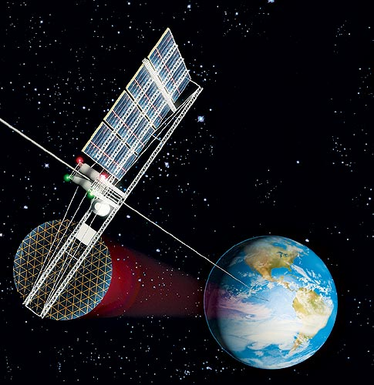
New York 2010

Review Part 1d of non-Rocket PS 3 23 11
Review of new ideas, innovation of non-rocket
propulsion systems for Space Launch and Flight
(Part 1)
by Alexander Bolonkin
C&R, NJIT <aBolonkin@juno.com>
Abstract
In the past years the author and other scientists have published a series of new methods which promise to revolutionize the space propulsion systems, space launching and flight. These include the cable propulsion system, circle propulsion system and space keeper, kinetic propulsion system, gas-tube propulsion system, sliding rotary method, asteroid employment, electromagnetic accelerator, Sun and magnetic sail, solar wind sail, radioisotope sail, electrostatic space sail, laser beam propulsion system, kinetic anti-gravitator (repulsator), Earth-Moon non-rocket and Earth-Mars non-rocket transport system, multi-reflective beam propulsion system, electrostatic levitation, etc.
Some of them have the potential to decrease launch costs thousands of time, other allow to change the speed and direction of space apparatus without the spending of fuel.
The author reviews and summarizes some revolutionary propulsion systems for scientists, engineers, inventors, students and the public.
Key words: Review, Non-rocket propulsion, non-rocket space launching, non-rocket space flight, cable launch system, circle launch system, space keeper, kinetic propulsion system, gas-tube launch system, sliding rotary method, asteroid employment, electromagnetic accelerator, Sun and magnetic sail, solar wind sail, radioisotope sail, electrostatic space sail, laser beam propulsion system, kinetic anti-gravitator (repulsator), Earth-Moon non-rocket and Earth-Mars non-rocket transport system, multi-reflective beam propulsion system, electrostatic levitation, recombination engine, electronic sail, solar sail.
Introduction
Brief History. People have long dreamed to reach the sky. The idea of building a tower high above the Earth into the heavens is very old [1],[6]. The Greed Pyramid of Gaza in Egypt constructed c.2570 BCE has a height 146 m. The writings of Moses, about 1450 BC, in Genesis, Chapter 11, refer to an early civilization that in about 2100 BC tried to build a tower to heaven out of brick and tar. This construction was called the Tower of Babel, and was reported to be located in Babylon in ancient Mesopotamia. Later in chapter 28, about 1900 BC, Jacob had a dream about a staircase or ladder built to heaven. This construction was called Jacob’s Ladder. More contemporary writings on the subject date back to K.E. Tsiolkovski in his manuscript “Speculation about Earth and Sky and on Vesta,” published in 1895 [2-3]. Idea of Space Elevator was suggested and developed Russian scientist Yuri Artsutanov and was published in the Sunday supplement of newspaper “Komsomolskaya Pravda” in 1960 [4]. This idea inspired Sir Arthur Clarke to write his novel, The Fountains of Paradise, about a Space Elevator located on a fictionalized Sri Lanka, which brought the concept to the attention of the entire world [5].
Rockets for military and recreational uses date back to at least 13th century China.
Wernher von Braun, at the time a young aspiring rocket scientist, joined the military (followed by two former VfR members) and developed long-range weapons for use in World War II by Nazi Germany. In 1943, production of the V-2 rocket began in Germany. It had an operational range of 300 km (190 mi) and carried a 1,000 kg (2,200 lb) warhead, with an amatol explosive charge. It normally achieved an operational maximum altitude of around 90 km (56 mi), but could achieve 206 km (128 mi) if launched vertically.
After World War 2 the missile systems have received the great progress and achieved a great success. But rocket system is very expensive. In end of 1990 the researchers begin to study the non-rocket systems which promise to decrease the space launch and flight cost in hundreds times. The pioneer of these researches professor Alexander Bolonkin published the first serious book [1] in this field.
Current status of non-rocket space launch and flight systems. Over recent years interference-fit joining technology including the application of space methods has become important in the achievement of space propulsion system. Part results in the area of non-rocket space launch and flight methods have been patented recently or are patenting now.
Professor Bolonkin made ​​a significant contribution to the study of the different types of non-rocket space launch and flight in recent years [1],[6]-[22] (1982-2011). Some of them are presented in given review.
Cable Space Launcher is researched in [1, pp.39-58]; Circle Launcher and Space Keeper were developed in [1, pp.59-82]; Kinetic Launcher and Kinetic Keeper were researched in [1, Ch.5, 9], [9], [10]; Gas tube hypersonic launcher presented in [1, pp.125-146]; Earth-Moon cable transport system was offered in [1, pp.147-156]; Earth-Mars cable transport system [1, pp.157-164]; Centrifugal space launchers were suggested in [1, pp.187-208, pp.223-244]; Asteroids as propulsion system of space ships were published in [1, pp.209-222]; Multi-reflex propulsion systems were researched in [1, pp.223-244]; Electrostatic Solar wind propulsion was developed in [1, pp.245-270]; Electrostatic utilization of asteroids as space propulsion in [1, pp.271-280]; Electrostatic levitation is presented in [1. pp.281-302]; Guided solar sail and energy generator is described in [1, pp.303-308]; Radioisotope space sail and electro-generator is presented in [1, pp.309-316]; Electrostatic solar sail is researched in [1, pp. 317-326]; Recombination space jet propulsion engine is described in [1, pp.327-340]; and Electronic sail is described in [1, pp.327-340]. Some of these systems were developed in [2]-[23].
Significant scientific, interplanetary and industrial use did not occur until the 20th century, when rocketry was the enabling technology of the Space Age, including setting foot on the moon.
But rockets are very expensive and have limited possibilities. In the beginning 21th century the researches of non-rocket launch and flight started [1], [5]-[8].Some of them are described in this review.
Main types of Non-Rocket Space Propulsion System
Contents:
1. Cable Space Launcher
2. Circle Launcher and Space Keeper
3. Kinetic Launcher and Kinetic keeper
4. Gas tube hypersonic launcher
5. Earth-Moon cable transport system
6. Earth-Mars cable transport system
7. Centrifugal space launchers
8. Asteroids as propulsion system of space ships
9. Multi-reflex propulsion systems
10. Electrostatic Solar wind propulsion
11. Electrostatic utilization of asteroids as space propulsion
12. Electrostatic levitation
13. Guided solar sail and energy generator
14. Radioisotope space sail and electro-generator
15. Electrostatic solar sail
16. Recombination space jet propulsion engine
17. Electronic sail
1. Cable Space Launcher*
A method and facilities for delivering payload and people into outer space are presented. This method uses, in general, engines and a cable located on a planetary surface. The installation consists of a space apparatus, power drive stations located along the trajectory of the apparatus, the cable connected to the apparatus and to the power stations, and a system for suspending the cable. The drive stations accelerate the apparatus up to hypersonic speed.
The estimations and computations show the possibility of making these projects a reality in a short period of time (two project examples are given: a launcher for tourists and a launcher for payloads). The launch will be very cheap at a projected cost of $1–$5 per pound. The cable is made from cheap artificial fiber widely produced by modern industry.
----------------
*This chapter was presented as Bolonkin’s papers IAC-02-V.P.06, IAC-02-S.P.14 at World Space Congress-2002, Oct. 10–19, Houston, TX, USA, and as variant No. 8057 at symposium “The Next 100 years”, 14–17 July 2003, Dayton, Ohio, USA; or see [1, pp.39-58].
Brief Description. The installation includes (see notations in Fig. 1.1): a cable; power drive stations; winged space apparatus (space ship, missile, probe, projectile and so on); conventional engines and flywheels; and a launching area (airdrome). Between drive stations the cable is supported by columns. The columns can also hold additional cables for future launches and a delivery system for used cable.
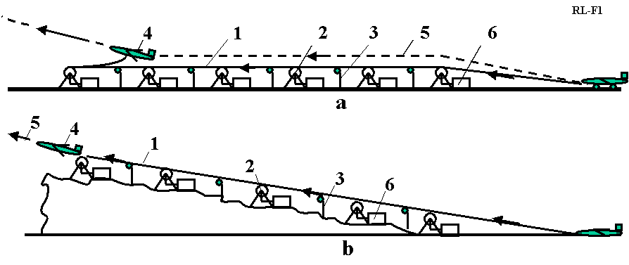
Fig. 1.1. a. Launcher for a crewed space ship with single cable. Notations: 1 – cable contains 3 parts: main part, outlet part, and directive part; 2 – power drive station; 3 – cable support columns; 4 – winged space apparatus (space ship, missile, probe, projectile and so on); 5 – trajectory of space apparatus; 6 – engine. b. A fixed slope small launcher for projectiles.

The installation works in the following way. All drive station start to run. The first power station pulls the cable, 1, connected to the winged space apparatus. The apparatus takes off from the start area and flies with acceleration along trajectory 5. When the apparatus reaches the first drive station, this drive station disconnects from the cable and the next drive station continues the apparatus acceleration, and so on. At the end of the distance, the winged apparatus has reached hypersonic speed, disconnects from the cable, changes the horizontal acceleration into vertical acceleration (while it is flying in the atmosphere) and leaves the Earth’s atmosphere.
. The power stations contain the engines. The engine can be any type, for example, gas turbines, or electrical or mechanical motors. The power drive station has also an energy storage system (flywheel accumulator of energy), a type transmission and a clutch. The installation can also have a slope and launch a projectile at an angle to horizon (Fig. 1.1b).
2. Circle Launcher and Space Keeper*
The author proposes a new method and installation for flight in space. This method uses the centrifugal force of a rotating circular cable that provides a means to launch a load into outer space and to keep the stations fixed in space at altitudes at up to 200 km. The proposed installation may be used as a propulsion system for space ships and/or probes. This system uses the material of any space body for acceleration and changes to the space vehicle trajectory. The suggested system may also be used as a high capacity energy accumulator.
The article contains the theory of estimation and computation of suggested installations and four projects. Calculations include: a maximum speed given the tensile strength and specific density of a material, the maximum lift force of an installation, the specific lift force in planet’s gravitation field, the admissible (safe) local load, the angle and local deformation of material in different cases, the accessible maximum altitudes of space cabins, the speed than a space ship can obtain from the installation, power of the installation, passenger elevator, etc. The projects utilize fibers, whiskers, and nanotubes produced by industry or in scientific laboratories.
------------------------
* Detail manuscript was presented as Bolonkin’s paper IAC-02-IAA.1.3.03 at the Would Space Congress-2002, 10-19 October, Houston, TX, USA. The material is published in JBIS, vol. 56, No 9/10, 2003, pp. 314-327. See in [1, pp.59-82].
Short description of Circle Launcher.
The installation includes (Fig. 2.1): a closed-loop cable made from light, strong material (such as artificial fibers, whiskers, filaments, nanotubes, composite material) and a main engine, which rotates the cable at a fast speed in a vertical plane. The centrifugal force makes the closed-loop cable a circle. The cable circle is supported by two pairs (or more) of guide cables, which connect at one end to the cable circle by a sliding connection and at the other end to the planet’s surface. The installation has a transport (delivery) system comprising the closed-loop load cables (chains), two end rollers at the top and bottom that can have medium rollers, a load engine and a load. The top end of the transport system is connected to the cable circle by a sliding connection; the lower end is connected to a load motor. The load is connected to the load cable by a sliding control connection.
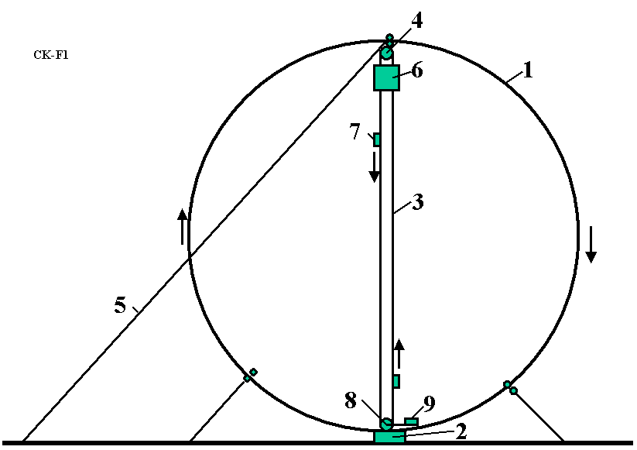
Fig. 2.1. Circle launcher (space station keeper) and space transport system. Notations are: 1 – cable circle, 2 – main engine, 3 – transport system, 4 – top roller, 5 – additional cable, 6 – the load (space station), 7 – mobile cabin, 8 – lower roller, 9 – engine of the transport system.

The installation can have the additional cables to increase the stability of the main circle, and the transport system can have an additional cable in case the load cable is damaged.
The installation works in the following way. The main engine rotates the cable circle in the vertical plane at a sufficiently high speed so the centrifugal force becomes large enough to it lifts the cable and transport system. After this, the transport system lifts the space station into space.
The first modification of the installation is shown in Fig. 2.2. There are two main rollers 20, 21. These rollers change the direction of the cable by 90 degrees so that the cable travels along the diameter of the circle, thus creating the form of a semi-circle. It can also have two engines. The other parts are same.
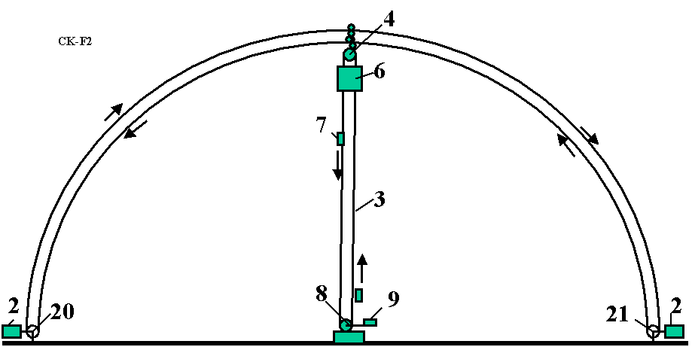
Fig. 2.2. Semi-circle launcher (space station keeper) and transport system. Notation is the same with Fig. 3.1 with the additional 20 and 21 – rollers. The semi-circle is the same (see right side of Fig. 3.4).

The installation can be used for the launch of a payload to outer space (Fig. 2.3). The load is connected to the cable circle by a sliding bearing through a brake. The load is accelerated by the cable circle, lifted to a high altitude, and disconnected at the top of the circle (semi-circle).
The installation may also be used as transport system for delivery of people and payloads from one place to another through space (Fig. 3.4 in [1]).
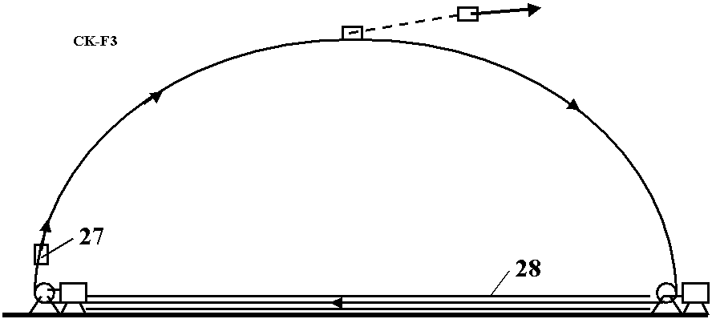
Fig. 2.3. Launching the space ship (probe) into space using cable semi-circle. 27 – load, 28 – vacuum tube (option).

This system works in the following way. The installation has two cable circles, which move in the opposite directions at the same speed. The space stations are connected to the cable circle through the sliding connection. They can move along the circle in any direction when they are connected to one of the cable circles through a friction clutch, transmission, gearbox, brake, and engine, and can use the transport system in Figs. 2.1 and 2.2 for climbing to or descending from the station. Because energy can be lost through friction in the connections, the energy transport system and drive rollers transfer energy to the cable circle from the planet surface. The cable circles are supported at a given position by the guide cables (see Project 2 in [1, Ch.3)]. No towers for supporting the circle cable are needed.
The system can have only one cable (Figs. 2.1, 2.3).
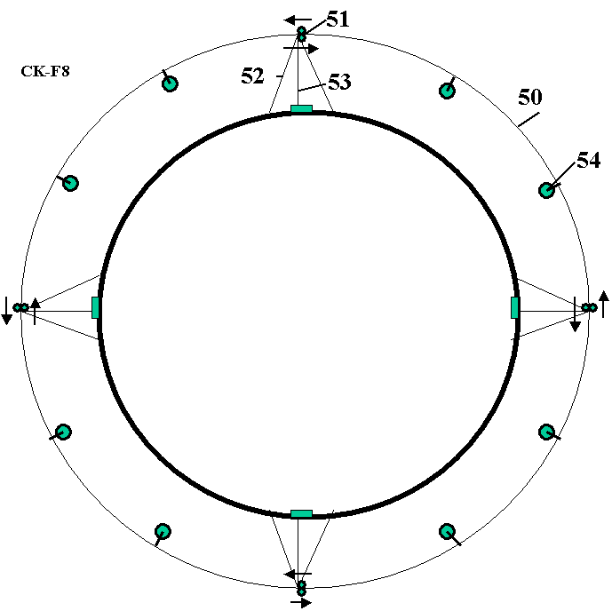
Fig. 2.4. Cable circle around the Earth for 8–10 space objects. Notations are: 50 – double circle, 51 – drive stations, 52 – guide cable, 53 – energy transport system, 54 – space station.

The installation can have a system for changing the radius of the cable circle ([1], Fig. 3.9). When an operator moves the tackle block, the length of the cable circle is changed and the radius of the circle is also changed.
3. Kinetic launcher on kinetic towers*
The author discusses a revolutionary new method to access outer space. A cable stands up vertically and pulls up its payload into space with a maximum force determined by its strength. From the ground the cable is allowed to rise up to the required altitude. After this, one can climb to an altitude using this cable or deliver a payload at altitude. The author shows how this is possible without infringing the law of gravity.
The original article contains the theory of the method and the computations for four projects for towers that are 4, 75, 225 and 160,000 km in height. The first three projects use the conventional artificial fiber widely produced by current industry, while the fourth project use nanotubes made in scientific laboratories. The chapter also shows in a fifth project how this idea can be used to launch a load at high altitude.
------------------------------------------------------------
*Presented as paper IAC-02-IAA.1.3.03 at Would Space Congress 2002, 10–19 October, Houston, TX, USA. Detail manuscript was published as Bolonkin, A.A. “Kinetic Space Towers and Launchers”, JBIS, Vol. 57, No.1/2, 2004, pp.33-39. Or see in [1, Ch.5, pp.107-124].
Brief description of innovation.
The installation (kinetic tower) includes (see notations in Fig. 3-1a,b and others): a strong closed-loop cable, two rollers, any conventional engine, a space station, a load elevator, and support stabilization ropes.
The installation works in the following way. The engine rotates the bottom roller and permanently sends up the closed-loop cable at high speed. The cable reaches a top roller at high altitude, turns back and moves to the bottom roller. When cable turns back it creates a reflected (centrifugal) force. This force can easily be calculated using centrifugal theory, or as reflected mass using a reflection theory. The force keeps the space station suspended at the top roller; and the cable (or special elevator) allows the delivery of a load to the space station. The station has a parachute that saves people if the cable or engine fails.
The theory shows, that current widely produced artificial fibers (see References¹ for cable properties) allow the cable to reach altitudes up to 100 km (see Projects 1 and 2 in [1] Ch.5). If more altitude is required a multi-stage tower must be used ([1], Fig. 5.2, see also Project 3 in [1] Ch.5). If a very high altitude is needed (geosynchronous orbit or more), a very strong cable made from nanotubes must be used (see Project 4).
The offered tower may be used for a horizon launch of the space apparatus (Fig. 3.2). The vertical kinetic towers support horizontal closed-loop cables rotated by the vertical cables. The space apparatus is lifted by the vertical cable, connected to horizontal cable and accelerated to the required velocity.
The closed-loop cable can have variable length. This allows the system to start from zero altitude, and gives the ability to increase the station altitude to a required value, and to spool the cable for repair. The device for this action is shown in [1], p.110, Fig. 5.4. The offered spool can reel in the left and right branches of the cable at different speeds and can change the length of the cable.

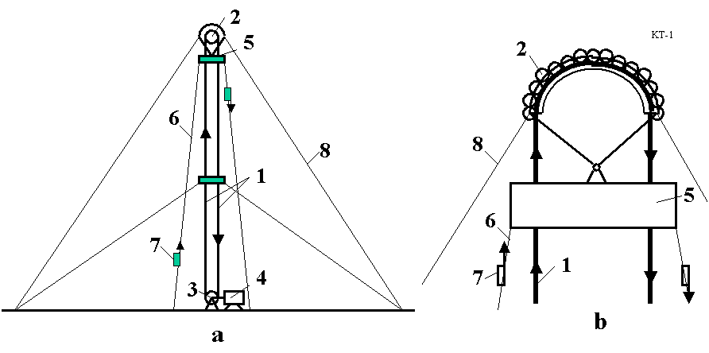
Fig. 3.1. a. Offered kinetic tower: 1 – mobile closed loop cable, 2 – top roller of the tower, 3 – bottom roller of the tower, 4 – engine, 5 – space station, 6 – elevator, 7 – load cabin, 8 – tensile element (stabilizing rope). b. Design of top roller.

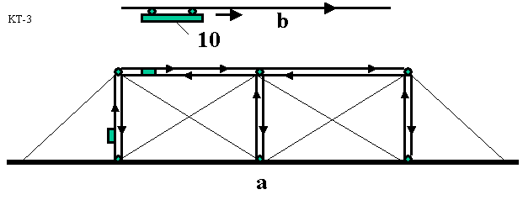
Fig. 3.2. a. Kinetic space installation with horizontally accelerated parts. b. 10 – accelerated missile.
4. Gas Tube Hypersonic Launcher*
The present review describes a hypersonic gas rocket, which uses tube walls as a moving compressed air container. Suggested burn programs (fuel injection) enable use of the internal tube components as a rocket. A long tube (up to 0.4–0.8 km) provides mobility and can be aimed in water. Relatively inexpensive oxidizer and fuel are used (compressed air or gaseous oxygen and kerosene). When a projectile crosses the Earth’s atmosphere at an angle more than 15º, loss of speed and the weight of the required thermal protection system are small. The research shows that the launcher can give a projectile a speed of up to 5–8 km/s. The proposed launcher can deliver up to 85,000 tons of payloads to space annually at a cost of one to two dollars per pound of payload. The launcher can also deliver about 500 tons of mail or express parcels per day over continental distances and may be used as an energy station and accumulator. During war, this launch system could deliver military munitions to targets thousands to tens of thousands of kilometers away from the launch site.
------------------------
* This review is based on a paper presented at the 38th AIAA Propulsion Conference, 7–10 July 2002, Indianapolis, USA (AIAA-2002-3927) and the World Space Congress, 10–19 Oct. 2002, Houston, USA (IAC-02-S.P.15). Detailed material is published as A.A.Bolonkin, “Hypersonic Gas-Rocket Launcher of High Capacity”, JBIS, vol. 57, No. 5/6, 2004, pp. 162–172; Journal Actual Problems of Aviation and Aerospace Systems, Kazan, 1 (15), pp. 45-69, 2003.
See also in [1, Ch.6, pp.125-146].
Description
Fig. 4.1a shows a design of the tube of the suggested hypersonic gas-rocket system. The system is made up of a tube, a piston with a fuel tank and payload, and nozzle connected to the piston, and valves.
The tube rocket engine can be made without a special nozzle (Fig. 4.1b). In this case, the fuel efficiency of the gas-rocket engine will decrease but its construction becomes simpler.
The tube may be placed into a frame (Fig. 4.1c). The frame is placed into water and connected to a ship for mobility and aiming.
The launch sequence is as follows. First the movable piston with the fuel tank (containing liquid fuel), and payload are loaded into the tube. The piston is held in place by the fasteners or closed valve 17 (Fig. 4.1). The direction and angle of the launch tube are set.

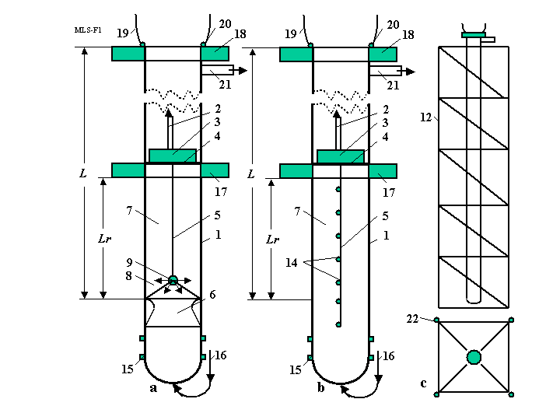
Fig. 4.1. a - Space launcher with the gas rocket and rocket nozzle in the tube. The system comprises the following: 1 – tube, 2 – payload (projectile), 3 – fuel tank, 4 – piston , 5 – fuel pipeline, 6 – nozzle connected to piston, 7 – rocket air column, 8 – combustion chamber, 9 – injectors of the combustion chamber, 12 – tube frame, 14 – additional injectors, 15 – lower tube injectors, 16 – air pipeline, 17 – lower valve, 18 – upper valve, 19 – top valve, 20 – air lock, 21– gas pipe, 22 – electric engines.
b - Space launcher with the gas rocket and no the rocket nozzle. c – Launcher in frame.
Valve 19 (Fig. 4.1) is closed and a vacuum (about 0.005 atm) is created in the launch tube space above the payload/piston to reduce the drag imparted to the payload/piston as it moves along the launch tube. The tube, of a length of 630 m and a diameter of 10 m, contains 61 tons of air at atmospheric pressure. If this air is not removed, the payload must be decreased by the same value. If air pressure is decreased down to 0.005 atm, the parasitic air mass is decreased to 300 kg. This is an acceptable parasitic load.
Valve 17 is closed and an oxidizer (air, oxygen, or a mixture) is pumped into the space below the payload/piston.
Liquid fuel (benzene, kerosene) is injected into the space below nozzle 6 through the launch tube injectors (item 15, Fig. 4-1) and ignited. Valve 17 (Fig. 4-1) is opened. The hot combustion gas expands and pushes the payload/piston system along the launch tube together with the air column (item 7) between the piston and nozzle.
When the piston reaches the maximum gun speed (about 1 km/s), the compressed air column begins to work as a rocket engine using one of the special injection fuel programs (see Reference in [1, Ch.6¹²]).
As the payload/piston approaches the end of the launch tube, valve 19 is opened and the airlock (item 20) begins to operate. After the payload/piston has left the launch tube, valve 18 closes the end of the launch tube and re-directs the hot combustion gases down the bypass tube (item 21) to various turbo-machines preparing compressed air for the next shot and electricity for customers.
If a high launch frequency is required, then internal tube water injectors are used to quickly cool the launch tube.
After the payload/piston system leaves the launch tube, the payload (projectile) separates from the piston and the empty fuel tank. The payload continues to fly along a ballistic trajectory. At apogee, the payload may use a small rocket engine to reach orbit or to fly to any point on Earth.
The method by which the fuel is injected and ignited within the launch tube is critical to high-speed (hypersonic) acceleration of the payload. The author has developed the five fuel injection programs for the launch system¹².
In these programs the thrust (force) is constant at all times, which means that pressure and all parameters in the rocket engine are constant. Parts of the programs have two steps. In the first step the fuel is injected into compressed air at the lower part of the tube to support a constant pressure and provide the initial acceleration of the rocket (together with air column L_{r}) to the velocity V_{o}. In the second step the rocket engine begins to thrust and support the constant pressure and temperature in the rocket combustion chamber. The result is that the thrust force of the gas-rocket engine remains constant. In the reference article the author considered only a simplified model ([1, Fig. 6.1b]) when a rocket nozzle is absent.
5. Earth–Moon Cable Transport System*
The author proposes a new transportation system for travel between Earth and the Moon. This transportation system uses mechanical energy transfer and requires only minimal energy, using an engine located on Earth. A cable directly connects a pole of the Earth through a drive station to the lunar surface. The equation for an optimal equal stress cable for the complex gravitational field of the Earth–Moon has been derived that allows significantly lower cable masses. The required strength could be provided by cables constructed of carbon nanotubes or carbon whiskers. Some of the constraints on such a system are discussed.
-----------------------------------------------------------
* This review is based on paper B0.3-F3.3-0032-02 that was presented to 34th COSPAR Scientific Assembly, The World Space Congress 2002, 10–19 Oct 2002, Houston, Texas, USA. This is only part of the original manuscript (one version of the system) presented to the WSC. This part of WSC manuscript was published in as “Non-Rocket Earth–Moon Transport System”, in Advanced Space Research, Vol. 31, No. 11, pp. 2485–2490, 2003. See also [1, Ch.7, pp.147-155].
Brief Description.
The objectives of the proposed system are to provide an inexpensive means of travel between the Earth and the Moon, to simplify space transportation technology, and to eliminate complex hardware. The proposed Earth–Moon cable transport system is shown in Fig. 5.1. The system consists of three cables: a main (central) cable, which supports the weight of the entire system, and two closed-loop transport cables, which include a set (5–10) of cable chain links connected sequentially to one other by rollers [1, Ch.7^{3, 4} (see Fig.7.3a)]. The system is connected at the Earth’s pole and to any position on the Moon’s surface that continually faces Earth. An engine located on a planet (e.g. the Earth, but it could be the Moon) drives the cable transport system. On the Earth, the cable is supported in the atmosphere by a winged device, which also counteracts the rotation of the Earth. The transfer cable system transfers energy between load cabins moved up and down, which requires the engine moving the cable system to overcome only frictional forces.
An optimal (minimum mass, equal stress) variable diameter cable is defined for the main tether. The main cable has a relatively large but variable cross-section area (diameter) because it has to support the total system weight, which is several hundred times the load weight. In an optimal main cable the cross-section area increases (for K = 2, about 20 times) in the altitude range 0 – 150,000 km, is approximately constant in the range 150,000–380,000 km, and decreases near the Moon’s surface, from 20,000 km to the surface.
The mass of the main cable is minimized because its diameter is variable along the distance (see the next section for calculation of the main cable cross-section areas and mass). The transport cables pull (move) the load cabins (one up, the other down) along the main cable. As these are moveable parts, they must have constant diameter. If they had to carry a load the full distance to the Moon, their mass would be very large. My concept separates the full distance into sub-distances (5–10), with closed-loop links for every sub-distance connected by rollers. These rollers transfer the transport cable movement from one link to another. In this case, the mass of the transport cables is minimized because at every local length (sub-distance) the cable diameter is determined by the local force. Total mass of the transport cable should be close to double the mass of the main cable.
The load containers are connected to the transport cable. When containers come up to the rollers, they pass the rollers, connect to the next link and continue their motion along the main cable. The load (cabin) has special clamps to allow this transfer between the different diameter cables in each link¹. Most space payloads, like tourists, must be returned to Earth. When one container is moved up, another container is moved down. The work of lifting equals the work of descent, except for a small friction loss in the rollers. The transport system may be driven by a conventional motor located at the Earth drive station, on a space station, or on the Moon. When payloads are not being delivered into space, the system may be used to transfer mechanical energy to the Moon. For example, the Earth drive station can rotate an electric generator on the Moon.

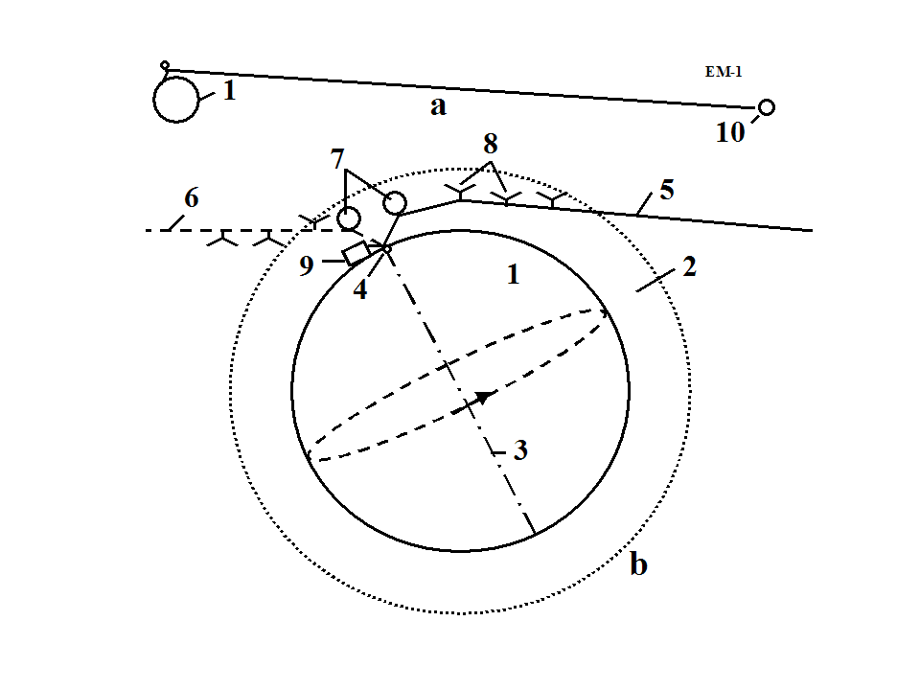
Fig. 5.1. A conceptual Earth–Moon transportation system. One end is connected to the Earth’s pole. the second end is connected to the Moon. Notation: 1 – the Earth; 2 – Earth’s atmosphere; 3 – axis of Earth rotation; 4 – Earth Pole; 5 – Earth–Moon cable transport system in right position (one extreme of the Moon’s position); 6 – Earth–Moon system in left position; 7 – air balloons; 8 – support wings; 9 – drive station; 10 – Moon.

The cable is supported in the Earth’s atmosphere by air balloons (around the pole) and winged devices (far from the pole). The maximum speed of the system in the atmosphere is about 190 m/sec at the maximum distance of 2700 km in the right-hand position of Fig. 5-1. When the cable is located in the left-hand position, some wings may be out of the atmosphere and not so effective.
The Moon’s orbit has eccentricity. Every 29 days the Moon’s distance from Earth changes by about 50,000 km. Devices shown in Fig. 7.4 (in [1, Chapter 7]) must be used to change the length (or link length) of the transport cables as the Earth–Moon distance changes. They may be located at the Earth drive station, on a space station, in space, and/or on the Moon. The average speed of a cable length change is about 40 m/s. As the Moon pulls the transport system, it may be used to produce mechanical energy. If the cables can support 9 tons, the power can reach 1.8 million Watts. The cables rotate the electric generator and negligibly brake the Moon’s movement.
6. Earth–Mars Cable Transport System*
The author offers and computes a new permanent cable transport system that links a pole of the Earth with Mars orbit. This system connects Earth and Mars for 1–1.5 months every 1.7–2 years when they are located at the nearest distance and allows the transfer of people and loads to Mars and back. The system has many advantages because it uses a transport engine located on Earth, but it also requires the high strength cable made from nanotubes. This work contains theory of an optimal equal stress cable, that connects the Earth and Mars orbit, as well as computed parameters of the suggested system.
-------------------------------
*Presented as paper BO.4-C3.4-0036-02 to The World Space Congress-2002 10–19 Oct. 2002, Houston, Texas, USA. Detailed material was published in Actual Problems of Aviation and Aerospace Systems. No. 2 (16), vol. 8, 2003. See also [1, Ch.8, pp.157-164].
Brief Description
The review contains the theory and results of computation for a special project. This project uses three cables (one main cable and two for driving loads) mass from artificial material: whiskers, nanotubes, with the specific tensile strength (ratio of tensile stress to density) k = σ/γ = 20.10⁷ (K = 20) or more. Nanotubes with the same or better parameters are available in scientific laboratories. The theoretical limit of nanotubes of SWNT type is about k = 100.10⁷ (K = 100).
A proposed centrifugal Mars cable transport system is shown in Figs. 6.1 and 6.2. The system includes the optimal equal stress cable which has a length approximately equal to the minimum distance of the Earth to Mars orbit. The installation has a transport system with chains connected by rollers and two transport cables.

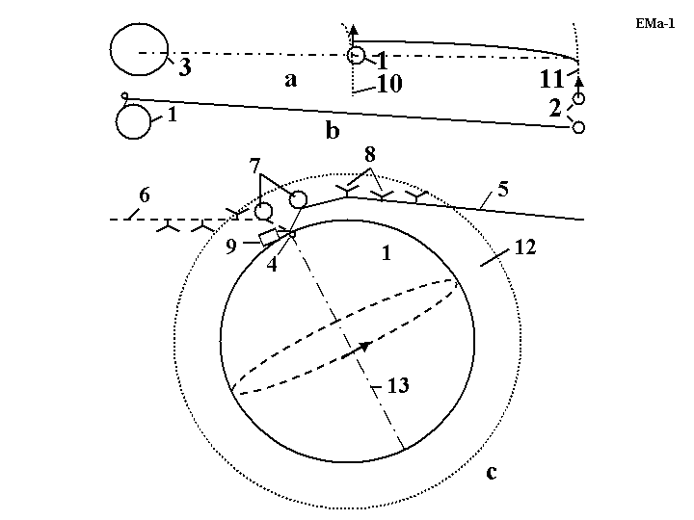Fig. 6.1. The offered Earth–Mars orbit Transport System. a. Sun–Earth–Mars; b. Earth–Mars; c. Connection to Earth pole. Notations: 1– Earth, 2 – Mars, 3 – Sun, 4 – Earth pole, 5 – Earth–Mars cable transport system in right position, 6 – Earth–Mars cable transport system in left position, 7 – air balloon, 8 – support wing, 9 – drive station, 10 – Earth orbit, 11 – Mars orbit, 12 – Earth atmosphere, 13 – axis of Earth rotation.
15
144
17
18

Fig. 6.2. Cables of transport system. Notations: 144 – space ship, 15 – rollers, 17 – transport cable, 18 – main cable.

The upper ends of the cables are located near Mars orbit and the lower ends of the cables are connected to the Earth’s pole. They are supported in the Earth’s atmosphere by air balloons (near the Pole) and winged devices at a maximum distance of up to 2800 km. The rotary speed of the cables changes from zero (at the pole) to 190 m/s (at the end of the maximum distance in the atmosphere). These winged devices can support cables when they are located within the lower atmosphere.
The installation would have a device that allows the length of the cables to be changed. The device would consist of a spool, motor, brake, transmission, and controller. The facility could have mechanisms for delivering people and payloads to Mars and back using the suggested transport system.
The delivery devices include: containers (passenger cabins, space ships, etc.), cables, motors, brakes, and controllers.
The space cabin can temporarily land on the surface of the Mars for loading and performing research. The space cabin has a small rocket engine for maneuvering and landing on the surface of Mars.
Every two years Mars comes within a minimum distance from Earth. For about 1–1.5 months the cable transport system (CTS) can be used to deliver people and loads to Mars. The space ship moves in advance to the upper end of the CTS, then when Mars arrives, the vehicles land on its surface and the people work on for Mars 1–1.5 months; afterwards the space ships return to Earth. While living on Mars, the people can fly from one place to another with speeds of about 230 m/s (including Mars round trip at low altitude) in their space cabin (ship). Exploring using the CTS would not require rocket fuel.
7. Centrifugal Space Launcher*
This manuscript describes a method and devices that provides a repulsive (repel, push, opposed to gravitation) force between given bodies. The basic concept is that a strong, heavy cable is projected upwards using a motorized wheel on the ground. The upward momentum of the cable is transferred to the apparatus by means of a pulley/roller mechanism, which sends the cable back down to the motor. The momentum transferred from the cable to the apparatus produces a push force which can suspend the apparatus in the air or lift it. There is an equal and opposite force on the motorized wheel on the ground. The push force can be great (up to tens of tons) and operate over long distances (up to hundreds of kilometers). This force produces great accelerations and velocities of given bodies (vehicles).
-----------------
*The main idea of this Chapter was presented as IAC-02-IAA.1.3.03, 53rd International Astronautical Congress. The World Space Congress – 2002, 10–19 Oct. 2002, Houston, Texas, USA, and the full manuscript accepted as AIAA-2005-4504, 41 Propulsion Conference, 10–12 July, 2005, Tucson, Arizona, USA. See also [1, Ch.10, pp.187-206].
Description of Innovative Launcher
Ground sling launcher. The installation includes (see notations in Fig. 7.1): a tower, a lever (or disk), a sling (cable), conventional engines and flywheels (drive station). Optimally, the installation is located on a mountain (high altitude) to reduce air drag on the sling and apparatus and for a lower slope of initial trajectory angle. A winged space apparatus (space ship, missile, probe, projectile, etc.) is connected to the end of the sling.
The installation works in the following way (Fig. 7.1). The engine rotates the flywheels. When the flywheels accumulate sufficient energy, they rotate as a lever. The lever accelerates the space apparatus (“s.a.”). The apparatus may be located on the lever and the sling is increased after the start. The apparatus speed increases. It is greater than the lever speed in the ratio R/R₀, where R is the radius of the apparatus trajectory circle, R₀ is the radius of the lever (or disk). When the apparatus reaches its chosen speed, the winged apparatus is disconnected from the sling at the desired point of the circle. While the winged apparatus is flying in the atmosphere, it can increase its slope and correct its trajectory. If the apparatus has a hypersonic (supersonic) form, the speed loss is small¹³.
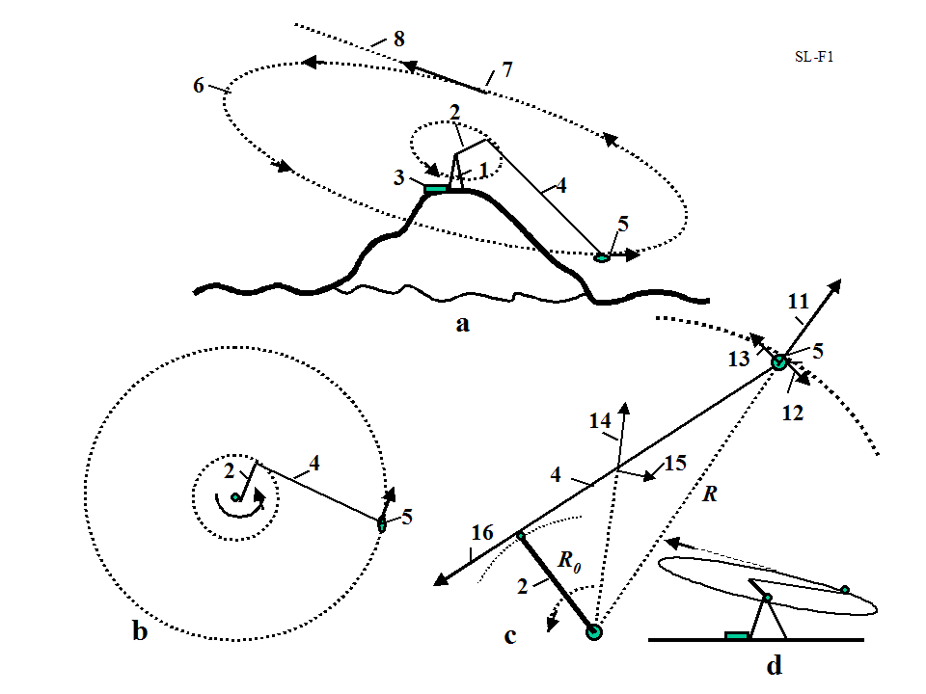
Fig. 7.1. Sling rotary launcher. a) launcher located on mountain, b) top view of installation, c) acting forces, d) side view. Notations: 1 – tower, 2 – lever or disk, 3 – engine, 4 – sling, 5 – space apparatus (s.a.), 6 – circular launch trajectory, 7 – point of disconnection, 8 – direction of launch, 11 – centrifugal force of space apparatus, 12 – drag of s.a., 13 – speed of s.a., 14 – centrifugal force of sling, 15 – drag of sling, 16 – lever force.
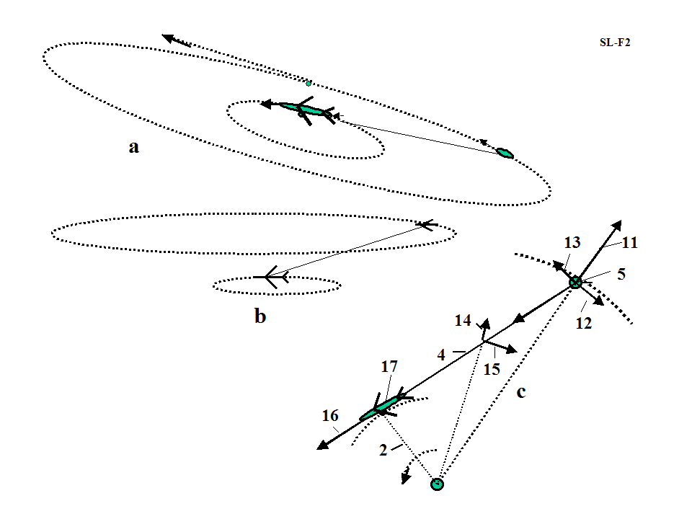
Fig. 7.2. Launching a space ship using aircraft. a) slinging slope start, b) upper start, c) installation forces.

The offered launcher is different from conventional centrifugal catapults, which have a projectile in a lever. This launcher has a long sling and the projectile is in the sling. The sling increases the lever speed many times and decreases the mass of the lever. Conventional catapults made from nanotubes have a huge mass and requires gigantic energy to work. This sling is also made from nanotubes (for space speed), but its mass is small.
If the circle is parallel to the Earth’s surface, the winged apparatus disconnects from the cable, converts the linear and centrifugal acceleration into vertical acceleration (while it is flying in the atmosphere) and leaves the Earth’s atmosphere.
The power station houses the engine. It can be any engine, for example, a gas turbine, or an electrical or mechanical motor. The power drive station also has an energy storage system (flywheel accumulator of energy), a transmission drive train and a clutch mechanism.
The installation can be set on a slope, and launch a projectile at an angle to the horizon (Fig. 7.1).
The attained speed may be up to eight or more km/s (see project 2 below). If the planet does not have an atmosphere, a small installation (with a small lever) can give the projectile a very high speed, limited only by the power of the engine and the strength of the sling.
On the Earth’s surface the launcher can be located under a special cover (or in a tube) in a vacuum.
Aircraft sling launcher. Another design of this sling launcher is presented in Figs. 7.2. A small spacecraft (1 – 2 tons) is connected to a large, high-speed aircraft. The aircraft flies in a circle, increasing the sling length and accelerating the ship to high speed. The attained speed depends largely on the specific strength of the sling, the maximum aircraft speed and the thrust of the aircraft. For large existing aircraft operating in the atmosphere, the launch speed may reach up 2 km/s. This is enough for the X-prize flight, reaching an altitude of up to 100 km and sufficient for a spaceship for tourists (see projects 3–4 below).
Advantages. The suggested launch cable system has advantages compared to the current rocket systems, as follows:
- The sling launcher is many times less expensive than modern rocket launch systems. No expensive rockets are needed. Only motor and cable are required.
- The sling launcher reduces the delivery cost by several thousand times (to as low as $5 to $10 per pound). (No rocket, cheaper fuel.)
- The sling launcher could be constructed within one to two years. The aircraft sling launcher requires only a cable and a spaceship. Modern rocket launch systems require many years for R&D and construction.
- The sling launcher does not require high technology and can be made by any non-industrial country.
- Rocket fuel is expensive. The ground sling launcher can use the cheapest sources of energy, such as wind, water, or nuclear power, or the cheapest fuels such as gas, coal, peat, etc., because the engine is located on the Earth’s surface. Flywheels may be used as an accumulator of energy.
- It is not necessary to have highly qualified personnel, such as rocket specialists with high salaries.
- The fare for space tourists would be small.
- There is no pollution of the atmosphere from toxic rocket gas.
- Thousands of tons of useful payloads can be launched annually.
Shortcomings of sling space launchers:
1. The need for a very strong sling (cable), made from carbon whiskers or still-to-be manufactured long nanotubes.
2. The Earth ground sling launcher may be used only for robust loads because high centrifugal acceleration is imposed on the payload. Such payloads normally account for 70–80% of space payloads.
Cable (sling) discussion. The experimental and industrial fibers, whiskers, and nanotubes are considered in [1], Chapters 1–2.
The reader can find a more complete cable discussion of cable and cable characteristics in [1], Ch.10, the References^{3–13, 17–20}.
8. Asteroids as Propulsion System of Space Ships*
The purpose of this section is to draw attention to the idea of sling rotary launchers. This idea allows the building of inexpensive new space launcher systems, to launch missiles, projectiles, and space apparatus, and to use many types of energy. This chapter describes the possibilities of this method and the conditions which influence its efficiency. Included are four projects: a non-rocket sling projectile launcher, a space sling launcher, a spaceship for launching using conventional supersonic, and a space ship using subsonic aircraft. The last two only require low-cost cable made from artificial fiber, using whiskers that are produced in industry now or increasingly perfected nanotubes that are being created in a scientific laboratories.
---------------------
*The detailed work was presented as AIAA-2005-4035 at the 41 Propulsion Conference, 10–12 July, 2005, Tucson, Arizona, USA. See also [1, Ch.11, pp. 209-222].
Introduction.
There are many small solid objects in the Solar System called asteroids. The vast majority are found in a swarm called the asteroid belt, located between the orbits of Mars and Jupiter at an average distance of 2.1 to 3.3 astronomical units (AU) from the Sun. Scientists know of approximately 6,000 large asteroids of a diameter of 1 kilometer or more, and of millions of small asteroids with a diameter of 3 meters or more. Ceres, Pallas, and Vesta are the three largest asteroids, with diameters of 785, 110 and 450 km (621, 378, and 336 miles), respectively. Others range all the way down to meteorite size. In 1991 the Galileo probe provided the first close-up view of the asteroid Caspra; although the Martian moons (already seen close up) may also be asteroids, captured by Mars. There are many small asteroids, meteorites, and comets outside the asteroid belt. For example, scientists know of 1,000 asteroids of diameter larger than one kilometer located near the Earth. Every day 1 ton meteorites with mass of over 8 kg fall on the Earth. The orbits of big asteroids are well known. The small asteroids (from 1 kg) may be also located and their trajectory can be determined by radio and optical devices at a distance of hundreds of kilometers.
Radar observations enable to discern of asteroids by measuring the distribution of echo power in time delay (range) and Doppler frequency. They allow a determination of the asteroid trajectory and spin and the creation of an asteroid image.
Most planets, such as Mars, Jupiter, Saturn, Uranus, and Neptune have many small moons that can be used for the proposed space transportation method.
There are also the asteroids located at the stable Lagrange points of the Earth–Moon system. These bodies orbit with the same speed as Jupiter, and might be very useful for propelling spacecraft further out into the solar system. Comets may also be useful for propulsion once a substantial spacecraft speed is obtained. It seems likely that the kinetic and rotational energy of both comets and asteroids will eventually find application in space flight.
Most asteroids consist of carbon-rich minerals, while most meteorites are composed of stony-iron.
The present idea [1]^{6–8} is to utilize the kinetic energy of asteroids, comets, meteorites, and space debris to change the trajectory and speed of space ships (probes). Any space bodies more than 10% of a ship’s mass may be used, but here mainly bodies with a diameter of 2 meters (6 feet) or larger are considered. In this case the mass (20–100 tons) of the space body (asteroid) is some 10 times more than the mass of probe (1 ton, 2000 lb) and the probe mass can be disregarded.
Connection Method
The method includes the following main steps:
(a) Finding an asteroid using a locator or telescope (or looking in catalog) and determining its main parameters (location, mass, speed, direction, rotation); selecting the appropriate asteroid; computing the required position of the ship with respect to the asteroid.
(b) Correcting the ship’s trajectory to obtain the required position; convergence of the ship with the asteroid.
(c) Connecting the space apparatus (ship, station, and probe) to the space body (planet, asteroid, moon, satellite, meteorite, etc.) by a net, anchor, and a light strong rope (cable), when the ship is at the minimum distance from the asteroid.
(d) Obtaining the necessary position for the apparatus by moving around the space body and changing the length of the connection rope.
(e) Disconnecting the space apparatus from the space body; spooling the cable.
The equipment required to change a probe (spacecraft) trajectory includes:
(a) A light strong cable (rope).
(b) A device to measure the trajectory of the spacecraft with relative to the space body.
(c) A device for spacecraft guidance and control.
(d) A device for the connection, delivery, control, and disconnection and spooling of the rope.

Description of Utilization
The following describes the general facilities and process for a natural space body (asteroid, comet, meteorite, or small planet) with a small gravitational force to change the trajectory and speed of a space apparatus.
Figs. 8.1a,b,c show the preparations for using a natural body to change the trajectory of the space apparatus; for example, the natural space body 2, which is moving in the same direction as the apparatus (perpendicular to the sketch, Fig. 8.1a). The ship wants to make a maneuver (change direction or speed) in plane 3 (perpendicular to the sketch), and the position of the apparatus is corrected and moved into plane 3. It is assumed that the space body has more mass than the apparatus.

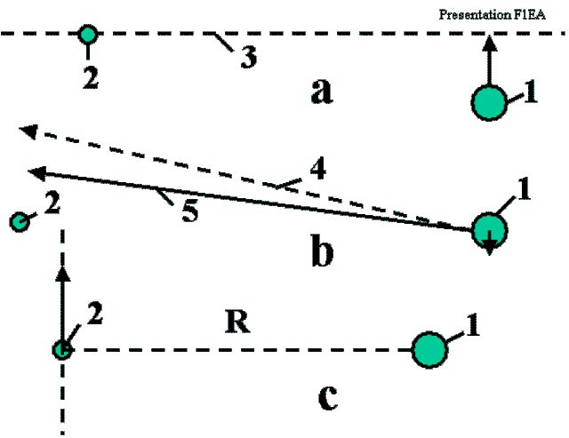
Fig. 8.1. Preparing for employment of the asteroid. Notations: 1 – space ship, 2 – asteroid, 3 – plane of maneuver. 4 – old ship direction, 5 – corrected ship direction. a) Reaching the plane of maneuver; b) Correcting the flight direction and reaching the requested radius; c) Connection to the asteroid.

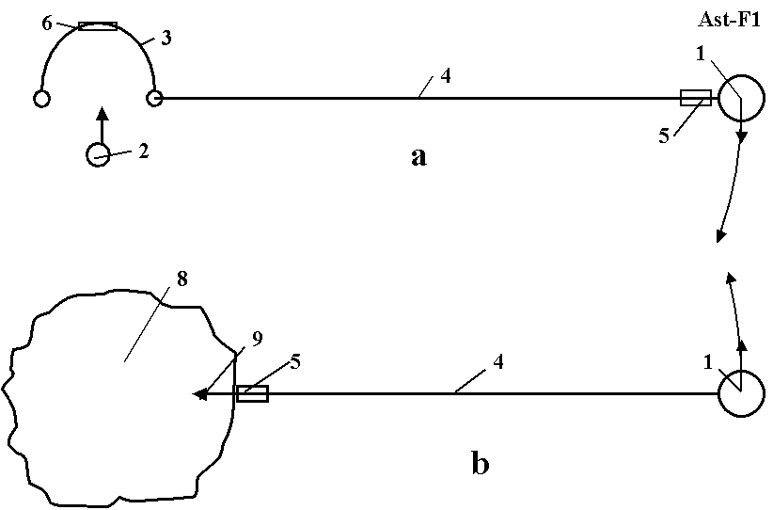
Fig. 8.2. a) Catching a small asteroid using net; b) Connection to a big asteroid using an anchor and cable. Notation: 1 – space ship, 2, 8 – asteroid, 3 – net with inflatable ring, 4 – cable (rope), 5 – load cabin, 6 – valve, 9 – anchor.

When the apparatus is at the shortest distance R from the space body, it connects to the space body means of the net (Fig. 8.2a) or by the anchor (Fig. 8.2b) and rope. The apparatus rotates around the common center of gravity at the angle j with angular speed w and linear speed DV . The cardioids of additional speed and direction of the apparatus are shown in [1] Fig. 11.4 (right side). The maximum additional velocity is DV = 2V_{a}, where V_{a} is the relative asteroid velocity when the coordinate center is located in the apparatus.
Fig. 8.2a shows how a net can be used to catch a small asteroid or meteorite. The net is positioned in the trajectory of the meteorite or small asteroid, supported in an open position by the inflatable ring and connected to the space apparatus by the rope. The net catches the asteroid and transfers its kinetic energy to the space apparatus. The space apparatus changes its trajectory and speed and then disconnects from the asteroid and spools the cable. If the asteroid is large, the astronaut team can use the asteroid anchor (Figs. 8.2b).
The astronauts use the launcher (a gun or a rocket engine) to fire the anchor (harpoon fork) into the asteroid. The anchor is connected to the rope and spool. The anchor is implanted into the asteroid and connects the space apparatus to the asteroid. The anchor contains the rope spool and a disconnect mechanism. The space apparatus contains a spool for the rope, motor, gear transmission, brake, and controller. The apparatus may also have a container for delivering a load to the asteroid and back (Fig. 8.2b). One possible design of the space anchor is shown in [1, Fig. 11.3]. The anchor has a body, a rope, a cumulative charge (shared charge), the rocket impulse (explosive) engine, the rope spool and the rope keeper. When the anchor strikes the asteroid surface the cumulative charge burns a deep hole in the asteroid and the rocket-impulse engine hammers the anchor body into the asteroid. The anchor body pegs the catchers into the walls of the hole and the anchor’s strength keeps it attached to the asteroid. When the apparatus is to be disconnected from the asteroid, a signal is given to the disconnect mechanism.
If the asteroid is rotated with angular speed w, its rotational energy can be used for increasing the velocity and changing the trajectory of the space apparatus. The rotary asteroid spools the rope on its body. The length of the rope is decreased, but the apparatus speed is increased (see a momentum theory in physics).
The ship can change the length of the cable. When the radius decreases, the linear speed of the apparatus increases; conversely, when the radius increases the apparatus speed decreases. The apparatus can obtain energy from the asteroid by increasing the length of the rope.
The computations and estimations show the possibility of making this method a reality in a short period of time.
An abandoned space vehicle or large piece of space debris in Earth orbit can also be used to increase the speed of the new vehicle and to remove the abandoned vehicle or debris from orbit.
9. Multi-reflex Propulsion Systems for Space and Air Vehicles and Energy Transfer for Long Distance*
The purpose of this article is to draw attention to the revolutionary idea of light multi-reflection. This idea allows the design of new engines, space and air propulsion systems, storage systems (for a beam or solar energy), transmission of energy (over millions of kilometers), creation of new weapons, etc. This method and the main innovations were offered by the author in 1983 in the former USSR. Now the author shows the immense possibilities of this idea in many fields of engineering – astronautics, aviation, energy, optics, direct conversion of light (laser beam) energy to mechanical energy (light engine), to name a few. This chapter considers the multi-reflex propulsion systems for space and air vehicles and energy transmission over long distances in space.
--------------------------
* A detailed manuscript was published by A.A. Bolonkin, JBIS, Vol. 57, No. 11/12. 2004, pp. 379–390, 2004. See also [1, Ch.12, pp.223-244].

Introduction
The reflection of light is the most efficient method to use for a propulsion system. It gives the maximum possible specific impulse (light speed is 3.10⁸ m/s). The system does not expend mass. However, the light intensity in full reflection is very small, about 0.6×10^{–6} kg/ kW. In 1983 the author suggested the idea of increasing the light intensity by a multi-reflex method (multiple reflection of the light beam) and he offered some innovations to dramatically decrease the losses in mirror reflection (including a cell mirror and reflection by a super–conducting material). This allows the system to make some millions of reflections and to gain some Newtons of thrust per kW of beam power. This allows for the design of many important devices (in particular, beam engines [1, Ch.12⁷]) which convert light directly into mechanical energy and solve many problems in aviation, space, energy and energy transmission.

Description of innovation
Multi-reflex launch installation of a space vehicle. In a multiple reflection propulsion system a set of tasks appear: how to increase a mirror’s reflectivity, how to decrease the light dispersion (from mirror imperfections and non-parallel surfaces), how to decrease the beam divergence, how to inject the beam between the mirrors (while keeping the light between the mirrors for as long as possible), how to decrease the attenuation (a mirror, prism material, etc), how to increase the beam range, and how much force the system has.
To solve of these problems, the author proposes [1] Ch.12⁵, a special “cell mirror” which is very reflective and reflects light in the same direction from which it came, a “laser ring” which decreases the beam divergence, “light locks” which allows the light beam to enter but keep it from exiting, a “beam transfer”, a “focusing prismatic thin lens“, prisms, a set of lenses, mirrors located in space, on asteroids, moons, satellites, and so on.
Cell mirrors. To achieve the maximum reflectance, reduce light absorption, and preserve beam direction the author uses special cell mirrors which have millions of small 45º degree prisms (1 in Fig. 9.1a,g). Cell mirror are retroreflector cells or cube corner cells. A light ray incident on a cell is returned parallel to itself after three reflections (Fig. 9.1g). In the mirror, provided the refractive index of the prism is greater than (≅1.414), the light will be reflected by total internal reflection. The small losses may be only from prism (medium) attenuation, scattering, or due to small surface imperfections and Fresnel reflections at the entrance and exit faces. Fresnel reflections do not result losses when the beam is perpendicular to the entry surface. No entry losses occur where the beam is polarized in parallel of the entry surface or the entry surface has an anti-reflection coating with reflective index Here n₀, n₂ are reflective indexes of the vacuum and prism respectively. These cell mirrors turn a beam (light) exactly back at 180º if the beam deviation is less 5–10º from a perpendicular to the mirror surface. For incident angles greater than sin^{–1}(n₁/n₂), no light is transmitted, an effect called total internal reflection. Here n is the refractive index of the medium and the lens (n ≈ 1–4). Total internal reflection is used for our reflector, which contains two plates (mirrors) with a set of small corner cube prisms reflecting the beam from one side (mirror) to the other side (mirror) (Fig. 9.1b,c, f). Each plate can contain millions of small (30–100 μm) prisms from highly efficient optic material used in optical cables [1] Ch.12⁹. For this purpose a superconductivity mirror [1] Ch.12⁵ may also be used,
Laser ring. The small lasers are located in a round ring (Fig. 9.1c). A round set of lasers allows us to increase the aperture, resulting in a smaller divergence angle θ. The entering round beam (9 in Fig. 9.1a) has slip θ (or θ/2) to the vertical. The beam is reflected millions of times as is shown in Fig. 9.1b,c and creates a repulsive force F. This force may be very high, tens of N/kW (see the computation below) for motionless plates. In a vacuum it is limited only by the absorption (dB) of the prism material (see below) and beam divergence. For the mobile mirror (as for a launch vehicle) the wavelength increases and beam energy decreases as the mirrors move apart.
This system [1] Ch.12⁵ can be applied to a space vehicle launch on a planet that has no atmosphere and small gravity (for example, the Moon; high gravity requires high beam power).
The offered multi-reflex light launcher, space and air focused energy transfer system is very simple (needing only special mirrors, lenses and prisms), and it has a high efficiency. One can directly transfer the light beam into space acceleration and mechanical energy. A distant propulsion system can obtain its energy from the Earth. However, we need very powerful lasers. Sooner or later the industry will create these powerful lasers (and cell mirrors) and the ideas presented here will become possible. The research on these problems should be started now.
Multi-reflex engines⁷ may be used in aviation as the energy can be transferred from the power stations on the ground to the aircraft using laser beams. The aircraft would no longer carry fuel and the engine would be lighter in weight so its load capability would double. The industry produces a one Megawatt (1000 kW) laser now. This is the right size for mid-weight aircraft (10–12 tons).

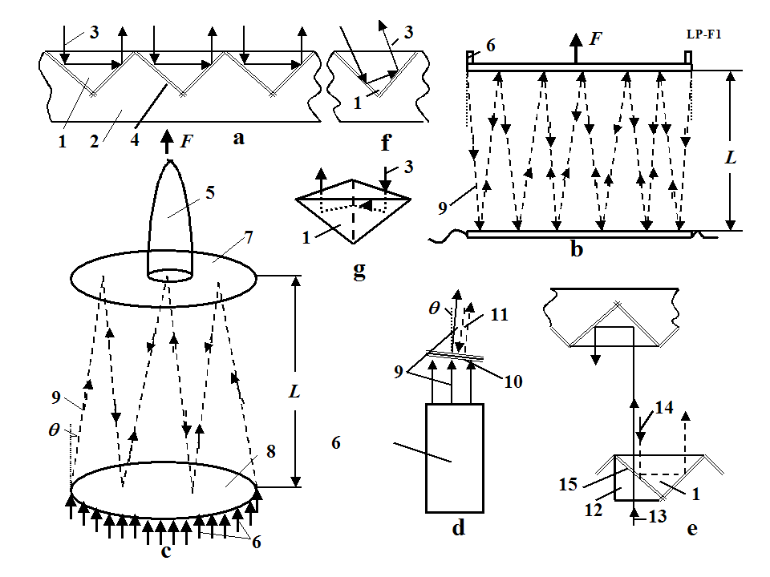
Fig. 9.1. Space launcher. Notations are: 1 – prism, 2 – mirror base, 3 – laser beam, 4 – mirror after chink (optional), 5 – space vehicle, 6 – lasers (ring set of lasers), 7 – vehicle (ship) mirror, 8 – planet mirror, 9 –laser beam, 10 – multi-layer dielectric mirror, 11 – laser beam after multi-reflection (wavelength λ₁₁ > λ₉ ), 12 – additional prism, 13 – entry beam, 14 – return beam, 15 – variable chink between main and additional prisms. (a) Prism (cell, corner cube) reflector. (b) Beam multi-reflection, (c) Launching by multi-reflection, (d) The first design of the light lock, (e) The second design of the light lock, (f) Reflection in the same direction when the beam is not perpendicular to mirror surface, (g) Mirror cell (retroreflector cell or cube corner cell). A light ray incident on it is returned parallel to itself after three reflections.

The linear light engine does not have a limit to its speed and may be used to launch space equipment and space ships in non-rockets method described in [1] Ch.12^{10–29}. This method is certain also to have many military applications.

10. Electrostatic Solar wind propulsion*
A revolutionary method for space flights in outer space is suggested by the author. Research is present to shows that an open high charged (100 MV/m) ball of small diameter (4–10 m) made from thin film collects solar wind (protons) from a large area (hundreds of square kilometers). The proposed propulsion system creates many Newtons of thrust, and accelerates a 100 kg space probe up to 60–100 km/s for 100–800 days. The 100 kg space apparatus offers flights into Mars orbit of about 70 days, to Jupiter about 150 days, to Saturn about 250 days, to Uranus about 450 days, to Neptune about 650 days, and to Pluto about 850 days.
The author has computed the amount thrust (drag), to mass of the charged ball, and the energy needed for initial charging of the ball and discusses the ball discharging in the space environment. He also reviews apparent errors found in other articles on these topics. Computations are made for space probes with a useful mass of 100 kg.
-----------------
*The work was presented as AIAA-2005-3857 at the 41st Propulsion Conference, 10–13 July 2005, Tucson, Arizona, USA. See also [1, Ch.13, pp.245-270].

Introduction.
Brief information about solar Wind. The Sun emits plasma which is a continuous outward flow (solar Wind) of ionized solar gas throughout our solar system. The solar wind contains about 90% protons and electrons and some quantities of ionized α-particles and gases. It attains speeds in the range of 300–750 km/s and has a flow density of 5×10⁷ – 5×10⁸ protons/ electrons/cm²s. The observed speed rises systematically from low values a 300–400 km/s to high values of 650–700 km/s in 1 or 2 days and then returns to low values during the next 3 to 5 days ([1], Fig. 13.1). Each of these high-speed streams tends to appeal at approximately 27-day intervals or to recur with the rotation period of the Sun. On days of high Sun activity the solar wind speed reaches 1000 (and more) km/s and its flow density 10⁹ – 10¹⁰ protons/electrons/ cm²s, 8–70 particles in cm³. The Sun has high activity periods some days each year.
The pressure of the solar wind is very small. For full braking it is in the interval 2.5×10^{–10} ÷ 6.3×10^{–9} N/m². This value is double when the particles have full reflection. The interstellar medium also has high energy particles. Their density is about 1 particle/cm³.

Brief description of the propulsion system.
Space propulsion system. The suggested propulsion system is very simple. It includes a hollow ball made up of a thin, strong, film – covered conductive layer or a ball of thin net. The ball is charged by high voltage static electricity which creates a powerful electrostatic field around it. Charged particles of solar wind of like charges repel and particles with the unlike charges attract. A small proportion of them run through the ball, a larger proportion flow round the ball in hyperbolic trajectory into the opposive direction, and another proportion are deviates from their initial direction in hyperbolic curves. As a result the charged ball has drag when the ball speed is different from solar speed (Fig.10.1). The drag also occurs when the particles and the ball have the same electrical charge. In this case the particles are repelled from the charged ball (Fig. 10.1) and brake it. This solar wind drag provides thrust in our proposed propulsion system. The pressure of solar wind is very small, but the offered system (a charged ball of radius 6–10 m) collects particles (protons or electrons) from a large area (an area of tens of kilometers radius for protons and hundreds of kilometers for electrons), creates a thrust of some Newtons and a 100-kg space ship reaches speeds of tens of km/s in 50–300 days (see theory and computation below and References [1] Ch.13^{29, 42–47}).
The proposed new propulsion mechanism differs from previous concepts in very important respects; including the coupling to the protons of the solar wind using an open single-charge ball. The opposite charge is expelled into infinite space. This innovation increases the area of influence by up to hundreds of kilometers for protons and allows the acquisition of significant vehicle thrust. This thrust is enough to accelerate a heavy space craft to very high speed and permits very short flight times to far planets.
The offered revolutionary propulsion system has a simple design, which can give useful acceleration to various types of spacecraft. The offered propulsion system creates many Newtons of thrust, and can accelerate a 100 kg space probe up to 60–100 km/sec in 100–800 days.
In the offered wind propulsion system the particles run away from the ball, brake and return in infinity for initial speed. These premises must be examined using more complex theories to account for the full intersection between the suggested installation and solar wind (including thermonuclear reactions). This would be a revolutionary breakthrough in interplanetary space exploration.

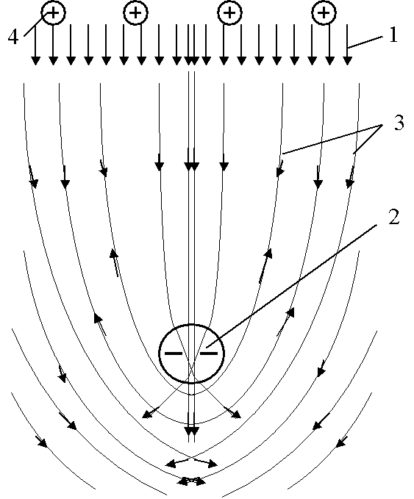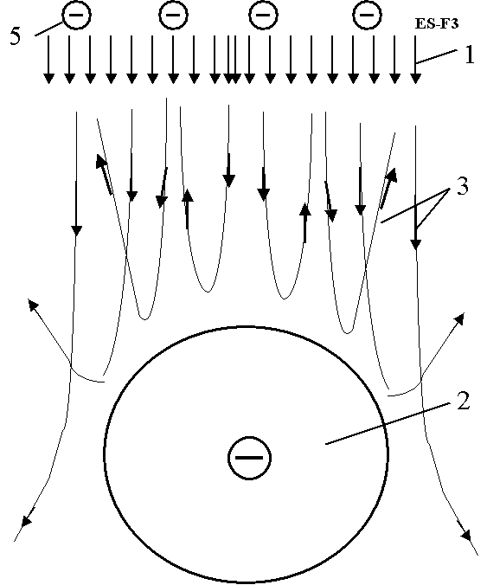
Fig. 10.1 (Left) Hyperbolic trajectory of protons around static negative charge (or electrons around positive charge) (unlike charges). Notations are: 1 – solar wind (charged particles); 2 – hollow negatively charged ball of thin film; 3 – hyperbolic trajectory of charged particles; 4 – positively charged particles (protons).
(Right). Trajectory of particles having the same charge as the ball. Notations are: 5 – negatively charged particles.
The author has developed the initial theory and the initial computations to show the possibility of the offered concept. He calls on scientists, engineers, space organizations, and companies to research and develop the offered perspective concepts.
11. Electrostatic Utilization of Asteroids for Space Flight*
The author offers an electrostatic method for changing the trajectory of space probes. The method uses electrostatic force and the kinetic or rotary energy of asteroids, comet nuclei, meteorites or other space bodies (small planets, natural planet satellites such a moons, space debris, etc.) to increase or decrease ship/ probe speed by 1000 m/s or more and to achieve any new direction in outer space. The flight possibilities of spaceships and probes are thereby increased by a factor of millions.
--------------------
*The full text was presented by the author as Paper AIAA-2005-4032 at the 41 Propulsion Conference, 10–12 July 2005, Tucson, Arizona, USA; or [1, Ch.14, pp.271-280].

Description
. The method includes the following main steps (Fig. 11.1):
(a) Finding an asteroids using a locator or telescope (or looking in a catalog) an asteroid and determining its main parameters (location, mass, speed, direction, rotation); selecting the appropriate asteroid; computing the required position of the ship with respect to the asteroid.
(b) Correcting the ship’s trajectory to obtain the required position; convergence of the ship with the asteroid.
(c) Charging the asteroid and space apparatus ball using a charge gun.
(d) Obtaining the necessary apparatus position and speed for the apparatus by flying it around the space body and changing the charge of the apparatus and space body (asteroids).
(e) Discharging the space apparatus and the space body.
The equipment requires for changing a probe (spacecraft) trajectory includes:
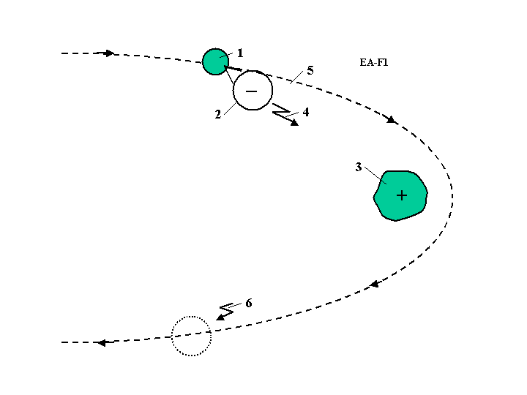
Fig. 11.1. Method of electrostatic maneuvers of the space apparatus. Notations: 1 – space apparatus, 2 – charged ball, 3 – asteroid, 4 – charged gun, 5 – new apparatus trajectory, 6 – discharging the apparatus and asteroid.

(a) A charging gun.
(b) Devices for finding and measuring the asteroids (space bodies), and computing the trajectory of the spacecraft relative of the space body.
(c) Devices for spacecraft guidance and control.
(d) A device for discharging of the apparatus and asteroids (space body) (see [1] Fig. 14.1).

12. Electrostatic Levitation on the Earth and Artificial Gravity for Space Ships and Asteroids*
The author offers and researches the conditions which allow people and vehicles to levitate on the Earth using the electrostatic repulsive force. He shows that by using small electrically charged balls, people and cars can take flight in the atmosphere. Also, a levitated train can attain high speeds. He has computed some projects and discusses the problems which can appear in the practical development of this method. It is also shown how this method may be used for creating artificial gravity (attraction force) into and out of space ships, space hotels, asteroids, and small planets which have little gravity.
-------------------
*Presented as paper AIAA-2005-4465 at 41 Propulsion Conference, 10–13 July 2005, Tucson, Arizona, USA; or [1, Ch. 15, pp. 281-302].
Brief description of innovation
It is known that like electric charges repel, and unlike electric charges attract (Fig. 12.1a,b,c). A large electric charge (for example, positive) located at altitude induces the opposite (negative) electric charge at the Earth’s surface (Figs. 12.1d,e,f,g) because the Earth is an electrical conductor. Between the upper and lower charges there is an electric field. If a small negative electric charge is placed in this electric field, this charge will be repelled from the like charges (on the Earth’s surface) and attracted to the upper charge (Fig. 12.1d). That is the electrostatic lift force. The majority of the lift force is determined by the Earth’s charges because the small charges are conventionally located near the Earth’s surface. As shown below, these small charges can be connected to a man or a car and have enough force to lift and supports them in the air.
The upper charge may be located on a column as shown in Fig. 12.1d,e,f,g or a tethered air balloon (if we want to create levitation in a small town) (Fig. 12.1e), or air tube (if we want to build a big highway), or a tube suspended on columns (Fig. 12.1f,g). In particular, the charges may be at two identically charged plates, used for a non-contact train.
A lifting charge may use charged balls. If a thin film ball with maximum electrical intensity of below 3×10⁶ V/m is used, the ball will have a radius of about 1 m (the man mass is 100 kg). For a 1 ton car, the ball will have a radius of about 3 m (see the computation in [1] and Fig. 15.2g,h,i). If a higher electric intensity is used, the balls can be small and located underneath clothes.

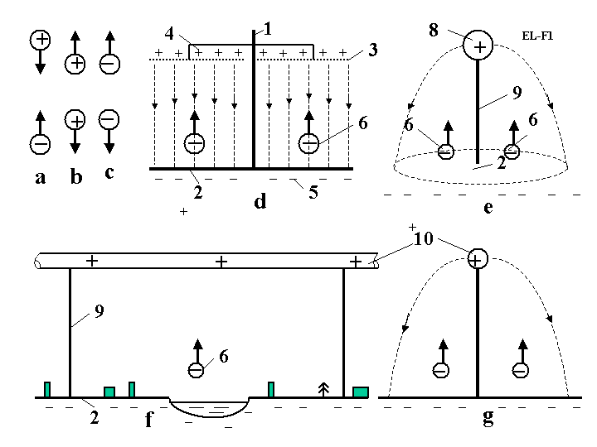
Fig. 12.1. Explanation of electrostatic levitation: a) Attraction of unlike charges; b,c) repulsion of like charges; d) Creation of the homogeneous electric field (highway); e) Electrical field from a large spherical charge ; f,g) Electrical field from a tube (highway) (side and front views). Notations are: 1, 9 – column, 2 – Earth (or other) surface charged by induction, 3 – net, 4 – upper charges, 5 – lower charges, 6 – levitation apparatus, 8 – charged air balloon, 9 – column, 10 – charged tube.
13. Guided Solar Sail and Energy Generator*
A solar sail is a large thin film mirror that uses solar energy for propulsion. The author proposed innovations and a new design of Solar sail in 1985 [1] Ch.16¹. This innovation allows (main advantages only):
1) An easily controlled amount and direction of thrust without turning a gigantic sail;
2) Utilization of the solar sail as a power generator (for example, electricity generator);
3) Use of the solar sail for long-distance communication systems.
-----------------------------
* The detail manuscript was presented as AIAA-2005-3857 on the 41st Propulsion Conference, 10–12 July 2005, Tucson, Arizona, USA; or see [1, Ch.16, pp. 303-308].
Description of innovation and their advantages
The proposed innovation of a solar sail¹ is presented in Fig. 13.1. Theory developed in author publication [1, Ch.16²] may be useful for flight analysis. The solar sail contains: a space ship, 1, a spherical reflector, 2, a mirror, 5, and additional devices to support spherical reflector, control the thrust direction, and convert the light energy into electricity and additional thrust.
The suggested propulsion system works in the following way. The reflector, 2, focuses the sunlight into the control ship mirror, 5, located at the spaceship’s center of mass. We are able to change the position of this mirror, send the focused beam in the right direction and achieve the necessary thrust direction without turning the space sail because the space sail is large, turning it is very complex problem, but this problem is avoided in the suggested design.
If we direct the solar beam into the ship, we can convert the huge solar energy into any other sort of energy, for example, into electricity using a conventional method (solar cell or heat machine). A reflector of 100×100 m² produces 14,000 kW energy at 1 AU. The developed ion thrusters are very efficient and have a high specific impulse, but they need a great amount of energy. We have this energy in the proposed sail and can increase the thrust over time.
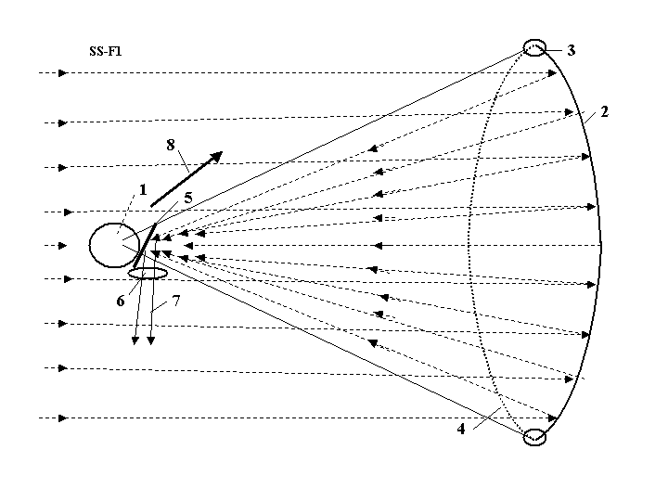
Fig. 13.1. Proposed guided solar sail and electricity generator. Notations are: 1 – space ship; 2 – thin film reflector; 3 – inflatable (or electrically charged) toroid which support the reflector in an open (unfolded) position; 4 – transparent thin film or light charged net which support the spherical form of the reflector; 5 – control mirror, which guides thrust direction; 6 – lens or trap for communication; 7 – reflected beam (located at the center of the ship’s mass). 8 – direction of thrust.
The offered system can be also used for long distance communication by sending a focused beam is to the Earth and transmitting the necessary information.
The author has also proposed a method using surface tension of a solar sail and a solar mirror [1, Ch.16¹⁰].
The suggested revolutionary propulsion system uses current technology and may be produced in the near future but needs detailed research and computation.
14. Radioisotope Space Sail and Electro-Generator*
Radioisotope sail is a thin film of an alpha particle emitting radioisotope deposited on the back of a plastic sail that can provide useful quantities of both propulsion and electrical power to a deep space vehicle. The momentum kick of the emitted alpha particles provides radioisotope sail thrust levels per square meter comparable to that of a solar sail at one astronautical unity (1 AU). The electrical power generated per 1 square m is comparable to that obtained from solar cells at 1 AU. Radioisotope sail systems will maintain these propulsion and power levels at distances from the Sun where solar powered systems are ineffective.
The propulsion and power levels available from this simple and reliable high-energy-density system would be useful for supplying propulsion and electrical power to a robotic deep space mission to the Oort Cloud or beyond, or to a robotic interstellar flyby or rendezvous probe after its arrival at the target star.
------------------------
* Detailed work was presented by the author as AIAA-2005-4225 at the 41st Propulsion Conference, 10–12 July, 2005, Tucson, Arizona, USA; or see [1, Ch.17, pp.309-316].
Description of method and innovations
Brief history of innovation
The idea of using a radioisotope recoil propulsion as it is shown in Fig.14.1a is very old [1, Ch.17¹⁵].
The author has proposed many innovations in method is using radioisotope space sail and electric generators in patent applications [1, Ch.17^{1–13} ] in 1983 and in paper IAF 92-0573 presented to the World Space Congress in 1992 ]1, Ch.17¹⁴]. The work [1, Ch.17¹⁶ ] written in 1995 summarized the knowledge for the conventional case in Fig. 14.1a. Bolonkin innovations decrease the weight of traditional radioisotope sail (RadSail, RS, IsoSail) by 2–4 times; increase the thrust by 2–3 times, and the electric power by 2 times and allows control of thrust and thrust direction without needing to turn the large RadSail.
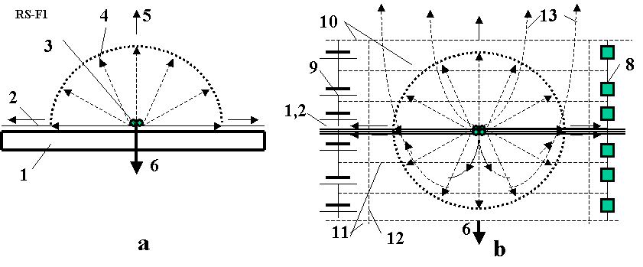
Fig. 14.1. a) Conventional radioisotope sail; b) suggested (innovated) radioisotope sail. Notations are: 1 – substrate (base of sail), 2 – isotope layer, 3 – isotope atom, 4 – alpha particles, 5 – direction of 1/6 particle flow, 6 – thrust, 8 – electric loading, 9 – initial charging, 10, 11, 12 – condenser nets, 13 – particle trajectory.

Offered innovation allows us to reach a probe speed of more than 2000 km/s, so the design may be used for interstellar probes.
This method allows nuclear waste and unnecessary nuclear bombs to be used for producing the radioisotope material.
The offered method is realistic at the present time, has a high possibility to being successful, and is much cheaper for deep missions than other currently proposed method.
15. Electrostatic Solar Sail*
The solar sail has become well-known after much discussion in the scientific literature as a thin continuous plastic film, covered by sunlight-reflecting appliquéd aluminum. Earlier, there were attempts to launch and operate solar sails in near-Earth space and there are experimental projects planned for long powered space voyages. However, as currently envisioned, the solar sail has essential disadvantages. Solar light pressure in space is very low and consequently the solar sail has to be very large in area. Also it is difficult to unfold and unfurl the solar sail in space. In addition it is necessary to have a rigid framework to support the thin material. Such frameworks usually have great mass and, therefore, the spacecraft’s acceleration is small.
Here, the author proposes to discard standard solar sail technology (continuous plastic aluminum-coated film) with the intention instead of using millions of small, very thin aluminum charged plates and to release these plates from a spacecraft, instigated by an electrostatic field. Using this new technology, the solar sail composed of millions of plates can be made gigantic area but have very low mass. The acceleration of this new kind of solar sail may be as much as 300 times that achieves by an ordinary solar sail. The electrostatic solar sail can even reach a speed of about 300 km/s (in a special maneuver up to 600–800 km/sec). The electrostatic solar sail may be used to move a large spaceship or to act as an artificial Moon illuminating a huge region of the Earth’s surface.
----------------------
*See [1, Ch.18, pp. 317-326].
Brief description of the innovations
A conventional solar sail is a dielectric thin film (thickness 5 mkm = 5000 nm) with an aluminum layer 100 nm thick, and it has 90% reflectivity. The weight of one square meter is 5–7 g/m². If it accelerates by itself the maximum acceleration is about 1 mm/s². However, the gigantic thin film needs a rigid structure to support the very thin film in an unfolded position and to unable it to be controlled. This rigid structure has a large weight, so it is very difficult to launch and to unfurl the structure in space. All attempts to do this (for example, to unfurl the inflatable radio-antennas in space) have failed.
The author proposes to use small thin charged aluminums plates (petals) supported by a central electrostatic ball and rotated around the ball (Fig. 15.1). They rotate also around their own axis and main thin a direction perpendicular to the solar rays. The diameter of the plate-petals is small, about 1 mm or less, and, it is not a necessity to use the dielectric film. The aluminum film may be very thin because the individual petal size is small.
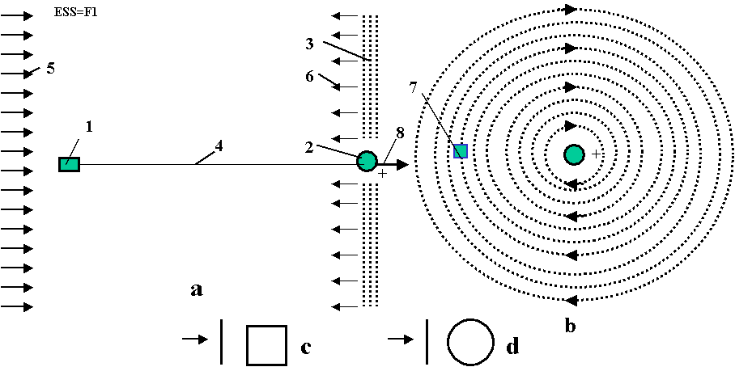
Fig. 15.1. The proposed electrostatic solar sail. a. Side view; b. Front view; c. Side and front views of square petal; d. Side and front views of round petal. Notation: 1 – spaceship, 2 – charged ball, 3 – charged plate-petals, 4 – cable connecting the ship and the ball, 5 – solar rays, 6 – reflected rays, 7 – charged petals, 8 – thrust (drag).
16. Recombination Space Jet Propulsion Engine*
There are four known ionized layers in the Earth’s atmosphere, located at an altitude of 85–400 km. Here the concentration of ions reaches millions of particles in 1 cubic centimeter. In the inter-planetary medium the concentration of ion reaches 10–10³ particles in 1 cm³ and in interstellar space it is about 1–10 in 1 cm³. As a result there is interaction between solar radiation in the Earth’s atmosphere, solar wind, and galactic radiation.
About 90% these particles are protons and electrons. The particle density is low and they can exist for a long time before they come into collision with each other. However, if we increase the density of the particles in an engine, they collide with one another, recombine, warm up, leave the propulsion system with high speed, and create thrust.
The energy of recombination is significantly more than the heat capability of conventional fuel and the specific impulse of the propulsion system is high.
The author proposes collecting and concentrating charged particles from a large area using a magnetic field. Space ships, space apparatus, and satellites would then not need fuel and could be accelerated or fly to infinity. This may be a revolution in aerospace.
=======
*See [1, Ch. 19, pp. 327-338].
Description of innovation
In the recombination propulsion engine contains a tube with an intake and a nozzle, and a solenoid (Fig. 16.1).
The solenoid may be conventional or superconductive. It produces a powerful magnetic field, which collects charged particles. If the density of the charged particles is sufficient (the distance the particles travel is less than the tube length) the particles came into contact with each other and recombine.
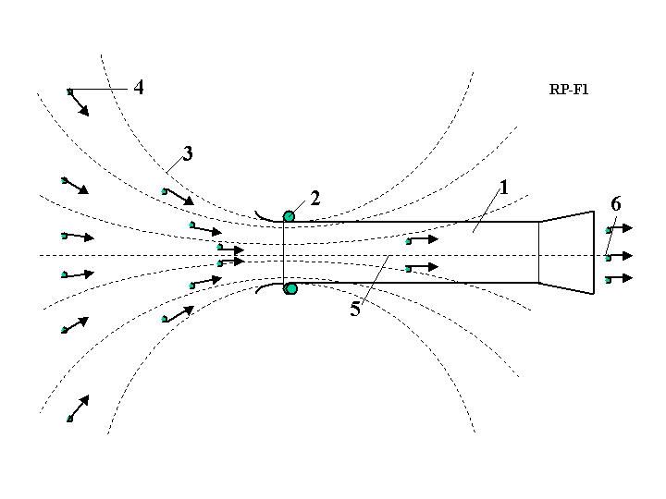
Fig. 16.1. Recombination space jet propulsion engine (actuator of magnetic field). Notations are: 1
engine, 2 – solenoid, 3 – magnetic lines, 4 – charged particles, 5 – recombination zone, 6 – exit.

This minimum energy is more than the energy of the most efficient chemical reaction, H₂ + O = H₂O, by hundreds of times. This means the specific impulse of the recombination engine will be very high. The heating of engine walls will be small, however, because the density of the particle gas is low. Using this proposed method, we do not need to expend fuel and can achieve a large acceleration of a space vehicle, or support the satellite at altitude for an infinite amount of time.
Idea’s are needed in research and development of this method.

17. Electronic Sail*
A solar sail reflects solar light and can be a used as propulsion system, as described in [1, Ch. 16]. It needs thin film of a very large area. This manuscript proposes a new way of creating a reflecting surface of large area using an electronic method. This method needs research and development but it may be easier and more efficient than the film method.
-------------
*See [1, Ch.19, pp.334-335].
Brief description of innovation
The proposed electronic sail has a positive charge, 1 (see Fig. 17.1). The free electrons, 2, are injected into space around the positive charge so they rotate around the center of the charge and form a thin disk in a plane perpendicular to the direction of the Sun light. If the concentration of electrons is sufficient, they will reflect the solar light like a mirror and produce thrust.
This electronic sail may be an electrostatic solar wind sail, as described in [1] Chapter 13, if the central charge is positive. The solar wind electrons became concentrated around it and the mass of electrons reflects the solar light. Thrust from the solar wind is small because the electron mass is about 2000 times less than the proton mass, but the solar light pressure is thousands of times greater than solar wind (protons) pressure. The offered installation may also be used as a space mirror to illuminate the Earth’s surface. This idea needs further research.

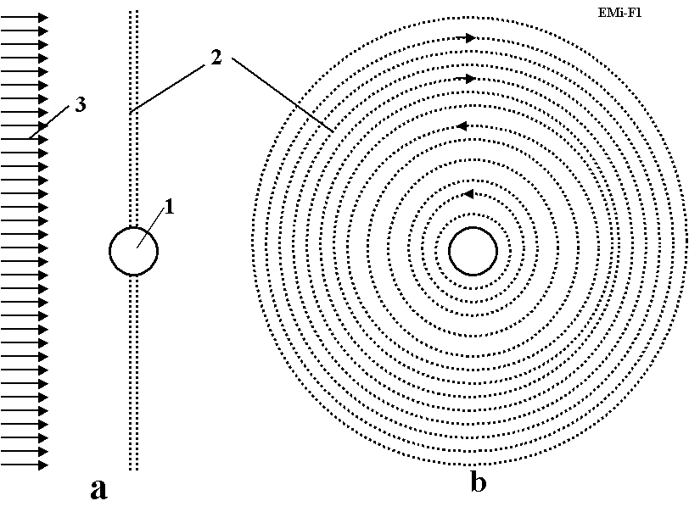
Fig. 17.1. Electronic solar sail. a – side view, b – front view. Notations are: 1 – positive charge, 2 – electronic disk, 3 – solar light.
References
Many works noted below the reader can find on site Cornel University <http://arxiv.org/>, sites <http://www.scribd.com> , http://www.archive.org, <http://bolonkin.narod.ru/p65.htm> and in Conferences 2002-2006 (see, for example, Conferences AIAA, <http://aiaa.org/> , search "Bolonkin" )
1. Bolonkin A.A., (2005) "Non-Rocket Space Launch and Flight", Elsevier. 2005,
http://www.archive.org/details/Non-rocketSpaceLaunchAndFlight, http://www.scribd.com/doc/24056182
2. K.E. Tsiolkovski:”Speculations Abot Earth and Sky on Vesta”, Moscow, Izd-vo AN SSSR, 1959;
Grezi o zemle i nebe (in Russian), Academy of Sciences, USSR., Moscow, p. 35, 1999.
3. Geoffrey A. Landis, Craig Cafarelli, The Tsiolkovski Tower Re-Examined, JBIS, Vol. 32, p. 176–180, 1999.
4. Y. Artsutanov. Space Elevator, http://www.liftport.com/files/Artsutanov_Pravda_SE.pdf.
5. A.C. Clarke: Fountains of Paradise, Harcourt Brace Jovanovich, New York, 1978.
6. Bolonkin A.A. (2006), Book "New Concepts, Ideas and Innovation in Aerospace", NOVA, 2008.
http://www.scribd.com/doc/24057071 .
http://www.archive.org/details/NewConceptsIfeasAndInnovationsInAerospaceTechnologyAndHumanSciences
7. Bolonkin A.A. (2007), "Macro-Engineering: Environment and Technology", NOVA, 2008. http://Bolonkin.narod.ru/p65.htm, http://www.scribd.com/doc/24057930 .
http://www.archive.org/details/Macro-projectsEnvironmentsAndTechnologies
8. Bolonkin A.A. (2008), “New Technologies and Revolutionary Projects”, Scribd, 2008, 324 pgs,
http://www.scribd.com/doc/32744477 ,
http://www.archive.org/details/NewTechnologiesAndRevolutionaryProjects
9. Bolonkin A.A., Book "Non-Rocket Space Launch and Flight", Elsevier. 2006, Ch. 9 “Kinetic Anti-Gravotator”, pp. 165-186; http://Bolonkin.narod.ru/p65.htm, http://www.scribd.com/doc/24056182 ; Main idea of this Chapter was presented as papers COSPAR-02, C1.1-0035-02 and IAC-02-IAA.1.3.03, 53rd International Astronautical Congress. The World Space Congress-2002, 10-19 October 2002, Houston, TX, USA, and the full manuscript was accepted as AIAA-2005-4504, 41st Propulsion Conference, 10-12 July 2005, Tucson, AZ, USA.http://aiaa.org search “Bolonkin”.
10. Bolonkin A.A., Book "Non-Rocket Space Launch and Flight", Elsevier. 2006, Ch.5 “Kinetic Space Towers”, pp. 107-124, Springer, 2006. http://Bolonkin.narod.ru/p65.htm or http://www.scribd.com/doc/24056182 . http://www.archive.org/details/Non-rocketSpaceLaunchAndFlight
11. Bolonkin A.A., “Transport System for Delivery Tourists at Altitude 140 km”, manuscript was presented as paper IAC-02-IAA.1.3.03 at the World Space Congress-2002, 10-19 October, Houston, TX, USA. http://Bolonkin.narod.ru/p65.htm ,
12. Bolonkin A.A. (2003), “Centrifugal Keeper for Space Station and Satellites”, JBIS, Vol.56, No. 9/10, 2003, pp. 314-327. http://Bolonkin.narod.ru/p65.htm . See also [11] Ch.3.
13. Bolonkin A.A., Book "Non-Rocket Space Launch and Flight", by A.Bolonkin, Elsevier. 2006, Ch.3 ”Circle Launcher and Space Keeper”, pp.59-82. http://www.scribd.com/doc/24056182 , http://www.archive.org/details/Non-rocketSpaceLaunchAndFlight
14. Bolonkin A.A., Book "New Concepts, Ideas and Innovation in Aerospace", NOVA, 2008, Ch. 3 “ Electrostatic AB-Ramjet Space Propulsion)”, pp.33-66. http://www.scribd.com/doc/24057071. http://www.archive.org/details/NewConceptsIfeasAndInnovationsInAerospaceTechnologyAndHumanSciences
15 Bolonkin A.A., Book "New Concepts, Ideas and Innovation in Aerospace", NOVA, 2008, Ch.12, pp.205-220, “AB Levitrons and Their Applications to Earth’s Motionless Satellites”. http://www.scribd.com/doc/24057071 , http://www.archive.org/details/NewConceptsIfeasAndInnovationsInAerospaceTechnologyAndHumanSciences
16. Bolonkin A.A., Book "Macro-Projects: Environment and Technology”, NOVA, 2008, Ch.10,
pp.199-226, “ AB-Space Propulsion”, http://www.scribd.com/doc/24057930 ,
http://Bolonkin.narod.ru/p65.htm .
http://www.archive.org/details/Macro-projectsEnvironmentsAndTechnologies
17. Bolonkin A.A., Magnetic Suspended AB-Structures and Moveless Space Satellites.
http://www.scribd.com/doc/25883886 .
18. Bolonkin A.A., Femtotechnology: Design of the Strongest AB-Matter for Aerospace.
http://www.archive.org/details/FemtotechnologyDesignOfTheStrongestAb-matterForAerospace.
19. Bolonkin A.A., Converting of any Matter to Nuclear Energy by AB-Generator and Aerospace .
http://www.archive.org/details/ConvertingOfAnyMatterToNuclearEnergyByAb-generatorAndAerospace.
20. Bolonkin A.A., LIFE. SCIENCE. FUTURE (Biography notes, researches and innovations). Scribd, 2010,
208 pgs. 16 Mb. http://www.scribd.com/doc/48229884,
http://www.archive.org/details/Life.Science.Future.biographyNotesResearchesAndInnovations
21. Krinker M., Magnetic-Space-Launcher. http://www.scribd.com/doc/24051286/
22. Krinker M., Review of Space Towers. http://www.scribd.com/doc/26270139,
http://arxiv.org/ftp/arxiv/papers/1002/1002.2405.pdf
23. Pensky O.G., Monograph “Mathematical Models of Emotional Robots”, Perm, 2010, 193 ps
(in English and Russian) (http://arxiv.org/ftp/arxiv/papers/1011/1011.1841.pdf ).
24. Pensky O.G., K. V. Chernikov“Fundamentals of Mathematical Theory of Emotional Robots “
(http://www.scribd.com/doc/40640088/).
25. Wikipedia. Some background material in this article is gathered from Wikipedia under
the Creative Commons license. http://wikipedia.org .

2010

