NEW SELF-PROPELLED PENETRATION BOMB
Alexander Bolonkin abolonkin@juno.com
Shmuel Neumann strategictechno@gmail.com
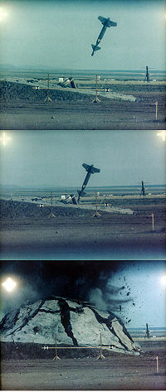

New York, Scribd, 2011
Article Pen Bomb after Shmuel 3 27 12

NEW SELF-PROPELLED PENETRATION BOMB
Alexander Bolonkin abolonkin@juno.com
Shmuel Neumann strategictechno@gmail.com

Abstract
Authors offer the new anti-bunker bombs which reach 80-150 m and more of the Earth depth. They can destroy armor protected underground bunkers. This bomb is named as “Self-propelled Bomb” because after conventional kinetic penetration, multiple cumulative charges creates a narrow canal, then injects into this canal explosives which upon detonation pushes the bomb deeper into the Earth by special rocket explosions and reaches a deep location. The other feature of Burn Bomb is the use of liquid explosive which makes it more comfortable, easy for design, safety and operates more effective than current bunker buster bomb. The same method may be used for super-fast very deep oil/gas drilling because the liquid explosive may be delivered to same apparatus by a long tube line.
Key words: Penetration bomb, anti-bunker bomb, Earth depth bomb.

Introduction

Inadequacy to Terminate Iran Nuclear Weapons Program
Despite the intolerable threat of a nuclear Iran, the United States appears to lack the technology to inflict severe damage on Iran’s atomic weapons program. According to the Wall Street Journal and other reliable sources, the United States simply does not have weapons to destroy enough of the right targets that, if damaged or destroyed would significantly slow or stop Iran’s weapons program. It is more than likely that the west has imperfect knowledge about Iranian atomic facilities, especially those with a weapons nexus. However, the following are the known sites which would have to be targeted.
Esfahan is an above ground uranium conversion facility that converts raw material into uranium gas which is then shipped to the Natanz facility for enrichment. The complex includes an extensive tunnel complex which could house more sensitive uranium activities.
Natanz is an underground enrichment facility buried under 25 meters of earth with a 2.5-meter thick concrete ceiling and houses at least 8,000 centrifuges which have turned out enough material for several nuclear warheads. The complex includes three large underground buildings, two of which are designed to be cascade halls to hold 50,000 centrifuges.
Fordow is an underground enrichment facility buried 80 meters inside a mountain and protected by anti-aircraft weapons. Recently uranium fuel arrived for further enrichment. The facility is large and safe enough from attack to provide for quick weapons grade enrichment.
Arak is a heavy water production plant. The above ground plant once operational could produce about 9 kilograms of plutonium annually or enough for about two nuclear weapons.
Bushehr is an above ground 1,000-megawatt reactor. The fuel from this facility is sufficient to produce 50 to 75 bombs.
Parchin is a high explosives testing site which houses a containment vessel used to conduct tests of the high explosives used in triggering a fissile reaction.
Mojdeh is the center for weapons development located on the Ministry of Defense’s Malek-Ashtar University of Technology in Esfahan. It works on the trigger for an atomic bomb, casting and machining of uranium metals, research on fissile material needed for a bomb, high explosives and radiation detection.
Abyek, a formerly top secret nuclear site is inside a mountain and has three large halls, 20 by 200 meters, and is 100 meters below the mountain surface. It is one of the newest command centers under the direction of Mojdeh. It is noteworthy that in 2010 Tehran announced plans to build 10 additional enrichment sites inside mountains beginning in March 2011. It appears Abyek is the first of those sites.

State of the Art of Bunker Busters
These targets vary in vulnerability. The above ground unfortified facilities are easy targets for standoff cruise missiles but the hard and deeply buried targets (HDBT) are especially challenging. U.S.-made bunker-buster bombs for HDBT might breech the cavity containing some of Iran’s buried facilities. The GBU-27 can penetrate 2.4 meters of concrete and the GBU-28 can penetrate 6 meters of concrete and another layer of earth 30 meters deep. Last week, the Washington, DC-based Bipartisan Policy Center’s National Security Project called for providing Israel 200 GBU-31 bombs, which include the Boeing Co. GPS tail-kit, to increase the credibility of a strike. An article in Israel’s Tablet magazine suggested Israel might attack HDBT sites like Fordow with a series of bunker busters, dropped at the same point to burrow through the granite. Successfully striking an HDBT depends on accuracy of fuse settings which depends on knowing with great accuracy the types of cover, such as the PSI of the concrete, types of layering, and depth. The most accurate fuses rely on delays, and the delay settings are determined by the time it takes for the weapon to travel from impact to the area of detonation.

The greatest limitation of the enormous penetration bomb GBU-57A/B is that this bomb is very heavy (14 tons) and as such, must be delivered only by large bombers. Worse, this bunker buster bomb claims to be effective in destroying a bunker located underground 60 m. This exaggerated claim is probably part of a necessary disinformation campaign, and in reality this bomb’s effective depth is more like 30 meters. Even worse, it is very likely that the underground nuclear facilities are armored, not just by the commonly known thick layer of steel reinforced concrete.
An example of a Russian bunker buster is the KAB-1500L-Pr. It is delivered with the Su-24M and the Su-27IB aircraft. It is claimed to be able to penetrate 10-20 m of earth or 2 m of reinforced concrete. The bomb weighs 1,500 kg (3,300 lb.), with 1,100 kg (2,400 lb.) being the high explosive penetrating warhead. It is laser guided and has a reported strike accuracy of 7 m (23 ft.) CEP.
The US has a series of custom made bombs to penetrate hardened or deeply buried structures:
Depth of Penetration | Weapon Systems
Penetration of reinforced concrete: 1.8 m (6 ft.) | BLU-109 Penetrator |  | GBU-10, GBU-15, GBU-24, GBU-27, AGM-130
Penetration of reinforced concrete: 3.4 m (11 ft.) | BLU-116 Advanced Unitary Penetrator (AUP) |  | GBU-15, GBU-24, GBU-27, AGM-130
Penetration of reinforced concrete: 3.4 m (11 ft.) | BLU-118/B Thermobaric Warhead |  | GBU-15, GBU-24, AGM-130
Penetration of reinforced  concrete: more than 6 m (20 ft.) | BLU-113 Super Penetrator | GBU-28, GBU-37
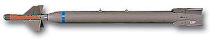
Bomb GBU-28
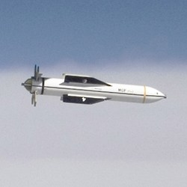
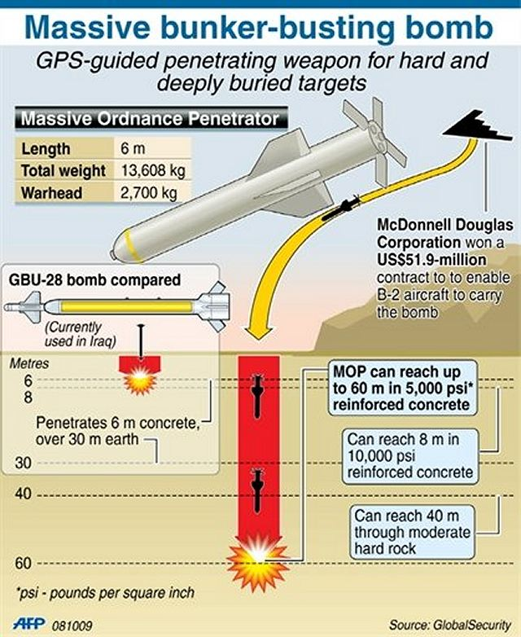
Fig.1. Penetration bomb GBU-28 (top) and GBU-57 (right). For 5000 psi the penetration of GBU-28 and CBU-57 is same.
More recently, the US has developed the 30,000-pound GBU-57. The Massive Ordnance Penetrator (MOP) GBU-57A/B is a U.S. Air Force massive, precision-guided, 30,000-pound (13,608 kg) "bunker buster" bomb. This is substantially larger than the deepest penetrating bunker busters previously available, the 5,000-pound (2,268 kg) GBU-28 and GBU-37.
The need for greater penetration bombs became salient following the 2003 invasion of Iraq, in which analysis of sites that had been targeted with bunker-buster bombs revealed poor penetration and inadequate levels of destruction. This renewed interest in the development of a super-large bunker-buster, and the MOP project was initiated by the Defense Threat Reduction Agency to fulfill a long-standing Air Force requirement. The U.S. Air Force has a call for a collection of massively sized penetrator and blast weapons, the so-called "Big BLU" collection, which includes the MOAB (Massive Ordnance Air Burst) bomb. Development of the MOP is now underway at the Air Force Research Laboratory, Munitions Directorate, Eglin Air Force Base, Florida. Design and testing work is also being performed by Boeing. The initial explosive test of MOP took place on March 14, 2007 in a tunnel belonging to the Defense Threat Reduction Agency (DTRA) at the White Sands Missile Range, New Mexico. The project has had at least one successful Flight Test MOP launch. The final testing will be completed in 2012. The Air Force took delivery of 20 bombs, designed to be delivered by the B-2 bomber, in September 2011. In February 2012, Congress approved $81.6 million to further develop and improve the weapon.

Mechanics of Penetration Bombs
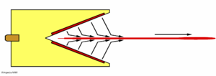
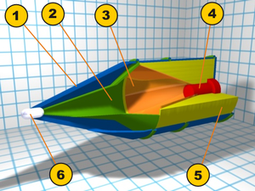
Penetration bombs use kinetic energy and sometimes a shaped charge, an explosive charge shaped to focus the effect of the explosive's energy. Various types are used to cut and form metal, to initiate nuclear weapons, to penetrate armor, and to "complete" wells in the oil and gas industry. A typical modern lined shaped charge can penetrate armor steel to a depth of 7 or more times the diameter of the charge (charge diameters, CD), though greater depths of 10 CD and above have been achieved. Contrary to a widespread misconception, the shaped charge does not depend in any way on heating or melting for its effectiveness, that is, the jet from a shaped charge does not melt its way through armor, as its effect is purely kinetic in nature.

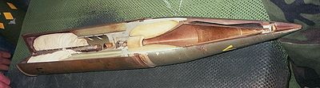

Figure 2 (left): Sections 1: Aerodynamic cover; 2: Empty cavity; 3: Conical liner; 4: Detonator; 5: Explosive; 6: Piezo-electric trigger
Figure 3 (Top-right). Work of shaped charge.
Figure 4 (bottom-right): Sectioned high explosive anti-tank round with the inner shaped charge visible
A typical device consists of a solid cylinder of explosive with a metal-lined conical hollow in one end and a central detonator, array of detonators, or detonation wave guide at the other end. Explosive energy is released directly away from (normal to) the surface of an explosive, so shaping the explosive will concentrate the explosive energy in the void. If the hollow is properly shaped (usually conically), the enormous pressure generated by the detonation of the explosive drives the liner in the hollow cavity inward to collapse upon its central axis. The resulting collision forms and projects a high-velocity jet of metal forward along the axis. Most of the jet material originates from the innermost part of the liner, a layer of about 10% to 20% of the thickness. The rest of the liner forms a slower-moving slug of material, which, because of its appearance, is sometimes called a "carrot".
Because of the variation along the liner in its collapse velocity, the jet's velocity also varies along its length, decreasing from the front. This variation in jet velocity stretches it and eventually leads to its break-up into particles. Over time, the particles tend to fall out of alignment, which reduces the depth of penetration at long standoffs.
Also, at the apex of the cone, which forms the very front of the jet, the liner does not have time to be fully accelerated before it forms its part of the jet. This results in its small part of jet being projected at a lower velocity than the jet formed later behind it. As a result, the initial parts of the jet coalesce to form a pronounced wider tip portion.
Most of the jet travels at hypersonic speed. The tip moves at 7 to 14 km/s, the jet tail at a lower velocity (1 to 3 km/s), and the slug at a still lower velocity (less than 1 km/s). The exact velocities depend on the charge's configuration and confinement, explosive type, materials used, and the explosive-initiation mode. At typical velocities, the penetration process generates such enormous pressures that it may be considered hydrodynamic; to a good approximation, the jet and armor may be treated as inviscid, incompressible fluid, with their material strengths ignored.
The location of the charge relative to its target is critical for optimum penetration, for two reasons. If the charge is detonated too close there is not enough time for the jet to fully develop. But the jet disintegrates and disperses after a relatively short distance, usually well under 2 meters. At such standoffs, it breaks into particles which tend to tumble and drift off the axis of penetration, so that the successive particles tend to widen rather than deepen the hole. At very long standoffs, velocity is lost to air drag, further degrading penetration.
The key to the effectiveness of the hollow charge is its diameter. As the penetration continues through the target, the width of the hole decreases leading to a characteristic "fist to finger" action, where the size of the eventual "finger" is based on the size of the original "fist". In general, shaped charges can penetrate a steel plate as thick as 150% to 700% of their diameter, depending on the charge quality. The figure is for basic steel plate, not for the composite armor, reactive armor, or other types of modern armor.

The Explosive

For optimal penetration, a high explosive having a high detonation velocity and pressure is normally chosen. The most common explosive used in high performance anti-armor warheads is HMX (octogen), though it is never used in pure form, as it would be too sensitive. It is normally compounded with a few percent of some type of plastic binder, such as in the polymer-bonded explosive (PBX) LX-14, or with another less-sensitive explosive, such as TNT, with which it forms Octol. Other common high-performance explosives are RDX-based compositions, again either as PBXs or mixtures with TNT (to form Composition B and the Cyclotols) or wax (Cyclonites). Some explosives incorporate powdered aluminum to increase their blast and detonation temperature, but this addition generally results in decreased performance of the shaped charge. There has been research into using the very high-performance but sensitive explosive CL-20 in shaped-charge warheads, but, at present, due to its sensitivity, this has been in the form of the PBX composite LX-19 (CL-20 and Estane binder).

Other Features
A waveshaper is a body (typically a disc or cylindrical block) of an inert material (typically solid or foamed plastic, but sometimes metal, perhaps hollow) inserted within the explosive for the purpose of changing the path of the detonation wave. The effect is to modify the collapse of the cone and resulting jet formation, with the intent of increasing penetration performance. Waveshapers are often used to save space; a shorter charge can achieve the same performance as a longer one without a waveshaper.
Another useful design feature is sub-calibration, the use of a liner having a smaller diameter (caliber) than the explosive charge. In an ordinary charge, the explosive near the base of the cone is so thin that it is unable to accelerate the adjacent liner to sufficient velocity to form an effective jet. In a sub-calibrated charge, this part of the device is effectively cut off, resulting in a shorter charge with the same performance.

Shaped Charge Variants

Explosively Formed Penetrator
A conventional shaped charge generally has a conical metal liner that projects a hypervelocity jet of metal able to penetrate to great depths into steel armor; in travel over some distance the jet breaks up along its length into particles that drift out of alignment, greatly diminishing its effectiveness at a distance.
An Explosively Formed Penetrator or EFP, on the other hand, has a liner face in the shape of a shallow dish. The force of the blast molds the liner into any of a number of shapes, depending on the shape of the plate and how the explosive is detonated. Some sophisticated EFP warheads have multiple detonators that can be fired in different arrangements causing different types of waveform in the explosive, resulting in either a long-rod penetrator, an aerodynamic slug projectile, or multiple high-velocity fragments. A less sophisticated approach for changing the formation of an EFP is the use of wire-mesh in front of the liner: with the mesh in place the liner fragments into multiple penetrators.
In addition to single-penetrator EFPs (also called single EFPs or SEFPs), there are EFP warheads whose liners are designed to produce more than one penetrator; these are known as multiple EFPs, or MEFPs. The liner of an MEFP generally comprises a number of dimples that intersect each other at sharp angles. Upon detonation the liner fragments along these intersections to form up to dozens of small, generally spheroidal projectiles, producing an effect similar to that of a shotgun. The pattern of impacts on target can be finely controlled based on the design of the liner and the manner in which the explosive charge is detonated. A nuclear-driven MEFP was apparently proposed by a member of the JASON group in 1966 for terminal ballistic missile defense. A related device was the proposed nuclear pulse propulsion unit for Project Orion.
The (single) EFP generally remains intact and is therefore able to penetrate armor at a long range, delivering a wide spray of fragments of liner material and vehicle armor into the vehicle's interior, injuring its crew and damaging other systems.
As a rule of thumb, an EFP can perforate a thickness of armor steel equal to half the diameter of its charge for a copper or iron liner, and armor steel equal to the diameter of its charge for a tantalum liner, whereas a typical shaped charge will go through six or more diameters.
The penetration is proportional to the density of the liner metal; tantalum 16,654 g/cm3, copper 8,960 g/cm3, iron 7,874 g/cm3. Tantalum is preferable in delivery systems that have limitations in size, like the SADARM, which is delivered by a howitzer. For other weapon systems where the size does not matter, a copper liner of double the caliber is used.
Extensive research is going on in the zone between jetting charges and EFPs, which combines the advantages of both types, resulting in very long stretched-rod EFPs for short-to-medium distances (because of the lack of aero stability) with improved penetration capability.
EFPs have been adopted as warheads in a number of weapon systems, including the CBU-97 and BLU-108 air bombs (with the Skeet submunition), the M303 Special Operations Forces demolition kit, the M2/M4 Selectable Lightweight Attack Munition (SLAM), the SADARM submunition, the Low Cost Autonomous Attack System, and the TOW-2B anti-tank missile.
An EFP eight inches in diameter threw a seven-pound copper slug at Mach 6, or 2,000 meters per second. (A .50-caliber bullet, among the most devastating projectiles on the battlefield, weighs less than two ounces and has a muzzle velocity of 900 meters per second.).— Rick Atkinson, The Washington Post.
Self-Forging Projectile
The Explosively Formed Penetrator (EFP) is also known as the Self-Forging Fragment (SFF), Explosively Formed Projectile (EFP), SElf-FOrging Projectile (SEFOP), Plate Charge, and Misznay-Schardin (MS) Charge. An EFP uses the action of the explosive's detonation wave (and to a lesser extent the propulsive effect of its detonation products) to project and deform a plate or dish of ductile metal (such as copper, iron, or tantalum) into a compact high-velocity projectile, commonly called the slug. This slug is projected toward the target at about two kilometers per second. The chief advantage of the EFP over a conventional (e.g., conical) shaped charge is its effectiveness at very great standoffs, equal to hundreds of times the charge's diameter (perhaps a hundred meters for a practical device).
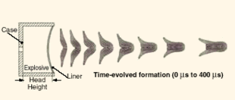

Fig.5. Self-Fording Projectile and formation of slug.
The EFP is relatively unaffected by first-generation reactive armor and can travel up to perhaps 1000 charge diameters (CDs) before its velocity becomes ineffective at penetrating armor due to aerodynamic drag, or successfully hitting the target becomes a problem. The impact of a ball or slug EFP normally causes a large-diameter but relatively shallow hole, of, at most, a couple of CDs. If the EFP perforates the armor, spalling and extensive behind armor effects (BAE, also called behind armor damage, BAD) will occur. The BAE is mainly caused by the high-temperature and high-velocity armor and slug fragments being injected into the interior space and the blast overpressure caused by this debris. More modern EFP warhead versions, through the use of advanced initiation modes, can also produce long-rods (stretched slugs), multi-slugs and finned rod/slug projectiles. The long-rods are able to penetrate a much greater depth of armor, at some loss to BAE, multi-slugs are better at defeating light or area targets and the finned projectiles are much more accurate. The use of this warhead type is mainly restricted to lightly armored areas of main battle tanks (MBT) such as the top, belly and rear armored areas. It is well suited for the attack of other less heavily protected armored fighting vehicles (AFV) and in the breaching of material targets (buildings, bunkers, bridge supports, etc.). The newer rod projectiles may be effective against the more heavily armored areas of MBTs. Weapons using the EFP principle have already been used in combat; the "smart" submunitions in the CBU-97 cluster bomb used by the US Air Force and Navy in the 2003 Iraq war employed this principle, and the US Army is reportedly experimenting with precision-guided artillery shells under Project SADARM (Seek And Destroy ARMor). There are also various other projectile (BONUS, DM 642) and rocket submunitions (Motiv-3M, DM 642) and mines (MIFF, TMRP-6) that use EFP principle. Examples of EFP warheads are US patents 5038683 and US6606951.

Liquid Explosives
One of the innovations of the proposed New Generation Penetration Bomb is the use of liquid rather than solid explosives. Certainly not all liquid explosives are common domain knowledge but some candidates follow.

Oxyliquit
An oxyliquit, also called liquid air explosive or liquid oxygen explosive, is an explosive material made of a mixture of liquid air or liquid oxygen (LOX) with a suitable fuel, usually carbon (as lampblack) or some organic chemical (e.g. a mixture of soot and naphthalene), wood meal, or aluminum powder or sponge; the material is capable of absorbing several times its weight of LOX. It is a class of Sprengel explosives which is a generic class of materials invented by Hermann Sprengel in the 1870s. They consist of stoichiometric mixtures of strong oxidizers and reactive fuels, mixed just prior to use in order to enhance safety. Either the oxidizer or the fuel, or both, should be a liquid to facilitate mixing, and intimate contact between the materials for a fast reaction rate. Sprengel suggested nitric acid, nitrates and chlorates as oxidizers, and nitroaromatics (e.g. nitrobenzene) as fuels. Other Sprengel explosives used at various times include charcoal with liquid oxygen (an oxyliquit), "Rackarock", and ANFO ammonium nitrate (oxidizer) mixed with a fuel oil (fuel), normally diesel kerosene or nitromethane "Rackarock" consisted of potassium chlorate and nitrobenzene. It was provided in the form of permeable cartridges of the chlorate, which were placed in wire baskets and dipped in the nitrobenzene for a few seconds before use. It was famously used in the massive submarine demolition of a navigational hazard in Long Island Sound in 1885. The charge of over a hundred tonnes of explosive (laid in tunnels 20 meters below sea level) destroyed approximately 600,000 tonnes of rock, and created a wave 30 m high.
A mixture of lampblack and liquid oxygen was measured to have detonation velocity of 3,000 m/s, and 4 to 12% more strength than dynamite. However, the flame it produces has too long duration to be safe in possible presence of explosive gases, so oxyliquits found their use mostly in open quarries and strip mining. However, this is a candidate for liquid explosives for the New Generation Penetration Bomb that may also be used as rocket fuel to propel the bomb to great velocities before impact. As a disadvantage, oxyliquits, once mixed, are sensitive to sparks, shock and friction, and there were reported cases of spontaneous ignition. The power relative to weight is high, but the density is low, so the brisance is low as well. Ignition by a fuse alone is sometimes unreliable. The charge should be detonated within 5 minutes of soaking, but even after 15 minutes it may be capable of exploding, even though weaker and with production of carbon monoxide.

Nitroglycerin and Pentaerythritol tetranitrate (PETN).

The best known liquid explosive, Nitroglycerin is a high explosive which is so unstable that the slightest jolt, friction, or impact can cause it to detonate. The molecule contains oxygen, nitrogen, and carbon with weak chemical bonds. Hence when it explodes, great energy is released as the atoms rearrange to form new molecules with strong, stable bonds such as N2, H2O, and CO2. It is the speed of the decomposition reaction which makes it such a violent explosive. A supersonic wave passing through the material causes it to decompose almost instantly. This is an unlikely candidate because of its instability.
Structurally, PETN (Chemical Abstract Services Registry Number 78-11-5) structurally resembles nitroglycerin, and is also known as PENT, PENTA, TEN, corpent, penthrite, is the nitrate ester of pentaerythritol. PETN is one of the most powerful high explosives known, with a relative effectiveness factor of 1.66. PETN is practically insoluble in water (0.01 g/100 ml at 50 °C), weakly soluble in common nonpolar solvents such as aliphatic hydrocarbons (like gasoline) or tetrachloromethane, but soluble in some other organic solvents, particularly in acetone (about 15 g/100 g of the solution at 20 °C, 55 g/100 g at 60 °C) and dimethylformamide (40 g/100 g of the solution at 40 °C, 70 g/100 g at 70 °C). PETN forms eutectic mixtures with some liquid or molten aromatic nitro compounds, e.g. trinitrotoluene (TNT) or tetryl. Due to its highly symmetrical structure, PETN is resistant to attack by many chemical reagents; it does not hydrolyze in water at room temperature or in weaker alkaline aqueous solutions. Water at 100° or above causes hydrolysis to dinitrate; presence of 0.1% nitric acid accelerates the reaction. Addition of certain aromatic nitro derivatives lowers thermal stability of PETN.
PETN is as an explosive with high brisance and its basic explosion characteristics are:
- Explosion energy: 5810 kJ/kg (1390 kcal/kg), so 1 kg of PETN has the energy of 1.24 kg TNT.
- Detonation velocity: 8350 m/s (1.73 g/cm³), 7910 m/s (1.62 g/cm³), 7420 m/s (1.5 g/cm³), 8500 m/s (pressed in a steel tube)
- Volume of gases produced: 790 dm³/kg (other value: 768 dm³/kg)
- Explosion temperature: 4230 °C
- Oxygen balance: -6.31 atom -g/kg
- Melting point: 141.3 °C (pure), 140–141 °C (technical)
- Trauzl lead block test: 523 cm³ (other values: 500 cm³ when sealed with sand, or 560 cm³ when sealed with water)
- Critical diameter (minimal diameter of a rod that can sustain detonation propagation): 0.9 mm for PETN at 1 g/cm³, smaller for higher densities (other value: 1.5 mm)
Nonphlegmatized PETN is stored and handled with approximately 10% water content. PETN has been replaced in many applications by RDX, which is thermally more stable and has longer shelf life. Replacement of the central carbon atom with silicon produces Si-PETN, which is extremely sensitive. PETN can be initiated by a laser. A pulse with duration of 25 nanoseconds and 0.5–4.2 joules of energy from a Q-switched ruby laser can initiate detonation of a PETN surface coated with a 100 nm thick aluminum layer in less than half microsecond.
  - Description, Workings and Innovations of new Bomb
Description. The offered penetration bunker bomb (Self-propelled bomb) is shown in Fig.6. One contains: the body 1; forward part 2 (initial implantation); flight accelerator 4; explosion chamber (underground engine) 5; folding hooks 6; main shaped (cumulative) chamber 7; channels for exhaust gas 8; tank for a liquid explosives 9 having one or two component; injectors for liquid explosives10 – 12.
The forward part 2 contains the initial shaped (cumulative) chamber 3.
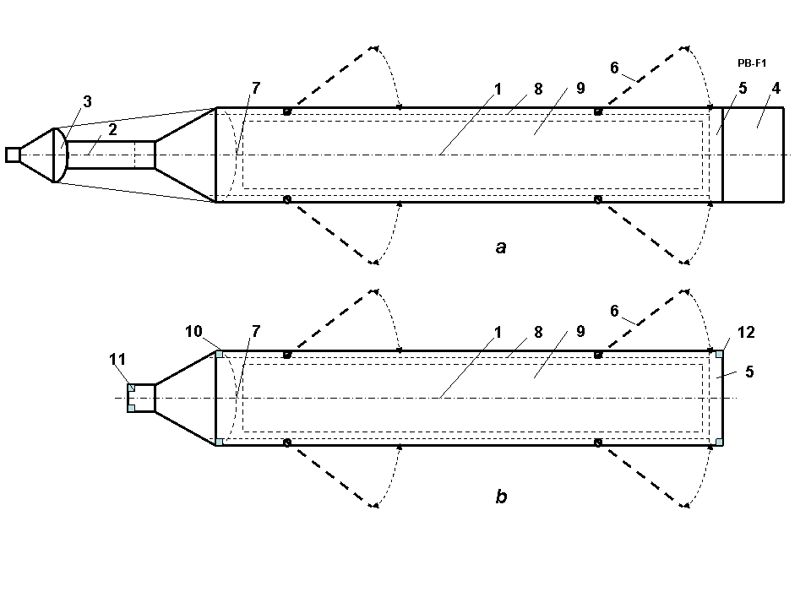
Fig. 6, Suggested penetration bunker bomb (Self-propelled bomb). (a) Flight bomb; (b) Underground part of Self Propelled bomb. Notations: 1 – body of bomb; 2 – Initial implantation; 3 – initial shaped (cumulative) charge; 4 – flight accelerator; 5 – explosion chamber (underground engine. It may be a serial set of the solid fuel simple rocket disks); 6 - folding hooks; 7 – main shaped (cumulative) chambers (it may be a serial set of the solid fuel shaped explosive semi-spherical disks); 8 – channels for exhaust gas; 9 – tank for a liquid explosives; 10 – 12 – injectors for liquid explosives.
Work. The bomb uses the following method. After delivering the bomb to the vicinity of the target, the accelerator 4 turns on increasing the speed 250 – 500 m/s over a falling speed. The forward cumulative charge produces the narrow channel into the bunker solid protection (it may be armor), injects the liquid explosive into channel and explodes it. The bomb utilizes initially the enormous kinetic energy for initial penetration. After this, the bomb begins to penetrate by itself. Bomb produces the following actions) (fig. 7): (a) Explode the first explosive in main shaped chamber 7 (SFF). Slug creates the canal 1 (fig.7) into concrete or/and soil; (b) Inject the liquid explosive by the very strong jet (strong pressure) into canal; (c) Open hooks 3 and ignite the explosive in the canal. We get the cavity 4 under bomb; (d) remove the exhaust gases from chamber 4 from canals into bomb; (e) remove hooks, explode a first solid fuel disk in chamber 6 of underground rocket engine (or inject a liquid explosive into the engine chamber 5 and ignite). The exhaust rocket gases (explosion) move the bomb into empty cavity 4 and penetrate into concrete (ground); (f)-(g) repeat the actions (a)-(e) while the bomb has shared and rocket disks and the liquid explosive. (h) In final stage (or given depth) the bomb explodes.
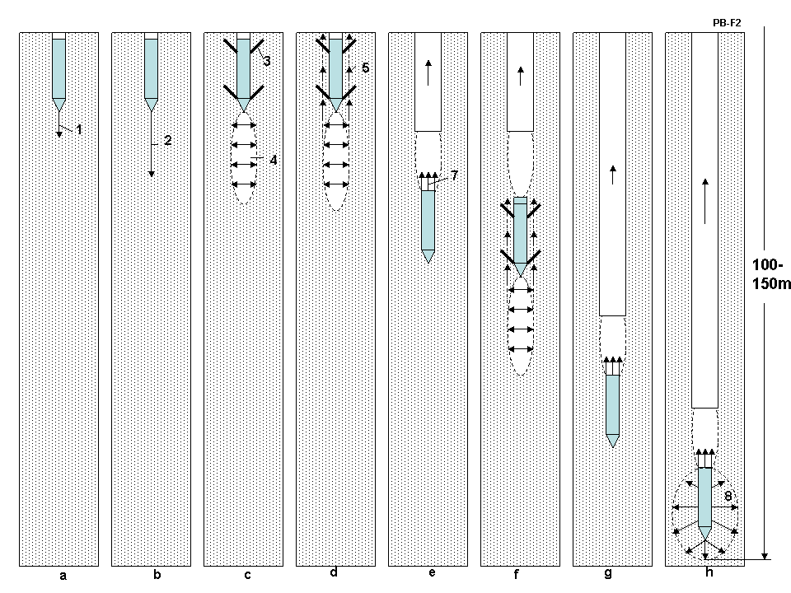
Fig.7. Work of Self-propelled Bomb after the penetration as the conventional penetration bunker bomb into Earth (or protected concrete). Action and notations: (a) Explode the first explosive disk in the main shaped chamber 7 (SFF). Slug creates the canal 1 (fig.2) into concrete; (b) Inject the liquid explosive by the very strong jet (big pressure) into canal; (c) Open hooks 3 and ignite the explosive in the canal. We get the cavity 4 under bomb; (d) delete the exhaust gases from cavity 4 threw canal 8 (fig.6); (e) remove hooks, explode a first solid fuel disk in chamber 6 of the underground rocket engine (or inject a liquid explosive into the engine chamber 5 and ignite). The exhaust rocket gases (explosion) moves the bomb into empty cavity 4 and penetrates into concrete (ground); (f)-(g) repeat the actions (a)-(e) while the bomb has shared and rocket disks and the liquid explosive. (h) In final stage (or given depth) the bomb explodes.
Innovations. Method:
- Using liquid explosive.
- Using the initial cumulative charge for destroying the armor cover of object (aim).
- Multiple using the cumulative (shaped) charges for producing the narrow channels.
- Injecting the liquid explosive into these channels.
- Firing (exploding) of this liquid explosive and creating the cavity for bomb (apparatus).
- Pushing the bomb (apparatus) in given cavity and ground by firing of the charge on the
bomb bottom (rocket effect).
- Repeating this process while there are explosive or while we reach our purpose (bunker/given depth).
8. Exploding bomb.
9. Bomb has forward part which has the cumulative and conventional charges for initial destruction of a bunker armor protection.
Advantages:
- Liquid bomb can reach a big additional depth up 70 - 100 m by kinetic energy to the depth received by a current conventional penetration bunker bomb and hundreds additional meters of depth by self-moving .
- The weight of bomb is about 1.5 – 2.5 tons. That is acceptable for most military aircraft.
- Method may be used for the super quick drilling of the oil and gas pipe lines. We can add (delivery) the explosive to the apparatus by tube and reach previously unfathomable depths.

Theory, Estimation and Computation of Penetration Bombs
The theory allows estimating the main parameters of the penetration/bunker bomb.
1. Kinetic penetration ability of the bunker bomb. Theory of a penetration the projectile into barrier is very complex. The depth of penetration depends from many values. There are a numerous of methods of computing this but the different methods give different results. That way the best method is testing on dissimilar bunkers. For example, Kinetic penetration ability of the bunker bomb may be estimated by equation:
, (1)
where E is energy, J; L is penetration distance, m; M is mass of bomb, kg; p is average specific drag of medium, N/m²; S is maximal cross section area of bomb, m². For example, if the bomb has mass M = 2000 kg, diameter 0.3 m (S = 0.225 m²) and speed V = 447 m/s, the bomb penetrates L = 80 m into the reinforced concrete having a strong p = 36 MPa (360 atm).
The critical collapsing pressures p for different materials are presented in Table 1.
Material | Density, kg/m³ | p, MPa=10 atm | Material | Density kg/m³ | p, MPa=10 atm
Reinforced concrete | 2000÷2200 | 4.9 ÷34 | Sand | 1200÷1600 | 0.1 ÷ 1
Brick | 1600÷1700 | 7 ÷29 | Sandstone | 1500 ÷ 1800 | 1 ÷ 5
Granite | 2010 ÷2250 | 147÷255 | Soil, gravel | 1500÷2000 | 1 ÷ 4
Table 1. Critical collapsing pressures p for different materials [1].
Ice | 900 | 1 ÷ 2 | Armor (steel) | 7900 | 373 ÷ 412
In War II designers used the following method for calculation the artillery shell penetration in bunker protection.
, (2)
where L is depth of penetration, m; k is coefficient of penetration from Table 2, M is mass of shell; V is speed of shell at bunker, m/s; d is caliber of gun, m; α is angle between axis of shell and a bunker surface.
Table 2. Coefficient of penetration of artillery shell into the bunker protection [2]
No | Material | k | No | Material
1 | Reinforced concrete | 0.7÷1.3 | 9 | Sand | 4.5
2 | Granite rock without cracking | 1.6 | 10 | Clay loam, dry | 5
3 | Gravel without cracking | 2 | 11 | Clay loam, moist | 6
4 | Stone in cement mortar | 2 | 12 | undisturbed soil,  the earth's array | 6.5
5 | Brick-paving stone, dry | 2.5 | 13 | Compact clay | 7
6 | Brick in cement mortar | 2.5 | 14 | Bulk sand | 9
7 | Brick, dry | 3 | 15 | Wet clay, wet soil, swamp | 10
8 | Pine in logs | 6 | 16 | filled up the land | 13
2. Bomb speed from altitude falling without air drag is
(3)
where g = 9.81 m/s² is the Earth acceleration; H is altitude, m. Example, if the bomb fall from
altitude H = 10,000 m, one gets a speed about V = 450 m/s.
3. Maximal bomb fall speed with air drag approximately equals
, (4)
where C_{d} is average drag coefficient (C_{d} = 0.12 ÷ 0.3); ρ = 1.225 kg/m³ is air density.
Typical value is approximately V_{m} ≈1400 m/s. That does not limit the vertical speed of bomb having the good aerodynamic form.
The wing bomb having good ration K (lift force/drag) can convert the part of a horizontal aircraft speed in an additional vertical bomb speed. This part equals
, (5)
where V_{v} is the horizontal aircraft speed converted in a vertical bomb speed, m/s; V_{a} is the horizontal aircraft speed, m/s; g = 9.81 m/s² is Earth’s acceleration; r_{b} is radius of bomb trajectory from wing, m. For V_{a} = 200 m/s, r_{b} = 1000 m, K = 10 the additional (to an altitude bomb speed V (Eq.(3)) speed V_{v} = 192 m/s.
4. If the bomb has wings, the maximal gliding range is
, (6)
where K is ratio lift force to air drag, K ≈ 5 ÷ 12. From altitude H = 10 km the wing bomb can glide
up 120 km with aircraft speed.
5. Additional bomb speed from rocket accelerator is
, (7)
where V_{g} is speed of rocket exhaust gas, m/s. For a solid fuel rocker one is about V_{g} = 2300 ÷2800
m/s, for a liquid rocket engine V_{g} = 3100 ÷3300 m/s; M₀ is initial rocket mass; M_{f} is a final rocket
mass. Example: if solid fuel rocket spend 1% its mass, one receives speed about ∆V ≈ 25 m/s.
6. The conic shape (cumulative) explosive we can penetrate the good armor
. (8)
Here l is length of shape jet (EFP), m; α is angle between axis and conic cover; γ is density of conic cover and media respectively; d is diameter of shape charge. For α =15º and = 4, value b ≈ 4d for strong armor (special steel). Special forms increase l in two times.
For special semi-sphere shape explosive (SFF) the speed of slug can reach tens of kilometers/sec and the small projectile (into shape jet) can reach some kilometers/sec and the length of penetration (canal) in some hundreds d. The length of canal may be estimated by Equation (1) for speed more 2000 m/s.
7. Liner mass m [kg/m] of explosive is needed for increasing canal/cavity up to the radius of bomb r may be calculated by equation:
, (9)
where w is the specific energy of explosive, J/kg; typically w = 4.5 ÷ 6 MJ/kg.

Project
Let us take one configuration of the new bomb with the mass of M = 2000 kg, diameter d = 0.3 m and length 7 m. Bomb has a solid fuel rocket accelerator having mass 5% from the bomb mass (Ma = 100kg). If the bomb drops out from altitude H = 10 km, one gets the additional (to aircraft 220 m/s) speed from falling 447 m/s. The rocket accelerator adds 132 m/s. If total speed is 447+132=579 m/s (without aircraft speed), for reinforced concrete 5000 psi (36 MPa) the initial bomb depth is 80 m.
After the initial kinetic penetration the offered bomb begin a self-penetration actuated by multiple detonations of shaped charges (SFF). The shaped charge penetrates into the soil, and produces a narrow channel with a diameter of 1 cm and a length of 5 - 80 meters (depending on the hardness of the soil: from concrete to sand, 2 - 36 MPa). In this channel the bomb injects a liquid explosive in amounts of from 13 to 234 gr/m, which upon detonation the channel expands to a diameter of 0.3 m. Then the bomb blasts the a charge - up to (1-2)% from the bomb mass at the bottom of the bomb and the bomb get a speed 25 - 50 m/s which pushes it into the cavity – canal after explosion. In the result, the bomb spent only 1-2% of their mass moving into the additional depths of the Earth in 5 - 80 m. This procedure can be repeated by the bomb many times. Bomb can reach depths in the hundreds of meters. When the bomb reaches at a predetermined specific depth or an enemy bunker, it explodes.

Summary
The authors offered the new penetration bomb/projectile (Self-propelled underground bomb) which can move underground in hundreds of meters. This bomb can reach the deepest bunker in the World. Same design may be used for the self-moving underground apparatus for super quick oil/gas drilling. The reader may find additional relevant information in [3]-[5].
References
[1] Кошкин Н.И., Ширкевич М.Г., Справочник по элементарной физике. Москва, Наука, 1982,
стр.44. (Directory of Physic).
[2] Armor http://btvt.narod.ru/4/armor_penetration.htm (in Russian).
[3] Bolonkin A.A., “New Concepts, Ideas, Innovations in Aerospace, Technology and the Human Sciences”,
NOVA, 2006, 510 pgs. http://www.scribd.com/doc/24057071 ,
http://www.archive.org/details/NewConceptsIfeasAndInnovationsInAerospaceTechnologyAndHumanSciences
[4] Bolonkin A.A., Femtotechnologies and Revolutionary Projects. Scribd, USA, 2011. 538 p. 16 Mb.
http://www.scribd.com/doc/75519828/
http://www.archive.org/details/FemtotechnologiesAndRevolutionaryProjects
[5] Wikipedia, Some background material in this article is gathered from Wikipedia under the Creative Commons license.
http://wikipedia.org .

