WATER DISCHARGE SYSTEMS IN ROAD CONSTRUCTION
Mihai Netid
Master Degree
Roads, Materials, and Mechanization in Construction
Technical University of Moldova
Abstract. It is known that the water can be termed as the biggest „enemy” of the road constructions. Basically, all the construction geometry of road surfaces is organized by the exhaust systems of the surface water drains, side grooves, underground drains, culverts, etc. One essential thing in the design and construction of roads, is to achieve maximum and fast removing of water from the road constructions.
Keywords: exhaust system, road, groundwaters, rainwaters, capillary waters.
- The actuality of the problem: water in definition is the main product of humanity’s existence on earth, but which in turn can be a dangerous environment for the existence and durability of road constructions.
As we can see (fig.1), there are a number of sources of water origin to the road objectives, namely:
- Rain waters;
- Groundwaters;
- Capillary waters;
- Waters from snow meltings;
- Technical waters (industrial, factory, etc).
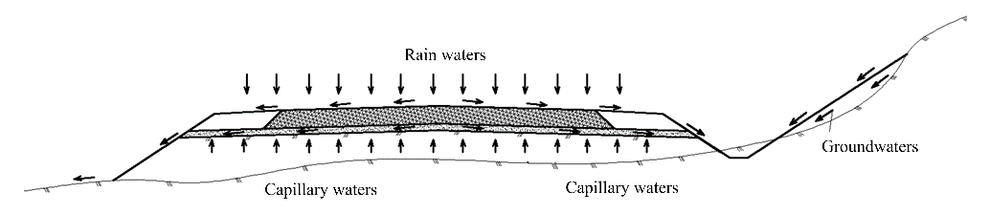
Figure 1. Sources of water origin to roads
The situation of irregular atmospheric precipitation for the last years in all around the world, puts the problem of predicting the complementary rainwater evacuation systems in addition to clasic execution.
- Classic water evacuation systems. According to the design an construction requirements of the roads SNIP 2.05.02-85, SNIP 3.06.03-85, and recommendations to these rules, water evacuation proceeds as follows:
- Through the declivity of the longitudinal profiles, where the minimum required declivity is 0.005, and in some exceptional cases 0.003;
- The transverse profile of the road surface with a minimum of 0.02 for flexible pavement surfaces, with the maintenance of the road camber for certain types of surface courses: flexible pavement, rigid pavement, macadam road surface, etc.;
- Water evacuation from the road surface in case of declivity of the longitudinal profiles more than 0.05, is achieved through lateral constructions located in the cross section, the water being directed through the gutters at the edge of the road (figure 2);
- The accumulation and evacuation of water from the edge of the embankment is achieved through the gutters (lateral ditches);
- The capillary waters that are directed from the embankment to foundation of surface course, is captured and discharged through the drained sand layer with a filtration capacity of 3m/24h;
- Ground water can be removed by some drainage systems.
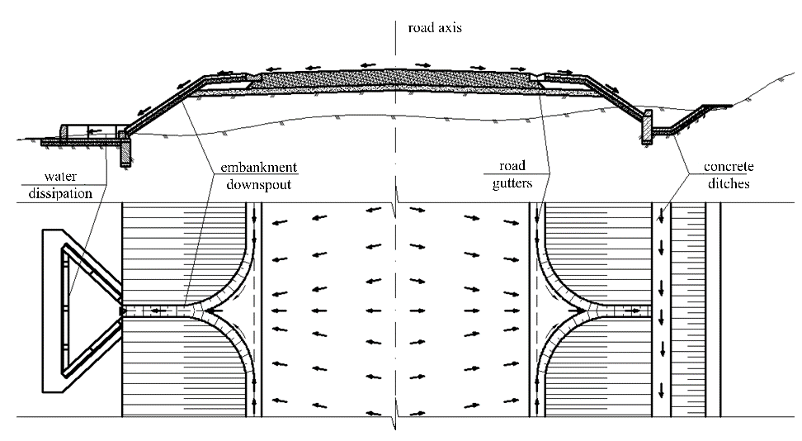
Figure 2. Drainage system through the gutters at the edge of the road and embankment downspouts.
- Alternative evacuation system
Changing the road camber especially for urban and rural conditions.
Changing the geometric form of the road camber is the posibility to offer a clean surface during the storm rain, especially for 2-way road.
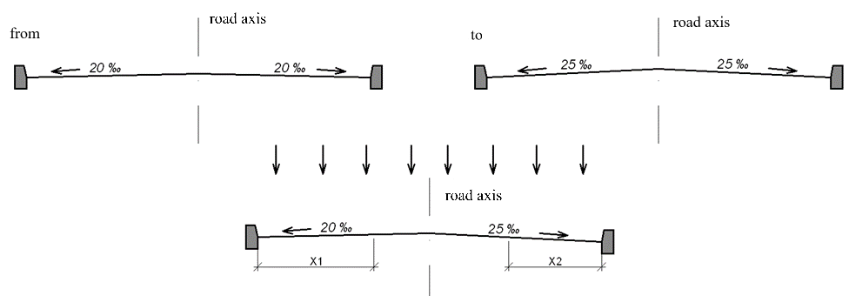 Figure 3. Changing the geometric form of the road camber.

  - There are situations when typical decisions of water evacuation from the road surface (ditches, edge gutters, culverts, etc.), cannot be fit in the execution finished grades or geometric of the road, especially for urban or rural roads.
The following types of execution are proposed:
- The discharge of water through a closed classical system;
- Water drainage through open systems, trapezoidal concrete ditches;
- Water discharge through monolith rectangular ditches (or prefabricated), with prefabricated plate TYPE “I”.
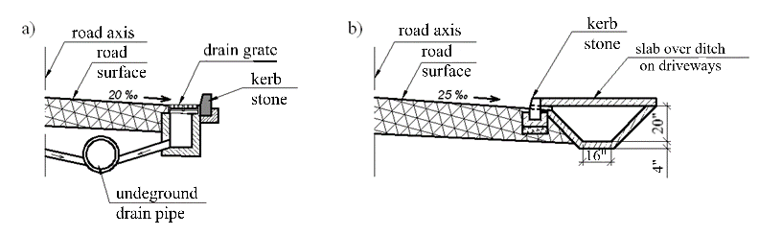
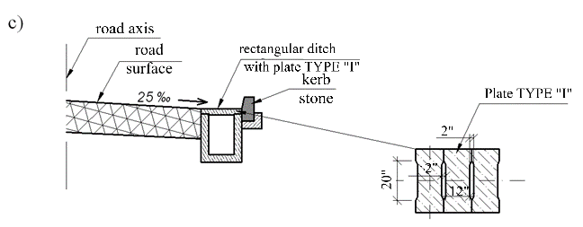
Figure 4. Drainage systems in localities.
These decisions can be used when is not enough space for fitting of road geometry and classic evacuation systems, in parking areas, access to the main road, driveways, garages, etc.
  - In cases when on the current road sections, does not allow us to fit a regular culvert, during the reconstruction or replacement of the culvert when it does not match with hydraulic capabilities (figure 5), can be replaced with a rectangular nonclassic form.

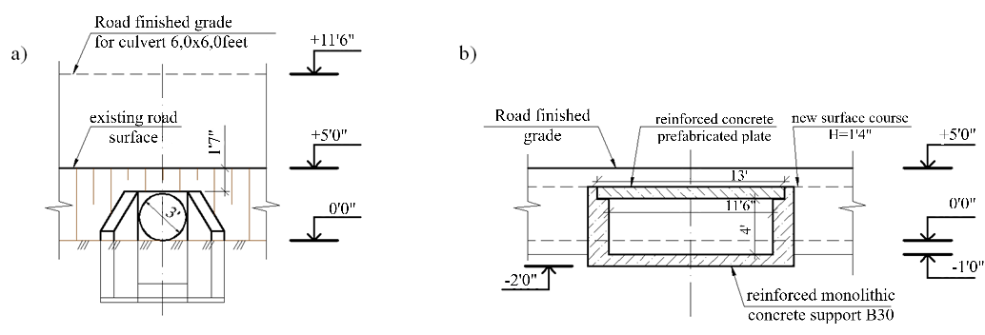
Figure 5. Situation of reconstruction of a culvert. a- current situation, b- the proposed option.
Example from the figure 5, shows us that in this situation, the problem emerged from the hydrological calculation (current culvert Ø3,0feet), where the result of the final calculation given that this culvert must be replaced with one of minimal 6,0x6,0 feet, where the finished grade in the culvert area must be higher with aproximately +6,0 feet, which requires extra embankment work on the section with lateral roads and a convex curve on a relative short road sector (figure 6), which will lead to a prolonged technological process and additional costs. In the alternative, it is being suggested a rectangular culvert with dimensions 10,5x3,6 feet with a prefabricated plate placed on a reinforced monolithic concrete support B30.
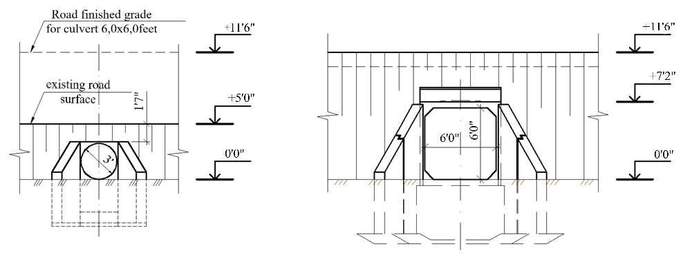
Figure 6. Framing of a rectangular culvert 6,0x6,0 feet according to the type projects
- Final conclusions. In conclusion, we can say that any engineering decision for the execution of water evacuation systems is important, but, the alternative engineering decisions give a possibility to gain invaluable time, an architectural view of the work, and of course a lower cost of execution
References
- SNIP 2.05.03-84 „Bridges and Culverts”.
- SNIP 2.05.02-85 „Road Ways”.
- SNIP 3.06.03-85 „Road Ways”.
- CP D.02.11-2014 „Recommendations on the design of streets and roads in urban and rural areas”.
- CP D.01.04-2007 „Determination of the main calculation hydrological characteristics”.
- Typical projects:
6.1. Series 3.501.1-144 „Reinforced concrete circular combined culverts for Railroads and Roadways”. Release 0-0 0-4.
6.2. Series 503-09-7.84 „Water Drainage Structures for Roadways of the common network of Soviet Union”.
6.3. Series 3.501.1-177.93 „Reinforced concrete rectangular combined culverts for Railroads and Roadways”.

