CONSTRUCTION AND ARRANGEMENT OF DEFORMATION-EXPANSION JOINTS OF BRIDGES WITH SIMPLE SUPPORTING ELEMENTS SUPERSTRUCTURE
Mihai Netid
Master Degree
Roads, Materials, and Mechanization in Construction
Road design engineer
Abstract. Bridge expansion joints are designed to allow for continuous traffic between structures while accommodating movement, shrinkage, and temperature variations on reinforced and prestressed concrete, composite, and steel structures.
Keywords: waterproofing, deformation joints, displacements, simplicity, joint cover device, mastic, crushed stone.
General required trends to the execution materials
From test experience of different types of joint devices, has confirmed the need to develop requirements for their construction, for proper use [1]:
- Unjustification of complicated or mild constructions;
- Structures, calculated for reduced intensity under conditions of increased traffic intensity;
- Structures with insufficient admissible displacements;
- Leaky structures.
In order to ensure the safety and long-term exploitation of the jointing device construction, they should meet to the next requirements [1]:
- When choosing and installing the joint cover device, it is necessary to know the size of the displacement of the heads of the openings and the absorption capacity of the device;
- The joint cover device must meet the requirements that will ensure safe operation:
- Do not allow the infiltration of water to the bridge seats and the beams' ends, to be tight;
- To be properly waterproofed: in the area of the device, the water must not infiltrate in the deck, the water must not contact the concrete and the reinforcement;
- The heads should be securely anchored, which must withstand the forces of the the load actions;
- Ensure drainage in the road system;
- Joint exploitation time must not be less than that of surface course and waterproofing;
- To be technologically secured, the use of machinery at all construction stages (fitting, maintenance, repairing, servicing).
- To possess the necessary properties which will assure the next:
- Safety and comfort of road traffic when crossing over the joint cover;
- Low noise emissions, especially in urban areas;
- Compliance with environmental requirements;
- Aesthetic appearance of the cover device because the top is visible to the road users;
- Simple operating conditions of the joint cover device;
- Easy maintenance and installation of the device.
- The cost of the device must be minimal, economical metal consumption; but it should be considered that too much savings at the initial stage may incur additional costs when exceeding the service life. Although the cost of a joint cover device accounts 1-2% of the total cost of bridge construction, it would not be right to choose the indicators that are important for workability and long service life to be guided only by their price.
- Construction of the „buried” deformation joints
Buried expansion joints, are used for joints of small length superstructures, mounted on mobile supports, as well as in the connection points of discontinuous superstructures, continue and continue without moving (from temperature), mounted on fixed supports [1].
In all cases of displacement absorption of longitudinal profile jointing devices typically does not exceed 10 ... 15 mm [2]. It is possible to use the construction at longitudinal displacements up to 20 mm. Vertical movements at the same time shall not exceed 1,3 mm [3].
The joint between the adjacent spans of the joint device „covered” type with a metal plate (tip RDM-1-10) (fig. 1.1).
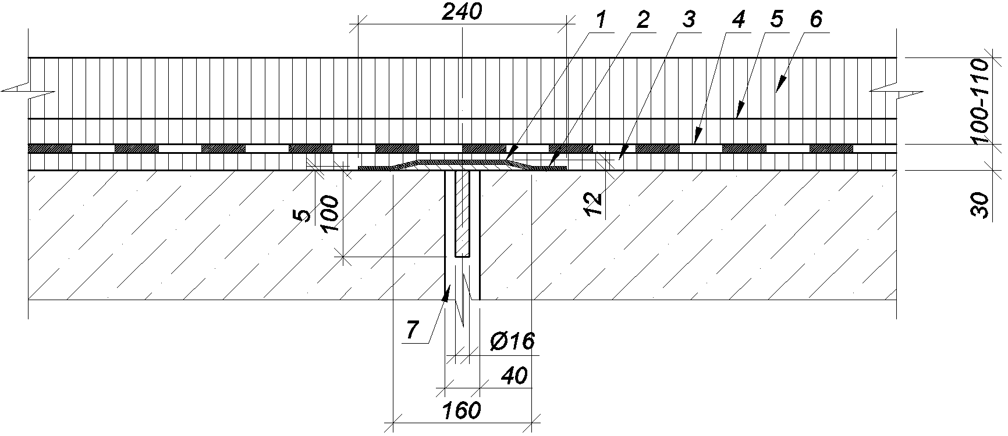
Figure 1.1. Buried deformation joint:
1 - metal support plate; 2 - separator lining s - 2-5 mm of mastic, hermetic, or waterproofing roller; 3 - equalization layer; 4 – waterproofing; 5 - base coat of asphalt concrete, h=30-40 mm; 6 - wear layer od aspalt concrete; 7 – joint between adjacent superstructures.
Buried deformation joint cover device, the construct of which is represented in figure 1.2, is an optimal solution for the smallest displacements, and this determines constructive simplicity. The displacements of the superstructures are perceived by the elastic deformation of the road clothing, arranged above the deformation joint, often without the use of different methods to compensate displacements. For this type of deformation joint, it is used continuous asphalt concrete that resists cracking above it. The opening between adjacent superstructures to the buried type device closes with the element 4 (figure 1.2), representing a metal plate itself, serving as the base for the above pavement, or a resilient sealing element, besides supporting, as well as an additional waterproofing role. The basic load of the waterproofing of the deformation joint, typically, fulfills the waterproofing of the pavement 1 (figure 1.2), which can pass without interruption over the joint (figure 1.1, 1.2, 1.4). The RDM-1-10 deformation joint is designed to provide a displacement of up to 10 mm (figure 1.1). The waterproofing can be broke, transmitting its functions to the sector above the deformation joint, namely the rubber compensator of the joint cover device (as the deformation joint of the type DRC-1-10 for the same movement (figure. 1.3)).
As an additional component, an elastic lining may be used, separating the elastic road clothing from its support (figure 1.1). This method is intended to reduce the adhesion between road clothing and the surface of the support layer and provide more uniform and free deformation of the road clothing and is recommended for displacements of more than 10 mm. In special cases for this situation, metal plates are used as separators, separating the road clothing and the protective layer.
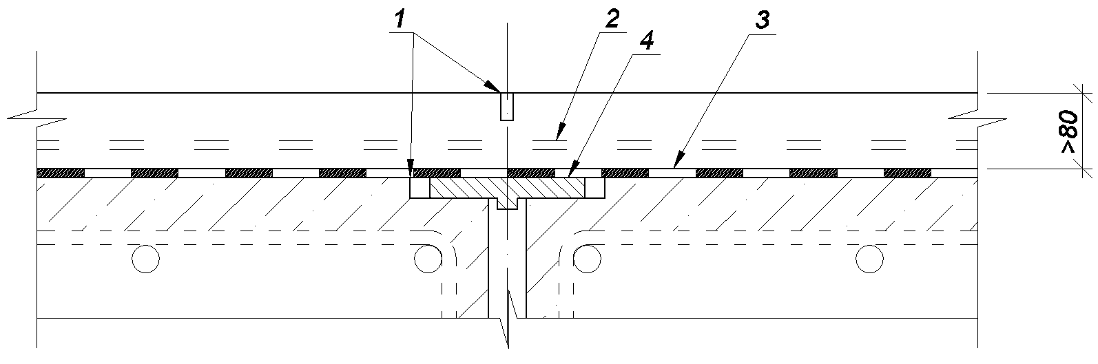
Figure 1.2. Deformation joint device RDM-1-10 with metal plate:
1- bituminous mastic; 2 - armouring of road clothing; 3- waterproofing the superstructure; 4- metal or elastic support element.
Sometimes a drainage system (figure 1.3) can be used, located under road clothing (surface drainage system).
The waterproofing may be deteriorated by transmitting its functions to the sector above the joint deformation joint of the joint "RDC-1-10" (figure 1.3).
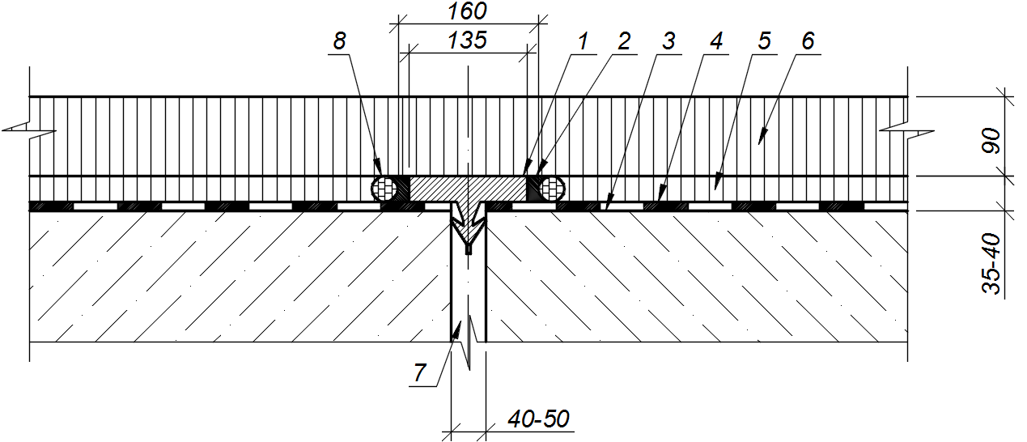
Figure 1.3. Deformation joint device with with rubber compensator type ” RDC-1-10”:
1- rubber filling; 2- sealant; 3- equalization layer; 4- waterproofing the superstructure; 5- base coat of asphalt concrete, h=40-55mm; 6- wear layer od aspalt concrete; 7- joint device between adjacent superstructures; 8- drainage system.
The same can be used bituminous mastic 1 (figure 1.2), arranged in a narrow space in the road clothing to reduce the risk of cracks. This is the case with the Sentinel ™ B 1-B4 joint device produced by Stirling Lloyd, which allowed them to achieve admissible displacement up to 20 mm
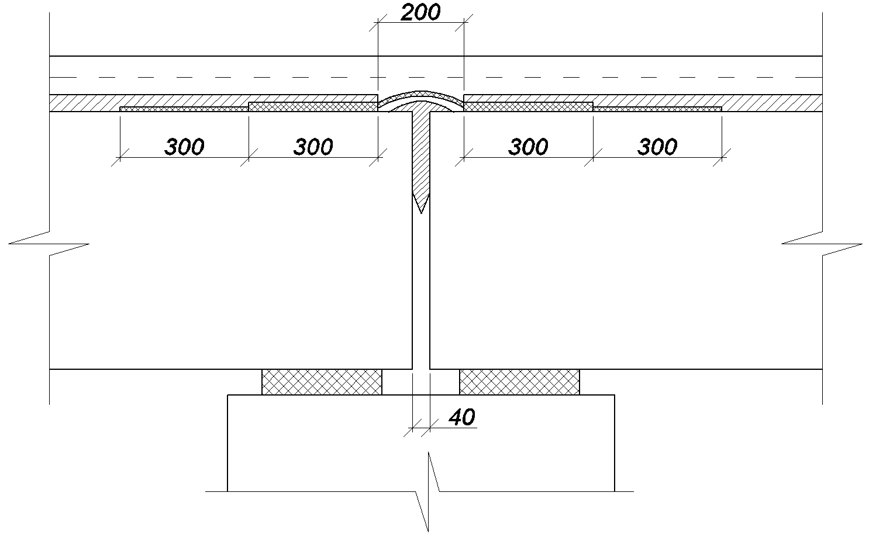
Figure 1.4. Deformation joint device type „RDT” sealed with silicone (produced by the company „Transmost”) with displacements up to 20 mm.
For similar situations, in some cases reinforcement of road clothing with steel mesh or synthetic materials (for example, polyester) is used. Thus, for example, joint coating devices manufactured by S.A. "Transmost" ("RDT" type) with displacements equal to 20 mm. In this type of device, is used a rubber support 1 (figure 1.4) attached to the concrete or to the metal of one of the superstructures, sealed suplimentary with silicone, isoplast-type hydrosillation roller, continuously above the deformation joint.
Buried deformation joint devices have a number of advantages [1]:
- Simple construction;
- Low cost of the device;
- Small number of items;
- Lack of complicated knots and low volume of embedded materials
- Plane surface;
- Good grip with vehicle tires;
- They do not deteriorate on crossing by the snow-cleaning machines.
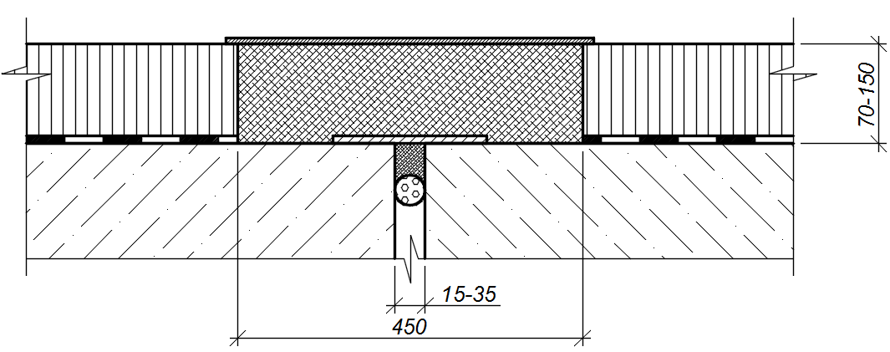
Figure 1.5. Buried deformation device
This type of joint cover device (Figure 2.1.5) has a number of advantages:
- Dependence of the deformation joint properties on the road clothing structure, which requires individual design;
- Dependence of the deformation joint properties on the condition of the road clothing, the materials used, the air temperature;
- Exposing to the actions of the aggressive environment due to the numerous cracks in ordinary asphalt clothing;
- Low wear resistance;
- It is practically impossible to undergo repairs;
- Works unsatisfactorily at angular and vertical displacements (bending and displacement of the road clothing);
- It is impossible to be used at the bridges with rigid pavement (Cement concrete road clothing).
- Construction and fitting of deformation joints devices with crushed stone and mastic.
The perceived displacements
These devices perceive horizontal longitudinal displacements within the range of 5...40 mm [3, 4, 5] (in special cases up to 50 mm [6, 7]). Vertical displacements should not exceed 3 mm [3]. Angular displacements will have to be insignificant or completely absent [3, 4].
Device construction analysis.
The constructional details of the device are shown in figure 2.1. The construction consists of two main elements: support plate, made in the form of a metal plate, covering the joint between the superstructures and serving as the basis for the mixture of mastic and crushed stone placed over the joint, the mixture of mastic and crushed stone, fitted in the channel, executed in the road system of the road. The mixture of crushed stone and mastic, flexible in all directions, deforming, takes over the displacements of the heads of the superstructures.
In practice, more complex and refined devices are used, for example, such devices as Freyssinet's Viajoint (figure 2.2), has in its composition a sealing gasket, performing the waterproofing role. This also prevents leakage of the mastic into the joint when installing the device. The width of the plate, acting as the supporting element, is 200 mm. The support plate is made of aluminum to avoid the corrosion of bridge elements. To ensure the high coefficient of adhesion of the surface to the tires of motor vehicles, the pressure above the deformation joint with fractional material is necessary. The joint cover device with crushed stone and mastic ensures that the displacements are absorbed within 15-35 mm, ie 20 mm. The main dimensions of the device are shown in figure 2.2.
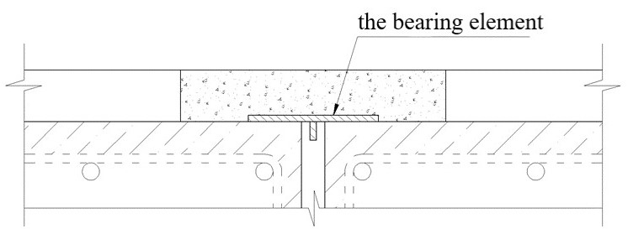
Figure 2.1. Execution of plain joint cover device.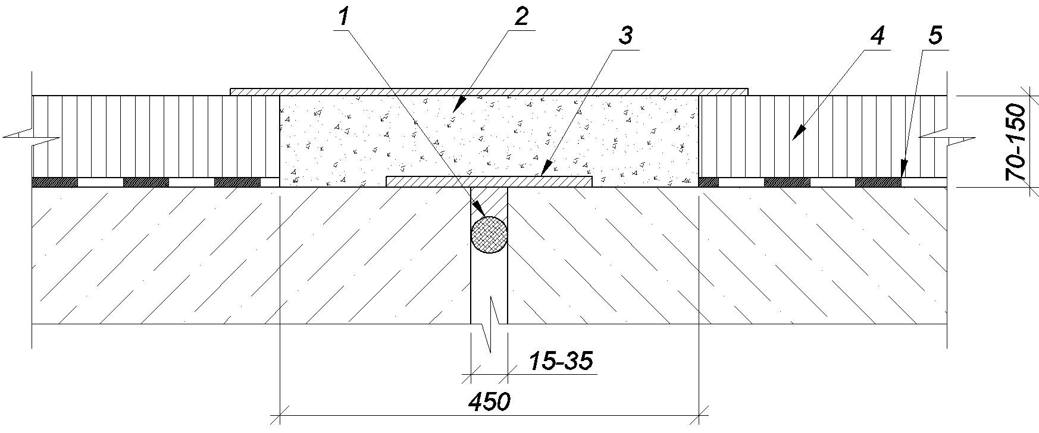
Figure 2.2. Construction of the Freyssinet company's Viajoint for displacements equal to 20 mm:
1- sealing gasket (porous material); 2- mixture of crushed stone and mastic; 3- support plate (aluminum); 4- covering the road; 5- waterproofing the roadway.
In addition to the indicated elements, the device may contain a surface drainage system and have other constructional specifications [8]. So, for example, the device designed of DPSM-2-25 type (figure 2.3) [9]. The limit displacements are presented in table 2.1
Table 2.1. Device limit displacements
Movements Δ, mm | 5-15 | 15-25
Device Width A, mm | 300-400 | 400-500
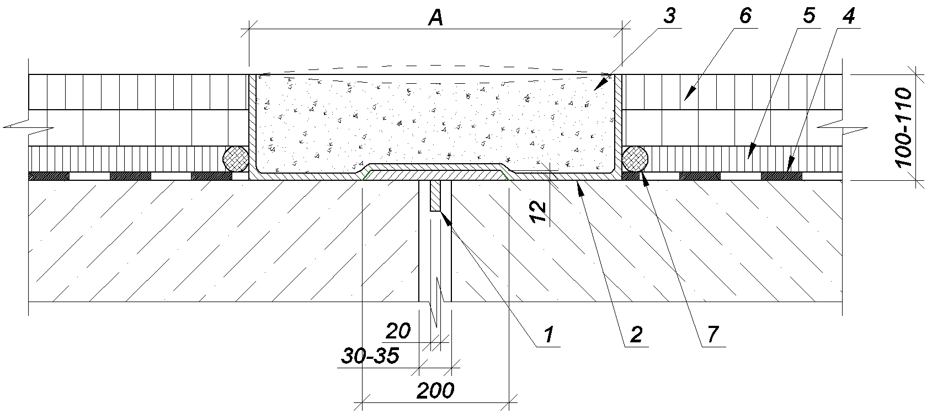
Figure 2.3. Joint cover device with crushed stone and mastic, type DPSM-2-25:
1- metal bearing plate; 2- sealing mastic; 3- stuffing of crushed stone and mastic; 4- waterproofing the superstructure; 5- protective layer (asphalt concrete, h=30mm); 6- double layer of asphalt concrete with total thickness, h=70-80mm; 7- drainage system
In the construction of these devices it is possible to use plate reinforcement of the mixture of crushed stone and mastic, as in the case of the device produced by "Irmas-Holding" (figure 2.4). The construction is designed to absorb horizontal displacements of superstructures up to 70 mm and vertical up to 60 mm. In the construction of the respective device (figure 2.4), a separate mixture of a crushed stone and mastic mixture is used in the support element (made of steel) by means of the aluminum foil arranged above the supporting element covered with antiadhesive.
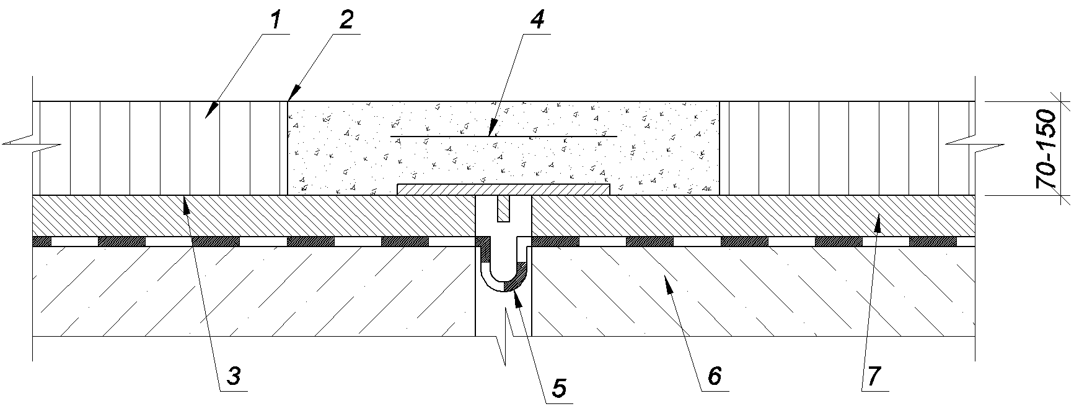
Figure 2.4. Joint cover device of crushed stone and mastic, with 70mm displacements, made by „Irmast-Holding” Company:
1- road pavement; 2- priming with a mastic layer; 3- waterproofing; 4- Polymer reinforcement mesh; 5- compensator; 6- superstructure; 7- protective layer.
Joint cover devices with crushed stone and mastis are also used on sidewalks.
Conclusions and Device Requirements
Devices possess a host of advantages, the main ones being:
- Simplicity of construction;
- Simplicity of repair and change;
- Quick-fitting works;
- Low noise emissions;
- Plane of the surface;
- The coefficient of adhesion of the surface of the device to the tire, very close to the coefficient for road clothing;
- Mobility in all directions;
- Simplicity of producing component materials and device layout;
- Autoregeneration of the mixture from crushed stone and mastic in the case of shallow degradation;
- Low cost device.
At the present stage it is established that, although the indisputable advantages, such devices are not subject to technical servicing. Disadvantages are:
- The trend of cracks at low temperatures, which will affect the tightness of the device;
- Unsatisfactory work of the device in the case of superstructures, which work at torsion, resulting in unequal deformations along the device;
- Unsatisfactory work on the device at angular superstructures and limitation of the length of the angle;
- Limiting the longitudinal gradient of the bridge construction in the area of the joint cover device;
- Dependence of the physical-mechanical properties of the mixture of crushed stone and the mastic of ambient temperature;
- Dependence of the technical and operating properties of the devices on the geometrical dimensions of the joint, the quantity of the mixed mixture, the correct composition of the mixture, the observance of the laying technology.
Conclusions.
In this way, the device can not be considered a universal solution for low-displacements bridges, but they are considered the most efficient types of devices for their field of use.
Following the analysis of the devices specified and described above, constructions, mobility absorption capacities and resistance to intensive traffic were observed, the advantages and disadvantages of each individual. Depending on the type of construction, the constructive dimensions, the climatic zone, the type of device that sums up all the needs (the absorption of the movements, the loads, the arrangement of the construction in the plan, etc.) is chosen.
At the design stage, repairing or rehabilitating of the bridge construction, it is often not appropriate to arrange the transition areas of the road system to the deformation joint with more resistant materials than ordinary asphalt concrete recommended by the company that manufactures and supplies the joint device; and normative documents for motorways with an increased intensity of road traffic, all of which lead to premature degradation.
References:
- Road Bridges deformation joints: Features of construction and work. A.V.Efanov, I.G. Ovchinikov, V.I.Shesternikov, V.N.Makarov. Saratov 2005 – 94 pages.
- Performance testing for modular bridge joint systems . NCHRP report 467 / R.J. Dexter, M.J. Mutziger, C.B. Osberg; University of Minnesota. Washington, D.C.: National Academy Press, 2002. - 92 p.
- BD 33/94. Expansion joints for use in highway bridge decks / The Highways Agency. - Great Britain, London, 1994. - 18 p.
- Ramberger G. Structural bearings and expansion joints for bridges. Structural Engineering Documents 6 / G. Ramberger. - Switzerland, Zurich: 1A13SE, 2002. -P. 51-89.
- http//www.bridgejoints.org.uk/publications/ A Standard for Asphaltic Plug Joints.2005. - 19 p.
- Bridge deck of road bridges with the use of molded asphalt concrete and modern expansion joints: monograph/I. G. Ovchinikov, V. N. Makarov, A. V. Efanov – Saratov. State Technical University, 2004 – 214 pages.
- Bridge Engineering Handbook. Chapter 25. Expansion Joints / R.J. Dorn-sife; Ed. by W.-F. Chen, L. Duan. - USA, Florida, Boca Raton: CRC Press, 2000.-P. 25-1 -25-14.
- Manual of Bridge Engineering. 15.3. Expansion joints / P. Thaurc, D.E. Jenkins, R.A. Broome, D.J. Grout; Ed. by M.J. Ryall, G.A.R. Parke, J.A. Harding. - Great Britain, London: Thomas Telford Publishing, 2000. P. 783-793.
- Expansion joints of road bridges: tutorial/I. G. Ovchinikov, V. V. Ratkin, V. N. Makarov, A. A. Piskynov – Kazan: 2003 – 137 pages.
- https://en.wikipedia.org/wiki/Expansion_joint.

