Physics of Sport
DEPENDENCE OF THE SIZE OF THE VISIBLE PART OF THE OPPONENT'S GOAL OPENING AREA ON THE ANGLE OF THE STRIKER'S ATTACK IN FOOTBALL

Professor Karlo Moistsrapishvili
Georgian State University of Physical Culture and Sports
Tbilisi, Georgia
e-mail: karlo.moistsrapishvili@gmail.com karlo.moistsrapishvili@sportuni.ge
Abstract: The article discusses the situation that arises in football at the opponent's goal for a forward attacking at an acute angle to the goal line. A formula linking the angle of attack with the visible opening of the opponent's goal is established, and a corresponding graph is built.
Key words: football, forward, angle of attack, area of the goal opening.
Introduction: Football’s ranking as the most popular team sport is hardly debatable
Each player on the pitch performs variety of pre-defined tasks based on their functionality. The wingers, by very nature of their position, most often end up attacking the opponent's goal at an acute angle to the goal line, that is, to the area of the goal opening, and this situation deserves to be studied.
Main Body.
A player attacking the opponent's goal in the middle of the field, at
$α={90}^{0}$ angle to the goal line, sees the full area of the goal ($S_{0}=а∙h$ where $а$ is goal length and $h$ is goal height), i.e. he has the maximum view of the opponent's goal.
The situation is completely different when the striker (forward) attacks from the flank, i.e. $α≠{90}^{0}$. In this case, the visibility of the goal is reduced, and can reach zero when $α=0^{0}$
Let's consider the case when the striker (forward) attacks from the flank, i.e. the angle of attack is sharp. When attacking at an acute angle to the goal line, the field of vision of the player narrows and he does not see the entire goal line, but only a part of this line, namely a segment (Fig. 1).$х=|AC|$
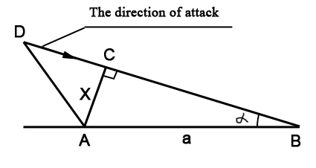
Fig. 1
$α$ - Angle of attack, $а=|AВ|$ goal line (goal length)
$х=|AC|$ - the part of the goal line that is visible to the striker
$D$ - the position of the forward attacking from the flank.
Figure 1 shows a scheme (horizontal projection at the forward's eye level) of a forward attacking from the flank at an angle; usually, performed by wingers [1]. The angle of attack refers to the angle between the goal line ($а=|AВ|$) and the forward’s direction of attack (direction of movement). The vector indicates the direction of attach (the direction of movement) of the forward.
In this arrangement, the attacking forward sees only part of the goal line $х=|AC|$, which also can be defined as
$х=а∙\sin{α}$ (1)
where x is the part of the goal line visible to the forward, $а$ is the length of the goal line ($а=|AВ|$) and $α$is the angle of the forward's attack.
From equation (1) it is easy to derive a new equation linking the visible part of the area of the opponent's goal opening to the angle of attack:
$S^{'}=S_{0}∙\sin{α}$ (2)
where $S^{'}$is the part of the area of the goal opening that is visible to the striker when attacking at an angle $α$, while $S_{0}$ is the total area of the goal opening ($S_{0}=а∙h$, a is the length of the goal, h is the height of the goal). According to international standards $а=\left|AB\right|=7,32 м$; $h=2,44 м$ . [2].
When $α={30}^{0} S^{'}=0,5∙S_{0}$, only half of the whole area of the opponent's goal is in the field of view of the attacking forward, in contrast to $α={90}^{0}$when the forward sees the full area $S_{0}$of the opponent's goal. Therefore, his task to score is twice as difficult [3].
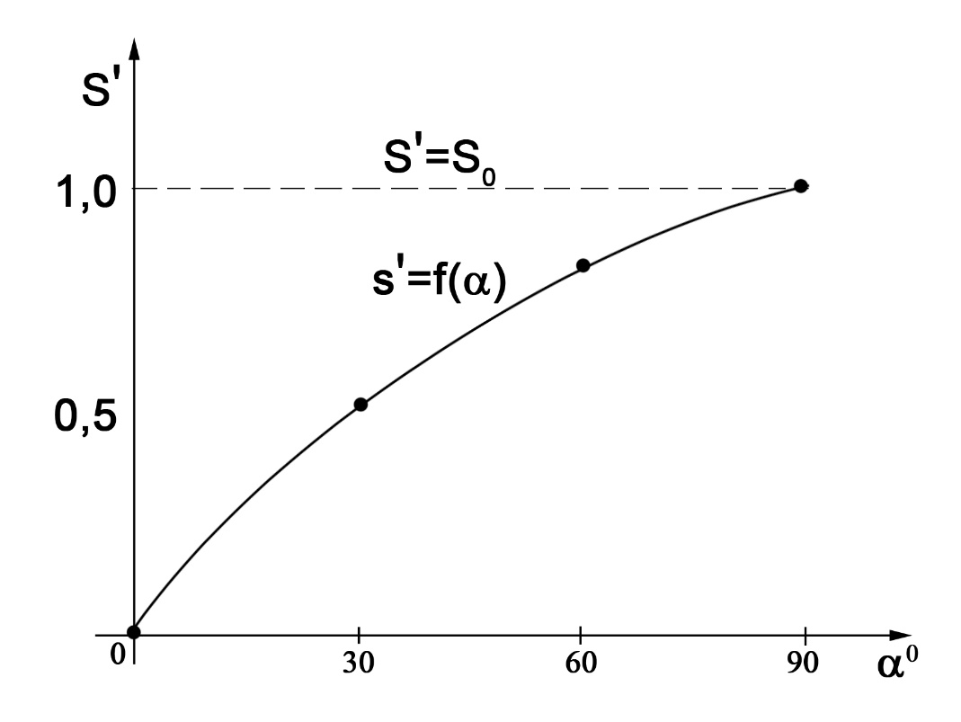
Fig. 2
Fig. 2 shows the relationship curve of the visible part of the area of the opponent's goal opening and the angle of attack ($S^{'}=f(α)$) for a winger attacking at an angle $α$.
When attacking from the flank, the visible area of the opponent's goal opening reduces as the angle of attack becomes narrower, therefore, the player must possess high skills and impeccable technique to achieve the desired objective - to score a goal.
The author would like to thank Mr. Mamuka Kvantaliani for his assistance in this work and Ms. Maia Gelashvili for her support in Information Technology.
This article is dedicated to the Georgian national football team qualifying for UEFA EURO 2024 finals.

References
- Emiel Schulze, Ross Julian & Tim Meyer (2022). Exploring Factors Related to Goal Scoring Opportunities in Professional Football, Science and Medicine in Football, 6:2, 181-188, DOI: 10.1080/24733938.2021.1931421
- Pratas, José Maria; Volossovitch, Anna; Carita, Ana Isabel. Goal scoring in elite male football: A systematic review - Journal of Human Sport and Exercise - 2018, Vol. 13, No. 1.
- Smith, R. A., & Lyons, K. (2017). A strategic analysis of goals scored in open play in four FIFA World Cup football championships between 2002 and 2014. International Journal of Sports Science & Coaching, 12(3), 398-403. https://doi.org/10.1177/1747954117710516

