Book Computation the Inertial Fusion Reactor 2 12 19
Fusion Energy

Computation the Inertial Fusion Reactors and Capacitor Driver
Alexander Bolonkin

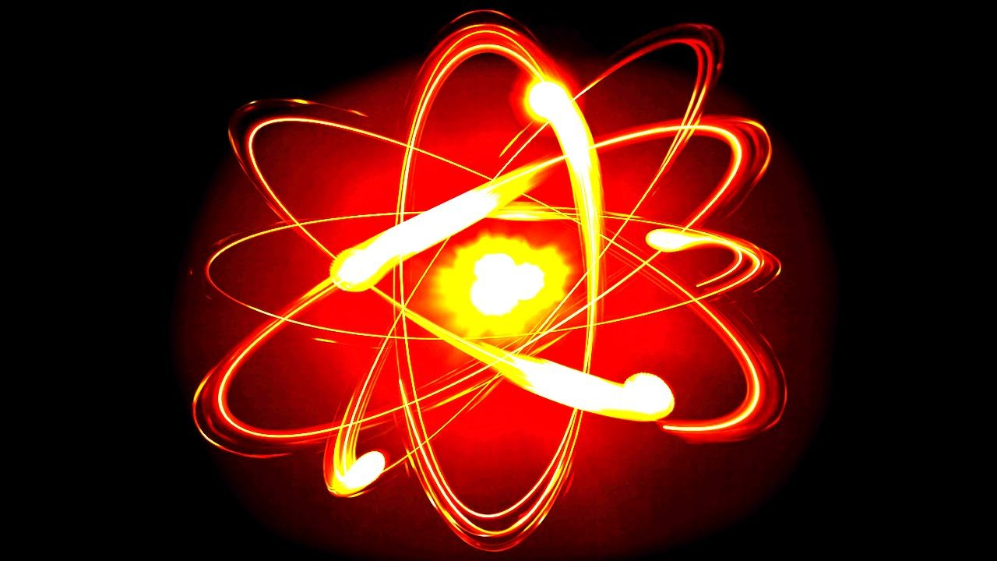

USA, LULU, 2019

Title: Computation the Inertial Fusion Reactors and Capacitor Driver
Author: Alexander Bolonkin <abolonkin@gmail.com>
ISBN:
In the last sixty years, the government spent the tens billion dollars attempting to develop useful thermonuclear energy. However, scientists cannot yet reach a stable thermonuclear reaction. They still are promising publically, after another 15 – 20 years, and additional tens of billions of US dollars to finally design the expensive workable industrial installation, which possibly will produce electric energy more expensive than current heat, wind and hydroelectric stations can in 2018.
Author offers in his book “Small Non-Expensive Electric Inertial Thermonuclear Reactors (v.2)”, USA, LULU, 2019.
the new, small cheap, impulse thermonuclear reactors. In given book he offers the new thermonuclear fuels for Inertial Fusion Reactors, makes computations a new cheap fusion reactor and offers and computes a new capacitor as a cheap driver for fusion ignition.
In Part 1 (Fuel) he considers old and new fuels for Inertial Fusion Reactors - hydranes.
In Part 2 the author computes the the new thermonuclear reactions for different fuels. He assumes, that ignition temperature is 10 keV and volume of fuel camera is constant.
In Part 3 the author suggests a new capasitor as driver and computes the capasitor - driver. He defines the requests which new capasitor must satisfay for reaching the ignition 10 keV.
Copyright@ 2019 by author
Publisher: LULU in USA www.lulu.com

Content:
Abstract 5
Part 1. Fuel for Inertial Fusion and Fission Reactors 6
1. Request for fuel. 6
2. Types of fuel for Fusion and Fission Reators (Tritium, Deuterium, Helium-3, Hydrogen, Litium,
Boron, Beryllium, Uranion-238, Uranion-235, Plutonium). 6
3. Hydranes.
4. Deuterides. 11
Referance.
Part 2. Theory and Computation the Inertial Fusion Reactors. 13
1. Theory of burn the fusion fuel. 13
2. Computer programs and Results of Computation for the solid, liquid and gas fusion fuel. 22
T+D 22
D+D 39
LiD 48
D₂O 58
pB11, 6B10H 68
DHe 79
Part 3. Computation of the ignition capacitor. 85
1. Theory. 85
2. Computer program. 94
3. Results. 97
References 101

About the Author

Short biography of Bolonkin, Alexander Alexandrovich
Alexander A. Bolonkin was born in the former USSR. He holds doctoral degree in aviation engineering from Moscow Aviation Institute and a post-doctoral degree in aerospace engineering from Leningrad Polytechnic University. He has held the positions of senior engineer in the Antonov Aircraft Design Company and Chairman of the Reliability Department in the Clushko Rocket Design Company. He has also lectured at the Moscow Aviation Universities. Following his arrival in the United States in 1988, he lectured at the New Jersey Institute of Technology and worked as a Senior Scientist at NASA and the US Air Force Research Laboratories.
Bolonkin is the author of more than 250 scientific articles and books and has 17 inventions to his credit. His most notable books include The Development of Soviet Rocket Engines (Delphic Ass., Inc., Washington , 1991); Non-Rocket Space Launch and Flight (Elsevier, 2006); New Concepts, Ideas, Innovation in Aerospace, Technology and Human Life (USA, NOVA, 2007); Macro-Projects: Environment and Technology (NOVA, 2008); Human Immortality and Electronic Civilization, 3-rd Edition, (Lulu, 2007; Publish America, 2010): Life and Science. Lambert Academic Publishing, Germany, 2011, 205 pgs. ISBN: 978-3-8473-0839-3. http://www.archive.org/details/Life.Science.Future.biographyNotesResearchesAndInnovations; Femto technology and Revolutionary Projects, Lambert, 2011, p.530; New Methods of Optimization and their Application, Moscow High Technical University named Bauman (in Russian: Новые Методы Оптимизации и их применение. МВТУим. Баумана, 1972г., 220 стр). List and links of some Bolonkin’s publications: https://archive.org/details/List5.3s8518, Homepage: http://Bolonkin.narod.ru , https://en.wikipedia.org/wiki/Alexander_Bolonkin .
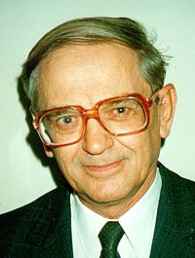

Abstract
In the last sixty years, the government spent the tens billion dollars attempting to develop useful thermonuclear energy. However, scientists cannot yet reach a stable thermonuclear reaction. They still are promising publically, after another 15 – 20 years, and additional tens of billions of US dollars to finally design the expensive workable industrial installation, which possibly will produce electric energy more expensive than current heat, wind and hydroelectric stations can in 2018.
Author offers in [1] the new, small cheap, impulse thermonuclear reactors. In given book he offers the new thermonuclear fuels for Inertial Fusion Reactors, makes computations a new cheap fusion reactor and offers and computes a new capacitor as a cheap driver for fusion ignition.
In Part 1 (Fuel) Author cosides the fuel for Fusion and Fission Reators (Tritium, Deuterium, Helium-3, Hydrogen, Litium, Boron, Beryllium, Uranion-238, Uranion-235, Plutonium, Hydranes)
In Part 2 (Theory and Computation) the author computes the the new thermonuclear reactions for different fuels. He assumes, that ignition temperature is 10 keV and volume of fuel camera is constant.
In Part 3 (Thery and computation of the new capasitor-deiver) the author suggests a new capasitor as driver and computes the capasitor-driver. He defines the requests which new capasitor must satisfay for to reaches the ignition 10 keV.
----------------------------------------------------
Keywords: Micro-thermonuclear reactor, Impulse thermonuclear reactor, electric thermonuclear reactor, Inertial thermonuclear reactor, thermonuclear reactor for transport, aerospace thermonuclear propulsion, nuclei fuse, thermonuclear rocket.

Part 1. Fuel for Inertial Fusion and Fission Reactor.
Abstract
Author studies the requests to the thermonuclear fuel and offers the new cheap fuel. His the fuel main idea is change the gas thermonuclear fuel (T, D) by the fuel having the solid or liquied form in room temperature. That alloys avoid the not accebtable for practice a kriogenic temperature and the expensive laser instellation for compressing the fuel. He offers as fuel the chemical connection having a lot of H (hydrides) in which H are change by D. In this case not nessusary to compress the fuel.
-----------------------------------------
Key words: Nuclear fuel, nuclear fusion fuel, thermonuclear fuel, inertial fusion fuel.
1. Requests for fuel.
The probability of the connection of two nuclei with the subsequent decay depends on the probability of a direct collision (penetration into each other). The penetration of nuclei into each other depends on the composition of the reacting nuclei, their kinetic energy (temperature), density and reaction time.
The probability of a direct collision of nuclei is described by a cross section that depends on the type of nuclei and their temperature and is measured in bars [cm²]. For the Tritium + Deuterium reaction, from the condition that the heating ignition energy is equal to the energy produced, Lawson got criterion
L ≈ nTτ > 10²⁰ ÷ 10 ²¹.
Here n is fuel matter density [1/m³]; T is temperature [keV, 1 eV= 1.16×10⁴ K]; τ is reaction time [s].
This probability is very small and for many nuclei reaches a maximum of about 10⁻²⁵ cm² at a temperature of about 0.1 ÷ 1 MeV (1 ÷ 10 billion degrees). Similar temperatures and pressures currently cannot withstand any material.
There are theoretical developments in the creation of artificial nuclear materials that are millions of times stronger than conventional ones and are able to withstand temperatures of millions of degrees [2]. But this is a matter of the future.
In present time in Inertial Fusion reactors the scientists try to reach the need conditions - very high pressure (density) and heating a fuel by laser pressure in very shot time (10⁻⁸ s).
We need for it in very big and expensive the laser instellations (NOVA, Laser NIF cost $3.5 B). They have a low efficiency (~10%) and not acceptable for transpart vehicles.
The other method uses a big time, low density and heating fuel by electric currency. This method needs in a strong magnetic field for separating the high energy nuclears from camera walls. That requests superconductivity and creogenic temperature. The instellation is also big and very expensive (ITER).
For more then 60 years research and tens billions of dollars the scientists all countries can not reach the acceptable reactor.
2. Types of fuel used in Fusion and Fission reactors.
The thermonuclear fuel may be gas, liquied, or solid. The highest ignition temperature has pair Tritium (T) + Deuterium (D) (Part 2, Chapter 1, fig.1).
Unfortunately, the T and D as many suitable components (He3, H) are the gas. They request very high compression or very low (criogenic) temperature. Some of them (T, He3) absent in Earth and are very expensive (30,000 $/gr). We can get them in atomic reactors.
The properties of some of thermonuclear nuclear fuels are below:
Tritium: His symbol is T or ³H, also known as hydrogen-3). Tritium is a radioactive isotope of hydrogen. Half-life
12.32 years. One uses for thermonuclear weapon.
Tritium is an important fuel for controlled nuclear fusion in both magnetic confinement and inertial confinement fusion reactor designs. The experimental fusion reactor ITER and the National Ignition Facility (NIF) will use deuterium-tritium fuel. The deuterium-tritium reaction is favorable since it has the largest fusion cross-section (about 5.0 barns) and it reaches this maximum cross-section at the lowest energy (about 65 keV center-of-mass) of any potential fusion fuel.
The Tritium Systems Test Assembly (TSTA) was a facility at the Los Alamos National Laboratory dedicated to the development and demonstration of technologies required for fusion-relevant deuterium-tritium processing.
Deuterium. Deuterium (or hydrogen-2, symbol D or ²H, also known as heavy hydrogen) is one of two stable isotopes of hydrogen (the other being protium, or hydrogen-1). The nucleus of deuterium, called a deuteron, contains one proton and one neutron, whereas the far more common protium has no neutron in the nucleus. Deuterium has a natural abundance in Earth's oceans of about one atom in 6420 of hydrogen. Thus deuterium accounts for approximately 0.0156% (or, on a mass basis, 0.0312%) of all the naturally occurring hydrogen in the oceans, while protium accounts for more than 99.98%.
Density: Liquid 162.4 kg/m³, Gas: 0.452 kg/m³.
Compounds of hydrogen isotopes are practically no different in chemical properties, but have rather different physical properties (melting point, boiling point, weight). D₂ molecule, consists of two deuterium atoms. Substance has the following physical properties:
• Melting point −254,5 ° C.
• Boiling point: −249.5 ° C (23.57K).
• The internuclear distance of 0.07416 nm.
• The dissociation energy (at 0K) is 439.68 kJ / mol.
The deuterium content in natural gas - (1.10 ÷ 1.34) · 10⁻⁴ (1: 7500 ÷ 9100).
Helium-3 (³He, see also helion) is a light, non-radioactive isotope of helium with two protons and one neutron. Because of its low atomic mass of 3.02 atomic mass units, helium-3 has some physical properties different from those of helium-4, with a mass of 4.00 atomic mass units. Because of the weak, induced dipole–dipole interaction between the helium atoms, their microscopic physical properties are mainly determined by their zero-point energy. Also, the microscopic properties of helium-3 cause it to have a higher zero-point energy than helium-4. This implies that helium-3 can overcome dipole–dipole interactions with less thermal energy than helium-4 can.
Helium-3 boils at 3.19 K compared with helium-4 at 4.23 K, and its critical point is also lower at 3.35 K, compared with helium-4 at 5.2 K. Helium-3 has less than half the density of Helium-4 when it is at its boiling point: 59 gram per liter compared to the 125 gram per liter of helium-4—at a pressure of one atmosphere. Its latent heat of vaporization is also considerably lower at 0.026 kilojoules per mole compared with the 0.0829 kilojoules per mole of helium-4.
³He can be produced by the low temperature fusion of (D-p)²H + ¹p → ³He + γ + 4.98 MeV. If the fusion temperature is below that for the helium nuclei to fuse, the reaction produces a high energy alpha particle which quickly acquires an electron producing a stable light helium ion which can be utilized directly as a source of electricity without producing dangerous neutrons.
The fusion reaction rate increases rapidly with temperature until it maximizes and then gradually drops off. The DT rate peaks at a lower temperature (about 70 keV, or 800 million kelvins) and at a higher value than other reactions commonly considered for fusion energy.
³He can be used in fusion reactions by either of the reactions
²H + ³He → ⁴He + ¹p + 18.3 MeV, or ³He + ³He → ⁴He + 2 ¹p+ 12.86 MeV.
The conventional deuterium + tritium ("D-T") fusion process produces energetic neutrons which render reactor components radioactive with activation products. The appeal of helium-3 fusion stems from the aneutronic nature of its reaction products. Helium-3 itself is non-radioactive. The lone high-energy by-product, the proton, can be contained using electric and magnetic fields. The momentum energy of this proton (created in the fusion process) will interact with the containing electromagnetic field, resulting in direct net electricity generation.
Because of the higher Coulomb barrier, the temperatures required for ²H + ³He fusion are much higher than those of conventional D-T fusion. Moreover, since both reactants need to be mixed together to fuse, reactions between nuclei of the same reactant will occur, and the D-D reaction (²H + ²H) does produce a neutron. Reaction rates vary with temperature, but the D-³He reaction rate is never greater than 3.56 times the D-D reaction rate (see graph 1 in Chapter 2). Therefore, fusion using D-³He fuel at the right temperature and a D-lean fuel mixture, can produce a much lower neutron flux than D-T fusion, but is not clean, negating some of its main attraction.
The second possibility, fusing ³He with itself (³He + ³He), requires even higher temperatures (since now both reactants have a +2 charge), and thus is even more difficult than the D-³He reaction. However, it does offer a possible reaction that produces no neutrons; the charged protons produced can be contained using electric and magnetic fields, which in turn results in direct electricity generation. ³He + ³He fusion is feasible as demonstrated in the laboratory and has immense advantages, but commercial viability is many years in the future.
The amounts of helium-3 needed as a replacement for conventional fuels are substantial by comparison to amounts currently available. The total amount of energy produced in the ²D + ³He reaction is 18.4 MeV, which corresponds to some 493 megawatt-hours (4.93×10⁸ W·h) per three grams (one mole) of ³He if the total amount of energy could be converted to electrical power with 100% efficiency (a physical impossibility), it would correspond to about 30 minutes of output of a gigawatt electrical plant per mole of ³He. Thus, a year's production (at 6 grams for each operation hour) would require 52.5 kilograms of helium-3. The amount of fuel needed for large-scale applications can also be put in terms of total consumption: electricity consumption by 107 million U.S. households in 2001 totaled 1,140 billion kW·h (1.14×10¹⁵ W·h). Again assuming 100% conversion efficiency, 6.7 tonnes per year of helium-3 would be required for that segment of the energy demand of the United States, 15 to 20 tonnes per year given a more realistic end-to-end conversion efficiency.
Physical properties of Helium-3:
The atomic mass of helium-3 is equal to 3.016 (for helium-4, it is equal to 4.0026, which is why their physical properties are very different). Helium-3 boils at 3.19 K (helium-4 - at 4.23 K), its critical point is 3.35 K (for helium-4 it is 5.19 K). The density of liquid helium-3 at boiling point and normal pressure is equal to 59 g / l, whereas for helium-4 it is equal to 124.73 g / l, 2 times more. The specific heat of evaporation is 26 J / mol (for helium-4 it is 82.9 J / mol).
Heliumg-3 as under normal conditions (T = 273.15 K = 0 ° C, P = 101 325 Pa) has a density of 0.1346 g / l. Accordingly, the volume of one gram of helium-3 at NU equal to 7.43 liters.
Hydrogen. ¹H has density in room condition ρ = 0.0000899 gr/cm³, temperature boiling 20.28K, cost 2-7 $/kg.

Lithium. Lithium is a chemical element with symbol Li and atomic number 3. It is a soft, silvery-white alkali metal. Under standard conditions, it is the lightest metal and the lightest solid element.
Density (at n.) 0.534 g / cm3; Melting point 453.69 K (180.54 °C, 356.97 °F); Boiling point 1613 K (1339.85 °C, 2443.73 °F); UD. the heat of fusion 2.89 kJ/mol; Ood. heat of evaporation 148 kJ/mol;

Physical properties: Lithium is a silvery white metal, soft and ductile, harder than sodium but softer than lead. It can be processed by pressing and rolling. Of all the alkali metals, lithium has the highest melting and boiling points (180.54 and 1340 °C, respectively) and the lowest density at room temperature of all metals (0.533 g/cm³, almost half the density of water). The ⁶Li and ⁷Li isotopes have different nuclear properties (the absorption cross section for thermal neutrons, the products of the reactions) and their scope are different.

Lithium-6. It is used in thermonuclear energy. Irradiation nuclide ⁶Li with thermal neutrons obtained from radioactive tritium ³H: Because of this, lithium-6 can be used as a replacement for radioactive, unstable and inconvenient to handle tritium in military (thermonuclear weapons) and peaceful (controlled thermonuclear fusion) purposes. In thermonuclear weapons usually used lithium deuteride-6 6LiD.

It is also promising to use lithium-6 to produce helium-3 (via tritium) for further use in deuterium-helium thermonuclear reactors.
Boron. Colorless, gray or red crystalline or dark amorphous substance.
Boron is a chemical element with symbol B and atomic number 5. Produced entirely by cosmic ray spallation and supernovae and not by stellar nucleosynthesis, it is a low-abundance element in the Solar system and in the Earth's crust. Boron is concentrated on Earth by the water-solubility of its more common naturally occurring compounds, the borate minerals. These are mined industrially as evaporites, such as borax and kernite. The largest known boron deposits are in Turkey, the largest producer of boron minerals.
Elemental boron is a metalloid that is found in small amounts in meteoroids but chemically uncombined boron is not otherwise found naturally on Earth. Industrially, very pure boron is produced with difficulty because of refractory contamination by carbon or other elements

Boron isotopes: In nature, boron is in the form of two isotopes ¹⁰B (19.8%) and ¹¹B (80.2%). ¹⁰B has a very high thermal neutron capture cross-section, equal to 3837 barn (for most nuclides this cross section is close to units or fractions of a barn), and two non-radioactive nuclei (alpha particle and lithium-7) are formed when a neutron is captured, and penetrating radiation (gamma-quanta) is absent, unlike analogous neutron capture reactions by other nuclides:
¹⁰B + n → ¹¹B * → α + ⁷Li + 2.31 MeV.
Therefore, ¹⁰B in the composition of boric acid and other chemical compounds is used in atomic reactors to regulate reactivity, as well as for biological protection against thermal neutrons. In addition, boron is used in neutron capture cancer therapies.
In addition to the two stable, another 12 radioactive isotopes of boron are known, of which the longest-lived is ⁸B, with a half-life of 0.77 s.
Physical properties: Melting temperature 2 348 K (2075 ° C); Boiling temperature 4,138 K (3865 ° C); Ud. heat of fusion 23.60 kJ / mol; Ud. heat of evaporation 504.5 kJ / mol.
Extremely hard substance (second only to diamond, boron nitride (borazon), boron carbide, boron-carbon-silicon alloy, scandium-titanium carbide). It has brittleness and semiconductor properties (wide-gap semiconductor).
Boron has the highest tensile strength of 5.7 GPa. Density 2.34 gr/cm³; Melting temperature 2348K.

Beryllium. ⁹Be is metal. Density 1.848 gr/cm³ . Melting temperature 1561K. One is used as reflector of neutrons:
⁹Be + α → n + ¹²C.
Uranion-238. Uranium-238 (²³⁸U or U-238) is the most common isotope of uranium found in nature, with a relative abundance of 99%. Unlike uranium-235, it is non-fissile, which means it cannot sustain a chain reaction in a thermal-neutron reactor. However, it is fissionable by fast neutrons, and is fertile, meaning it can be transmuted to fissile plutonium-239.
In a fission nuclear reactor, uranium-238 can be used to generate ²³⁹Pu, which itself can be used in a nuclear weapon or as a nuclear-reactor fuel supply. In a typical nuclear reactor, up to one-third of the generated power does come from the fission of ²³⁹Pu, which is not supplied as a fuel to the reactor, but rather, produced from ²³⁸U.
Most modern nuclear weapons utilize ²³⁸U as a "tamper" material (see nuclear weapon design). A tamper which surrounds a fissile core works to reflect neutrons and to add inertia to the compression of the Pu-239 charge. As such, it increases the efficiency of the weapon and reduces the critical mass required. In the case of a thermonuclear weapon ²³⁸U can be used to encase the fusion fuel, the high flux of very energetic neutrons from the resulting fusion reaction causes ²³⁸U nuclei to split and adds more energy to the "yield" of the weapon. Such weapons are referred to as fission-fusion-fission weapons after the order in which each reaction takes place. An example of such a weapon is Castle Bravo.

Uranion-235. Uranium-235 (²³⁵U) is an isotope of uranium making up about 0.72% of natural uranium. Unlike the predominant isotope uranium-238, it is fissile, i.e., it can sustain a fission chain reaction. It is the only fissile isotope with a primordial nuclide found in significant quantity in nature.
Uranium-235 has a half-life of 703.8 million years. Its fission cross section for slow thermal neutrons is about 584.994 barns. For fast neutrons it is on the order of 1 barn. Most but not all neutron absorptions result in fission; a minority result in neutron capture forming uranium-236.
The fission of one atom of uranium-235 generates 202.5 MeV = 3.24 × 10⁻¹¹ J, which translates to 19.54 TJ/mol, or 83.14 TJ/kg. This is around 2.5 million times more than the energy released from burning coal. When ₉₂U-²³⁵ nuclides are bombarded with neutrons, one of the many fission reactions that it can undergo is the following (shown visually in the adjacent image):
n + ²³⁵U → ¹⁴¹Ba + ⁹²Kr + 3n
Heavy water reactors, and some graphite moderated reactors can use unenriched uranium, but light water reactors must use low enriched uranium because of light water's neutron absorption. Uranium enrichment removes some of the uranium-238 and increases the proportion of uranium-235. Highly enriched uranium (HEU), which contains an even greater proportion of uranium-235, is sometimes used in nuclear weapon design.
If at least one neutron from uranium-235 fission strikes another nucleus and causes it to fission, then the chain reaction will continue. If the reaction will sustain itself, it is said to be critical, and the mass of U-235 required to produce the critical condition is said to be a critical mass. A critical chain reaction can be achieved at low concentrations of U-235 if the neutrons from fission are moderated to lower their speed, since the probability for fission with slow neutrons is greater. A fission chain reaction produces intermediate mass fragments which are highly radioactive and produce further energy by their radioactive decay. Some of them produce neutrons, called delayed neutrons, which contribute to the fission chain reaction. In nuclear reactors, the reaction is slowed down by the addition of control rods which are made of elements such as boron, cadmium, and hafnium which can absorb a large number of neutrons. In nuclear bombs, the reaction is uncontrolled and the large amount of energy released creates a nuclear explosion.
Uranium-235 has many uses such as fuel for nuclear power plants, and nuclear weapons such as nuclear bombs. Other uses include the satellite SNAP-10A^{[7]} and the RORSAT satellites.

Plutonium. ⁹⁴Pu-239. Plutonium is a radioactive chemical element with symbol Pu and atomic number 94. It is an actinide metal of silvery-gray appearance that tarnishes when exposed to air, and forms a dull coating when oxidized. Unlike most metals, it is not a good conductor of heat or electricity. It has a low melting point (640 °C) and an unusually high boiling point (3,228 °C).
Alpha decay, the release of a high-energy helium nucleus, is the most common form of radioactive decay for plutonium. A 5 kg mass of ²³⁹Pu contains about 12.5×10²⁴ atoms. With a half-life of 24,100 years, about 11.5×10¹² of its atoms decay each second by emitting a 5.157 MeV alpha particle. This amounts to 9.68 watts of power. Heat produced by the deceleration of these alpha particles makes it warm to the touch.
Nuclear fission. Plutonium is a radioactive actinide metal whose isotope, plutonium-239, is one of the three primary fissile isotopes (uranium-233 and uranium-235 are the other two); plutonium-241 is also highly fissile. To be considered fissile, an isotope's atomic nucleus must be able to break apart or fission when struck by a slow moving neutron and to release enough additional neutrons to sustain the nuclear chain reaction by splitting further nuclei.
Pure plutonium-239 may have a multiplication factor (k_{eff}) larger than one, which means that if the metal is present in sufficient quantity and with an appropriate geometry (e.g., a sphere of sufficient size), it can form a critical mass. During fission, a fraction of the nuclear binding energy, which holds a nucleus together, is released as a large amount of electromagnetic and kinetic energy (much of the latter being quickly converted to thermal energy). Fission of a kilogram of plutonium-239 can produce an explosion equivalent to 21,000 tons of TNT (88,000 GJ). It is this energy that makes plutonium-239 useful in nuclear weapons and reactors.
The presence of the isotope plutonium-240 in a sample limits its nuclear bomb potential, as plutonium-240 has a relatively high spontaneous fission rate (~440 fissions per second per gram—over 1,000 neutrons per second per gram), raising the background neutron levels and thus increasing the risk of predetonation. Plutonium is identified as either weapons-grade, fuel-grade, or reactor-grade based on the percentage of plutonium-240 that it contains. Weapons-grade plutonium contains less than 7% plutonium-240. Fuel-grade plutonium contains from 7% to less than 19%, and power reactor-grade contains 19% or more plutonium-240. Supergrade plutonium, with less than 4% of plutonium-240, is used in U.S. Navy weapons stored in proximity to ship and submarine crews, due to its lower radioactivity. The isotope plutonium-238 is not fissile but can undergo nuclear fission easily with fast neutrons as well as alpha decay.

Isotopes and nucleosynthesis. Twenty radioactive isotopes of plutonium have been characterized. The longest-lived are plutonium-244, with a half-life of 80.8 million years, plutonium-242, with a half-life of 373,300 years, and plutonium-239, with a half-life of 24,110 years. All of the remaining radioactive isotopes have half-lives that are less than 7,000 years. This element also has eight metastable states, though all have half-lives less than one second.
The known isotopes of plutonium range in mass number from 228 to 247. The primary decay modes of isotopes with mass numbers lower than the most stable isotope, plutonium-244, are spontaneous fission and alpha emission, mostly forming uranium (92 protons) and neptunium (93 protons) isotopes as decay products (neglecting the wide range of daughter nuclei created by fission processes). The primary decay mode for isotopes with mass numbers higher than plutonium-244 is beta emission, mostly forming americium (95 protons) isotopes as decay products. Plutonium-241 is the parent isotope of the neptunium decay series, decaying to americium-241 via beta emission.
Plutonium-238 and 239 are the most widely synthesized isotopes.^{[4]} Plutonium-239 is synthesized via the following reaction using uranium (U) and neutrons (n) via beta decay (β⁻) with neptunium (Np) as an intermediate:
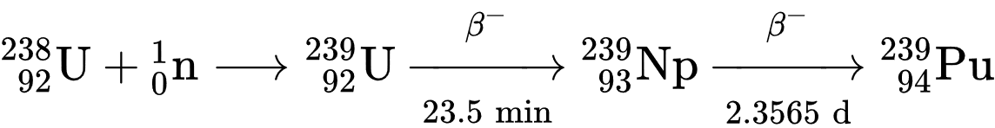
Neutrons from the fission of uranium-235 are captured by uranium-238 nuclei to form uranium-239; a beta decay converts a neutron into a proton to form neptunium-239 (half-life 2.36 days) and another beta decay forms plutonium-239. Egon Bretscher working on the British Tube Alloys project predicted this reaction theoretically in 1940.
Plutonium-238 is synthesized by bombarding uranium-238 with deuterons (D, the nuclei of heavy hydrogen) in the following reaction:
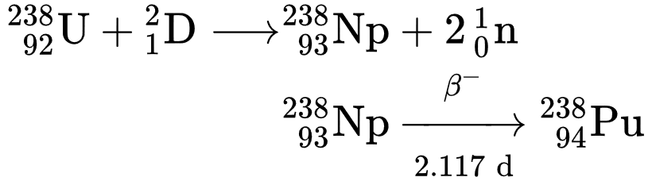
In this process, a deuteron hitting uranium-238 produces two neutrons and neptunium-238, which spontaneously decays by emitting negative beta particles to form plutonium-238.
Average cost of elements in period 2005 – 2015.
Element | Price, $ | Element | Price, $ | Element | Price, $
Be | 4480 kg | Ag, Silver | 1022 kg | D | 1 $/gr
B | 11146 kg | Au, Cold | 53000 kg (2-3-13) | T | 30000 $/gr
Fe | 22 kg | LiH | 1.3 $/gr | U-238 | 80 $/kg
Li | 270 kg | ⁶LiD | 4050 kg | U-235 | 1000 $/gr
C | 24 cent/kg | H | 0.7-4.1 kg (2004) | Pu, Plutonium | 4000 $/gr

3. Hydride
In chemistry, a hydride is the anion of hydrogen, H⁻, or, more commonly, it is a compound in which one or more hydrogen centres have nucleophilic, reducing, or basic properties in it. In compounds that are regarded as hydrides, the hydrogen atom is bonded to a more electropositive element or groups. Compounds containing hydrogen bonded to metals or metalloid may also be referred to as hydrides. Common examples are ammonia (NH₃), methane (CH₄), ethane (C₂H₆) (or any other hydrocarbon), and Nickel hydride (NiH), used in NiMH rechargeable batteries.
Almost all of the elements form binary compounds with hydrogen, the exceptions being He, Ne, Ar, Kr, Pm, Os, Ir, Rn, Fr, and Ra.

Types of hydrides
According to the general definition every element of the periodic table (except some noble gases) forms one or more hydrides. These substances have been classified into three main types according to the nature of their bonding:^{[1]}
- Ionic hydrides, which have significant ionic bonding character.
- Covalent hydrides, which include the hydrocarbons and many other compounds which covalently bond to hydrogen atoms.
- Interstitial hydrides, which may be described as having metallic bonding.
While these divisions have not been used universally, they are still useful to understand differences in hydrides.
The electron shells of hydrogen and deuterium are the same. Therefore, their chemical and physical properties are close. We can replace Hydrogen with Deuterium in hydrides. And deuterium is one of thermonuclear fuel.
The electron shells of hydrogen and deuterium are the same. Therefore, their chemical and physical properties are close. We can replace Hydrogen with Deuterium in hydrides. And deuterium is one of thermonuclear fuels.

4. Deuterides
Hydrides containing deuterium are known as deuterides. Some deuterides, such as LiD, are important fusion fuels in thermonuclear weapons, and useful moderators in nuclear reactors.
Some Hydrides:
1) LiH is cristals, melting temperature 692 ºC, density 0.78 gr/cm³;
2) H₂Be is cristals, melting temperature 190 ºC;
Borogododa has types B_{n}H_{n+4}; dihydroboranes B_{n}H_{n+6}.
Physical properties some hydrides
Connection | T_{melt} ºC | Density, gr/cm³ | Connection | T_{melt} ºC | Density, gr/cm³
AlH₃ | 100-150 | 1.45 | NaH | 300 | 1.38
BeH₂ | 200-250 | 0.8 | CaH₂ | 815 | 1.9
LiH | 680 | 0.78 | BaH₂ | 800 | 4.22
Reference:
1. Bolonkin A.A., Small Non-Expensive Electric Inertial Thermonuclear Reactors (v.2), LULU, 2019, 200 ps.
2. Bolonkin A.A., Femtotechnologies and Innovative Projects, LULU, 2011, Chapters 1-2. 518 ps.
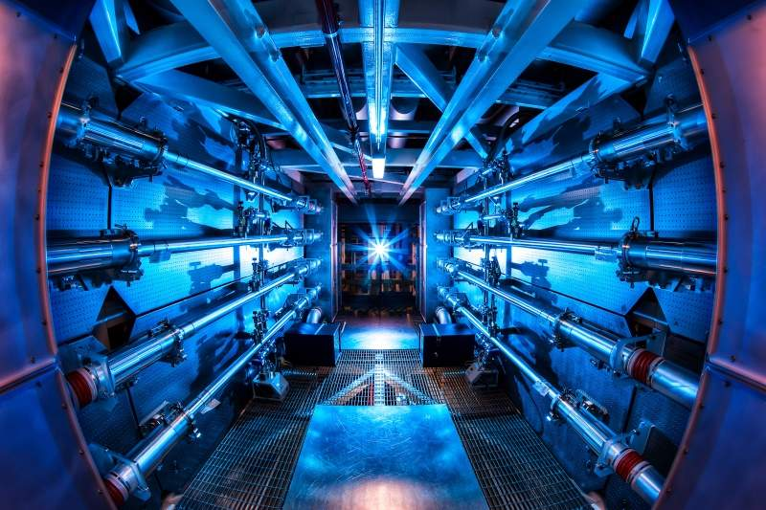
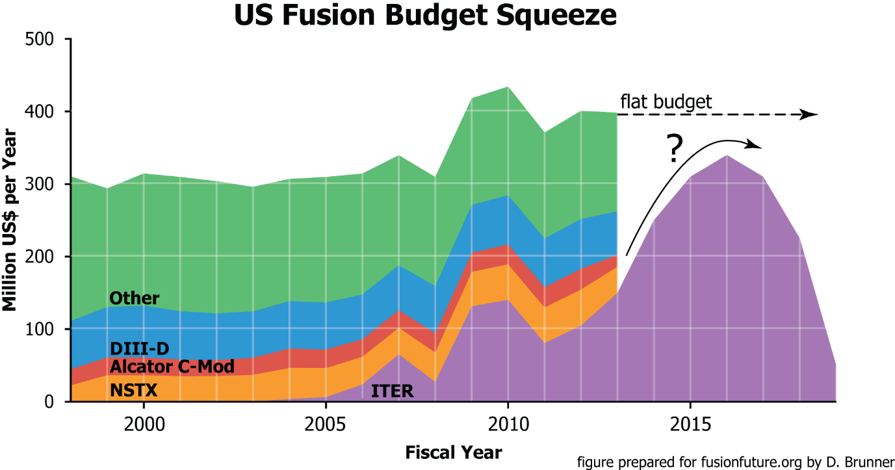
Part 2. Theory and Computations Inertial Fusion Reactions.
Abstract
Автор кратко описывает элементарную теорию термоядерной реакции и приводит программы и результаты расчетов различных видов топлива ID, DD, LiD, D₂O, DHe3, pB11, 6B10H в предположении, что начальная температура зажигания 10 кеВ, топливо помещено в специальную капсулу, удерживающую почти постоянный объем в течении одной микросекунды (10⁻⁶ ) и нагрев капсулы осуществляется электрическим током.
Chapter 1.
Theory of the Inertial Fusion Reaction
1. The following reactions are suitable for thermonuclear fusion:
Table 1. Suitable reactions for thermonuclear fusion
# | Syntezis | Result (received Energy, MeV) | %
1 | D+T→ | ⁴He(3.5)+n(14.1)
2a | D+D→ | T(1.01)+p(3.02) | 50%
2b | D+D→ | ³He(0.82)+n(2.45) | 50%
3 | D+³He→ | ⁴He(3.06)+p(14.7)
4 | T+T→ | ⁴He+2n(+11.3)
5 | ³He+³He→ | ⁴He+2p(+12.9)
6a | ³He+T→ | ⁴He+p+n(+12,1) | 51%
6b | ³He+T→ | ⁴He(4.8)+D(9.5) | 43%
6c | ³He+T→ | ⁵He(2.4)+p(+11.9) | 6%
7 | p+⁶Li → | ⁴He(1.7)+³He(2.3)
8a | p+⁷Li → | 2⁴He(17.3) | 20%
8b | p+⁷Li → | ⁷Be+n(1.6) | 80%
9 | D+⁶Li→ | 2⁴He(22.4)
10 | p+¹¹B→ | 3⁴He(+8.7)
11 | n+⁶Li→ | ⁴He(2.1)+T(2.7)
12 | ³He+⁶Li→ | 2⁴He+p(+16.9)
Here are: p = ¹H (protium), D = ²H (deuterium), and T = ³H (tritium) are shorthand notation for the main three isotopes of hydrogen. ⁴He = ά –alpha particle.
Very important value is the cross section of thermonuclear reaction. The nuclear cross section of a nucleus is used to characterize the probability that a nuclear reaction will occur. The concept of a nuclear cross section can be quantified physically in terms of "characteristic area" where a larger area means a larger probability of interaction. The standard unit for measuring a nuclear cross section (denoted as σ) is the barn, which is equal to 10⁻²⁸ m² or 10⁻²⁴ cm². Nuclear cross section very strong depent from kinetic energy of particles. Typical thermonuclear cross section main fuel particles are shown in fig.4.
For reactions with two products, the energy is divided between them in inverse proportion to their masses, as shown. In most reactions with three products, the distribution of energy varies. For reactions that can result in more than one set of products, the branching ratios are given.
Some reaction candidates can be eliminated at once. The D+⁶Li reaction has no advantage compared to p+¹¹B because it is roughly as difficult to burn but produces substantially more neutrons through D+D side reactions. There is also a p+⁷Li reaction, but the cross-section is far too low accepted possible for T_{i} > 1 MeV, but at such high temperatures, an endothermic, direct neutron-producing reaction also becomes very significant. Finally, there is also a p+⁹Be reaction, which is not only difficult to burn, but ⁹Be can be easily induced to split into two alphas and a neutron.
Typical nuclear radii are of the order 10⁻¹⁴ m. Assuming spherical shape, we therefore expect the cross sections for nuclear reactions to be of the order of πr ² or 10⁻²⁸ m² (i.e. 1 barn). Observed cross sections vary enormously – for
example, slow neutrons absorbed by the (n, ) reaction show a cross section much higher than 1,000 barns in some cases (boron-10, cadmium-113, and xenon-135), while the cross sections for transmutations by gamma-ray absorption are in the region of 0.001 barn.
The some cross sections and corresponding energy are shown in Table 2. In Table 2 we use the shortly notation the nuclear reaction. For example D+T → ⁴He + n as ²H(t,n)⁴He. If result has many products canals, we do not write them.
Fig.1. Thermonuclear cross section reaction D+T, D+D (2a), D+D (2b), D+³He, and p+B vs kinetic energy E [keV] of the light particles.
Table 2. Cross section and corresponding energy of some thermonuclear reaction
Fig. # | Reaction | Reaction  Energy  MeV | Temperat.  ≈10 kV and σ | Temperat.  ≈10² kV  and σ | Temperat.  ≈10³ kV  and σ | Temperat.  ≈10⁴ kV  and σ | Temperat.  and σ=max
43-1(2) | ²H(d,n)³H | 4.033 | 10kV,  σ=10⁻²⁹ | 10²kV,  σ=2h.10⁻²⁶ | 10³kV,  σ=7.10⁻²⁶ | 10⁴kV,  σ=7.10⁻²⁶ | 10³kV,  σ=7.10⁻²⁶
43-1(7) | ⁶Li(p,ά)³He | 4.021 | - | 10²kV,  σ=8.10⁻²⁷ | 10³kV,  σ=10⁻²⁶ | 10⁴kV,  σ=2.10⁻²² | -
43-1(8) | ⁶Li(t,n)… | 16 | - | - | 10³kV,  σ=3.10⁻²⁵ | - | -
43-1(3) | ²H(t,d)⁴H | 4.321 | - | 10²kV,  σ=1.1.10⁻²⁶ | 10³kV,  σ=7.10⁻²⁶ | 10⁴kV,  σ=7.10⁻²⁶ | 10³kV,  σ=7.10⁻²⁶
43-2(2) | ³H(d,n)⁴He  D+T→⁴He+n | 17,6 | 10kV,  σ=2.10⁻²⁷ | 10²kV,  σ=5.10⁻²⁴ | 10³kV,  σ=2.10⁻²⁵ | 10⁴kV,  σ=6.10⁻²⁶ | 10²kV,  σ=5.10⁻²⁴
43-2(1) | ²H(d,n)³He | 7.3 | 10¹kV,  σ=1.1.10⁻²⁹ | 10²kV,  σ=5.10⁻²⁶ | 10³kV,  σ=0.9.10⁻²⁵ | 10²kV,  σ=0.8.10⁻²⁵ | 10²kV,  σ=0.9.10⁻²⁵
43-2(4) | ³H(d,p)⁴He | 18.35 | - | 10²kV,  σ=3.10⁻²⁷ | 10³kV,  σ=3.10⁻²⁶ | 10⁴kV,  σ=5.10⁻²⁷ | 4.10²kV, σ=9.10⁻²⁶
43-2(5) | ³H(t,pn)⁴He | 12 | - | 10²kV,  σ=7.10⁻²⁸ | 10³kV,  σ=6.10⁻²⁶ | - | -
43-2(6) | ⁶Li(d,p)⁷Li | 5.028 | - | 10²kV,  σ=6.10⁻²⁸ | 10³kV,  σ=10⁻²⁵ | - | -
43-3(4) | ⁶Li(d,ά)⁴He | 22.375 | - | 10²kV,  σ=7.10⁻²⁸ | 7.10²kV, σ=7.10⁻²⁶ | - | -
43-4(6) | ⁹Be(p,ά)⁶Li | 2.126 | - | 5.10²kV, σ=3.10⁻²⁶ | 1.1.10³kV, σ=3.10⁻²⁵ | - | -
Source: [12] pp. 947-950.
In addition to the fusion reactions, the following reactions with neutrons are important in order to "breed" tritium in "dry" fusion bombs and some proposed fusion reactors:
n + ⁶Li → T + ⁴He + 4.5 MeV , n + ⁷Li + 2.5 MeV→ T + ⁴He + n’ .
To evaluate the usefulness of these reactions, in addition to the reactants, the products, and the energy released, one needs to know something about the cross section. Any given fusion device will have a maximum plasma pressure that it can sustain, and an economical device will always operate near this maximum. Given this pressure, the largest fusion output is obtained when the temperature is selected so that <σv>/T² is a maximum. This is also the temperature at which the value of the triple product nTτ required for ignition is a minimum. This chosen optimum temperature and the value of <σv>/T² at that temperature is given for a few of these reactions in the following table.
Table 3. Optimum temperature and the value of <σv>/T² at that temperature
fuel | T [keV] | <σv>/T² [m³/s/keV²]
D-T | 13.6 | 1.24×10⁻²⁴
D-D | 15 | 1.28×10⁻²⁶
D-³He | 58 | 2.24×10⁻²⁶
p-⁶Li | 66 | 1.46×10⁻²⁷
p-¹¹B | 123 | 3.01×10⁻²⁷

Note: that many of the reactions form chains. For instance, a reactor fueled with T and ³He will create some D, which is then possible to use in the D + ³He reaction if the energies are "right". An elegant idea is to combine the reactions (7) and (12). The ³He from reaction (7) can react with ⁶Li in reaction (12) before completely thermalizing. This produces an energetic proton which in turn undergoes reaction (7) before thermalizing. A detailed analysis shows that this idea will not really work well, but it is a good example of a case where the usual assumption of a Maxwellian plasma is not appropriate.
Any of the reactions above can, in principle, be the basis of fusion power production. In addition to the temperature and cross section discussed above, we must consider the total energy of the fusion products E_{fus}, the energy of the charged fusion products E_{ch}, and the atomic number Z of the non-hydrogenic reactant.
Specification of the D-D reaction entails some difficulties, though. To begin with, one must average over the two branches (2) and (3). More difficult is to decide how to treat the T and ³He products. T burns so well in a deuterium plasma that it is almost impossible to extract from the plasma. The D-³He reaction is optimized at a much higher temperature, so the burn-up at the optimum D-D temperature may be low, so it seems reasonable to assume the T but not the ³He gets burned up and adds its energy to the net reaction.
Thus we will count the D-D fusion energy as E_{fus} = (4.03+17.6+3.27)/2 = 12.5 MeV and the energy in charged particles as E_{ch} = (4.03+3.5+0.82)/2 = 4.2 MeV.
Another unique aspect of the D-D reaction is that there is only one reactant, which must be taken into account when calculating the reaction rate.
With this choice, we tabulate parameters for four of the most important reactions.
Table 4. Parameters of the most important reactions
Fuel | Z | E_{fus} [MeV] | E_{ch} [MeV] | neutronicity
D-T | 1 | 17.6 | 3.5 | 0.80
D-D | 1 | 12.5 | 4.2 | 0.66
D-³He | 2 | 18.3 | 18.3 | ~0.05
p-¹¹B | 5 | 8.7 | 8.7 | ~0.001
The last column is the neutronicity of the reaction, the fraction of the fusion energy released as neutrons. This is an important indicator of the magnitude of the problems associated with neutrons like radiation damage, biological shielding, remote handling, and safety. For the first two reactions it is calculated as (E_{fus}-E_{ch})/E_{fus}. For the last two reactions, where this calculation would give zero, the values quoted are rough estimates based on side reactions that produce neutrons in a plasma in thermal equilibrium.
Of course, the reactants should also be mixed in the optimal proportions. This is the case when each reactant ion plus its associated electrons accounts for half the pressure. Assuming that the total pressure is fixed, this means that density of the non-hydrogenic ion is smaller than that of the hydrogenic ion by a factor 2/(Z+1). Therefore, the rate for these reactions is reduced by the same factor, on top of any differences in the values of <σv>/T². On the other hand, because the D-D reaction has only one reactant, the rate is twice as high as if the fuel were divided between two hydrogenic species.
Thus, there is a "penalty" of (2/(Z+1)) for non-hydrogenic fuels arising from the fact that they require more electrons, which take up pressure without participating in the fusion reaction. There is, at the same time, a "bonus" of a factor 2 for D-D due to the fact that each ion can react with any of the other ions, not just a fraction of them.
We can now compare these reactions in the following table 5.
Table 5. Comparison of reactions
fuel | <σv>/T² | penalty/  bonus | reactivity | Lawson  criterion | power  density
D-T | 1.24×10⁻²⁴ | 1 | 1 | 1 | 1
D-D | 1.28×10⁻²⁶ | 2 | 48 | 30 | 68
D-³He | 2.24×10⁻²⁶ | 2/3 | 83 | 16 | 80
p-¹¹B | 3.01×10⁻²⁷ | 1/3 | 1240 | 500 | 2500
The maximum value of <σv>/T² is taken from a previous table. The "penalty/bonus" factor is that related to a non-hydrogenic reactant or a single-species reaction. The values in the column "reactivity" are found by dividing (1.24×10⁻²⁴ by the product of the second and third columns. It indicates the factor by which the other reactions occur more slowly than the D-T reaction under comparable conditions. The column "Lawson criterion" weights these results with E_{ch} and gives an indication of how much more difficult it is to achieve ignition with these reactions, relative to the difficulty for the D-T reaction. The last column is labeled "power density" and weights the practical reactivity with E_{fus}. It indicates how much lower the fusion power density of the other reactions is compared to the D-T reaction and can be considered a measure of the economic potential.

Bremsstrahlung (Brake) Losses
1. Bremsstrahlung, (from the German bremsen, to brake and Strahlung, radiation, thus, "braking radiation"), is electromagnetic radiation produced by the acceleration of a charged particle, such as an electron, when deflected by another charged particle, such as an atomic nucleus. The term is also used to refer to the process of producing the radiation. Bremsstrahlung has a continuous spectrum. The phenomenon was discovered by Nikola Tesla (1856-1943) during high frequency research he conducted between 1888 and 1897.
Bremsstrahlung may also be referred to as free-free radiation. This refers to the radiation that arises as a result of a charged particle that is free both before and after the deflection (acceleration) that causes the emission. Strictly speaking, bremsstrahlung refers to any radiation due to the acceleration of a charged particle, which includes synchrotron radiation; however, it is frequently used (even when not speaking German) in the more literal and narrow sense of radiation from electrons stopping in matter.
The ions undergoing fusion will essentially never occur alone but will be mixed with electrons that neutralize the ions' electrical charge and form a plasma. The electrons will generally have a temperature comparable to or greater than that of the ions, so they will collide with the ions and emit Bremsstrahlung. The Sun and stars are opaque to Bremsstrahlung, but essentially any terrestrial fusion reactor will be optically thin at relevant wavelengths. Bremsstrahlung is also difficult to reflect and difficult to convert directly to electricity, so the ratio of fusion power produced to Bremsstrahlung radiation lost is an important figure of merit. This ratio is generally maximized at a much higher temperature than that which maximizes the power density (see the previous subsection). The following table shows the rough optimum temperature and the power ratio at that temperature for several reactions.
Table 6. Rough optimum temperature and the power ratio of fusion and Bremsstrahlung radiation lost
Fuel | T_{i} (keV) | P_{fusion}/  P_{Bremsstrahlung}
D-T | 50 | 140
D-D | 500 | 2.9
D-³He | 100 | 5.3
³He-³He | 1000 | 0.72
p-⁶Li | 800 | 0.21
p-¹¹B | 300 | 0.57
The actual ratios of fusion to Bremsstrahlung power will likely be significantly lower for several reasons. For one, the calculation assumes that the energy of the fusion products is transmitted completely to the fuel ions, which then lose energy to the electrons by collisions, which in turn lose energy by Bremsstrahlung. However because the fusion products move much faster than the fuel ions, they will give up a significant fraction of their energy directly to the electrons. Secondly, the plasma is assumed to be composed purely of fuel ions. In practice, there will be a significant proportion of impurity ions, which will lower the ratio. In particular, the fusion products themselves must remain in the plasma until they have given up their energy, and will remain some time after that in any proposed confinement scheme. Finally, all channels of energy loss other than Bremsstrahlung have been neglected. The last two factors are related. On theoretical and experimental grounds, particle and energy confinement seem to be closely related. In a confinement scheme that does a good job of retaining energy, fusion products will build up. If the fusion products are efficiently ejected, then energy confinement will be poor, too.
The temperatures maximizing the fusion power compared to the Bremsstrahlung are in every case higher than the temperature that maximizes the power density and minimizes the required value of the fusion triple product (Lawson criterion). This will not change the optimum operating point for D-T very much because the Bremsstrahlung fraction is low, but it will push the other fuels into regimes where the power density relative to D-T is even lower and the required confinement even more difficult to achieve. For D-D and D-³He, Bremsstrahlung losses will be a serious, possibly prohibitive problem. For ³He-³He, p-⁶Li and p-¹¹B the Bremsstrahlung losses appear to make a fusion reactor using these fuels impossible.
In a plasma, the free electrons are constantly producing Bremsstrahlung in collisions with the ions. The power density of the Bremsstrahlung radiated is given by
, (1a)
T_{e} is the electron temperature, α is the fine structure constant, h is Planck's constant, and the "effective" ion charge state Z_{eff} is given by an average over the charge states of the ions:
Z_{eff} = Σ (Z²n_{Z}) / n_{e} .
This formula is derived in "Basic Principles of Plasmas Physics: A Statistical Approach" by S. Ichimaru, p. 228. It applies for high enough T_{e} that the electron deBroglie wavelength is longer than the classical Coulomb distance of closest approach. In practical units, this formula gives
P_{Br} | = | (1.69×10⁻³² /W cm⁻³) (n_{e}/cm⁻³)² (T_{e}/eV)^{1/2} Z_{eff}
 | = | (5.34×10⁻³⁷ /W m⁻³) (n_{e} /m⁻³)² (T_{e} /keV)^{1/2} Z_{eff} ,
where Wcm⁻³, cm⁻³, eV, Wm⁻³, m⁻³, keV are units of corresponding magnitudes. For very high temperatures there are relativistic corrections to this formula, that is, additional terms of order T_{e}/m_{e}c².
Below are some equations useful for computation:
2. The Deep of Penetration of outer radiation into plasma is
. [cm] | (1b)
For plasma density n_{e} = 10²² 1/cm³ d_{p} = 5.31×10⁻⁶ cm. That means the most of brake radiation will heat the fuel.
3. The Gas (Plasma) Dynamic Pressure, p_{k}, is
, | (2)
where k = 1.38×10⁻²³ is Boltzmann constant; T_{e} is temperature of electrons, ºK; T_{i} is temperature of ions, ʌºK. These temperatures may be different; n is plasma density, 1/m³; p_{k} is plasma pressure, N/m².
4. The gas (plasma) ion pressure, p, is
(3a)
Here n is plasma density in 1/m³.
4a. Ion collision rate
v_{i} = 4.80×10⁻⁸z⁴µ^{-1/2}n_{i}lnʌT_{i}^{-3/2} [1/s]; (3b)
Here lnʌ is Columbus logarithm (~10); T_{i} is in eV. For T_{i} = 10⁴ eV v_{i} = 3.4·10⁶, for T_{i} = 10⁶ eV v_{i} = 3.4·10³.
4b. Loss energy W in collisions of two balls.
W_{k1}/W_{k1,0} = [(m₁-m₂)/(m₁+m₂)]²; For m₁ = 100m₂ Loss energy is 4%, (3c)
m₁, m₂ – mass of balls.
5. The magnetic p_{m} and electrostatic pressure, p_{s}, are
, | (4)
where B is electromagnetic induction, Tesla; μ₀ = 4π×10⁻⁷ electromagnetic constant; ε₀ = 8.85×10⁻¹² , F/m,is electrostatic constant; E_{S} is electrostatic intensity, V/m.
6. Ion thermal velocity is
, | (5)
where μ = m_{i} /m_{p}, m_{i} is mass of ion, kg; m_{p} = 1.67×10⁻²⁷ is mass of proton, kg.
7. Transverse Spitzer plasma resistivity
, | (6)
where ln Λ = 5 ÷ 15 ≈ 10 is Coulomb logarithm, Z is charge state.
8. Reaction rates <σv> (in cm³ s⁻¹) averaged over Maxwellian distributions for low energy (T<25 keV)
may be represent by
(7)
where T is measured in keV.
Reaction rates are presented in Table 7 below:
Table 7. Reaction rates <σv> (in cm³ s⁻¹) averaged over Maxwellian distributions
Tempera-ture, keV | D+D,  (2a + 2b) | D+T ,  (1) | D+³He,  (3) | T+T,  (4) | T+³He,  (6a-c)
1.0 | 1.5×10⁻²² | 5.5×10⁻²¹ | 10⁻²⁶ | 3.3×10⁻²² | 10⁻²⁸
2.0 | 5.4×10⁻²¹ | 2.6×10⁻¹⁹ | 1.4×10⁻²³ | 7.1×10⁻²¹ | 10⁻²⁵
5.0 | 1.8×10⁻¹⁹ | 1.3×10⁻¹⁷ | 6.7×10⁻²¹ | 1.4×10⁻¹⁹ | 2.1×10⁻²²
10.0 | 1.2×10⁻¹⁸ | 1.1×10⁻¹⁶ | 2.3×10⁻¹⁹ | 7.2×10⁻¹⁹ | 1.2×10⁻²⁰
20.0 | 5.2×10⁻¹⁸ | 4.2×10⁻¹⁶ | 3.8×10⁻¹⁸ | 2.5×10⁻¹⁸ | 2.6×10⁻¹⁹
50.0 | 2.1×10⁻¹⁷ | 8.7×10⁻¹⁶ | 5.4×10⁻¹⁷ | 8.7×10⁻¹⁸ | 5.3×10⁻¹⁸
100.0 | 4.5×10⁻¹⁷ | 8.5×10⁻¹⁶ | 1.6×10⁻¹⁶ | 1.9×10⁻¹⁷ | 7.7×10⁻¹⁷
200.0 | 8.8×10⁻¹⁷ | 6.3×10⁻¹⁶ | 2.4×10⁻¹⁶ | 4.2×10⁻¹⁷ | 9.2×10⁻¹⁷
500.0 | 1.8×10⁻¹⁶ | 3.7×10⁻¹⁶ | 2.3×10⁻¹⁶ | 8.4×10⁻¹⁷ | 2.9 ×10⁻¹⁶
1000.0 | 2.2×10⁻¹⁶ | 2.7×10⁻¹⁶ | 1.8×10⁻¹⁶ | 8.0×10⁻¹⁷ | 5.2×10⁻¹⁶
Sourse: AIP, Desk Reference, Thied Edition, p. 644.
Fig.5. Reactivity is requested for thermonuclear reaction.
The deuterium cannot be used in the laser reactor because one requests in 100 times more ignition criterion then D + T. But, as you see in (23), one may be used in AB reactor (Fig.5).
9. The power density released in the form of charged particles is
(8)
Here in P_{DD} equation it is included D+T reaction.
10. Cost of the nuclear fuel (2012).
Deuterium. The sea water contains about 1.55.10⁻⁴ %. The World produces about tens thousend tons
in year. Cost 1 $/g.
Tritium. The special nuclear reactors can produced it. Now the cost is 30,000 $/g. In future an
expected cost will be from 100K÷200K $/g.
Helium-3. Very rare isotop. The Helium-4 contains 1.3.10⁻⁶/1 of the Helium-3. Cost is 30K $/g.
One project offers to extract it on Moon and delivery to Earth.
Litium 6 -7. Nature mixture cost 150 $/kg.
Uranium-238 contains 0.7% of Uranium-235. It cost 90÷250 $/kg.
Plutonium-239. Cost 5600 $/g.
As you see the thermonucler fuel D+D is the cheapest, but D+T has the lowest temperature for themonucler reaction. All the current experimental thermonuclear instellations are using the D+T.

Références
(Reader can find part of these articles inWEBs:

https://archive.org/details/List5OfBolonkinPublications, http://Bolonkin.narod.ru/p65.htm, http://arxiv.org/find/all/1/au:+Bolonkin/0/1/0/all/0/1, http://vixra.org).
[1] Bolonkin A.A., Small, Non-Expensive Electric Impulse Thermonuclear Reactor with colliding jets.
7 11 16, 11 19 16, LULU 2017, 144 ps, http://viXra.org/abs/1611.0276,
https://archive.org/download/ArticleThermonuclearReactorOfCollisingJets10416
[2] Bolonkin A.A. , Electric Cumulative Thermonuclear Reactors. 7 17 16.
http://vixra.org/abs/1610.0208 , https://archive.org/details/abolonkin_gmail_201610 ,
[3] Bolonkin A.A., “Inexpensive Mini Thermonuclear Reactor”. International Journal of Advanced
Engineering Applications, Vol.1, Iss.6, pp.62-77 (2012). http://viXra.org/abs/1305.0046,
http://archive.org/details/InexpensiveMiniThermonuclearReactor.
[4] Bolonkin A.A. , Cumulative Thermonuclear AB-Reactor. Vixra 7/ 8/2015, http://viXra.org/abs/1507.0053 ,
https://archive.org/details/ArticleCumulativeReactorFinalAfterCathAndOlga7716 .
[5] Bolonkin A.A., Ultra-Cold Thermonuclear Synthesis: Criterion of Cold Fusion. 7 18 2015.
http://viXra.org/abs/1507.0158, GSJornal: http://gsjournal.net/Science-
Journals/%7B$cat_name%7D/View/6140 .
[6] Bolonkin A.A., Cumulative and Impulse Mini Thermonuclear Reactors. 3 30 16,
http://viXra.org/abs/1605.0309, https://archive.org/download/ImpulseMiniThermonuclearReactors.
[7] Bolonkin, A.A., “Non Rocket Space Launch and Flight”. Elsevier, 2005. 488 pgs. ISBN-13:
978-0-08044-731-5, ISBN-10: 0-080-44731-7 . http://vixra.org/abs/1504.0011 v4,
[8] Bolonkin, A.A., “New Concepts, Ideas, Innovations in Aerospace, Technology and the Human
Sciences”, NOVA, 2006, 510 pgs. ISBN-13: 978-1-60021-787-6. http://viXra.org/abs/1309.0193,
[9] Bolonkin, A.A., Femtotechnologies and Revolutionary Projects. Lambert, USA, 2011. 538 p. 16 Mb.
ISBN:978-3-8473-0839-0.http://viXra.org/abs/1309.0191,
[10] Bolonkin, A.A., Innovations and New Technologies (v2). Lulu, 2014. 465 pgs. 10.5 Mb, ISBN:
978-1-312-62280-7. https://archive.org/details/Book5InnovationsAndNewTechnologiesv2102014/
[11] Bolonkin, A.A., Stability and Production Super-Strong AB Matter.
International Journal of Advanced Engineering Applications. 3-1-3, February 2014, pp.18-33.
http://fragrancejournals.com/wp-content/uploads/2013/03/IJAEA-3-1-3.pdf
The General Science Journal, November, 2013, #5244.
[12] Bolonkin, A.A., Converting of Any Matter to Nuclear Energy by AB-Generator.
American Journal of Engineering and Applied Science, Vol. 2, #4, 2009, pp.683-693.
http://viXra.org/abs/1309.0200,
[13] Kikoin I.K., Tables of Physical Values, Moscow, Atomizdat, 1975 (Russian).
[14] Koshkin N.I., Shirkevich M.G., Handbook of elementary physics, Moscow, Nauka, 1982 (Russian).
[15] AIP, Physics Desk Reference, AIP PRESS. Third Edition.
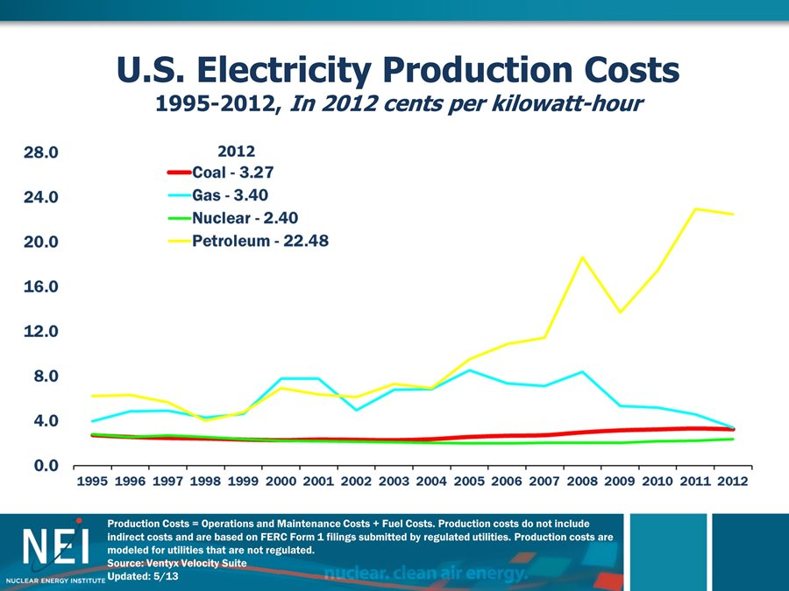
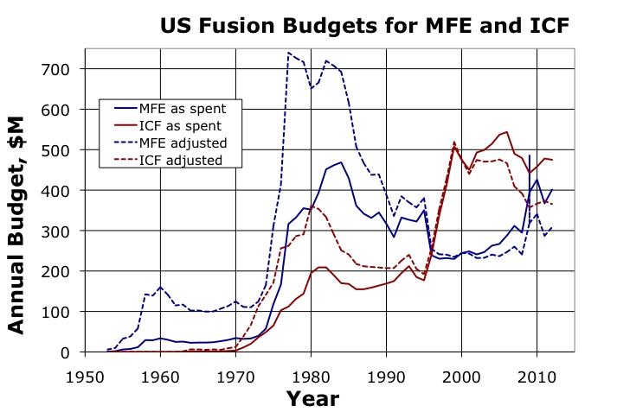

Chapter 2.
Programs and Computations
1. Fuel T+D
Program of compuaion T+D with brake, Tk, Pa 3 10 18
Program T+D with T in K 6 23 18
% Reaction fuel T+D with Brake radiation, T in K and Pressure in atm, volume is const 6 23 18
clear all

% Initial Data
n=100; % Number of steps
Di=3*(10^(-7)); % Distance of integration, sec
dt=Di/n; % step, sec
to=2*(10^(-8)); % Initial time, sec
v=1.4*(10^(-4)); % Volume of capcule, cm3
t(1)=2*(10^(-8)); % Initial time,sec
tt(1)=2*(10^(-8)); % Initial time,sec

%Data of fuel D+He3
Z=1; %Efficiency brake ratiation TD
K=1; %Initial Relative part of particles is ready reaction (Reactive Part)
Etf=17.6*(10^6); %Total energy of D+T reaction the one pair , eV
Ekf=3.5*(10^6); % Energy heating the capcule the one pair, eV
Kk=Ekf/Etf; % relative coefficient (loss neutrons)
Te(1)=2*(10^4); %Initial temperature, eV
TeK(1)=1.16*(10^4)*Te(1); % Initial temperature,K

%Teb(1)=2*(10^4); %Initial temperature with brake, eV
gamma=9*(10^(-5)); % Specific weight of hydrogen (gas) at 1 atm, g/cm3
mu=5; %relative mass of micture mu=3+2
mp=1.67*(10^(-27)); %nuclon mass, kg
p=800; %Pressure in capsule, atm
N1(1)=2*(10^(-3))*gamma*p/(mu*mp); % Total number nucleo DHe3 in 1 cm3
Ke=1; %Number electrons in one paricle.
N1e=Ke*N1(1); %Number of electrons in 1 cm3.
N1r(1)=N1(1)*K; %Initial namber of reactive particles in 1 cm3
Nv=N1(1)*v; % Common number particles into capsule. Consider the leaving neutron.
Nr(1)=N1(1)*v*K; %Initial number of reative particles into capcule
Ev(1)=7.23*(10^3); % Initial Reaction energy, J
Ek(1)=7.23*(10^3); % Initial RE into capsule, J
Eb(1)=7.23*(10^3); % Initial RE into capsule, J
Nvr(1)=0.; % Initial relatived part of partocles.
Nvrr(1)=0.; %initial procent reacted fuel
Pbr(1)=1.69*(10^(-32))*(N1e^2)*(Te(1)^0.5)*Z; %Power of brake radiation of 1 cm3
dEb(1)=Pbr(1)*v*dt; %Incriment brake energy in capsule J.
Teb(1)=0.625*(10^19)*Eb(1)/Nv; %Iniial energy into capsule from brake, eV

%Reaction Rate (Extentioned up 10 MeV)
x = [1000. 2000. 5000. 10000. 20000. 50000. 100000. 200000. ...
500000. 1000000. 10000000.]; % Temperature, eV
ydd = [1.5*(10^(-22)) 5.4*(10^(-21)) 1.8*(10^(-19)) ...
1.2*(10^(-18)) 5.2*(10^(-18)) 2.1*(10^(-17)) 4.5*(10^(-17)) ...
8.8*(10^(-17)) 1.8*(10^(-16)) 2.2*(10^(-16)) 10^(-16)]; % for D+D
ydt = [5.5*(10^(-21)) 2.6*(10^(-19)) 1.3*(10^(-17)) ...
1.1*(10^(-16)) 4.2*(10^(-16)) 8.7*(10^(-16)) 8.5*(10^(-16)) ...
6.3*(10^(-16)) 3.7*(10^(-16)) 2.7*(10^(-16)) 10^(-16)]; % for D+T
ytt = [1.3*(10^(-21)) 7.1*(10^(-21)) 1.4*(10^(-19)) ...
7.1*(10^(-19)) 2.5*(10^(-18)) 8.7*(10^(-18)) 1.9*(10^(-17)) ...
4.2*(10^(-17)) 8.4*(10^(-17)) 8.0*(10^(-17)) 10^(-16)]; % for T+T
ydhe3 = [1*(10^(-26)) 1.4*(10^(-23)) 6.7*(10^(-21)) 2.3*(10^(-19)) ...
3.8*(10^(-18)) 5.4*(10^(-17)) 1.6*(10^(-16)) ...
2.4*(10^(-16)) 2.3*(10^(-16)) 1.8*(10^(-16)) 10^(-16)]; % D+He3
ythe3= [1*(10^(-28)) 1*(10^(-25)) 2.1*(10^(-22)) 1.2*(10^(-20)) ...
2.6*(10^(-19)) 5.3*(10^(-18)) 7.7*(10^(-17)) ...
9.3*(10^(-17)) 2.9*(10^(-16)) 5.2*(10^(-16)) 10^(-16)]; % T+He3

RR(1)=interp1(x,ydt,Te(1)); % RR step 1

% Cycle of integration
for i=1:n
t(i+1)=t(i)+dt; %Time, sec.n+1
tt(i)= t(i)+dt; %Time, sec, n
RR(i+1)=interp1(x,ydt,Te(i)); % RR step 1
Pdt(i)=2.9*(10^(-12))*0.25*N1r(i)*N1r(i)*RR(i); %Power 1 cm3, W
dEdt(i)=Pdt(i)*dt; %Increament energy in 1cm3, J
dN1r(i)=dEdt(i)*2*0.625*(10^19)/Etf; %Increment reacted particles in eV
N1r(i+1)=N1r(i)-dN1r(i); % Rest of ready particles in 1cm3
Pv(i)=Pdt(i)*v*K; %Power,W in capsule
dEv(i)=Pdt(i)*v*K*dt; %Increament of Energy in capsule of volume v. J
Ev(i+1)=Ev(i)+dEv(i); % Total Reaction Energy in capsule, J
Ek(i+1)=Ek(i)+dEv(i)*Kk; %Reaction energy into capsule, J
dT(i)=0.625*(10^19)*dEv(i)/Nv; %Incriment energy into capsule, eV
Te(i+1)=Te(i)+dT(i); % Temperature into capsule, eV
TeK(i+1)=1.16*(10^4)*Te(i+1); % Temperature into capsule, K
Pa(i)=10*(N1(1)+N1e)*1.38*(10^(-23))*TeK(i); %Pressure into capsule in atm.

%Computatin number of reaction particles
dNrr(i+1)=dEv(i)*Nv/Etf; %Relative number of particles take part into reaction
Nvr(i+1)=Nvr(i)+dNrr(i); %Total relative reactived particles
Nvrr(i+1)=Nvr(i)/Nr(1); %Proncentage of reacted fuel

%Computation of brake radiation
Pbr(i)=1.69*(10^(-32))*(N1e^2)*(Te(i)^0.5)*Z; %Power of brake radiation of 1 cm3
dEb(i+1)=Pbr(i)*v*dt; %Incriment brake energy in capsule, J
Eb(i+1)=Eb(i)+dEb(i); %Brake Energy in capsule,J
%dTb(i)=0.625*(10^19)*dEb(i)/Nv; %Incriment energy into capsule, eV
%Teb(i+1)=Teb(i)+dTb(i); % Temperature into capsule, eV

end

figure (1) % Temperature into capsule in eV
hnd1=plot(t,Te);
set (hnd1, 'linewidth',2);
t1=xlabel ('Time, sec');
set (t1,'Fontsize',12);
set (t1, 'Fontweight', 'bold');
t2=ylabel ('Temperature, eV');
set (t2,'Fontsize',12);
set (t2, 'Fontweight', 'bold');
t3= title ('Temperature from reaction TD vs time');
set (t3, 'Fontsize', 14);
set (t3, 'Fontweight', 'bold');
grid on
hold on

figure (8) % Temperature into capsule in K
hnd1=plot(t,TeK);
set (hnd1, 'linewidth',2);
t1=xlabel ('Time, sec');
set (t1,'Fontsize',12);
set (t1, 'Fontweight', 'bold');
t2=ylabel ('Temperature, K');
set (t2,'Fontsize',12);
set (t2, 'Fontweight', 'bold');
t3= title ('Temperature in K from reaction TD vs time');
set (t3, 'Fontsize', 14);
set (t3, 'Fontweight', 'bold');
grid on
hold on

figure (9) % Pressure into capsule in atm
hnd1=plot(tt,Pa);
set (hnd1, 'linewidth',2);
t1=xlabel ('Time, sec');
set (t1,'Fontsize',12);
set (t1, 'Fontweight', 'bold');
t2=ylabel ('Pressure, atm');
set (t2,'Fontsize',12);
set (t2, 'Fontweight', 'bold');
t3= title ('Pressure in atm from reaction TD vs time');
set (t3, 'Fontsize', 14);
set (t3, 'Fontweight', 'bold');
grid on
hold on
% Fuel DHe3
figure (2); % Termonuclear energy DHe3
hnd2=plot(t,Ev,t,Ek,'--');
set (hnd2, 'linewidth',2);
t1=xlabel ('Time, sec');
set (t1,'Fontsize',12);
set (t1, 'Fontweight', 'bold');
t2=ylabel ('Energy, J');
set (t2,'Fontsize',12);
set (t2, 'Fontweight', 'bold');
t3= title ('Total and capsule energy TD vs time');
set (t3, 'Fontsize', 14);
set (t3, 'Fontweight', 'bold');
grid on
hold on

figure (3); % Relatived number of reacted particles
hnd3=plot(t,Nvr);
set (hnd3, 'linewidth',2);
t1=xlabel ('Time, sec');
set (t1,'Fontsize',12);
set (t1, 'Fontweight', 'bold');
t2=ylabel ('Reacted part of DT Particles');
set (t2,'Fontsize',12);
set (t2, 'Fontweight', 'bold');
t3= title ('Reactived Part of TD particles vs time');
set (t3, 'Fontsize', 14);
set (t3, 'Fontweight', 'bold');
grid on
hold on

figure (4); % reaction rate DHe3
hnd4=plot(t,RR);
set (hnd4, 'linewidth',2);
t1=xlabel ('Time, sec');
set (t1,'Fontsize',12);
set (t1, 'Fontweight', 'bold');
t2=ylabel ('Reaction rate TD, sm3/sec');
set (t2,'Fontsize',12);
set (t2, 'Fontweight', 'bold');
t3= title ('Reaction Rate TD vs time');
set (t3, 'Fontsize', 14);
set (t3, 'Fontweight', 'bold');
grid on
hold on

figure (5); % Power of termoreaction DHe3
hnd5=plot(tt,Pv);
set (hnd5, 'linewidth',2);
t1=xlabel ('Time, sec');
set (t1,'Fontsize',12);
set (t1, 'Fontweight', 'bold');
t2=ylabel ('Power, W/cm3');
set (t2,'Fontsize',12);
set (t2, 'Fontweight', 'bold');
t3= title ('Power TD vs time');
set (t3, 'Fontsize', 14);
set (t3, 'Fontweight', 'bold');
grid on
hold on

figure (6); % Procentage of reacted particles
hnd6=plot(t,Nvrr);
set (hnd6, 'linewidth',2);
t1=xlabel ('Time, sec');
set (t1,'Fontsize',12);
set (t1, 'Fontweight', 'bold');
t2=ylabel ('% TD reacted Particles');
set (t2,'Fontsize',12);
set (t2, 'Fontweight', 'bold');
t3= title ('% reacted particles TD vs time');
set (t3, 'Fontsize', 12);
set (t3, 'Fontweight', 'bold');
grid on
hold on

figure (7) %Heat= Brake Power in capsule DHe3
hnd7=plot(tt,Pdt, tt,Pbr,'--');
set (hnd7, 'linewidth',2);
t1=xlabel ('Time, sec');
set (t1,'Fontsize',12);
set (t1, 'Fontweight', 'bold');
t2=ylabel ('Power. W/sm3');
set (t2,'Fontsize',12);
set (t2, 'Fontweight', 'bold');
t3= title ('Heat-Brake Power TD vs time');
set (t3, 'Fontsize', 12);
set (t3, 'Fontweight', 'bold');
grid on
hold on
---------------------------------------------------------
Program of compuaion T+D with brake 3 10 18
% Reaction fuel T+D and T+He3 with Brake radiation 3 7 18
clear all

% Initial Data
n=100; % Number of steps
Di=3*(10^(-7)); % Distance of integration, sec
dt=Di/n; % step, sec
to=2*(10^(-8)); % Initial time, sec
v=1.4*(10^(-4)); % Volume of capcule, cm3
t(1)=2*(10^(-8)); % Initial time,sec
tt(1)=2*(10^(-8)); % Initial time,sec

%Data of fuel D+He3
Z=1; %Efficiency brake ratiation TD
K=1; %Initial Relative part of particles is ready reaction (Reactive Part)
Etf=17.6*(10^6); %Total energy of D+T reaction the one pair , eV
Ekf=3.5*(10^6); % Energy heating the capcule the one pair, eV
Kk=Ekf/Etf; % relative coefficient (loss neutrons)
Te(1)=2*(10^4); %Initial temperature, eV
%Teb(1)=2*(10^4); %Initial temperature with brake, eV
gamma=9*(10^(-5)); % Specific weight of hydrogen (gas) at 1 atm, g/cm3
mu=5; %relative mass of micture mu=3+2
mp=1.67*(10^(-27)); %nuclon mass, kg
p=800; %Pressure in capsule, atm
N1(1)=2*(10^(-3))*gamma*p/(mu*mp); % Total number nucleo DHe3 in 1 cm3
Ke=1; %Number electrons in one paricle.
N1e=Ke*N1(1); %Number of electrons in 1 cm3.
N1r(1)=N1(1)*K; %Initial namber of reactive particles in 1 cm3
Nv=N1(1)*v; % Common number particles into capsule. Consider the leaving neutron.
Nr(1)=N1(1)*v*K; %Initial number of reative particles into capcule
Ev(1)=7.23*(10^3); % Initial Reaction energy, J
Ek(1)=7.23*(10^3); % Initial RE into capsule, J
Eb(1)=7.23*(10^3); % Initial RE into capsule, J
Nvr(1)=0.; % Initial relatived part of partocles.
Nvrr(1)=0.; %initial procent reacted fuel
Pbr(1)=1.69*(10^(-32))*(N1e^2)*(Te(1)^0.5)*Z; %Power of brake radiation of 1 cm3
dEb(1)=Pbr(1)*v*dt; %Incriment brake energy in capsule J.
Teb(1)=0.625*(10^19)*Eb(1)/Nv; %Iniial energy into capsule from brake, eV

%Reaction Rate (Extentioned up 10 MeV)
x = [1000. 2000. 5000. 10000. 20000. 50000. 100000. 200000. ...
500000. 1000000. 10000000.]; % Temperature, eV
ydd = [1.5*(10^(-22)) 5.4*(10^(-21)) 1.8*(10^(-19)) ...
1.2*(10^(-18)) 5.2*(10^(-18)) 2.1*(10^(-17)) 4.5*(10^(-17)) ...
8.8*(10^(-17)) 1.8*(10^(-16)) 2.2*(10^(-16)) 10^(-16)]; % for D+D
ydt = [5.5*(10^(-21)) 2.6*(10^(-19)) 1.3*(10^(-17)) ...
1.1*(10^(-16)) 4.2*(10^(-16)) 8.7*(10^(-16)) 8.5*(10^(-16)) ...
6.3*(10^(-16)) 3.7*(10^(-16)) 2.7*(10^(-16)) 10^(-16)]; % for D+T
ytt = [1.3*(10^(-21)) 7.1*(10^(-21)) 1.4*(10^(-19)) ...
7.1*(10^(-19)) 2.5*(10^(-18)) 8.7*(10^(-18)) 1.9*(10^(-17)) ...
4.2*(10^(-17)) 8.4*(10^(-17)) 8.0*(10^(-17)) 10^(-16)]; % for T+T
ydhe3 = [1*(10^(-26)) 1.4*(10^(-23)) 6.7*(10^(-21)) 2.3*(10^(-19)) ...
3.8*(10^(-18)) 5.4*(10^(-17)) 1.6*(10^(-16)) ...
2.4*(10^(-16)) 2.3*(10^(-16)) 1.8*(10^(-16)) 10^(-16)]; % D+He3
ythe3= [1*(10^(-28)) 1*(10^(-25)) 2.1*(10^(-22)) 1.2*(10^(-20)) ...
2.6*(10^(-19)) 5.3*(10^(-18)) 7.7*(10^(-17)) ...
9.3*(10^(-17)) 2.9*(10^(-16)) 5.2*(10^(-16)) 10^(-16)]; % T+He3

RR(1)=interp1(x,ydt,Te(1)); % RR step 1

% Cycle of integration
for i=1:n
t(i+1)=t(i)+dt; %Time, sec.n+1
tt(i)= t(i)+dt; %Time, sec, n
RR(i+1)=interp1(x,ydt,Te(i)); % RR step 1
Pdt(i)=2.9*(10^(-12))*0.25*N1r(i)*N1r(i)*RR(i); %Power 1 cm3, W
dEdt(i)=Pdt(i)*dt; %Increament energy in 1cm3, J
dN1r(i)=dEdt(i)*2*0.625*(10^19)/Etf; %Increment reacted particles in eV
N1r(i+1)=N1r(i)-dN1r(i); % Rest of ready particles in 1cm3
Pv(i)=Pdt(i)*v*K; %Power,W in capsule
dEv(i)=Pdt(i)*v*K*dt; %Increament of Energy in capsule of volume v. J
Ev(i+1)=Ev(i)+dEv(i); % Total Reaction Energy in capsule, J
Ek(i+1)=Ek(i)+dEv(i)*Kk; %Reaction energy into capsule, J
dT(i)=0.625*(10^19)*dEv(i)/Nv; %Incriment energy into capsule, eV
Te(i+1)=Te(i)+dT(i); % Temperature into capsule, eV

%Computatin number of reaction particles
dNrr(i+1)=dEv(i)*Nv/Etf; %Relative number of particles take part into reaction
Nvr(i+1)=Nvr(i)+dNrr(i); %Total relative reactived particles
Nvrr(i+1)=Nvr(i)/Nr(1); %Proncentage of reacted fuel

%Computation of brake radiation
Pbr(i)=1.69*(10^(-32))*(N1e^2)*(Te(i)^0.5)*Z; %Power of brake radiation of 1 cm3
dEb(i+1)=Pbr(i)*v*dt; %Incriment brake energy in capsule, J
Eb(i+1)=Eb(i)+dEb(i); %Brake Energy in capsule,J
%dTb(i)=0.625*(10^19)*dEb(i)/Nv; %Incriment energy into capsule, eV
%Teb(i+1)=Teb(i)+dTb(i); % Temperature into capsule, eV

end
Te(1)

figure (1) % Temperature from capsule DHe3
hnd1=plot(t,Te);
set (hnd1, 'linewidth',2);
t1=xlabel ('Time, sec');
set (t1,'Fontsize',12);
set (t1, 'Fontweight', 'bold');
t2=ylabel ('Temperature, eV');
set (t2,'Fontsize',12);
set (t2, 'Fontweight', 'bold');
t3= title ('Temperature from reaction TD vs time');
set (t3, 'Fontsize', 14);
set (t3, 'Fontweight', 'bold');
grid on
hold on

figure (2); % Temonuclear energy DHe3
hnd2=plot(t,Ev,t,Ek,'--');
set (hnd2, 'linewidth',2);
t1=xlabel ('Time, sec');
set (t1,'Fontsize',12);
set (t1, 'Fontweight', 'bold');
t2=ylabel ('Energy, J');
set (t2,'Fontsize',12);
set (t2, 'Fontweight', 'bold');
t3= title ('Total and capsule energy TD vs time');
set (t3, 'Fontsize', 14);
set (t3, 'Fontweight', 'bold');
grid on
hold on

figure (3); % Relatived number of reacted particles
hnd3=plot(t,Nvr);
set (hnd3, 'linewidth',2);
t1=xlabel ('Time, sec');
set (t1,'Fontsize',12);
set (t1, 'Fontweight', 'bold');
t2=ylabel ('Reacted part of DT Particles');
set (t2,'Fontsize',12);
set (t2, 'Fontweight', 'bold');
t3= title ('Reactived Part of TD particles vs time');
set (t3, 'Fontsize', 14);
set (t3, 'Fontweight', 'bold');
grid on
hold on

figure (4); % reaction rate DHe3
hnd4=plot(t,RR);
set (hnd4, 'linewidth',2);
t1=xlabel ('Time, sec');
set (t1,'Fontsize',12);
set (t1, 'Fontweight', 'bold');
t2=ylabel ('Reaction rate TD, sm3/sec');
set (t2,'Fontsize',12);
set (t2, 'Fontweight', 'bold');
t3= title ('Reaction Rate TD vs time');
set (t3, 'Fontsize', 14);
set (t3, 'Fontweight', 'bold');
grid on
hold on

figure (5); % Power of termoreaction DHe3
hnd5=plot(tt,Pv);
set (hnd5, 'linewidth',2);
t1=xlabel ('Time, sec');
set (t1,'Fontsize',12);
set (t1, 'Fontweight', 'bold');
t2=ylabel ('Power, W/cm3');
set (t2,'Fontsize',12);
set (t2, 'Fontweight', 'bold');
t3= title ('Power TD vs time');
set (t3, 'Fontsize', 14);
set (t3, 'Fontweight', 'bold');
grid on
hold on

figure (6); % Procentage of reacted particles
hnd6=plot(t,Nvrr);
set (hnd6, 'linewidth',2);
t1=xlabel ('Time, sec');
set (t1,'Fontsize',12);
set (t1, 'Fontweight', 'bold');
t2=ylabel ('% TD reacted Particles');
set (t2,'Fontsize',12);
set (t2, 'Fontweight', 'bold');
t3= title ('% reacted particles TD vs time');
set (t3, 'Fontsize', 12);
set (t3, 'Fontweight', 'bold');
grid on
hold on

figure (7) %Heat= Brake Power in capsule DHe3
hnd7=plot(tt,Pdt, tt,Pbr,'--');
set (hnd7, 'linewidth',2);
t1=xlabel ('Time, sec');
set (t1,'Fontsize',12);
set (t1, 'Fontweight', 'bold');
t2=ylabel ('Power. W/sm3');
set (t2,'Fontsize',12);
set (t2, 'Fontweight', 'bold');
t3= title ('Heat-Brake Power TD vs time');
set (t3, 'Fontsize', 12);
set (t3, 'Fontweight', 'bold');
grid on
hold on
---------------------------------------------------------
Reaction fuel TD with Brake radiation
% Reaction fuel TD with Brake radiation, T in K and Pressure in atm, volume is const 6 23 18
clear all

% Initial Data
n=100; % Number of steps
Di=3*(10^(-7)); % Distance of integration, sec
dt=Di/n; % step, sec
to=2*(10^(-8)); % Initial time, sec
v=1.4*(10^(-4)); % Volume of capcule, cm3
t(1)=2*(10^(-8)); % Initial time,sec
tt(1)=2*(10^(-8)); % Initial time,sec

%Data of fuel D+He3
Z=1; %Efficiency brake ratiation TD
K=1; %Initial Relative part of particles is ready reaction (Reactive Part)
Etf=17.6*(10^6); %Total energy of D+T reaction the one pair , eV
Ekf=3.5*(10^6); % Energy heating the capcule the one pair, eV
Kk=Ekf/Etf; % relative coefficient (loss neutrons)
Te(1)=2*(10^4); %Initial temperature, eV
TeK(1)=1.16*(10^4)*Te(1); % Initial temperature,K

%Teb(1)=2*(10^4); %Initial temperature with brake, eV
gamma=9*(10^(-5)); % Specific weight of hydrogen (gas) at 1 atm, g/cm3
mu=5; %relative mass of micture mu=3+2
mp=1.67*(10^(-27)); %nuclon mass, kg
p=800; %Pressure in capsule, atm
N1(1)=2*(10^(-3))*gamma*p/(mu*mp); % Total number nucleo DHe3 in 1 cm3
Ke=1; %Number electrons in one paricle.
N1e=Ke*N1(1); %Number of electrons in 1 cm3.
N1r(1)=N1(1)*K; %Initial namber of reactive particles in 1 cm3
Nv=N1(1)*v; % Common number particles into capsule. Consider the leaving neutron.
Nr(1)=N1(1)*v*K; %Initial number of reative particles into capcule
Ev(1)=7.23*(10^3); % Initial Reaction energy, J
Ek(1)=7.23*(10^3); % Initial RE into capsule, J
Eb(1)=7.23*(10^3); % Initial RE into capsule, J
Nvr(1)=0.; % Initial relatived part of partocles.
Nvrr(1)=0.; %initial procent reacted fuel
Pbr(1)=1.69*(10^(-32))*(N1e^2)*(Te(1)^0.5)*Z; %Power of brake radiation of 1 cm3
dEb(1)=Pbr(1)*v*dt; %Incriment brake energy in capsule J.
Teb(1)=0.625*(10^19)*Eb(1)/Nv; %Iniial energy into capsule from brake, eV

%Reaction Rate (Extentioned up 10 MeV)
x = [1000. 2000. 5000. 10000. 20000. 50000. 100000. 200000. ...
500000. 1000000. 10000000.]; % Temperature, eV
ydd = [1.5*(10^(-22)) 5.4*(10^(-21)) 1.8*(10^(-19)) ...
1.2*(10^(-18)) 5.2*(10^(-18)) 2.1*(10^(-17)) 4.5*(10^(-17)) ...
8.8*(10^(-17)) 1.8*(10^(-16)) 2.2*(10^(-16)) 10^(-16)]; % for D+D
ydt = [5.5*(10^(-21)) 2.6*(10^(-19)) 1.3*(10^(-17)) ...
1.1*(10^(-16)) 4.2*(10^(-16)) 8.7*(10^(-16)) 8.5*(10^(-16)) ...
6.3*(10^(-16)) 3.7*(10^(-16)) 2.7*(10^(-16)) 10^(-16)]; % for D+T
ytt = [1.3*(10^(-21)) 7.1*(10^(-21)) 1.4*(10^(-19)) ...
7.1*(10^(-19)) 2.5*(10^(-18)) 8.7*(10^(-18)) 1.9*(10^(-17)) ...
4.2*(10^(-17)) 8.4*(10^(-17)) 8.0*(10^(-17)) 10^(-16)]; % for T+T
ydhe3 = [1*(10^(-26)) 1.4*(10^(-23)) 6.7*(10^(-21)) 2.3*(10^(-19)) ...
3.8*(10^(-18)) 5.4*(10^(-17)) 1.6*(10^(-16)) ...
2.4*(10^(-16)) 2.3*(10^(-16)) 1.8*(10^(-16)) 10^(-16)]; % D+He3
ythe3= [1*(10^(-28)) 1*(10^(-25)) 2.1*(10^(-22)) 1.2*(10^(-20)) ...
2.6*(10^(-19)) 5.3*(10^(-18)) 7.7*(10^(-17)) ...
9.3*(10^(-17)) 2.9*(10^(-16)) 5.2*(10^(-16)) 10^(-16)]; % T+He3

RR(1)=interp1(x,ydt,Te(1)); % RR step 1

% Cycle of integration
for i=1:n
t(i+1)=t(i)+dt; %Time, sec.n+1
tt(i)= t(i)+dt; %Time, sec, n
RR(i+1)=interp1(x,ydt,Te(i)); % RR step 1
Pdt(i)=2.9*(10^(-12))*0.25*N1r(i)*N1r(i)*RR(i); %Power 1 cm3, W
dEdt(i)=Pdt(i)*dt; %Increament energy in 1cm3, J
dN1r(i)=dEdt(i)*2*0.625*(10^19)/Etf; %Increment reacted particles in eV
N1r(i+1)=N1r(i)-dN1r(i); % Rest of ready particles in 1cm3
Pv(i)=Pdt(i)*v*K; %Power,W in capsule
dEv(i)=Pdt(i)*v*K*dt; %Increament of Energy in capsule of volume v. J
Ev(i+1)=Ev(i)+dEv(i); % Total Reaction Energy in capsule, J
Ek(i+1)=Ek(i)+dEv(i)*Kk; %Reaction energy into capsule, J
dT(i)=0.625*(10^19)*dEv(i)/Nv; %Incriment energy into capsule, eV
Te(i+1)=Te(i)+dT(i); % Temperature into capsule, eV
TeK(i+1)=1.16*(10^4)*Te(i+1); % Temperature into capsule, K
Pa(i)=10*(N1(1)+N1e)*1.38*(10^(-23))*TeK(i); %Pressure into capsule in atm.

%Computatin number of reaction particles
dNrr(i+1)=dEv(i)*Nv/Etf; %Relative number of particles take part into reaction
Nvr(i+1)=Nvr(i)+dNrr(i); %Total relative reactived particles
Nvrr(i+1)=Nvr(i)/Nr(1); %Proncentage of reacted fuel

%Computation of brake radiation
Pbr(i)=1.69*(10^(-32))*(N1e^2)*(Te(i)^0.5)*Z; %Power of brake radiation of 1 cm3
dEb(i+1)=Pbr(i)*v*dt; %Incriment brake energy in capsule, J
Eb(i+1)=Eb(i)+dEb(i); %Brake Energy in capsule,J
%dTb(i)=0.625*(10^19)*dEb(i)/Nv; %Incriment energy into capsule, eV
%Teb(i+1)=Teb(i)+dTb(i); % Temperature into capsule, eV

end

figure (1) % Temperature into capsule in eV
hnd1=plot(t,Te);
set (hnd1, 'linewidth',2);
t1=xlabel ('Time, sec');
set (t1,'Fontsize',12);
set (t1, 'Fontweight', 'bold');
t2=ylabel ('Temperature, eV');
set (t2,'Fontsize',12);
set (t2, 'Fontweight', 'bold');
t3= title ('Temperature from reaction TD vs time');
set (t3, 'Fontsize', 14);
set (t3, 'Fontweight', 'bold');
grid on
hold on

figure (8) % Temperature into capsule in K
hnd1=plot(t,TeK);
set (hnd1, 'linewidth',2);
t1=xlabel ('Time, sec');
set (t1,'Fontsize',12);
set (t1, 'Fontweight', 'bold');
t2=ylabel ('Temperature, K');
set (t2,'Fontsize',12);
set (t2, 'Fontweight', 'bold');
t3= title ('Temperature in K reaction TD vs time');
set (t3, 'Fontsize', 14);
set (t3, 'Fontweight', 'bold');
grid on
hold on

figure (9) % Pressure into capsule in atm
hnd1=plot(tt,Pa);
set (hnd1, 'linewidth',2);
t1=xlabel ('Time, sec');
set (t1,'Fontsize',12);
set (t1, 'Fontweight', 'bold');
t2=ylabel ('Pressure, atm');
set (t2,'Fontsize',12);
set (t2, 'Fontweight', 'bold');
t3= title ('Pressure in atm reaction TD vs time');
set (t3, 'Fontsize', 14);
set (t3, 'Fontweight', 'bold');
grid on
hold on

figure (2); % Temonuclear energy DHe3
hnd2=plot(t,Ev,t,Ek,'--');
set (hnd2, 'linewidth',2);
t1=xlabel ('Time, sec');
set (t1,'Fontsize',12);
set (t1, 'Fontweight', 'bold');
t2=ylabel ('Energy, J');
set (t2,'Fontsize',12);
set (t2, 'Fontweight', 'bold');
t3= title ('Total and capsule energy TD vs time');
set (t3, 'Fontsize', 14);
set (t3, 'Fontweight', 'bold');
grid on
hold on

figure (3); % Relatived number of reacted particles
hnd3=plot(t,Nvr);
set (hnd3, 'linewidth',2);
t1=xlabel ('Time, sec');
set (t1,'Fontsize',12);
set (t1, 'Fontweight', 'bold');
t2=ylabel ('Reacted part of DT Particles');
set (t2,'Fontsize',12);
set (t2, 'Fontweight', 'bold');
t3= title ('Reactived Part of TD particles vs time');
set (t3, 'Fontsize', 14);
set (t3, 'Fontweight', 'bold');
grid on
hold on

figure (4); % reaction rate DHe3
hnd4=plot(t,RR);
set (hnd4, 'linewidth',2);
t1=xlabel ('Time, sec');
set (t1,'Fontsize',12);
set (t1, 'Fontweight', 'bold');
t2=ylabel ('Reaction rate TD, sm3/sec');
set (t2,'Fontsize',12);
set (t2, 'Fontweight', 'bold');
t3= title ('Reaction Rate TD vs time');
set (t3, 'Fontsize', 14);
set (t3, 'Fontweight', 'bold');
grid on
hold on

figure (5); % Power of termoreaction DHe3
hnd5=plot(tt,Pv);
set (hnd5, 'linewidth',2);
t1=xlabel ('Time, sec');
set (t1,'Fontsize',12);
set (t1, 'Fontweight', 'bold');
t2=ylabel ('Power, W/cm3');
set (t2,'Fontsize',12);
set (t2, 'Fontweight', 'bold');
t3= title ('Power TD vs time');
set (t3, 'Fontsize', 14);
set (t3, 'Fontweight', 'bold');
grid on
hold on

figure (6); % Procentage of reacted particles
hnd6=plot(t,Nvrr);
set (hnd6, 'linewidth',2);
t1=xlabel ('Time, sec');
set (t1,'Fontsize',12);
set (t1, 'Fontweight', 'bold');
t2=ylabel ('Relative part TD reacted');
set (t2,'Fontsize',12);
set (t2, 'Fontweight', 'bold');
t3= title ('Part reacted particles TD vs time');
set (t3, 'Fontsize', 12);
set (t3, 'Fontweight', 'bold');
grid on
hold on

figure (7) %Heat= Brake Power in capsule DHe3
hnd7=plot(tt,Pdt, tt,Pbr,'--');
set (hnd7, 'linewidth',2);
t1=xlabel ('Time, sec');
set (t1,'Fontsize',12);
set (t1, 'Fontweight', 'bold');
t2=ylabel ('Power. W/sm3');
set (t2,'Fontsize',12);
set (t2, 'Fontweight', 'bold');
t3= title ('Heat-Brake Power TD vs time');
set (t3, 'Fontsize', 12);
set (t3, 'Fontweight', 'bold');
grid on
hold on
-------------------------------
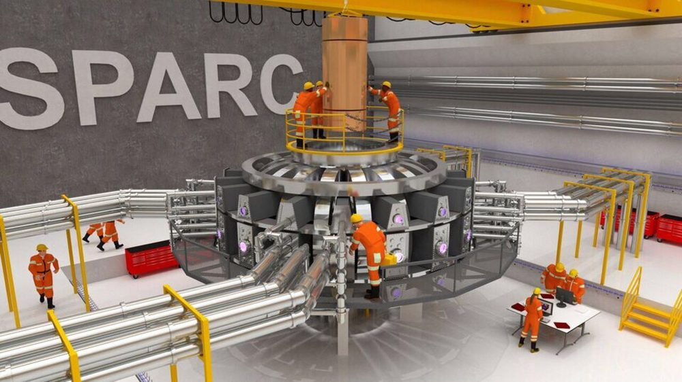

Result of computation the Fuel T+D
Result computation T+D with brake 3 10 18
Fig.1. Tempetue in capsule vs time of fuel T+D for different initial gas pressure into capcule p = 600, 800, 1000, 1200 atm. Initial temperature 10keV. Volume is constant.
Fig.2. Total and capsule energy vs time of fuel T+D for the different initial pressure p = 600, 800, 1000,
1200 atm. The volume is constant.
Fig.2a. Total and capsule energy vs time of fuel T+D for the different initial pressure
p = 600, 800, 1000, 1200 atm. The volume is constant.
Fig.3. Persentage reacted particles T+D vs time of fuel T+D for the different inicial pressure
p = 600, 800, 1000, 1200 atm. The volume is constant.
Fig.4. Heat-Brake Power T+D vs time for the different inicial pressure p=600,
800, 1000, 1200 atm in capsule. The volume is constant.
Fig.4a. Heat-Brake Power T+D (in LOG coordinate) vs time for the different inicial pressure
p=600, 800, 1000, 1200 atm. The volume is constant.
Fig.5. Initial gas pressure in capsule p = 600, 800, 1000, 1200 atm.
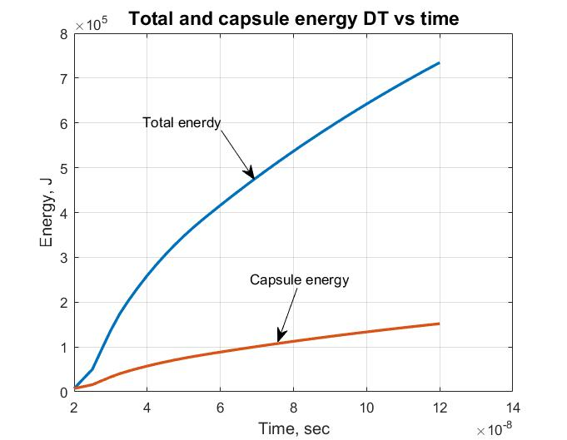
Fig. 5a. Total (include neutrons) and capcusule energy (only charged particles).
------------------------------------------------------------
Result of computation
Temperature and pressure T+D and D+D in K and atm. Date 6 24 18
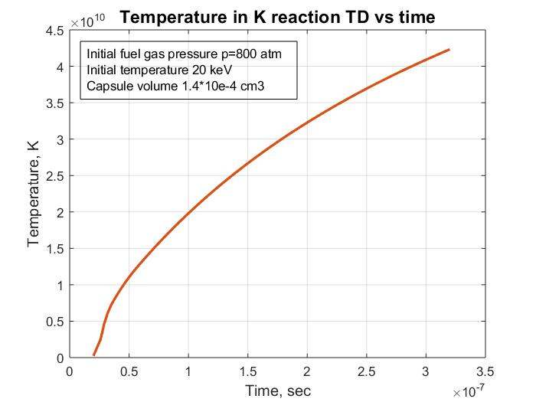
Fig.6. Temperature in K reaction TD vs. time
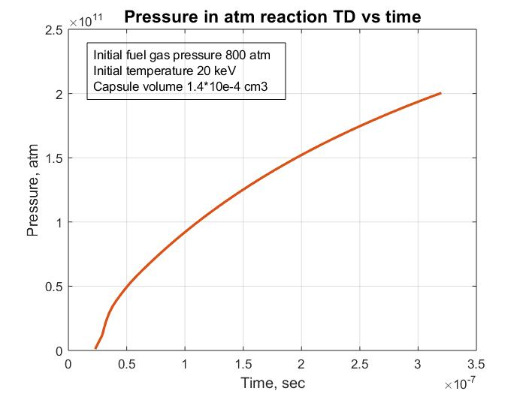
Fig.7. Pressure in atm Reaction TD vs time.
==========================================================================
Fuel D+D
Program
% Reaction fuel DD with Brake radiation 6 23 18
clear all

% Initial Data
n=100; % Number of steps
Di=3*(10^(-7)); % Distance of integration, sec
dt=Di/n; % step, sec
to=2*(10^(-8)); % Initial time, sec
v=1.4*(10^(-4)); % Volume of capcule, cm3
t(1)=2*(10^(-8)); % Initial time,sec
tt(1)=2*(10^(-8)); % Initial time,sec

%Data of fuel D+He3
Z=1; %Efficiency brake ratiation DD
K=1; %Initial Relative part of particles is ready reaction (Reactive Part)
Etf=3.64*(10^6); %Total energy of D+T reaction the one pair , eV
Ekf=2.43*(10^6); % Energy heating the capcule the one pair, eV
Kk=Ekf/Etf; % relative coefficient (loss neutrons)
Te(1)=2*(10^4); %Initial temperature, eV
TeK(1)=1.16*(10^4)*Te(1); % Initial temperature,K

%Teb(1)=2*(10^4); %Initial temperature with brake, eV
gamma=9*(10^(-5)); % Specific weight of hydrogen (gas) at 1 atm, g/cm3
mu=4; %relative mass of micture mu=3+2
mp=1.67*(10^(-27)); %nuclon mass, kg
p=800; %Pressure in capsule, atm
N1(1)=2*(10^(-3))*gamma*p/(mu*mp); % Total number nucleo DHe3 in 1 cm3
Ke=1; %Number electrons in one paricle.
N1e=Ke*N1(1); %Number of electrons in 1 cm3.
N1r(1)=N1(1)*K; %Initial namber of reactive particles in 1 cm3
Nv=N1(1)*v; % Common number particles into capsule. Consider the leaving neutron.
Nr(1)=N1(1)*v*K; %Initial number of reative particles into capcule
Ev(1)=7.23*(10^3); % Initial Reaction energy, J
Ek(1)=7.23*(10^3); % Initial RE into capsule, J
Eb(1)=7.23*(10^3); % Initial RE into capsule, J
Nvr(1)=0.; % Initial relatived part of partocles.
Nvrr(1)=0.; %initial procent reacted fuel
Pbr(1)=1.69*(10^(-32))*(N1e^2)*(Te(1)^0.5)*Z; %Power of brake radiation of 1 cm3
dEb(1)=Pbr(1)*v*dt; %Incriment brake energy in capsule J.
Teb(1)=0.625*(10^19)*Eb(1)/Nv; %Iniial energy into capsule from brake, eV

%Reaction Rate (Extentioned up 10 MeV)
x = [1000. 2000. 5000. 10000. 20000. 50000. 100000. 200000. ...
500000. 1000000. 10000000.]; % Temperature, eV
ydd = [1.5*(10^(-22)) 5.4*(10^(-21)) 1.8*(10^(-19)) ...
1.2*(10^(-18)) 5.2*(10^(-18)) 2.1*(10^(-17)) 4.5*(10^(-17)) ...
8.8*(10^(-17)) 1.8*(10^(-16)) 2.2*(10^(-16)) 10^(-16)]; % for D+D
ydt = [5.5*(10^(-21)) 2.6*(10^(-19)) 1.3*(10^(-17)) ...
1.1*(10^(-16)) 4.2*(10^(-16)) 8.7*(10^(-16)) 8.5*(10^(-16)) ...
6.3*(10^(-16)) 3.7*(10^(-16)) 2.7*(10^(-16)) 10^(-16)]; % for D+T
ytt = [1.3*(10^(-21)) 7.1*(10^(-21)) 1.4*(10^(-19)) ...
7.1*(10^(-19)) 2.5*(10^(-18)) 8.7*(10^(-18)) 1.9*(10^(-17)) ...
4.2*(10^(-17)) 8.4*(10^(-17)) 8.0*(10^(-17)) 10^(-16)]; % for T+T
ydhe3 = [1*(10^(-26)) 1.4*(10^(-23)) 6.7*(10^(-21)) 2.3*(10^(-19)) ...
3.8*(10^(-18)) 5.4*(10^(-17)) 1.6*(10^(-16)) ...
2.4*(10^(-16)) 2.3*(10^(-16)) 1.8*(10^(-16)) 10^(-16)]; % D+He3
ythe3= [1*(10^(-28)) 1*(10^(-25)) 2.1*(10^(-22)) 1.2*(10^(-20)) ...
2.6*(10^(-19)) 5.3*(10^(-18)) 7.7*(10^(-17)) ...
9.3*(10^(-17)) 2.9*(10^(-16)) 5.2*(10^(-16)) 10^(-16)]; % T+He3

RR(1)=interp1(x,ydd,Te(1)); % RR step 1

% Cycle of integration
for i=1:n
t(i+1)=t(i)+dt; %Time, sec.n+1
tt(i)= t(i)+dt; %Time, sec, n
RR(i+1)=interp1(x,ydd,Te(i)); % RR step 1
Pdt(i)=2.9*(10^(-12))*0.25*N1r(i)*N1r(i)*RR(i); %Power 1 cm3, W
dEdt(i)=Pdt(i)*dt; %Increament energy in 1cm3, J
dN1r(i)=dEdt(i)*2*0.625*(10^19)/Etf; %Increment reacted particles in eV
N1r(i+1)=N1r(i)-dN1r(i); % Rest of ready particles in 1cm3
Pv(i)=Pdt(i)*v*K; %Power,W in capsule
dEv(i)=Pdt(i)*v*K*dt; %Increament of Energy in capsule of volume v. J
Ev(i+1)=Ev(i)+dEv(i); % Total Reaction Energy in capsule, J
Ek(i+1)=Ek(i)+dEv(i)*Kk; %Reaction energy into capsule, J
dT(i)=0.625*(10^19)*dEv(i)/Nv; %Incriment energy into capsule, eV
Te(i+1)=Te(i)+dT(i); % Temperature into capsule, eV
TeK(i+1)=1.16*(10^4)*Te(i+1); % Temperature into capsule, K
Pa(i)=10*(N1(1)+N1e)*1.38*(10^(-23))*TeK(i); %Pressure into capsule in atm.

%Computatin number of reaction particles
dNrr(i+1)=dEv(i)*Nv/Etf; %Relative number of particles take part into reaction
Nvr(i+1)=Nvr(i)+dNrr(i); %Total relative reactived particles
Nvrr(i+1)=Nvr(i)/Nr(1); %Proncentage of reacted fuel

%Computation of brake radiation
Pbr(i)=1.69*(10^(-32))*(N1e^2)*(Te(i)^0.5)*Z; %Power of brake radiation of 1 cm3
dEb(i+1)=Pbr(i)*v*dt; %Incriment brake energy in capsule, J
Eb(i+1)=Eb(i)+dEb(i); %Brake Energy in capsule,J
%dTb(i)=0.625*(10^19)*dEb(i)/Nv; %Incriment energy into capsule, eV
%Teb(i+1)=Teb(i)+dTb(i); % Temperature into capsule, eV

end
Te(1)

figure (1) % Temperature from capsule DHe3
hnd1=plot(t,Te);
set (hnd1, 'linewidth',2);
t1=xlabel ('Time, sec');
set (t1,'Fontsize',12);
set (t1, 'Fontweight', 'bold');
t2=ylabel ('Temperature, eV');
set (t2,'Fontsize',12);
set (t2, 'Fontweight', 'bold');
t3= title ('Temperature from reaction DD vs time');
set (t3, 'Fontsize', 14);
set (t3, 'Fontweight', 'bold');
grid on
hold on

figure (8) % Temperature into capsule in K
hnd1=plot(t,TeK);
set (hnd1, 'linewidth',2);
t1=xlabel ('Time, sec');
set (t1,'Fontsize',12);
set (t1, 'Fontweight', 'bold');
t2=ylabel ('Temperature, K');
set (t2,'Fontsize',12);
set (t2, 'Fontweight', 'bold');
t3= title ('Temperature in K from reaction TD vs time');
set (t3, 'Fontsize', 14);
set (t3, 'Fontweight', 'bold');
grid on
hold on

figure (9) % Pressure into capsule in atm
hnd1=plot(tt,Pa);
set (hnd1, 'linewidth',2);
t1=xlabel ('Time, sec');
set (t1,'Fontsize',12);
set (t1, 'Fontweight', 'bold');
t2=ylabel ('Pressure, atm');
set (t2,'Fontsize',12);
set (t2, 'Fontweight', 'bold');
t3= title ('Pressure in atm from reaction TD vs time');
set (t3, 'Fontsize', 14);
set (t3, 'Fontweight', 'bold');
grid on
hold on

figure (2); % Temonuclear energy DHe3
hnd2=plot(t,Ev,t,Ek,'--');
set (hnd2, 'linewidth',2);
t1=xlabel ('Time, sec');
set (t1,'Fontsize',12);
set (t1, 'Fontweight', 'bold');
t2=ylabel ('Energy, J');
set (t2,'Fontsize',12);
set (t2, 'Fontweight', 'bold');
t3= title ('Total and capsule energy DD vs time');
set (t3, 'Fontsize', 14);
set (t3, 'Fontweight', 'bold');
grid on
hold on

figure (3); % Relatived number of reacted particles
hnd3=plot(t,Nvr);
set (hnd3, 'linewidth',2);
t1=xlabel ('Time, sec');
set (t1,'Fontsize',12);
set (t1, 'Fontweight', 'bold');
t2=ylabel ('Reacted part of DD Particles');
set (t2,'Fontsize',12);
set (t2, 'Fontweight', 'bold');
t3= title ('Reactived Part of DD particles vs time');
set (t3, 'Fontsize', 14);
set (t3, 'Fontweight', 'bold');
grid on
hold on

figure (4); % reaction rate DHe3
hnd4=plot(t,RR);
set (hnd4, 'linewidth',2);
t1=xlabel ('Time, sec');
set (t1,'Fontsize',12);
set (t1, 'Fontweight', 'bold');
t2=ylabel ('Reaction rate DD, sm3/sec');
set (t2,'Fontsize',12);
set (t2, 'Fontweight', 'bold');
t3= title ('Reaction Rate DD vs time');
set (t3, 'Fontsize', 14);
set (t3, 'Fontweight', 'bold');
grid on
hold on

figure (5); % Power of termoreaction DHe3
hnd5=plot(tt,Pv);
set (hnd5, 'linewidth',2);
t1=xlabel ('Time, sec');
set (t1,'Fontsize',12);
set (t1, 'Fontweight', 'bold');
t2=ylabel ('Power, W/cm3');
set (t2,'Fontsize',12);
set (t2, 'Fontweight', 'bold');
t3= title ('Power DD vs time');
set (t3, 'Fontsize', 14);
set (t3, 'Fontweight', 'bold');
grid on
hold on

figure (6); % Procentage of reacted particles
hnd6=plot(t,Nvrr);
set (hnd6, 'linewidth',2);
t1=xlabel ('Time, sec');
set (t1,'Fontsize',12);
set (t1, 'Fontweight', 'bold');
t2=ylabel (Relative part DD reacted Particles');
set (t2,'Fontsize',12);
set (t2, 'Fontweight', 'bold');
t3= title (' Part reacted DD vs time');
set (t3, 'Fontsize', 12);
set (t3, 'Fontweight', 'bold');
grid on
hold on

figure (7) %Heat= Brake Power in capsule DHe3
hnd7=plot(tt,Pdt, tt,Pbr,'--');
set (hnd7, 'linewidth',2);
t1=xlabel ('Time, sec');
set (t1,'Fontsize',12);
set (t1, 'Fontweight', 'bold');
t2=ylabel ('Power. W/sm3');
set (t2,'Fontsize',12);
set (t2, 'Fontweight', 'bold');
t3= title ('Heat-Brake Power DD vs time');
set (t3, 'Fontsize', 12);
set (t3, 'Fontweight', 'bold');
grid on
hold on
-------------------------------
Results
Result computation D+D
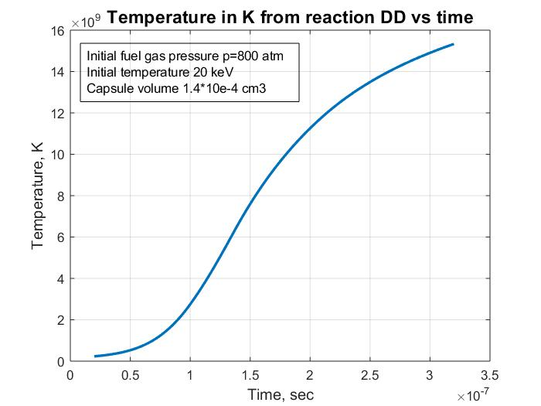
Fig.1. Temperature in K from reation D+D vs time.
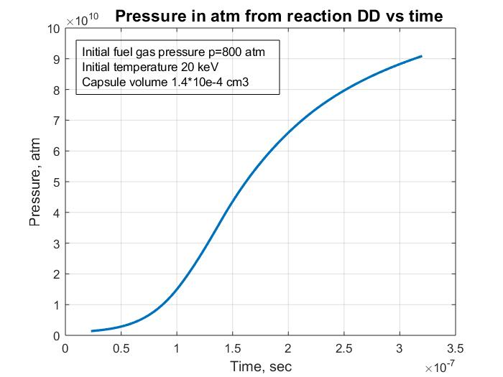
Fig.2. Pressure in atm. For reaction D+D vs. time.
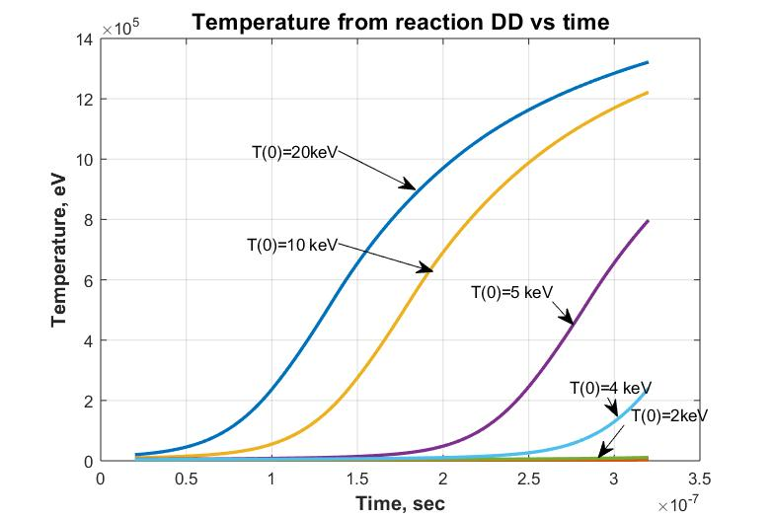
Fig. 3. Reaction temperature vs time for different initial ignition temperatures.
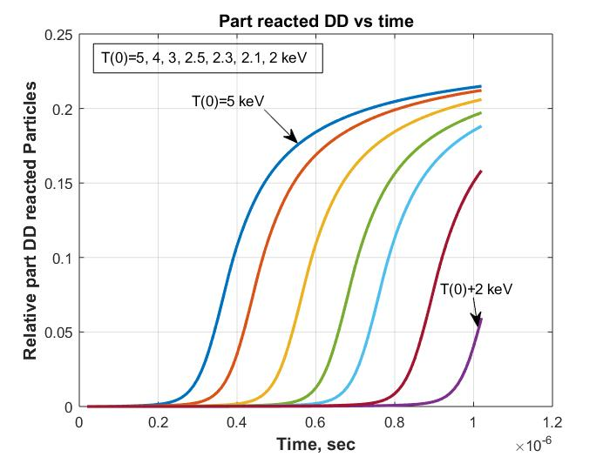
Fig.4. Relative part D+D reactived particles vs. time for different ignition temperatures.
Result computaion D+D with brake 3 10 18
Fig.5. Temperature in capsule vs time of fuel D+D for different
inicial pressure p=600, 800, 1000, 1200 atm.
Fig.6. Energy total and in capsule vs time of fuel D+D for different inicial pressure p=600, 800, 1000, 1200 atm.
Fig.7. Number of reacted paricles in capsule vs time of fuel D+D for different inicial pressure p=600, 800, 1000, 1200 atm.
Fig.8. Relative Number of reacted particles (in 100%) in capsule vs time of fuel D+D for different inicial pressure p = 600,800,1000,1200 atm.
Fig.9. Heat-Brake Power of reacted paricles in capsule vs time of fuel D+D for different initial pressure p=600, 800, 1000, 1200 atm.
Fig.10. Reaction rate DD vs time for different initial pressure p = 600, 800, 1000, 1200 atm.
===============================================

Fuel LiD (solid),(Li+D)
Program.
% Reaction fuel LiD with Brake radiation. Only D+D 3 10 18
clear all

% Initial Data
n=100; % Number of steps
Di=3*(10^(-7)); % Distance of integration, sec
dt=Di/n; % step, sec
to=2*(10^(-8)); % Initial time, sec
v=1.4*(10^(-4)); % Volume of capsule, cm3
t(1)=2*(10^(-8)); % Initial time, sec
tt(1)=2*(10^(-8)); % Initial time, sec

%Data of fuel D+He3
Z=5/4; %Efficiency brake radiation DD
K=0.5; %Initial Relative part of particles is ready reaction (Reactive Part)
Etf=3.64*(10^6); %Total energy of D+T reaction the one pair , eV
Ekf=2.43*(10^6); % Energy heating the capsule the one pair, eV
Kk=Ekf/Etf; % relative coefficient (loss neutrons)
Te(1)=2*(10^4); %Initial temperature, eV
%Teb(1)=2*(10^4); %Initial temperature with brake, eV
% gamma=9*(10^(-5)); % Specific weight of hydrogen (gas) at 1 atm, g/cm3
gamma=0.82; % g/cm3 Specific weight
mu=4; %relative mass of mixture mu=3+2
mp=1.67*(10^(-27)); %nucleon mass, kg
% p=600; %Pressure in capsule, atm
% N1(1)=2*(10^(-3))*gamma*p/(mu*mp); % Total number nucleo DHe3 in 1 cm3
N1(1)=2*(10^(-3))*gamma*K/(mu*mp); % Total number nucleo DD in 1 cm3
Ke=2; %Number electrons in one paricle.
N1e=Ke*N1(1); %Number of electrons in 1 cm3.
N1r(1)=N1(1)*K; %Initial namber of reactive particles in 1 cm3
Nv=N1(1)*v; % Common number particles into capsule. Consider the leaving neutron.
Nr(1)=N1(1)*v*K; %Initial number of reative particles into capcule
Ev(1)=7.23*(10^3); % Initial Reaction energy, J
Ek(1)=7.23*(10^3); % Initial RE into capsule, J
Eb(1)=7.23*(10^3); % Initial RE into capsule, J
Nvr(1)=0.; % Initial relatived part of partocles.
Nvrr(1)=0.; %initial procent reacted fuel
Pbr(1)=1.69*(10^(-32))*(N1e^2)*(Te(1)^0.5)*Z; %Power of brake radiation of 1 cm3
dEb(1)=Pbr(1)*v*dt; %Incriment brake energy in capsule J.
Teb(1)=0.625*(10^19)*Eb(1)/Nv; %Iniial energy into capsule from brake, eV

%Reaction Rate (Extentioned up 10 MeV)
x = [1000. 2000. 5000. 10000. 20000. 50000. 100000. 200000. ...
500000. 1000000. 10000000.]; % Temperature, eV
ydd = [1.5*(10^(-22)) 5.4*(10^(-21)) 1.8*(10^(-19)) ...
1.2*(10^(-18)) 5.2*(10^(-18)) 2.1*(10^(-17)) 4.5*(10^(-17)) ...
8.8*(10^(-17)) 1.8*(10^(-16)) 2.2*(10^(-16)) 10^(-16)]; % for D+D
ydt = [5.5*(10^(-21)) 2.6*(10^(-19)) 1.3*(10^(-17)) ...
1.1*(10^(-16)) 4.2*(10^(-16)) 8.7*(10^(-16)) 8.5*(10^(-16)) ...
6.3*(10^(-16)) 3.7*(10^(-16)) 2.7*(10^(-16)) 10^(-16)]; % for D+T
ytt = [1.3*(10^(-21)) 7.1*(10^(-21)) 1.4*(10^(-19)) ...
7.1*(10^(-19)) 2.5*(10^(-18)) 8.7*(10^(-18)) 1.9*(10^(-17)) ...
4.2*(10^(-17)) 8.4*(10^(-17)) 8.0*(10^(-17)) 10^(-16)]; % for T+T
ydhe3 = [1*(10^(-26)) 1.4*(10^(-23)) 6.7*(10^(-21)) 2.3*(10^(-19)) ...
3.8*(10^(-18)) 5.4*(10^(-17)) 1.6*(10^(-16)) ...
2.4*(10^(-16)) 2.3*(10^(-16)) 1.8*(10^(-16)) 10^(-16)]; % D+He3
ythe3= [1*(10^(-28)) 1*(10^(-25)) 2.1*(10^(-22)) 1.2*(10^(-20)) ...
2.6*(10^(-19)) 5.3*(10^(-18)) 7.7*(10^(-17)) ...
9.3*(10^(-17)) 2.9*(10^(-16)) 5.2*(10^(-16)) 10^(-16)]; % T+He3

RR(1)=interp1(x,ydd,Te(1)); % RR step 1

% Cycle of integration
for i=1:n
t(i+1)=t(i)+dt; %Time, sec.n+1
tt(i)= t(i)+dt; %Time, sec, n
RR(i+1)=interp1(x,ydd,Te(i)); % RR step 1
Pdt(i)=2.9*(10^(-12))*0.25*N1r(i)*N1r(i)*RR(i); %Power 1 cm3, W
dEdt(i)=Pdt(i)*dt; %Increament energy in 1cm3, J
dN1r(i)=dEdt(i)*2*0.625*(10^19)/Etf; %Increment reacted particles in eV
N1r(i+1)=N1r(i)-dN1r(i); % Rest of ready particles in 1cm3
Pv(i)=Pdt(i)*v*K; %Power,W in capsule
dEv(i)=Pdt(i)*v*K*dt; %Increament of Energy in capsule of volume v. J
Ev(i+1)=Ev(i)+dEv(i); % Total Reaction Energy in capsule, J
Ek(i+1)=Ek(i)+dEv(i)*Kk; %Reaction energy into capsule, J
dT(i)=0.625*(10^19)*dEv(i)/Nv; %Incriment energy into capsule, eV
Te(i+1)=Te(i)+dT(i); % Temperature into capsule, eV

%Computatin number of reaction particles
dNrr(i+1)=dEv(i)*Nv/Etf; %Relative number of particles take part into reaction
Nvr(i+1)=Nvr(i)+dNrr(i); %Total relative reactived particles
Nvrr(i+1)=Nvr(i)/Nr(1); %Proncentage of reacted fuel

%Computation of brake radiation
Pbr(i)=1.69*(10^(-32))*(N1e^2)*(Te(i)^0.5)*Z; %Power of brake radiation of 1 cm3
dEb(i+1)=Pbr(i)*v*dt; %Incriment brake energy in capsule, J
Eb(i+1)=Eb(i)+dEb(i); %Brake Energy in capsule,J
%dTb(i)=0.625*(10^19)*dEb(i)/Nv; %Incriment energy into capsule, eV
%Teb(i+1)=Teb(i)+dTb(i); % Temperature into capsule, eV

end
Te(1)

figure (1) % Temperature from capsule DHe3
hnd1=plot(t,Te);
set (hnd1, 'linewidth',2);
t1=xlabel ('Time, sec');
set (t1,'Fontsize',12);
set (t1, 'Fontweight', 'bold');
t2=ylabel ('Temperature, eV');
set (t2,'Fontsize',12);
set (t2, 'Fontweight', 'bold');
t3= title ('Temperature from reaction LiD vs time');
set (t3, 'Fontsize', 14);
set (t3, 'Fontweight', 'bold');
grid on
hold on

figure (2); % Temonuclear energy DHe3
hnd2=plot(t,Ev,t,Ek,'--');
set (hnd2, 'linewidth',2);
t1=xlabel ('Time, sec');
set (t1,'Fontsize',12);
set (t1, 'Fontweight', 'bold');
t2=ylabel ('Energy, J');
set (t2,'Fontsize',12);
set (t2, 'Fontweight', 'bold');
t3= title ('Total and capsule energy LiD vs time');
set (t3, 'Fontsize', 14);
set (t3, 'Fontweight', 'bold');
grid on
hold on

figure (3); % Relatived number of reacted particles
hnd3=plot(t,Nvr);
set (hnd3, 'linewidth',2);
t1=xlabel ('Time, sec');
set (t1,'Fontsize',12);
set (t1, 'Fontweight', 'bold');
t2=ylabel ('Reacted part of Particles');
set (t2,'Fontsize',12);
set (t2, 'Fontweight', 'bold');
t3= title ('Reactived Part of LiD particles vs time');
set (t3, 'Fontsize', 14);
set (t3, 'Fontweight', 'bold');
grid on
hold on

figure (4); % reaction rate DHe3
hnd4=plot(t,RR);
set (hnd4, 'linewidth',2);
t1=xlabel ('Time, sec');
set (t1,'Fontsize',12);
set (t1, 'Fontweight', 'bold');
t2=ylabel ('Reaction rate LiD, sm3/sec');
set (t2,'Fontsize',12);
set (t2, 'Fontweight', 'bold');
t3= title ('Reaction Rate LiD vs time');
set (t3, 'Fontsize', 14);
set (t3, 'Fontweight', 'bold');
grid on
hold on

figure (5); % Power of termoreaction DHe3
hnd5=plot(tt,Pv);
set (hnd5, 'linewidth',2);
t1=xlabel ('Time, sec');
set (t1,'Fontsize',12);
set (t1, 'Fontweight', 'bold');
t2=ylabel ('Power, W/cm3');
set (t2,'Fontsize',12);
set (t2, 'Fontweight', 'bold');
t3= title ('Power LiD vs time');
set (t3, 'Fontsize', 14);
set (t3, 'Fontweight', 'bold');
grid on
hold on

figure (6); % Procentage of reacted particles
hnd6=plot(t,Nvrr);
set (hnd6, 'linewidth',2);
t1=xlabel ('Time, sec');
set (t1,'Fontsize',12);
set (t1, 'Fontweight', 'bold');
t2=ylabel ('% reacted Particles');
set (t2,'Fontsize',12);
set (t2, 'Fontweight', 'bold');
t3= title ('% reacted particles LiD vs time');
set (t3, 'Fontsize', 12);
set (t3, 'Fontweight', 'bold');
grid on
hold on

figure (7) %Heat= Brake Power in capsule DHe3
hnd7=plot(tt,Pdt, tt,Pbr,'--');
set (hnd7, 'linewidth',2);
t1=xlabel ('Time, sec');
set (t1,'Fontsize',12);
set (t1, 'Fontweight', 'bold');
t2=ylabel ('Power. W/sm3');
set (t2,'Fontsize',12);
set (t2, 'Fontweight', 'bold');
t3= title ('Heat-Brake Power LiD vs time');
set (t3, 'Fontsize', 12);
set (t3, 'Fontweight', 'bold');
grid on
hold on
-----------------------------
Program
% Reaction fuel LiD To=2 keV
clear all
% Initial Data
n=100; % Number of steps
Di=2.5*(10^(-7)); % Distance of integration, sec
dt=Di/n; % step, sec
to=2*(10^(-8)); % Initial time, sec
v=1.4*(10^(-4)); % Volume of capcule, cm3
t(1)=2*(10^(-8)); % Initial time,sec
tt(1)=2*(10^(-8)); % Initial time,sec
%Data of fuel LiD
K=0.5; % Initial Relative part of particles is ready for reaction
Etf=3.65*(10^6); %Total energy of D+D reaction the one pair , eV
Ekf=2.42*(10^6); % Energy for heating the capcule the one pair, eV
Kk=Ekf/Etf; % relative coefficient
Te(1)=2*(10^3); %Initial temperature, eV
N1(1)=1.23*(10^(23)); % Common namber of particles in 1 cm3
N1r(1)=N1(1)*K; %Initial namber of reactive particles in 1 cm3
Nv=N1(1)*v; % Common number particles into capsule
Nr(1)=N1(1)*v*K; %Initial number of reative particles d into capcule
Ev(1)=7.23*(10^3); % Initial Reaction energy, J
Ek(1)=7.23*(10^3); % Initial RE into capsule, J
Nvr(1)=0.; % Initial relatived part of partocles.
Nvrr(1)=0.; % Initial prosentage of reacted nucleis

%Reaction Rate
x = [1000. 2000. 5000. 10000. 20000. 50000. 100000. 200000. ...
500000. 1000000.]; % Temperature, eV
ydd = [1.5*(10^(-22)) 5.4*(10^(-21)) 1.8*(10^(-19)) ...
1.2*(10^(-18)) 5.2*(10^(-18)) 2.1*(10^(-17)) 4.5*(10^(-17)) ...
8.8*(10^(-17)) 1.8*(10^(-16)) 2.2*(10^(-16))]; % for D+D
ydt = [5.5*(10^(-21)) 2.6*(10^(-19)) 1.3*(10^(-17)) ...
1.1*(10^(-16)) 4.2*(10^(-16)) 8.7*(10^(-16)) 8.5*(10^(-16)) ...
6.3*(10^(-16)) 3.7*(10^(-16)) 2.7*(10^(-16))]; % for D+T
ytt = [1.3*(10^(-21)) 7.1*(10^(-21)) 1.4*(10^(-19)) ...
7.1*(10^(-19)) 2.5*(10^(-18)) 8.7*(10^(-18)) 1.9*(10^(-17)) ...
4.2*(10^(-17)) 8.4*(10^(-17)) 8.0*(10^(-17))]; % for T+T
RR(1)=interp1(x,ydd,Te(1)); % RR for step 1

% Cycle of integration
for i=1:n
t(i+1)=t(i)+dt; %Time, sec.n+1
tt(i)= t(i)+dt; %Time, sec, n
RR(i+1)=interp1(x,ydd,Te(i)); % RR for step 1
Pdd(i)=3.3*(10^(-13))*N1r(i)*N1r(i)*RR(i); %Power ! cm3, W
dEdd(i)=Pdd(i)*dt; %Increament energy in 1cm3, J
dN1r(i)=dEdd(i)*2*0.625*(10^19)/Etf; %Increment reacted particles
N1r(i+1)=N1r(i)-dN1r(i); % Rest of ready particles in 1cm3
Pv(i)=Pdd(i)*v; %Power,W
dEv(i)=Pdd(i)*v*dt; %Increament of Energy in capsule of volume v. J
Ev(i+1)=Ev(i)+dEv(i); % Total Reaction Energy, J
Ek(i+1)=Ek(i)+dEv(i)*Kk; %Reaction energy into capsule, J
dT(i)=0.625*(10^19)*dEv(i)/Nv; %Incriment energy into capsule, eV
Te(i+1)=Te(i)+dT(i); % Temperature into capsule, eV
%Computatin number of reaction particles
dNrr(i+1)=dEv(i)*Nv/Etf; %Relative number of particles take part into reaction
Nvr(i+1)=Nvr(i)+dNrr(i); %Total relative reactived particles
Nvrr(i+1)=Nvr(i)/Nr(1); % Relative part of oarticles reacted
end

figure (1) % Temperature LiD into capsule
hnd1=plot(t,Te);
set (hnd1, 'linewidth',2);
t1=xlabel ('Time, sec');
set (t1,'Fontsize',12);
set (t1, 'Fontweight', 'bold');
t2=ylabel ('Temperature LiD, eV');
set (t2,'Fontsize',12);
set (t2, 'Fontweight', 'bold');
t3= title ('Temperature eV LiD vs time for To=2keV');
set (t3, 'Fontsize', 12);
set (t3, 'Fontweight', 'bold');
grid on
hold on

figure (2); % Temonuclear energy LiD
hnd2=plot(t,Ev,t,Ek);
set (hnd2, 'linewidth',2);
t1=xlabel ('Time, sec');
set (t1,'Fontsize',12);
set (t1, 'Fontweight', 'bold');
t2=ylabel ('Energy, J');
set (t2,'Fontsize',12);
set (t2, 'Fontweight', 'bold');
t3= title ('Total and capsule energy LiD vs time, To=2keV');
set (t3, 'Fontsize', 14);
set (t3, 'Fontweight', 'bold');
grid on
hold on

figure (3); % Relacted number of LiD reacted nucleis
hnd3=plot(t,Nvr);
set (hnd3, 'linewidth',2);
t1=xlabel ('Time, sec');
set (t1,'Fontsize',12);
set (t1, 'Fontweight', 'bold');
t2=ylabel ('Reacted part of Particles');
set (t2,'Fontsize',12);
set (t2, 'Fontweight', 'bold');
t3= title ('Reacted Part of particles LiD vs time, To=2keV');
set (t3, 'Fontsize', 12);
set (t3, 'Fontweight', 'bold');
grid on
hold on

figure (4); % reaction rate LiD
hnd4=plot(t,RR);
set (hnd4, 'linewidth',2);
t1=xlabel ('Time, sec');
set (t1,'Fontsize',12);
set (t1, 'Fontweight', 'bold');
t2=ylabel ('Reaction rate, cm3/sec');
set (t2,'Fontsize',12);
set (t2, 'Fontweight', 'bold');
t3= title ('Reaction Rate LiD vs time, To=2keV');
set (t3, 'Fontsize', 14);
set (t3, 'Fontweight', 'bold');
grid on
hold on

figure (5); % Power of termoreaction LiD
hnd5=plot(tt,Pv);
set (hnd5, 'linewidth',2);
t1=xlabel ('Time, sec');
set (t1,'Fontsize',12);
set (t1, 'Fontweight', 'bold');
t2=ylabel ('Power, W');
set (t2,'Fontsize',12);
set (t2, 'Fontweight', 'bold');
t3= title ('Power reaction LiD vs time, To=2keV');
set (t3, 'Fontsize', 14);
set (t3, 'Fontweight', 'bold');
grid on
hold on

figure (6); % percentage of reacted nucleis
hnd3=plot(t,Nvrr);
set (hnd3, 'linewidth',2);
t1=xlabel ('Time, sec');
set (t1,'Fontsize',12);
set (t1, 'Fontweight', 'bold');
t2=ylabel ('Reacted part of Particles');
set (t2,'Fontsize',12);
set (t2, 'Fontweight', 'bold');
t3= title ('Percentage of reacted nuckeis LiD vs time, To=2keV');
set (t3, 'Fontsize', 12);
set (t3, 'Fontweight', 'bold');
grid on
hold on

-------------------------------------
Result Li+D
Result of computation Li+D with brake 3 10 18
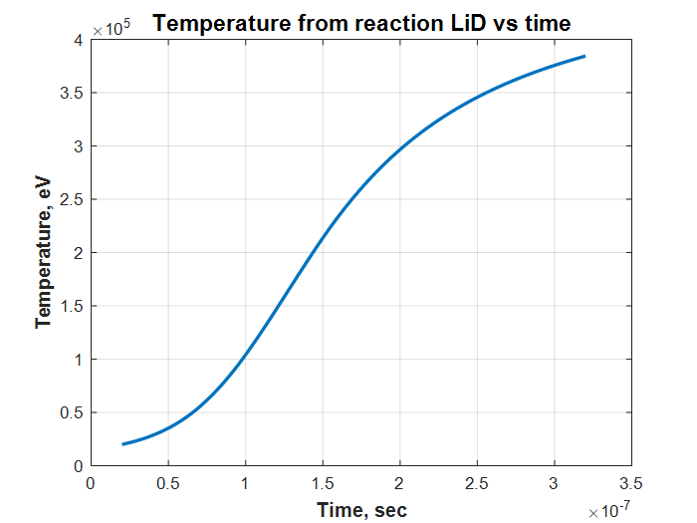
Fig.1. Temperature (eV) D+D of fuel LiD in capsule vs time. Volume is constant. Reaction D+D only.
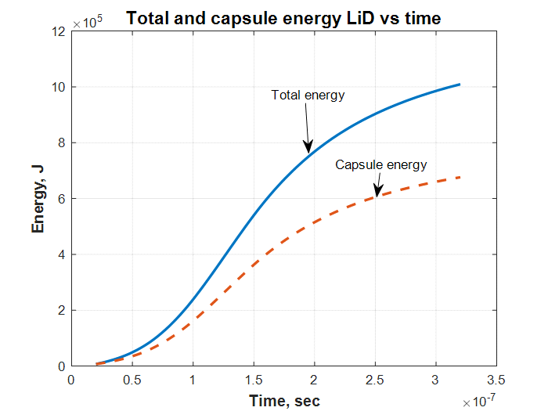
Fig.2. Total (with neutron) energy from capsule 0.3ꭖ2 mm of solid LiD and energy in capsule vs time.
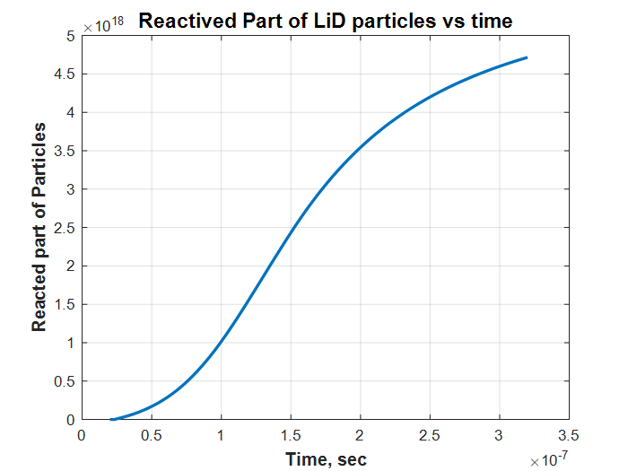
Fig.3. Reacted number particles D+D vs time. Volume is constant.
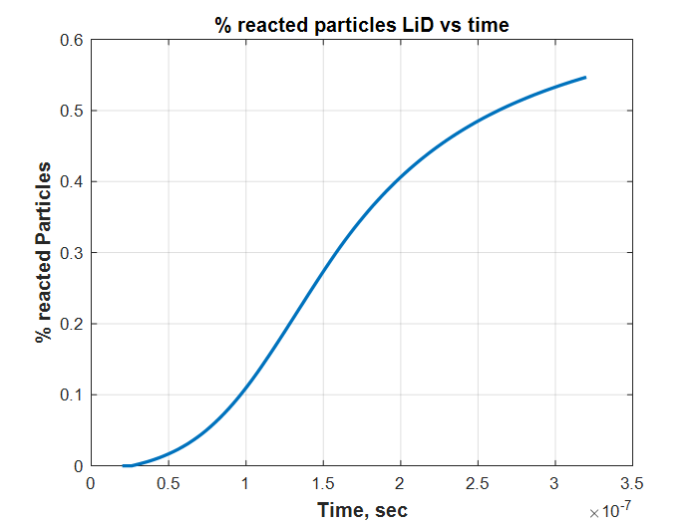
Fig.4. Percentage Reacted number particles D+D vs time. Volume is constant.
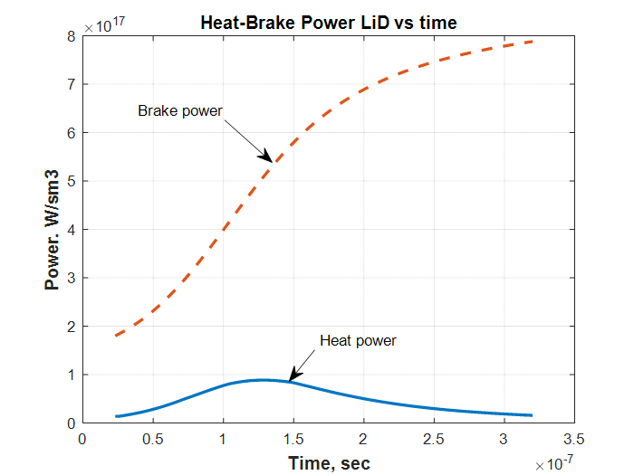
Rig.5. Heat-Brake power LiD vs time
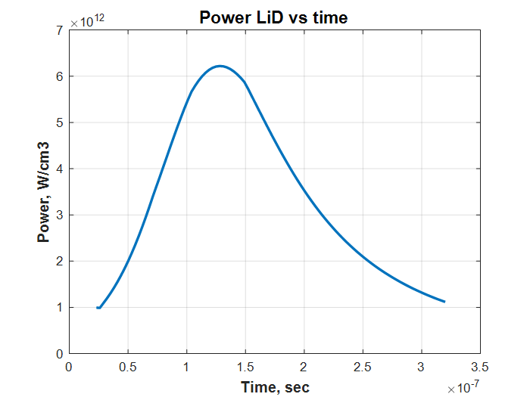
Fig.6. Power LiD vs. time.
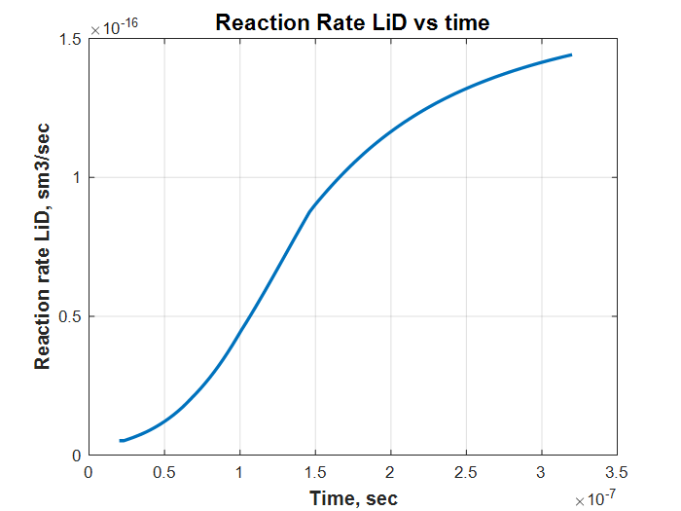
Fig.7. Reaction Rate vs. time.
===================================================================
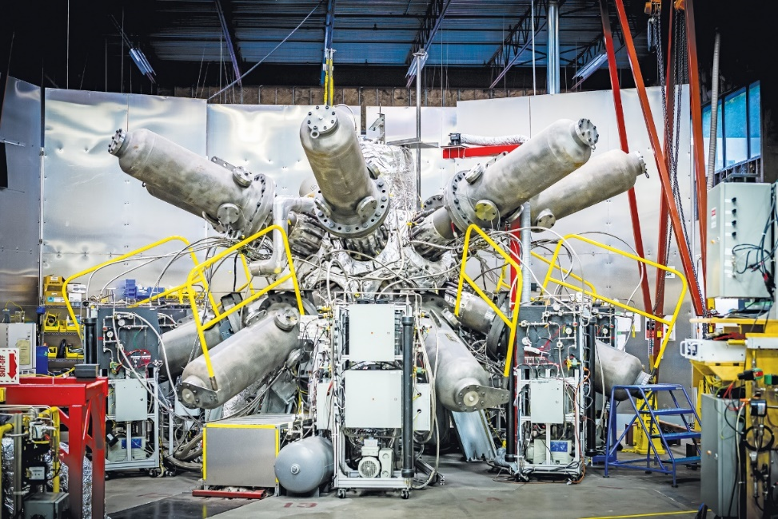
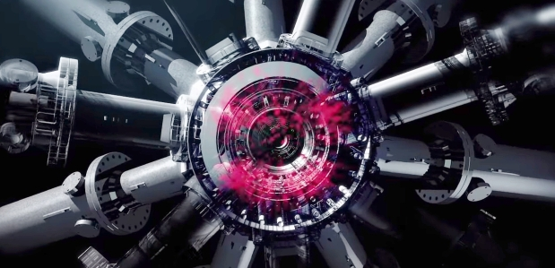
Fuel D₂O (liquid)(Reaction D+D).
Program D2O with brake 3 10 18
% Reaction fuel D2O with Brake radiation. Only D+D 3 10 18
clear all

% Initial Data
n=100; % Number of steps
Di=3*(10^(-7)); % Distance of integration, sec
dt=Di/n; % step, sec
to=2*(10^(-8)); % Initial time, sec
v=1.4*(10^(-4)); % Volume of capcule, cm3
t(1)=2*(10^(-8)); % Initial time,sec
tt(1)=2*(10^(-8)); % Initial time,sec

%Data of fuel D+He3
Z=2.27; %Efficiency brake ratiation DD
K=0.666; %Initial Relative part of particles is ready reaction (Reactive Part)
Etf=3.64*(10^6); %Total energy of D+T reaction the one pair , eV
Ekf=2.43*(10^6); % Energy heating the capcule the one pair, eV
Kk=Ekf/Etf; % relative coefficient (loss neutrons)
Te(1)=2*(10^4); %Initial temperature, eV
%Teb(1)=2*(10^4); %Initial temperature with brake, eV
% gamma=9*(10^(-5)); % Specific weight of hydrogen (gas) at 1 atm, g/cm3
gamma=1.; % g/cm3 Specific weight
mu=4; %relative mass of micture mu=3+2
mp=1.67*(10^(-27)); %nuclon mass, kg
% p=600; %Pressure in capsule, atm
% N1(1)=2*(10^(-3))*gamma*p/(mu*mp); % Total number nucleo DHe3 in 1 cm3
N1(1)=2*(10^(-3))*gamma*K/(mu*mp); % Total number nucleo DD in 1 cm3
Ke=10/3; %Number electrons in one paricle.
N1e=Ke*N1(1); %Number of electrons in 1 cm3.
N1r(1)=N1(1)*K; %Initial namber of reactive particles in 1 cm3
Nv=N1(1)*v; % Common number particles into capsule. Consider the leaving neutron.
Nr(1)=N1(1)*v*K; %Initial number of reative particles into capcule
Ev(1)=7.23*(10^3); % Initial Reaction energy, J
Ek(1)=7.23*(10^3); % Initial RE into capsule, J
Eb(1)=7.23*(10^3); % Initial RE into capsule, J
Nvr(1)=0.; % Initial relatived part of partocles.
Nvrr(1)=0.; %initial procent reacted fuel
Pbr(1)=1.69*(10^(-32))*(N1e^2)*(Te(1)^0.5)*Z; %Power of brake radiation of 1 cm3
dEb(1)=Pbr(1)*v*dt; %Incriment brake energy in capsule J.
Teb(1)=0.625*(10^19)*Eb(1)/Nv; %Iniial energy into capsule from brake, eV

%Reaction Rate (Extentioned up 10 MeV)
x = [1000. 2000. 5000. 10000. 20000. 50000. 100000. 200000. ...
500000. 1000000. 10000000.]; % Temperature, eV
ydd = [1.5*(10^(-22)) 5.4*(10^(-21)) 1.8*(10^(-19)) ...
1.2*(10^(-18)) 5.2*(10^(-18)) 2.1*(10^(-17)) 4.5*(10^(-17)) ...
8.8*(10^(-17)) 1.8*(10^(-16)) 2.2*(10^(-16)) 10^(-16)]; % for D+D
ydt = [5.5*(10^(-21)) 2.6*(10^(-19)) 1.3*(10^(-17)) ...
1.1*(10^(-16)) 4.2*(10^(-16)) 8.7*(10^(-16)) 8.5*(10^(-16)) ...
6.3*(10^(-16)) 3.7*(10^(-16)) 2.7*(10^(-16)) 10^(-16)]; % for D+T
ytt = [1.3*(10^(-21)) 7.1*(10^(-21)) 1.4*(10^(-19)) ...
7.1*(10^(-19)) 2.5*(10^(-18)) 8.7*(10^(-18)) 1.9*(10^(-17)) ...
4.2*(10^(-17)) 8.4*(10^(-17)) 8.0*(10^(-17)) 10^(-16)]; % for T+T
ydhe3 = [1*(10^(-26)) 1.4*(10^(-23)) 6.7*(10^(-21)) 2.3*(10^(-19)) ...
3.8*(10^(-18)) 5.4*(10^(-17)) 1.6*(10^(-16)) ...
2.4*(10^(-16)) 2.3*(10^(-16)) 1.8*(10^(-16)) 10^(-16)]; % D+He3
ythe3= [1*(10^(-28)) 1*(10^(-25)) 2.1*(10^(-22)) 1.2*(10^(-20)) ...
2.6*(10^(-19)) 5.3*(10^(-18)) 7.7*(10^(-17)) ...
9.3*(10^(-17)) 2.9*(10^(-16)) 5.2*(10^(-16)) 10^(-16)]; % T+He3

RR(1)=interp1(x,ydd,Te(1)); % RR step 1

% Cycle of integration
for i=1:n
t(i+1)=t(i)+dt; %Time, sec.n+1
tt(i)= t(i)+dt; %Time, sec, n
RR(i+1)=interp1(x,ydd,Te(i)); % RR step 1
Pdt(i)=2.9*(10^(-12))*0.25*N1r(i)*N1r(i)*RR(i); %Power 1 cm3, W
dEdt(i)=Pdt(i)*dt; %Increament energy in 1cm3, J
dN1r(i)=dEdt(i)*2*0.625*(10^19)/Etf; %Increment reacted particles in eV
N1r(i+1)=N1r(i)-dN1r(i); % Rest of ready particles in 1cm3
Pv(i)=Pdt(i)*v*K; %Power,W in capsule
dEv(i)=Pdt(i)*v*K*dt; %Increament of Energy in capsule of volume v. J
Ev(i+1)=Ev(i)+dEv(i); % Total Reaction Energy in capsule, J
Ek(i+1)=Ek(i)+dEv(i)*Kk; %Reaction energy into capsule, J
dT(i)=0.625*(10^19)*dEv(i)/Nv; %Incriment energy into capsule, eV
Te(i+1)=Te(i)+dT(i); % Temperature into capsule, eV

%Computatin number of reaction particles
dNrr(i+1)=dEv(i)*Nv/Etf; %Relative number of particles take part into reaction
Nvr(i+1)=Nvr(i)+dNrr(i); %Total relative reactived particles
Nvrr(i+1)=Nvr(i)/Nr(1); %Proncentage of reacted fuel

%Computation of brake radiation
Pbr(i)=1.69*(10^(-32))*(N1e^2)*(Te(i)^0.5)*Z; %Power of brake radiation of 1 cm3
dEb(i+1)=Pbr(i)*v*dt; %Incriment brake energy in capsule, J
Eb(i+1)=Eb(i)+dEb(i); %Brake Energy in capsule,J
%dTb(i)=0.625*(10^19)*dEb(i)/Nv; %Incriment energy into capsule, eV
%Teb(i+1)=Teb(i)+dTb(i); % Temperature into capsule, eV

end
Te(1)

figure (1) % Temperature from capsule DHe3
hnd1=plot(t,Te);
set (hnd1, 'linewidth',2);
t1=xlabel ('Time, sec');
set (t1,'Fontsize',12);
set (t1, 'Fontweight', 'bold');
t2=ylabel ('Temperature, eV');
set (t2,'Fontsize',12);
set (t2, 'Fontweight', 'bold');
t3= title ('Temperature from reaction L2O vs time');
set (t3, 'Fontsize', 14);
set (t3, 'Fontweight', 'bold');
grid on
hold on

figure (2); % Temonuclear energy DHe3
hnd2=plot(t,Ev,t,Ek,'--');
set (hnd2, 'linewidth',2);
t1=xlabel ('Time, sec');
set (t1,'Fontsize',12);
set (t1, 'Fontweight', 'bold');
t2=ylabel ('Energy, J');
set (t2,'Fontsize',12);
set (t2, 'Fontweight', 'bold');
t3= title ('Total and capsule energy D2O vs time');
set (t3, 'Fontsize', 14);
set (t3, 'Fontweight', 'bold');
grid on
hold on

figure (3); % Relatived number of reacted particles
hnd3=plot(t,Nvr);
set (hnd3, 'linewidth',2);
t1=xlabel ('Time, sec');
set (t1,'Fontsize',12);
set (t1, 'Fontweight', 'bold');
t2=ylabel ('Reacted part of Particles');
set (t2,'Fontsize',12);
set (t2, 'Fontweight', 'bold');
t3= title ('Reactived Part of D2O particles vs time');
set (t3, 'Fontsize', 14);
set (t3, 'Fontweight', 'bold');
grid on
hold on

figure (4); % reaction rate DHe3
hnd4=plot(t,RR);
set (hnd4, 'linewidth',2);
t1=xlabel ('Time, sec');
set (t1,'Fontsize',12);
set (t1, 'Fontweight', 'bold');
t2=ylabel ('Reaction rate LiD, sm3/sec');
set (t2,'Fontsize',12);
set (t2, 'Fontweight', 'bold');
t3= title ('Reaction Rate LiD vs time');
set (t3, 'Fontsize', 14);
set (t3, 'Fontweight', 'bold');
grid on
hold on

figure (5); % Power of termoreaction DHe3
hnd5=plot(tt,Pv);
set (hnd5, 'linewidth',2);
t1=xlabel ('Time, sec');
set (t1,'Fontsize',12);
set (t1, 'Fontweight', 'bold');
t2=ylabel ('Power, W/cm3');
set (t2,'Fontsize',12);
set (t2, 'Fontweight', 'bold');
t3= title ('Power D2O vs time');
set (t3, 'Fontsize', 14);
set (t3, 'Fontweight', 'bold');
grid on
hold on

figure (6); % Procentage of reacted particles
hnd6=plot(t,Nvrr);
set (hnd6, 'linewidth',2);
t1=xlabel ('Time, sec');
set (t1,'Fontsize',12);
set (t1, 'Fontweight', 'bold');
t2=ylabel ('% reacted Particles');
set (t2,'Fontsize',12);
set (t2, 'Fontweight', 'bold');
t3= title ('% reacted particles D2O vs time');
set (t3, 'Fontsize', 12);
set (t3, 'Fontweight', 'bold');
grid on
hold on

figure (7) %Heat= Brake Power in capsule DHe3
hnd7=plot(tt,Pdt, tt,Pbr,'--');
set (hnd7, 'linewidth',2);
t1=xlabel ('Time, sec');
set (t1,'Fontsize',12);
set (t1, 'Fontweight', 'bold');
t2=ylabel ('Power. W/sm3');
set (t2,'Fontsize',12);
set (t2, 'Fontweight', 'bold');
t3= title ('Heat-Brake Power D2O vs time');
set (t3, 'Fontsize', 12);
set (t3, 'Fontweight', 'bold');
grid on
hold on
------------------------------------------------------------------
% Reaction fuel D2O To=20 keV Te(1)=2*10^4, Te(1)=3*10^4
clear all
% Initial Data
n=100; % Number of steps
Di=2.5*(10^(-7)); % Distance of integration, sec
dt=Di/n; % step, sec
to=2*(10^(-8)); % Initial time, sec
v=1.4*(10^(-4)); % Volume of capcule, cm3
t(1)=2*(10^(-8)); % Initial time,sec
tt(1)=2*(10^(-8)); % Initial time,sec
%Data of fuel LiD
K=0.666; % Initial Relative part of particles is ready for reaction
Etf=3.65*(10^6); %Total energy of D+D reaction the one pair , eV
Ekf=2.42*(10^6); % Energy for heating the capcule the one pair, eV
Kk=Ekf/Etf; % relative coefficient
Te(1)=3*(10^4); %Initial temperature, eV
N1(1)=6.59*(10^(22)); % Common namber of particles in 1 cm3
N1r(1)=N1(1)*K; %Initial namber of reactive particles in 1 cm3
Nv=N1(1)*v; % Common number particles into capsule
Nr(1)=N1(1)*v*K; %Initial number of reative particles into capcule
Ev(1)=7.23*(10^3); % Initial Reaction energy, J
Ek(1)=7.23*(10^3); % Initial RE into capsule, J
Nvr(1)=0.; % Initial relatived part of partocles.
Nvrr(1)=0.; % Initial prosentage of reacted nucleis

%Reaction Rate
x = [1000. 2000. 5000. 10000. 20000. 50000. 100000. 200000. ...
500000. 1000000.]; % Temperature, eV
ydd = [1.5*(10^(-22)) 5.4*(10^(-21)) 1.8*(10^(-19)) ...
1.2*(10^(-18)) 5.2*(10^(-18)) 2.1*(10^(-17)) 4.5*(10^(-17)) ...
8.8*(10^(-17)) 1.8*(10^(-16)) 2.2*(10^(-16))]; % for D+D
ydt = [5.5*(10^(-21)) 2.6*(10^(-19)) 1.3*(10^(-17)) ...
1.1*(10^(-16)) 4.2*(10^(-16)) 8.7*(10^(-16)) 8.5*(10^(-16)) ...
6.3*(10^(-16)) 3.7*(10^(-16)) 2.7*(10^(-16))]; % for D+T
ytt = [1.3*(10^(-21)) 7.1*(10^(-21)) 1.4*(10^(-19)) ...
7.1*(10^(-19)) 2.5*(10^(-18)) 8.7*(10^(-18)) 1.9*(10^(-17)) ...
4.2*(10^(-17)) 8.4*(10^(-17)) 8.0*(10^(-17))]; % for T+T
RR(1)=interp1(x,ydd,Te(1)); % RR for step 1

% Cycle of integration
for i=1:n
t(i+1)=t(i)+dt; %Time, sec.n+1
tt(i)= t(i)+dt; %Time, sec, n
RR(i+1)=interp1(x,ydd,Te(i)); % RR for step 1
Pdd(i)=3.3*(10^(-13))*N1r(i)*N1r(i)*RR(i); %Power ! cm3, W
dEdd(i)=Pdd(i)*dt; %Increament energy in 1cm3, J
dN1r(i)=dEdd(i)*2*0.625*(10^19)/Etf; %Increment reacted particles
N1r(i+1)=N1r(i)-dN1r(i); % Rest of ready particles in 1cm3
Pv(i)=Pdd(i)*v; %Power,W
dEv(i)=Pdd(i)*v*dt; %Increament of Energy in capsule of volume v. J
Ev(i+1)=Ev(i)+dEv(i); % Total Reaction Energy, J
Ek(i+1)=Ek(i)+dEv(i)*Kk; %Reaction energy into capsule, J
dT(i)=0.625*(10^19)*dEv(i)/Nv; %Incriment energy into capsule, eV
Te(i+1)=Te(i)+dT(i); % Temperature into capsule, eV
%Computatin number of reaction particles
dNrr(i+1)=dEv(i)*Nv/Etf; %Nnumber of particles take part into reaction
Nvr(i+1)=Nvr(i)+dNrr(i); %Total relative reactived particles
Nvrr(i+1)=Nvr(i)/Nr(1); % Relative part (percent) of particles reacted
end

Te(101)
Ev(101)
Nvp=Nvr(101)/Nr(1)

figure (1) % Temperature D2O into capsule
hnd1=plot(t,Te);
set (hnd1, 'linewidth',2);
t1=xlabel ('Time, sec');
set (t1,'Fontsize',12);
set (t1, 'Fontweight', 'bold');
t2=ylabel ('Temperature LiD, eV');
set (t2,'Fontsize',12);
set (t2, 'Fontweight', 'bold');
t3= title ('Temperature eV D2O vs time');
set (t3, 'Fontsize', 12);
set (t3, 'Fontweight', 'bold');
grid on
hold on

figure (2); % Temonuclear energy D2o
hnd2=plot(t,Ev,t,Ek,'--');
set (hnd2, 'linewidth',2);
t1=xlabel ('Time, sec');
set (t1,'Fontsize',12);
set (t1, 'Fontweight', 'bold');
t2=ylabel ('Energy, J');
set (t2,'Fontsize',12);
set (t2, 'Fontweight', 'bold');
t3= title ('Total and capsule energy D2O vs time');
set (t3, 'Fontsize', 14);
set (t3, 'Fontweight', 'bold');
grid on
hold on

figure (3); % Relacted number of D2O reacted nucleis
hnd3=plot(t,Nvr);
set (hnd3, 'linewidth',2);
t1=xlabel ('Time, sec');
set (t1,'Fontsize',12);
set (t1, 'Fontweight', 'bold');
t2=ylabel ('Reacted part of Particles');
set (t2,'Fontsize',12);
set (t2, 'Fontweight', 'bold');
t3= title ('Reacted Part of particles D2O vs time');
set (t3, 'Fontsize', 12);
set (t3, 'Fontweight', 'bold');
grid on
hold on

figure (4); % reaction rate D2O
hnd4=plot(t,RR);
set (hnd4, 'linewidth',2);
t1=xlabel ('Time, sec');
set (t1,'Fontsize',12);
set (t1, 'Fontweight', 'bold');
t2=ylabel ('Reaction rate, cm3/sec');
set (t2,'Fontsize',12);
set (t2, 'Fontweight', 'bold');
t3= title ('Reaction Rate D2O vs time');
set (t3, 'Fontsize', 14);
set (t3, 'Fontweight', 'bold');
grid on
hold on

figure (5); % Power of termoreaction D2O)
hnd5=plot(tt,Pv);
set (hnd5, 'linewidth',2);
t1=xlabel ('Time, sec');
set (t1,'Fontsize',12);
set (t1, 'Fontweight', 'bold');
t2=ylabel ('Power, W');
set (t2,'Fontsize',12);
set (t2, 'Fontweight', 'bold');
t3= title ('Power reaction D2O vs time');
set (t3, 'Fontsize', 14);
set (t3, 'Fontweight', 'bold');
grid on
hold on

figure (6); % percentage of reacted nuckleis
hnd3=plot(t,Nvrr);
set (hnd3, 'linewidth',2);
t1=xlabel ('Time, sec');
set (t1,'Fontsize',12);
set (t1, 'Fontweight', 'bold');
t2=ylabel ('Reacted part of Particles');
set (t2,'Fontsize',12);
set (t2, 'Fontweight', 'bold');
t3= title ('Percentage of reacted nuckleis D2O vs time');
set (t3, 'Fontsize', 12);
set (t3, 'Fontweight', 'bold');
grid on
hold on
==============================================
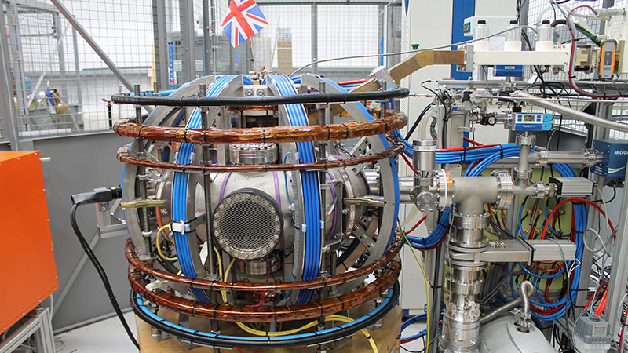
Result D₂O. Computation reaction only D+D.
Result of computation D2O with brake 3 10 18
Fig.1. Temperature in capsule vs time for reation D+D. Fuel D₂O.
Fig. 2. Total and capsule Energy vs time. Fuel D₂O. Reaction only D+D.
Fig.3. Number of reacted particles D₂O vs time
Fig.4. Power D₂O vs. time.
Fig. 5. Procent of reacted particles D₂O vs. time.
Fig.6. Heat-Brake Power D2O vs. time. Brake radiation heats the fuel.
===========================================================
Fuel pB₁₁.
Program p+B final 7 18 18
% Reaction fuel p+B11 with Brake radiation 7 13 18
% Here 5B, 1H=p. Reaction p+11B=3 4He +8.7 MeV, Fuel 6B10H

clear all

% Initial Data
n=100; % Number of steps
Di=3*(10^(-6)); % Distance of integration, sec
dt=Di/n; % step, sec
v=1.4*(10^(-4)); % Volume of capcule, cm3
t(1)=2*(10^(-8)); % Initial time,sec
tt(1)=2*(10^(-8)); % Initial time,sec

%Data of fuel pB11, (6B10H)
%n=6; %Number of atoms B in fuel 6B10H (nBmH)
%m=10; %Number of atoms H in fuel 6B10H
Z=5; %Efficiency brake radiation pB11
EEtf=8.7*(10^6); %Total energy of pH11 reaction the one pair pB, eV
Te(1)=1*(10^4); %Initial temperature, eV in capsule
gamma=0.69; % Specific mass of fuel 6B10H (liquid), g/cm3
mu=76; %relative mass of fuel 6B10H mu=6*11+1*10=76
mp=1.67*(10^(-27)); %nucleon mass, kg

%Initial density and number of fuel particles
n1m(1)=(10^(-3))*gamma/(mu*mp);%Density of molecules “6B10H” in 1 cm3
n1B(1)=6*n1m(1); % Density of nuclear “B” in 1 cm3
n1p(1)=10*n1m(1); % Density of nuclear “p” in 1 cm3
n1pB(1)=n1B(1)+n1p(1); %Density of nuclear p+B in 1 cm3
n1e=5*n1B(1)+n1p(1); %Density of electrons in 1 cm3
nn(1)=n1pB(1); % Common Density pB with He(1)=0 in t=1 in 1cm^3

NB(1)=n1B(1)*v; %number of nuclear B in volume v.
Np(1)=n1p(1)*v; %number of nuclear p in volume v.
Ne=n1e*v; % number of electron e in volume v.
Nn(1)=NB(1)+Np(1); %number of nuclear B+p in volume v.
NN(1)=Nn(1)+Ne; %Total initial Number of partivles include electrons p+B+e in volube v.

Ec(1)=NN(1)*Te(1)*(1.6*10^(-19)); %Initial energy of capsule, J.

NBr(1)=1; %Initial value reacted nuclear

%Number of electrons in one particle.
N1e=5*n1B(1)+n1p(1); %Number of electrons in 1 cm3
Eb(1)=0; %Brake energy in capsule

%Reaction Rate (Extentioned up 10 MeV)
x = [1000. 2000. 5000. 10000. 20000. 50000. 100000. 200000. ...
500000. 1000000. 10000000.]; % Temperature, eV
ydd = [1.5*(10^(-22)) 5.4*(10^(-21)) 1.8*(10^(-19)) ...
1.2*(10^(-18)) 5.2*(10^(-18)) 2.1*(10^(-17)) 4.5*(10^(-17)) ...
8.8*(10^(-17)) 1.8*(10^(-16)) 2.2*(10^(-16)) 10^(-16)]; % for D+D
ydt = [5.5*(10^(-21)) 2.6*(10^(-19)) 1.3*(10^(-17)) ...
1.1*(10^(-16)) 4.2*(10^(-16)) 8.7*(10^(-16)) 8.5*(10^(-16)) ...
6.3*(10^(-16)) 3.7*(10^(-16)) 2.7*(10^(-16)) 10^(-16)]; % for D+T
ytt = [1.3*(10^(-21)) 7.1*(10^(-21)) 1.4*(10^(-19)) ...
7.1*(10^(-19)) 2.5*(10^(-18)) 8.7*(10^(-18)) 1.9*(10^(-17)) ...
4.2*(10^(-17)) 8.4*(10^(-17)) 8.0*(10^(-17)) 10^(-16)]; % for T+T
ydhe3 = [1*(10^(-26)) 1.4*(10^(-23)) 6.7*(10^(-21)) 2.3*(10^(-19)) ...
3.8*(10^(-18)) 5.4*(10^(-17)) 1.6*(10^(-16)) ...
2.4*(10^(-16)) 2.3*(10^(-16)) 1.8*(10^(-16)) 10^(-16)]; % D+He3
ythe3= [1*(10^(-28)) 1*(10^(-25)) 2.1*(10^(-22)) 1.2*(10^(-20)) ...
2.6*(10^(-19)) 5.3*(10^(-18)) 7.7*(10^(-17)) ...
9.3*(10^(-17)) 2.9*(10^(-16)) 5.2*(10^(-16)) 10^(-16)]; % T+He3
ypb11=[1*(10^(-28)) 10^(-26) 10^(-23) 3*(10^(-22)) 10^(-20) 3*(10^(-18)) ...
5*(10^(-17)) 4*(10^(-16)) 3*(10^(-16)) 10^(-16) 10^(-17)]; % p+B11

RR(1)=interp1(x,ypb11,Te(1)); % RR step 1

% Cycle of integration
for i=1:n
t(i+1)=t(i)+dt; %Time, sec.n+1
tt(i)= t(i)+dt; %Time, sec, n
RR(i+1)=interp1(x,ypb11,Te(i)); % RR step i, cm^3/s
P(i)=2.9*(10^(-12))*n1B(i)*n1p(i)*RR(i); %Power in 1 cm3, W
Pc(i)=P(i)*v; % Power of capsule W
dE(i)=P(i)*dt; %Increament energy in 1cm3, J
dEc(i)=v*dE(i); %Increment energy in capsule, J
dEce(i)=dEc(i)*0.625*(10^19); %Increment energy in capcule, eV
Ec(i+1)=Ec(i)+dEc(i); %Energy in capsule, J
Ece(i+1)=Ec(i)*0.625*(10^19); %Energy in capsule, eV
dNr(i+1)=dEce(i)/EEtf; %Number particles take part in reaction in dt in capcule,
%EEtf - Energy reaction 1 pair pB, eV
NB(i+1)=NB(i)-dNr(i); %Number of rest nuclear B in capsule
Np(i+1)=Np(i)-dNr(i); %Number of rest nuclear H in capsule
NN(i+1)=NN(i)+dNr(i); %Number of common nuclear p+B+e in capsule

n1B(i+1)=NB(i+1)/v; % Density B in 1cm^3
n1p(i+1)=Np(i+1)/v; % Density p in 1cm^3
nn(i+1)=NN(i+1)/v; % Common Density in 1cm^3
nnr(i+1)=nn(i+1)/nn(1); % Relative common density

NBr(i+1)=NB(i+1)/NB(1); %Relative burn B

dT1(i)=dEce(i)/NN(i); %Increment temperature in eV in 1 particles
Te(i+1)=Te(i)+dT1(i); % temperature in capsule, eV
B(i)=Ec(i)/Ec(1); % Energy gain

%Computation of brake radiation
Pbr(i)=1.69*(10^(-32))*(n1e^2)*(Te(i)^0.5)*Z; %Power of brake radiation of 1 cm3
dEb(i+1)=Pbr(i)*v*dt; %Incriment brake energy in capsule, J
Eb(i+1)=Eb(i)+dEb(i); %Brake Energy in capsule,J

end
Te(1)
t(100)
Te(70)
Te(100)
NBr(50)
NBr(100)

figure (1) % Temperature in capsule 6B10H
hnd1=plot(t,Te);
set (hnd1, 'linewidth',2);
t1=xlabel ('Time, sec');
set (t1,'Fontsize',12);
set (t1, 'Fontweight', 'bold');
t2=ylabel ('Temperature fuel 6B10H, eV');
set (t2,'Fontsize',12);
set (t2, 'Fontweight', 'bold');
t3= title ('Temperature from reaction pB11 vs time');
set (t3, 'Fontsize', 14);
set (t3, 'Fontweight', 'bold');
grid on
hold on

figure (2); % Thermonuclear energy 6B10H
hnd2=plot(t,Ec);
set (hnd2, 'linewidth',2);
t1=xlabel ('Time, sec');
set (t1,'Fontsize',12);
set (t1, 'Fontweight', 'bold');
t2=ylabel ('Energy pH11, J');
set (t2,'Fontsize',12);
set (t2, 'Fontweight', 'bold');
t3= title ('Capsule energy pB11 vs time');
set (t3, 'Fontsize', 14);
set (t3, 'Fontweight', 'bold');
grid on
hold on

figure (3); % Relative number “B” of reacted particles
hnd3=plot(t,NBr);
set (hnd3, 'linewidth',2);
t1=xlabel ('Time, sec');
set (t1,'Fontsize',12);
set (t1, 'Fontweight', 'bold');
t2=ylabel ('Relative reacted part of B nuclear');
set (t2,'Fontsize',12);
set (t2, 'Fontweight', 'bold');
t3= title ('Reactive Part of “B" nuclear vs time');
set (t3, 'Fontsize', 14);
set (t3, 'Fontweight', 'bold');
grid on
hold on

figure (4); % Relative Energy Gain in pB11
hnd4=plot(tt,B);
set (hnd4, 'linewidth',2);
t1=xlabel ('Time, sec');
set (t1,'Fontsize',12);
set (t1, 'Fontweight', 'bold');
t2=ylabel ('Relative Energy Gain');
set (t2,'Fontsize',12);
set (t2, 'Fontweight', 'bold');
t3= title ('Energy Gain of pB11 vs time');
set (t3, 'Fontsize', 14);
set (t3, 'Fontweight', 'bold');
grid on
hold on

figure (5); % Power of thermoreaction 6B10H
hnd5=plot(tt,Pc);
set (hnd5, 'linewidth',2);
t1=xlabel ('Time, sec');
set (t1,'Fontsize',12);
set (t1, 'Fontweight', 'bold');
t2=ylabel ('Power, W');
set (t2,'Fontsize',12);
set (t2, 'Fontweight', 'bold');
t3= title ('Power pB11 vs time');
set (t3, 'Fontsize', 14);
set (t3, 'Fontweight', 'bold');
grid on
hold on

figure (6); %Relative of reacted “B” nuclear
hnd6=plot(t,RR);
set (hnd6, 'linewidth',2);
t1=xlabel ('Time, sec');
set (t1,'Fontsize',12);
set (t1, 'Fontweight', 'bold');
t2=ylabel ('Reaction rate, cm^3/s');
set (t2,'Fontsize',12);
set (t2, 'Fontweight', 'bold');
t3= title (' Reaction Rate vs time, cm^3/s');
set (t3, 'Fontsize', 12);
set (t3, 'Fontweight', 'bold');
grid on
hold on

figure (7) %Heat= Brake Power in capsule 6B10H
hnd7=plot(t,Ec, t, Eb, '--');
set (hnd7, 'linewidth',2);
t1=xlabel ('Time, sec');
set (t1,'Fontsize',12);
set (t1, 'Fontweight', 'bold');
t2=ylabel ('Energy. J');
set (t2,'Fontsize',12);
set (t2, 'Fontweight', 'bold');
t3= title ('Heat--Brake energy 6B10H vs time');
set (t3, 'Fontsize', 12);
set (t3, 'Fontweight', 'bold');
grid on
hold on

% figure (8) %Reaction Rate vs Temperature of different fuels
%hnd7=plot(x,ydd, x,ydt, x,ytt, x,ydhe3, x,ythe3, x,ypb11);
%set (hnd7, 'linewidth',2);
% t1=xlabel ('T, eV');
% set (t1,'Fontsize',12);
% set (t1, 'Fontweight', 'bold');
%t2=ylabel ('Reaction rate, cm^3/s');
% set (t2,'Fontsize',12);
% set (t2, 'Fontweight', 'bold');
% t3= title ('Reaction Rate vs temperature');
% set (t3, 'Fontsize', 12);
% set (t3, 'Fontweight', 'bold');
%grid on
%hold on

figure (9); % Relative number particles vs time
hnd3=plot(t,nnr);
set (hnd3, 'linewidth',2);
t1=xlabel ('Time, sec');
set (t1,'Fontsize',12);
set (t1, 'Fontweight', 'bold');
t2=ylabel ('Relative number particles');
set (t2,'Fontsize',12);
set (t2, 'Fontweight', 'bold');
t3= title ('Relative number of particles vs time');
set (t3, 'Fontsize', 14);
set (t3, 'Fontweight', 'bold');
grid on
hold on
---------------------------------
Program pB11 with brake 7 13 18
Fuel 6B10H liquid temperature 108ºC, density 0.69 g/cm³
% Reaction fuel p+B11 with Brake radiation 7 13 18
% Here ⁵B, ¹H=p. Reaction p+₁₁B=3⁴He +8.7 MeV, Fuel 6B10H
clear all

% Initial Data
n=100; % Number of steps
Di=3*(10^(-6)); % Distance of integration, sec
dt=Di/n; % step, sec
v=1.4*(10^(-4)); % Volume of capcule, cm3
t(1)=2*(10^(-8)); % Initial time,sec
tt(1)=2*(10^(-8)); % Initial time,sec

%Data of fuel pB11, (6B10H)
%n=6; %Number of atoms B in fuel 6B10H (nBmH)
m=10; %Number of atoms H in fuel 6B10H
Z=5; %Efficiency brake radiation pB11
EEtf=8.7*(10^6); %Total energy of pH11 reaction the one pair pB, eV
Te(1)=1*(10^4); %Initial temperature, eV
gamma=0.69; % Specific mass of fuel 6B10H (liquid), g/cm3
mu=76; %relative mass of fuel 6B10H mu=6*11+1*10=76
mp=1.67*(10^(-27)); %nucleon mass, kg
%Initial density and number of fuel particles
n1m(1)=(10^(-3))*gamma/(mu*mp);%Density of molecules “6B10H” in 1 cm3
n1B(1)=6*n1m(1); % Density of nuclear “B” in 1 cm3
n1p(1)=10*n1m(1); % Density of nuclear “p” in 1 cm3
n1pB(1)=n1B(1)+n1p(1); %Density of nuclear p+B in 1 cm3
nn(1)=n1pB(1); % Common Density

NB(1)=n1B(1)*v; %number of nuclear B in volume v.
Np(1)=n1p(1)*v; %number of nuclear p in volume v.
Nn(1)=NB(1)+Np(1); %number of nuclear B+p in volume v.

Ec(1)=Nn(1)*Te(1)*(1.6*10^(-19)); %Initial energy of capsule, J.

NBr(1)=0; %Initial value reacted nuclear
%Number of electrons in one particle.
N1e=5*n1B(1)+n1p(1); %Number of electrons in 1 cm3
Eb(1)=0; %Brake energy in capsule

%Reaction Rate (Extentioned up 10 MeV)
x = [1000. 2000. 5000. 10000. 20000. 50000. 100000. 200000. ...
500000. 1000000. 10000000.]; % Temperature, eV
ydd = [1.5*(10^(-22)) 5.4*(10^(-21)) 1.8*(10^(-19)) ...
1.2*(10^(-18)) 5.2*(10^(-18)) 2.1*(10^(-17)) 4.5*(10^(-17)) ...
8.8*(10^(-17)) 1.8*(10^(-16)) 2.2*(10^(-16)) 10^(-16)]; % for D+D
ydt = [5.5*(10^(-21)) 2.6*(10^(-19)) 1.3*(10^(-17)) ...
1.1*(10^(-16)) 4.2*(10^(-16)) 8.7*(10^(-16)) 8.5*(10^(-16)) ...
6.3*(10^(-16)) 3.7*(10^(-16)) 2.7*(10^(-16)) 10^(-16)]; % for D+T
ytt = [1.3*(10^(-21)) 7.1*(10^(-21)) 1.4*(10^(-19)) ...
7.1*(10^(-19)) 2.5*(10^(-18)) 8.7*(10^(-18)) 1.9*(10^(-17)) ...
4.2*(10^(-17)) 8.4*(10^(-17)) 8.0*(10^(-17)) 10^(-16)]; % for T+T
ydhe3 = [1*(10^(-26)) 1.4*(10^(-23)) 6.7*(10^(-21)) 2.3*(10^(-19)) ...
3.8*(10^(-18)) 5.4*(10^(-17)) 1.6*(10^(-16)) ...
2.4*(10^(-16)) 2.3*(10^(-16)) 1.8*(10^(-16)) 10^(-16)]; % D+He3
ythe3= [1*(10^(-28)) 1*(10^(-25)) 2.1*(10^(-22)) 1.2*(10^(-20)) ...
2.6*(10^(-19)) 5.3*(10^(-18)) 7.7*(10^(-17)) ...
9.3*(10^(-17)) 2.9*(10^(-16)) 5.2*(10^(-16)) 10^(-16)]; % T+He3
ypb11=[1*(10^(-28)) 10^(-26) 10^(-23) 3*(10^(-23)) 10^(-20) 3*(10^(-18)) ...
5*(10^(-17)) 4*(10^(-16)) 3*(10^(-16)) 10^(-16) 10^(-17)]; % p+B11

RR(1)=interp1(x,ypb11,Te(1)); % RR step 1

% Cycle of integration
for i=1:n
t(i+1)=t(i)+dt; %Time, sec.n+1
tt(i)= t(i)+dt; %Time, sec, n
RR(i+1)=interp1(x,ypb11,Te(i)); % RR step 1
Pdt(i)=2.9*(10^(-12))*n1B(i)*n1p(i)*RR(i); %Power 1 cm3, W
Pdtc(i)=Pdt(i)*v; % Power of capsule W
dEdt(i)=Pdt(i)*dt; %Increament energy in 1cm3, J
dEc(i)=v*dEdt(i); %Increment energy in capsule, J
dEce(i)=dEc(i)*0.625*(10^19); %Increment energy in capcule, eV
Ec(i+1)=Ec(i)+dEc(i); %Energy in capsule, J
Ece(i+1)=Ec(i)*0.625*(10^19); %Energy in capsule, eV
dNr(i+1)=Ece(i)/EEtf; %Number particles take part in reaction in dt,
%EEtf - Energy reaction 1 pair pB, eV
NB(i+1)=NB(i)-dNr(i); %Number of rest nuclear B in capsule
Np(i+1)=Np(i)-dNr(i); %Number of rest nuclear H in capsule
Nn(i+1)=Nn(i)+dNr(i); %Number of common nuclear in capsule
NBr(i+1)=(NBr(i)+dNr(i))/NB(1); %Relative burn B
n1B(i+1)=NB(i+1)/v; % Density B in capsule
n1p(i+1)=Np(i+1)/v; % Density p in capsule
nn(i+1)=Nn(i+1)/v; % Common Density in capsule
nnr(i)=nn(i)/nn(1); % Relative common density

dT1(i)=dEce(i)/Nn(i); %Increment temperature in eV in 1 particles
Te(i+1)=Te(i)+dT1(i); % temperature in capsule, eV
B(i)=Ec(i)/Ec(1); % Energy gain

%Computation of brake radiation
Pbr(i)=1.69*(10^(-32))*(N1e^2)*(Te(i)^0.5)*Z; %Power of brake radiation of 1 cm3
dEb(i+1)=Pbr(i)*v*dt; %Incriment brake energy in capsule, J
Eb(i+1)=Eb(i)+dEb(i); %Brake Energy in capsule,J

end
Te(1)
t(1)
t(20)
t(50)
t(100)

figure (1) % Temperature in capsule 6B10H
hnd1=plot(t,Te);
set (hnd1, 'linewidth',2);
t1=xlabel ('Time, sec');
set (t1,'Fontsize',12);
set (t1, 'Fontweight', 'bold');
t2=ylabel ('Temperature fuel 6B10H, eV');
set (t2,'Fontsize',12);
set (t2, 'Fontweight', 'bold');
t3= title ('Temperature from reaction pB11 vs time');
set (t3, 'Fontsize', 14);
set (t3, 'Fontweight', 'bold');
grid on
hold on

figure (2); % Thermonuclear energy 6B10H
hnd2=plot(t,Ec);
set (hnd2, 'linewidth',2);
t1=xlabel ('Time, sec');
set (t1,'Fontsize',12);
set (t1, 'Fontweight', 'bold');
t2=ylabel ('Energy pH11, J');
set (t2,'Fontsize',12);
set (t2, 'Fontweight', 'bold');
t3= title ('Capsule energy pB11 vs time');
set (t3, 'Fontsize', 14);
set (t3, 'Fontweight', 'bold');
grid on
hold on

figure (3); % Relative number “B” of reacted particles
hnd3=plot(t,NBr);
set (hnd3, 'linewidth',2);
t1=xlabel ('Time, sec');
set (t1,'Fontsize',12);
set (t1, 'Fontweight', 'bold');
t2=ylabel ('Relative reacted part of B nuclear');
set (t2,'Fontsize',12);
set (t2, 'Fontweight', 'bold');
t3= title ('Reactive Part of “B” nuclear vs time');
set (t3, 'Fontsize', 14);
set (t3, 'Fontweight', 'bold');
grid on
hold on

figure (4); % Relative Energy Gain in pB11
hnd4=plot(tt,B);
set (hnd4, 'linewidth',2);
t1=xlabel ('Time, sec');
set (t1,'Fontsize',12);
set (t1, 'Fontweight', 'bold');
t2=ylabel ('Relative Energy Gain');
set (t2,'Fontsize',12);
set (t2, 'Fontweight', 'bold');
t3= title ('Energy Gain of pB11 vs time');
set (t3, 'Fontsize', 14);
set (t3, 'Fontweight', 'bold');
grid on
hold on

figure (5); % Power of thermoreaction 6B10H
hnd5=plot(tt,Pdtc);
set (hnd5, 'linewidth',2);
t1=xlabel ('Time, sec');
set (t1,'Fontsize',12);
set (t1, 'Fontweight', 'bold');
t2=ylabel ('Power, W');
set (t2,'Fontsize',12);
set (t2, 'Fontweight', 'bold');
t3= title ('Power pB11 vs time');
set (t3, 'Fontsize', 14);
set (t3, 'Fontweight', 'bold');
grid on
hold on

figure (6); % Relative of reacted “B” nuclear
hnd6=plot(t,NB);
set (hnd6, 'linewidth',2);
t1=xlabel ('Time, sec');
set (t1,'Fontsize',12);
set (t1, 'Fontweight', 'bold');
t2=ylabel ('Relative reacted Boron');
set (t2,'Fontsize',12);
set (t2, 'Fontweight', 'bold');
t3= title ('Relative reacted B vs time');
set (t3, 'Fontsize', 12);
set (t3, 'Fontweight', 'bold');
grid on
hold on

figure (7) %Heat= Brake Power in capsule 6B10H
hnd7=plot(t,Ec, t,Eb,'--');
set (hnd7, 'linewidth',2);
t1=xlabel ('Time, sec');
set (t1,'Fontsize',12);
set (t1, 'Fontweight', 'bold');
t2=ylabel ('Energy. J');
set (t2,'Fontsize',12);
set (t2, 'Fontweight', 'bold');
t3= title ('Heat--Brake energy 6B10H vs time');
set (t3, 'Fontsize', 12);
set (t3, 'Fontweight', 'bold');
grid on
hold on

figure (8) %Reaction Rate vs Temperature of different fuels
hnd7=plot(x,ydd, x,ydt, x,ytt, x,ydhe3, x,ythe3, x,ypb11);
set (hnd7, 'linewidth',2);
t1=xlabel ('T, eV');
set (t1,'Fontsize',12);
set (t1, 'Fontweight', 'bold');
t2=ylabel ('Reaction rate, cm^3/s');
set (t2,'Fontsize',12);
set (t2, 'Fontweight', 'bold');
t3= title ('Reaction Rate vs temperature');
set (t3, 'Fontsize', 12);
set (t3, 'Fontweight', 'bold');
grid on
hold on
---------------------------------
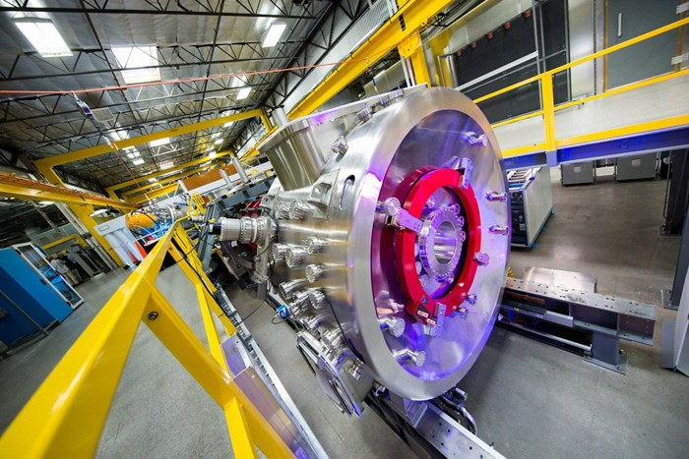

Result
Computation nuclear fuel ₆B₁₀H for different initial temperature Te(1) 7 18 18
Capsule volume=1.4*10⁻⁴ cm³, 6B10H is liquid (not poisonous), specific mass 0.69 g/cm³. Initial temperature are Te(1)=1*10⁴, 2*10⁴, 3*10⁴ K.
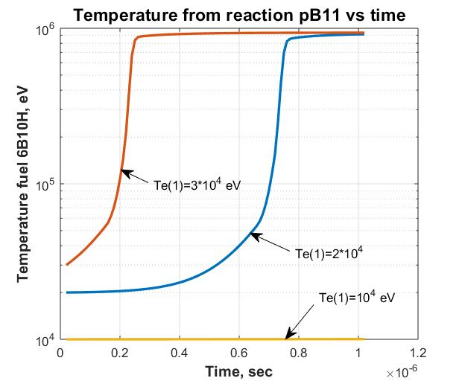
Fig.1. Temperature (eV) in capsule pB₁₁ vs time, for different the initial temperature.
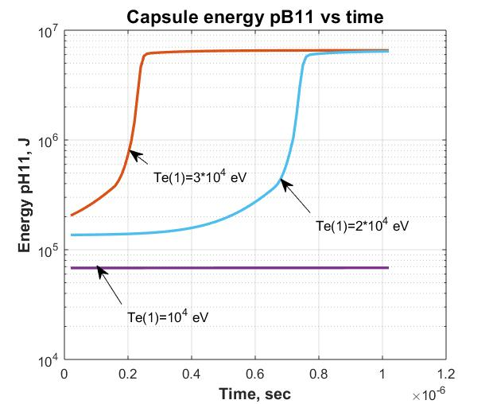
Fig.2. Energy (J) in capsule pB₁₁ vs time, for different the initial temperature.

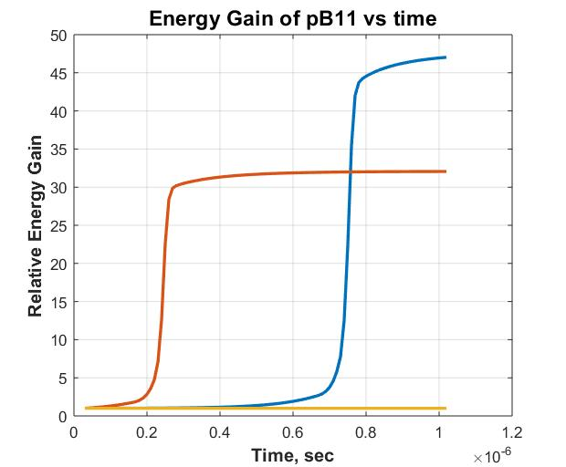
Fig.3. Energy Gain for different the initial temperature. Blue line (top) for Te(1)=2*10⁴ K,
Middle line for Te(1)=3*10⁴ K, low line for Te(1)=10⁴ K.
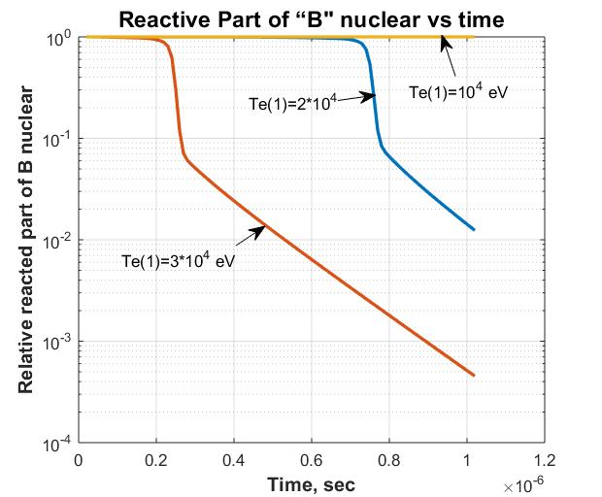
Fig.4. Relative reacted part of B nuclear vs. time.
=========================================================
Program and Fuel D+He3
Program
% Reaction fuel DHe3 with Brake radiation 3 7 18
clear all

% Initial Data
n=100; % Number of steps
Di=3*(10^(-7)); % Distance of integration, sec
dt=Di/n; % step, sec
to=2*(10^(-8)); % Initial time, sec
v=1.4*(10^(-4)); % Volume of capcule, cm3
t(1)=2*(10^(-8)); % Initial time,sec
tt(1)=2*(10^(-8)); % Initial time,sec

%Data of fuel D+He3
Z=2; %Efficiency brake ratiation DHe3
K=1; %Initial Relative part of particles is ready reaction (Reactive Part)
Etf=18.4*(10^6); %Total energy of D+He3 reaction the one pair , eV
Ekf=18.4*(10^6); % Energy heating the capcule the one pair, eV
Kk=Ekf/Etf; % relative coefficient (loss neutrons)
Te(1)=2*(10^4); %Initial temperature, eV
%Teb(1)=2*(10^4); %Initial temperature with brake, eV
gamma=9*(10^(-5)); % Specific weight of hydrogen (gas) at 1 atm, g/cm3
mu=5; %relative mass of micture mu=3+2
mp=1.67*(10^(-27)); %nuclon mass, kg
p=1200; %Pressure in capsule, atm
N1(1)=2*(10^(-3))*gamma*p/(mu*mp); % Total number nucleo DHe3 in 1 cm3
Ke=1.5; %Number electrons in one paricle.
N1e=Ke*N1(1); %Number of electrons in 1 cm3.
N1r(1)=N1(1)*K; %Initial namber of reactive particles in 1 cm3
Nv=N1(1)*v; % Common number particles into capsule. Consider the leaving neutron.
Nr(1)=N1(1)*v*K; %Initial number of reative particles into capcule
Ev(1)=7.23*(10^3); % Initial Reaction energy, J
Ek(1)=7.23*(10^3); % Initial RE into capsule, J
Eb(1)=7.23*(10^3); % Initial RE into capsule, J
Nvr(1)=0.; % Initial relatived part of partocles.
Nvrr(1)=0.; %initial procent reacted fuel
Pbr(1)=1.69*(10^(-32))*(N1e^2)*(Te(1)^0.5)*Z; %Power of brake radiation of 1 cm3
dEb(1)=Pbr(1)*v*dt; %Incriment brake energy in capsule J.
Teb(1)=0.625*(10^19)*Eb(1)/Nv; %Iniial energy into capsule from brake, eV

%Reaction Rate (Extentioned up 10 MeV)
x = [1000. 2000. 5000. 10000. 20000. 50000. 100000. 200000. ...
500000. 1000000. 10000000.]; % Temperature, eV
ydd = [1.5*(10^(-22)) 5.4*(10^(-21)) 1.8*(10^(-19)) ...
1.2*(10^(-18)) 5.2*(10^(-18)) 2.1*(10^(-17)) 4.5*(10^(-17)) ...
8.8*(10^(-17)) 1.8*(10^(-16)) 2.2*(10^(-16)) 10^(-16)]; % for D+D
ydt = [5.5*(10^(-21)) 2.6*(10^(-19)) 1.3*(10^(-17)) ...
1.1*(10^(-16)) 4.2*(10^(-16)) 8.7*(10^(-16)) 8.5*(10^(-16)) ...
6.3*(10^(-16)) 3.7*(10^(-16)) 2.7*(10^(-16)) 10^(-16)]; % for D+T
ytt = [1.3*(10^(-21)) 7.1*(10^(-21)) 1.4*(10^(-19)) ...
7.1*(10^(-19)) 2.5*(10^(-18)) 8.7*(10^(-18)) 1.9*(10^(-17)) ...
4.2*(10^(-17)) 8.4*(10^(-17)) 8.0*(10^(-17)) 10^(-16)]; % for T+T
ydhe3 = [1*(10^(-26)) 1.4*(10^(-23)) 6.7*(10^(-21)) 2.3*(10^(-19)) ...
3.8*(10^(-18)) 5.4*(10^(-17)) 1.6*(10^(-16)) ...
2.4*(10^(-16)) 2.3*(10^(-16)) 1.8*(10^(-16)) 10^(-16)]; % D+He3
ythe3= [1*(10^(-28)) 1*(10^(-25)) 2.1*(10^(-22)) 1.2*(10^(-20)) ...
2.6*(10^(-19)) 5.3*(10^(-18)) 7.7*(10^(-17)) ...
9.3*(10^(-17)) 2.9*(10^(-16)) 5.2*(10^(-16)) 10^(-16)]; % T+He3

RR(1)=interp1(x,ydhe3,Te(1)); % RR step 1

% Cycle of integration
for i=1:n
t(i+1)=t(i)+dt; %Time, sec.n+1
tt(i)= t(i)+dt; %Time, sec, n
RR(i+1)=interp1(x,ydhe3,Te(i)); % RR step 1
Pdt(i)=2.9*(10^(-12))*0.25*N1r(i)*N1r(i)*RR(i); %Power 1 cm3, W
dEdt(i)=Pdt(i)*dt; %Increament energy in 1cm3, J
dN1r(i)=dEdt(i)*2*0.625*(10^19)/Etf; %Increment reacted particles in eV
N1r(i+1)=N1r(i)-dN1r(i); % Rest of ready particles in 1cm3
Pv(i)=Pdt(i)*v*K; %Power,W in capsule
dEv(i)=Pdt(i)*v*K*dt; %Increament of Energy in capsule of volume v. J
Ev(i+1)=Ev(i)+dEv(i); % Total Reaction Energy in capsule, J
Ek(i+1)=Ek(i)+dEv(i)*Kk; %Reaction energy into capsule, J
dT(i)=0.625*(10^19)*dEv(i)/Nv; %Incriment energy into capsule, eV
Te(i+1)=Te(i)+dT(i); % Temperature into capsule, eV

%Computatin number of reaction particles
dNrr(i+1)=dEv(i)*Nv/Etf; %Relative number of particles take part into reaction
Nvr(i+1)=Nvr(i)+dNrr(i); %Total relative reactived particles
Nvrr(i+1)=Nvr(i)/Nr(1); %Proncentage of reacted fuel

%Computation of brake radiation
Pbr(i)=1.69*(10^(-32))*(N1e^2)*(Te(i)^0.5)*Z; %Power of brake radiation of 1 cm3
dEb(i+1)=Pbr(i)*v*dt; %Incriment brake energy in capsule, J
Eb(i+1)=Eb(i)+dEb(i); %Brake Energy in capsule,J
%dTb(i)=0.625*(10^19)*dEb(i)/Nv; %Incriment energy into capsule, eV
%Teb(i+1)=Teb(i)+dTb(i); % Temperature into capsule, eV

end
Te(1)

figure (1) % Temperature from capsule DHe3
hnd1=plot(t,Te);
set (hnd1, 'linewidth',2);
t1=xlabel ('Time, sec');
set (t1,'Fontsize',12);
set (t1, 'Fontweight', 'bold');
t2=ylabel ('Temperature, eV');
set (t2,'Fontsize',12);
set (t2, 'Fontweight', 'bold');
t3= title ('Temperature from reaction DHe3 vs time');
set (t3, 'Fontsize', 14);
set (t3, 'Fontweight', 'bold');
grid on
hold on

figure (2); % Temonuclear energy DHe3
hnd2=plot(t,Ev,t,Ek,'--');
set (hnd2, 'linewidth',2);
t1=xlabel ('Time, sec');
set (t1,'Fontsize',12);
set (t1, 'Fontweight', 'bold');
t2=ylabel ('Energy, J');
set (t2,'Fontsize',12);
set (t2, 'Fontweight', 'bold');
t3= title ('Total and capsule energy DHe3 vs time');
set (t3, 'Fontsize', 14);
set (t3, 'Fontweight', 'bold');
grid on
hold on

figure (3); % Relatived number DHe3 of reacted particles
hnd3=plot(t,Nvr);
set (hnd3, 'linewidth',2);
t1=xlabel ('Time, sec');
set (t1,'Fontsize',12);
set (t1, 'Fontweight', 'bold');
t2=ylabel ('Reacted part of DTHe3 Particles');
set (t2,'Fontsize',12);
set (t2, 'Fontweight', 'bold');
t3= title ('Reactived Part of DHe3 particles vs time');
set (t3, 'Fontsize', 14);
set (t3, 'Fontweight', 'bold');
grid on
hold on

figure (4); % reaction rate DHe3
hnd4=plot(t,RR);
set (hnd4, 'linewidth',2);
t1=xlabel ('Time, sec');
set (t1,'Fontsize',12);
set (t1, 'Fontweight', 'bold');
t2=ylabel ('Reaction rate DHe3, sm3/sec');
set (t2,'Fontsize',12);
set (t2, 'Fontweight', 'bold');
t3= title ('Reaction Rate DHe3 vs time');
set (t3, 'Fontsize', 14);
set (t3, 'Fontweight', 'bold');
grid on
hold on

figure (5); % Power of termoreaction DHe3
hnd5=plot(tt,Pv);
set (hnd5, 'linewidth',2);
t1=xlabel ('Time, sec');
set (t1,'Fontsize',12);
set (t1, 'Fontweight', 'bold');
t2=ylabel ('Power, W');
set (t2,'Fontsize',12);
set (t2, 'Fontweight', 'bold');
t3= title ('Power DHe3 vs time');
set (t3, 'Fontsize', 14);
set (t3, 'Fontweight', 'bold');
grid on
hold on

figure (6); % Procentage DHe3 of reacted particles
hnd6=plot(t,Nvrr);
set (hnd6, 'linewidth',2);
t1=xlabel ('Time, sec');
set (t1,'Fontsize',12);
set (t1, 'Fontweight', 'bold');
t2=ylabel ('% DHe3 reacted Particles');
set (t2,'Fontsize',12);
set (t2, 'Fontweight', 'bold');
t3= title ('% reacted particles DHe3 vs time');
set (t3, 'Fontsize', 12);
set (t3, 'Fontweight', 'bold');
grid on
hold on

figure (7) %Heat= Brake Power in capsule DHe3
hnd7=plot(tt,Pdt, tt,Pbr,'--');
set (hnd7, 'linewidth',2);
t1=xlabel ('Time, sec');
set (t1,'Fontsize',12);
set (t1, 'Fontweight', 'bold');
t2=ylabel ('Power. W/sm3');
set (t2,'Fontsize',12);
set (t2, 'Fontweight', 'bold');
t3= title ('Heat-Brake Power DHe3 vs time');
set (t3, 'Fontsize', 12);
set (t3, 'Fontweight', 'bold');
grid on
hold on
---------------------------------------
Result D+He3 (gas)(no neutrino)
Result computation DHe3 3 9 18
Fig.1. Temperature from reaction D+He₃ vs time.

Fig.2.Total and capsule energy particles DHe₃ for different
initial pressure vs. time vs.time.
Fig.3. Prosent reacted particles DHe₃ for different initial
pressure vs. time
Fig.4. Head-Brake Power particles DHe₃ for different initial
pressure vs. time
=================================================
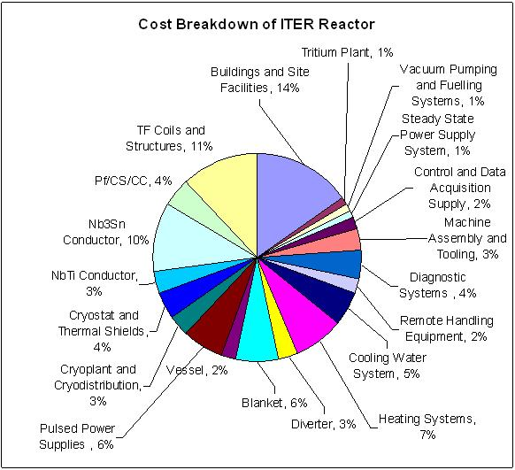
Part 3. Capacitor
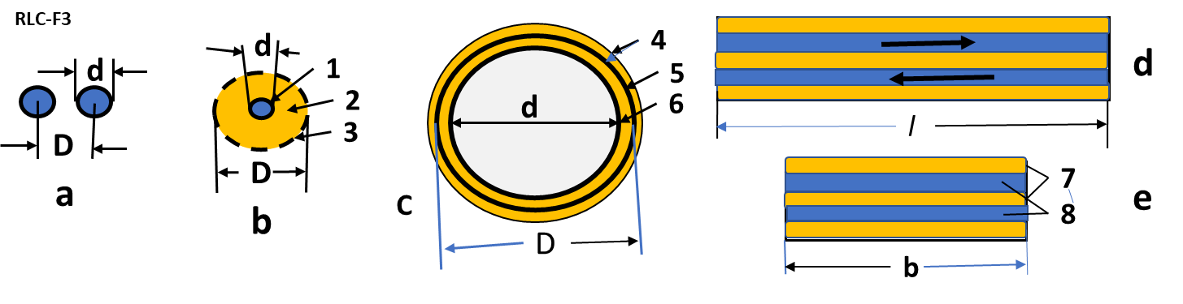
Fig. 2. Cross-sections of conductors for the delivery of electrical energy to the consumer.
Legend: a - two round conductor, located alongside; b - coaxial cable: 1 - center wire, 2 – insulator, 3 - surface wire (fly-through); с - coaxial cylinders: 4 - insulator, 5 - outer cylinder, 6 - inner cylinder; e, d - two lanes located one above the other at the minimum distance: 7 – insulator, 8 - conductive strips, l - long strip, b - strip width.
The author proposes the other two configurations with low inductance (Fig. 2c). One of them is two isolated conductive cylinders located one in another. The other is two molded conductive strips, one above the other. With the right construction, both solutions (c, d) give better results on inductance than the known solutions (a, b).
Reducing the electrical resistance of a system (without a capsule) can be done quite simply - by increasing the cross sections of the conductors. This requires the creation of new capacitors. Powerful capacitors with low inductance are also not produced even by US factories, since before they were not required by industry. Manufacturers can only offer a parallel connection of capacitors, which reduces the inductance of a capacitor bank (reduces the magnetic field energy by reducing the current in individual capacitors when connected in parallel), but increases the inductance of external connections.
Estimates show that the required power capacitor can measure 1.1 × 1.1 × 1.6 m and weigh about 2.5 tons.
Note that the abandonment of huge, very expensive LTD structures and their replacement with capacitors with the correct design can reduce the cost of installing energy delivery to a nuclear capsule by a factor of about a thousand.
Designing a capsule for such a reactor is also not an easy task. This is not Ohm's task. Plasma resistance is strongly dependent on its temperature. The voltage applied to it causes the collective acceleration of separately positive and negative particles in opposite directions. They freely pass between them and strike the electrodes by heating them, causing X-ray and bremsstrahlung. This task will be considered by the author in other papers.
The theory of the proposed energy transfer.
The theory of radar (discharge of a capacitor) is used for the calculation with the difference that the electrical resistance is variable, since the specific electrical resistance of the plasma is very dependent on its temperature, and the temperature strictly depends on the energy received.
The electrical circuit for discharging a capacitor is shown in Fig. 3. Please note that for our design of the capsule L and R1 we consider constant, R2 is the resistance of the capsule variable, and the inductance of the capsule is so small that it can be neglected.
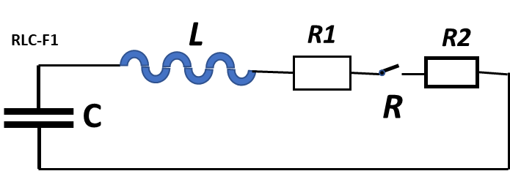
Fig.3. The schematic diagram of our installation. Notation: C is capacitor, L is Internal inductance of capacitor and external wiring; R1 is
to deliver 30 kJ of energy to the capsule fuel from 50 kJ of energy, that is in the capacitor, ASAP (< 4x10⁻⁷ sec). Otherwise, the capsule will have time to explode, expand, and the ignition of thermonuclear fuel will not occur.
The schematic diagram of our installation is sown in Fig. 3.
A typical curve for charging and discharging a capacitor is shown in Fig.4.
We are satisfied with the data:
Charge time about 10 min (now) and 1 sec (in future).
Hold time about 1 - 5 min.
Discharge Time 4x10⁻⁷ sec.
Ringing Period – any now.
Voltage Reversal <10 ÷ 20%.
Author offer new innovation design of the capacitor which allow to get the need requirements and alloy to have any single impulse of the electric current.
He reaches these by:
1) The opposed closed currents which create the opposed magnetic fields. These
fields neutralize each other and spend little energy on their creation. These
made in main sheets and all wiles.
2) All wires are made in the form of wide strips with the opposite direction of the
currents and with a minimum distance between them.
3) The capacitor is divided into the maximum number of individual parallel films/plates with
alternating current directions.
4) Special low-ohm strip contacts of the thin films to the main plates with the main wiring are
made.
5) Wiring has a small equal resistance everywhere except for two cuts and the contact area
of ​​the plates in the output wire.
6) The mass and thickness of the plates of wires is sufficiently for the permissible heating.
Conventional capacitors are made of a long-insulated tape rolled into a roll (Fig. 7a).
The proposed capacitor is made from a set of insulated thin plates/films. These plates have a special arrangement and a separate connection with special central leads/sheets.
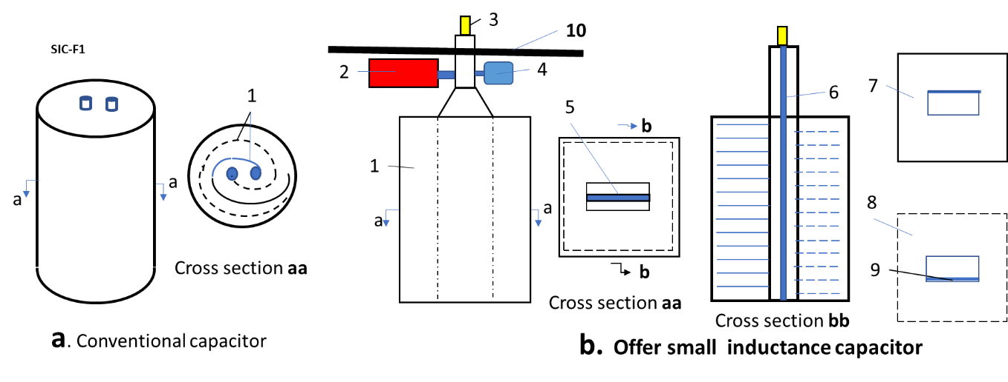
Fig.7. Conventional and offered capacitor. Notifications: a – conventional capacitor. 1- a long insulated tape rolled into a roll; b - proposed small inductance capacitor. Capacitor is made from a set of insulated thin plates: 1 – capacitor, 2 –high voltage switch, 3 – connection to variable object, 4 – charger, 5 – insulator between main exit/enter plates; 6 – insulator of the main plate; 7 – the first thin film, 8 – the second thin film, connection film, 9 – the second thin film, 10 – steel plate (10 mm), which separate the capacitor, high voltage switch and charger from an explosive area.
Estimation. Example of the proposed Installation
Recommended (computed) sizes, thickness and material (electric engineers and designers can offer the better):
Voltage U = 100 kV, capacity C =10⁻⁸ F, energy E = 50 kJ, discharge time t <4x10⁻⁷ sec.
Offered material:
1) Electric copper for the thin film and main plate. Data: specific electric resistance ρ =1.7x10⁻⁶ Ohm.cm; specific mass γ = 8.91 gr/cm³; Heat capacity Cp =1.99 kJ/kg·K.
2) Isolator PTFE. Teflon (C₂F₄)_{n}: dielectric strength (1 MHz) 60 ÷ 173 MV/m; ε = 2.1; specific electric resistance ρ =1x10²³ ÷ 1x10²⁵ Ohm·m; specific mass γ = 2200 kg/m³; yield strength 23 MPa, melting temperature is 327ºC.
Computed parameters (see theory and computation in given article Bolonkin A.A., Low Inductive and Resistance Energy Capacitor): Inductive of installation is <2×10-8 Hz, resistance <10⁻⁴ Ohm, discharge time about <4x10⁻⁷ sec, heating of object is about 10 keV.
Requested area of thin film for capacitor is:
S=$\frac{Cd}{ε_{o}ε}$=215 sq.m, (23)
where S – area of capacitor, m²; C = 10⁻⁵– capacity of capacior, F; d = 4 mm – thickness of isolator, m; ε_{o}= 8.85x10⁻¹¹ F/m – electric constant; ε = 2.1 – dielectric constant of Teflon.
This area requests about 215 thin copper film/foil 105x105 cm (or 430 copper film 57.5x 105 cm) and > 216 the 110x110 cm sheets of Teflon having the thickness 4 mm.
Size (option) of the capacitor/installation box is about 120x120x120 cm. Mass is about 3.5 tons. Average R2$≈5×10e-3 Ohm.$ (R2 < 5·10⁻³ Ω).
Let us estimate the thickness of the coper thin film/foil and main plate.
If we take the cross section area of internal wires 20 sq.cm and width of main sheet is 50 cm, then thickness if the thin film will be about 0.25 mm and main sheet is about 4 mm, the R1$≈0.0001 Ohm, L≈2×10e-8$ Hz (2·10⁻⁸), $time of "\text{shot"} ∆t=10e-6 sec.$ (<10⁻⁶). The heating of main sheets is about 0.2ºC after “shot”. Connection 3 (Fig.8) must be checkup in tensile stress because the strong impulse current will try disconnect them. That may reach hundreds kg.
1
b
2
c
C-1
C-2

3
4
6
6
500
12
4
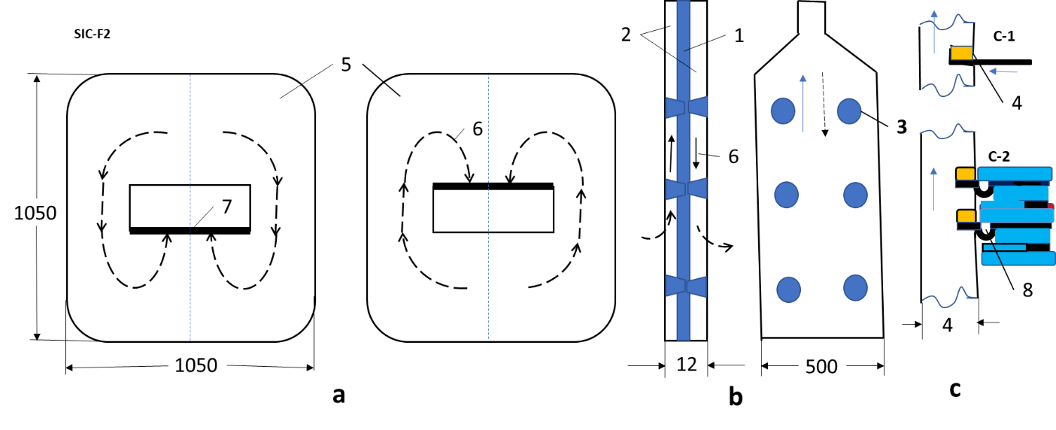
Fig.8. Direction of current in the first and second thin films (a) and main plates (b). (c) – connection the thin films to the main plates. Notification: 1 – insulator; 2 - insulator of the main plate, insulator between thin film/foil has form “a”; 3 – connection main plates by insulator; 4 (c1, c2) – connection (by copper) thin film and main plate; 5 – thin films; 6 – direction of current; 7 – connection thin film to main plate; 8 – compensation of the thin film.
Selected initial data are not optimal. Creative electric engineer can offer and recalculate the better version. I think the thin film 145x145 cm $≈2 sq.m$ decrease the capacitor height up 80 cm. Decreasing the Teflon thickness from 4 mm to 3 mm decreases the mass in 25%. Decreasing the wire cross section to 10 sq.cm decrease the foil thickness up 0.13$÷0.15$ mm. (Voids at the ends are filled with Teflon tape of the same thickness). Increasing of voltage can improve the main parameters of heating and time of “shot”. And so on.
Offered capacitor must be tested in a short circuit. Capacitor inductive and resistance must be measured.
Look also attention in the high voltage (100 kV) switch (and charger). Switch must work very fast (10⁻⁷ sec) and have a small resistance.
Some Results of Computations
Below some results of computation, the heating of thermonuclear fuel into capsule and influence of inductive and electric resistance are presented. Assume, the volume of capsule is constant in heating, the fuel is LiD – sold crystals, mass of fuel is about 0.0001 grams.
The Program and result of integration system differential equations (4)-(8) are below:
Program Capacitor
Program6 heating by capacitor having induction 11 2 18
% Heating6 (Discharging) by capacitor having induction. Fuel LiD
clear all
% Initial data
R1=0.0001; % resistance outer part cycle, Ohm
Te(1)=10; % Initial temperature of capsule, eV
Zc=2; % charge of LiD fuel Z=2, DD Z=1,TD Z-1, He3D Z=1.5, D2O Z=8/3
ro2(1)=0.1*Zc/(Te(1)^1.5); % Special resistance of capsule
L2=0.2; % length of capsule, cm
d2=0.03; % diameter of capsule, cm
s2=(pi/4)*(d2^2); % Cross section of capsule, cm2
v2=L2*s2; % Volume of capsule. cm3
%gamma=10^(-4); % specific weight of hydrogen H, gr/cm3
gamma=0.82; % specific weight of fuel LiD, gr/cm3
mu=8; % Number of nucleons of fuel LiD, DD mu=4, TD mu=5
N1=2*(10^(-3))*gamma/(mu*1.67*(10^(-27))); % Number of particles in 1 cm3
N=N1*v2; % Number of particles in capsule
R2(1)=ro2(1)*0.25*L2/s2; % Initial resistance of capsule, Ohm
R(1)=R1+R2(1); % Full initial resistance, Ohm
U(1)=1*(10^5); % Initial voltage of capacitor, V
I(1)=0; % Initial current, A
n=100; % Number of steps integration
Di=10^(-6); % Distance of integration, sec
dt=Di/n; % Step of integration, sec
t(1)=0.; % time, sec
C=10*(10^(-6)); % capacity of capacitor, Farads
q(1)=U(1)*C; % Initial charge, C
dq(1)=I(1)*dt; % Step charge, C
Ec(1)=0.5*C*(U(1)^2); % initial Energy of capacitor, J
Ek(1)=0.; % Initial energy into capsule, J
ER1(1)=0.; % Initial energy in R1 , J
ER2(1)=0.; % Initial energy in R2, J
LL=2*10^(-8); % Induction Henry,

% Cycle of integration
for i=1:n
t(i+1)=t(i)+dt; %Time, sec.n+1
tt(i)= t(i)+dt; %Time, sec, n
ro2(i)=0.1*Zc/(Te(i)^1.5); % Special resistance of capsule
R2(i)=ro2(i)*L2/s2; % resistance of capsule, Ohm
R(i)=R1+R2(i); % Full initial resistance, Ohm
dI(i)=-(R(i)*I(i)-U(i))*dt/LL; % Increment current, A
I(i+1)=I(i)+dI(i); % Current, A
dq(i)=I(i)*dt; % Increment of charge, C
q(i+1)=q(i)-dq(i); % Change of charge, C
U(i+1)=q(i)/C; % Voltage of capacitor
dEc(i)=I(i)*U(i)*dt; % Increment of energy from capacitor. J
Ec(i+1)=Ec(i)-dEc(i); %% Energy in capacitor, J
dEch(i)=R2(i)*I(i)*I(i)*dt; % Increment of capsule heating energy, J
Ek(i+1)=Ek(i)+dEch(i); % Energy into capsule, J
dEche(i)=dEch(i)*0.625*(10^19); %Increment of capsule heating energy, eV
dTf(i)= dEche(i)/N; %Increment of temperature one particles in capsule, eV
Te(i+1)=Te(i)+dTf(i); %Temperature of fuel from capacitor, eV
dER1(i)=R1*I(i)*I(i)*dt; % Increment Energy in resistance 1. J
ER1(i+1)=ER1(i)+dER1(i); %Energy in resistance R1. J
dER2(i)=R2(i)*I(i)*I(i)*dt; % Increment energy in resistance 2. J
ER2(i+1)=ER2(i)+dER2(i); %Energy in resistance R2. J
end

figure (1) % Temperature in capsule LiD
hnd1=plot(t,Te);
set (hnd1, 'linewidth',2);
t1=xlabel ('Time, sec');
set (t1,'Fontsize',12);
set (t1, 'Fontweight', 'bold');
t2=ylabel ('Temperature, eV');
set (t2,'Fontsize',12);
set (t2, 'Fontweight', 'bold');
t3= title ('Temperature LiD from capacitor vs time');
set (t3, 'Fontsize', 14);
set (t3, 'Fontweight', 'bold');
grid on
hold on

figure (2); % Voltage of capacitor
hnd2=plot(t,U);
set (hnd2, 'linewidth',2);
t1=xlabel ('Time, sec');
set (t1,'Fontsize',12);
set (t1, 'Fontweight', 'bold');
t2=ylabel ('Voltage, V');
set (t2,'Fontsize',12);
set (t2, 'Fontweight', 'bold');
t3= title ('LiD, Voltage of capacitor vs time');
set (t3, 'Fontsize', 14);
set (t3, 'Fontweight', 'bold');
grid on
hold on

figure (3); % Current from capacitor
hnd3=plot(t,I);
set (hnd3, 'linewidth',2);
t1=xlabel ('Time, sec');
set (t1,'Fontsize',12);
set (t1, 'Fontweight', 'bold');
t2=ylabel ('Electric current, A');
set (t2,'Fontsize',12);
set (t2, 'Fontweight', 'bold');
t3= title ('LiD, Current vs time');
set (t3, 'Fontsize', 14);
set (t3, 'Fontweight', 'bold');
grid on
hold on

figure (4); % Energy in capsule (--) and in capacitor
hnd4=plot(t,Ek,'--',t,Ec);
set (hnd4, 'linewidth',2);
t1=xlabel ('Time, sec');
set (t1,'Fontsize',12);
set (t1, 'Fontweight', 'bold');
t2=ylabel ('Energy, J');
set (t2,'Fontsize',12);
set (t2, 'Fontweight', 'bold');
t3= title ('LiD, Energy in capsule(--) and in capacitor vs time');
set (t3, 'Fontsize', 11);
set (t3, 'Fontweight', 'bold');
grid on
hold on

figure (5); % Charge in capacitor
hnd5=plot(t,q);
set (hnd5, 'linewidth',2);
t1=xlabel ('Time, sec');
set (t1,'Fontsize',12);
set (t1, 'Fontweight', 'bold');
t2=ylabel ('Charge of capacitor, C');
set (t2,'Fontsize',12);
set (t2, 'Fontweight', 'bold');
t3= title ('LiD, Charge of capacitor, vs time, C');
set (t3, 'Fontsize', 14);
set (t3, 'Fontweight', 'bold');
grid on
hold on

figure (6); % Energy is lost in Resistance R1,R2 J
hnd6=plot(t,ER2, t,ER1,'--');
set (hnd6, 'linewidth',2);
t1=xlabel ('Time, sec');
set (t1,'Fontsize',12);
set (t1, 'Fontweight', 'bold');
t2=ylabel ('Energy in Resistance R1(--), R2, J');
set (t2,'Fontsize',12);
set (t2, 'Fontweight', 'bold');
t3= title ('LiD, Energy in R1(--), R2 vs time');
set (t3, 'Fontsize', 14);
set (t3, 'Fontweight', 'bold');
grid on
hold on
------------------------------------------------------------
Result
Result discharging U=100 kV R1 =3.5e-5, R1=10e-5 3 18 18
Figs.1-5. Result computation the discharging vs time of capacitor having U(0)=100kV, capacity C=20*10⁻⁶ F, outer resistance R1=(3.5 – 10)e-5 Ohm (e-5=10⁻⁵), fuel -LiD, mass of fuel 10⁻⁷ kg., capsule about 0.3x2 mm. L=0.
Fig.1.
Fig.2.
Fig.3.
Fig.4.
Fig. 5.
---------------------------------------------------------------------------------
Some Results of Computations for different initial data.
Below some results of computation, the heating of thermonuclear fuel into capsule and influence of inductive and electric resistance are presented. Assume, the volume of capsule is constant in heating, the fuel is LiD – solid crystals, mass of fuel is about 0.0001 grams.
The result of integration system differential equations (4)-(8) are below:
The result of integration system differential equations (4)-(8) are below:
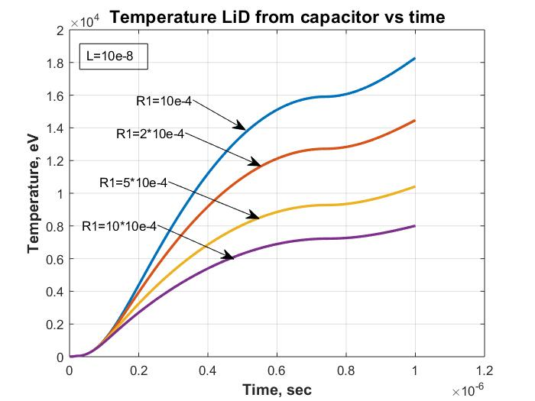
Fig.6. Temperature into capsule vs time from capacitor having C=20 µF, V(0)=100 kV for induction
10⁻⁸H and different outer resistance R₁ =10⁻⁴ – 10⁻³ Ohm.
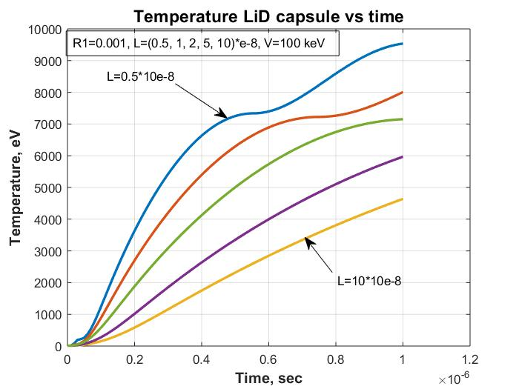
Fig.7. Temperature into capsule vs time from capacitor having 20 µF, V(0)=100 kV for resistance
R₁ = 0.001 Ohm. and different induction L = (0.5 ÷ 10).10⁻⁸ H .
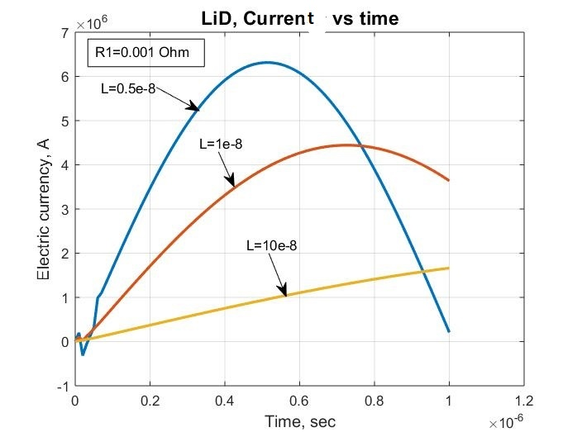
Fig.8. Electric current vs time from capacitor having C = 20 µF, V(0)=100 kV for resistance R₁ =0.001
Ohm. and different induction L = (0.5 ÷ 10).10⁻⁸ F.
Fig.9. Peak of capacitor current vs time for initial voltage U(0)=100 kV and 200 kV. Capacity
is C = 20.10⁻⁶ Farad. R1= 0, L= 0, R2(t)= 0.1·Z/T(t)^{-3/2}.
Fig.9 shows, the heat time may be decreased the maximum up 0.5x10⁻⁸ sec, if we decrease the inductive up zero.
References
1. Bolonkin A.A., Small non-Expensive Electric Inecial Thermonuclear Reactors (v2), USA, Lulu, 2019. 200 ps.
2. Bolonkin A.A., Femtotechnologies and Innovative Projects, USA, Lulu, 2011, p.140.
3. Кошкин Н.И., Ширкевич М.Г., Справочник по элементарной физике, Москва, Наука, 1982.
Koshkin N.I., Shirkevich M.G., Handbook of elementary physics, Moscow, Science, 1982.
4. Калашников С.Г., Электричество. Москва, Наука, 1985.
Kalashnikov C.G., Electricity, Moscow, Nauka, 1985.
5. Wikipedia, Inertial Thermonuclear Reactor.
20 November 2018
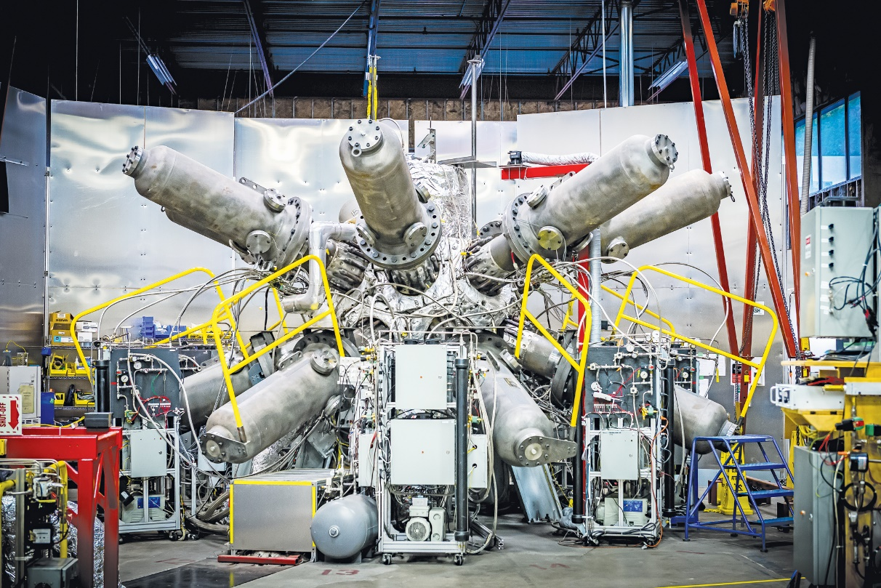

Short biography of Bolonkin, Alexander Alexandrovich
Alexander A. Bolonkin was born in the former USSR. He holds doctoral degree in aviation engineering from Moscow Aviation Institute and a post-doctoral degree in aerospace engineering from Leningrad Polytechnic University. He has held the positions of senior engineer in the Antonov Aircraft Design Company and Chairman of the Reliability Department in the Clushko Rocket Design Company. He has also lectured at the Moscow Aviation Universities. Following his arrival in the United States in 1988, he lectured at the New Jersey Institute of Technology and worked as a Senior Scientist at NASA and the US Air Force Research Laboratories.
Bolonkin is the author of more than 250 scientific articles and books and has 17 inventions to his credit. His most notable books include The Development of Soviet Rocket Engines (Delphic Ass., Inc., Washington , 1991); Non-Rocket Space Launch and Flight (Elsevier, 2006); New Concepts, Ideas, Innovation in Aerospace, Technology and Human Life (USA, NOVA, 2007); Macro-Projects: Environment and Technology (NOVA, 2008); Human Immortality and Electronic Civilization, 3-rd Edition, (Lulu, 2007; Publish America, 2010):Life and Science. Lambert Academic Publishing, Germany, 2011, 205 pgs. ISBN: 978-3-8473-0839-3. http://www.archive.org/details/Life.Science.Future.biographyNotesResearchesAndInnovations; Femto technology and Revolutionary {rojectsts, Lambert, 2011, p.530; New Methods of Optimization and their Application, Moscow High Technical University named Bauman (in Russian: Новые Методы Оптимизации и их применение. МВТУим. Баумана, 1972г., 220 стр). List and links of some Bolonkin’s publications: https://archive.org/details/List5.3s8518.
Homepage: http://Bolonkin.narod.ru. https://en.wikipedia.org/wiki/Alexander_Bolonkin

