Article Thermonuclear Electric Generator 10 19 19
Impulse Thermonuclear Electric Generator
C&R, Alexander Bolonkin <abolonkin@gmail.com>
Abstract
The article offers a small pulsed electric thermonuclear generator, which converts the energy of thermonuclear microexplosion directly into electrical energy of high voltage. It is the most convenient, economical and perspective method of direct conversion of thermonuclear energy. Unlike the conventional thermal cycle, electrical energy can be transmitted over long distances and easily converted to any other type of energy. The method is based on the separation of negative and positively charged particles of thermonuclear reaction (electrons and nuclei) and conversion of kinetic energy of nuclei into electrical voltage. In other works, the author used this method to create electric motors (propulsion systems), pumps, and direct energy production from weakly ionized plasma.
Introduction
Thermonuclear reactions were theoretically discovered almost a hundred years ago (in 1920). And since then, scientists have been thinking about how to implement and use them. These attempts have been especially intense in recent decades (since 1970). Experimental reactors have been built in many countries, but scientists have failed to carry out useful thermonuclear reactions even stably, despite the investments of billions of dollars and decades of work of large teams. Even optimists require additional billions and at least 10 years of work to create a huge facility, which is impossible to use even on a large ship and which (as preliminary estimates [1] Ch.12 show) will produce energy at a much higher cost than modern conventional power plants. This was because from the very beginning the wrong standard path was chosen. And standard-minded leaders continue to stubbornly (for their own good) storm the mountain, instead of seeing that it has a huge height, to look for ways to bypass it.
A brief history of attempts to build a thermonuclear reactor.
As it is well-known the thermonuclear reaction occurs when Lawson criterion
L = nTτ >c,
where n is matter (fuel) density, [1/m³]; T is temperature, [KeV], 1 eV = 1.16×10⁴ K; τ is reaction time, [s]; c is constant for given nuclear fuel. For tritium-deuterium fuel (T + D) c ≈ 10²⁰ ÷10²¹ in CI units. The current Inertial Confinement Fusion (ICF) uses the laser compression method (high matter density n), low temperature T and low reaction time τ. With a compression by 10³, the compressed density will be 200 g/cm³ (T+D), and the compressed radius can be as small as 0.05 mm. For this density (n = 4.8.10³¹ m⁻³ ) and τ = 10⁻⁹ s the Lawson criterion gives a low temperature, which is very few for nuclear reaction. But laser ICF cannot reach this temperature. Trying to warm up the fuel capsule by additional X-rays and other particles have been unsuccessful.
The other method of the current thermonuclear reaction is Magnetic Confinement Fusion (MCF). It uses the other idea – high time reaction (τ = seconds, up minutes) and low plasma density (n = 10²¹m⁻³) and low temperature. That method has a lot of technical problems, is very expensive and also not reaches the stable ignition.
Both current main methods (ICF and MCF) are developed more 60 years by the thousands scientists in all main countries. The governments spent the billions of dollars for their R&D (Research and Development) and are spending hundreds of millions of dollars every year. But optimist sciences only promise to reach the useful stable nuclear reaction throw 10 – 15 years (after 2016) and build the industrial electric station after the additional 5 – 10 years. The other scientists show: the price of the nuclear energy used tritium fuel (main fuel for current reactors is T+D) will be cost ten times more than in present electric stations using the natural fuel (tritium costs 30,000 $/gram, trend up 100,000 $/gr) [1] Ch. 12.
The Lawson criterion is based on the assumption that the reaction energy is equal to or exceeds the ignition energy. However, practice has shown that it can be valid only within the narrow limits of the specified values and under severe external conditions, which are practically not observed. Therefore, scientists began to say that in practice it should be hundreds of times higher.

Brief Information and history about Current Thermonuclear Reactors,
Fusion power is useful energy generated by nuclear fusion reactions. In this kind of reaction two light atomic nuclei fuse together to form a heavier nucleus and release energy. The largest current nuclear fusion experiment, NOVA, JET, has resulted in fusion power production somewhat larger than the power put into the plasma, maintained for a few seconds. In June 2005, the construction of the experimental reactor ITER, designed to produce several times more fusion power than the power into it generating the plasma over many minutes, was announced. The unrealized production of net electrical power from fusion machines is planned for the next generation experiment after R&D ITER.
Unfortunately, this task is not easy, as scientists thought early on. Fusion reactions require a very large amount of energy to initiate in order to overcome the so-called Coulomb barrier or fusion barrier energy. The key to practical fusion power is to select a fuel that requires the minimum amount of energy to start, that is, the lowest barrier energy. The best fuel from this standpoint is a one-to-one mix of deuterium and tritium; both are heavy isotopes of hydrogen. The D-T (Deuterium and Tritium) mix has suitable low barrier energy. In order to create the required conditions, the fuel must be heated to tens of millions of degrees, and/or compressed to immense pressures.
At present, D-T is used by two main methods of fusion: inertial confinement fusion (ICF) and magnetic confinement fusion (MCF)--for example, tokomak device.
In inertial confinement fusion (ICF), nuclear fusion reactions are initiated by heating and compressing a target. The target is a pellet that most often contains deuterium and tritium (often only micro or milligrams). Intense focused laser or ion beams are used for compression of pellets. The beams explosively detonate the outer material layers of the target pellet. That accelerates the underlying target layers inward, sending a shockwave into the center of each pellet’s mass. If the shockwave is powerful enough, and if high enough density at the center is achieved, some of the fuel will be heated enough to cause pellet fusion reactions. In a target which has been heated and compressed to the point of thermonuclear ignition, energy can then heat surrounding fuel to cause it to fuse as well, potentially releasing tremendous amounts of energy.
The thermonuclear reaction depends from production three magnitudes: density (compression of fuel), temperature and time. At present time the scientists use two main methods for attempts to reach efficiency thermonuclear: Inertial Confinement Fusion (ICF) and Magnetic Confinement Fusion (MCF). In ICF the scientists use the high compression (by laser beam), but low time, in MCF they use low compression, but long time.
Laser method. Disadvantages. Thermonuclear reactors and, in particular, Laser methods are having been under development for about 60 years. Governments have already spent tens billions of US dollars, but it is not yet seen as an industrial application of thermonuclear energy for the coming 10-15 years. The laser has very low efficiency (2- 3%), high-pressure acts is every shot time (10⁻⁹– 10⁻¹⁰ s), enough energy is not delivered to the center of the spherical fuel pellet (low temperature), there are many future problems the radioactivity and converting the thermonuclear energy into useful energy.
Data of same current inertial laser installations:
1. NOVA uses laser NIF (USA), has 192 beams, impulse energy up 120 kJ. One reach density
20 g/cm³, speed of cover is up 300 km/s. NIF has failed to reach ignition and is, as of 2013,
generating about 1/3rd of the required energy levels. NIF cost is about $3.5B.
2. YiPER (EU) has impulse energy up 70 kJ.
2. OMEGA (USA) has impulse energy up 60 kJ.
3. Gekko-XII (Japan) has impulse energy up 20 kJ. One reaches density 120 g/cm³.
4. Febus (France) has impulse energy up 20 kJ.
5. Iskra-5 (Russia) has impulse energy up 30 kJ.
There are some important projects. But they do not reach success.
Computation of author shown: for IGNITION the thermonuclear reaction in ICF we need the minimum temperature T = 10 keV, density n ~ 2.4x10²⁹ [1/m³] (fuel in solid condition), and time τ = 10⁻⁶ sec. This gives the Lawson criterion L = 2.4x10²⁴ in thousand times more. Lawson criterium is wrong.
For heating the one milligram fuel (10⁻³ gr) to temperature 10 keV we need 2x10⁶ J energy; for 10⁻⁴ gr, we need 200 kJ. This is in 3 – 10 – 100 times more than any modern ICF gives.
But the most important thing is that this energy is wasted on fuel compression. Compression increases the temperature very little. For example, adiabatic compression by 200 times (i.e. compression by 200 times without heat supply and removal) increases the temperature by only 3 - 8 times. That is, if the fuel had a room temperature of 288 K, its temperature will be about 1500 K. This is a miser. Recall that the mixture of tritium + deuterium to increase the density cooled down to almost absolute zero (2 K), the temperature of the mixture after compression will be 200 times only 16 K.
In laser inertial thermonuclear reactors, the supplied energy is wasted on evaporation of the capsule shell. Most thermonuclear reactors use tritium as fuel because tritium has the lowest ignition temperature. But tritium emits 80% of its energy in the form of neutrons, which produce radioactive isotopes. In addition, tritium is so expensive that the cost of energy from it is 10 times more expensive than fossil fuel energy.
Surprisingly, such a mass of scientists and managers, afraid of losing their jobs, could not make simple estimates and spent billions of people's money on inefficient, expensive installations that have many present and future problems [1]. What is the statement of the head of the Soviet delegation at the International Conference on ICF in London in the second half of the 20 centuries: the more we spend thermonuclear fuel (tritium), the more we will receive it!
Let's briefly list the difficult problems that will inevitably arise in the future, even if the problem of laser ignition of tritium fuel is solved:
1) The huge cost of tritium. It will be necessary to build special plants for the production of tritium.
2) Problems with the use of tritium, as liquid or solid tritium has cryogenic temperatures. For example, military missiles have completely abandoned the most efficient rocket fuel for liquid oxygen and liquid hydrogen only for this reason.
3) The problem of converting thermonuclear energy into electrical energy will require the construction of special expensive facilities.
4) Problems of radioactive waste.
5) Problems of huge and expensive thermonuclear facilities and difficulties of their direct use in transport.
At present, these problems are almost ignored. All efforts are focused on the main but local problem - to achieve a stable thermonuclear reaction, the energy of which would exceed the ignition energy.
The author's solutions offer to reduce the listed problems and according to his estimates to allow to solve many problems.
Features of the offered electric generator ICF. Advantages and possible problems.
The main feature of the proposed thermonuclear reactor is that instead of heating with a huge laser shell of fuel capsule, we directly heat the thermonuclear fuel with an electric pulse. That is, instead of the compression method, we use the method of direct heating with electricity. This is not as easy as it may seem at first glance. First, the pulse must be powerful to heat the fuel to a thermonuclear ignition temperature (one hundred million degrees). Second, the plasma density should be sufficient. And third, the burning time (plasma density and high temperature) should be no more than a millionth of a second.
To solve these problems, the author proposed (and confirmed by calculations) a number of methods. Some of them are described in the Collection [1]. In particular:
1. He sharply (10-100 times) reduced the amount of fuel burnt.
2. All ignition energy was used only for heating fuel.
3. He proposed a new effective design of the fuel capsule, which heats the fuel not by heating, but by counter-electric fields and counter-flow fluctuations.
4. Proposed and calculated a new type of fuel, which is solid at room temperature, cheaper than tritium 30-70,000 times, and its reserves are not limited in any country.
5. Proposed and calculated a new simple source of ignition (special pulse capacitor), providing sufficient current impulse in millionths of a second.
6. Proposed a new pulsed electric generator for thermonuclear reactor energy utilization.
7. Proposed a method to increase the reaction time.
All this allowed to reduce the cost and size of the thermonuclear reactor and the cost of thermonuclear energy by thousands of times and make it acceptable for land and sea vehicles of medium size.
Design and operation of a thermonuclear power generator.
The device of the simplest thermonuclear cylindrical electric generator is shown in Fig. 1.
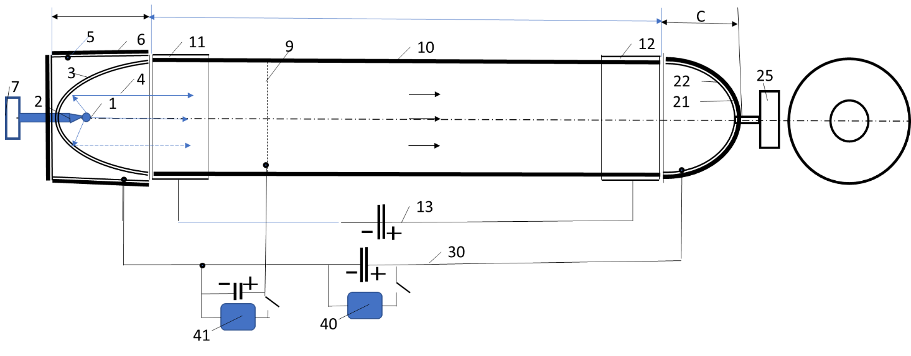
Fig.1. The simplest cylindrical Impulse thermonuclear electric generator. Nomenclature: Section A (thermonuclear micro-reactor and collector of negative particles-electrons): 1 - micro-fuel capsule, 2 – deliver of fuel capsule and electric energy, 3 – three net electrostatic mirror, 4 – trajectory of positive nuclear, 5 – electrode of the electron collector, 6 – isolator, 7 – issue of ignition and mechanism for delivery of fuel; section B (brake of nuclear): 9 - thin conductive heat-resistant film (option, for positive particles having strong difference energy, for example, fuel D+D), 10 – isolation pipe, 11-12 brake electrodes (negative and positive), 13 – issue of voltage; section C (collector of positive particles-nucleus): 21 – isolator, 22 – collector positive particles, 25 – vacuum pump.
Electric curcumas: 13 – create the brake field; 30 – electric curcumas of consumer, 40 – main consumer of energy, 41 – consumer for low voltage positive particles (option, for example, fuel D+D).
The electric generator consists of three sections: A, B, C. The first section A by means of three grid modified electronic mirrors reflects positively charged particles along the cylinder 10 to its other end in section C. For this purpose the electrical voltage between the grids 1 and 2 should be slightly higher than the maximum energy (eV) of the positive particles to reflect the positive high energy particles. The electrical voltage between the grids 2 - 3 should be slightly higher than between the grids 1 - 2 to extinguish the additional energy of the negative particles (electrons) acquired between the grids 1 - 2. The grids (starting from the inner grid) are numbered 1 - 2 - 3 and have charges "-", "+", "-" respectively. Section A contains fuel capsule 1, which explodes to produce a mixture of low energy particles of inactive fuel nuclei and electrons (energy about 10 keV) and active positive fuel nuclei with a giant kinetic energy of 1 - 15 MeV. Section A separates the electrons that settle on the conductive surface 5 and then close through load 40 with the positive charges collected in collector C. They create an electric current and perform useful work.
Section B has a pipe 10 made of insulator with two electrodes 11 and 12 with electric charges "-" and "+" respectively attached at the ends. These charges create an electric field that brakes positively charged particles to almost zero speed. For a better reflection of the particles, the inside of the pipe 10 can be covered with a thin layer of heavy elements.
Braked positive particles get into section C, precipitated on the conductive surface 22 and then neutralized by the consumer 40.
In some types of thermonuclear fuel, high-energy nuclei differ greatly in energy. For example, D+D produce T(1.01 MeV), ³He(0.82 MeV), p(3.02 MeV). If we also want to use lower energy, a thin heat-resistant film 9 (or cylinder) and an additional consumer 41 can be placed in section B. However, it is necessary to check whether the film is sufficiently cooled by radiation.
Low-temperature evaporated fuel components, capsule shell, holder tip 2 (~10 keV) (plasma) will be cooled, combined and removed by a pump type 25, also connected to section A.
Figure 2 shows a more complex cylindrical generator. It has additional electrical charges in sections B, C to increase their efficiency.
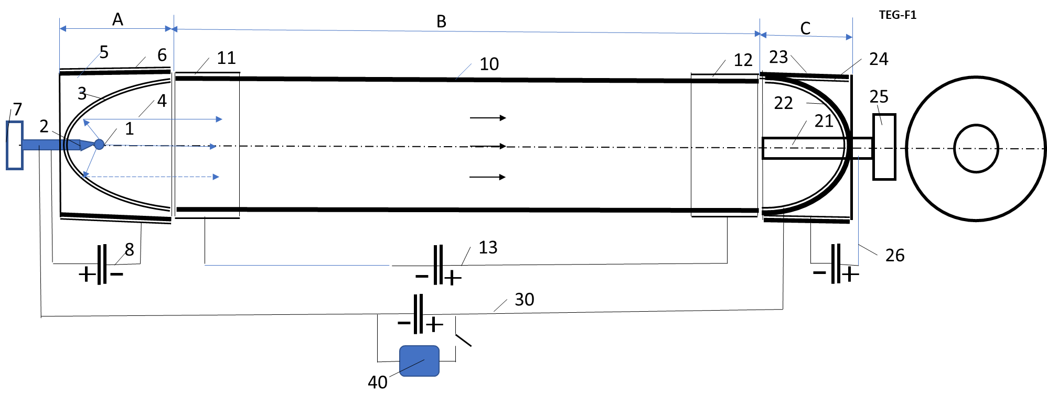
Fig.2. Cylindrical Impulse thermonuclear electric generator. Nomenclature: Section A (thermonuclear micro-reactor and collector of negative particles-electrons): 1 - micro-fuel capsule, 2 – deliver of fuel capsule and electric energy, 3 – electrostatic mirror, 4 – trajectories of nuclear, 5 – positive electrode of the electron collector, 6 – isolator, 7 – issue of ignition and mechanism for delivery of fuel; section B (brake of nuclear): 10 – isolation pipe, 11-12 brake electrodes (positive and negative), 13 – issue of voltage; section C (collector of positive particles-nucleus): 21 – negative electrode, 22 – collector surface, 23 – isolator, 24 – positive electrode, 25 – vacuum pump.
Electric curcumas: 8 – create the electric field for electron collector; 13 – create the brake field; 26 – create the electric field for positive (nucleus) collector; 30 – electric curcumas of consumer. 40 – consumer of energy.
Theoretically, the spherical thermonuclear electric generator shown in Fig. 4 should have the highest efficiency. But it has internal reflective and brake heat-resistant grids. Complex calculations are needed to determine whether or not the radiation is enough to cool them down.
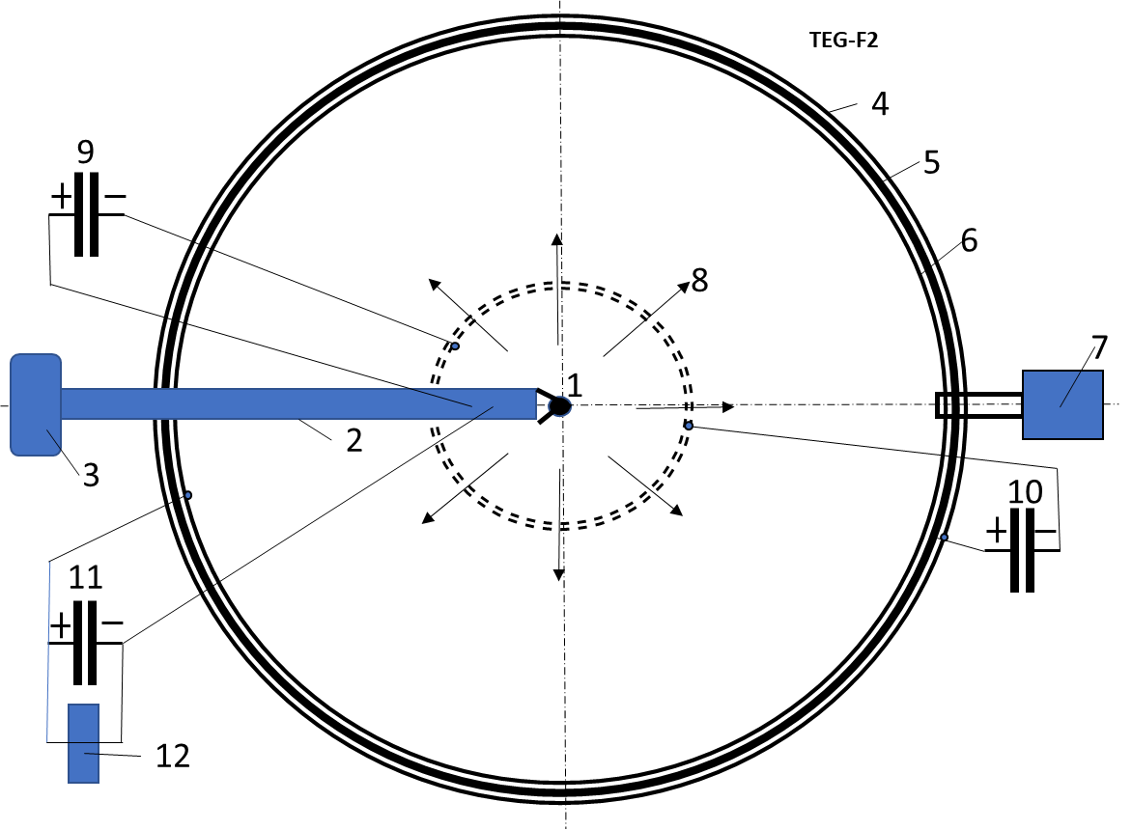
Fig.3. Spherical Impulse thermonuclear electric generator. Nomenclature: 1 - micro-fuel capsule, 2 – deliver of fuel capsule and electric energy, 3 – issue of ignition and mechanism for delivery of fuel, 4 – outer electrode of brake, 5 – isolator, 6 – inter (positive) electrode of collector, 7 – vacuum pump, 8 – trajectory of nuclear.
Electric curcumas: 9 – condenser which creates the electric field for electron collector; 10 – condenser which creates the brake field; 11 – condenser-collector of energy. 12 – consumer of energy.
Figure 4 shows the circuit diagram for delivering the fuel capsule, the energy to it and the output of electrons for generators in Figs. 2, 3. A similar device can be used for the generator in Fig. 1.
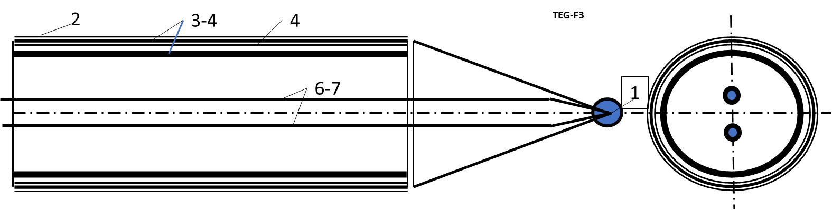
Fig. 4. Deliver of fuel capsule and electric energy for Fig.2-3. Nomenclature: 1 - fuel capsule, 2 - conductive layer, 3-4 – isolator, 4 - conductive layer, 6-7 – delivery energy (electricity) to fuel capsule.
Advantages and disadvantages.
1. The device for direct conversion of thermonuclear energy into electricity is offered. This device in its simplest form (Fig. 1) is applicable to the majority of nuclear fuels producing two components (positive nucleus and electron) during an explosion. The device uses the fact that these components have sharply different kinetic speeds. The kinetic energy of positively charged nuclei is converted into an electric field (voltage between the separated charges). This avoids the thermal cycle and all related problems.
2. Simplifies the design of the generator.
3. The efficiency (efficiency) of the electrical part of the device is increased.
4. The device (Fig.1, 2) is easily converted into a highly efficient rocket engine (part C is removed) with a huge velocity of expiration (7K - 30K km/sec).
Theory, estimation and computation of the IR Electric Generator
Let us to estimate the need parameters of the IR (Inertial Reactor) Electric Generator. As thermonuclear fuel we take the ⁶LiD (deuterate of lithium). That is the solid crystals having the melting temperature 692ºC. Specific mass of LiD is γ = 0.82 g/cm³. Fuel have: mass M = 10⁻⁷ kg, volume v = M/γ =1.22.10⁻⁴ cm³. We will only consider the thermonuclear reaction D+D because the probability reactions Li+D and Li+Li are small. That reaction is:
D+D→T(1.01)+p(3.02) 50% , (1)
D+D→³He(0.82)+n(2.4) 50% .
Here are: D=²H is deuterium, T=³H is tritium, ³He is helium, p is proton, n is neutron, numbers into brackets are million electron volts.
Number of nucleus T, p, ³He, n is
(2)
Maximal theoretical energy reaction D+D (include heat energy) from neutrons
, (3)
where E₁= 1.01 MeV for T, E₂= 3.02 MeV for p, E₃= 0.82 MeV for ³He, E₄=2,45 MeV for n.
Maximal theoretical electric energy reaction D+D (without neutrons n) is
(4)
Note that voltages are obtained by the difference in kinetic energy of charged particles - the removal of electrons and nuclei from each other.
When calculating the energy of the particles we must take into account that part of the energy of the particles will be transferred to the transformation of the shell of the fuel capsule and the lead wires into a high-temperature plasma.
This will lead to a decrease in voltage and an increase in current.
Equtions for compute the condenser:
where C is capacitor capacitance, F; q is electric charge, C; U is voltage: C_{F} is capacitor capacitance of plate capacitor. C; F is force of plate capacitor, N; d is distance between plates, m.
Using LiD in solid form, we can escape the pressing of fuel D+D in gas form.
Discussion.
Currently, the main efforts of scientists are aimed at obtaining a stable thermonuclear reaction, the energy of which exceeds the cost of obtaining it. For this purpose, huge very expensive installations are being built, and many years of research are being carried out. Tritium, which has the lowest ignition temperature, is used in fuel quality. But tritium is very expensive (1 gram 30K $, in the long run 100K $) and the cost of energy from it is 10 times higher than from conventional natural fuel. Besides, for ignition the compression method and huge laser installations are applied. Converting thermonuclear energy into electricity is a complex and expensive process ahead, which can take years. Huge installations cannot be used in transportation.
That's why the challenge is to create compact, low-cost fusion reactors and electric generators that directly convert IR energy into electricity.
The author's works collected in the Collection [1] and this article are devoted to the solution of these problems. As their solution, a special IR-reactor and a method of direct heating of cheap solid nuclear fuel in a special capsule with opposite oscillating flows of plasma and a shell that delays the flight of plasma are proposed. Instead of a huge transformer [1] Ch.2 p.25, fig.1 is offered a small special capacitor. Instead of a thermal converter, an electrical generator described in this paper using the non-equilibrium IR blast plasma is used.
All this can help to get out of the impasse, which has reached the problem of obtaining IR energy.
References
1. Bolonkin A.A., Small non-Expensive Electric Inertial Fusion Reactors (v.2). USA LULU, 2019, 200 ps.
13 November 2019

