REGENERATION OF WATER IN THE INFRASTRUCTURE OF A SMART HOME

Aleksanian Artem Arturovich
Saratov State Technical University named after Yu. A. Gagarin

Electrochemical regeneration of tap water in the infrastructure of a smart home for the purpose of recirculation and comprehensive disinfection, using in online control lines, in real time, the principles of electromagnetic resonance spectroscopy under the control of elements of artificial intelligence and artificial neural networks.

Moscow, Russia

Abstract
A comprehensive water-supply system in the infrastructure of a smart home, as a rule, includes four groups of components interconnected by principle and interaction. These are: incoming inspection and preliminary treatment modules, which include tanks for the water at the entry to the system and reserve tanks for peak loads, where preliminary treatment is performed by methods of electrochemical disinfection, aeration and oxygen saturation up to the level of full saturation, while parameter control is performed by a non-contact method based on the principles of electromagnetic resonance spectroscopy. Next come local electrochemical-treatment modules installed separately for each dwelling unit and including, at the inlet, flow-meter blocks with a real-time control section also operating by a non-contact method based on electromagnetic resonance spectroscopy. The third group consists of modules for storing used water, ensuring its separation into at least two categories — water containing toilet waste and general used water. The fourth group is represented by regeneration modules that include at least two sections — for water with fecal particles and for the remaining water — in which separation systems with vortex foam generators are used, as well as final non-contact control systems, also operating on the principles of electromagnetic resonance spectroscopy. In addition to the operational modules, the comprehensive water-supply system includes a control and processor section with elements of artificial intelligence and artificial neural networks, which provides the ability to remotely control and monitor all processes in real time.
Keywords:
- Water in the infrastructure of a smart home;
- Electrochemical regeneration of water in the infrastructure of a smart home;
- Regeneration of water without the use of chemical reagents;
- Comprehensive recirculation of water;
- Compact modules for electrochemical regeneration of water;
- Comprehensive water-supply system in a smart-home ecosystem;
- Incoming inspection and preliminary water-treatment modules;
- Modules for storing used water;
- Separation systems with vortex foam generators;
- Final non-contact control systems;
- Control and processor section for remote real-time monitoring.

Proposal for a centralized, comprehensive system for preliminary inlet treatment of tap water and for regeneration of this water after use
The volume of water used corresponds to the standards for supplying dwelling units with water. The calculated number of dwelling units is 100; the anticipated number of residents in these dwelling units is 150 people.
The comprehensive water-supply system includes four groups of components interconnected by principle and interaction. The first group is the incoming inspection and preliminary treatment modules, which include tanks for the water at the entry to the system and reserve tanks for peak loads. Preliminary treatment is carried out by methods of electrochemical disinfection, aeration, and oxygen saturation up to the level of full saturation. The incoming-inspection modules operate by a non-contact method based on the principles of electromagnetic resonance spectroscopy.
The second group is local electrochemical-treatment modules installed for each dwelling unit and including, at the inlet, water-consumption flow-meter blocks with a real-time control section, which also operates by a non-contact method based on electromagnetic resonance spectroscopy.
The third group is modules for storing used water with its separation into at least two categories: water containing toilet waste and general used water.
The fourth group is used-water regeneration modules that have at least two sections: for water containing fecal particles and for the remaining water. These modules include separation systems with vortex foam generators, as well as final non-contact control systems based on the principles of electromagnetic resonance spectroscopy.
In addition to the operational modules, the comprehensive water-supply system includes a control and processor section with elements of artificial intelligence and artificial neural networks, providing the ability to remotely control and monitor all processes in real time.
A fabric made of a carbon–carbon composite performs several functions. In the anode block of a water-desalination unit it significantly increases the contact area between the anode and the stream of saline water, which, passing through the apertures in such a fabric-anode, receives the maximum possible amount of positive electric charge. In an electrochemical disinfection cell (an electrochemical reactor of any type) this fabric, not connected to a power source, is used as a spacer between the electrodes — anode and cathode. It stabilizes the liquid flow, which in the electric field between the electrodes is separated: liquid with a positive charge is directed to the cathode, and liquid with a negative charge — to the anode. In the ascending flow, the charged liquid exits the inter-electrode space: on the cathode side — a flow with a negative charge and acidic background, on the anode side — a flow with a positive charge and alkaline background.
Inventions in this area open an innovative scientific and technical direction related to the development of service technologies and their application in augmented reality. Augmented reality in consumer and personal optics is at an early stage of development; however, a significant future is forecast for it. Headsets remain expensive and inconvenient for constant wear, but even now there are several quality devices that are either available on the market or are at the final stage of development.
More than ten years have passed since the release of the first successful augmented-reality glasses, Oculus Rift. These devices initially produced a strong wow effect; however, over time interest in them declined, since developers failed to make augmented-reality glasses as familiar and mass-market a product as smartphones, game consoles, or smart watches. One of the reasons for this situation is the insufficient development level of service technologies, which are not yet ready to provide mass maintenance for such complex devices.
The state of patent protection for these technologies also remains ambiguous. Despite the projected growth of the market for augmented-reality visualization devices, the dynamics of patent activity remain low. A patent search by keywords in the database of the U.S. Patent and Trademark Office revealed only 133 patent applications and not a single granted patent on this topic. At the same time, the overwhelming majority of applications are exploratory in nature and do not focus attention on designs or systems of augmented-reality glasses as finished products; mainly, the discussion is of devices at the final stage of development.
For the practical implementation of such products, a whole range of new technical solutions and products, including ancillary ones, is already needed today. Among them are technologies and devices intended for servicing augmented-reality glasses in everyday operation. One of the first solutions should be the development of a comprehensive technology for producing a washing and disinfecting liquid from water that does not contain high concentrations of salts, including hardness salts, for cleaning the lenses of glasses from organic and inorganic contaminants inevitable in daily use.
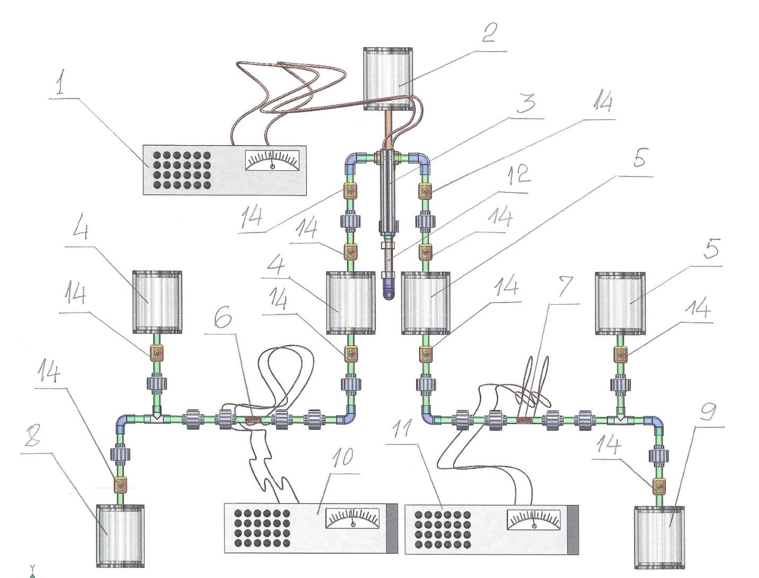
Figure 1. Model of a system for regulating the acidity and alkalinity of deionized water in two directions
1 – power supply for the electrochemical reactor
2 – tank with deionized water for feeding to the electrochemical reactor
3 – electrochemical reactor with an inter-electrode space in which treatment is carried out in two parallel ascending flows
4 – collector of water with a reduced level of acidity
5 – collector of water with an increased level of alkalinity
6 – sensor module for measuring the reduced level of acidity
7 – sensor module for measuring the increased level of alkalinity
8 – collector of water with a reduced level of acidity
9 – collector of water with an increased level of alkalinity
10 – pulse generator for an impedance-resonance sensor
11 – pulse generator for an impedance-resonance sensor
However, this proved insufficient, since practice showed that the liquid used for washing must possess insulating properties so as to exclude any possible local current impulses. Analysis of potential water sources for such a system led to photolithography production complexes, where deionized water is used, possessing characteristics most consistent with the requirements for servicing optical lenses of augmented-reality glasses. For comparison, distilled water and high-purity water were also considered; however, it was deionized water that demonstrated the best operating properties and proved preferable. Special attention was paid to the prospect of its use both before electrochemical treatment and after it — in particular, for preparing various emulsions that can be used in service procedures for the care of augmented-reality glasses. Trial checks confirmed the possibility of obtaining stable and high-quality emulsions both with deionized water before correction of acidity and alkalinity and with water that has undergone a change in pH balance.
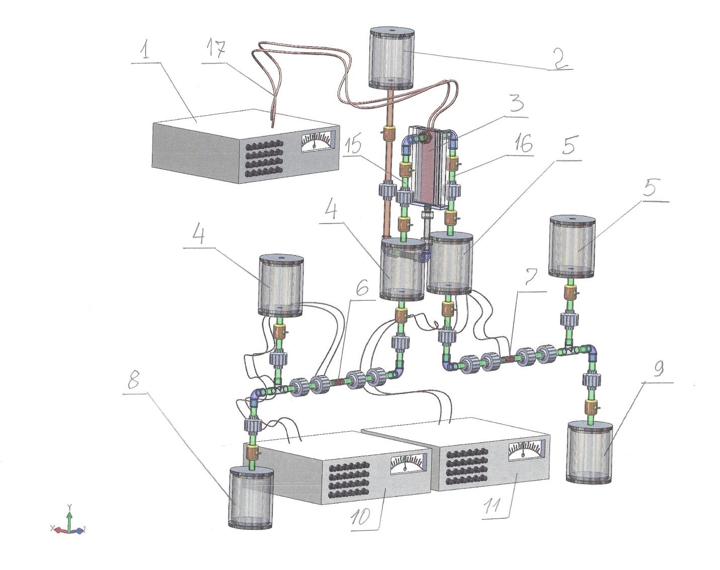
Figure 2. Model of a system for correcting the acidity and alkalinity of deionized water in both directions
12 – inlet pipeline to the electrochemical reactor
14 – regulating and control valves
15, 16 – flow meters
17 – current-supply cables
Selection and analysis of various options ultimately showed that the most suitable is the use of deionized water, which is widely used in microelectronics and has long been a familiar component of photolithography technology. This type of water is produced in significant volumes, while its cost remains relatively low.
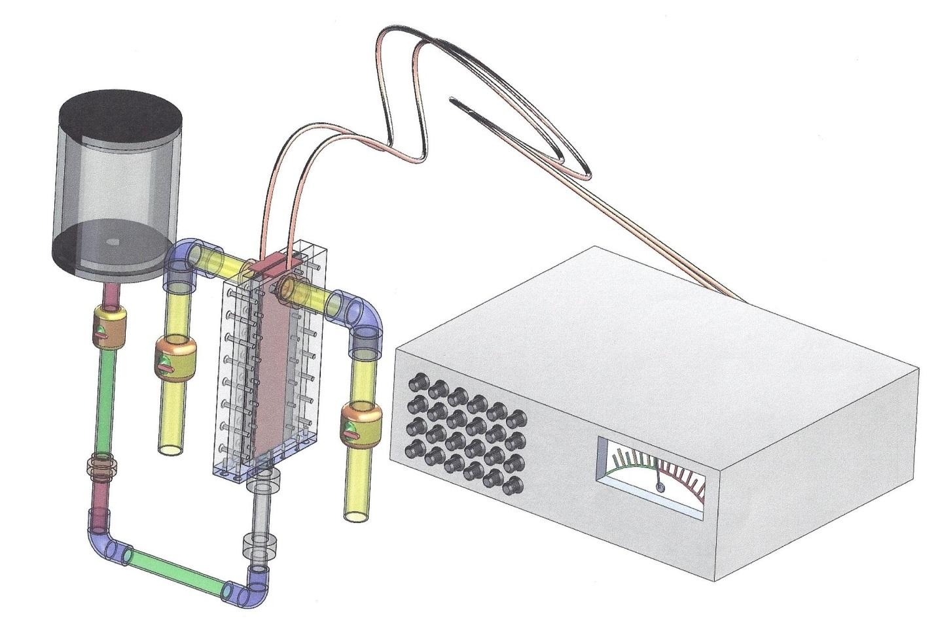
Figure 3. Model of an electrochemical reactor with connection to a power source.
Since this technology is being proposed for application for the first time, it became necessary to fabricate the simplest prototype to check, under real-world conditions, the feasibility of practical implementation of a number of innovative solutions, the first of which was the technique and technology of the electrochemical reactor. In this setup the electrode cells have working zones separated by a neutral membrane located symmetrically relative to the two electrodes. One of the key principles of operability is the treatment of deionized water in a developed ascending flow. In this case the distance between the working surfaces of the electrodes is only 3 millimeters, of which 1 millimeter falls on the membrane thickness. Thus, the thickness of the liquid flow inside the electrode cell is only 1 millimeter.
This configuration made it possible to significantly increase the current density — up to 100 amperes per square decimeter — which in turn made it possible to electrochemically correct acidity and alkalinity in water that is close in parameters and properties to a dielectric liquid. Since two streams are formed at the system outlet, for treating the optics of augmented-reality glasses it became possible to use water both with a pronounced acidic effect and with a pronounced alkaline effect. This makes it possible to clean the surface of optical lenses from microorganisms and bacteria with the acidic stream and to remove greasy contaminants with the alkaline stream.
It is important to note that the system for preparing and treating deionized water itself is simple in design and uses structural materials and components widely employed in mechanical engineering. This makes it possible to install it in small retail businesses specializing in optical instruments and glasses, including augmented-reality glasses of both current and future generations.
The anti-allergen effect deserves special attention. Since the power supply to the cathode and anode of the electrode cell is from a single source, and with identical active-surface area of the electrodes an equivalent current density is achieved, correction of the liquid parameters occurs strictly proportionally: the acidic reaction of one part of the flow and the alkaline reaction of the other do not cause allergic reactions when used simultaneously. This phenomenon radically increases the consumer qualities of the system not only for augmented-reality glasses, but also for any other optical instruments of wide application.
As in every system of dynamic electrochemical treatment of liquids, especially those with low electrical conductivity, the design of the electrode cell is crucial. All parameters are considered: design features, materials for manufacturing the electrodes, the properties and shape of the neutral membrane, and the materials and design of the housing. At the same time, particular efficiency potential proved to lie in the use of electrodes made of carbon–carbon composites.
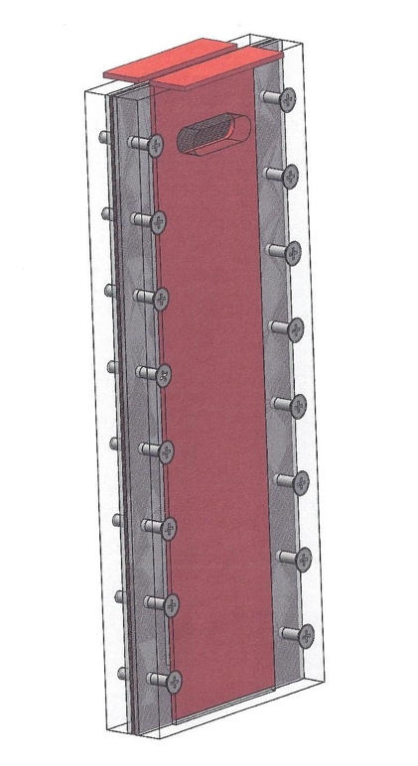
Figure 4. Model of the electrode cell of the electrochemical reactor.
The simplicity of the electrode-cell design determines the overall simplicity of the entire water-treatment system, making it reliable, easy to service, and accessible for installation even in small retail outlets selling optical instruments, including augmented-reality glasses.
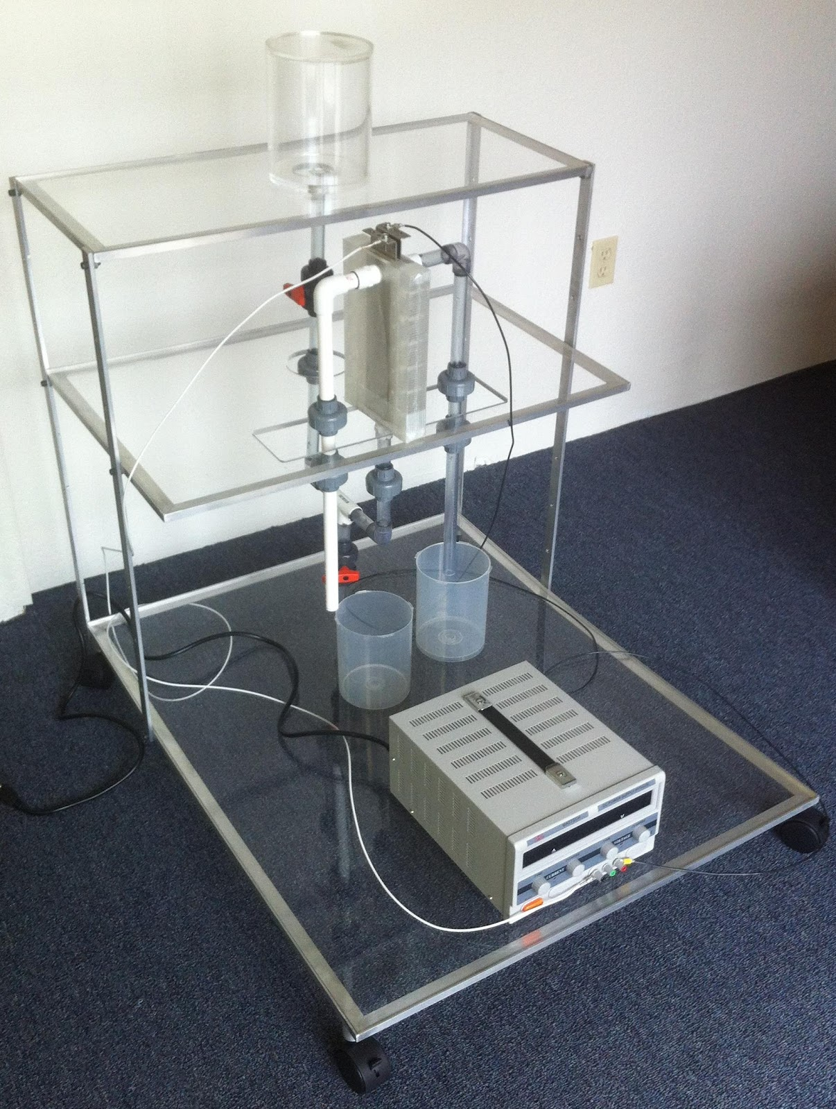
Figure 5 shows a photograph of a system for real correction of acidity and alkalinity in deionized water.
The photographs of the prototype vividly show the designed maximal simplicity of the construction, which ensures not only low cost but also ease of operation.
Such a system can be installed and operated without significant costs in practically any retail complex, and the products obtained with its help make it possible to bring the level of servicing optical instruments to technological perfection, relevant both for today’s and for future devices. To present the current state of affairs in a technological field that includes not only traditional optical technologies and materials but also many related processes and groups of technologies, subsequent publications will analyze the overall state of innovative development in this direction. The search for a free niche in the indicated technological field continues with high intensity; however, the exact level of this intensity remains not fully clear, since the dynamics of patent protection do not correspond to the declared level of project development and the breadth of the search for new technical solutions.

List of references and patent/licensing information
Appendix 1
United States Patent Application 20180031836
Kind Code: A1
Author(s): Johnson, Lonny Eric; et al.
Publication Date: February 1, 2018
Title: SMART GLASSES HAVING INTERFERING LIGHT FILTERING
Abstract: Smart glasses with an interfering-light filter include an optical frame, a semi-transparent display, and a projection mechanism for displaying virtual content with filtering of interfering light through a polarization shield.
Appendix 2
United States Patent Application 20170307787
Kind Code: A1
Author: Kawamura, Takumi
Publication Date: October 26, 2017
Title: HEAD MOUNTED APPARATUS AND GRIPPING APPARATUS
Abstract: A head-mounted device with a display and a light-shielding element that prevents the influence of external light and is convenient for users wearing eyeglasses.
Appendix 3
United States Patent Application 20150378155
Kind Code: A1
Author(s): Kuehne, Marcus; et al.
Publication Date: December 31, 2015
Title: METHOD FOR OPERATING VIRTUAL REALITY GLASSES AND SYSTEM WITH VIRTUAL REALITY GLASSES
Abstract: A method of operating VR glasses with display of virtual objects and continuous determination of the position of the glasses to adjust the virtual distance.
Appendix 4
United States Patent Application 20160034042
Kind Code: A1
Author: Joo, Ga-hyun
Publication Date: February 4, 2016
Title: WEARABLE GLASSES AND METHOD OF PROVIDING CONTENT USING THE SAME
Abstract: Wearable glasses with a sensor circuit, a communication interface, a display, and a controller for displaying notifications taking into account user movement.
Appendix 5
United States Patent Application 20180005421
Kind Code: A1
Author(s): Park, Jisoo; et al.
Publication Date: January 4, 2018
Title: GLASSES-TYPE MOBILE TERMINAL AND METHOD OF OPERATING THE SAME
Abstract: Glasses with a VR display and a controller interacting with a mobile terminal to control virtual reality depending on the time of return to reality.
Appendix 6
United States Patent Application 20170366805
Kind Code: A1
Author: Sevostianov, Petr Vyacheslavovich
Publication Date: December 21, 2017
Title: METHOD AND SYSTEM FOR DISPLAYING THREE-DIMENSIONAL OBJECTS
Abstract: A system for displaying 3D objects with binocular and motion parallax effects, including a display, glasses with optical shutters, sensor matrices, and devices for processing the coordinates of markers.
Appendix 7
United States Patent Application 20170371164
Kind Code: A1
Author: Liao, Chunyuan
Publication Date: December 28, 2017
Title: WEARABLE SMART GLASSES
Abstract: Smart glasses with a frame and resilient clips on the temples for comfortable fit on the user’s head.
United States Patent Application 20160173865
Kind Code: A1
Author: Park, Sung Woo
Publication Date: June 16, 2016
Title: WEARABLE GLASSES, CONTROL METHOD THEREOF, AND VEHICLE CONTROL SYSTEM
Abstract: Wearable glasses with front image capture and gaze-direction tracking for interaction with a 3D map of a vehicle interior.
Increasing the oxygen concentration in water
Technical report – water aeration
Description of TEI’s FAD test for aeration of undersaturated water:
- Water tank: 1,000 liters, filled with approximately 500 L of water
- Circulation pump – pressure up to 5 bar
- 2 FAD devices
- Compressed air – pressure 7–8 bar
- The installation configuration is intended for experiments on oxygen saturation of water
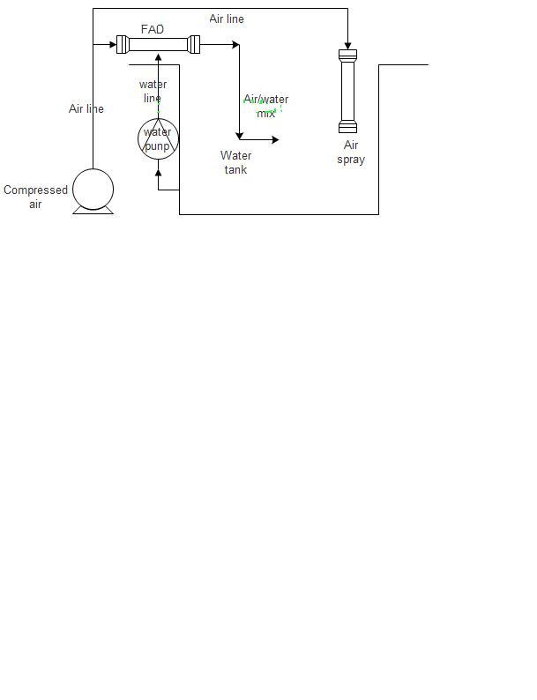
Experimental verification – oxygenating water
1. Water source and preparation
- Water taken from a deaerator that removes O₂ from water supplied to boilers.
- Initial water temperature: ≈80 °C.
- Water cooled to ≈40 °C before measurement.
2. Initial measurement
- Before starting the system, the oxygen content in the water was measured.
- Result: 40% saturation (oxygen-deficient water).
3. System start-up
- The system was activated to increase the dissolved-oxygen content.
4. Measurement after system operation
- Measurement performed after 10–15 minutes of system operation.
- Result: 96% oxygen saturation.
Conclusion:
- The system effectively increased the oxygen content in the water from 40% to 96% in just 10–15 minutes.

