Learning technical subjects of future specialists of computer systems using open source technology

Tatiana Bodnenko
Associate Professor of Automation and Computer Integrated Technologies, Candidate of Pedagogical Sciences, Cherkasy National University named after Bogdan Khmelnitsky, Cherkasy, Ukraine
Phone: +380678625875
Email: bod_t@ukr.net

Abstract. The article stressed the importance of expanding educational systems as a core component of the educational system to improve and raise the level of quality education that will encourage the formation of new quality, content and form. This process can be expanded using an open learning environment, the formation of which is to open education and open educational systems. The main of which is computer-oriented tools and information and communication technology. That is, when you create a form of open education, you should not create new educational content, and introduce a new methodological approach to its application. The essence of the concept of open education, closed learning environment, an open learning environment. The article presents the concept of open education, singled out the basic components of the application closed learning environment, highlights the main tools of the system of open education.
Keywords: open source technologies; open education; closed learning environment; open learning environment; technical disciplines.

- Introduction
To improve and boost the quality of education should pay attention to the expansion of educational systems as a core component of the education system and the achievement of their higher level on the educational process. This is done with altering the level and nature of the educational environment (learning environment), which is the main component of any educational system. It leads to the formation of a new quality, content and form.
The introduction of open learning environment, forming its means and technologies takes place in open education and open educational systems. The main of them are computer oriented tools and information and communication technology. They based information and communication platform for open education. Therefore, information education is a social phenomenon, an important basis for innovation and innovative tool for educational development.
That is, when you create a form of open education, you should not create new educational content, and introduce a new methodological approach to its application. The foundation of open education educational process is deliberate, controlled, active independent work of students who will study at random, convenient time and place, on an individual schedule, with a set of specialized educational tools, with the ability to communicate with the teacher and each other. The main goal of open education is to prepare the new methodological approach to the modern student further effective work after graduation.
In particular, Zhaldak M.I. believes that "The most important scientific, technical and social-economic problems now particularly urgent problems of information – a system of efficient provision of timely, credible and exhaustive information of all socially significant human activities, conditions for prompt, thorough and comprehensive analysis of the studied processes and phenomena, forecasting their development, predicting the consequences of decisions. Their resolve is indivisible from the problems of informatization of education, which, on the one hand, reflects the current level of scientific, technical and social-economic development of society and depend on him but on the other – it causes significant" [4, p 39].
So the question arises main features of the introduction of open learning environment with modern facilities and network technologies existing in it to improve, upgrade educational systems of different specialized areas, improve the quality of education at this didactic space.

- Concept of development of open education
Consider the concept of learning environment in traditional learning. It is based at the university and is closed learning environment is unrestricted in content and its components elements and has limited didactic implementation. The use of closed learning environment in the educational process lies in the components presented on Fig. 1.
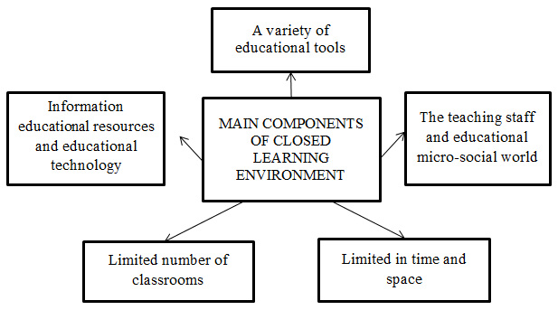
Figure 1. Key components of using a closed learning environment

Nowadays the traditional learning environment in the university is closed learning environment [2]. This environment unsuitable for extraterritorial involvement in the educational activities of the student and who teaches in Classroom space outside. There are instances where learning outside the institution are necessary to help you increase the potential space learning environment and to ensure the creation and implementation of open educational space, accessible to members of the educational process. Also learning environment in the school unlimited variety of its components. This is due to the availability of qualitative and quantitative content of information resources that can be used in the educational process, listed automated database and knowledge of computer sets that are available and work in modern computer networks (corporate, continental, Internet) communication characteristics of these networks.
These opportunities are open learning environment – a new, comprehensive component composition learning environment with the potential for significantly improving resource providing information and methodological training systems. It also provides for an increase of the diversity of learning and teaching technologies that will enable the effective application in the educational process [2].
Nowadays modern open learning environment is potentially unlimited as to the amount of resources that can be used in the educational process a large number of users. Also it can use its tools and technologies, as the number of students involved in solving a single problem didactic unlimited. It can create additional conditions to achieve different goals, strategies, trajectories of learning and education rights, to ensure adaptation component of a learning environment suited to individual capabilities and needs of students. Thus, an open learning environment as a whole significantly expands the didactic introduction of educational systems, increases their educational performance, positive impact on the learning process.
However, Zhaldak M.I. stresses some negative aspects of the use of open learning environment. This refers to the fact that unlimited access user creates an overload of information where you can navigate [4]. Therefore, all information resources open learning environment, planned for use in the educational process, must first "filtered" based educational preferences teacher education policy and values of society. You also need to teach students to critically and carefully separate the information offered in an open learning environment [2].
Open learning environment for today is the most comfortable compared to traditional forms of learning, where existing broader conditions for creative self-expression, self-improvement students with an opportunity to demonstrate their products to students creative activities for participants medium. Also, a wide possibility of expert evaluations creative achievements and more.

- Basic tools of open education system
Recently, for solving the problems of modern pedagogy gained rapid development of open educational tools that impact: to improve the quality of education and enrichment volume filling content of the information resource space; facilitating access to scientific and educational information to a wide range of users; increase design efficiency and the use of computer-oriented educational purposes [1]. Leading tools open education system are presented on Fig. 2 [3].
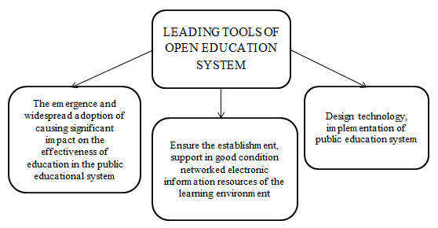
Figure 2. Leading tools of open education system

Let’s consider the wider system of open education tools. More commonly used technology educational process shown in Table 1.

Table 1
System tools of open education system
1 | Scientific and educational information networks that are automated information systems, consisting of texts educational and scientific guidance and serve as promoted by the education and science, technology based on computer information and communications platform for the transportation and processing of information objects.
2 | Special technology support virtual learning activities, which is expected to attract educational activity in the Internet space students and teachers from many schools around the world during their joint international educational projects on various topics and subjects. For specific project formed its own Internet-oriented, flexible network of project participants who will take part in it.
3 | Global Network "Partners in Learning" (Partners in Learning Network, established by Microsoft after the project "Partnership in Education" – Partners in Learning Program). It introduced support for virtual communities of educators from around the world, on its own initiative pool their efforts to modernize training content and pedagogical technologies, share best teaching experience, testing of new learning tools, developed teaching materials, discussion of new ideas and teaching innovation, immediate and long-term issues of education, educators free access to national and international educational electronic resources and more.
4 | Technology Electronic design education system that works to maintain and improve the efficiency of automated design and use of computer-oriented systems for educational purposes. In the field of teaching-oriented information technologies emerged and rapidly spread new class of technology – information technology "learning objects" technological base which is the use of interoperable learning objects content that the learning process repeatedly used. Submission of these technologies is with different systems of scientific and educational information technologies used by modern computer systems targeted for educational purposes, including distance learning.
5 | Technology Network e-distance learning, affecting the implementation of the common educational space science and technology and education policy based on the principles of open education, providing the ability to support the functioning of the single open learning environment. There is a single conceptual direction, which provides compliance in this environment of international and national standards, procedures and protocols of electronic network interaction and that it exists.
6 | Technology of the digital libraries, which is to ensure that local and network access to digital scientific and educational resources of electronic libraries - electronic subject information resources learning environment open education system, processing of these resources to create, classification and analysis of electronic documents and publications (IISN , SCOPUS).
7 | Technology areas close communication (NFC - Near Field Communication). They use portable electronic technologies, special vehicles used for unloading Internet from a large number of small-scale local and global electronic communications (e-communications), the identification of members of the electronic communication with their e-communications in a single information space overall objective setting, personalization tools wireless e-communications. This allows them extraterritorial space, regardless of the time to access the electronic resources of computer networks at various levels and subject areas.
8 | Electronic technology project management. At their base provides support for automated management of projects and programs of innovation development of various technical and socio-economic systems, as well the education system and its components. With them the opportunity to control the creation and improvement of complex systems in large parametric uncertainties and procedural innovation, increased efficiency of their preparation and implementation.
High-tech, innovative nature of the education system, including extension methods and techniques of basic and applied research, deepen the integration of science, education and industry, modernizing the theoretical content of education, educational technology and learning environment, training and skills development, influences of organizational structure of education and management of educational activities targeted needs sufficient, timely funding [5]. This work is aimed at development of psycho-pedagogy, science and technology, the wide application of achievements gained in educational practice, the professional competence of teachers and educational foundations aimed improving their skills.
The process of teaching technical subjects of future specialists of computer systems caused by the use of information especially education, the emergence of new information and communication technology-oriented teaching educational technology, innovative teaching aids. Preparing data professionals require the creation and implementation of educational system of modern computer-based learning environment with the gradual formation and development of computer and information technology platform educational space, educational electronic information resources, network services, to semantic content and procedural support.
For this study the education system needs to influence the most modern, the most promising technologies and forms of education, which should include open education systems, electronic distance education, electronic distance learning technology, built on the principles of open education.

- Discussion
The basis of the concept of open education system is the idea that all their knowledge - a social achievement. Open education includes the established tradition of sharing ideas acquired configured to cooperate, interactive, internet culture XXI century. Here, everyone is free to use, adapt to their needs, improve, distribute educational resources to education has become more accessible and more effective. Also, there are outdoor education as a tool for the promotion of open education movement that is open educational resources.
It is used in the formation of Ukraine principles of open education encourages researchers and practitioners on promising directions of development of education in the information society, which will include the use of the latest achievements of psycho-pedagogy, educational practices and scientific and technical progress, provide role models and play in the formation of Ukraine world trends in education systems will lead to integration of Ukraine's education system into the world educational space.

- Conclusion
Thus, high-tech, innovative development of education should include teaching the process of expanding the range of basic and applied research, deepen the integration of science, education and industry. You should also modernize the content of education, educational technology and learning environment, training and skills development. This leads to positive changes in the organization of the content of education and management of educational activities. This process requires a focused, sufficient and timely funding. Character development is built on the achievements of psychological pedagogy, science and technology, broad introduction of innovative achievements in educational practice, the professional competence of teachers and those involved in the organization of the educational process.

References

1. Bykov V.U. Open learning environment and modern networking tools of open education / V.U. Bykov // The scientific journal of the National Pedagogical University named after M.P. Dragomanov. Series 2. Computer-oriented education system. – Publishing Center NPU named after M.P. Dragomanov 2010, Edition 9 (16). – 9-16 p.
2. Bykov V.U. Innovative development of society and the modern network technologies of open education // Problems and prospects of forming a national humanitarian and technical elite: P78 collection of research papers / Publishing Center NPU named after L.L. Tovazhnyansky, O.G. Romanovsky. – Edition 23-24 (27-28). – Kharkov: NTU “KPI”, 2009. – 24-49 p.
3. Zhaldak M.I. Computer Science is fundamental scientific discipline // Computer in the school and in the family. – 2010. – Edition 2. – 39-43 p.
4. Kremen V.G. The human in front of the challenge of civilization: creativity, human, education // The phenomenon of innovation: education, society, culture / Publishing Center NPU named after V.G. Kremen. – K.: Pedagogical opinion – 2008 – 9-48 p.
5. Methods of teaching in higher education: a textbook / O.V Malykhin, I.G. Pavlenko, O.O. Lavrentyeva, G.I. Matukova. – Simferopol: Publishing Center “Dayfi”, 2011. – 270 p.
6. Fitsula M.M. Pedagogy of high school: a textbook – K. Publishing Center “Akademvydav”, 2006. – 352 p.

