OLEKSANDR KAPINUS
AMBR Cool Comfort Service LLC
NORTH BAY ROAD 1211
SUNNY ISLES BEACH, FL 33160
coolcomfortservice24@gmail.com

Modification of industrial air conditioning systems.
Modification of air conditioning systems using vortex tubes based on the temperature separation effect of compressed gas.

Abstract:
The article examines the possibilities of modifying industrial air-conditioning systems through the use of vortex tubes (Ranque–Hilsch tubes) based on the effect of temperature separation of compressed gas. Particular attention is paid to innovative technical solutions in the field of hydrodynamic and aerodynamic flow transformation, enabling cooling without the use of moving parts and traditional freon-based refrigerants. The advantages and limitations of vortex air-conditioning systems are analyzed, including their reliability, structural simplicity, operational safety, and energy-consumption characteristics.
The publication provides a detailed overview of the engineering developments of industrial air-conditioning specialist Oleksandr Sylyaiev related to the application of integrated hydrodynamic interfaces and devices for mixing, homogenizing, and activating liquids and compressed gases. Special emphasis is placed on the description of structural elements that form coaxial annular flows and ensure homogenization of the turbulence level within mixed flows. The article also discusses the use of synthesized terminology, such as the “double Bernoulli effect,” followed by the Joule–Thomson effect, in the context of new principles of flow transformation.
The article emphasizes that the technical solutions proposed by Oleksandr Sylyaiev have significant potential for application in local and industrial air-conditioning systems, as well as in other fields requiring efficient mixing and activation of liquid and gaseous media with a minimal number of structural components and without the use of moving mechanical parts.

Keywords:
Air conditioners; Industrial air conditioning systems; Modification of industrial equipment; Modification of industrial air conditioning systems; Modification of air conditioning systems using vortex tubes based on the temperature separation effect of compressed gas; Vortex tube; Compressed air source; Freon machines; Invention formulas; Synthesized terms; Devices for mixing, homogenizing, and activating liquid mixtures, liquids, and compressed gases, compressed gases; Mixing and homogenization of a mixture by turbulence level; Integral interface zone of a device for mixing, homogenizing, and activating liquid mixtures, liquids, and compressed gases, or several compressed gases; Multifunctional hydrodynamic or aerodynamic section of a device for mixing, homogenizing, and activating liquid mixtures, liquids, and compressed gases, several compressed gases.

System diagrams proposed by Oleksandr Sylyaiev for the modification of industrial air-conditioning systems.
The modification of air conditioning systems using a vortex tube (Ranque–Hilsch tube) is based on the use of the temperature separation effect of compressed gas. A vortex tube is a device without moving parts that, when supplied with compressed air, separates it into two streams: hot and cold.
Detailed information on the application of the vortex tube in air conditioning is provided below.

Operating Principle in Air Conditioning.
- Compressed Air Supply: The compressor supplies compressed air to the vortex tube.
- Energy Separation: In the vortex chamber, the gas is separated into a hot stream (exiting from one end) and a cold stream (exiting from the other end).
- Cooling: The cold stream is directed to the area requiring cooling (for example, a vehicle cabin or a workplace).
Advantages of the Modification.
- Reliability: The absence of moving parts ensures durability and ease of maintenance.
- Simplicity of Design: Vortex tubes are easy to manufacture and install.
- Safety: Freon and other hazardous refrigerants are not required.
- Instant Cooling: Cold air is produced immediately after the supply of compressed air.
Limitations and Disadvantages.
- High Energy Consumption: A high-power compressor is required to provide the necessary volume of compressed air.
- Low Efficiency: Despite its simplicity, the efficiency of the vortex tube is lower than that of traditional freon systems.
- Noise: The operation of compressed air creates a high noise level.
Fields of Application.
- Personal Cooling: Cooling suits for welders, firefighters, or operators working in high-temperature industrial environments.
- Local Air Conditioning: Cooling of small cabins, equipment, or workplaces.
- Automotive Air Conditioners: Experimental systems in which air is cooled during motion.
The modification of air conditioning systems using vortex tubes is most effective in areas where a compressed air source is already available and where the use of freon-based systems is difficult or hazardous.
Clarification of the Newly Introduced Terminology.
In the formulas of these inventions, synthesized terms are used, such as the double Bernoulli effect, and it is indicated that the Joule–Thomson effect arises following this effect.

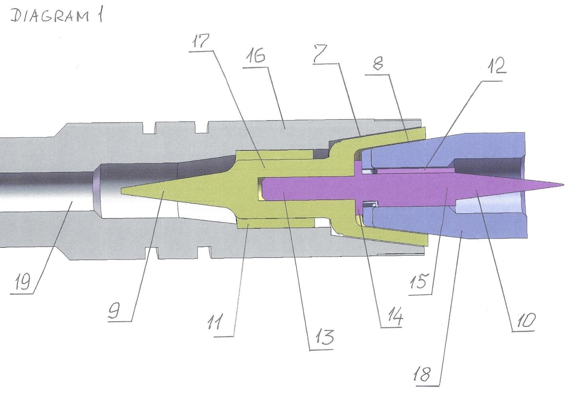
Figure (diagram) 1.
The diagram shows an axial cross-section of a device for mixing, homogenizing, and activating liquid mixtures, liquids, and compressed gases, compressed gases.
The cross-section shows two reflectors forming the hydrodynamic interface of the device in combination with a section for hydrodynamic transformation of the flow of the liquid component of the mixture and with a section for aerodynamic transformation (according to the first version) or a second hydrodynamic transformation of the flow of the liquid component of the mixture (according to the second version).

The numbers in the diagram indicate:
7 - a conical channel with a distance of 100 microns between the conical forming surfaces, which is part of a system homogenizing the flows of mixture components according to turbulence level, consisting of two coaxial conical annular channels of the device for mixing, homogenizing, and activating liquid mixtures, liquids, and compressed gases, several compressed gases.
8 - a conical channel with a distance of 25 microns between the conical forming surfaces, which is also part of a system homogenizing the flows of mixture components according to turbulence level, consisting of two coaxial conical annular channels of the device for mixing, homogenizing, and activating liquid mixtures, liquids, and compressed gases, several compressed gases.
9 - the first conical reflector along the direction of movement of the mixture components, which is part of the hydrodynamic interface; this reflector in the device performs the function of transforming the cylindrical flow of a mixture component into an annular flow with a more homogeneous turbulent background.
10 - the second conical reflector along the direction of movement of the mixture components, which, depending on the nature of the mixture components, forms part of either the hydrodynamic or aerodynamic interface; the apex of the conical surface of reflector 10 is directed opposite to the apex of reflector 9.
11 - a system of linear, predominantly capillary channels uniformly distributing the annular flow of mixture components across the annular cross-section while simultaneously increasing the turbulence level and linear velocity of the flow of mixture components; this system belongs to the integral hydrodynamic interface of the device for mixing, homogenizing, and activating liquid mixtures, liquids, and compressed gases, several compressed gases.
12 - a system of linear, predominantly capillary channels uniformly distributing the annular flow of mixture components across the annular cross-section while simultaneously increasing the turbulence level and linear velocity of the flow of mixture components; this system belongs to the second part of the integral hydrodynamic or aerodynamic interface of the device for mixing, homogenizing, and activating liquid mixtures, liquids, and compressed gases, several compressed gases.
13 - a guiding, centering, fixing, and spacing pin of the integral interface of the device for mixing, homogenizing, and activating liquid mixtures, liquids, and compressed gases, several compressed gases.
14 - a guiding, centering, fixing, and spacing flange of the integral interface of the device for mixing, homogenizing, and activating liquid mixtures, liquids, and compressed gases, several compressed gases, by means of which the distance between the conical surfaces of annular conical channel 8 is adjusted.
15 - a reverse element of the integral aerodynamic or hydrodynamic interface of the device for mixing, homogenizing, and activating liquid mixtures, liquids, and compressed gases, several compressed gases.
16 - a hydrodynamic section of the device for mixing, homogenizing, and activating liquid mixtures, liquids, and compressed gases, several compressed gases.
17 - a direct element of the integral aerodynamic or hydrodynamic interface of the device for mixing, homogenizing, and activating liquid mixtures, liquids, and compressed gases, several compressed gases.
18 - a multifunctional hydrodynamic or aerodynamic section of the device for mixing, homogenizing, and activating liquid mixtures, liquids, and compressed gases, several compressed gases.
19 - an inlet channel of the device for mixing, homogenizing, and activating liquid mixtures, liquids, and compressed gases, several compressed gases.

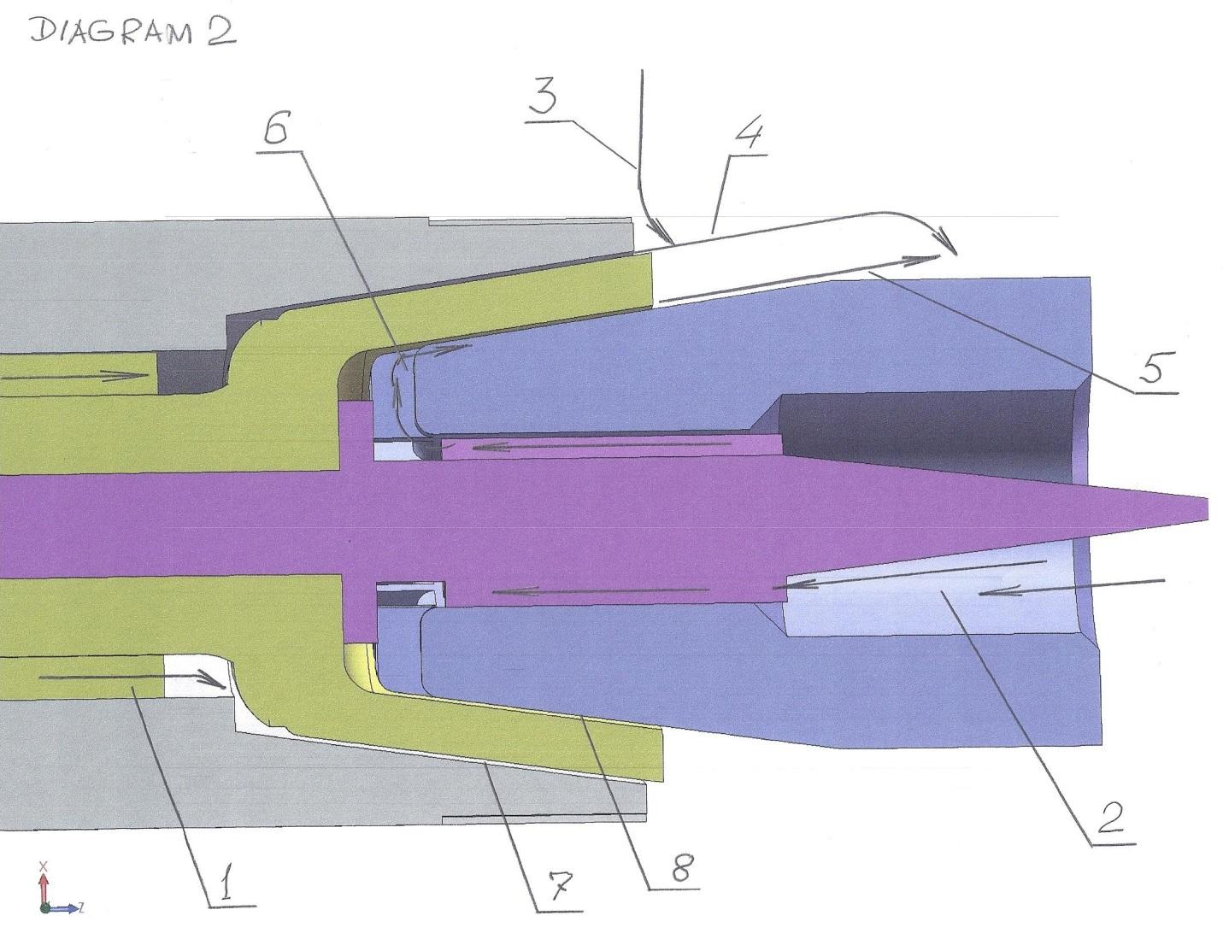
Figure (diagram) 2.

Diagram 2 shows an axial cross-section of the zone of the device for mixing, homogenizing, and activating liquid mixtures, liquids, and compressed gases, several compressed gases, in which the first stage of mixing and homogenization of the mixture according to turbulence level takes place.
The mixing and homogenization of the mixture according to turbulence level are carried out in a developed hydrodynamic regime, within a high-speed flow of moving mixture components, in a constant-volume annular cavity into which the mixture components are continuously introduced at constant speed and constant pressure in the form of coaxial high-speed annular flows, the thickness of which at the point of entry into the specified annular cavity is 100 microns for the outer flow and 25 microns for the inner flow.

The numbers in Diagram 2 indicate:
1 - the flow of the base component of the mixture (60% of its volume or weight); the direction of flow movement coincides with the direction from the inlet of the device for mixing, homogenizing, and activating liquid mixtures, liquids, and compressed gases, several compressed gases, toward the outlet of the specified device.
2 - the flow of the base component of the mixture (in the case of liquid–liquid mixing) in the amount of 40% of its volume or weight; in the case of liquid–gas mixing, this is a gas flow in the amount of 100% of its volume or weight; the flow direction is directly opposite to the direction of movement of base component flow 1.
3 - the flow of the second liquid component of the mixture (for cases involving the mixing of several liquid components).
4 - the trajectory of flow 1 after exiting conical annular channel 7 and at the location where conditions are formed for the occurrence of the Bernoulli effect, the formation of local annular rarefaction due to the Bernoulli effect, and the formation of flow discontinuities caused by cavitation; the flow thickness is 100 microns.
5 - the trajectory of flow 2 after a complete reversal and change in the direction of movement and after exiting conical annular channel 8 and at the location where conditions are formed for the occurrence of the Bernoulli effect, the formation of local annular rarefaction due to the Bernoulli effect, and the formation of flow discontinuities caused by cavitation; the flow thickness is 25 microns, which provides an increase in linear flow velocity by approximately four times compared to the linear velocity of flow 1, and all of this together makes it possible to increase the turbulence level in the central zone of the flows and to homogenize the mixture flow according to turbulence level.
6 - the location at which flow 2 performs a complete reversal and changes its direction of movement to the opposite direction; due to this, a coaxial flow system is formed, each flow generating a local Bernoulli effect, but with different rarefaction depths and different sizes of discontinuities; due to the higher flow velocity in the central zone of the annular cavity of the device, the level of rarefaction increases from the periphery of the annular zone toward the center, and the sizes of the discontinuities also increase from the periphery toward the center, thereby creating the most optimal conditions for volumetric homogenization of the turbulence level of the mixture flow.
7 - a conical channel with a distance of 100 microns between the conical forming surfaces, which is part of a system homogenizing the flows of mixture components according to turbulence level, consisting of two coaxial conical annular channels of the device for mixing, homogenizing, and activating liquid mixtures, liquids, and compressed gases, several compressed gases.
8 - a conical channel with a distance of 25 microns between the conical forming surfaces, which is also part of a system homogenizing the flows of mixture components according to turbulence level, consisting of two coaxial conical annular channels of the device for mixing, homogenizing, and activating liquid mixtures, liquids, and compressed gases, several compressed gases.
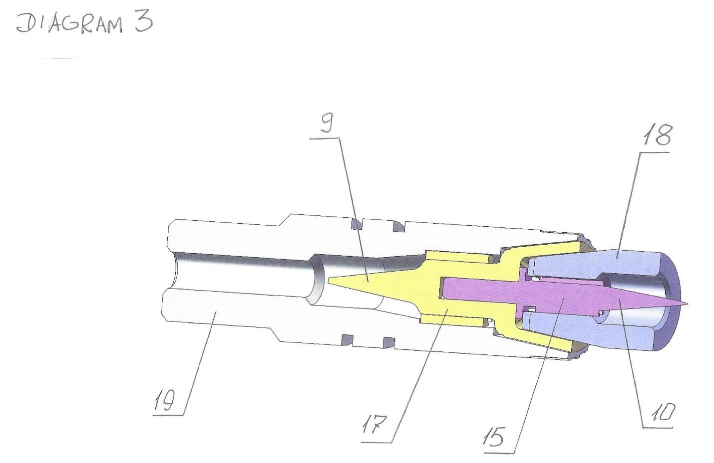
Figure (diagram) 3.
Diagram 3 shows the zone of the integral interface of the device for mixing, homogenizing, and activating liquid mixtures, liquids, and compressed gases, or several compressed gases.
The specified zone is shown in axial cross-section.

The numbers in Diagram 3 indicate:
9 - the first conical reflector along the direction of movement of the mixture components, which is part of the hydrodynamic interface; this reflector in the device performs the function of transforming the cylindrical flow of a mixture component into an annular flow with a more homogeneous turbulent background.
10 - the second conical reflector along the direction of movement of the mixture components, which, depending on the nature of the mixture components, forms part of either the hydrodynamic or aerodynamic interface; the apex of the conical surface of reflector 10 is directed opposite to the apex of reflector 9.
15 - a reverse element of the integral aerodynamic or hydrodynamic interface of the device for mixing, homogenizing, and activating liquid mixtures, liquids, and compressed gases, several compressed gases.
17 - a direct element of the integral aerodynamic or hydrodynamic interface of the device for mixing, homogenizing, and activating liquid mixtures, liquids, and compressed gases, several compressed gases.
18 - a multifunctional hydrodynamic or aerodynamic section of the device for mixing, homogenizing, and activating liquid mixtures, liquids, and compressed gases, several compressed gases.
19 - an inlet channel of the device for mixing, homogenizing, and activating liquid mixtures, liquids, and compressed gases, several compressed gases.
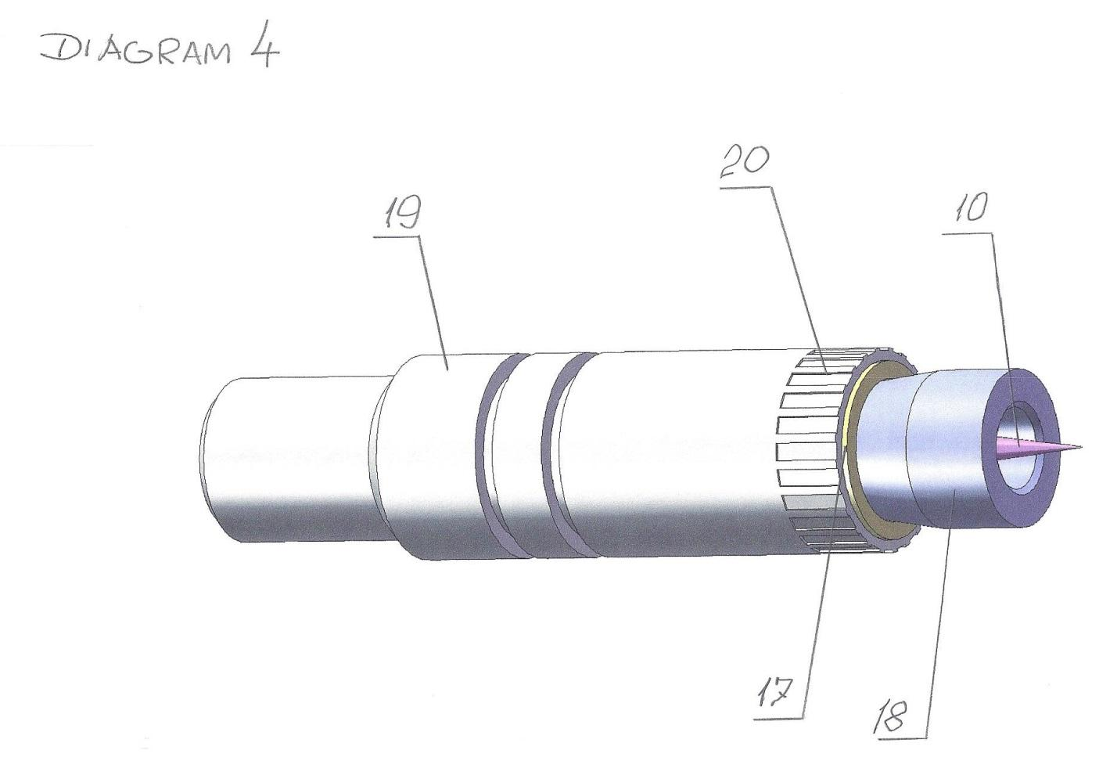
Figure (diagram) 4.

Diagram 4 shows the zone of the integral interface included in the device for mixing, homogenizing, and activating liquid mixtures, liquids, and compressed gases, or several compressed gases.

The numbers in Diagram 4 indicate:
10 - the second conical reflector along the direction of movement of the mixture components, which, depending on the nature of the mixture components, forms part of either the hydrodynamic or aerodynamic interface; the apex of the conical surface of reflector 10 is directed opposite to the apex of reflector 9.
17 - a direct element of the integral aerodynamic or hydrodynamic interface of the device for mixing, homogenizing, and activating liquid mixtures, liquids, and compressed gases, several compressed gases.
18 - a multifunctional hydrodynamic or aerodynamic section of the device for mixing, homogenizing, and activating liquid mixtures, liquids, and compressed gases, several compressed gases.
19 - an inlet channel of the device for mixing, homogenizing, and activating liquid mixtures, liquids, and compressed gases, several compressed gases.
20 - a system of uniformly distributed channels through which flow 3 of the mixture component, which may be water, methanol, or ethanol (flow 3 is indicated in Diagram 2), is introduced into the zone of the device for mixing, homogenizing, and activating liquid mixtures, liquids, and compressed gases, or several compressed gases, functionally intended for intensive dynamic mixing and homogenization of mixture components according to turbulence level.

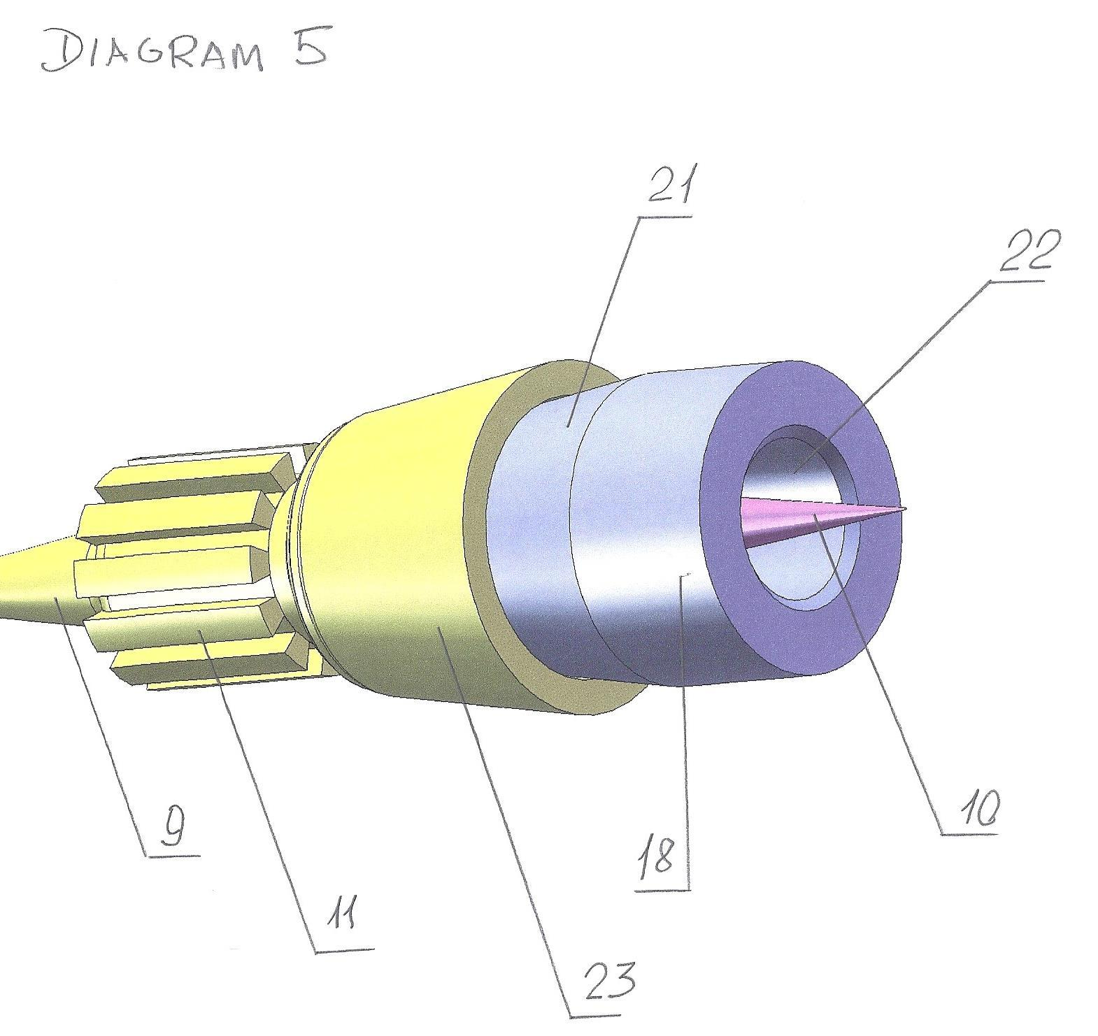
Figure (diagram) 5.
Diagram 5 shows the main structural elements of the integral interface of the device for mixing, homogenizing, and activating liquid mixtures, liquids, and compressed gases, or several compressed gases, structurally and functionally combined with the multifunctional hydrodynamic or aerodynamic section of the device for mixing, homogenizing, and activating liquid mixtures, liquids, and compressed gases, or several compressed gases.

The numbers in Diagram 5 indicate:
9 - the first conical reflector along the direction of movement of the mixture components, which is part of the hydrodynamic interface; this reflector in the device performs the function of transforming the cylindrical flow of a mixture component into an annular flow with a more homogeneous turbulent background.
10 - the second conical reflector along the direction of movement of the mixture components, which, depending on the nature of the mixture components, forms part of either the hydrodynamic or aerodynamic interface; the apex of the conical surface of reflector 10 is directed opposite to the apex of reflector 9.
11 - a system of linear, predominantly capillary channels uniformly distributing the annular flow of mixture components across the annular cross-section while simultaneously increasing the turbulence level and linear velocity of the flow of mixture components; this system belongs to the integral hydrodynamic interface of the device for mixing, homogenizing, and activating liquid mixtures, liquids, and compressed gases, or several compressed gases.
18 - a multifunctional hydrodynamic or aerodynamic section of the device for mixing, homogenizing, and activating liquid mixtures, liquids, and compressed gases, several compressed gases.
21 - a conical surface forming channel 8.
22 - a channel for introducing the second component of the mixture, either in the form of a 100% gaseous component or in the form of 40% of the main liquid component of the mixture.
23 - a conical surface forming channel 7.
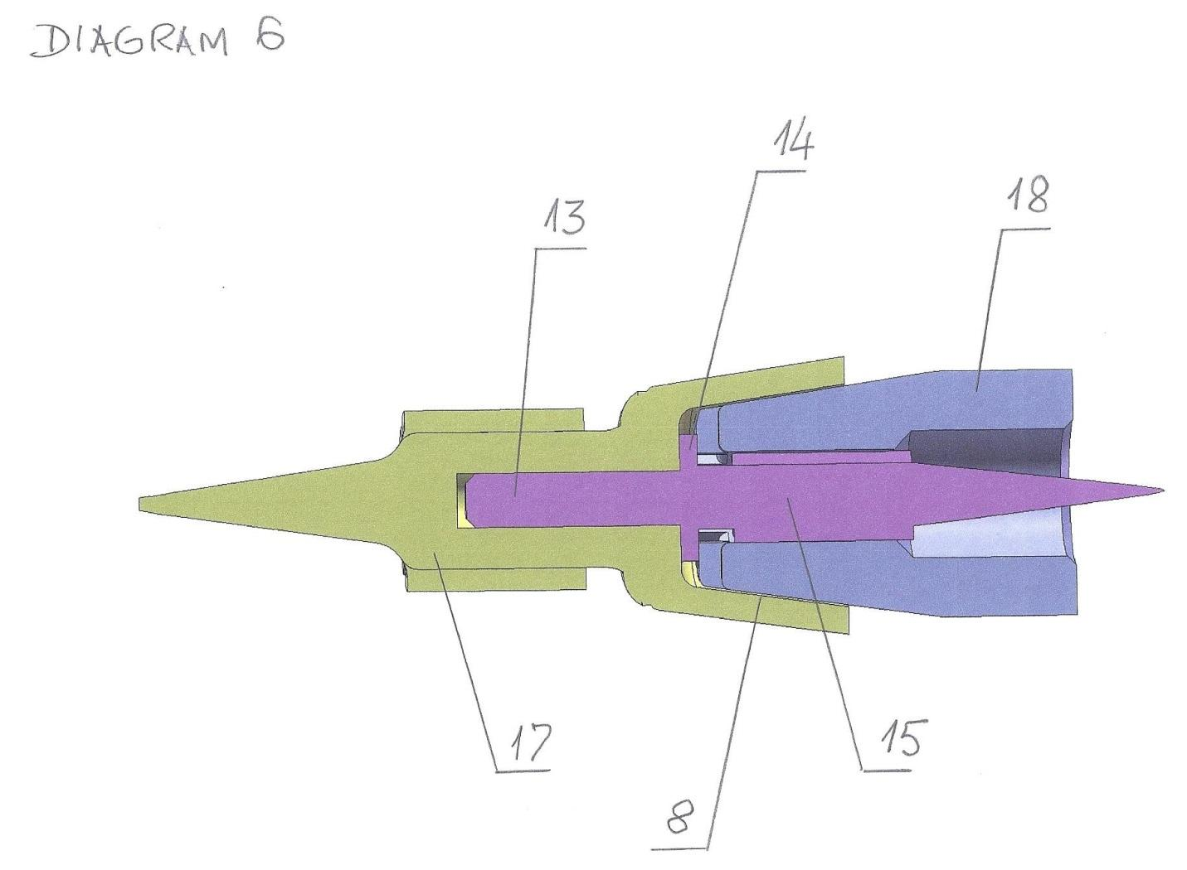
Figure (diagram) 6.
Diagram 6 shows an axial cross-section of the integral interface of the device for mixing, homogenizing, and activating liquid mixtures, liquids, and compressed gases, or several compressed gases.

The numbers in Diagram 6 indicate:
8 - a conical channel with a distance of 25 microns between the conical forming surfaces, which is also part of a system homogenizing the flows of mixture components according to turbulence level, consisting of two coaxial conical annular channels of the device for mixing, homogenizing, and activating liquid mixtures, liquids, and compressed gases, several compressed gases.
13 - a guiding, centering, fixing, and spacing pin of the integral interface of the device for mixing, homogenizing, and activating liquid mixtures, liquids, and compressed gases, several compressed gases.
14 - a guiding, centering, fixing, and spacing flange of the integral interface of the device for mixing, homogenizing, and activating liquid mixtures, liquids, and compressed gases, several compressed gases, by means of which the distance between the conical surfaces of annular conical channel 8 is adjusted.
15 - a reverse element of the integral aerodynamic or hydrodynamic interface of the device for mixing, homogenizing, and activating liquid mixtures, liquids, and compressed gases, several compressed gases.
17 - a direct element of the integral aerodynamic or hydrodynamic interface of the device for mixing, homogenizing, and activating liquid mixtures, liquids, and compressed gases, several compressed gases.
18 - a multifunctional hydrodynamic or aerodynamic section of the device for mixing, homogenizing, and activating liquid mixtures, liquids, and compressed gases, several compressed gases.

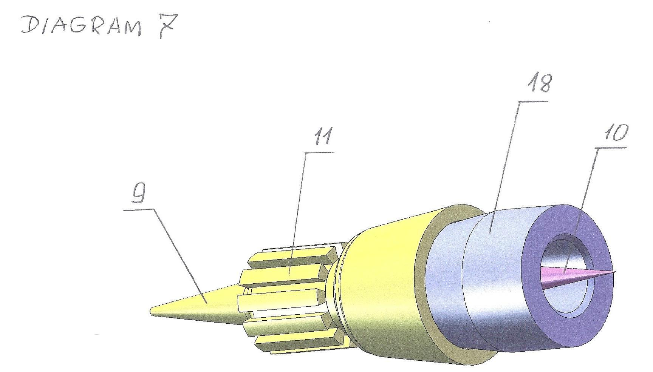
Figure (diagram) 7.
Diagram 7 shows the integral interface of the device for mixing, homogenizing, and activating liquid mixtures, liquids, and compressed gases, or several compressed gases.

The numbers in Diagram 7 indicate:
9 - the first conical reflector along the direction of movement of the mixture components, which is part of the hydrodynamic interface; this reflector in the device performs the function of transforming the cylindrical flow of a mixture component into an annular flow with a more homogeneous turbulent background.
10 - the second conical reflector along the direction of movement of the mixture components, which, depending on the nature of the mixture components, forms part of either the hydrodynamic or aerodynamic interface; the apex of the conical surface of reflector 10 is directed opposite to the apex of reflector 9.
11 - a system of linear, predominantly capillary channels uniformly distributing the annular flow of mixture components across the annular cross-section while simultaneously increasing the turbulence level and linear velocity of the flow of mixture components; this system belongs to the integral hydrodynamic interface of the device for mixing, homogenizing, and activating liquid mixtures, liquids, and compressed gases, or several compressed gases.
18 - a multifunctional hydrodynamic or aerodynamic section of the device for mixing, homogenizing, and activating liquid mixtures, liquids, and compressed gases, several compressed gases.
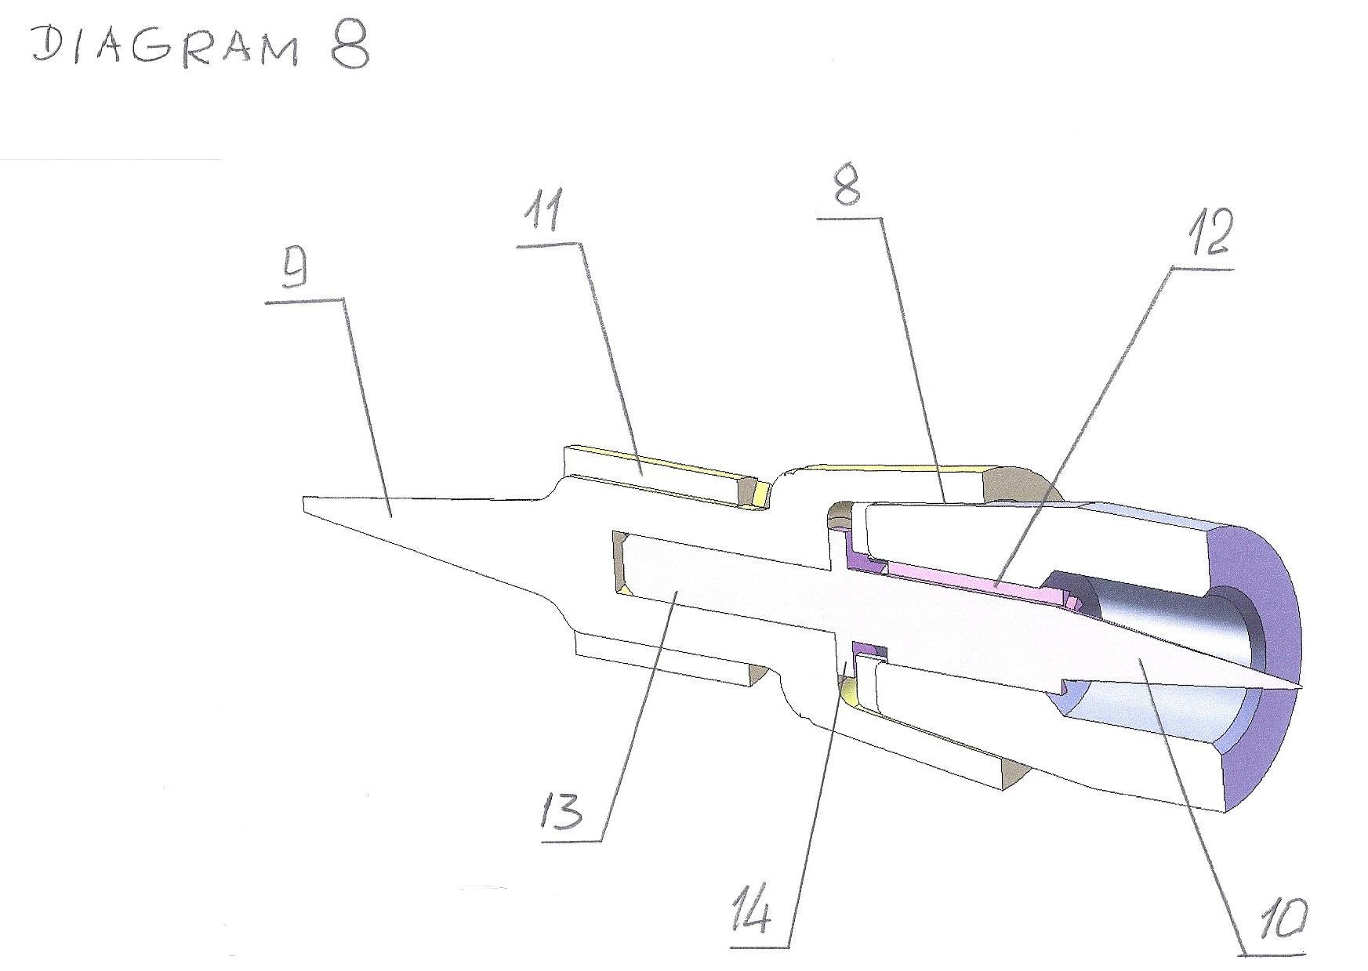
Figure (diagram) 8.

Diagram 8 shows a three-dimensional image of the integral interface of the device for mixing, homogenizing, and activating liquid mixtures, liquids, and compressed gases, several compressed gases, in axial cross-section.

The numbers in Diagram 8 indicate:
8 - a conical channel with a distance of 25 microns between the conical forming surfaces, which is also part of a system homogenizing the flows of mixture components according to turbulence level, consisting of two coaxial conical annular channels of the device for mixing, homogenizing, and activating liquid mixtures, liquids, and compressed gases, several compressed gases.
9 - the first conical reflector along the direction of movement of the mixture components, which is part of the hydrodynamic interface; this reflector in the device performs the function of transforming the cylindrical flow of a mixture component into an annular flow with a more homogeneous turbulent background.
10 - the second conical reflector along the direction of movement of the mixture components, which, depending on the nature of the mixture components, forms part of either the hydrodynamic or aerodynamic interface; the apex of the conical surface of reflector 10 is directed opposite to the apex of reflector 9.
11 - a system of linear, predominantly capillary channels uniformly distributing the annular flow of mixture components across the annular cross-section while simultaneously increasing the turbulence level and linear velocity of the flow of mixture components; this system belongs to the integral hydrodynamic interface of the device for mixing, homogenizing, and activating liquid mixtures, liquids, and compressed gases, or several compressed gases.
12 - a system of linear, predominantly capillary channels uniformly distributing the annular flow of mixture components across the annular cross-section while simultaneously increasing the turbulence level and linear velocity of the flow of mixture components; this system belongs to the second part of the integral hydrodynamic or aerodynamic interface of the device for mixing, homogenizing, and activating liquid mixtures, liquids, and compressed gases, several compressed gases.
13 - a guiding, centering, fixing, and spacing pin of the integral interface of the device for mixing, homogenizing, and activating liquid mixtures, liquids, and compressed gases, several compressed gases.
14 - a guiding, centering, fixing, and spacing flange of the integral interface of the device for mixing, homogenizing, and activating liquid mixtures, liquids, and compressed gases, several compressed gases, by means of which the distance between the conical surfaces of annular conical channel 8 is adjusted.
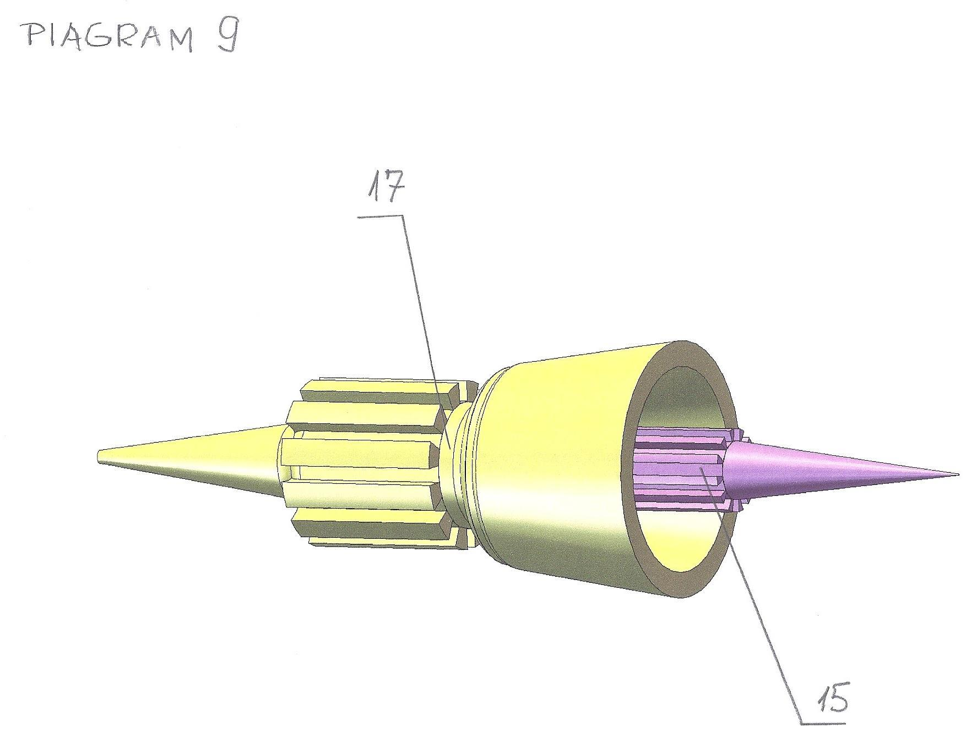
Figure (diagram) 9.
Diagram 9 shows both basic elements of the integral interface of the device for mixing, homogenizing, and activating liquid mixtures, liquids, and compressed gases, or several compressed gases.
Each of the constituent elements of the integral interface performs functions of dynamic transformation of the shape and geometric structure of the flow, expressed in the transformation of a cylindrical flow into an annular flow and in the exclusion from the flow of its central part, where the turbulence level is the lowest.
The form and functions of the integral interface are new and sufficient for the application of the integral interface as an autonomous independent element in hydrodynamic systems with a cylindrical flow configuration.

The numbers in Diagram 9 indicate:
15 - a reverse element of the integral aerodynamic or hydrodynamic interface of the device for mixing, homogenizing, and activating liquid mixtures, liquids, and compressed gases, several compressed gases.
17 - a direct element of the integral aerodynamic or hydrodynamic interface of the device for mixing, homogenizing, and activating liquid mixtures, liquids, and compressed gases, several compressed gases.

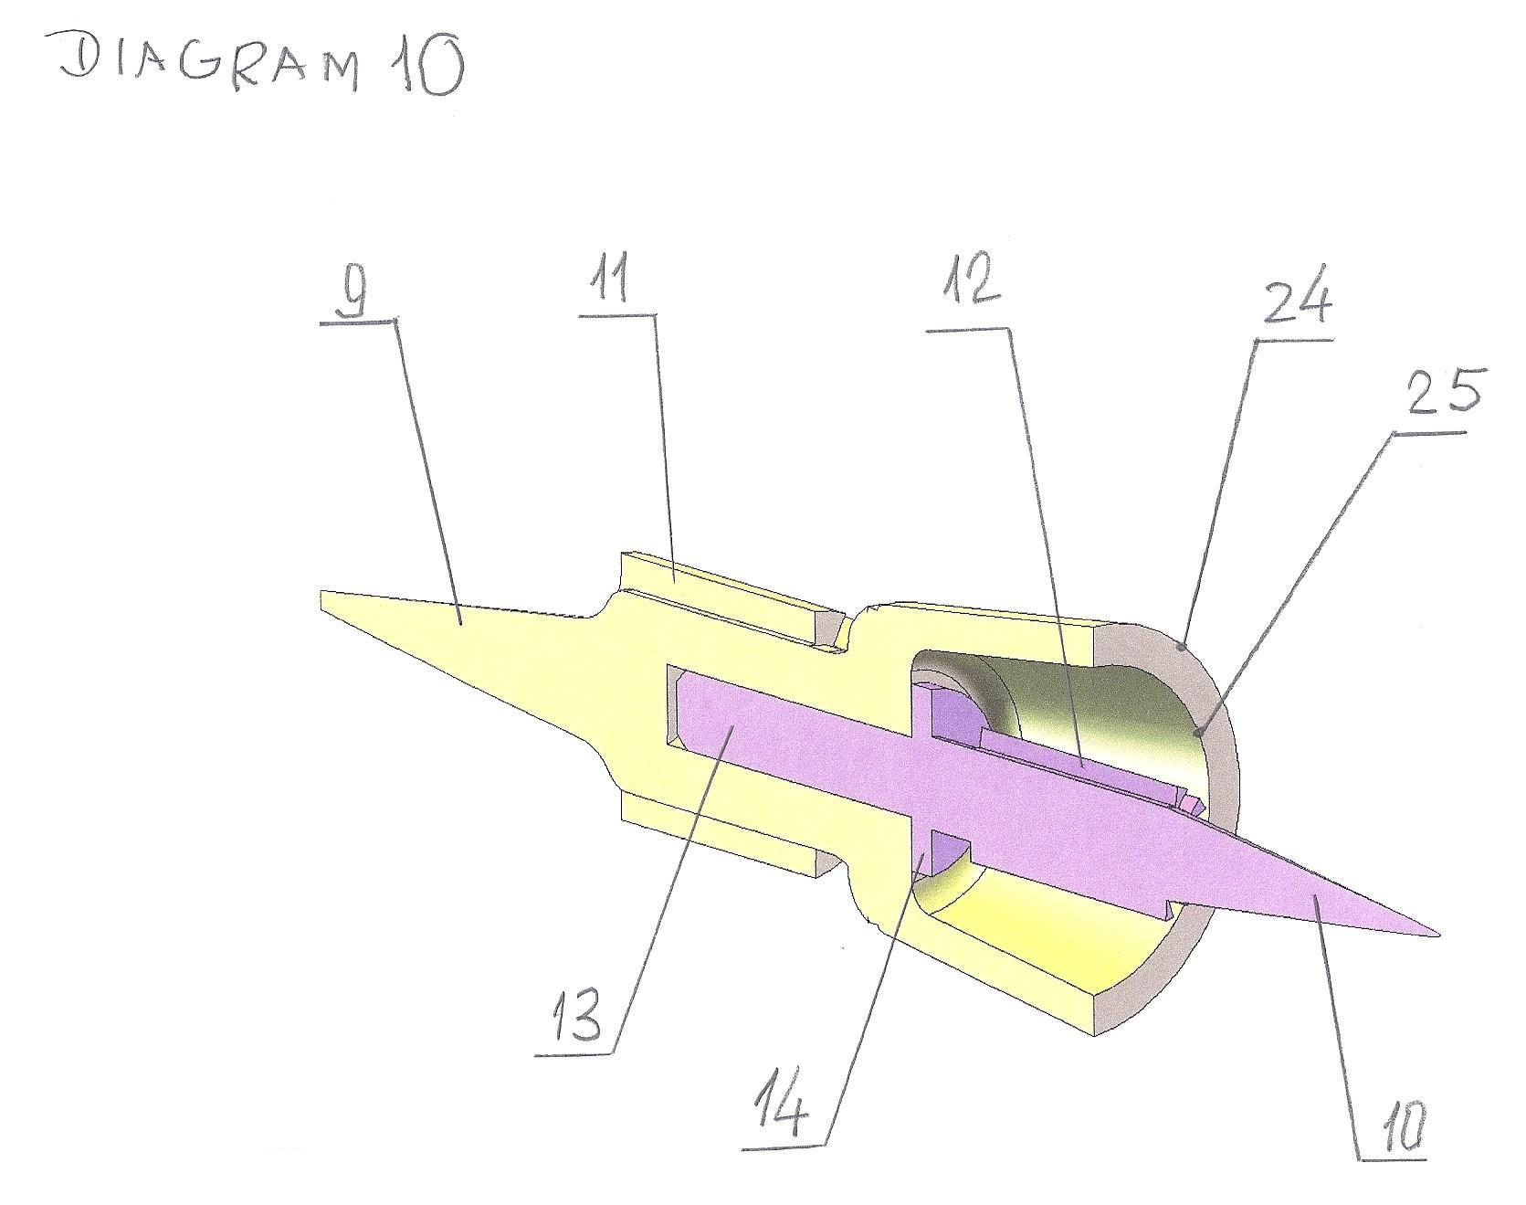
Chart (diagram) 10.
The diagram shows an axial cross-section of the integral interface of the device for mixing, homogenizing, and activating liquid mixtures, liquids, and compressed gases, several compressed gases.
Both structural and functional elements of the interface are connected to each other by pin 13; flange 14 limits and fixes the relative position of both elements with respect to each other.

The numbers in the diagram indicate:
24 - a conical surface forming the inner surface of the outer annular conical channel, the distance between the forming surfaces of which is 100 microns.
25 - a conical surface forming the outer conical surface of the inner annular conical channel, the distance between the forming surfaces of which is 25 microns.
This type of interface in the device for mixing, homogenizing, and activating liquid mixtures, liquids, and compressed gases, several compressed gases, performs the fundamental functions of transforming the flows of mixture components and provides all necessary changes in the trajectory and direction of movement of the flows of mixture components, which carry out homogenization of the uniformity level of the turbulent properties of the mixture, specifically by increasing the turbulence level in the center of the flow and homogenizing it with the turbulence level at the periphery of the flow.

Such an element is fundamentally new from structural, configurational, and functional points of view, as well as from the standpoint of ensuring the achievement of the entire set of objectives defined in the invention:
- ensuring the execution of the entire process of mixing and homogenization of mixture component flows according to turbulence level;
- ensuring the possibility of performing all functions of the device for mixing, homogenizing, and activating liquid mixtures, liquids, and compressed gases, several compressed gases, without the use of moving parts;
- forming a coaxial flow of the mixed components and transforming it into a mixture flow with a homogenized turbulence level;
- performing all functions of the device for mixing, homogenizing, and activating liquid mixtures, liquids, and compressed gases, several compressed gases, with a minimum number of structural components.
List of references, patent and licensing materials:
- Device for Producing a Gaseous Fuel Composite and System of Production Thereof. United States Patent Application US 20170184055 A9, published June 29, 2017.
- Device for Mixing Fluids. United States Patent Application US 20160207013 A1, published July 21, 2016.
- Method of Dynamic Mixing of Fluids. United States Patent Application US 20100243953 A1, published September 30, 2010.
- Dynamic Mixing of Fluids. United States Patent Application US 20100281766 A1, published November 11, 2010.
- Engine with Integrated Mixing Technology. United States Patent Application US 20110048353 A1, published March 3, 2011.

