THE MANAGEMENT OF VALUABLE ORIENTATIONS OF YOUNG SPECIALISTS IN CIVIL SERVICE DURING THEIR PROFESSIONALISM PROCESS.

AUTHOR: KATKOV I. M.
KATKOV Ivan Mikhailovich - Ph.D. in Sociology (Oxford). Address: 34, 15 line, Saint Petersburg, 199178 Tel.: +7 (812)321-73-30, +7 (981)112-09-86 E-mail: katkovs@yandex.ru.

Annotation
The article ‘The Management Of Valuable Orientations Of Young Specialists In Civil Service during Their Professionalism Process’ of Ivan Mikhailovich Katkov concentrates on the aspects of processes of personal socialization and professionalism of young specialists in civil service.
It shows social base of Civil Service definition and its parts. The goal of research is to approbate the author model of management of valuable orientations of young specialists in civil service during their professionalism process.
The ideological core is finding the resolution of existing problems of management of the spiritual formation and development processes, and also forming optimal conditions and instruments for the development of moral education system of young specialists in civil service.
The results of a scientific research achieved by author could be used in modernization in personnel policy in civil service and development of a young civil servants spirituality upbringing system.
The author’s technical contribution is stated in the development of a social model of management of forming of valuable orientations of young specialists in civil service during their professionalism process. Author also showed us the meaningful closer definition of civil servant, civil service.

Key words: civil service, young specialists, socialization, professionalism, culture, subculture, personality, valuable orientations.

The law concepts, enshrined in the Federal Law No. 79 of July 27, 2004define public civil service as “a type of the public service representing professional official activities of citizens of the Russian Federation at positions of the public civil service of the Russian Federation on ensuring execution of powers of federal government agencies, government agencies of subjects of the Russian Federation" [Federal Law Russian Federation, N 79 of 27.07.2004 "On public civil service of the Russian Federation". Art. 3].
In sociological meaning, the public civil service is a link between the state and society, and the sphere of professional activity on protection of the rights and interests of citizens. Public service is also a form of manifestation of public relations and the communications, efforts and ways reach the constitutional ideal of the state to objective reality, represents not only political and legal, but also ethical system of the authoritative relations.
Values of professional activity of public servants and employees of deputy corps are the base of their organizational behavior. Level of corporate culture development of the public civil service and personal values of the public civil servants form moral shape of the government representatives in society’s mind.
From a law definition, the public civil servant is the citizen of the Russian Federation who are responsible for being on the civil service, carried out according to the act of appointment to the post and with the office contract also receives the monetary allowance at the expense of means of the federal budget or budget of the subject of the Russian Federation [Federal Law Russian Federation, N 79 of 27.07.2004 "On public civil service of the Russian Federation". Art. 13].
From a sociological definition, the public civil servant is a professional worker, the representative of the government who is carrying out the activity on a basis both legal and the spiritual, moral standards accepted in the professional environment. Professionalism, level of personal moral qualities, and valuable bases of the identity of the public civil servant directly depend on conditions of his socialization and professionalizing.
The valuable foundation of the person of the public civil servant is formed at the first stages of socialization, and personality of the young specialist itself, future professional is formed all the way of socialization and is object of management. Society is the subject of management. It carries out social control on public institutes and comes as a regulator of this process.
We define a personality of a public civil servant as his position in a system of the public relations and an individual set of social and psychological properties. According to V. A. Maltsev, the personality of the public civil servant represents the set of social properties of the individual, which is characterized by specific social, psychological and personal features. as V. A. Maltsev describes the personality like an organic unity of rationality, spirituality, sensuality [Maltsev V. A., the State programming - a method problem, 2004. T. 9. No. 9. Page 24-27].
In scientific literature many definitions of the concept "socialization" are presented. The following one can be one of the most exact. Socialization is a "process and result of development by separately taken person available and personally to it necessary social experience" [Nemov R. S., the Psychological dictionary. 2007. Page 408]. The essence of concept of socialization of the personality consists in the following thing. Socialization is a difficult and multilevel process of acquisition and realization of social and life experience by the personality in daily practice.
three stages of socialization are defined at classical sociological school: before-labor, labor, post-labor. Before-labor socialization is carried out by the socializing institutes: family, preschool child care facilities, school, professional education establishments, labor collectives, organizations, public organizations, informal associations, etc.
Labor and post-labor socialization are provided with agents of socialization. Agents of socialization are people, institutions and social institutes which assistance goes near the socialization of the person. You can find in them the world important personalities, statesmen, scientists and art workers.
You can also range the periods in socialization. One of the periods is primary socialization. It covers the time personality spent at institute of a family where the main valuable orientations of the person are constructed and the first social experience is gained. Close people (brothers, sisters, etc.) carriers cultural and moral samples. Child reflex unconsciously "grabs" and acquires those values which are present at the social atmosphere of a family.
Process of socialization has no accurately designated final point, therefore, and accurate time frames. Conditionally process of partial socialization of the individual was designed on the basis of passing of three socializing institutes: family, school, high school.
One of socialization stages is an entrance of the individual in the labor and legal relations; this stage is defined as professionalizing. Process of professionalizing begins with the moment of accumulation of necessary amount of theoretical professional knowledge. The beginning of labor practice of the individual is the beginning of its formation as professional. Necessary professional knowledge, skills, and norms of professional ethics as well are formed during the personality professionalizing. From the author’s point of view, the professionalizing is a process of formation and professionalism development.
Professionalizing of the personality is based on two interconnected components: 1) formation of professional consciousness expressed in psychological aspect of professionalizing and reflected in concept - professional development; 2) formation of professional skills on the basis of assimilation of social and professional norms. It promotes formation of the personality as a professional activity subject and is expressed in the social aspect reflected in the concept "professional socialization".
Basic elements of primary professionalizing are professional education and a vocational education. The great value during secondary professionalizing gets professional self-education. We see it as an aspiration of the personality to creative development of own professional skills. It is obviously possible to construct model of management of socialization and professionalizing of the young specialist based on the considered provisions. You can see the model on picture 1.
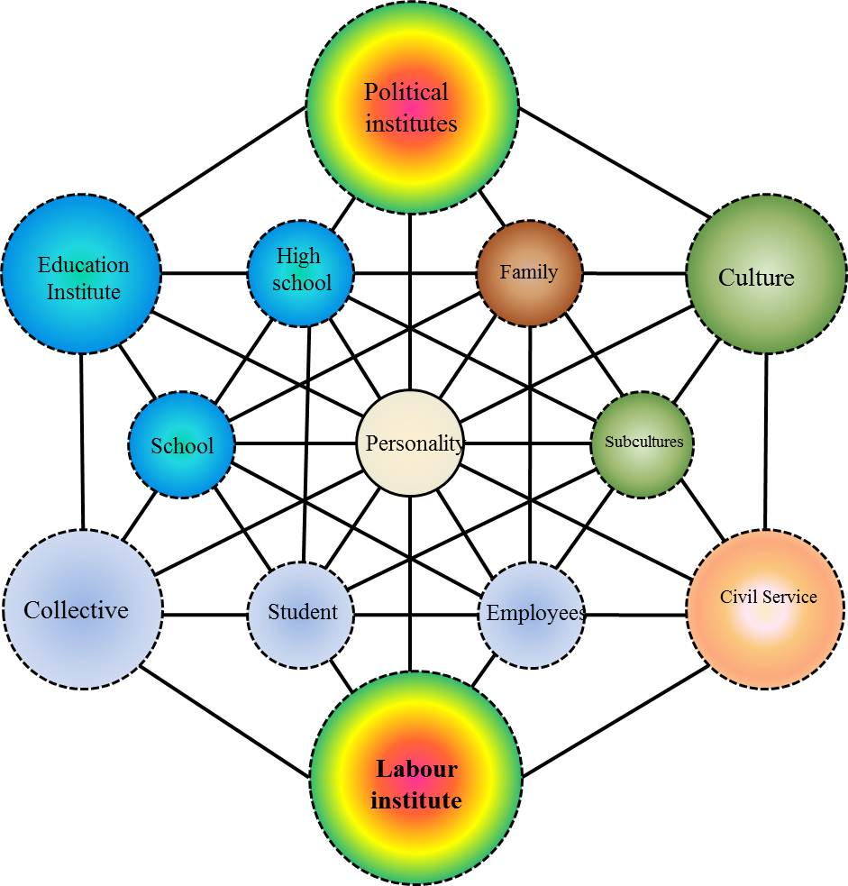

Picture 1 - Model of management of socialization and professionalizing of the young specialist of the public civil service
This model is agent based, which belongs to the class of imitating models. The feature of such model is poly-subjectness. Each of the elements presented in the model, except the of the young specialist personality, is the subject of management; each of subjects (agents) interacts with others [Klebanov B. I., Moskalyov I. M, Begunov N. A. Multi-agent imitating model of municipality / Imitating modeling. Theory and practice. 2007. T. 2. Page 86-90].
Great number of agents organize agent systems. The agent is some kind of essence, which is active, autonomous behavior which in forces to make decisions according to some set of rules to interact with an environment, independently to change, and to create round itself new conditions [Lychkina N. N., Morozov U.A Imitating modeling of the social sphere. 2011. Page 25].
The main difference of this model from other models is lack of the centralized definition of behavior (dynamics) of system in general. Because of it, the analyst defines behavior at the individual level, and the global behavior arises as result of activity of many agents (hundreds, thousands, millions), where everyone conforms to the own rules, lives in the common environment and interacts with it and with other agents [Lychkina N. N., Kobylkin M. N. Modeling of the social sphere based on methods of system dynamics, 2006. Page 1009-1023].
We will pay attention that the subject presented by the public civil service has "modular" character, so it can be replaced with any other social agent according to the researcher’s purposes. Property of the author's system’s modularity gives to it universality of application in models of management creation with a great number of subjects and subject systems.
Let’s see a ratio of social agents and the agent systems participating in process of socialization and professionalizing of the young specialist of the public civil service in the table (table 1).
Table 1-Social agents and agent systems.
№ П/П | Social agents | Agent systems
1 | Government political institutes | Institution systems, represented by schools and high schools
2 | The labor institute | Two types of collectives: student and employees
3 | Family | Culture and subcultures
4 | Civil service | Social organization culture of public servants

The author's scheme (Picture 1) is based on ordering of agents principle which consists of geometrical figures and their proportions. For this model, the number of social agents is equal to twelve. However, their real quantity is enormously big. This reason makes the author look through those social institutes, which influence needs to be studied within this dissertation research.
Eight of the agents presented to models organize three agent systems. You can see how six large agents forming big, or external, hexagon on the scheme; every agent is one of its corners. Other six agents form small, or internal hexagon. One of them are companions of large agents, creating with them agent systems, others play a role of independent agents.
Large agents have 5 connections. The smaller size agents have 7 connections. The individual in the center of the model has 12 connections because it is connected with each agent by direct or indirect link. All geometrical harmony of model is based on triangles. Thus, all social agents are located in corners of triangles and form strictly ordered and built system. All elements of system are in interrelation by means of either the direct, or mediated connections through adjacent agents.
The control system needs the presence of object and subject of management. In the model, that we are looking through, the object of management is the system of values of the identity of future young specialist of the public civil service. The public civil service acts as the subject of management. However the subject has no sharp borders. It is expressed through its components: culture of the social organization of the public civil service, labor collective, subcultures. It gives to the researcher opportunity of observation of influence separately of every part of the subject.
We understand the culture of social organizational public civil service like a system of values and social and cultures rules regulating its owners ‘behavior. The labor collective is a group of people who deal with the tasks given to them. The relations in such group are regulated by values of labor collective, which are formed under the influence of organizational culture. Personal, professional and cultural wealth, any representative of labor collective is shown in their social positions.
The subculture is a part of the culture, consolidating idea, values, outlooks of people which are united by the common goals and motives allowing to develop individual and group positions to other subcultures and culture of society in general [I.M. Katkov, Development of subcultures classification. 2014. Page 41].
The listed elements make subject of management – the public civil service. Note that the public civil service can be submitted by a large number of components, but it is enough for us to look through the listed elements. General number of subjects in the model offered by the author can vary depending on needs of the researchers studying various sociocultural phenomena.
The public civil service is one of subjects of management. The purpose of the subject is to form necessary valuable reference points of the young specialist of the public civil service. It is necessary to define tools to achieve purpose. The most influential elements of system - political institutes because their influence is traced at all levels of social life.
This influence is expressed in regulation of behavior and human relations at the level of legally consolidated norms and sanctions corresponding to them. However, the influence nature piercing everything does not indicate its universality, because regulation based on legal norms does not extend on area of the spiritual relations of people.
Thus, political institutes as the social subject influence other elements of system at the level of the legal relations. Therefore, the public civil service as the subject of social management has to operate with legal tools. It can be expressed in specific proposals of training programs modification of higher educational institutions in case of developing valuable orientations of the student’s personality, education in him feeling of civic consciousness and patriotism.
The family, working and educational collectives and subcultures also influence on process of formation of valuable orientations of the young specialist personality. Political institutes indirectly influence a personality, through other social agents, such as a family and collectives in which the person presents in fact.
Since the main feature of model is influence of each element to each other, political institutes impact on subcultures via social factors. The public civil service can influence subcultures through political institutes which in its turn influence the personality through social factors.
Observation the model presented in picture 1 gives us possibility to allocate the stable social relations forming the microsocial systems visualized as graphic elements – triangles. Such steady social systems are: the educational - labor collectives - the personality; school – higher education institution – the personality; higher education institution – a family – the personality; a family – subculture – the personality; the public civil service – political institutes – the personality; collective – political institutes – the personality; the public civil service – labor collective – the personality.
Valuable orientations are one of the powerful factors influencing professionalizing of young specialists of the public civil service. Therefore we consider it expedient to describe the mechanism of formation of valuable orientations of young specialists. The elements forming valuable orientations of the young specialist of the public civil service are values of organizational culture of the public civil service and value of labor collective.
Values of culture of the social organization of the public civil service contains standards of behavior, communication culture, humanistic values, labor values. They are also one of behavior regulators group in the relations of the public civil service system.
Values of labor collective is a system of norms, the behavioural and cultural samples reproduced in practice of collective and being regulators of the social relations in it.
The system of values of the young specialist of the public civil service is a set of cultural and professional wealth. The young specialist builds the relations in society according to this system. Valuable orientations of the young specialist of the public civil service is the relation of the young specialist to the material and spiritual benefits, which are ways to satisfy his requirements.
Thus, values of organizational culture of the public civil service form values of labor collective and influence system of values of the young specialist of the public civil service. Valuable orientations of the young specialist of the public civil service develop under the influence of its own system of values, values of labor collective and values of organizational culture of the public civil service.
The developed valuable orientations of the young specialist are regulators of his professionalizing. Young specialist develops a social position to all system of the relations of the public civil service according to them. In case of rejection of any values of organizational culture of the public civil service, it can break the professionalizing as a process of acquisition of necessary professional qualities and values of a profession.
From the author’s point of view, the successful and effective management of formation of valuable orientations of young specialists of the public civil service during their professionalizing has to be based on the principles of continuity and adaptation of moral values, social and labor norms and rules in modern conditions. Control should be executed through influence of social and political institutes and their interactions. The foundation of formation given and fixed valuable orientations of young specialists of the public civil service should be the state policy of social education of moral qualities of youth.

References:
- Federal Law Russian Federation, N 79 of 27.07.2004 "On public civil service of the Russian Federation". Art. 3
- Maltsev V. A., the State programming - a method problem, 2004, T. 9, No. 9, pp. 24-27
- Nemov R. S., the Psychological dictionary, 2007, 408 p.
- N. A. Begunov. Modeling of development of municipalities based on the agent approach. Modern researches of social problems, 2011, T. 8, No. 4, – 1 p.
- Klebanov B. I., Moskalyov I. M, Begunov N. A., Multi-agent imitating model of municipality, Imitating modeling. Theory and practice, 200, T. 2, pp. 86-90
- Lychkina N. N., Morozov U.A Imitating modeling of the social sphere. Germany: LAP LAMBERT Academic Publishing, 2011, 25 p.
- Lychkina N. N., Kobylkin M. N. Modeling of the social sphere based on methods of system dynamics. Works of the V international conference "Identification of Systems and purposes of Management" of SICPRO'06, M.: YIP RAHN, 2006. – pp. 1009-1023.
- I.M. Katkov, Development of subcultures classification. Ethnosociety and international culture, 2014, No. 1, pp 41-49.

