SMART TECHNICAL SYSTEMS OF MEASURING TECHNOLOGIES AND MEASURING EQUIPMENT, INTEGRATED IN COMPLEXES OF SMART MEDICAL TECHNOLOGIES, INCLUDING LASER DEVICES WITH ELEMENTS OF ARTIFICIAL INTELLIGENCE AND ARTIFICIAL NEURAL NETWORKS AS A FORM OF MACHINE LEARNING

Vladimir Nikiforov

Table of contents

Introduction 3
Stages and steps of development of a household or industrial device for controlling the quality of fluids, including drinking water or milk 36
Search for the optimal operating frequency of the sensor for building a monitoring system for one component of the mixture. 69
Preparation of samples for measurement 70
Scanning 71
Analysis of the results 71
Selecting the optimal detector 71
Search for the optimal operating frequencies of detectors for the building of a monitoring system for two components of the mixture. 73
Preparation of samples for measurement 73
Scanning 73
Analysis of the results 73
An option when there are frequencies at which there is a sensitivity only to one component. 74
An option when there are no frequencies at which there is sensitivity to only one component, but the obtained frequency samples do not coincide. 75
An option when the obtained frequency samples coincide. 75
Selecting optimal detectors 77
List of reference literature, patent, and licensed materials 80

Introduction
Currently, the so-called smart technologies are being introduced in almost all spheres of life, especially in the areas of high technology.

Technologies and equipment are the most important and decisive for the overall, innovative development of medical technologies and equipment, as well as materials and tools in the manufacturing sector.

At present, some features can be distinguished in this area. Let's look at the example of an announcement of a smart production pavilion at an exhibition in Silicon Valley, USA:
Where the Future of Manufacturing Goes Beyond Smart!
See and experience data-sharing breakthroughs that are creating smarter manufacturing processes, increasing yields and profits, and spurring innovation across the industry.
- Data Science and the Microelectronic Manufacturing and Design
- Best Known Practices, Guidelines, and Standards
- Secure Data Transfer
- The Road to the Smart, Digital and Connected Fab
- Smart Manufacturing in Packaging and Assembly
- Supply Chain Integration

All these branches of technological areas usually provide for the widespread use of elements of artificial intelligence and artificial neural networks or their equivalents in the systems of automatic control and checkout.

This is especially important when developing complex real-time control technologies for medical laser technologies using disposable appliances.

When changing the appliance, it is necessary to instantly measure the spectral background of the laser radiation and simultaneously monitor and measure other specified parameters.
The process can, normally, become more complicated if it is necessary to change the operating parameters of the radiation and the residual effect of previous operating factors of the laser system, including the heating of the laser diode and the structural elements of the laser diode module.
In this situation, elements of artificial intelligence and neural networks are necessary in order to monitor the correctness of the settings and the response of the device to the process control commands in real-time.

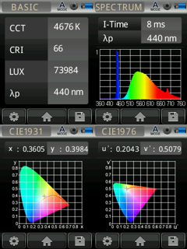

Figure 1. The figure shows a visual example of information displayed on the screen of a mobile device while monitoring the parameters of laser radiation of a medical laser device for highlighting the treatment process in the field of ophthalmology.

As you can see, the parameters shown are quite enough to establish the most optimal level and spectrum of radiation.

In such a system, a software application plays the role of artificial intelligence, and thanks to this role, at minimum cost, the user gets the maximum effect, with simultaneous full on-line monitoring in real-time.

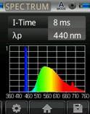
Figure 2. The figure shows a fragment of spectral information from the information board shown in Figure 1.
Such information is quite sufficient for quick analysis and appropriate response to optimize the working process of a device, apparatus or system and for fast communication with a technical system from the category of the supersystem.
The process of coordination of control and check commands should be combined with standard check and control parameters, one of which is the adjustment and control of the cooling system.
.
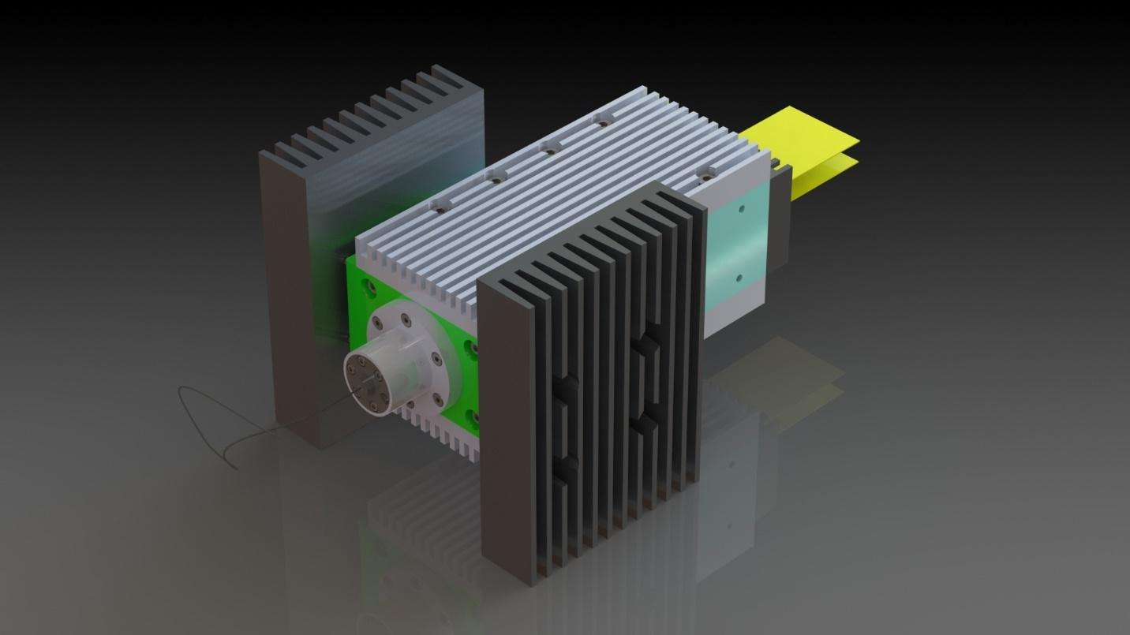
Figure 3. The figure shows the design of a laser system for use in medical technology. In this system, maximum attention was paid to cooling efficiency.
This was achieved through the use of composites materials such as a pseudo-porous structure, which consists of many spherical microcapsules, where the core is spherical and consists of artificial diamond, and the outer shell of the core is a ductile metal, such as copper or nickel, formed in the matrix, in the cold flow conditions.
The cores of an ideal dielectric-diamond create efficient heat dissipating in the system as a whole, which makes the cooling and maintaining the required temperature level processes stable and not expensive, with the exceptional simplicity of the design of the relevant parts and assemblies.

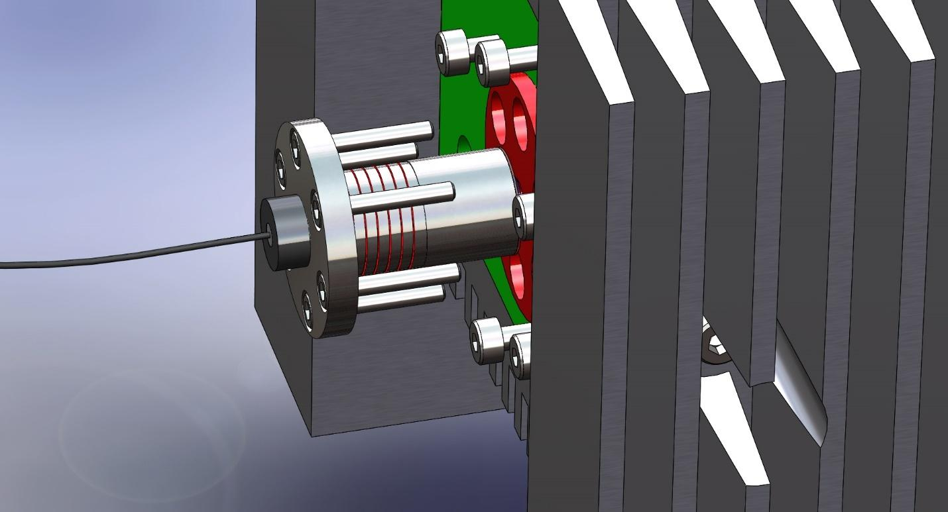
Figure 4. The figure shows a model of a laser module in which there is a coding or decoding system, which is extremely important when using disposable appliances
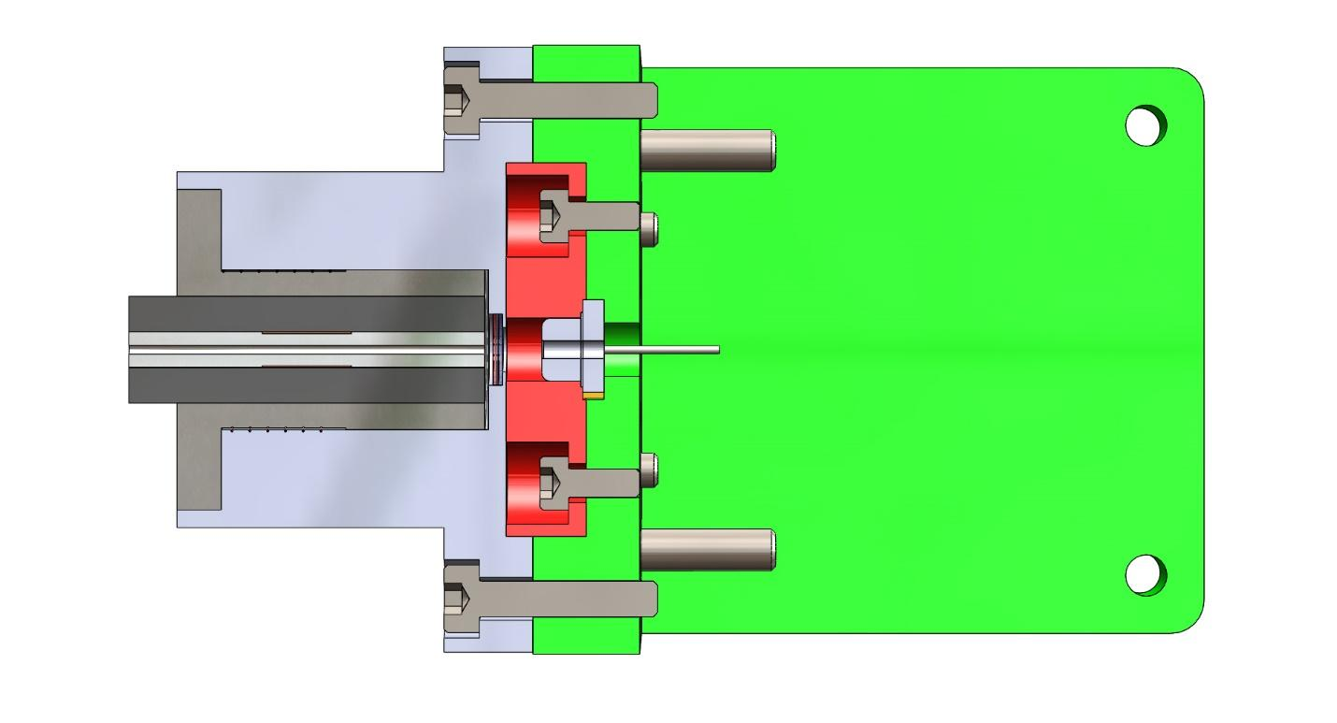
Figure 5. The figure shows the model of a laser module for working with disposable appliances based on optical fiber with a coding and decoding system that prevents connection of disposable appliances that do not match the programmed code to the system.
Control of compliance with the code is also carried out by methods of magnetic and resonant encoding and decoding.

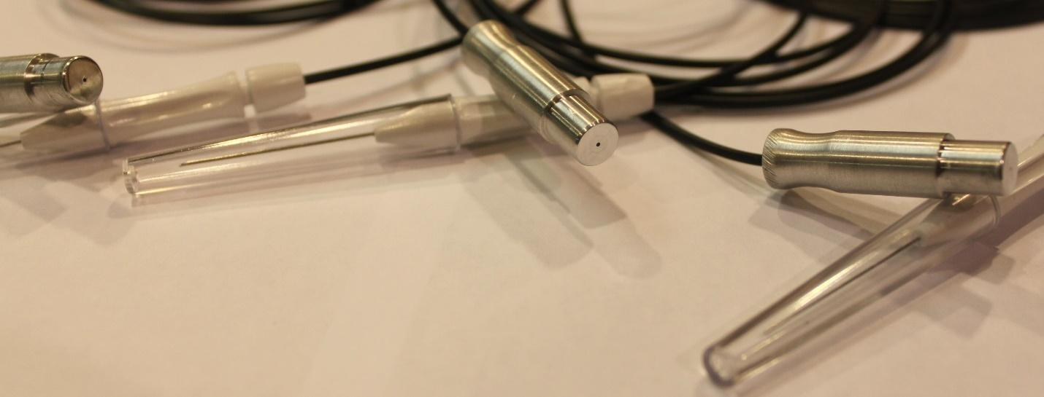
Figure 5-1. The picture shows photographs of disposable optical appliances with programmed codes for identification and counterfeit protection.
For disposable laser appliances, there are additional problems associated with the presence or absence of phosphors used to change the radiation spectrum or to protect an object for which radiation is emitted from direct laser radiation, which is toxic in some cases - for example, for living tissue.
For such a situation, the elements of artificial intelligence and, especially, neural networks, together, conduct a comparative analysis of the results and parameters of previous radiation factors as compared to the real radiation factors in a technical laser system, arising from an appliance change and potentially caused by even minimal differences in the composition and structure of the phosphor.
In addition, for comparison and analysis, feedback is often used, which shows the response of the object of radiation exposure to the whole complex of radiation parameters and characteristics, especially the slightest changes in spectral characteristics and energy saturation levels of radiation peculiar to previous therapeutic processes in comparison with the present ones that are being conducted constantly, in real-time and which are associated with the systems of regulation and checkup, including in the radio frequency driver.

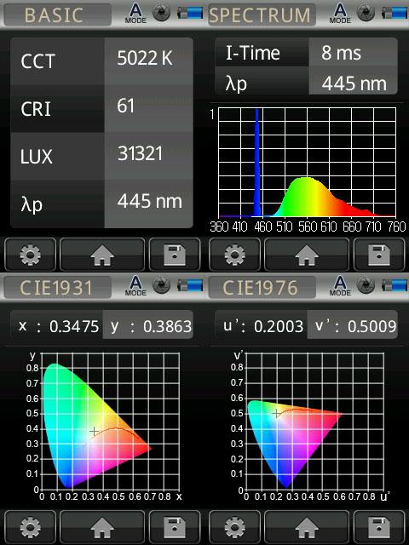
Figure 6. The figure shows the screen of the mobile device with the results of measuring the parameters of the ray of the laser diode
As can be seen from the figure, the presented parameters give a complete picture of the nature of the radiation of a laser diode, including the parameters of the radiation spectrum.
For use in the conditions of smart medical technologies such a range of measurement and control provides the operator with all the necessary information.
In general, the presented system is an example of the application of elements of artificial intelligence and neural networks in monitoring and control of laser appliances used for therapeutic purposes and requiring an instantaneous response to the slightest changes in the nature of the laser or laser diode radiation.
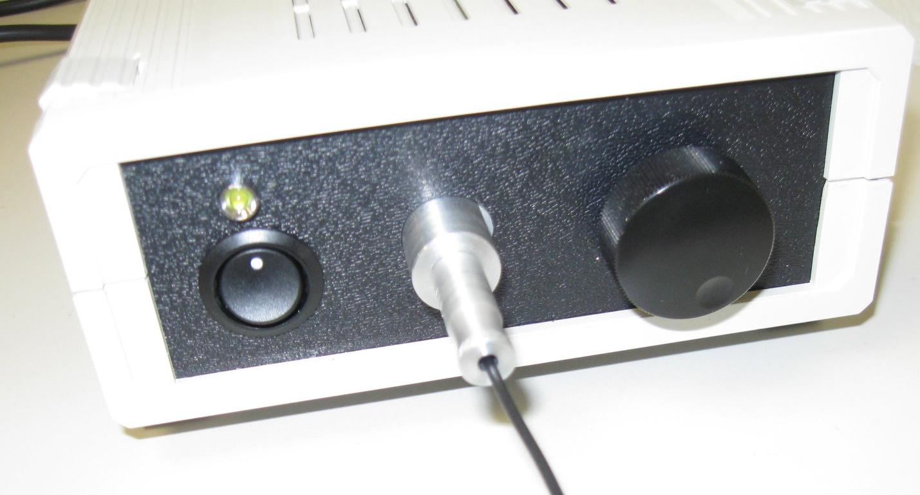
Figure 6–1. The figure shows a laser module with a radio frequency driver and disposable appliances, whose control of the code concurrence with the programmed code of the laser device is conducted using magnetic and resonance spectroscopy.
The use of a radio frequency driver can significantly expand the working range of the radiation, increase the rate of change of output parameters and, as a result, increase the energy parameters of the radiation, which in turn increases the risk of burn injuries and adds significance to the continuous analysis by using the potential of artificial intelligence and neural networks.
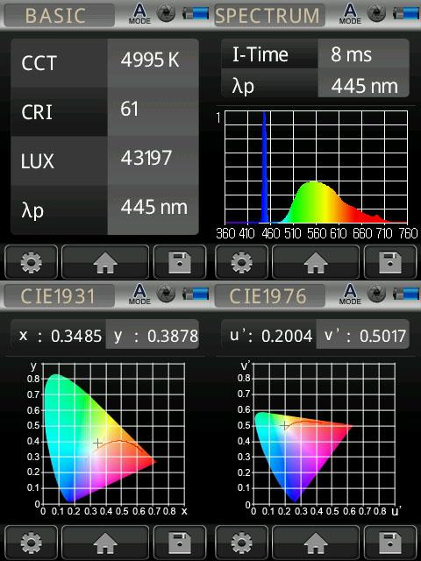
Figure 7. The figure shows the mobile device screen with results and preliminary processing of measurement and control results.
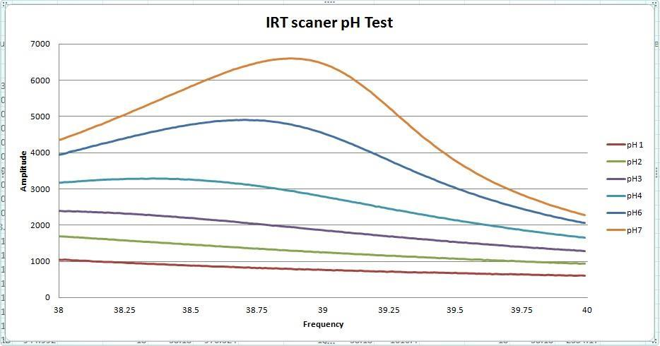
Figure 8. The figure shows a diagram of the use of the sensor for measuring control parameters of acidity in the range from 1 (sour) to 7 (neutral)
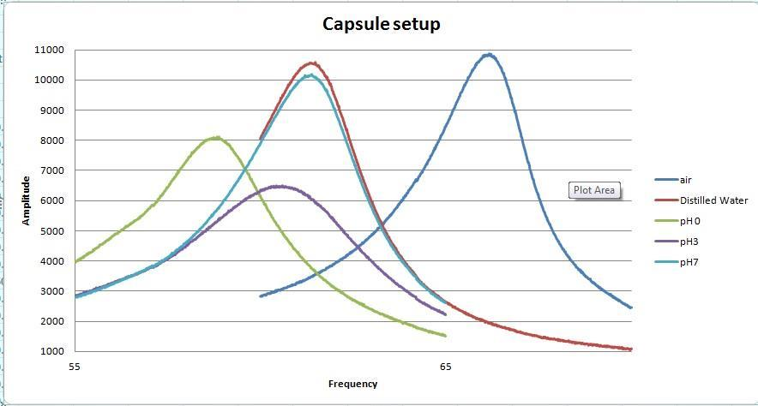
Figure 9. The figure shows a measurement diagram of a magnetic and resonant sensor of various physical and chemical media; As can be seen from the diagram, the sensor sensitivity is high enough to analyze the state of various media in real-time.
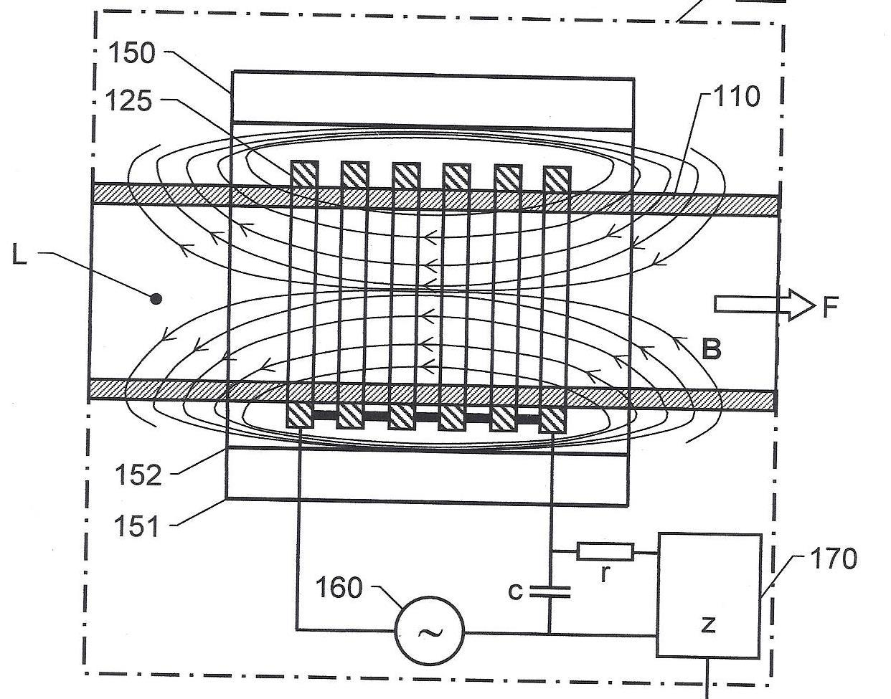
Figure 10. The figure shows a diagram of a magnetic and resonant sensor with the necessary infrastructure, as an example of building an industrial technical system with elements of artificial intelligence and functions of neural networks, including as a form of machine learning.
A variant of this sensor easily and functionally integrates into autonomous capsules used for, say, control of the acidity level of gastric juice in dairy animals, which plays an extremely important role in the operation of automatic dairy farms with carousel milking parlors where there strict individual monitoring of the state of gastric juice acidity is adopted, as with increasing acidity level there is a real danger of mastitis with all the negative consequences.
Such monitoring is also directly related to the presence and development of active elements of artificial intelligence and similarly active analytic neural networks in the system, as learning resources in this complex technical system.

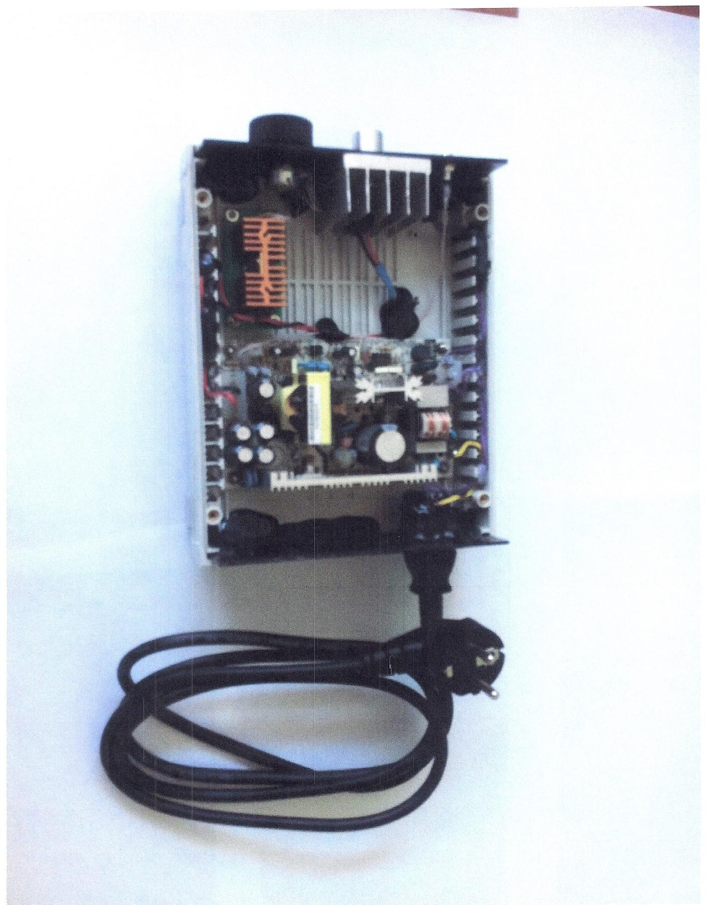
Figure 10–1. The figure shows the radio frequency driver for controlling the operation of a laser diode module of high-power and radiation strength used in operating rooms for local illumination.
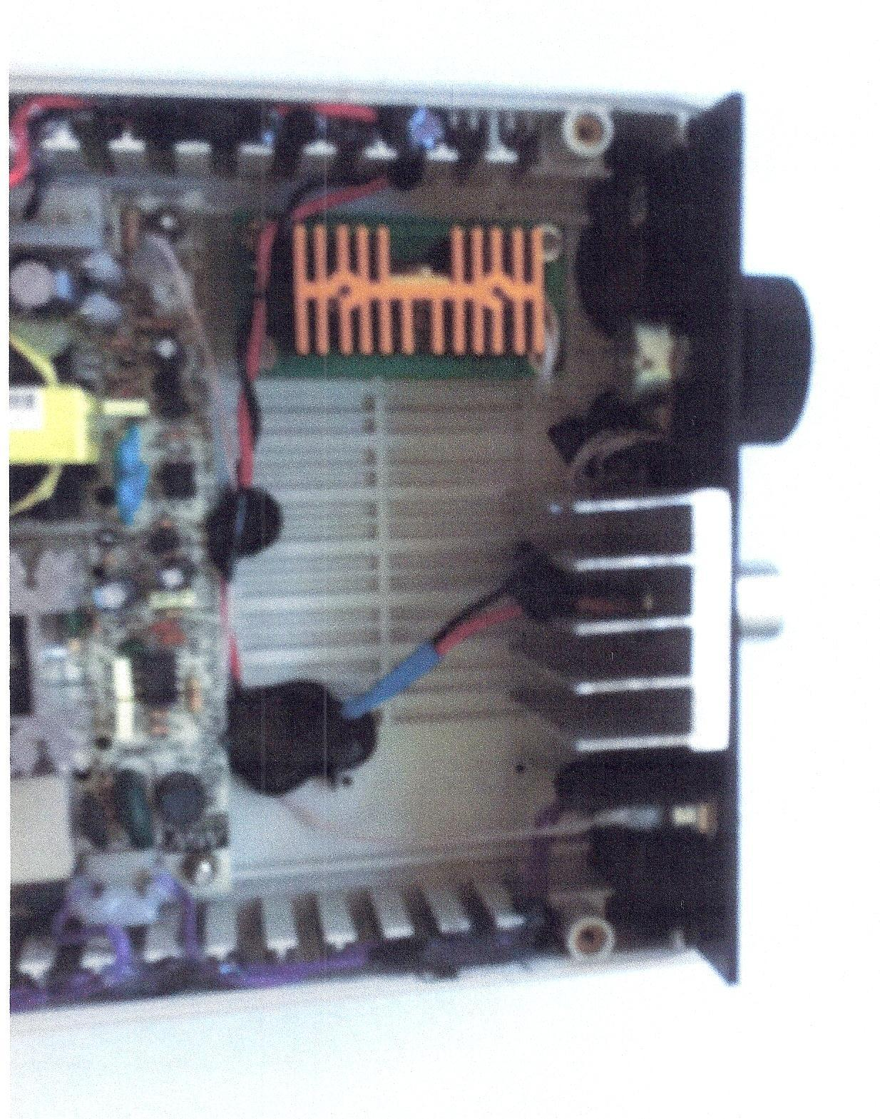
Figure 10–2. The figure shows an image of a radio frequency driver, made as a prototype
As can be seen, the radio frequency driver shown (made as a prototype), for all its functional complexity, is nevertheless assembled from ordinary standard components and parts, which proves the fact that a technical system with elements of artificial intelligence today can be a set of standard elements and it can be assembled by an ordinary average specialist through solving an unconventional task of obtaining output results equivalent to complex and unique technical systems with elements of artificial intelligence.
Taking into account all the features and complex technical conditions for the application of innovative methods of measurement and control in real-time, in any implementation variant, in medical equipment and medical technologies, the most important and decisive steps in the development of projects necessarily raise the question of the compliance of the main indicators of technology and equipment in conjunction with technical characteristics of measuring devices to the requirements of current standards.
In this case, since, as a rule, the results of various measurements become the basis of the diagnostic process, exact compliance with the requirements and limitations of the standards is mandatory.
Let's consider an example of real complex technical requirements for the technological concept of the measurement or checkup process, which in principle apply to all design and technological options and combinations of such devices and equipment, including special technological and clinical equipment, which in turn includes laser technologies with elements of artificial intelligence and neural networks.
Since all technologies more or less related to the field of medicine require the permission of controlling entities for implementation, built on the basis of correlation with the requirements and restrictions of standards, this is taken into account to the maximum extent in the following example.
Since the quality control of water used in many complexes of medical equipment and biology is the most important process, we propose to consider the plans and methods of the project to create sensors for non-contact monitoring of water quality or aqueous solutions used in these processes.

COMPLEX TECHNICAL REQUIREMENTS TO THE TECHNOLOGICAL CONCEPT OF THE MEASUREMENT PROCESS, INCLUDING THE REQUIREMENTS TO THE CONFORMITY OF THE APPLICABLE STANDARDS;
When implementing the technological concept, the following should be provided:
- the low specific cost of the measurement process;
- high reliability of the measurement process;
- the simplicity of the measurement process, which allows using service personnel of low qualification or home measurement technology to monitor or assess the quality of drinking water;
- small dimensions of equipment for control;
- the possibility of embedding into existing process flowsheets and equipment complexes;
- high performance;
- the possibility of continuous operation throughout the day;
- high process efficiency and fine precision;
- the possibility of simple and reliable process automation;
- the possibility of using disposable technologies and materials;
- the possibility to monitor and use the results of the monitoring process remotely;
- the possibility of a comparative assessment of the level of process quality and water quality by a small number of technological parameters;

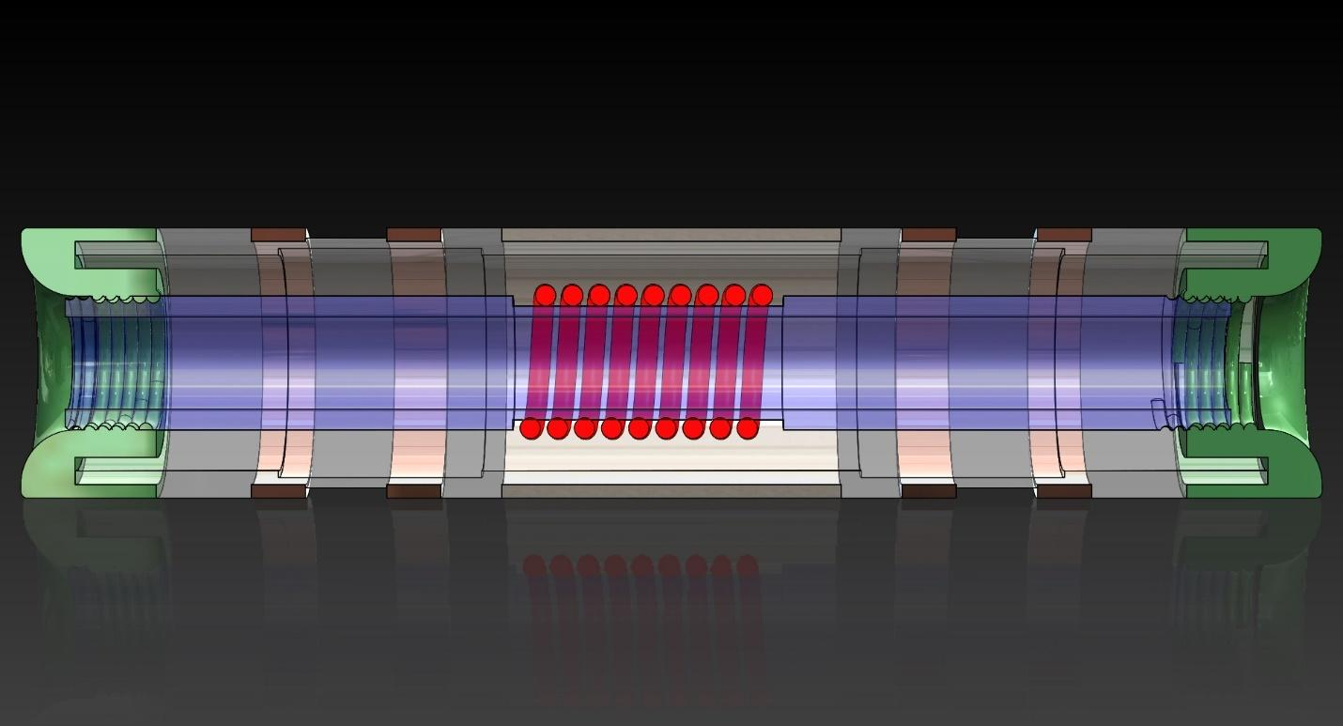
Figure 11. The figure shows a module for monitoring fluid in section

- Application-based product - Water quality RST-SENSOR; The product is a section of the pipeline, on the outer surface of which there is a resonant sensor installed, and on the edges of which there are nuts mounted for connection with the pipeline;
- The cable from the sensor is designed to connect with the control and analysis unit or with the control and monitoring system of the entire pipeline system;
- The size range of the product, - pipelines from 1/8 inch to 4 inches from various structural materials with annular sensors and from 4 inches or more, - with sectoral sensors;
- Specific product specifications:

4.1. High measurement accuracy - the device must be sensitive to changes in the chemical composition of water equivalent to concentrations of 0.000001 milligrams per liter;

4.2. The simplicity of construction design; The construction design of the device should use only standard or commercially available components and materials; The product should consist of fully standard elements of pipeline valves, which should determine its high reliability, maintainability, low production costs, the possibility of organizing production without the use of special processing equipment;

4.3. The reliability and durability of the device should be determined by the operating time to the first failure of at least 10,000 hours; the device must remain operational for at least 10 years;

4.4. Complete lack of contact with the measured fluid; the sensitivity of the device should not be reduced when being between the sensor element and the liquid of the dielectric strip up to 2.5 millimeters thick;

4.5. The possibility of embedding in any existing process flowsheet, capital equipment, boiler, steam equipment, water supply network, irrigation system in the agriculture industry and water supply systems of industrial enterprises;

4.6. Low energy consumption for the operation of the product; The total cost of electricity for the operation of the device should not exceed 50 watts per hour;

4.7. The ability to control aggressive and toxic liquids; The device should be made of materials and components, so it can be used to control corrosive and toxic liquids;

4.8. The ability to control ultrapure liquids; The materials from which the device is manufactured should not cause contamination of controlled liquids and should not be destroyed by the action of these liquids;

4.9. The possibility of embedding in automatic control systems; sensor signals should be perceived by mass-produced processors and elements of industrial and agricultural equipment control systems;

4.10. Ability to work in off-line mode; The device must have all the necessary components to operate in off-line mode, without the inclusion of networks and main technological equipment control systems.

- The device must be able to act as a level sensor; at the same time, the device should not be structurally different from the device for water quality control; all the necessary parts and components must be provided for its installation.

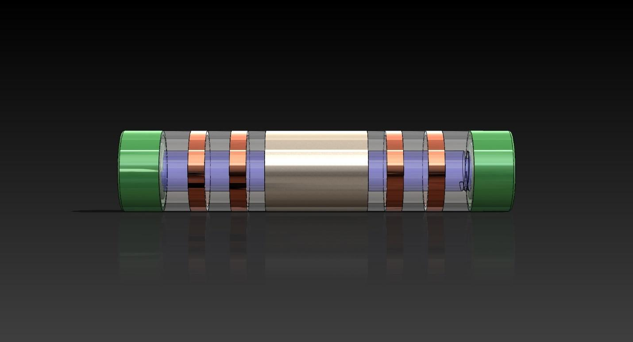

Figure 12. The figure shows the module for monitoring the state of the fluid, operating in off-line mode.

- THE NECESSARY CONDITION OF THE PROJECT OF DEVICE AND TECHNOLOGY AT THE START OF ITS SYSTEM DEVELOPMENT
By this time:

The main design and technological concepts of product design are developed.
The basic universal prototype of the product is made;
A cycle of preliminary tests of the product is made;
The universal prototype of the product is adjusted according to the results of preliminary tests;
Materials for a patent application are prepared;
A strategy for patent and license assertion of the technology is developed;

- The following work must be performed FOR THE REFINEMENT OF THE PRODUCT UP TO THE STAGE OF MASS PRODUCTION AND THE ACTIVE PHASE OF MARKETING:

Development of initial technical requirements for the product taking into account the wishes and recommendations of potential customers;
Development of technical task for the project;
Technical tender, including constructional design, manufacture, and testing of product models;
Preliminary design, including constructional design, manufacture, and testing of product models;
Detailed design, including constructional design, manufacture, and testing of product models;
Coordination and comparative analytical testing of products for compliance with the requirements of applicable standards;
Certification of products at the standards institution;
Issue installation batch of products;
Pilot operation of the installation batch of products;
Marketing strategy development;
Preparation of the plan of manufacturing and sales of products for the period of adaptation to market conditions; working out of the warranty service system; search for a strategic partner; the first phase of active marketing;

- DEVICES FOR THE RESONANT CONTROL OF THE QUALITY OF WATER AND OTHER LIQUIDS MUST BE FULLY SUITABLE FOR EFFICIENT WORK IN THE CONDITIONS OF THE FOLLOWING MAIN INDUSTRIES - CONSUMERS OF TECHNOLOGY

Pharmaceutical industry
Microbiological industry
Semiconductor manufacturing
Microelectronics
Energetics, INCLUDING, AND NUCLEAR POWER PLANTS
Industrial air conditioner
Water treatment in all industries, residential, industrial and public buildings and structures
Fine chemical engineering
Cosmetics production
Production of alcoholic and non-alcoholic beverages
Food industry
Greenhouse facility
Irrigation technologies in the agriculture sector
Electroplating and electrochemical production
Oil production

CONSUMER GOODS THAT MUST BE THE RESULT OF COMPLETION OF THE PROJECT:

- Household indicator of the purity of tap water;
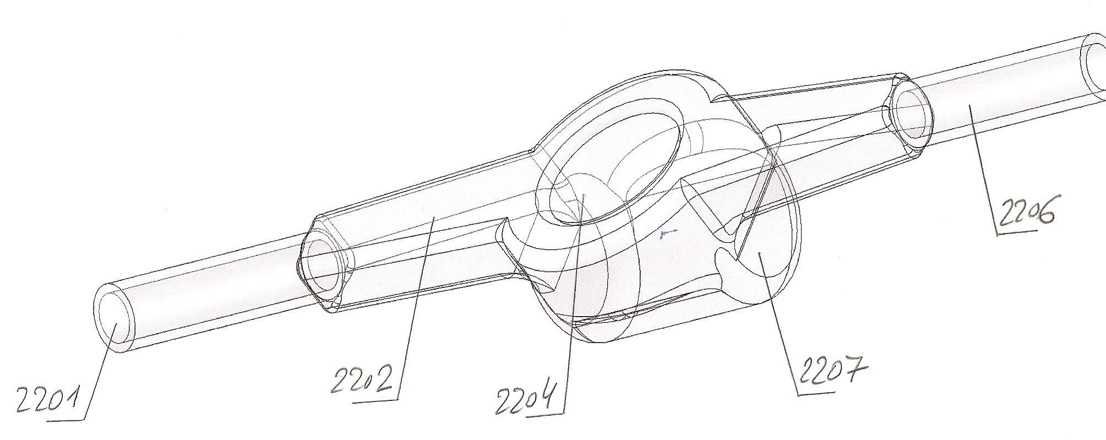

Figure 12–1. The figure shows a standard household fluid flow meter with an integrated magnetic and resonant sensor for monitoring the state of the liquid; Such a sensor can monitor the level of acidity, alkalinity, conductivity, viscosity, salt concentration and other required parameters in real-time, and at the same time exercise control of fluid flow, also in real-time
The numbers in the picture mark:
2201 - inlet pipe
2202 - introductory sector of a meter
2204 - the dial of the meter for the indication of a fluid flow
2206 - outlet pipe of the meter
2207 - section for magnetic and resonant control
The combined meter shown in Figure 12-1 can be used in various medical applications, including in the cooling systems of special medical laser devices that have an analytical control and checkup system including elements of artificial intelligence.
- Industrial indicator of the purity of tap water;
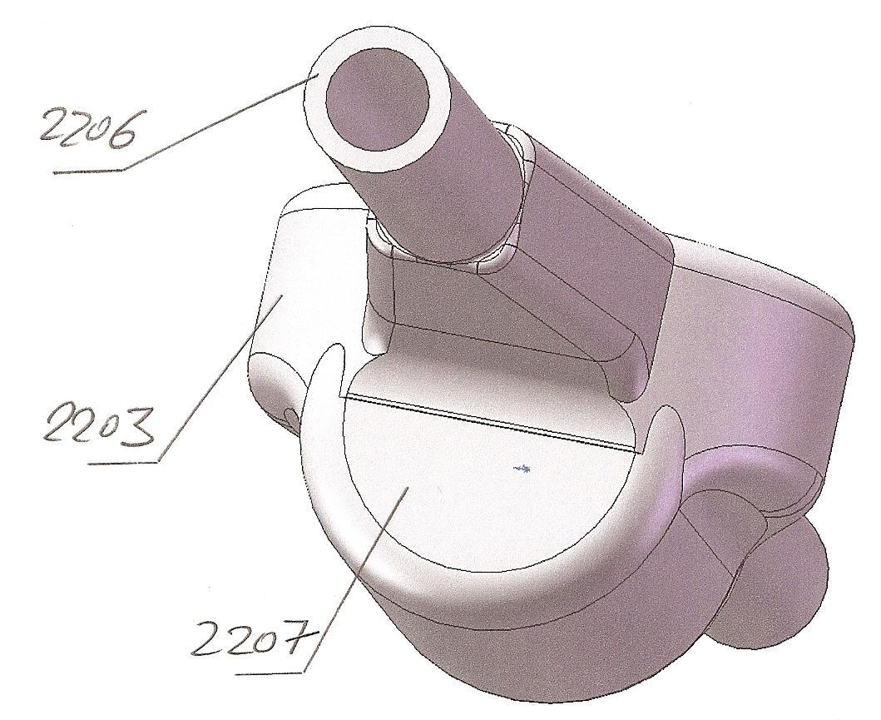
Figure 12–2. The figure shows an industrial fluid flow meter with an integrated magnetic and resonant sensor for monitoring of the state of the fluid; As in the household version, the control of the fluid flow and the control of the state of the fluid are carried out in real-time, in parallel and independently
The numbers in the picture mark:
2203 - dial and fluid flow meter
2206 - inlet part of the pipe
2207 - magnetic and resonant sensor for monitoring of the state of fluid

- Pipeline-sensor for non-contact control of the conductivity of fluids, made on the basis of industrial pipeline components made of polyvinyl chloride; functional diameters of pipelines, - 1/16; 1/8; ¼; 3/8; ½; ¾; 1; 1-1/4; and further on with an interval of ¼ of an inch up to 4 inches; the pipeline is intended to be integrated into the automatic production control systems;

- Pipeline-sensor for non-contact control of the conductivity of fluids made on the basis of industrial pipeline components from polypropylene; functional diameters similar to clause 3; the pipeline is intended to be integrated into the automatic production control systems;

- Autonomous pipeline-sensor for monitoring the conductivity of fluids made on the basis of industrial pipeline components from polyvinyl chloride; functional diameters as in clause 3;

- Autonomous pipeline-sensor for monitoring the conductivity of fluids made on the basis of industrial pipeline components from polypropylene; working diameters as in clause 3;

- Pipeline-sensor systems, similar to clauses 3–6, made on the basis of industrial pipeline components from polycarbonate;

- Pipeline-sensor systems, similar to clauses 3–6, made on the basis of industrial pipeline components from Teflon, composite polymeric materials, thermosetting plastics, polymers with various fillers and from heat-resistant materials;

- Sensor systems integrated into automatic control systems for non-contact quality control of the quality of fluids in pipelines with a diameter greater than 4 inches; pipelines are made of polyvinyl chloride; from polypropylene; from heat-resistant polymers; from thermosetting plastics;

- Sensor systems, in accordance with paragraphs 3-9, designed to check up the status of fluids supplied to irrigation systems in the agricultural sector;
- Sensor systems, in accordance with paragraphs 3-9, designed to check up the status of fluids in irrigation farming sector;

- Sensor systems, in accordance with paragraphs 3-9, designed to check up the status of fluids in greenhouse agricultural plants;

- Systems of non-contact level sensors with horizontal mounting method;

- Systems of non-contact level sensors with vertical mounting method;

- Systems of integrated level sensors and quality control sensors;

As an example, it makes sense to cite the development of a work plan for a complex project of a technical system designed to implement technique and method for remote, non-contact quality control of conductive fluids.
This example is built on the author’s positive professional experience and can illustrate the complex linking of the introduction and integration of elements of artificial intelligence and artificial neural networks with standards and industry-specific process instructions.
It should also be noted that one such solution may be in demand in many areas of engineering and technology, and the most unexpected ones.
The control of fluids in medicine and medical technologies proves to be no more relevant than the quality control of milk or drinking water.

WORK PLAN (example)

PROJECT ON TECHNIQUE AND METHOD OF REMOTE NON-CONTACT CONTROL OF QUALITY OF CONDUCTIVE FLUIDS
PARTICULAR BRANCH OF THE PROJECT - ACTIVE CONTROL OF THE CONTENT AND CONCENTRATION OF COMPONENTS OF COW’S MILK
THE FINAL PRODUCT OF THE PROJECT CONSISTS OF TWO BASIC COMPONENTS: - FIRST COMPONENT, - DEVICE FOR CONTROL OF QUALITY OF FLUIDS DIRECTLY IN A PIPELINE; - SECOND COMPONENT, - SENSOR MODULE, WHICH APPLIES TO VARIOUS SYSTEMS IN WHICH THE MEASURABLE FLUID CIRCULATES
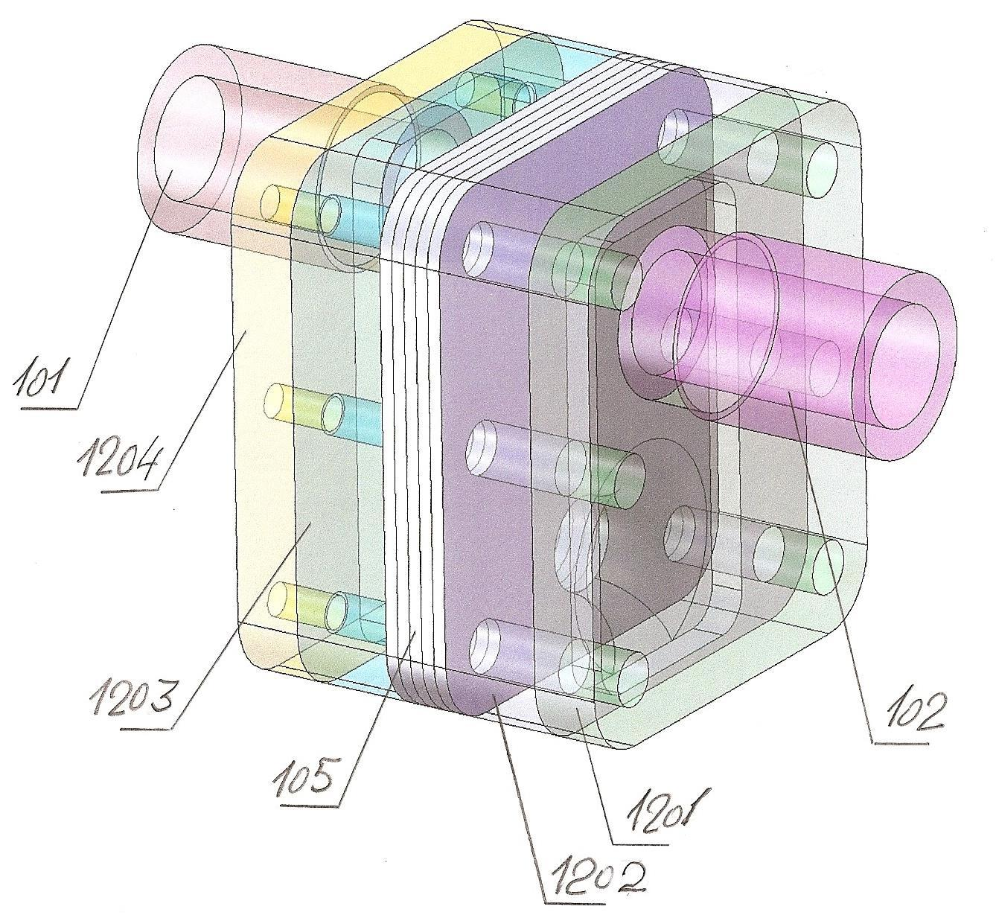
Figure 13. The figure shows the control and diagnostic module for controlling and diagnosing the state of the fluid in the pipeline, without contacting it; Such control is carried out in motion, in real-time, with the electromagnetic resonance spectroscopy sensor being in the lower branch of the control pipeline system, while it is located in a multilayer printed circuit board, mainly manufactured by RITM (partitive pickling of metals) production technique thus having the operating speed higher than that of boards made using conventional production technique
The numbers in the picture mark:
101 - inlet pipe
102 - outlet pipe
105 - multilayer printed circuit board with the mounted sensor
1201 - outer flange of the module
1202 - part of the module housing in which there is a vertical channel (ascending) for the sample of the controlled fluid
1203 - part of the module housing in which there is a vertical channel (descending) for the sample of the controlled fluid
1204 - outer flange of the module

Stages and steps of development of a household or industrial device for controlling the quality of fluids, including drinking water or milk

- Initial technical requirements

Initial technical requirements to device’s materials

Initial technical requirements for anti-corrosion and decorative coatings, which will be allowed for use in the construction design of the device

Initial technical requirements to device’s installation items

Initial technical requirements for the ideology of control of the quality of fluids, including drinking water and milk

Initial technical requirements for a system for identifying control results and sensor readings

Section, - initial technical requirements are carried out by the manufacturer and agreed with the customer
The time to complete this section is approximately 2 working weeks for 4 employees, two employees from each side
The estimated cost of the section for the manufacturer is $9,000 (2 x 5 x 8 = 80 hours per employee)
As a result of the implementation of the section, the manufacturer should develop and customer should approve: the basic project document, initial technical requirements for the project products, combined with tables of parameters and indicators of current international and national standards
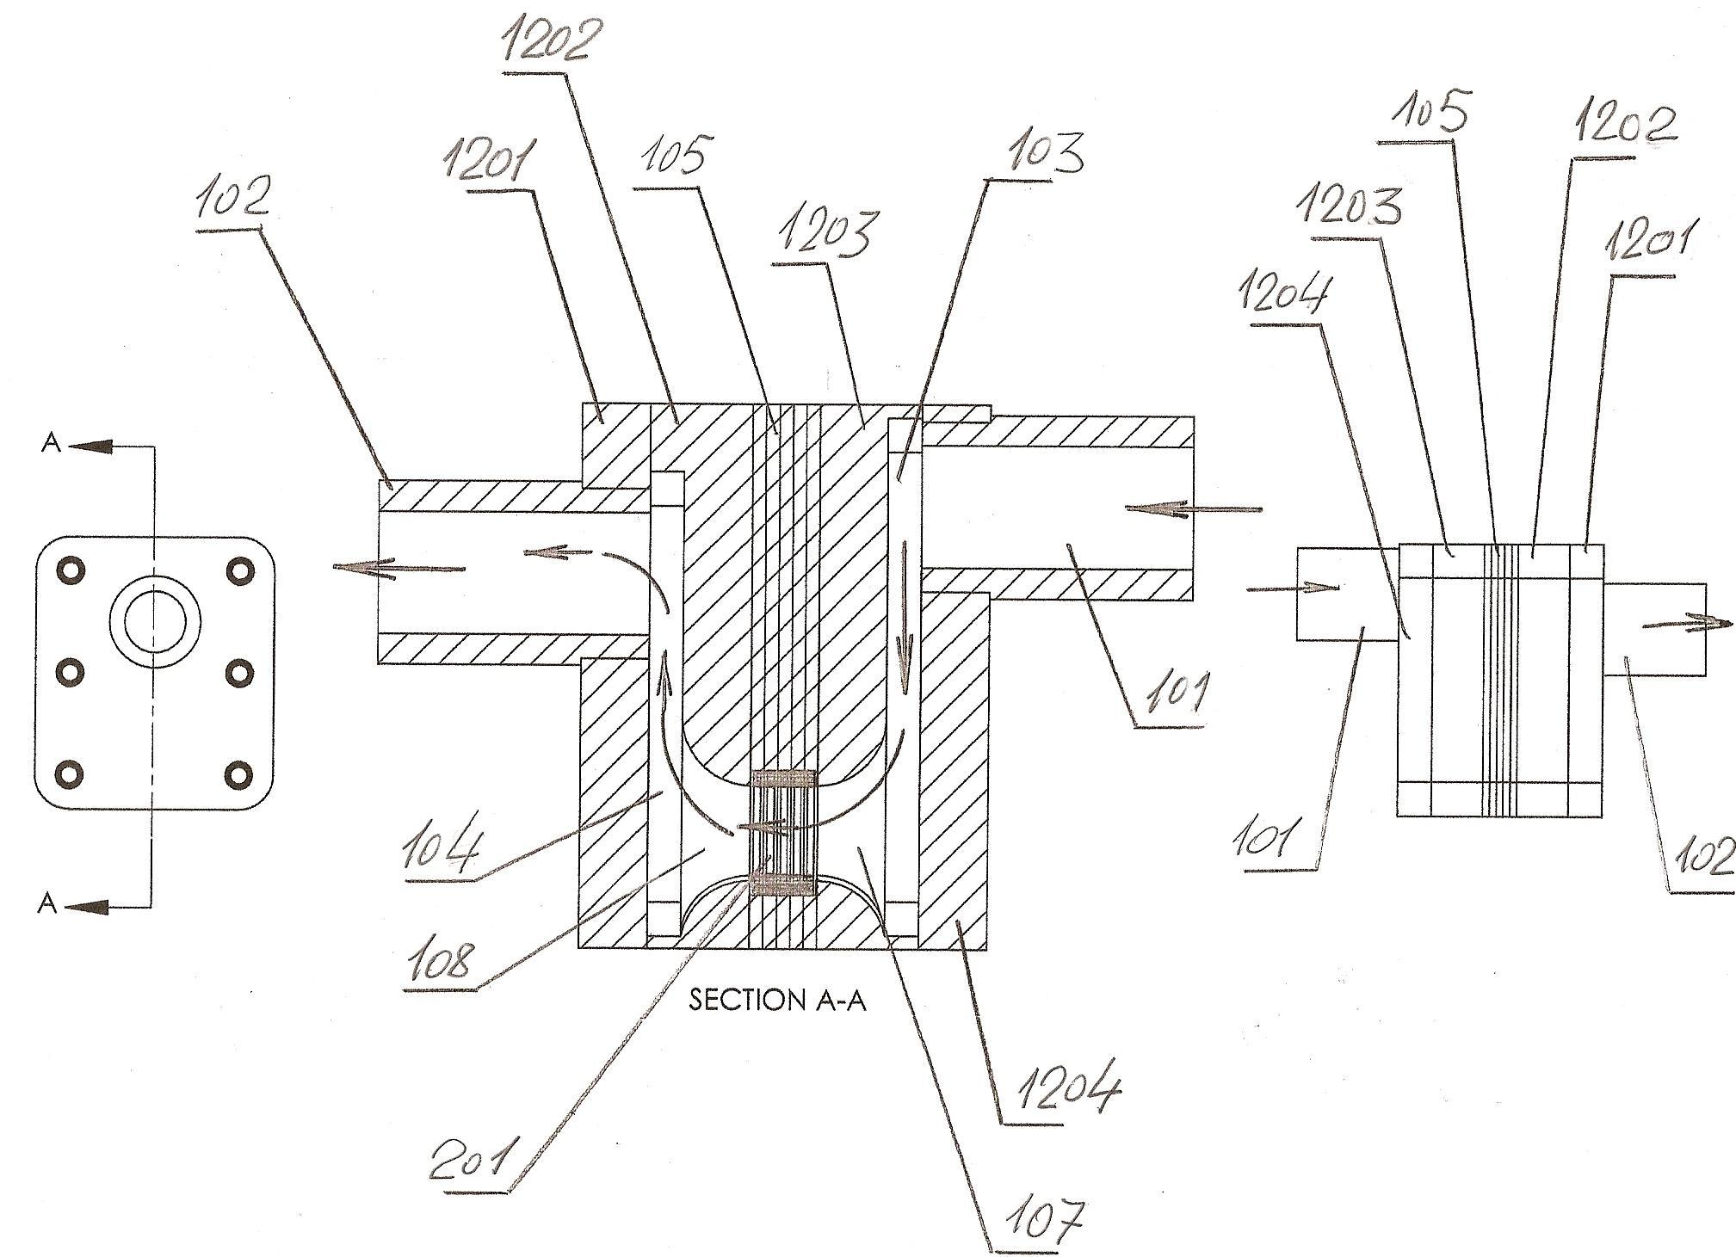
Figure 14. The figure shows the control and diagnostic module for control and diagnosing the state of a fluid in a developed hydrodynamical flow in real-time; The module is shown in longitudinal vertical section A - A
The numbers in the picture mark:
101 - inlet pipe of the module
102 - outlet pipe of the module
103 - the vertical delivery channel of the module for supplying fluid to the control zone
104 - vertical channel for the withdrawal of fluid flow from the control zone
105 - multilayer printed circuit board with the mounted sensor
107 - delivery channel to the sensor
108 - channel for withdrawal of fluid from the sensor space
201 - sensor
1201 - module housing flange
1202 - section with a vertical channel
1203 - section with a vertical channel
1204 - section with the inlet pipe
Figure 14 shows a module’s schematic diagram for the project's technical tender step

- Technical tender (as part of a work plan)

Engineering analysis note on the technical tender step; The analysis part of the note in the context of integration of a module into smart medical technologies should contain links to the combined software product as a part of the module with elements of artificial intelligence and artificial neural networks

Schematic diagrams of the project components at the stage of the technical tender

Models, mock-ups and prototypes of the full-scale specimen of the device

The program and methodology for testing the mock-ups of the final product for operation capability

Presentation on the step of the technical tender for the project

Section, – technical tender is carried out by the manufacturer and agreed with the customer
The time to complete this section is 2 working weeks for 4 employees, two employees from each side
The estimated cost of the section for the manufacturer is $9,000 (2 x 5 x 8 = 80 hours per employee)

As a result of the implementation of the section, the manufacturer should develop and customer should approve: the basic project document, engineering analysis note of the technical tender (including all the engineering, design and manufacturing documentation developed for this section)
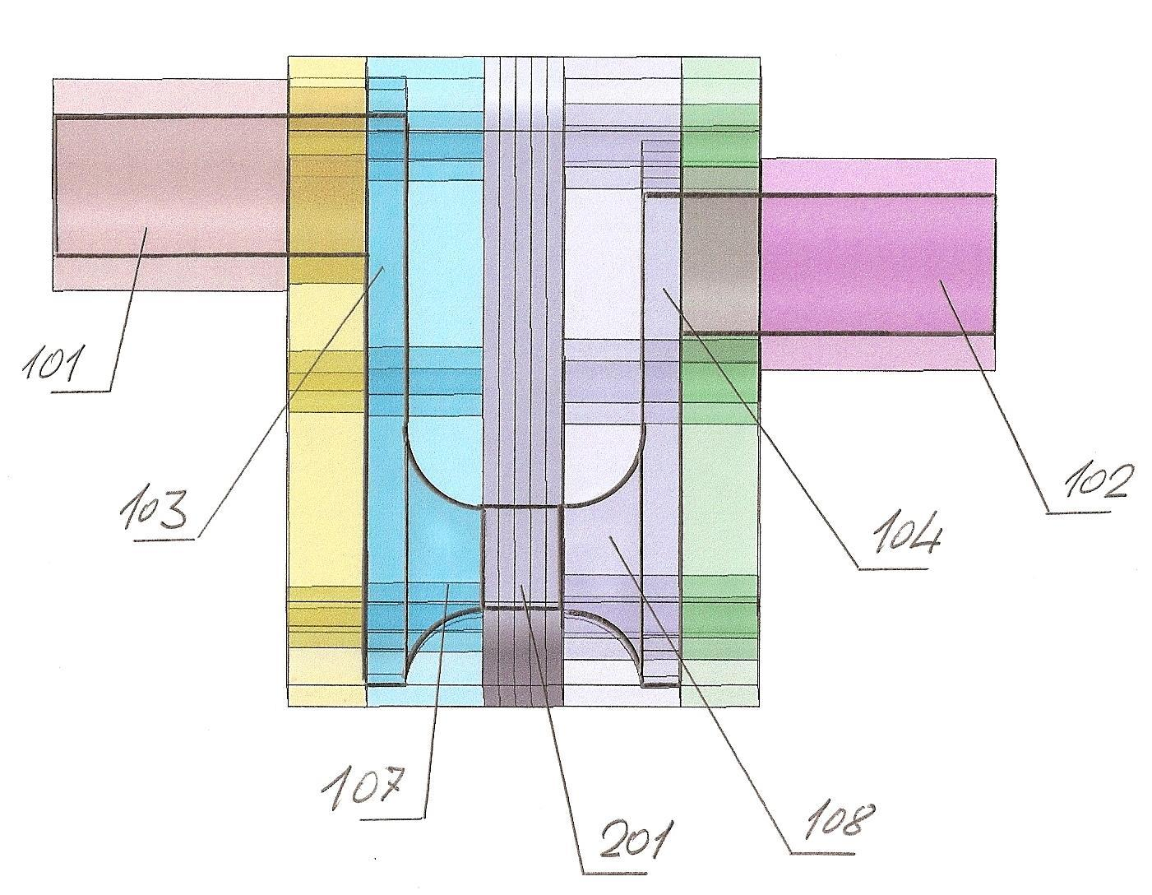
Figure 15. The figure shows a model of the control and diagnostic module with a detailed study of the channels for supplying fluid for control and for withdrawing fluid from the control zone
The numbers in the picture mark:
101 - pipe to inlet fluid to the control zone
102 - pipe to outlet fluid from the control zone
To create backwater, the level of pipeline 101 is made higher than the level of pipeline 102
103 - the vertical channel of backwater
104 - vertical channel for the outlet of fluid flow from the control zone
107 - globoid conical channel to inlet fluid to the control zone
108 - globoid conical channel to outlet fluid from the control zone
201 - sensor, the inner channel of which connects the conical globoid channels 107 and 108
- Technical task:
Formation of a project's development company
Development and preparation of all basic documents of the company
Formation of teams for the project execution
Development and approval of the technical task for designing process
Development and approval of the technical task for the product; development of technical characteristics for a new product; development of technical task for the manufacture of the pilot specimen of the product
Development of the technical task for every step of testing of the new product;
Development of the technical task for the industrial design of a new product, packaging, storage, transportation, composition, and form of operational documentation
Development of technical task for pilot-industrial documentation
Development of technical task for a patent and license assertion strategy for a new product and new technology

Section, - the technical task is carried out by the manufacturer and agreed with the customer
The time to complete this section is 2 working weeks for 4 employees, two employees from each side
The estimated cost of the section for the manufacturer is $9,000 (2 x 5 x 8 = 80 hours per employee)

As a result of the implementation of the section, the manufacturer should develop and customer should approve: the basic project document, Engineering analysis note of the technical task (including all the engineering, design and manufacturing documentation developed for this section)

- Draft design

Engineering analysis note of the draft design of the device
Schemes, graphs, drawings of general views
Models, mock-ups and prototypes of the engineering project step
Materials of presentation to draft design step

Section, – draft design is carried out by the manufacturer and agreed with the customer
The time to complete this section is 2 working weeks for 4 employees, two employees from each side
The estimated cost of the section for the manufacturer is $9,000 (2 x 5 x 8 = 80 hours per employee)

As a result of the implementation of the section, the manufacturer should develop and customer should approve: the basic project document, Engineering analysis note of the draft design (including all the engineering, design and manufacturing documentation developed for this section)
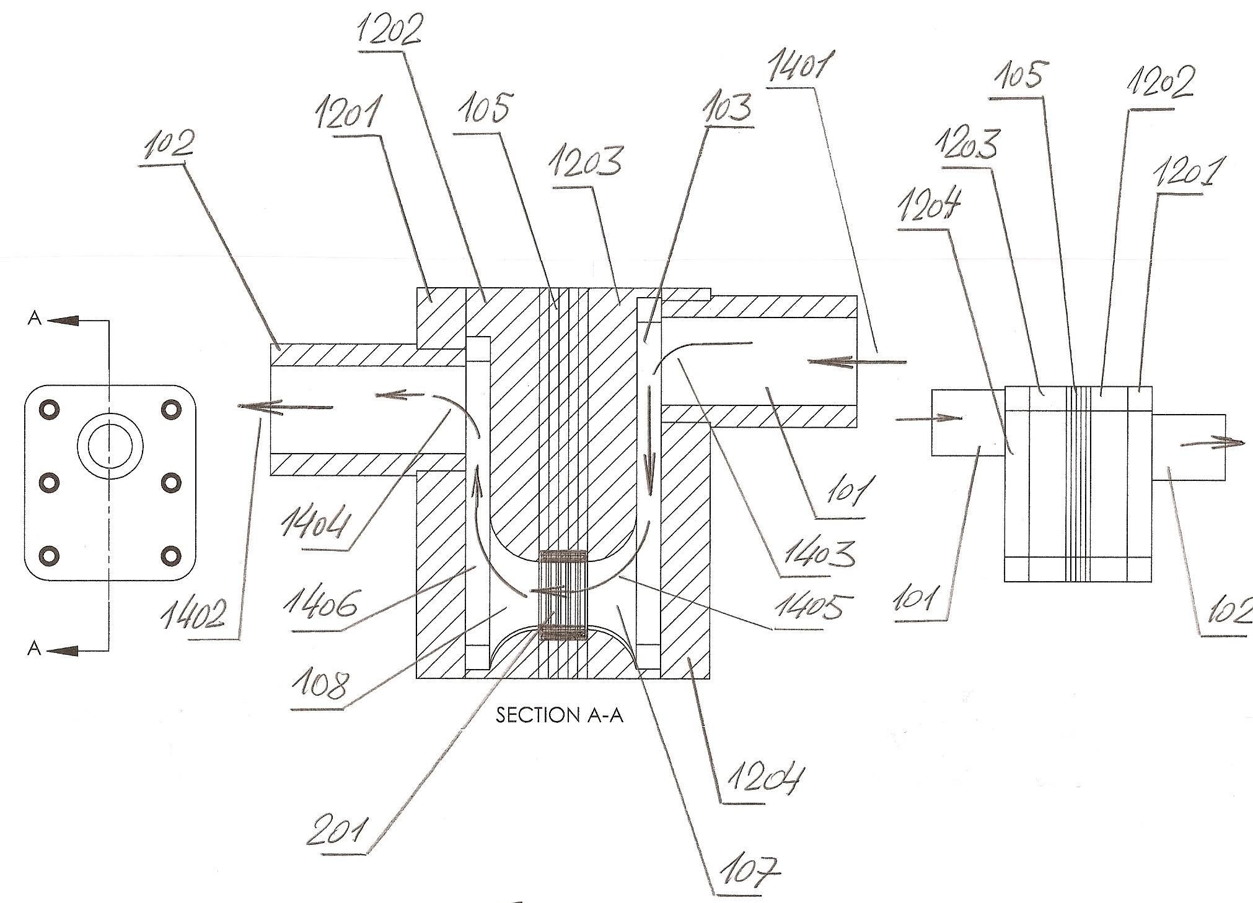
Figure 16. The figure shows the internal channels of the control and diagnostic module with a detailed study of the hydrodynamic flows of the controlled fluid
The numbers in the picture mark:
101 - inlet pipeline
102 - outlet pipeline
103 - vertical channel for filling-in the control zone
105 - multilayer printed circuit board with the mounted sensor
107 - sensor filling-in zone
108 - sensor off-loading zone
201 - sensor (solenoid)
1201 - external flange of the module on the side of fluid’s withdrawal off of the control zone
1202 - vertical channel on the way out of the sensory cylinder
1203 - vertical channel on the way into sensory cylinder
1204 - external flange of the module on the side of fluid’s inflow to the control zone
1401 - fluid's inflow to the module
1402 - fluid's outflow off of the module
1403 - fluid's inflow to the vertical channel at the entrance to the control zone
1404 - outlet of the fluid from the control zone
1405 - inlet of the fluid to the sensory cylinder
1406 - outlet of the fluid from the sensory cylinder
In order to ensure that the criteria for smart medical technologies and equipment are met at a later stage, a deep cycle of computer modeling and process simulation is intended at the draft design stage to identify key points at the development steps that require increased attention in design, manufacturing, and assembly

- Preliminary design

Engineering analysis note to the preliminary design of the device
Schemes, graphs, drawings of general views of modules and components of the device
Models of components and fragments of the device and its version for installation
Materials of presentation to preliminary design step
Materials of applications for inventions

Section, – preliminary design is carried out by the manufacturer and agreed with the customer
The time to complete this section is 2 working weeks for 4 employees, two employees from each side
The estimated cost of the section for the manufacturer is $9,000 (2 x 5 x 8 = 80 hours per employee)

As a result of the implementation of the section, the manufacturer should develop and customer should approve the basic project document, Engineering analysis note of the preliminary design (including all the engineering, design and manufacturing documentation developed for this section).
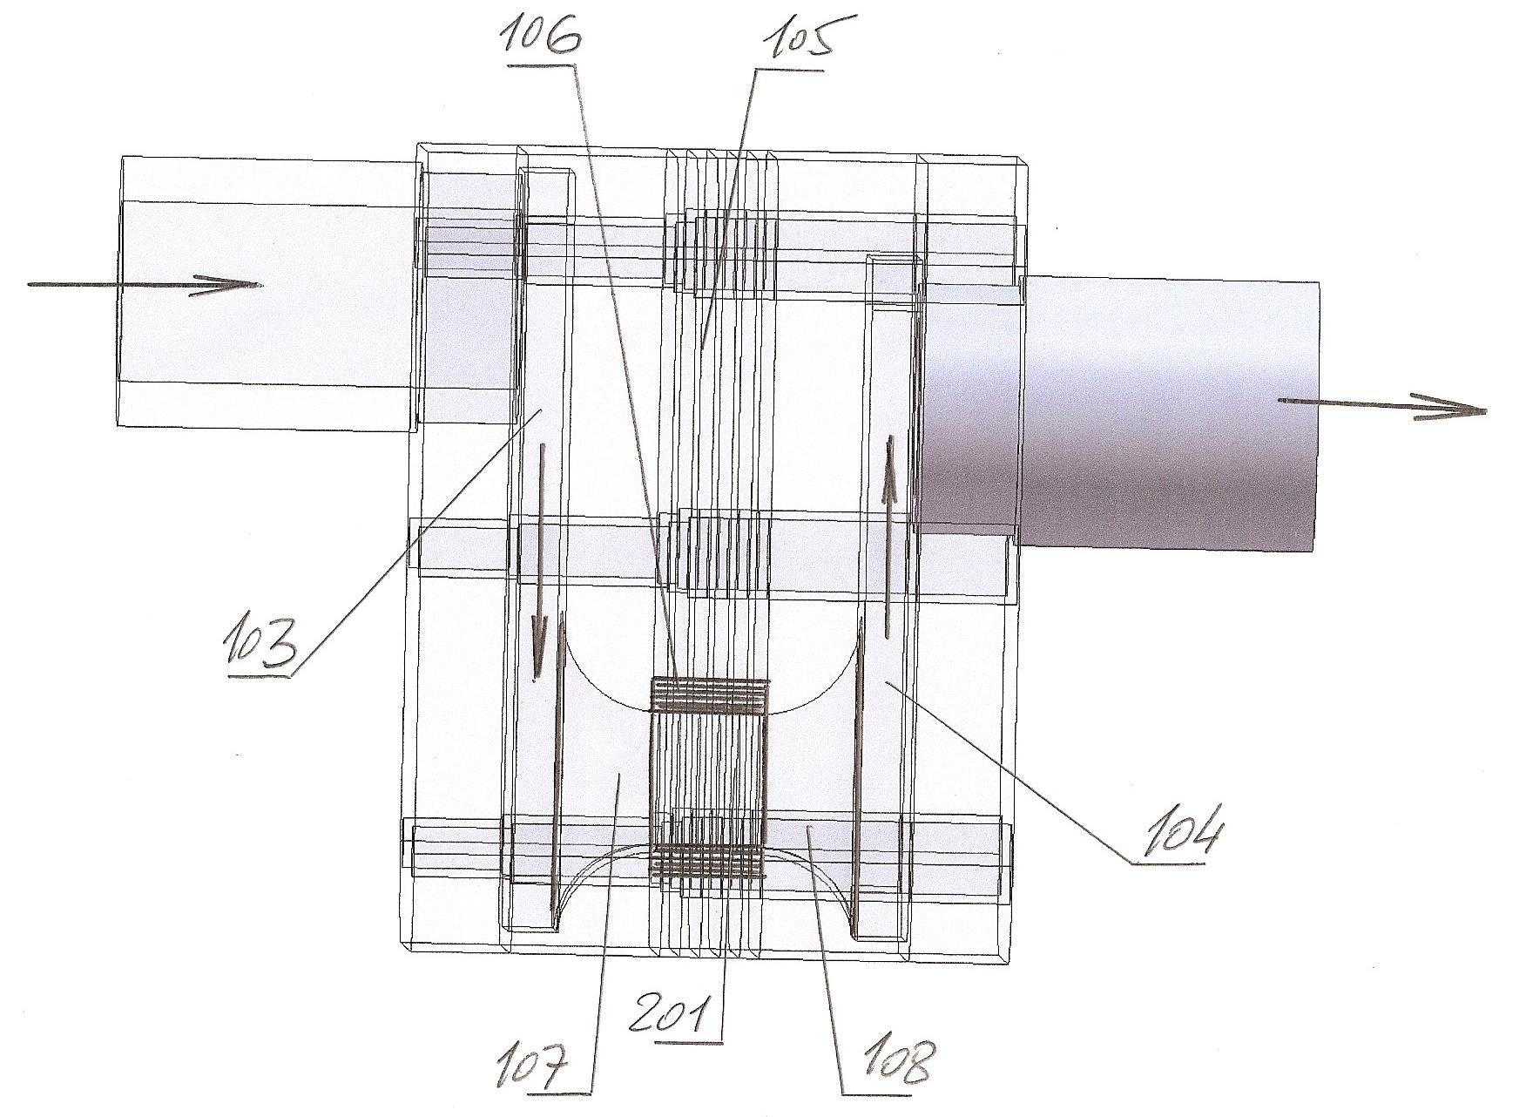
Figure 17. The figure shows a transparent model of the control and diagnostic module with the geometric orientation of the sensor in the system of supply and outlet channels
The numbers in the picture mark:
103 - vertical supply channel
104 - vertical outlet channel
105 - multilayer printed circuit board with integrated protective screen elements
106 - protective screen of the sensor
107 - inlet of the fluid to the sensory channel
108 - outlet of the fluid from the sensory channel
201 - sensor
- Detail design

Engineering analysis note to the detail design of the device and all components within; Full package of the engineering documentation of the device and variants of its installation
Mock-ups, prototypes and pilot specimen
Materials of presentation to detail design step
Materials of applications for inventions

Section, - detail design is carried out by the manufacturer and agreed with the customer
The time to complete this section is 3 working weeks for 4 employees, two employees from each side
The estimated cost of the section for the manufacturer is $12,000 (3 x 5 x 8 = 120 hours per employee)
As a result of the implementation of the section, the manufacturer should develop and customer should approve the basic project document, Engineering analysis note of the detail design (including all the engineering, design and manufacturing documentation developed for this section).

- Manufacturing of the pilot specimen of the device and its installation items

Preparation of process drawings for the device’s manufacturing process and its installation items
Preparation of instructions for all steps of the manufacture, assembly, and installation of the device

Section, - Manufacturing of the pilot specimen of the device and its installation items,
is carried out by the manufacturer and agreed with the customer

The time to complete this section is 6 working weeks for 3 employees, two of them from the manufacturer
The estimated cost of the section for the manufacturer is $18,000 (6 x 5 x 8 = 240 hours per employee)
The estimated cost of the prototype is estimated at $20,000
As a result of the implementation of the section, the manufacturer should develop and customer should approve the basic project document, Engineering analysis note of the manufacturing of the pilot specimen of the device (including all the engineering, design and manufacturing documentation developed for this section).
- Preliminary tests of the pilot specimen of the device

Section, - preliminary tests of the pilot specimen of the device is carried out by the manufacturer and agreed with the customer
To fulfill this section, it is extremely important to develop a protocol of preliminary tests and conform to this protocol and its applications with the requirements of current standards and instructions of health departments and institutes of health
Due to the fact that the scope of requirements is quite large, it is currently extremely important to prepare mobile applications for the analytical processing of test results and the possible adjustment or optimization of the preliminary testing program

The time to complete this section is 2 working weeks for 4 employees, two employees from each side
The estimated cost of the section for the manufacturer is $9,000 (2 x 5 x 8 = 80 hours per employee)
As a result of the implementation of the section, the manufacturer should develop and customer should approve the basic project document, Engineering analysis note of the preliminary tests of the pilot specimen of the device (including all the engineering, design and manufacturing documentation developed for this section)
- Correction of engineering, design and manufacturing documentation based on the results of preliminary tests of pilot specimen

Section, - is carried out by the manufacturer and agreed with the customer
The time to complete this section is 1 working week for 4 employees, two employees from each side
The estimated cost of the section for the manufacturer is $4,500 (1 x 5 x 8 = 40 hours per employee)
As a result of the implementation of the section, the manufacturer should develop and customer should approve the basic project document, Engineering analysis note of the section (including all the engineering, design and manufacturing documentation developed for this section).
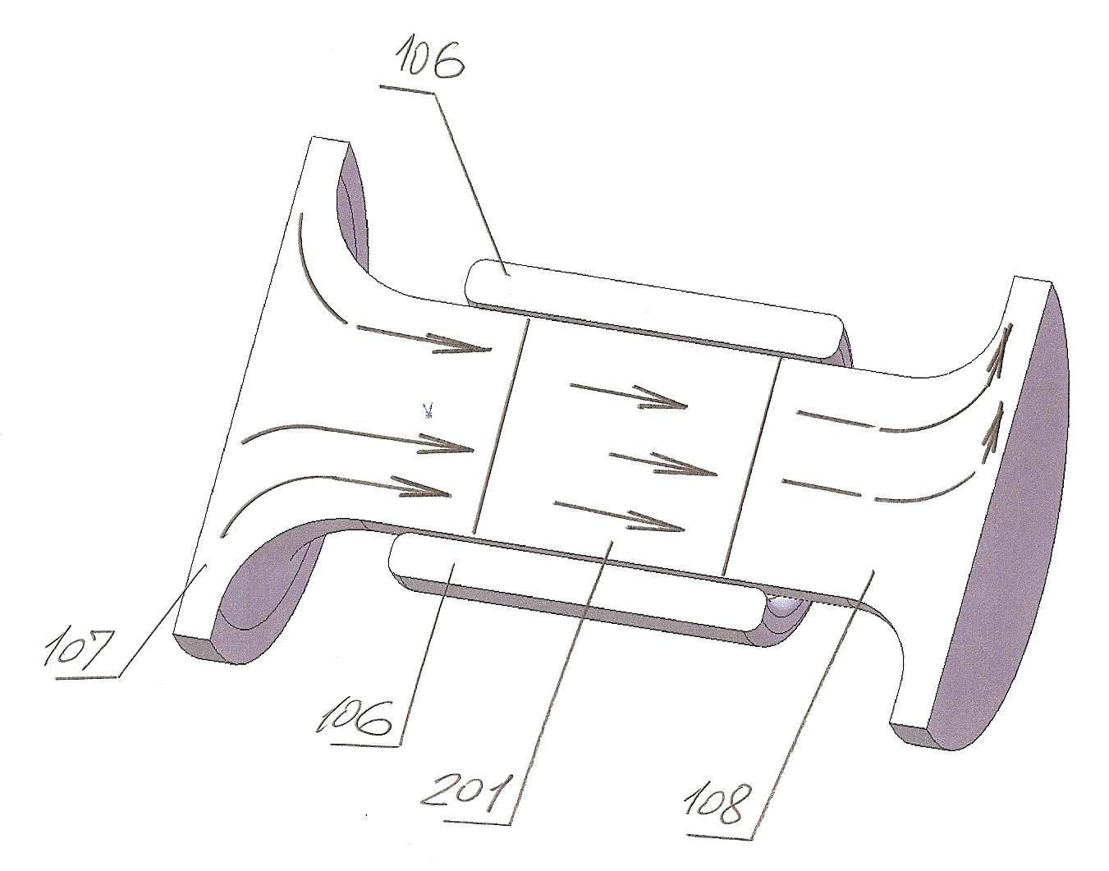
Figure 18. The figure shows a three-dimensional model of fluid flow during checkup and diagnostics.
The numbers in the picture mark:
106 – sensor
107 - inlet flow of fluid as a conical globoid
108 - outlet flow of fluid as a conical globoid
201 - controlled and diagnosed cylindrical sensor element

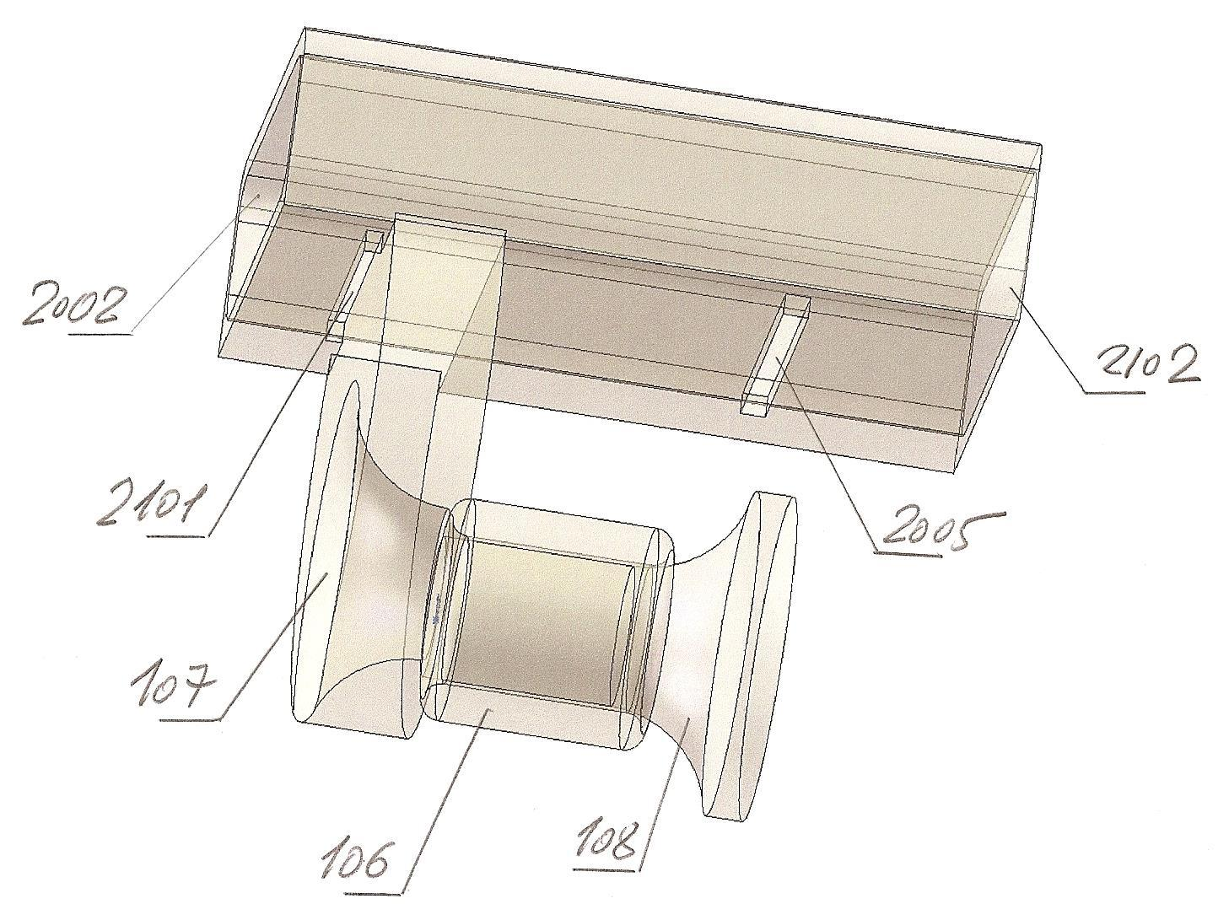
Figure 18–1. The figure shows a model of fluid flows in the process of checkup and diagnostics for the case of the formation of parallel motion of fluid flows, in which there is a main flow of fluid moving in the pipeline and an auxiliary fluid flow separated from the main flow and sent to checkup and diagnostics
The numbers in the picture mark:
106 - sensory cylinder
107 - the introductory conical globoid element of a checked and diagnosed fluid flow
108 - output conical globoid element of a checked and diagnosed fluid flow
2002 - inlet of the main fluid flow
2005 - inlet of auxiliary fluid flow after check and diagnostics in the main fluid flow
2101 - selection of auxiliary fluid flow for check and diagnostics
2102 - outlet of auxiliary fluid flow from check and diagnostics zone

- Correction and modification of pilot specimen according to the results of preliminary tests

The section is carried out by the manufacturer and agreed with the customer
The time to complete this section is 2 working weeks for 4 employees, two employees from each side
The estimated cost of the section for the manufacturer is $9,000 (2 x 5 x 8 = 80 hours per employee)

As a result of the implementation of the section, the manufacturer should develop and customer should approve the basic project document, Engineering analysis note of the section (including all the engineering, design and manufacturing documentation developed for this section).

- Approval of technical characteristics of the pilot specimen with the requirements of standards; Approval of technical characteristics with health standards

The section is carried out by the manufacturer and agreed with the customer
The time to complete this section is 2 working weeks for 4 employees, two employees from each side
The estimated cost of the section for the manufacturer is $9,000 (2 x 5 x 8 = 80 hours per employee)

As a result of the implementation of the section, the manufacturer should develop and customer should approve the basic project document, Engineering analysis note of the project (including all the engineering, design and manufacturing documentation developed for this section).
- Acceptance trials of the pilot specimen

The section is carried out by the manufacturer and agreed with the customer
The time to complete this section is 2 working weeks for 4 employees, two employees from each side
The estimated cost of the section for the manufacturer is $9,000 (2 x 5 x 8 = 80 hours per employee)

As a result of the implementation of the section, the manufacturer should develop and customer should approve the basic project document, Engineering analysis note of the project (including all the engineering, design and manufacturing documentation developed for this section).

- Testing program and procedure

Section, - is carried out by the manufacturer and agreed with the customer
The time to complete this section is 2 working weeks for 4 employees, two employees from each side
The estimated cost of the section for the manufacturer is $9,000 (2 x 5 x 8 = 80 hours per employee)

As a result of the implementation of the section, the manufacturer should develop and customer should approve the basic project document, Engineering analysis note of the section (including all the engineering, design and manufacturing documentation developed for this section).

- Correction of engineering, design and manufacturing documentation based on the results of preliminary tests

The section is carried out by the manufacturer and agreed with the customer
The time to complete this section is 2 working weeks for 4 employees, two employees from each side
The estimated cost of the section for the manufacturer is $9,000 (2 x 5 x 8 = 80 hours per employee)

As a result of the implementation of the section, the manufacturer should develop and customer should approve the basic project document, Engineering analysis note of the section (including all the engineering, design and manufacturing documentation developed for this section).

- Correction and modification of pilot specimen according to the results of preliminary tests

The section is carried out by the manufacturer and agreed with the customer
The time to complete this section is 2 working weeks for 4 employees, two employees from each side
The estimated cost of the section for the manufacturer is $9,000 (2 x 5 x 8 = 80 hours per employee)

As a result of the implementation of the section, the manufacturer should develop and customer should approve the basic project document, Engineering analysis note of the section (including all the engineering, design and manufacturing documentation developed for this section).

- Development of accompanying and operational documentation

The section is carried out by the manufacturer and agreed with the customer
The time to complete this section is 2 working weeks for 4 employees, two employees from each side
The estimated cost of the section for the manufacturer is $9,000 (2 x 5 x 8 = 80 hours per employee)

As a result of the implementation of the section, the manufacturer should develop and customer should approve the basic project document, Engineering analysis note of the section (including all the engineering, design and manufacturing documentation developed for this section).

- Industrial design, preparation of the design patent and trademark application

The section is carried out by the manufacturer and agreed with the customer
The time to complete this section is 2 working weeks for 4 employees, two employees from each side
The estimated cost of the section for the manufacturer is $9,000 (2 x 5 x 8 = 80 hours per employee)
As a result of the implementation of the section, the manufacturer should develop and customer should approve the basic project document, Engineering analysis note of the section (including all the engineering, design and manufacturing documentation developed for this section).
- Development of the business plan

Section, - the technical task is carried out by the manufacturer and agreed with the customer
The time to complete this section is 2 working weeks for 4 employees, two employees from each side
The estimated cost of the section for the manufacturer is $9,000 (2 x 5 x 8 = 80 hours per employee)

As a result of the implementation of the section, the manufacturer should develop and customer should approve the basic project document, Engineering analysis note of the section (including all the engineering, design and manufacturing documentation developed for this section).

- Development of the experimental-industrial operation program and search for strategic partners for experimental-industrial operation

The section is carried out by the manufacturer and agreed with the customer
The time to complete this section is 2 working weeks for 4 employees, two employees from each side
The estimated cost of the section for the manufacturer is $9,000 (2 x 5 x 8 = 80 hours per employee)

As a result of the implementation of the section, the manufacturer should develop and customer should approve the basic project document, Engineering analysis note of the section (including all the engineering, design and manufacturing documentation developed for this section).

- Manufacturing of the pilot batch for the experimental-industrial operation

The section is carried out by the manufacturer and agreed with the customer
The time to complete this section is 2 working weeks for 4 employees, two employees from each side
The estimated cost of the section for the manufacturer is $9,000 (2 x 5 x 8 = 80 hours per employee)

As a result of the implementation of the section, the manufacturer should develop and customer should approve the basic project document, Engineering analysis note of the section (including all the engineering, design and manufacturing documentation developed for this section).
- Experimental-industrial operation

The section is carried out by the manufacturer and agreed with the customer
The time to complete this section is 2 working weeks for 4 employees, two employees from each side
The estimated cost of the section for the manufacturer is $9,000 (2 x 5 x 8 = 80 hours per employee)

As a result of the implementation of the section, the manufacturer should develop and customer should approve the basic project document, Engineering analysis note of the section (including all the engineering, design and manufacturing documentation developed for this section).
- Correction of engineering and operation documentation based on results of experimental-industrial operation

The section is carried out by the manufacturer and agreed with the customer
The time to complete this section is 2 working weeks for 4 employees, two employees from each side
The estimated cost of the section for the manufacturer is $9,000 (2 x 5 x 8 = 80 hours per employee)
As a result of the implementation of the section, the manufacturer should develop and customer should approve the basic project document, Engineering analysis note of the section (including all the engineering, design and manufacturing documentation developed for this section).

- Delivery of pilot commercial batch of devices and component parts kit

The section is carried out by the manufacturer and agreed with the customer
The time to complete this section is 2 working weeks for 4 employees, two employees from each side
The estimated cost of the section for the manufacturer is $9,000 (2 x 5 x 8 = 80 hours per employee)
As a result of the implementation of the section, the manufacturer should develop and customer should approve the basic project document, Engineering analysis note of the section (including all the engineering, design and manufacturing documentation developed for this section).

- Pilot commercial realization of the pilot commercial batch of devices on the market

The section is carried out by the manufacturer and agreed with the customer
The time to complete this section is 2 working weeks for 4 employees, two employees from each side
The estimated cost of the section for the manufacturer is $9,000 (2 x 5 x 8 = 80 hours per employee)

As a result of the implementation of the section, the manufacturer should develop and customer should approve the basic project document, Engineering analysis note of the section (including all the engineering, design and manufacturing documentation developed for this section).

- Transfer of the project results to the mass production

The section is carried out by the manufacturer and agreed with the customer
The time to complete this section is 2 working weeks for 4 employees, two employees from each side
The estimated cost of the section for the manufacturer is $9,000 (2 x 5 x 8 = 80 hours per employee)

As a result of the implementation of the section, the manufacturer should develop and customer should approve the basic project document, Engineering analysis note of the section (including all the engineering, design and manufacturing documentation developed for this section).

- Preparation of the standard for the developed quality control technology

The section is carried out by the manufacturer and agreed with the customer
The time to complete this section is 2 working weeks for 4 employees, two employees from each side
The estimated cost of the section for the manufacturer is $9,000 (2 x 5 x 8 = 80 hours per employee)

As a result of the implementation of the section, the manufacturer should develop and customer should approve the basic project document, Engineering analysis note of the section (including all the engineering, design and manufacturing documentation developed for this section).
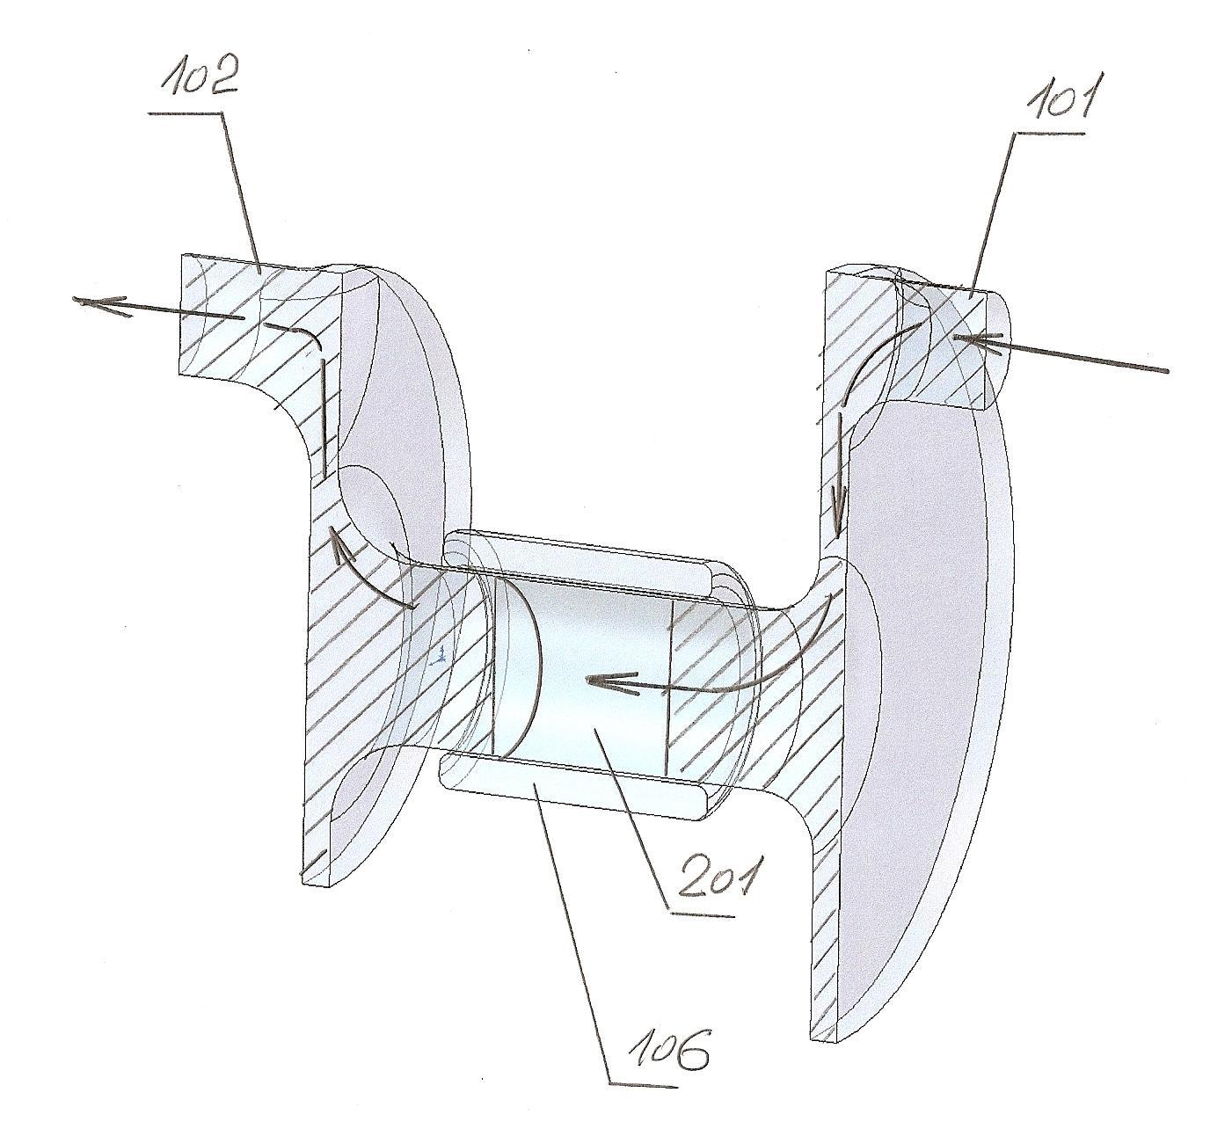
Figure 19. The figure shows a three-dimensional model of the fluid flow in the pipeline - before being fed into the sensor, during checkups and measurements in the sensory pipe, and after checkup and outlet from the control zone
The numbers in the picture mark:
101 - inlet part of the pipe
102 - outlet part of the pipe
106 – sensor
201 - zone of active checkup
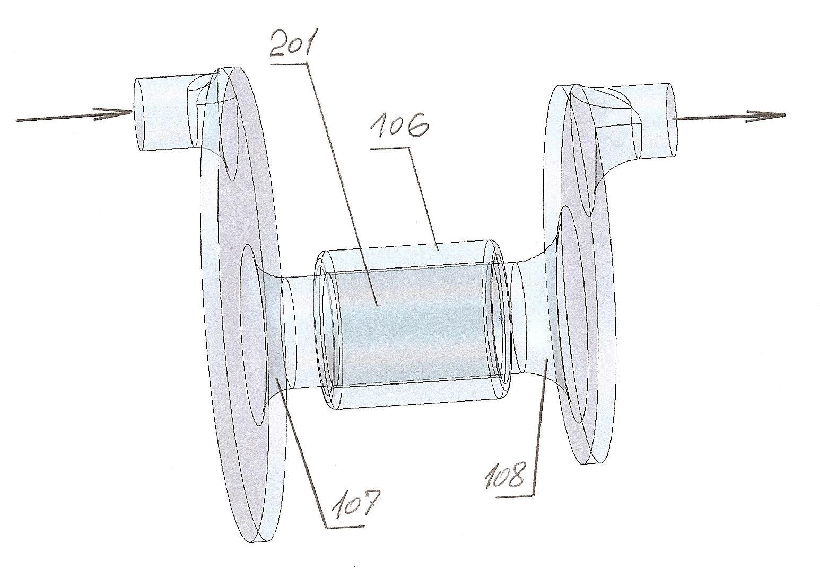
Figure 20. The figure shows a model of fluid flow in a checkup pipe.
The numbers in the picture mark:
106 – sensor
107 - injection globoid channel
108 - outputting globoid channel
201 - the amount being checked inside the sensor

- Approval of the standard's project

The section is carried out by the manufacturer and agreed with the customer
The time to complete this section is 2 working weeks for 4 employees, two employees from each side
The estimated cost of the section for the manufacturer is $9,000 (2 x 5 x 8 = 80 hours per employee)

As a result of the implementation of the section, the manufacturer should develop and customer should approve the basic project document, Engineering analysis note of the section (including all the engineering, design and manufacturing documentation developed for this section).
- Implementation of the standard

The section is carried out by the manufacturer and agreed with the customer
The time to complete this section is 2 working weeks for 4 employees, two employees from each side
The estimated cost of the section for the manufacturer is $9,000 (2 x 5 x 8 = 80 hours per employee)

As a result of the implementation of the section, the manufacturer should develop and customer should approve the basic project document, Engineering analysis note of the section (including all the engineering, design and manufacturing documentation developed for this section).

- Organization of mass production and sale of a new product

The section is carried out by the manufacturer and agreed with the customer
The time to complete this section is 2 working weeks for 4 employees, two employees from each side
The estimated cost of the section for the manufacturer is $9,000 (2 x 5 x 8 = 80 hours per employee)

As a result of the implementation of the section, the manufacturer should develop and customer should approve the basic project document, Engineering analysis note of the section (including all the engineering, design and manufacturing documentation developed for this section).

- Completing the formation of the company's intellectual property portfolio

The section is carried out by the manufacturer and agreed with the customer
The time to complete this section is 4 working weeks for 4 employees, two employees from each side
The estimated cost of the section for the manufacturer is $18,000 (2 x 5 x 8 = 80 hours per employee)

As a result of the implementation of the section, the manufacturer should develop and customer should approve: the basic project document, Engineering analysis note of the section (including all the engineering, design and manufacturing documentation developed for this section, plus original software, including for mobile applications).
THE METHODOLOGY IS DESIGNED FOR PREPARING THE INITIAL STAGE OF CHECKING THE TECHNOLOGY OF NON-CONTACT CONTROL OF THE STATE OF FLUIDS AND LIQUID SOLUTIONS IN A CLOSED PIPELINE
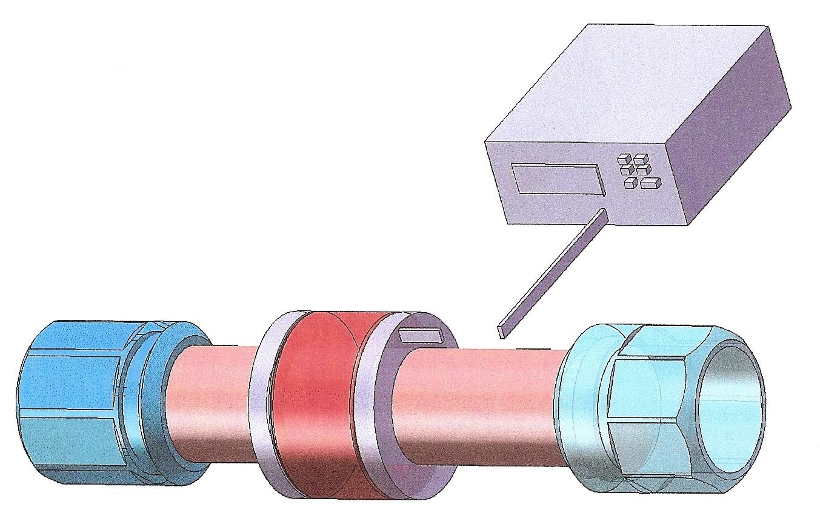
Figure 21. The figure shows a conventional section of the pipeline with the mounted sensor module for a magnetic and resonant checkup of the state of the fluid moving in the pipeline
The control and checkup system's module is connected to the sensor module, which necessarily includes an impulse generator and an analytical computing unit with a power source
Despite the fact that the thickness of the walls of the pipe separates the sensor and the controlled fluid, due to the fact that the level of turbulence in the pipe, as a rule, differs significantly in the core of the stream and on the periphery of the stream, and due to the fact that flow passes in the axial channel of the solenoid, the resulting resonance is stabilized and the difference in turbulence is also compensated, resulting in a sufficiently high measurement accuracy

Methods for selecting the operating frequencies of detectors
This technique describes the first step necessary to build a system for monitoring the concentration of the components of the test mixture.
The mixture is implied any combination of components, one of which is prevailing in volume and is considered as a conventional solvent, and the others are considered as conventional dissolved components.
The concept of a conventional solvent is not limited to a liquid single-component substance capable of forming solutions with other substances; it can also be a mixture of either gaseous or liquid and even solid substances (an example is a compound), which can serve as a basis for the formation of not only solutions but suspensions, aerosols, foams.
Accordingly, conventional dissolved components can be not only dissolved but also be present in solutions as suspensions, bacterial colonies, aerosol droplets, gas bubbles in the foam or filler particles in the compounds.

Search for the optimal operating frequency of the sensor for building a monitoring system for one component of the mixture.
Such a monitoring system can be used in technological processes in which it is possible to make a change in the concentration of one component, while the concentrations of other components remain unchanged.

Preparation of samples for measurement
It is necessary to prepare two samples with the concentrations of the investigated component corresponding to the boundaries of the proposed variation range of this concentration.
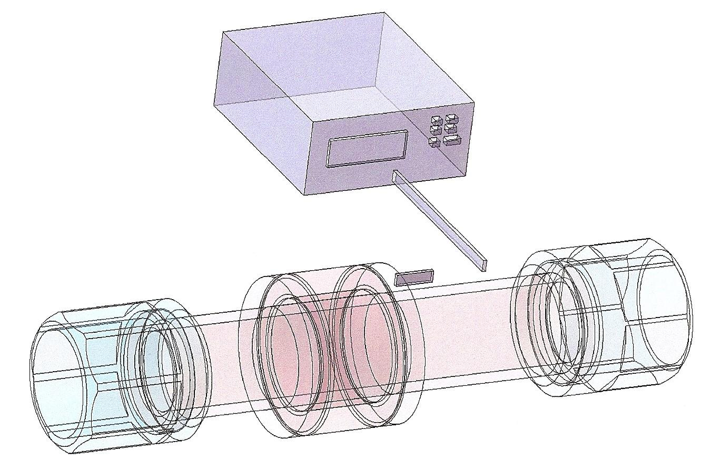
Figure 22. The figure shows the pipeline section with the sensor mounted on the pipe, while the fluid checkup is in a dynamic mode and, as can be seen from the model, the fluid flow moves in the pipe without obstructions

Scanning
Using a potentiometer, perform frequency scanning of the prepared samples using the entire bandwidth of the potentiometer (in our case: from 0.100 MHz to 170 MHz).
In the process of scanning, one should record readings of the potentiometer in the form of changes in the amplitude and phase shift of the current flowing through the sample relative to a harmonically varying probing voltage with a stabilized constant amplitude.

Analysis of the results
Based on the scan results, it is necessary to select several frequencies at which the difference between the amplitudes of the samples under study reaches the highest values and several frequencies at which the difference in frequency shifts reaches the highest values.
The selected frequencies will be the initial data for the constructional design for the manufacturing of pilot resonant sensors.

Selecting the optimal detector
The selection of a set of frequencies according to the results of scanning samples using a potentiometer is preliminary.
To decide on the optimal operating frequency of a one-component concentration monitoring system, it is necessary to test each pilot resonance detector, but not with two, but with at least 10 samples with different concentrations of the component under study that are within the expected range of its variation.
The best one can be chosen after testing all the pilot detectors; the preference should be given to detectors that, along with good sensitivity, have a monotonous change in readings in accordance with a change in the concentration of the controlled component (for the convenience of subsequent calibration).
Lower frequencies are preferable in terms of providing interference immunity.
Also, when choosing a detector, it is necessary to take into account design limitations
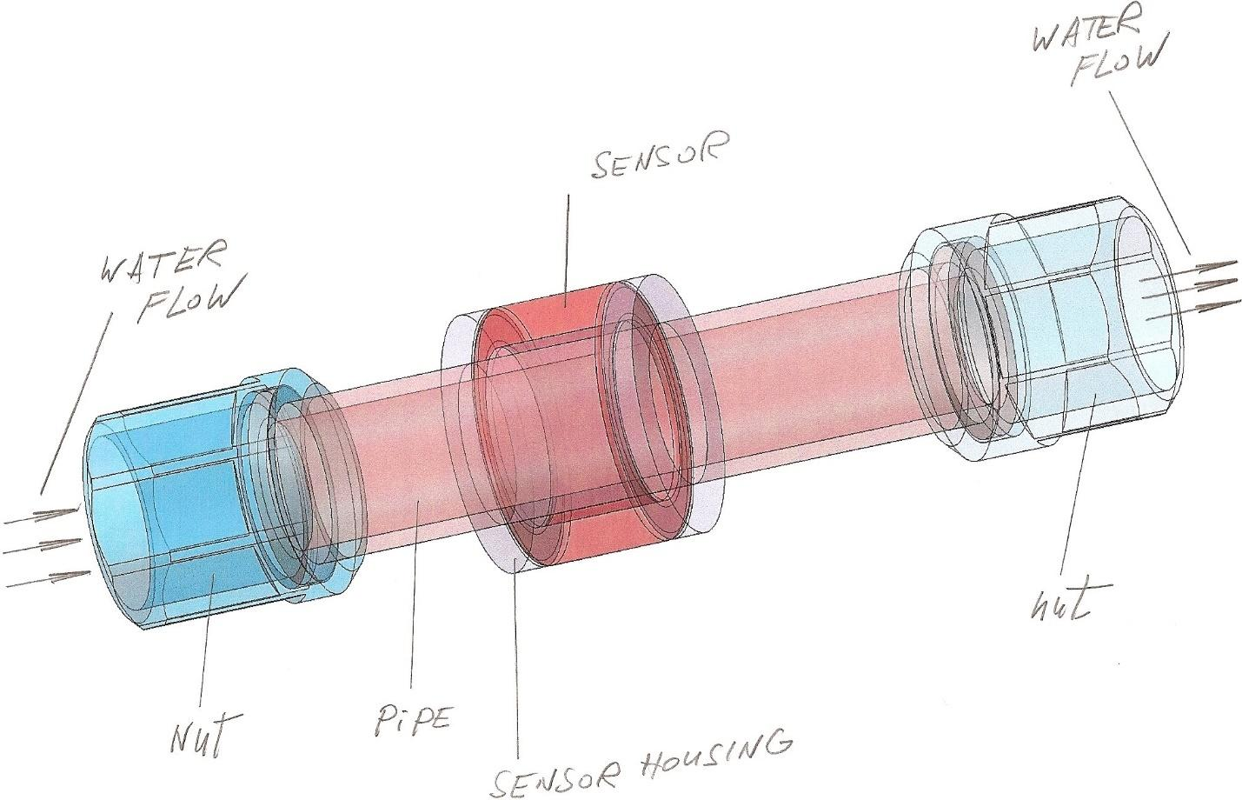
Figure 23. The figure shows the section of the pipeline on which the sensor is installed for magnetic and resonance checkup and measurements

Search for the optimal operating frequencies of detectors for the building of a monitoring system for two components of the mixture.
Such a monitoring system can be used in technological processes in which it is possible to make a change in the concentration of two components, while the concentrations of other components remain unchanged.

Preparation of samples for measurement
It is necessary to prepare two samples for each component under study with concentrations corresponding to the boundaries of the expected range of variation of these concentrations, as well as a sample in which these components are completely absent.

Scanning
Using a potentiometer, perform frequency scanning of the prepared samples using the entire bandwidth of the potentiometer (in our case: from 0.100 MHz to 170 MHz).
In the process of scanning, one should record readings of the potentiometer in the form of changes in the amplitude and phase shift of the current flowing through the sample relative to a harmonically varying probing voltage with a stabilized constant amplitude.

Analysis of the results
According to the results of scanning, it is necessary to select several frequencies for each component under study, at which the difference between the amplitudes of the samples under study reaches the highest values, several frequencies at which the difference in frequency shifts reaches the highest values and frequencies (or frequency ranges) at which there is no sensitivity to one component, while there is to the other.
Analyze the received frequency samples. Depending on the comparison results, there are several possible algorithms for selecting the operating frequencies of the detectors.

An option when there are frequencies at which there is a sensitivity only to one component.
This option is most preferable for constructing a monitoring system for the concentrations of the studied components.
If such frequencies exist for one component as well as for another, then the choice of operating frequencies is obvious: for the manufacture of the pilot specimen of resonant detectors, it is necessary to select such operating frequencies at which, in the absence of sensitivity to one component, sensitivity to the other is maximum.
At least one such frequency must be selected for each component.
If such frequencies exist only for one of the components, then for the manufacture of pilot specimen of resonant detectors for this component, it is necessary to select such operating frequencies at which, in the absence of sensitivity to one component, the sensitivity to the other is maximum; for another component from its set of frequencies, one should choose such operating frequencies at which the difference in sensitivity to the studied components is the greatest.

An option when there are no frequencies at which there is sensitivity to only one component, but the obtained frequency samples do not coincide.
In this case, for the manufacturing of pilot specimen of resonance detectors, one should select such operating frequencies from each set of frequencies at which the difference in sensitivity to the components under study is greatest.

An option when the obtained frequency samples coincide.
This option is most complex for constructing a monitoring system for the concentrations of the studied components.
If the set of frequencies for one component completely coincides with the set for another, then it is necessary to check at all frequencies whether the proportion between changes in the amplitude or phase shift for one component and changes in the amplitude or phase shift for the other component is maintained.
If everything matches, then one should try to repeat the scan using other values of the probing voltage.
If differences cannot be achieved, then most likely the components under study are indistinguishable from the point of view of electrochemical magnetic and resonance spectroscopy.
Nevertheless, even in this case, one can try to make several pilot specimen sensors with different operating frequencies, corresponding to the greatest sensitivity to changes in the concentrations of the studied components, since the resonant detector has a more complex effect (the effect of a magnetic field is added) on the sample under study than the effect of a potentiometer.
If testing of these sensors at least at one of the frequencies will show the presence of a change in the proportion of sensitivity to changes in concentrations, then there is a fundamental possibility of constructing a system for monitoring the concentration of the studied components, and the selectivity of this system will be the higher, the greater the difference in the proportion.

Selecting optimal detectors
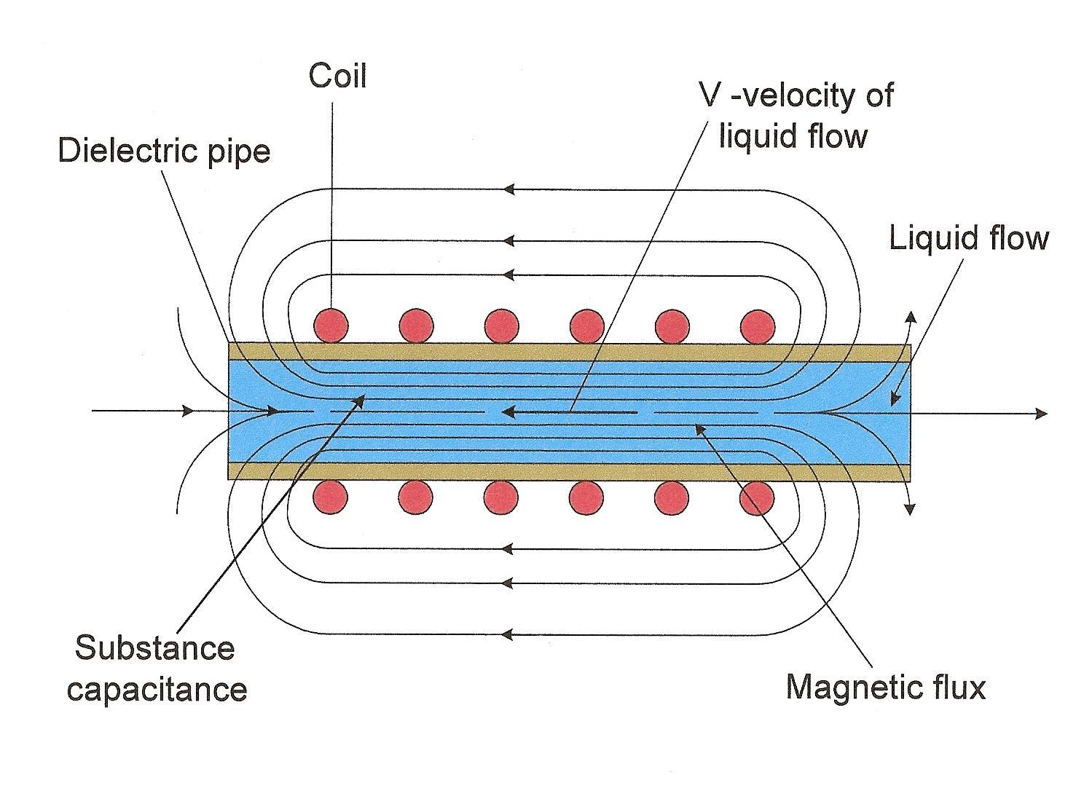
Figure 24. The figure shows a diagram of a magnetic and resonance sensor with a controlled fluid, moving in a pipe, outside of which a sensor’s solenoid is installed
The sensor can be also made in the printed form - as an element of a printed circuit board or as an element of a layer of a printed circuit board which is a component of a multilayer printed circuit board;
As practice has shown, this type of sensor and controlling technique with the help of it give the most optimal results, with maximum accuracy and at relatively low energy costs for the testing operation
Also, as practice shows, the design of such a control system or module fits very conveniently into sophisticated integral technical systems and the signals of such systems are unambiguously perceived by control and measuring systems, as well as tracking systems of the so-called super-systems and can easily be converted into command guided systems included in the super-system - subsystems
That is, this type of sensors easily and unequivocally fits into smart control and monitoring technological and design solutions with automatic monitoring and adjustment of basic parameters
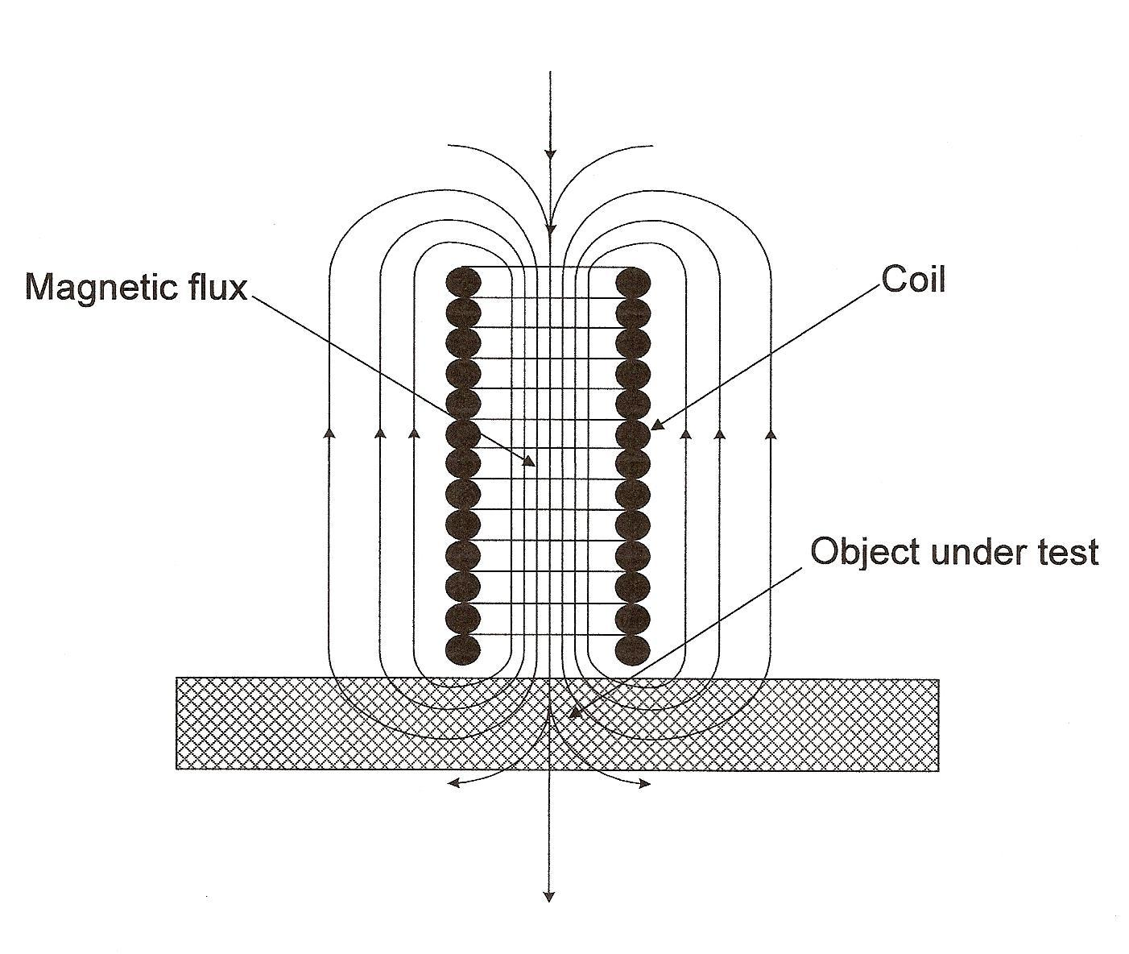
Figure 25. The figure shows a diagram of a magnetic and resonance sensor; The sensor is made in the form of a solenoid and can control objects perpendicular to the axis of the solenoid; As practice shows, this type of control is extremely precise and, in some cases, can distinguish controlled objects with a difference in size within 10 angstroms.
Processing checkup results requires large amounts of memory and effective elements of artificial intelligence.
The selection of a set of frequencies according to the results of scanning samples using a potentiometer is preliminary.
To decide on the optimal operating frequencies of a two-component concentration monitoring system it is necessary to test each pilot resonance detector, but not with two, but with, at least, 10 samples with different concentrations of components under study that are within the expected range of its variation.
Best pair can be chosen after testing all the pilot detectors; the preference should be given to detectors that, along with good sensitivity, have a monotonous change in readings in accordance with a change in the concentration of the controlled component (for the convenience of subsequent calibration).
Lower frequencies are the most preferable in terms of providing interference immunity.
Also, when choosing detectors, it is necessary to take into account the existing design, technological and metrological limitations.

List of reference literature, patent, and licensed materials
Annex 1
United States Patent Application | 20160329676
Kind Code | A1
LEE; Hyung Man; et al. | November 10, 2016

METHOD FOR MANUFACTURING LASER MODULE, AND LASER MODULE PACKAGE
Abstract
The present invention relates to a method for manufacturing a laser module, and a laser module package, and the method for manufacturing a laser module. Rapidity, accuracy and high reliability of the manufactured module can be obtained by aligning precisely using an automated equipment, and fixing components through laser welding.

Annex 2
United States Patent Application | 20170281077
Kind Code | A1
PYUN; Sung Hyun; et al. | October 5, 2017

SYSTEM WITH DISEASE DIAGNOSIS AND SKIN AGE MEASUREMENT FUNCTIONS AND HANDPIECE USED THEREWITH
Abstract
An aesthetic or medical system is provided. The aesthetic or medical system includes: a laser irradiation device configured to generate a laser and project the laser onto body tissue; a probe configured to collect light which is generated when the laser is projected onto the body tissue; and an analysis unit configured to diagnose a disease by analyzing a spectrum of the light collected by the probe, and the probe is detachably connected to the laser irradiation device.

Annex 3
United States Patent Application | 20090024243
Kind Code | A1
Suh; Jeong-Hun | January 22, 2009

Method and system for real-time monitoring and controlling height of deposit by using image photographing and image processing technology in laser cladding and laser-aided direct metal manufacturing process
Abstract
The object of this invention is to provide a method and system for real-time monitoring and controlling the height of a deposit by using image photographing and image processing technology in a laser cladding and laser-aided direct metal manufacturing process. This invention also provides a method of controlling the intensity of laser power, which is one of the most important process variables, regardless of the operational condition of a laser power unit (401). The method and system of this invention controls the height of a deposit (205) by real-time monitoring the position and the height of a melt pool (203) and controlling the process variables using the image photographing and image processing technology in such a laser cladding and laser-aided direct metal manufacturing process based on a laser surface modification technology, such as laser surface alloying and laser cladding, or a laser-aided direct metal manufacturing technology.

Annex 4
United States Patent Application | 20170017858
Kind Code | A1
ROH; Younggeun; et al. | January 19, 2017

LASER SPECKLE CONTRAST IMAGING SYSTEM, LASER SPECKLE CONTRAST IMAGING METHOD, AND APPARATUS INCLUDING THE LASER SPECKLE CONTRAST IMAGING SYSTEM
Abstract
Provided are a laser speckle contrast imaging method, a laser speckle contrast imaging system, and an apparatus which includes the laser speckle contrast imaging system. The laser speckle contrast imaging system includes a laser light source configured to irradiate laser beams toward a subject, the laser beams having a plurality of wavelength bands and different surface transmittances with respect to the subject. An imaging unit is configured to acquire speckle images by capturing images of speckles by using an image sensor, the speckles being formed when the irradiated laser beams are scattered from the subject. A signal processor is configured to convert the acquired speckle images into speckle contrast images and to acquire a compensated speckle contrast image by compensating for a change caused by a movement of the subject.

Annex 5
United States Patent Application | 20180228464
Kind Code | A1
Yang; Joon Mo; et al. | August 16, 2018

ARRAY TRANSDUCER-BASED SIDE-SCANNING PHOTOACOUSTIC-ULTRASONIC ENDOSCOPE
Abstract
A photoacoustic-ultrasonic (i.e. dual mode) endoscope includes: an optical fiber; a light diffuser configured to diffuse a laser beam delivered through the optical fiber to a target point of an object to be examined; and an array transducer through which the diffused laser beam passes and configured to generate ultrasonic waves or detect ultrasonic waves generated in the object to be examined.

Annex 6
United States Patent Application | 20160206251
Kind Code | A1
KWON; Yongjoo; et al. | July 21, 2016

APPARATUS FOR DETECTING BIO-INFORMATION
Abstract
An apparatus and a method for detecting bio-information are provided. The apparatus includes a bio-signal detector including a light emitter including a light-emitting diode (LED) and a laser diode (LD), the LED and the LD being configured to emit optical signals on an object. The bio-signal detector further includes an optical detector including a light-receiver configured to detect optical signals modulated by the object. The apparatus further includes a processor configured to process the optical signals to detect the bio-information of the object.

Annex 7
United States Patent Application | 20180055343
Kind Code | A1
Yang; Joon-Mo; et al. | March 1, 2018

PHOTOACOUSTIC AND ULTRASONIC ENDOSCOPY SYSTEM INCLUDING A COAXIALLY CONFIGURED OPTICAL AND ELECTROMAGNETIC ROTARY WAVEGUIDE ASSEMBLY AND IMPLEMENTATION METHOD THEREOF
Abstract
A photoacoustic-ultrasonic dual-mode endoscope includes: a probe and a probe driving unit, wherein the probe includes: a coaxially configured optical and electromagnetic rotary waveguide assembly including an optical fiber, the optical fiber including a core and a cladding, and a conductive path coaxially arranged with the optical fiber; a scanning tip located at an end of the coaxially configured optical and electromagnetic rotary waveguide assembly and configured to deliver a laser beam to an object to be examined and detect a photoacoustic signal and an ultrasonic signal generated from the object to be examined; and a plastic catheter surrounding outer surfaces of the coaxially configured optical and electromagnetic rotary waveguide assembly and the scanning tip, wherein the conductive path includes: a first conductive path including a portion coaxially arranged with the optical fiber; and a second conductive path including a portion coaxially arranged with the optical fiber and insulated from the first conductive path.
Annex 8
United States Patent Application | 20160058300
Kind Code | A1
Yoon; Youngzoon; et al. | March 3, 2016

APPARATUS FOR AND METHOD OF MONITORING BLOOD PRESSURE AND WEARABLE DEVICE HAVING FUNCTION OF MONITORING BLOOD PRESSURE
Abstract
A method of monitoring a blood pressure includes: emitting a laser to a blood vessel in a body part; detecting, from the body part, laser speckles caused by scattering of the emitted laser; obtaining a bio-signal indicating a change in a volume of the blood vessel by using the detected laser speckles; and estimating a blood pressure based on the obtained bio-signal.

Annex 9
nited States Patent Application | 20150131687
Kind Code | A1
OH; Su Hwan; et al. | May 14, 2015

LASER MODULE
Abstract
A laser module includes a Transmitter Optical Sub-Assembly (TOSA) and a heat radiating means. The TOSA generates light by an electrical signal and transmits the generated light through an optical fiber. The heat radiating means is in contact with the TOSA to discharge heat generated by the TOSA.

Annex 10
United States Patent Application | 20080188724
Kind Code | A1
Hwang; In Duk; et al. | August 7, 2008

Noninvasive apparatus and method for measuring blood sugar concentration
Abstract
An apparatus noninvasively measures blood sugar concentration. The apparatus includes: a tissue modulation unit applying a pressure to a tissue; a hemoglobin (Hb) concentration measurement unit analyzing an amount of absorption of electromagnetic waves on a first portion of the tissue before and after the applying of the pressure by the tissue modulation unit, and measuring Hb concentration of the tissue; and a photoacoustic module unit analyzing photoacoustic signals to measure blood sugar concentration, and correcting the measured blood sugar concentration based on the measured Hb concentration to output a final blood sugar level, the photoacoustic signals being created from the tissue by emitting a pulse laser ray towards a second portion of the tissue before and after the applying of the pressure by the tissue modulation unit.
Annex 11
United States Patent Application | 20090216300
Kind Code | A1
Keltner; Llew; et al. | August 27, 2009

METHOD AND APPARATUS FOR LIGHT-ACTIVATED DRUG THERAPY
Abstract
A prostate treatment system having a light delivery device positionable in a transurethral device for treatment of benign prostatic hyperplasia (BPH). The light delivery device includes light generator, such as light emitting diodes (LED), laser diodes (LDs) or a diffusion quartz fiber tip connected to a light generator or a light emitting polymer which produces light at a selected wavelength or waveband or alternative sources of suitable light energy. The treatment device may further include a temperature monitoring system for monitoring the temperature at the treatment site. A light-activated drug is administered to the treatment site prior to light activation. The light-activated drug therapy induces cell death of the target tissue. The device provides a minimally invasive transurethral method for treatment of BPH or prostate cancer.

Annex 12
United States Patent Application | 20060129327
Kind Code | A1
Kim; Myung L.; et al. | June 15, 2006

Ultrasensitive sensor and rapid detection of analytes
Abstract
The present invention relates to systems and methods for real time, rapid detection, identification, and enumeration of a wide variety of analytes, which include but are not limited to, cells (Eukarya, Eubacteria, Archaea), microorganisms, organelles, viruses, proteins (recombinant or natural proteins), nucleic acids, prionss, and any chemical, metabolites, or biological markers. The systems and methods, which include the laser/optic/electronic units, the analytic software, the assay methods and reagents, and the high throughput automation, are particularly adapted to detection, identification, and enumeration of pathogens and non-pathogens in contaminated foods, clinical samples, and environmental samples. Other microorganisms that can be detected with the present invention include clinical pathogens, protozoa and, viruses.
Annex 13
nited States Patent Application | 20170050043
Kind Code | A1
KANG; HYUN WOOK; et al. | February 23, 2017

PROBE COMPRISING OPTICALLY DIFFUSING FIBER, METHOD FOR MANUFACTURING SAME AND APPLICATIONS THEREOF
Abstract
The present invention relates to an optically diffusing fiber probe, a method for manufacturing the same, and an application thereof. More specifically, the present invention relates to an optically diffusing fiber probe capable of emitting light in a plurality of directions and a method for manufacturing the same, hybrid optical medical equipment for both diagnosis and treatment of tubular human tissue, a catheter-based laser treatment device, and an electromagnetic energy application device for tubular tissue stricture, comprising the optically diffusing fiber probe.

Annex 14
United States Patent Application | 20120002008
Kind Code | A1
Valin; David; et al. | January 5, 2012

Apparatus for secure recording and transformation of images to light for identification, and audio visual projection to spatial point targeted area
Abstract
The current invention presented here is an apparatus for securely managed recording, transformation, storage, and projection of digital or quantum media images and video by a server transforming laser light into a standalone or reflected audio video spatial point targeted display in free space, or reflected surface, for virtual or non virtual viewing and listening. The method and mechanism presented allows any individual or groups to view and listen to content in any space managed by an Illumination Transformer Audio Video Manager Interactive Server Transmitter (ITAVMIST) server, GSense H3DVARVP-IL or high resolution devices, goggles, glasses or without devices, and be able to view, video and listen to sound, in binaural stereo and 2D 3D video. The present invention also enables recording and transformations of audio and video with GSense H3DVARVP devices, goggles, glasses or other viewing device configurations, transmitted wireless or infrared to an ITAVMIST server for processing, transformation and transmission to spatial point targets in free space for viewing in virtual spaces or non virtual spaces.

